

Date: 13 January 2019

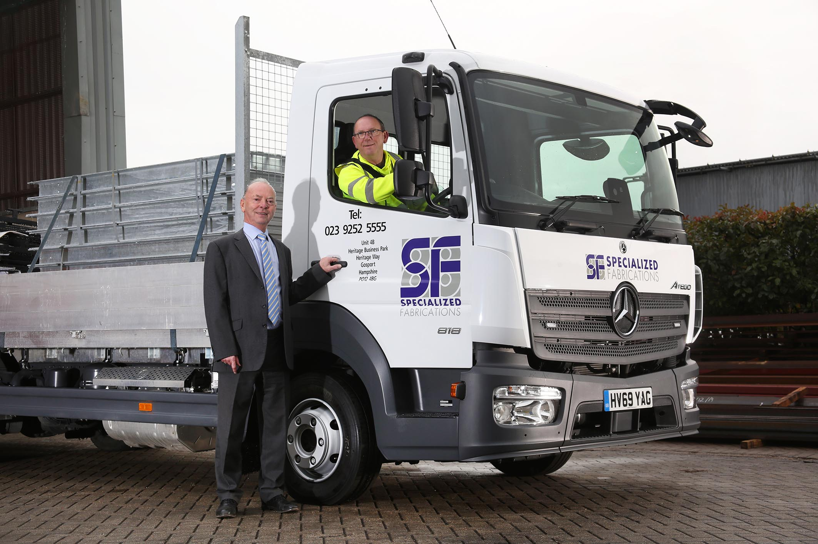

World view: Brothers Tony, left, and Kevin, are pictured with Specialized Fabrications’ latest Mercedes-Benz Atego

Specialized Fabrications places its trust in another Mercedes-Benz Atego from Marshall Truck & Van

A nasty road accident has only served to reinforce Specialized Fabrications’ loyalty to the Mercedes-Benz Atego, after its driver escaped unscathed.

The family-owned and run company designs, manufactures and installs a wide range of architectural metalwork, including staircases, balconies, canopies and balustrades, as well as secondary steelwork in both ferrous and non-ferrous materials.

Specialized Fabrications is based in Gosport, Hampshire, and has just taken delivery from local Dealer Marshall Truck & Van of another 7.5-tonne Atego, to replace the five-year-old vehicle which was ‘written off’ in the collision.

Fitted with a dropside body by Solent Bodybuilders, of Fareham, the new truck is now delivering the company’s products to development sites and other customer locations throughout the south of England.

The Atego 818 has an air-conditioned ClassicSpace day cab and an optional ventilated driver’s suspension seat with integral armrests. Its 5.1-litre four-cylinder engine produces 130 kW (177 hp) and drives through a six-speed Mercedes PowerShift 3 automated manual transmission.

Specialized Fabrications was established in 1984 by Managing Director Tony World. His brother Kevin drives its only truck, while another brother, Martin, is a Buyer, and son Nathan is a Contracts Engineer.

Purpose-designed for light- and medium-duty distribution work, as well as construction applications, the Mercedes-Benz Atego range from 7.5-16 tonnes GVW combines outstanding dynamics, comfort and manoeuvrability, with well-proven reliability and durability.

Specialized Fabrications bought its first 7.5-tonne Atego in 1999 and ran the truck for six years, before replacing it with one from another brand. “That was a big mistake,” recalled Tony World. “We bought the truck because it was so keenly priced, but it wasn’t really up to the job, and was forever in the garage.

“We quickly came to realise that we should have paid more attention to quality, and gone for another Mercedes-Benz. Having stuck it out until 2010 we switched back to a used Atego, which we ran for four years before buying our first brand new one.”

Mr World continued: “Our last Mercedes-Benz had given us five years of ultra-reliable service before it suffered a twisted chassis in the accident. The important thing, though, is that Kevin got out without a scratch, which says a lot for the strength and safety of the Atego.

“Kevin is delighted with his new truck. It has a more powerful engine than the last one, as well as the automated transmission, and is a nicer, more comfortable vehicle all round. Clients are also pleased to see us investing in premium-quality equipment, as it helps to reassure them of our determination to provide a reliable delivery service.”

Key to Specialized Fabrications’ continued loyalty to the Mercedes-Benz brand is the customer-focused support it receives from the workshop team at Marshall Truck & Van’s Fareham headquarters.

Once again, the operator has taken out a five-year Mercedes-Benz Complete Service Contract. “The plan is competitively priced and allows us to budget with confidence, while also protecting ourselves against price increases,” said Mr World.

“The Dealer knows us well and provides a great service, which means we never incur any downtime. We always drop our vehicle off at the end of the day so it can be inspected and serviced overnight, then pick it up at 7am ready to go to work again.”

www.specfabs.co.uk

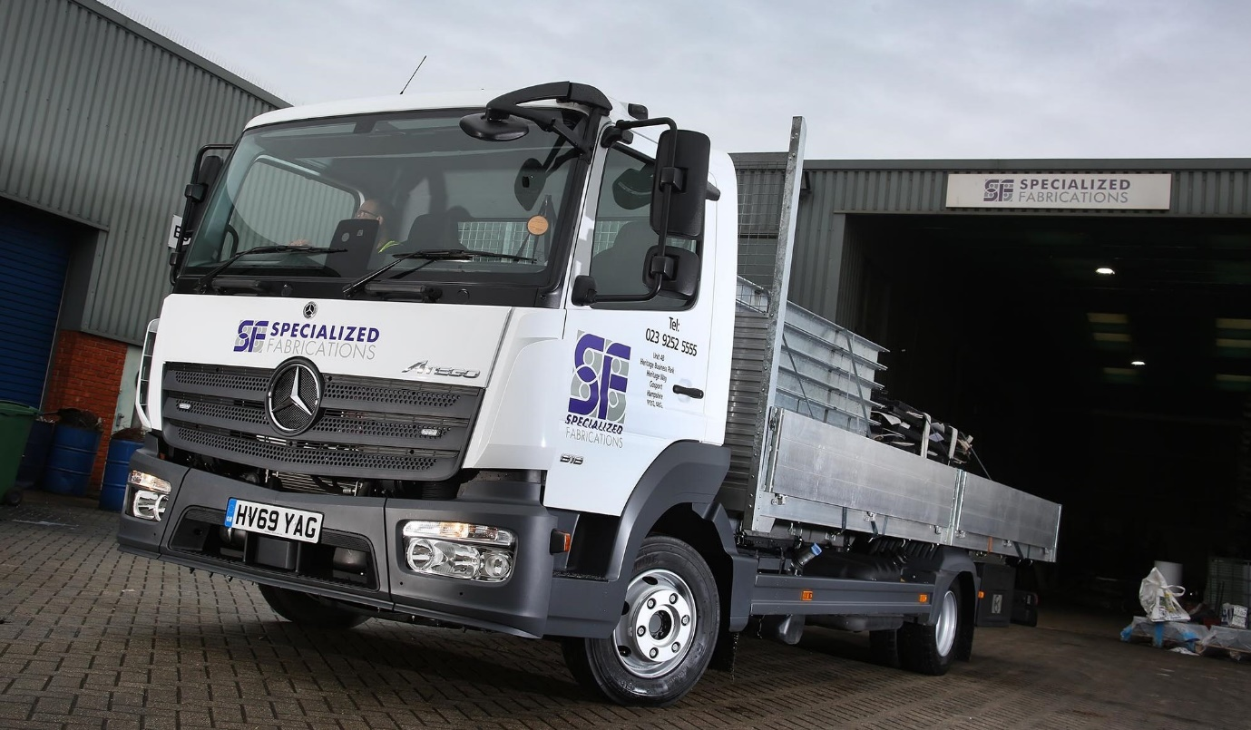

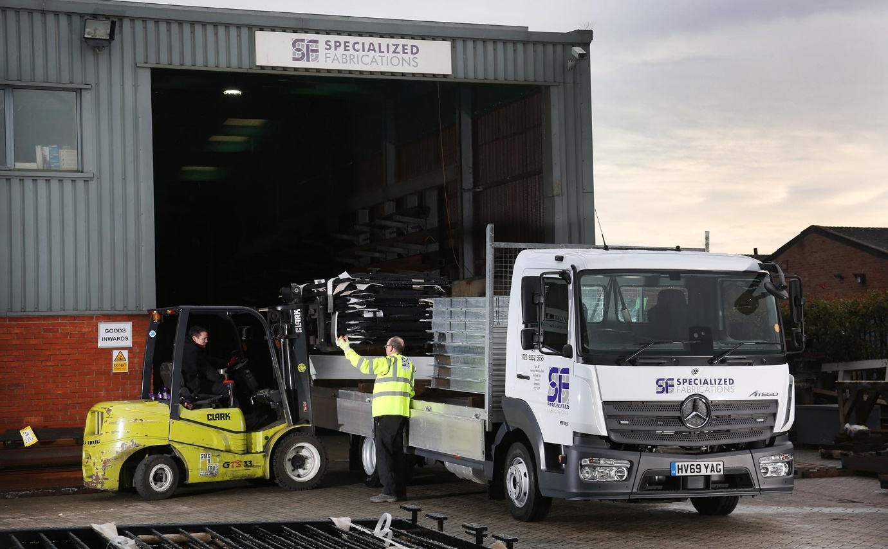
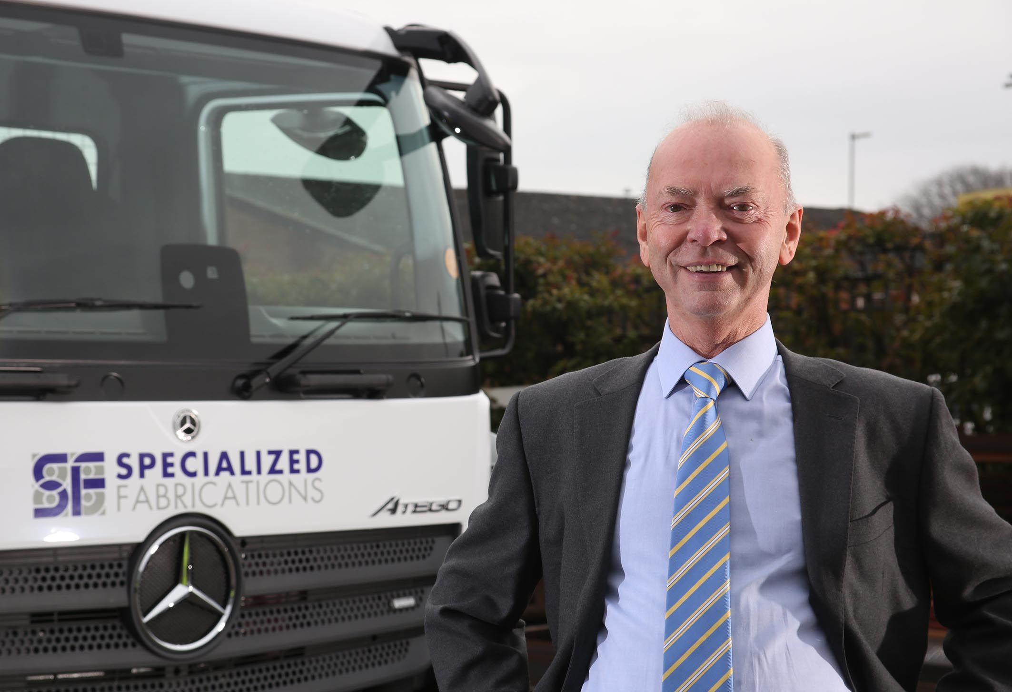

Precious metal: Managing Director Tony World knows Specialized Fabrications’ new Mercedes-Benz Atego can be relied upon to provide reliable, cost-effective service

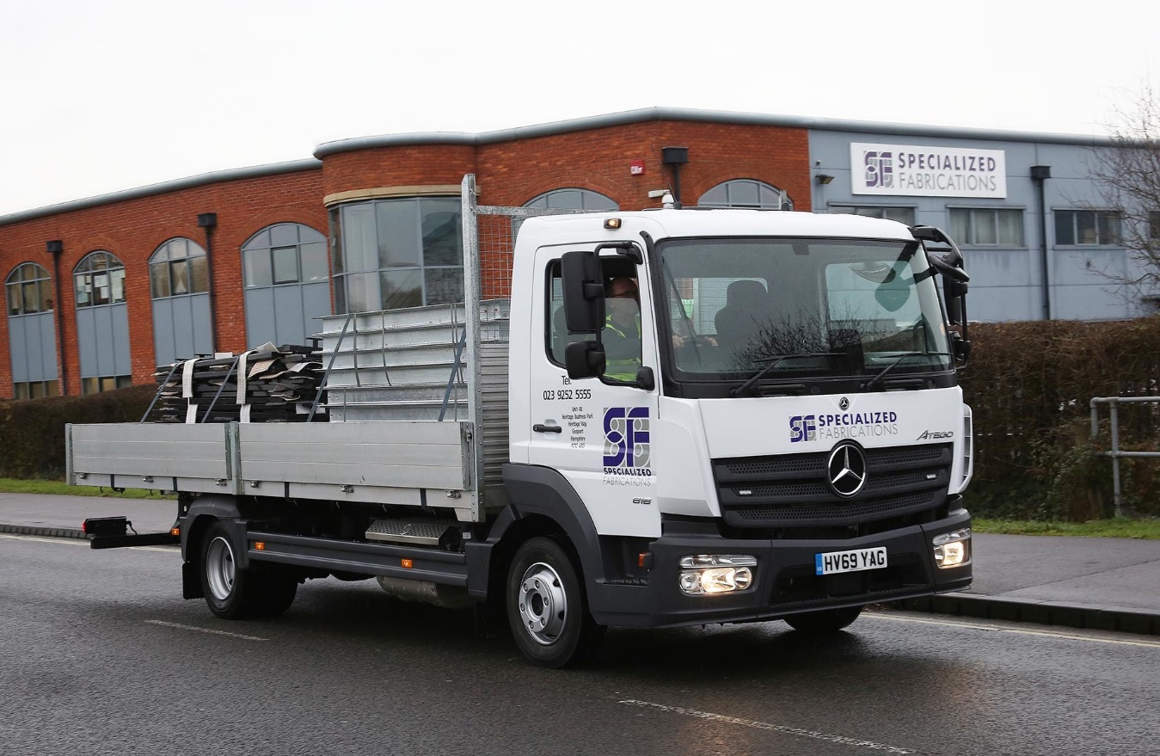

ends

For more information, or to request bigger/higher-res image files, please contact:
Steve Warren or John Ripley
Impact Communications, 01926 842126
Steve: 07770 470251, steve@impactcom.co.uk
John: 07771 484595, john@impactcom.co.uk

