

Date: 26 March 2021
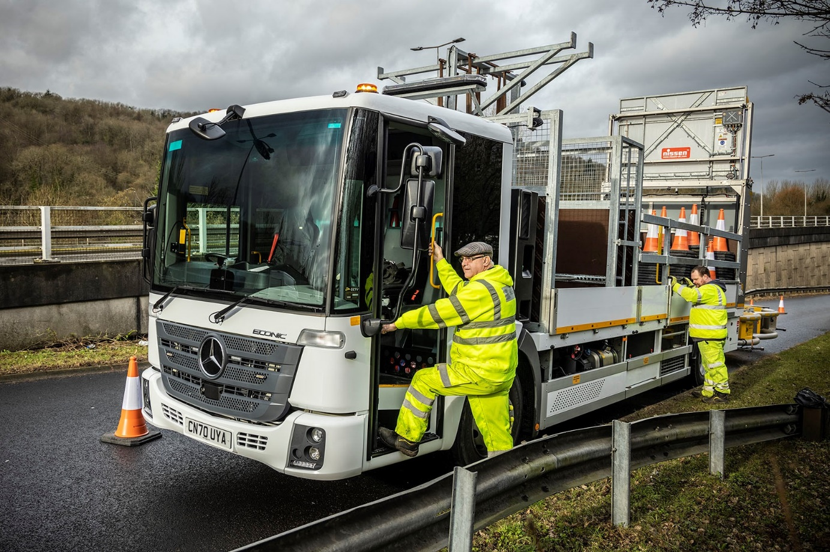

Cardiff Council drives safety with new Mercedes-Benz Econic impact protection vehicles

The safety of motorists and members of their own highways team was uppermost in the minds of Cardiff Council procurement chiefs when they ordered two new Mercedes-Benz trucks to help traffic flow smoothly in and around the city.

Based on low-entry 18-tonne Econic chassis supplied by South Wales Dealer Euro Commercials, the impact protection vehicles are the subject of a lease agreement with Swansea-based Days Fleet, an established supplier to the authority.

The trucks’ bodywork was purpose-designed and built to meet Cardiff Council’s requirements by leading traffic management vehicle and equipment specialist Acklea, at its facilities in Romsey, Hampshire, and Calne, Wiltshire.

Fabricated to high quality standards from galvanised steel and aluminium for a long service life, the bodies are fitted with Nissen LED light arrows and class-leading Traffix Scorpion attenuators (‘crash cushions’), which crush in progressive stages, simplifying the process and reducing the cost of replacing parts.

Tested to 70 mph and approved by the National Cooperative Highway Research Program (NCHRP), the Scorpion attenuator features a unique curved design that redirects side angle impacts away from the rear corner of the truck; it offers full-width protection along the entire length of the cushion and resists damage from nuisance knocks.

The Econic chassis, meanwhile, features a deep, panoramic windscreen that provides drivers with an unrivalled field of direct vision. Sitting lower than they would in a conventional truck, drivers can make eye contact with cyclists and other vulnerable road users at junctions and in traffic, through the fully glazed, folding passenger door specified by Cardiff Council. This contributes to safety by helping each to understand the other’s intentions.

Excellent cross-cab access also means that drivers can use the bus-style door to get in and out on the kerb side, rather than having to contend with passing traffic.

Fully air-suspended, and with spacious, air-conditioned cabs, both trucks are 1830L models. The 220 kW (299 hp) outputs from their 7.7-litre in-line six-cylinder engines are transmitted to the road via six-speed Allison automatic gearboxes. Other safety features include the Active Brake Assist 4 emergency braking system with pedestrian recognition.

The cone-carrying Econics are the first trucks that Days Fleet has sourced from Euro Commercials. However, Cardiff Council operates a number of Mercedes-Benz vehicles including 4x4 and 4x2 gritters, vacuum and jetting combinations for drainage work, as well as 7.5-tonne FUSO Canters supplied by the Dealer, which have tipping, refuse collection and traffic management bodies.

Richard Jones, the authority’s Procurement & Contracts Manager – Core Fleet, said the new impact protection vehicles were much better suited to their role than the rented trucks they had replaced. “We went out to tender for a low-entry vehicle that could be used for a broad range of road traffic management operations, including lane closures, barrier work and general repairs. In terms of its specification and cost-effectiveness the Econic was clearly the best solution.”

He continued: “With its investment in these highly specified vehicles the Council has resolved the operational issues its Highways team was facing. Like all Mercedes-Benz trucks the Econic is extremely well built, while the ergonomics are first class – not only does it offer excellent visibility, but it’s also easy for crews to step in and out of the cab, something they’ll typically do numerous times during a shift.”

Cardiff Council will be maintaining the Econics in-house at its College Road workshop, close to the city centre. As with its other Mercedes-Benz and FUSO vehicles though, it will be relying on Euro Commercials for warranty and technical support, as well as parts deliveries.

Mr Jones added: “We have very good relationships with Euro Commercials and Days Fleet, while Acklea has also impressed. All three parties worked exceptionally well together on this project, and as a result our highways colleagues now have the right equipment with which to undertake their important work.”

www.cardiff.gov.uk

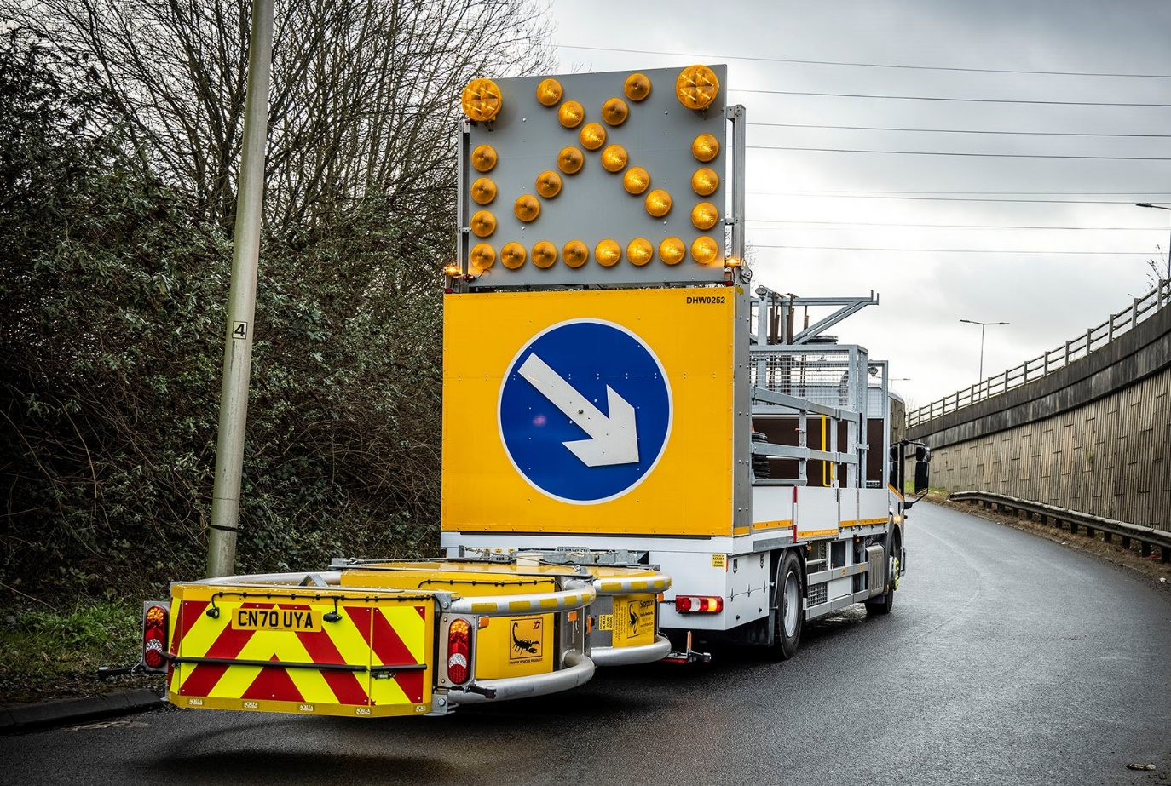

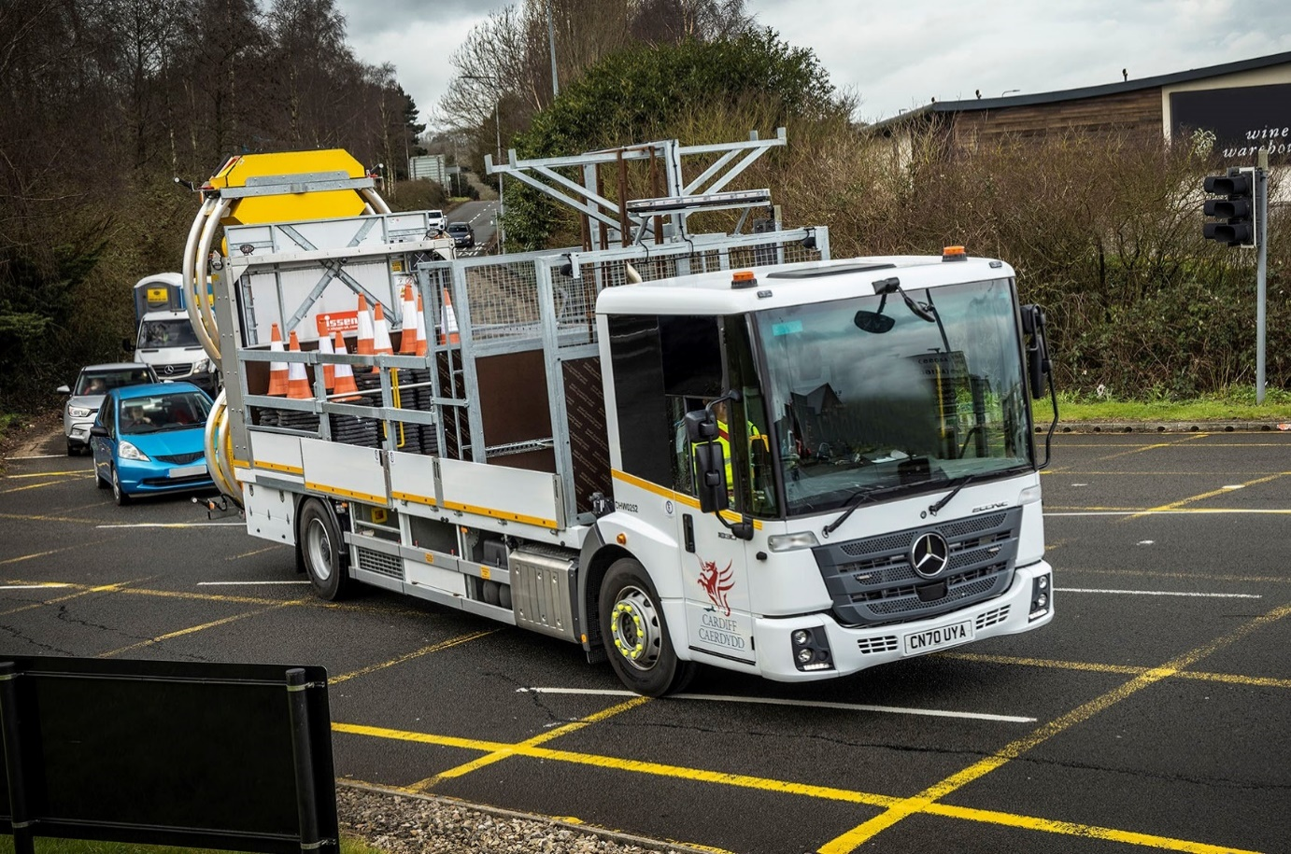

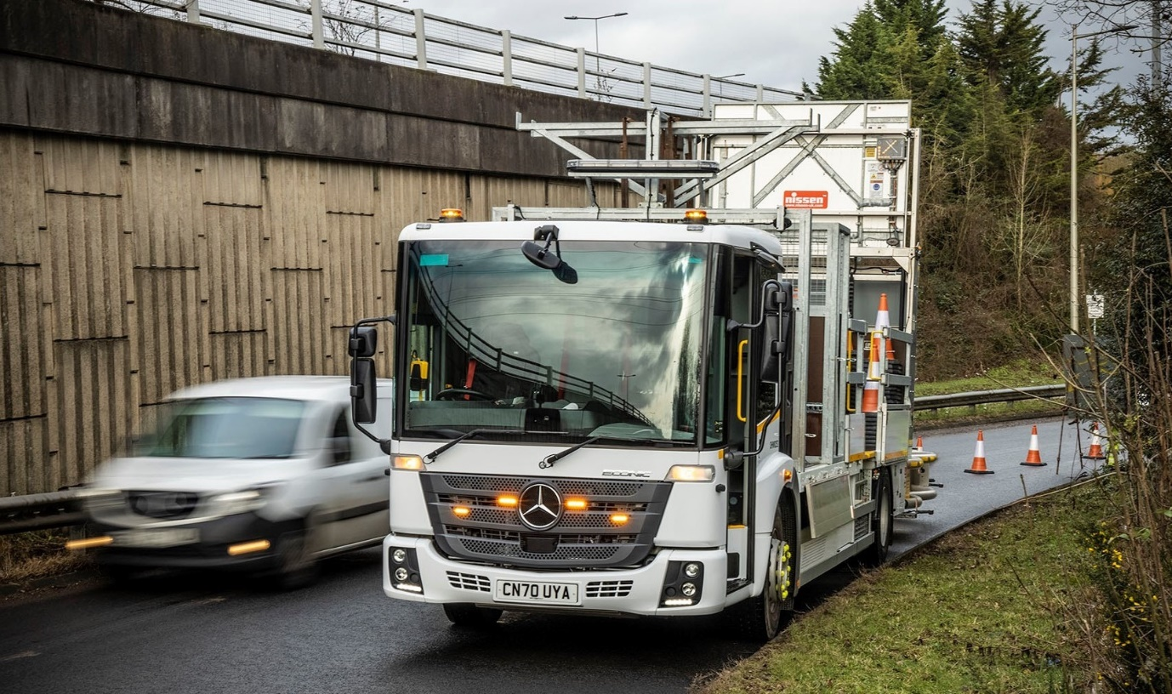
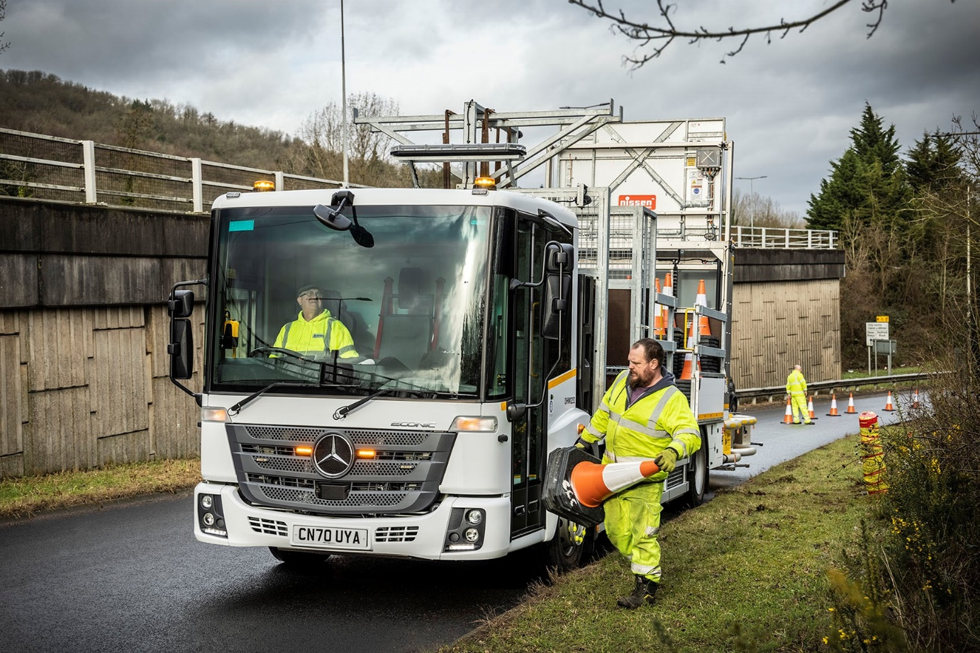

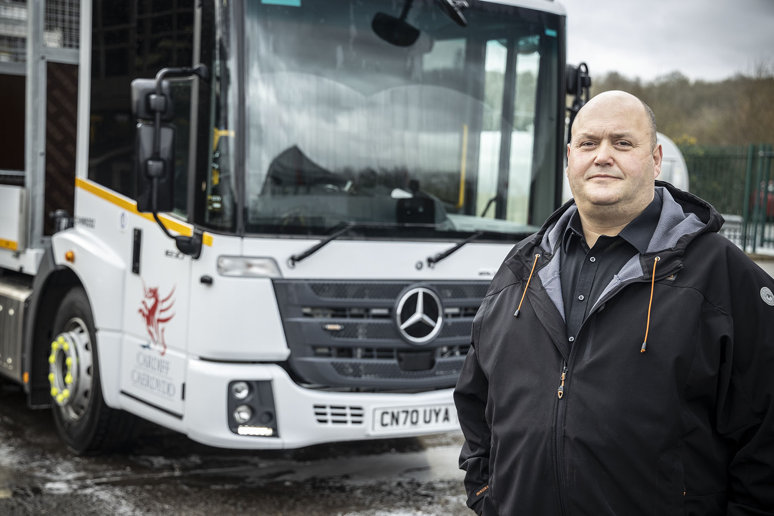

Right tool for the job: Cardiff Council’s Richard Jones said the Mercedes-Benz Econic outscored its competitors in terms of safety and cost-effectiveness

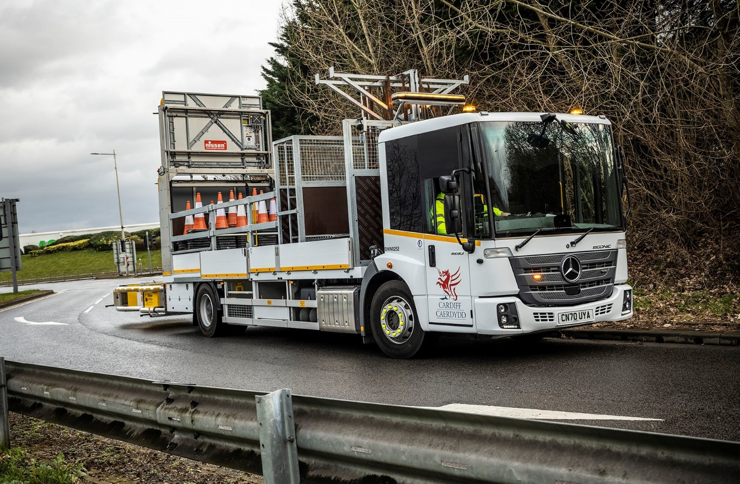

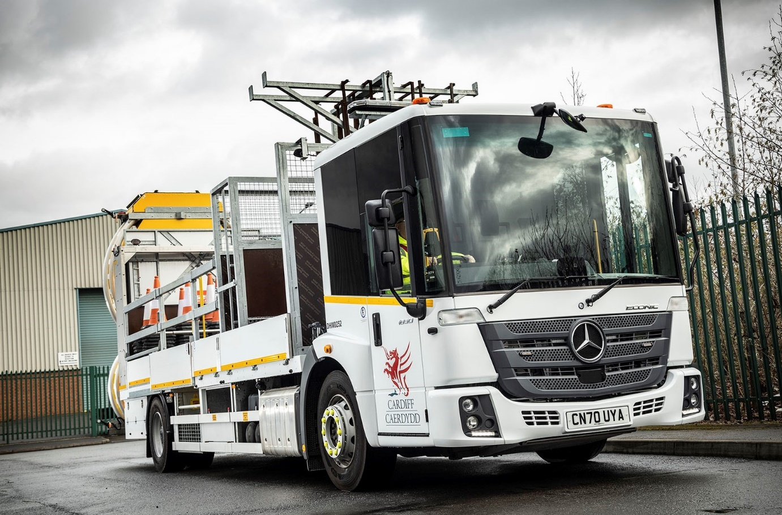

ends

For more information, or to request bigger/higher-res image files, please contact:
Steve Warren or John Ripley
Impact Communications, 01926 842126
Steve: 07770 470251, steve@impactcom.co.uk
John: 07771 484595, john@impactcom.co.uk

