

Date: 22 March 2022

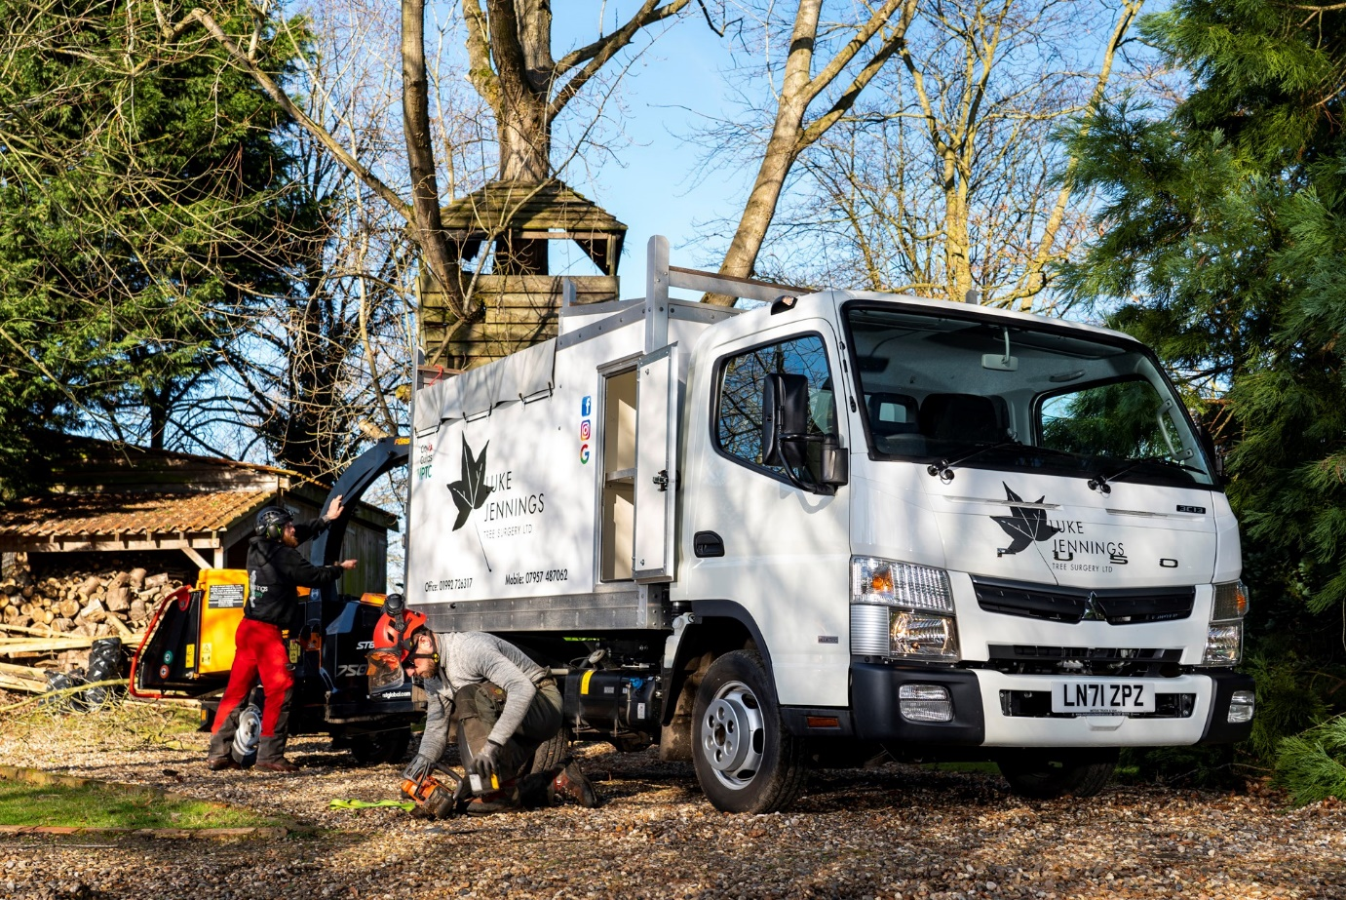

First FUSO Canter ‘cuts up tough’ for tree surgeon Luke

When Luke Jennings needed a new truck for his growing business, he decided to ‘take a leaf out of the book’ of fellow tree surgeons by buying a FUSO Canter.

Luke Jennings Tree Surgery is based in Enfield and serves private and commercial customers throughout North London, Hertfordshire and Essex.

Its smartly finished 3.5-tonne FUSO Canter was supplied by local Dealer Motus Truck & Van, which also sells and supports the Mercedes-Benz range – both brands are part of the Daimler Truck family.

The Canter is a popular choice for those working in the arboricultural sector, due largely to its strength and reliability. The vehicle is built around a rugged, ladder frame chassis – while many of its competitors in the 3.5-tonne segment have van-based underpinnings, the smallest Canter wins praise for being ‘a proper truck’.

Luke took advantage of competitive funding support from Mercedes-Benz Finance to acquire his new 3C13 variant. The vehicle employs a fuel-efficient 3.0-litre common-rail turbodiesel that produces 96 kW (130 hp) and 350 Nm of torque, and drives through a five-speed manual gearbox.

Its 2,500mm wheelbase – the shortest of the four available – contributes to a competitive body and payload allowance of 1,475kg; coupled with a tight turning circle, this also means the Canter is exceptionally agile, a big advantage for Luke and his colleagues when negotiating narrow lanes and accessing domestic driveways.

The truck’s high-sided tipping body was purpose-designed and built by Kurt Hobbs Coachworks, of Great Addington, near Kettering. It has the smooth and light GRP panels that Luke preferred to the more conventional aluminium, a full-width, integral tool box behind the cab, and a deflector for use when working with a chipper, that helps to prevent material from flying over the top of the vehicle.

Other features include split, barn-style rear doors and a canvas cover, while the vehicle’s 3.5-tonne towing capacity is more than sufficient for the chipper, and the cab will also carry a crew of three in comfort and safety.

Established in 2015, Luke Jennings Tree Surgery offers a full range of arboricultural services that includes tree-felling and thinning, and stump removal, as well as hedge trimming. The Canter is now working alongside its previous tipper. “Business is pretty good at the moment, so we’ve also just recruited a new member of the team,” said Luke.

Commenting on his new truck, he continued: “I wanted a vehicle that will get in and out of tight spots and having worked previously for a guy who now has four, I know the Canter can turn on a sixpence.

“There are plenty of other tree surgeons out there who also choose Canters. They’re very popular in this business – solid and durable, and with engines that don’t tend to go wrong.”

Luke’s order was managed by Motus Truck & Van’s FUSO Canter specialist Nigel Thomas, who recommended body Kurt Hobbs Coachworks. The Canter will be maintained by the workshop team at the Dealer’s Welham Green headquarters.

“Nigel’s service was brilliant,” reported Luke. “He’s very knowledgeable and couldn’t have been more helpful, while the bodybuilder also ticked all the boxes for me.

“I’m really pleased with the finished truck. Not only is it entirely fit for purpose, but it also looks very clean and smart. With our name and contact details on the side it’s already doubling as a highly effective mobile advertisement for the business.”

lukejenningstreesurgery.co.uk/

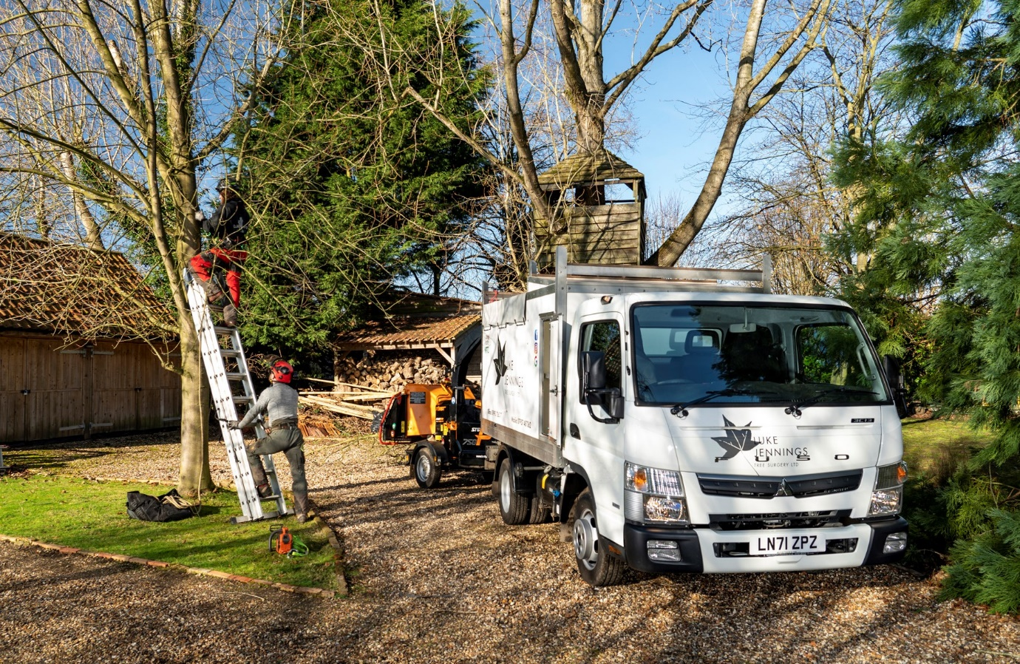

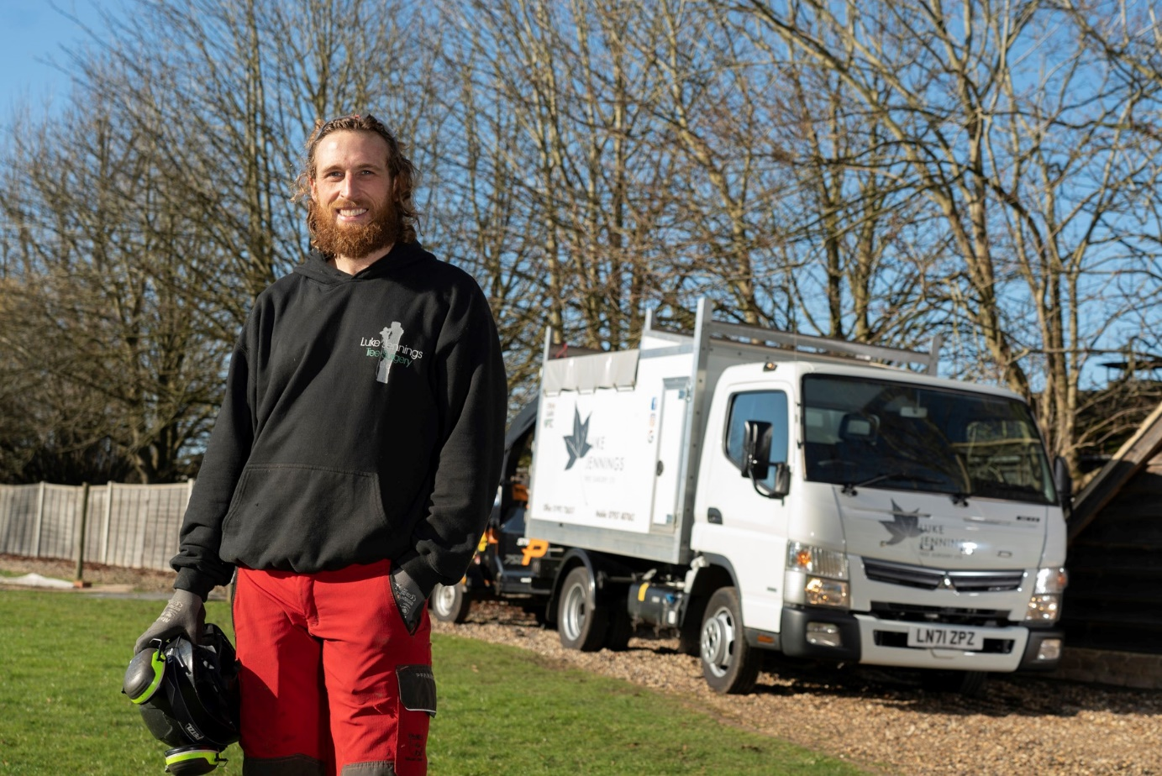

Branching out: Tree surgeon Luke Jennings is delighted with his first FUSO Canter

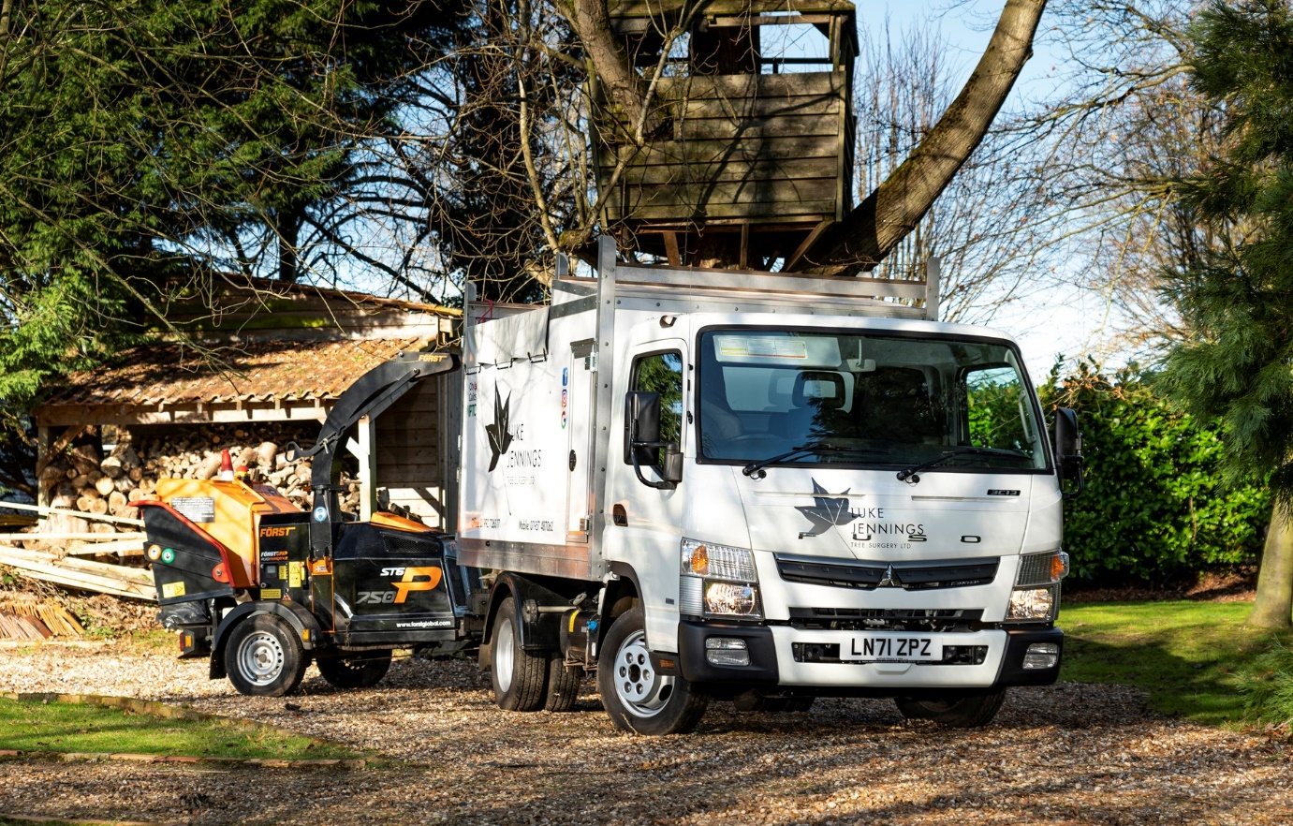

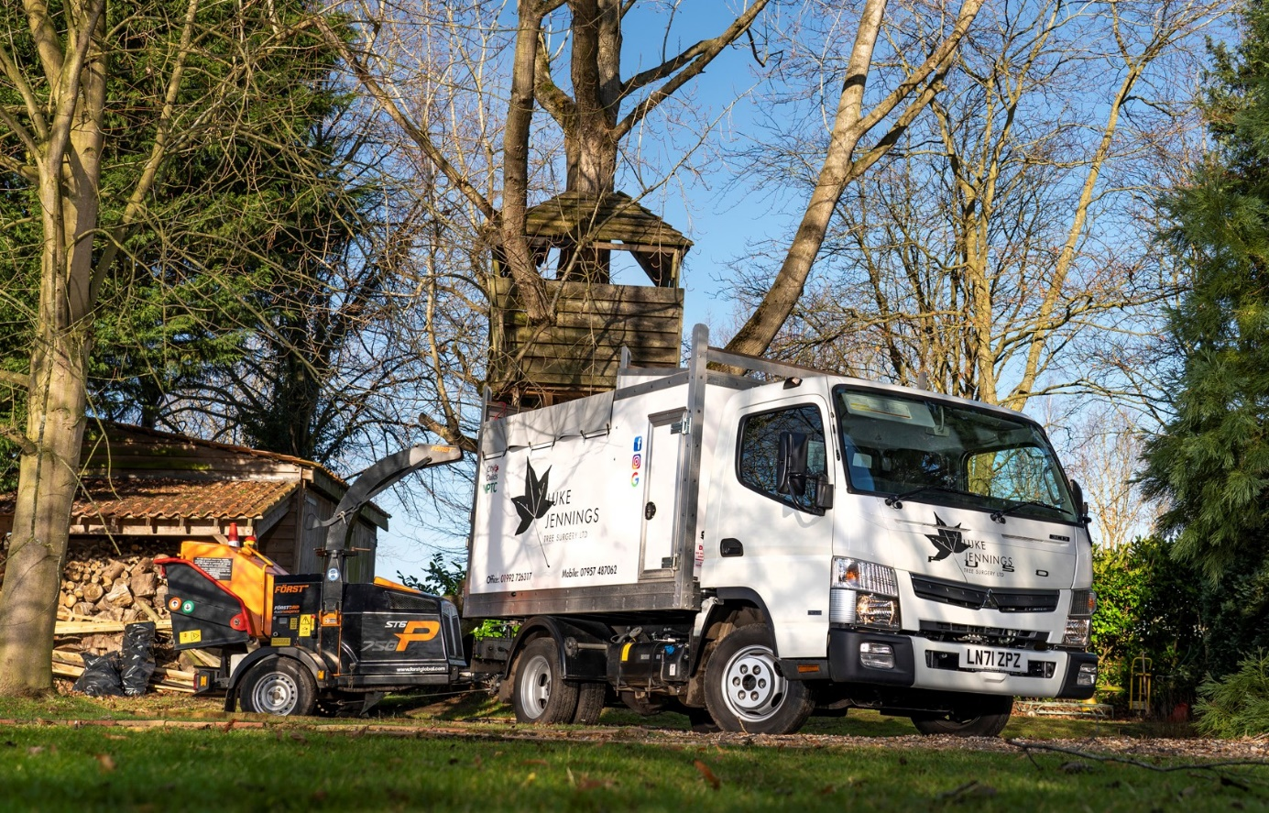

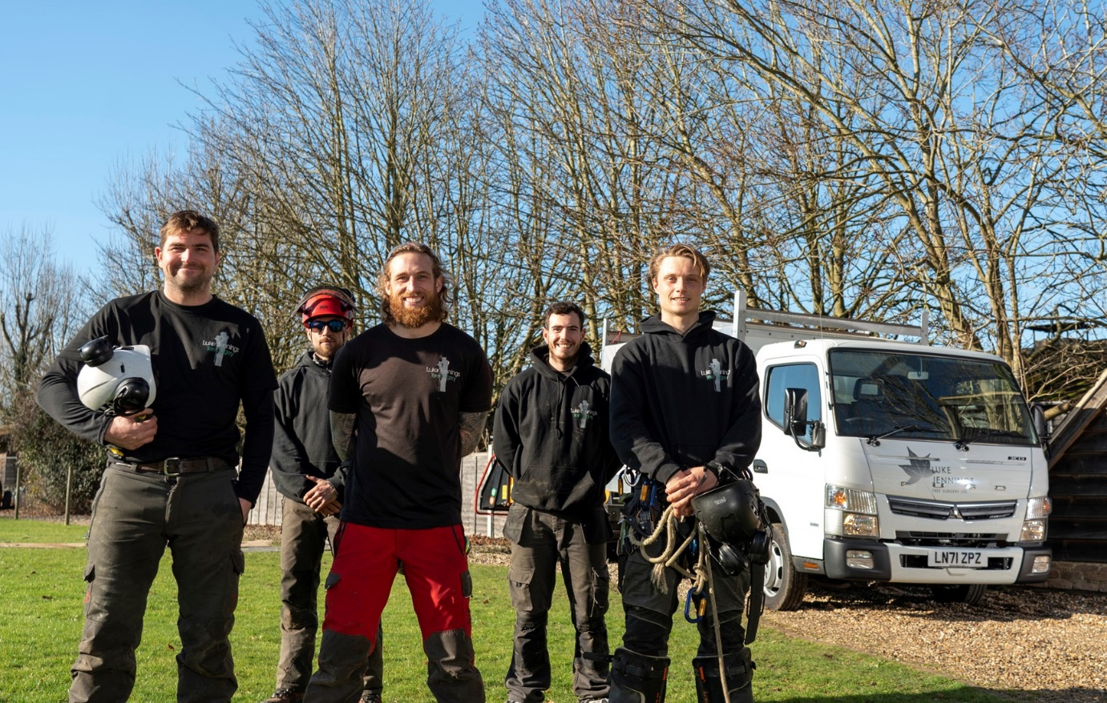

On the up: Luke Jennings, centre, is pictured with colleagues, from left, Michael Oakman, Sam Jennings, Alex Smurthwaite and James Gardener

ends

For more information, or to request higher-res image files, please contact:

Steve Warren or John Ripley
Impact Communications
Steve: 07770 470251, steve@impactcom.co.uk
John: 07771 484595, john@impactcom.co.uk

