

Date: 16 May 2022

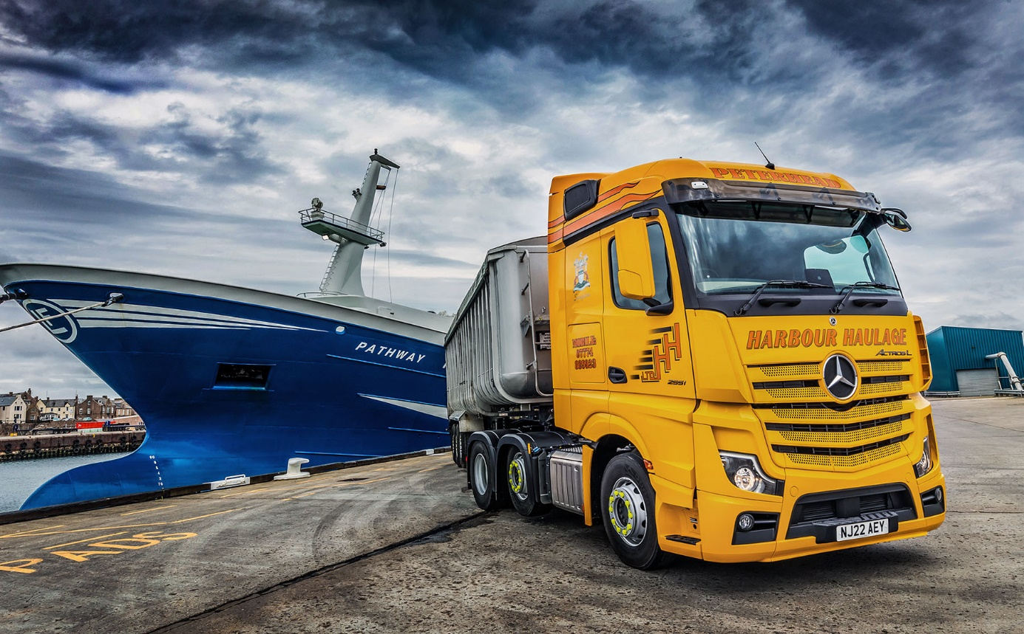

Harbour Haulage charts a course for enhanced efficiency and comfort with new Mercedes-Benz Actros L

Britain’s biggest fishing port is home to a prize catch in the shape of Harbour Haulage’s strikingly-finished Mercedes-Benz flagship.

The Peterhead-based operator became one of the first customers for a premium-specification Actros L last month (April), when it took delivery of its latest tractor unit from Aberdeen Dealer BLS Truck & Van.

The new truck, which wears Harbour Haulage’s bright yellow livery, is now earning its keep by transporting fish offal and other seafood-related products used in the manufacture of fertilisers and animal feed, to customers throughout Scotland.

Aimed at long-distance hauliers and those engaged in heavy-duty distribution, the Actros L combines previously unseen levels of efficiency with a more relaxed driving and living experience. Highlights include sophisticated aerodynamics, quieter cabs with improved heat insulation, and a lower, more comfortable seating position that also provides improved visibility.

Actros L customers can choose from beautifully finished GigaSpace, BigSpace and StreamSpace cabs, all of which are 2.5m wide and have flat floors. As well as four- and six-wheeled tractor units with single or double drive axles, Actros Ls are available as 18- and 26-tonne rigid chassis. All are additionally equipped with a full complement of advanced Mercedes-Benz technology.

Harbour Haulage’s 2551 variant pairs one of the more powerful engine options, a 12.8-litre ‘straight-six’ that produces 375kW (510 hp), with the lowest, Streamspace cab. Although at 1,970 mm headroom between the seats is 160 mm down on that offered by the range-topping GigaSpace, it nevertheless provides a spacious environment for work and relaxation that would be the envy of most truck drivers, not least because the interior has been further enhanced by the fitment of rear wall lockers, a fridge and a microwave.

Harbour Haulage’s Actros L has also been adapted to reflect the fact that while some deliveries are made with a curtainside trailer, the truck works more frequently with a bulker. To free up space for its tipping gear, Bailey Hydraulics, of Wisbech, removed and replaced the standard fuel tank with an aluminium combination tank for diesel and hydraulic oil.

Acquired with competitive funding support from Mercedes-Benz Finance, the Actros L has lined up alongside Harbour Haulage’s seven other tractor units, one of them a 2016 Actros. It will be inspected and maintained by BLS Truck & Van, under a three-year Mercedes-Benz Complete Service Contract.

Director Raymond Simpson reported: “Cost was certainly a big factor behind my decision to purchase the Actros L. Our established supplier’s prices have gone through the roof, and that applies to the servicing as well as the cost of the vehicles themselves. Also, though, BLS Sales Executive Chris Dyer impressed me; he’s a good guy and very enthusiastic, and he really wanted to sell me a truck.”

Explaining his choice of cab, Mr Simpson said: “We make a regular run for a major customer that takes the truck under a relatively low bridge on the west coast, near Inverawe. The BigSpace would probably get under it but we wanted to leave a margin so opted for the StreamSpace instead.”

Bulgarian driver Ivelin Lesev has been rewarded for taking such meticulous care of his previous vehicle, with the keys to the company’s most powerful truck yet. “Ivelin spends three or four nights in his cab each week and he’s delighted with the comfort of his Actros L,” said Mr Simpson.

“It looks fantastic in our colour scheme, too. If the truck performs as well and proves as cost-effective to operate as I confidently expect, then our decision to place this order with Mercedes-Benz will certainly have been vindicated.”

Mr Simpson’s experience of Mercedes-Benz trucks is not restricted to Harbour Haulage, as he is also a Director of Aberdeen-based transport concern R&J Simpson. Its fleet includes approximately 30 six-wheeled rigids that wear three-pointed stars.

BLS Truck & Van, which was appointed in 2018 to represent the Mercedes-Benz and FUSO brands in the north of Scotland, recently won an order from R&J Simpson for another two Actros six-wheelers.

Mr Simpson recalled: “Harbour Haulage was an all-Mercedes-Benz operation back in the late 1990s. The trucks were reliable and fuel-efficient, but we moved away from the brand because the aftersales back-up at the time wasn’t up to scratch.

“From the little I’ve seen so far, BLS Truck & Van looks professional and well managed. Having delivered the Actros L it now has a proper foot in the door; I’m optimistic the Dealer will make the most of this opportunity to prove itself.”

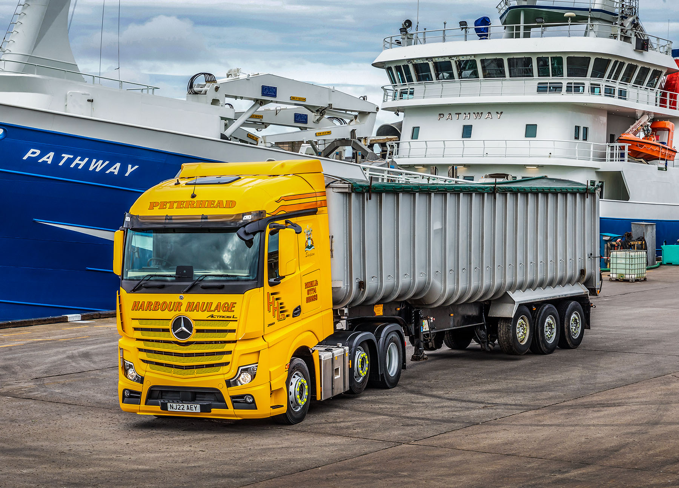

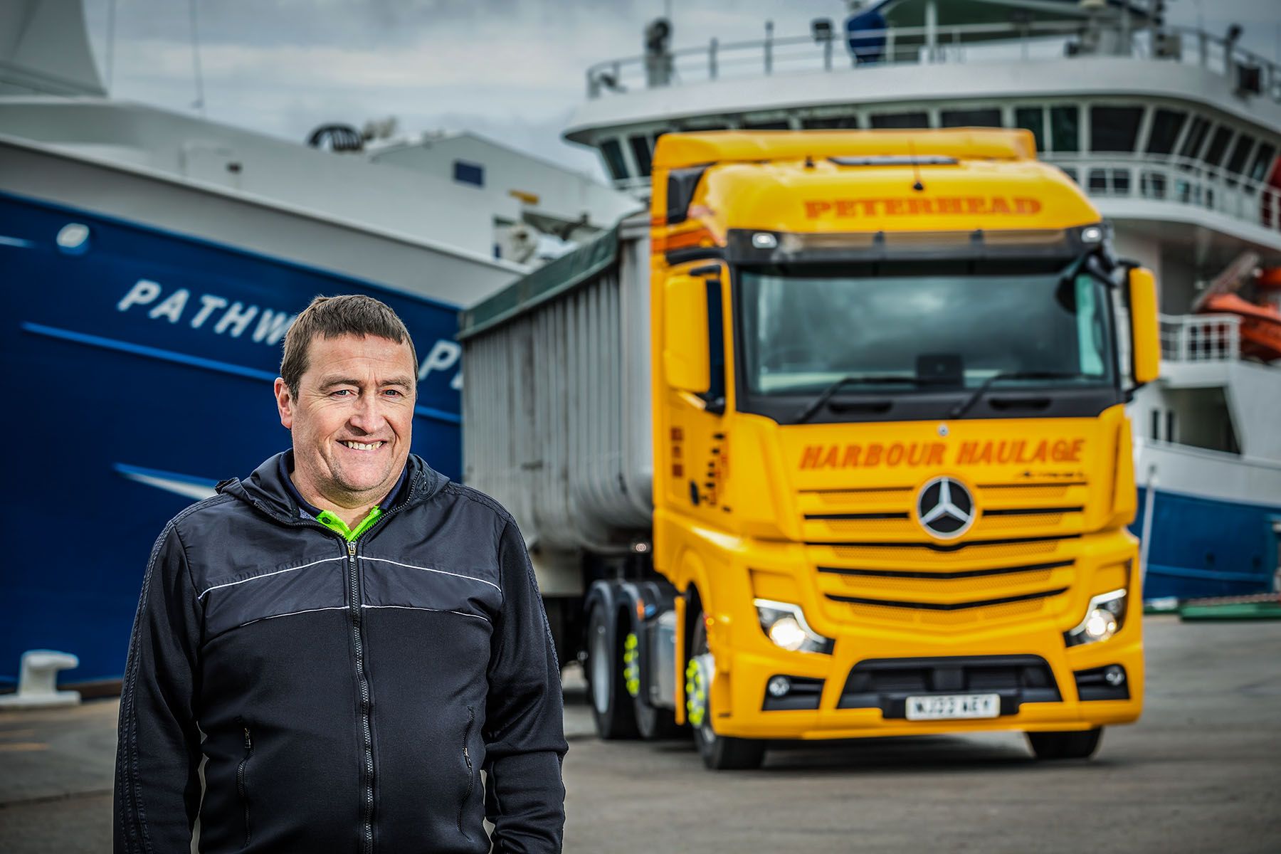

Quay to success: Director Raymond Simpson is delighted with the new Mercedes-Benz Actros L, which is Harbour Haulage’s most powerful truck yet

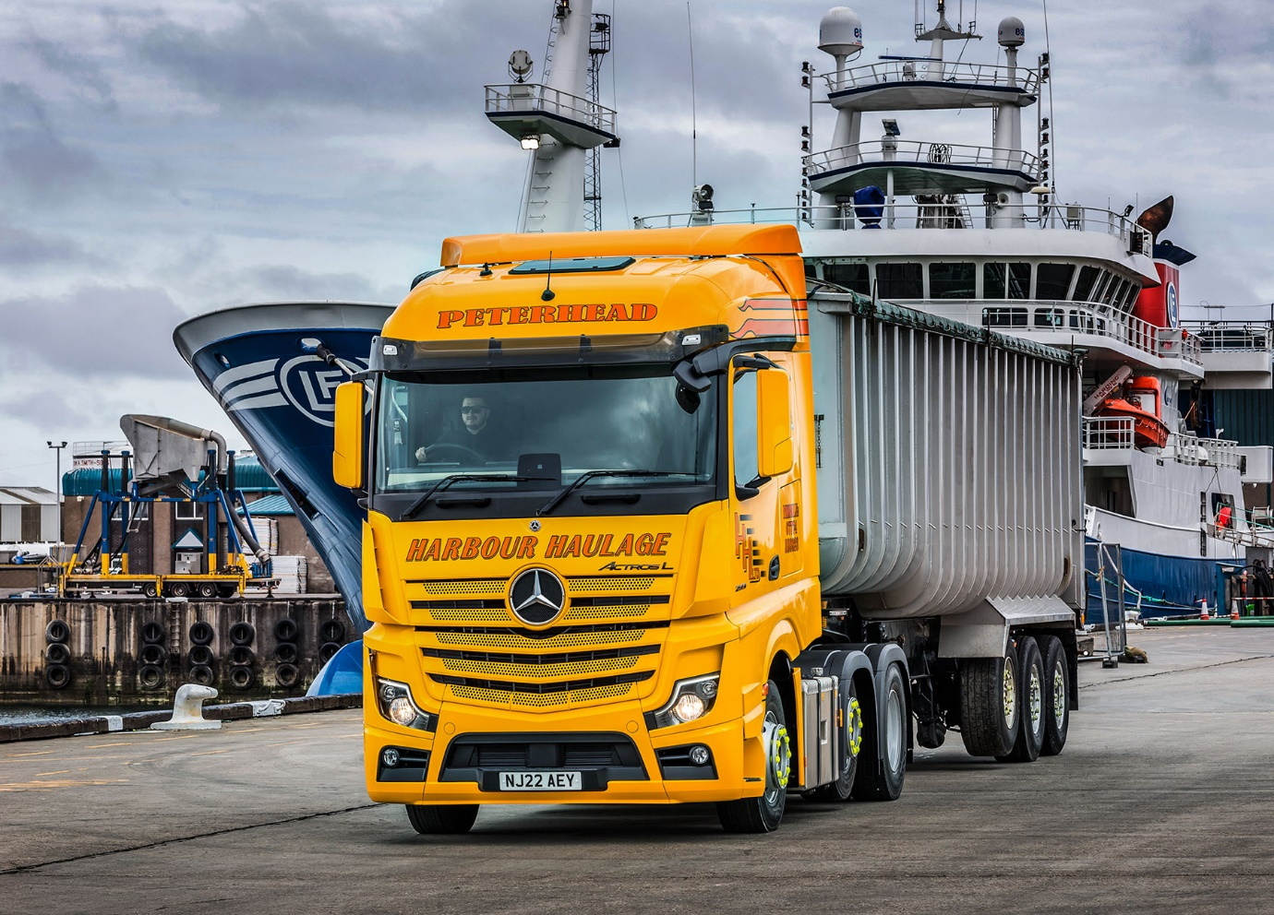

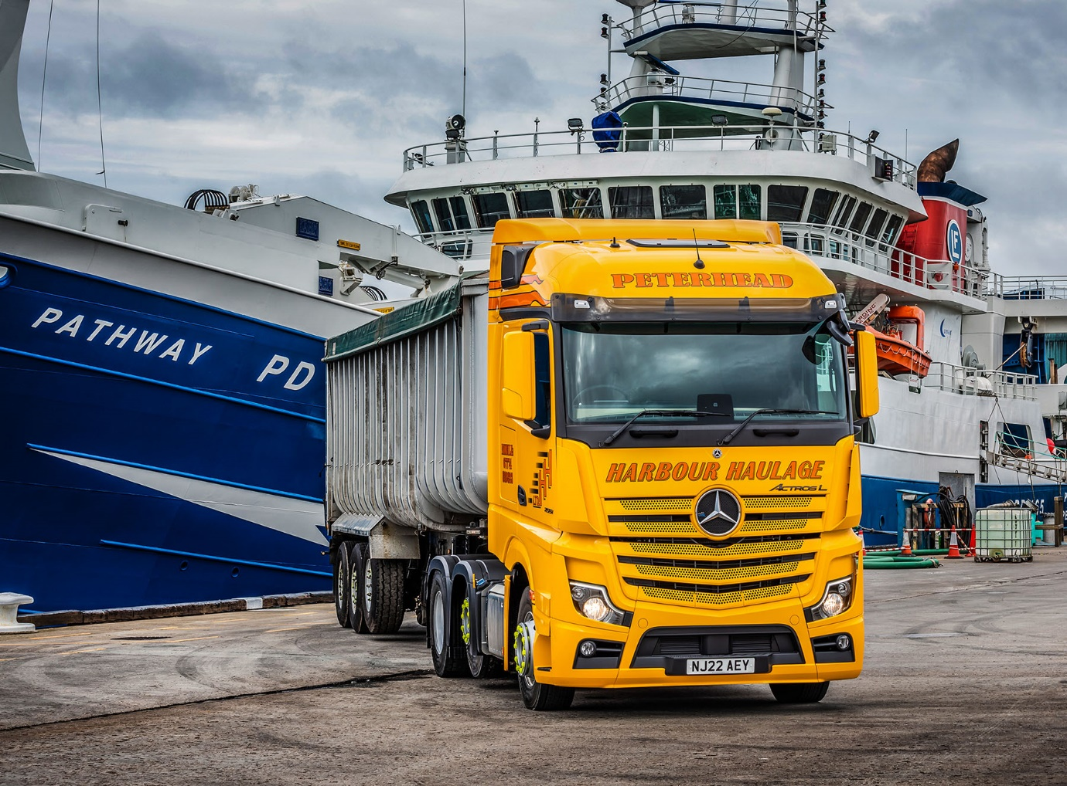

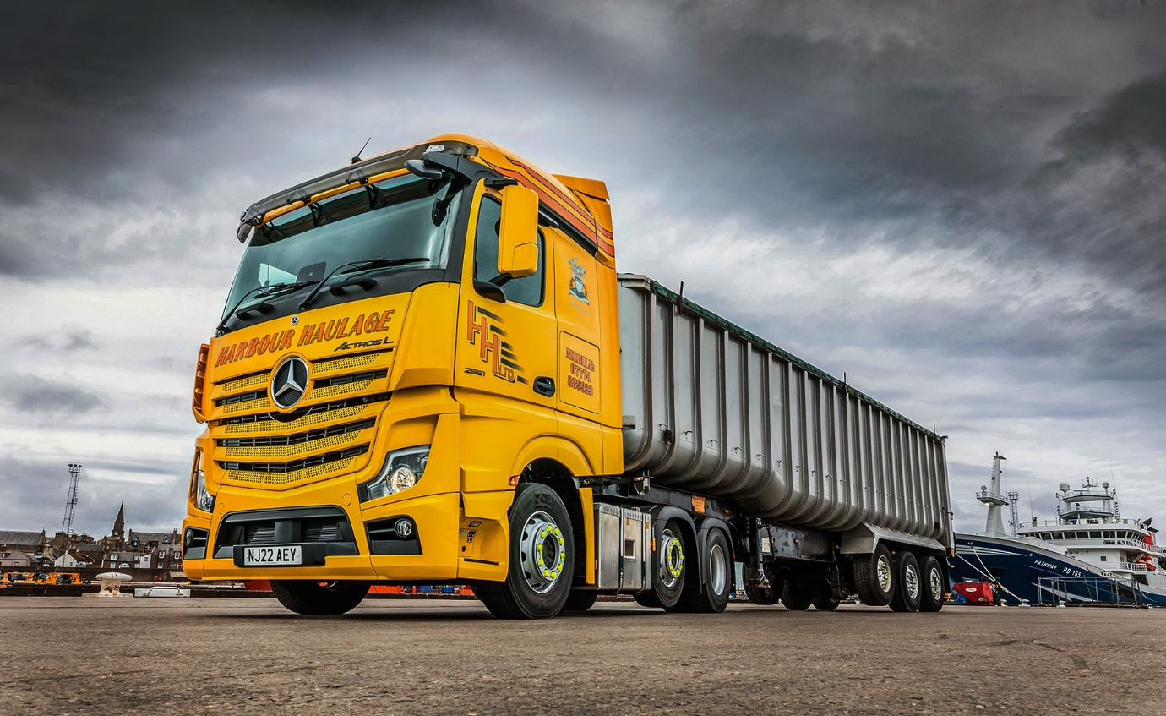

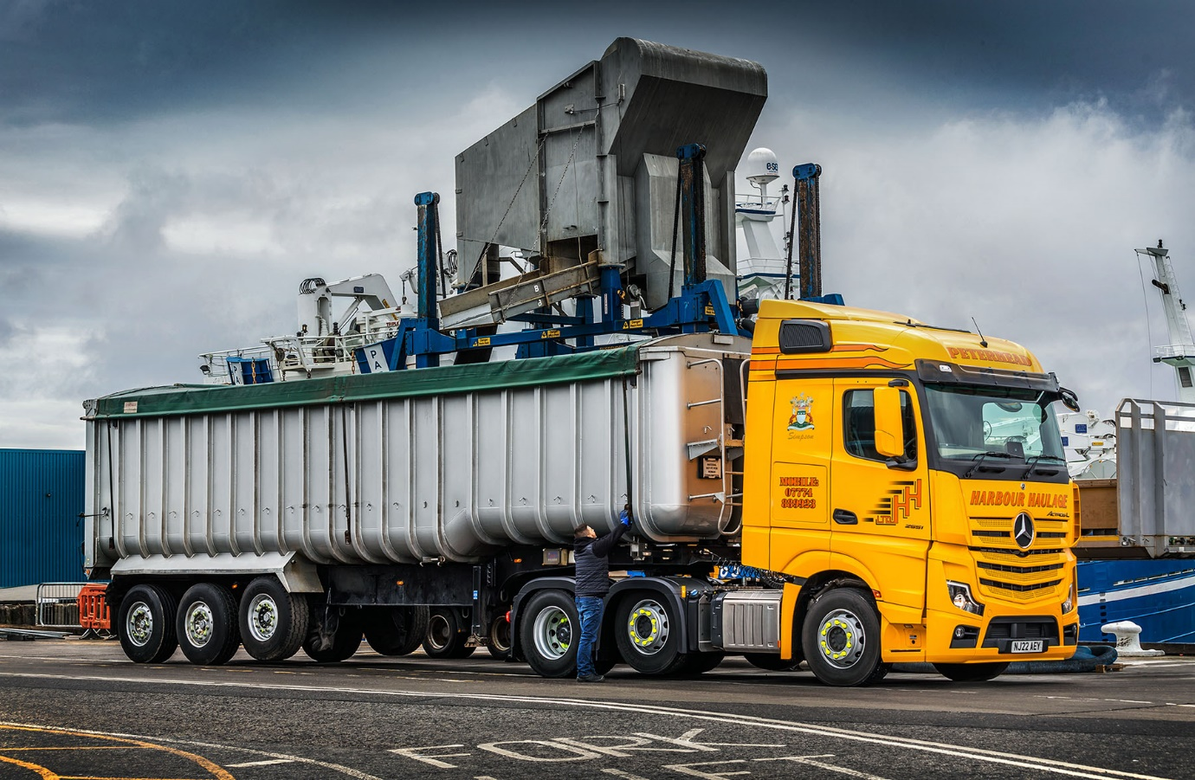

ends

For more information, or to request bigger versions of image files, please contact:
Steve Warren or John Ripley
Impact Communications
Steve: 07770 470251, steve@impactcom.co.uk
John: 07771 484595, john@impactcom.co.uk



