

Date: 2 June 2021

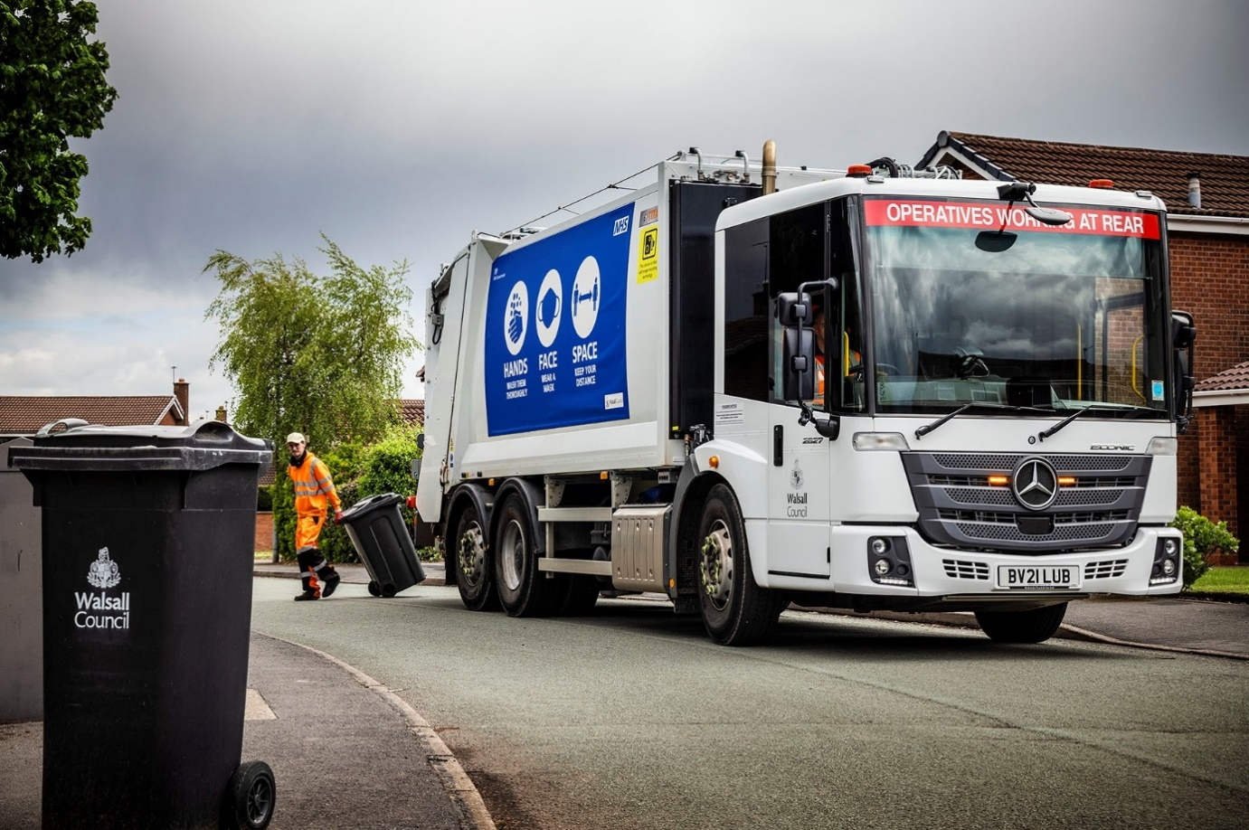

Competitive costs and crew feedback prompt Walsall Council’s return for eight more Mercedes-Benz Econics

Residents and businesses in the West Midlands borough of Walsall are now receiving collections of waste and recyclables from Mercedes-Benz Econics that make sound financial sense for cost-conscious fleet managers while winning the votes of crews who use them.

Walsall Council’s Clean & Green Services team sourced the eight low-entry trucks from primary contractor CPD, of Chorley, Lancashire, a leading municipal vehicle specialist and a Qualified Partner of Mercedes-Benz.

Armed with a ground-breaking safety armoury that includes the manufacturer’s Active Brake Assist 5 emergency braking system, all are 26-tonne Econic 2627L models with rear-steer axles that assist drivers by reducing turning circles.

The Econic range is purpose-designed for urban duties. Innovative catalyst technology helps to reduce emissions of particulate matter and oxides of nitrogen from the advanced Euro VI engines. These 7.7-litre ‘straight-sixes’ deliver plenty of torque, even at low engine speeds, and are highly fuel-efficient, while also restricting AdBlue consumption.

Customers for diesel-engined variants can choose from three power options – the 200 kW (272 hp) outputs produced by Walsall Council’s new trucks are transmitted to the road via six-speed Allison automatic gearboxes ideally suited to stop-start applications.

Its Econics are fitted with Terberg split bin lifts, and CPD Titan XLS bodies with 23m³ capacities. These offer class-leading payloads, 14-second compaction cycles, and – with only 890rpm required from the engine – fuel savings worth up to 15%. At 75dB(A) they are exceptionally quiet too, while short rear overhangs also contribute to manoeuvrability.

The authority’s latest order represents a breakthrough for Mercedes-Benz and CPD – although it was already running Titan-bodied Econics, more recently it had acquired refuse collection vehicles by another manufacturer.

Den Edwards, Walsall Council’s Procurement Manager for Clean & Green Services, confirmed: “After studying whole-life costs of the fleet, downtime figures and feedback from the drivers and crews, we decided to return to the tried and trusted combination of Mercedes-Benz Econic chassis, CPD Titan body and Terberg hoist.”

He continued: “We are still running vehicles of this combination which are near eight years old. Not only have they proved to be both durable and reliable, but they are also well-liked by the colleagues who use them, day-in, day-out.”

The new trucks work Walsall Council’s Environmental Depot in Brownhills and are fully interchangeable in being used to make fortnightly collections of general and green waste, and recyclables, from domestic properties, as well as trade waste.

The authority maintains the fleet in its own workshop but receives warranty support and parts deliveries from the Wolverhampton branch of Mercedes-Benz Dealer Midlands Truck & Van, which also supplied four of the chassis; the other four arrived via S & B Commercials.

The Econic’s air-conditioned cab has a deep, wraparound screen that provides the low-seated driver with an excellent view. Features specified by Walsall Council include an optional sliding window integrated into the glass panel on the nearside of the cab, which makes it easier for drivers and crew members inside the vehicle to communicate with those outside.

The Mercedes-Benz Econic leads the market in terms of safety technology. Added to the vehicle’s standard specification late last year, Active Brake Assist 5 adds a camera to the radar employed by previous versions to spot potential hazards. This cutting-edge system can detect vehicles ahead and stationary objects in its own lane, at speeds of up to 56 mph (90 km/h).

Detection of a dangerous situation triggers a three-stage reaction: first, the system warns the driver with visual and audible alerts; then, if the driver fails to react, it applies partial (approximately 50%) braking; finally, if the driver has still not intervened, it initiates maximum braking to bring the truck to a halt, activating the hazard warning lights to alert drivers behind.

The new sensor fusion has dramatically improved the truck’s response to moving pedestrians when it is travelling at speeds of up to 31 mph (50 km/h). Active Brake Assist 5 can apply full braking when encountering pedestrians crossing its path, approaching from the front or walking ahead. This remarkable capability increases safety for vulnerable road users and vehicle crews, while also helping to relieve stress for drivers.

The electronic architecture required for operation of Active Brake Assist 5 means Walsall Council’s Econics also benefit from Electronic Parking Brakes, which are applied automatically when the engine is switched off. When the truck is at a standstill, after full braking for example, the automatic HOLD function prevents unintended rolling away.

Walsall Council has also specified its Econics with two other optional Mercedes-Benz safety aids, Sideguard Assist and Rearguard Assist, both of which provide additional support to drivers.

Sideguard Assist comes into play when making left turns or changing lanes in busy environments where visibility may be restricted. Two short-range radar sensors mounted on the passenger side of the truck monitor up to a lane’s width. The system delivers acoustic and visual warnings when it detects the presence of cyclists, pedestrians or other vehicles.

When the vehicle is reversing at manoeuvring speed, Rearguard Assist displays on the instrument cluster the distance from objects being approached. Like Active Brake Assist 5 it also provides warnings that the driver can hear and see, and is able to brake the vehicle to a controlled stop when the distance to an object becomes critical.

“Previous experience and the analysis that we’ve conducted confirmed that there are compelling arguments in favour of the Econic in terms of costs, uptime and the opinions of front-line colleagues.

“Safety is another factor that weighs heavily in favour of Mercedes-Benz, and in this respect the latest enhancements to its standard specification and additions to the Mercedes-Benz options list have elevated the Econic to another level,” confirmed Den Edwards.

“Given the Council’s total commitment to responsible, compliant operation, it is reassuring to know that these new vehicles are so comprehensively equipped when it comes to the protection of our drivers and crews, and, indeed, of everyone else who uses the borough’s roads.”

go.walsall.gov.uk

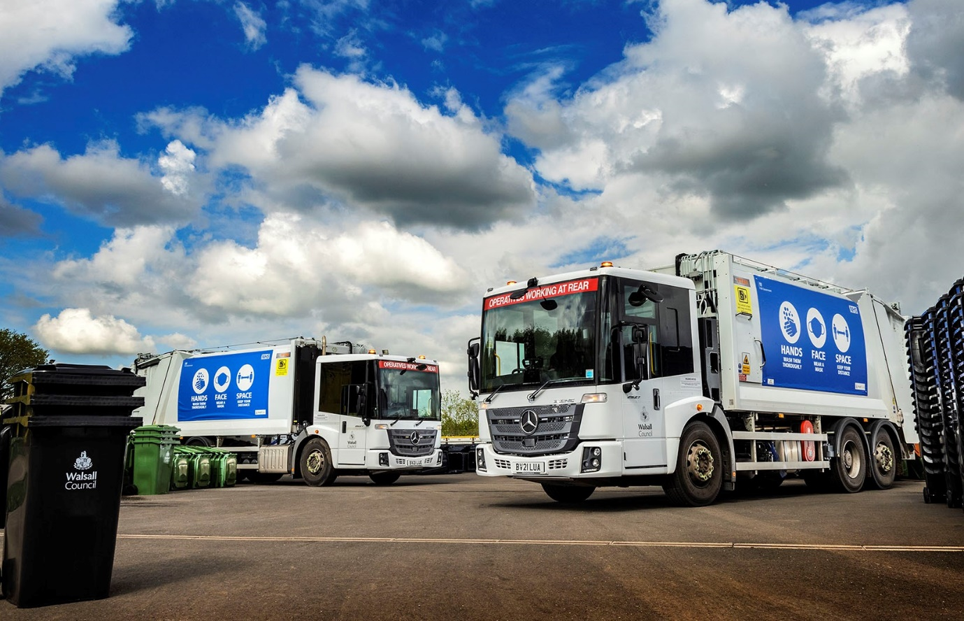

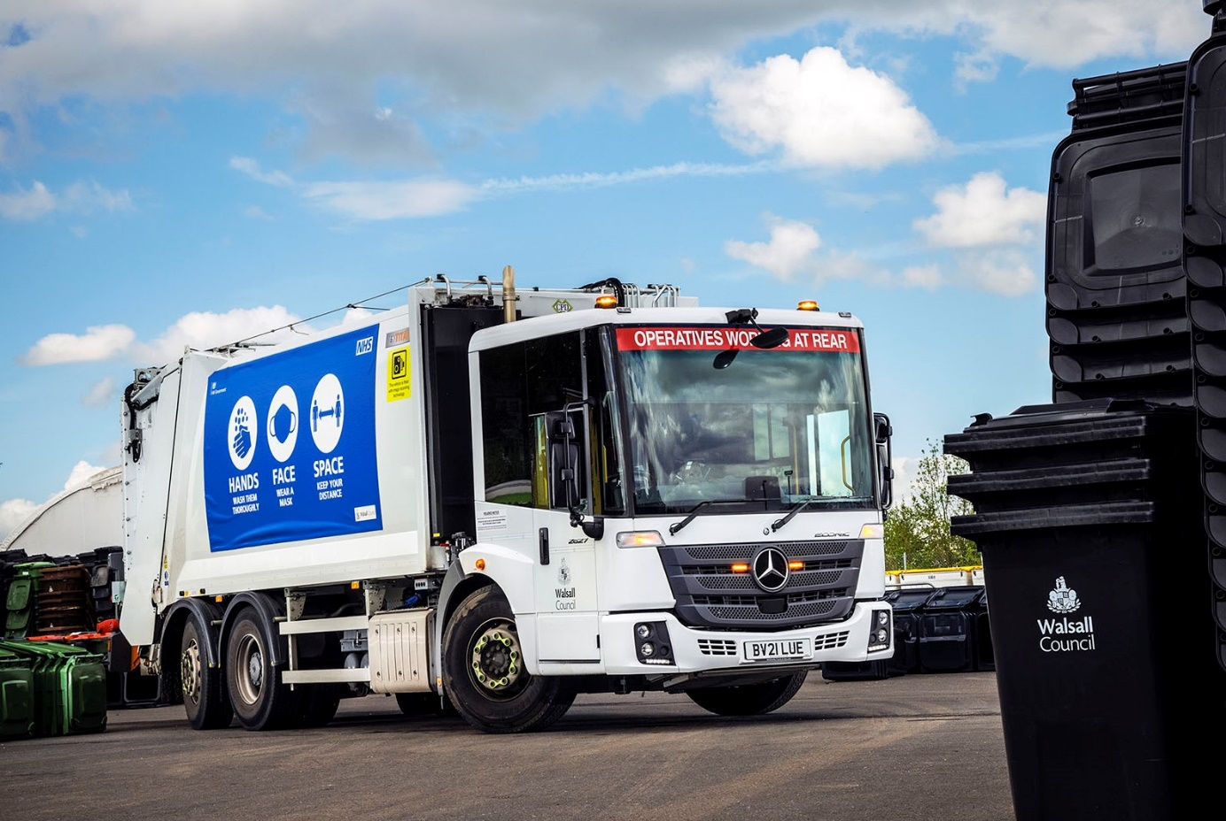

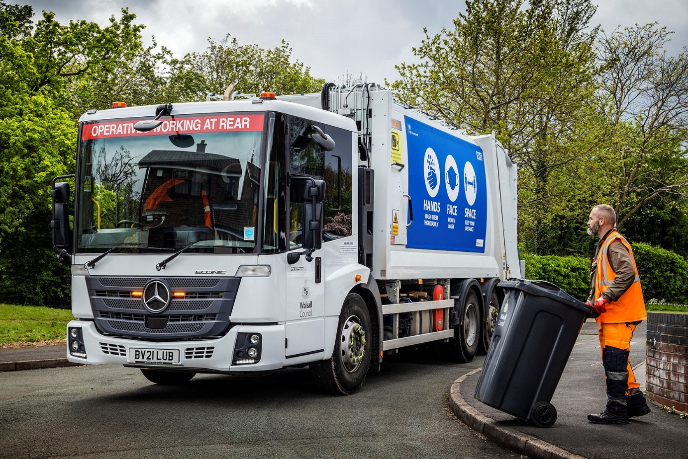

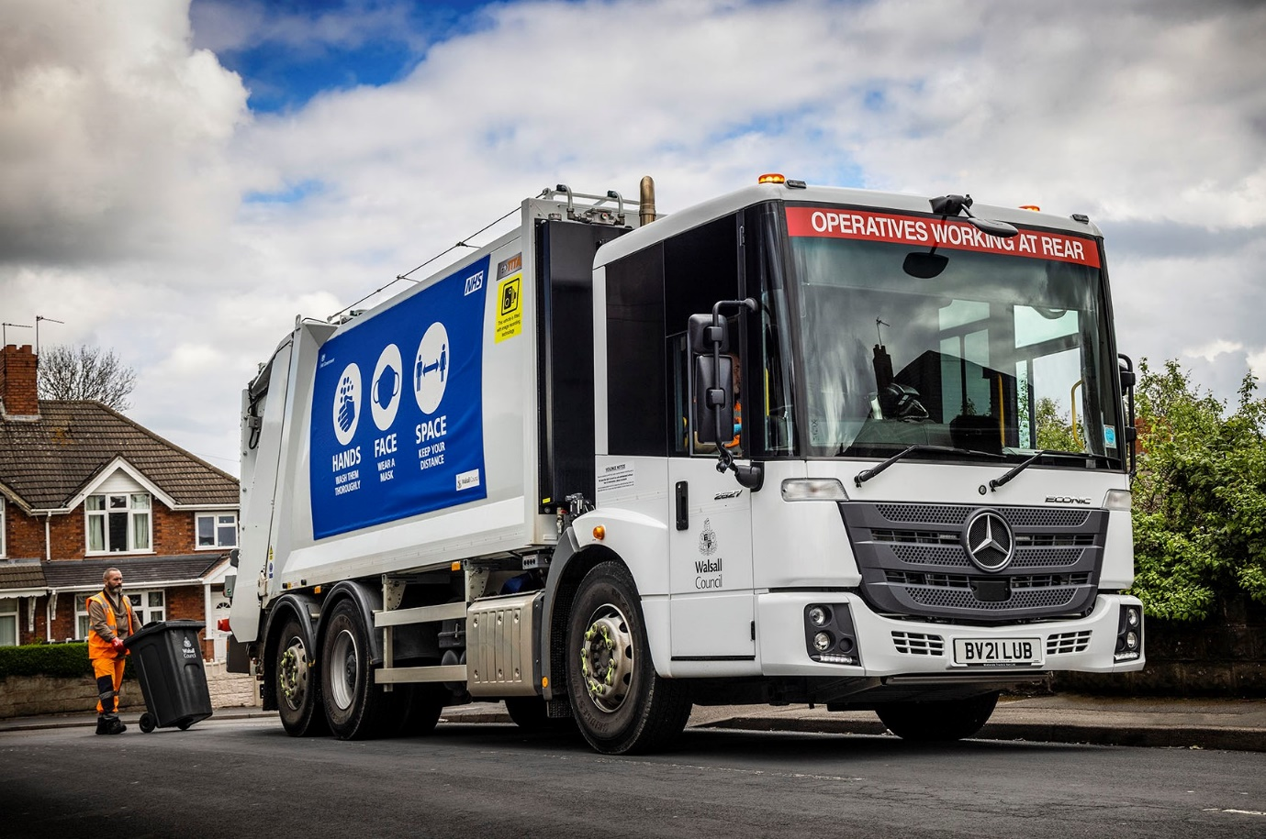

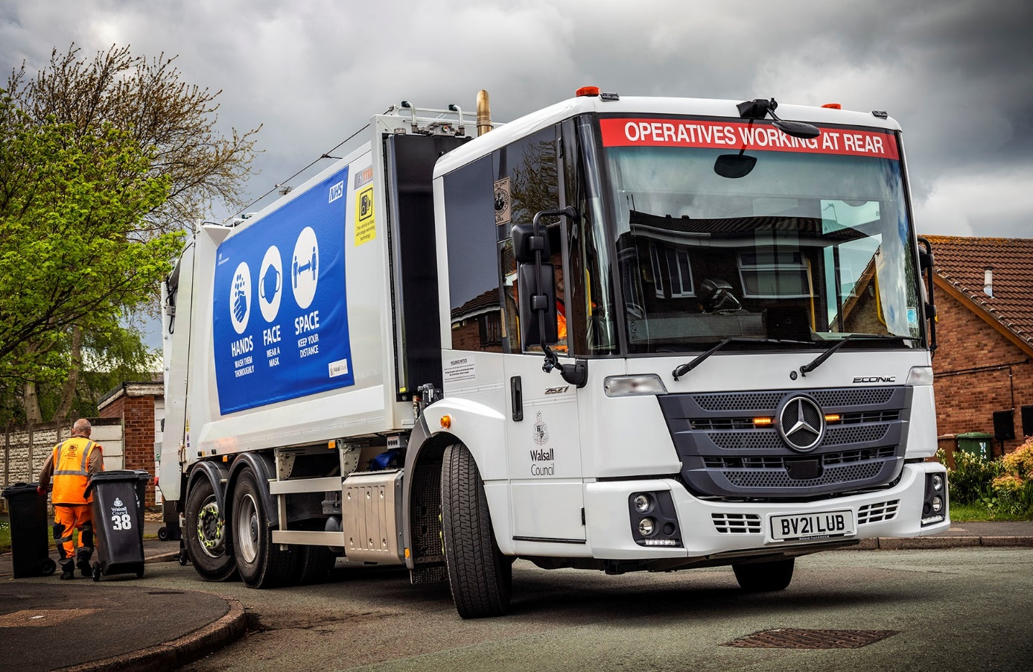

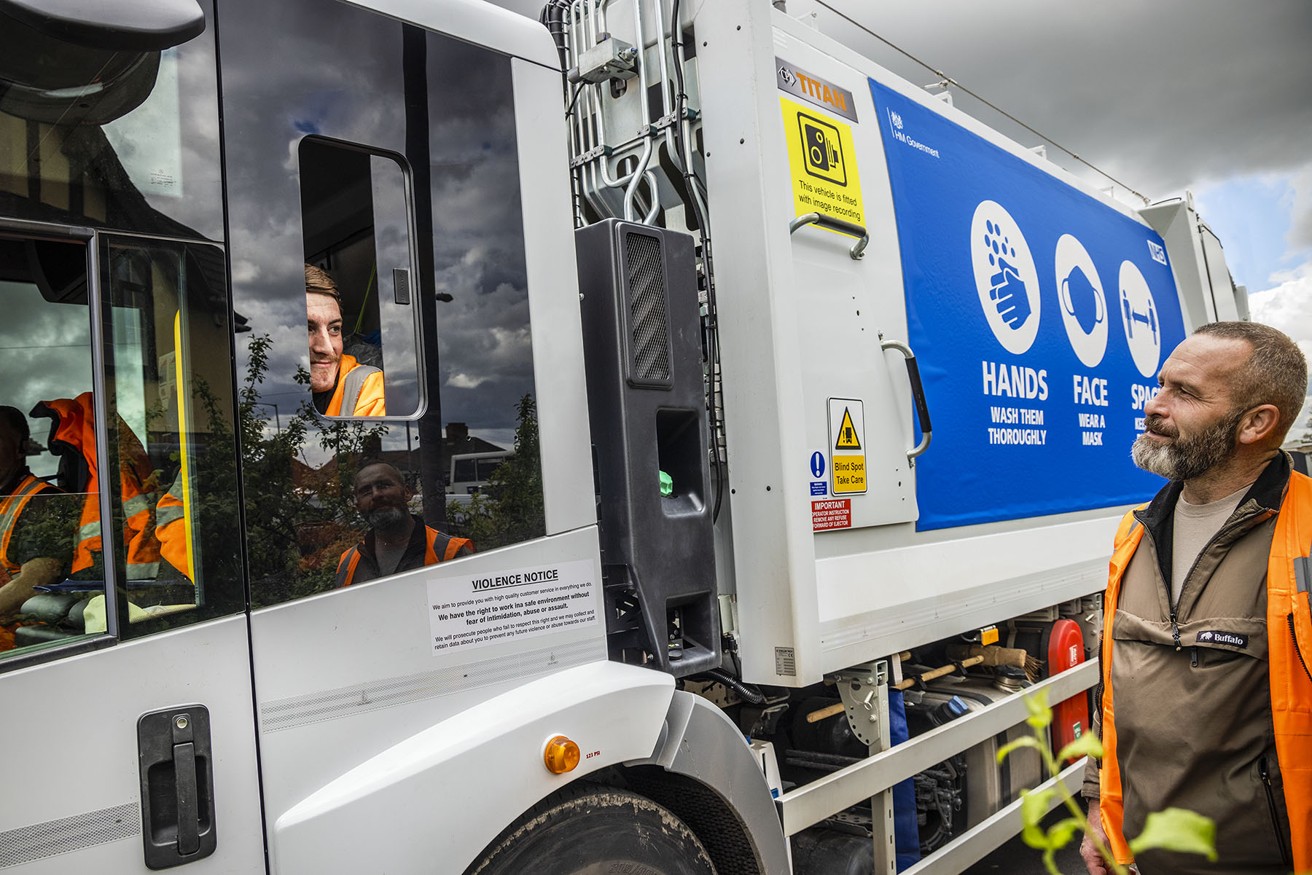

Window of opportunity: An optional sliding section within the glass panel allows occupants of the Econic cab to speak to colleagues outside

ends

For more information, or to request higher-res image files, please contact:

Jamie Fretwell at Mercedes-Benz Trucks UK Ltd
07712 519230, jamie.fretwell@daimler.com

or

Steve Warren or John Ripley
Impact Communications, 01926 842126
Steve: 07770 470251, steve@impactcom.co.uk
John: 07771 484595, john@impactcom.co.uk

About Mercedes-Benz Trucks UK Ltd
Mercedes-Benz Trucks UK Ltd is the sales and marketing organisation responsible for all Daimler truck products in the UK, including FUSO Canter.

In 2019, the company registered 6,963 new trucks. Mercedes-Benz accounted for 6,188 new trucks registered in 2019, making it the third-biggest truck brand in the UK. Meanwhile, FUSO registrations hit 775 – including 580 new trucks over 6.0-tonnes.

The flagship new Mercedes-Benz Actros which won the 2020 International Truck of the Year award, features seven core innovations including MirrorCam, Multimedia Cockpit and Active Brake Assist 5. Our premium range of innovative trucks – Actros, Arocs, Atego, Econic and Unimog – draw upon more than 125 years of exceptionally high standards of quality, backed up by our promise of Trucks You Can Trust.

www.mbtrucks.co.uk

