

Date: 17 July 2020

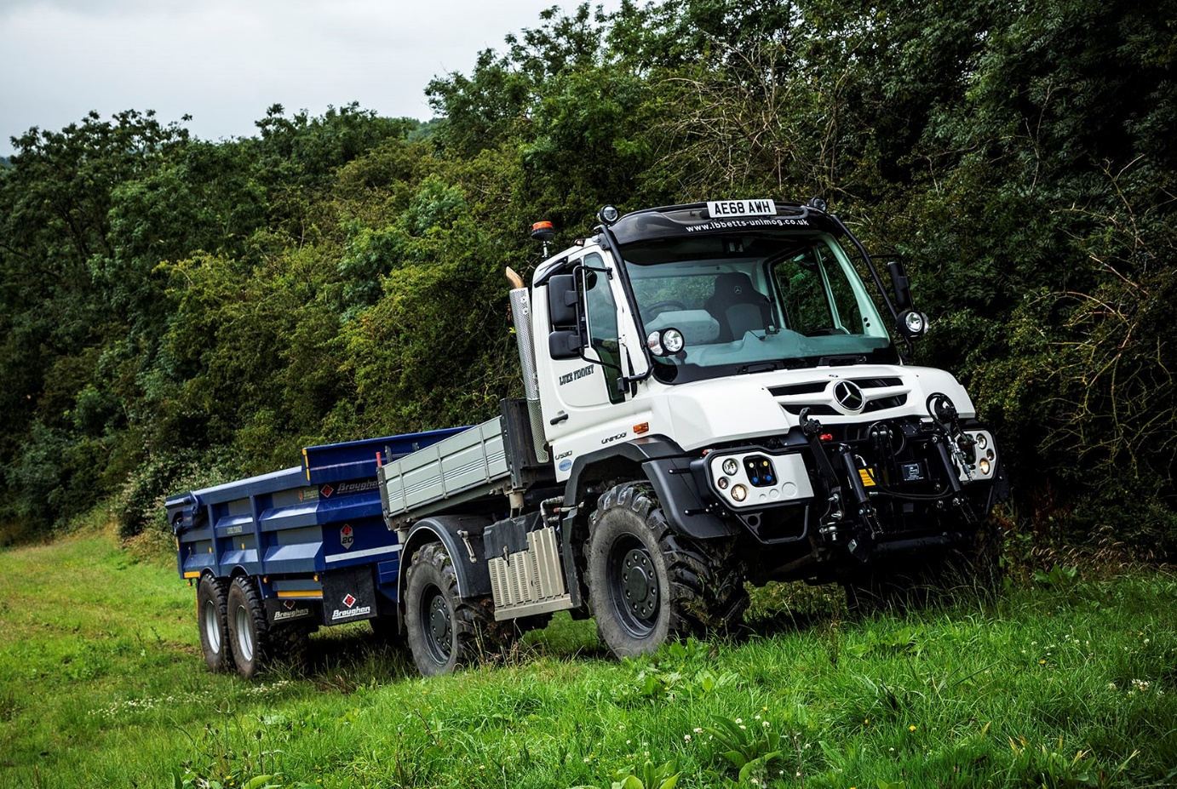

Versatile Mercedes-Benz Unimog leads the field for rural groundworks contractor Luke

Fourteen years after he began trading, agricultural and equestrian contractor Luke Finney is running his first Mercedes-Benz Unimog – but it’s unlikely to be his last.

“If I’d known Unimogs were this good I would have bought one years ago,” he declared. “Having experienced the vehicle’s amazing range of abilities, I can’t understand why anyone in my line of work would choose anything else. There’s no turning back now.”

Luke is based in Leicestershire, and bought his Unimog from Dealer Arthur Ibbett, of St Neots. It is now hard at work undertaking groundworks and building contracts for farms, rural businesses and private individuals, most of them within a 20-mile radius of home.

The U530 model is powered by a 7.7-litre six-cylinder engine which produces 220 kW (299 hp) and 1,200 Nm of torque, and drives through a 16-speed electro-pneumatic transmission. Permanent all-wheel drive, impressive ground clearance, and uprated portal axles that have differential locks and offer extreme levels of articulation, all contribute to the truck’s unrivalled cross-country capability.

Its impressive specification includes the optional Central Tyre Inflation (CTI) system. This unique technology enables the driver quickly and easily, and without leaving the cab, to lower tyre pressures, thereby minimising damage to particularly soft ground. VarioPilot, meanwhile, allows the steering wheel and instrument binnacle to be slid from one side of the cab to the other in minutes: an advantage, for example, when cutting verges.

The vehicle is also equipped with front and rear electrical and hydraulic connectors, a front implement plate, roof-mounted beacons and main beam lights, with others covering the rear working area, and cameras at both ends.

The U530’s ability to tow trailers at a gross train weights of up to 36 tonnes is another key attribute. Luke’s Unimog is often paired with a tri-axle low-loader by Chieftan, which carries plant including his Takeuchi excavator, or a Broughan dump trailer.

“The Unimog is a fantastically versatile piece of kit,” he enthused. “It can tow any equipment I need to move around, while its own load bed with dropsides is ideal for carrying tools and other gear.

“The Unimog is comfortable, too, with a great field of vision from the driver’s seat, and very easy to operate. Crucially, as well as being highly capable on any off-road terrain I need to cross, my truck is equally happy on the tarmac at speeds of up to 56 mph, where it’s far more fuel-efficient than an agricultural tractor.”

He continued: “The customer service from Arthur Ibbett has been excellent as well. I contacted the Dealer initially, because I was looking for a used model. However, when Tim Ibbett told me he had this new vehicle available, with a specification that was perfect for my needs, I jumped at it.

“Tim brought the truck over to show me, and I didn’t want to let him take it back! He also put together a five-year extended warranty package that was very reasonably priced. The Unimog was delivered in perfect condition and I’m absolutely delighted with it.”

Luke Finney employs four full-time operatives and provides work for a number of local sub-contractors too. Since he established his business in 2006 Luke has focused on providing a top-quality service for high-end customers – and his choice of tools for the job reflects this.

“All my equipment is the best available, and the Unimog is definitely a case in point,” he added. “The Mercedes-Benz brand image reflects perfectly the premium service that I provide to our customers.”

All Unimogs have 4x4 chassis with single rear wheels, while gross weights vary from 7.5 to 16.5 tonnes. There are two core variants: an implement carrier with front, side and rear attachment points, and an ultra-high mobility truck with extreme torsional flexibility, which can accommodate a range of bodies. Both are superbly adaptable to a huge variety of roles.

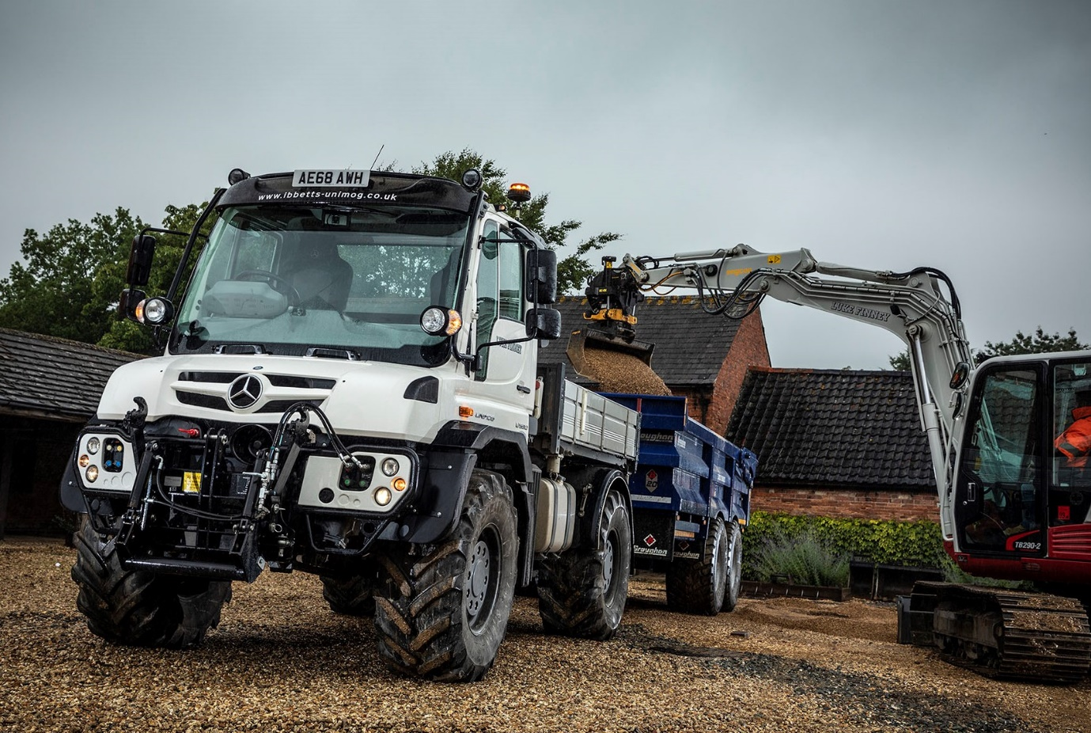

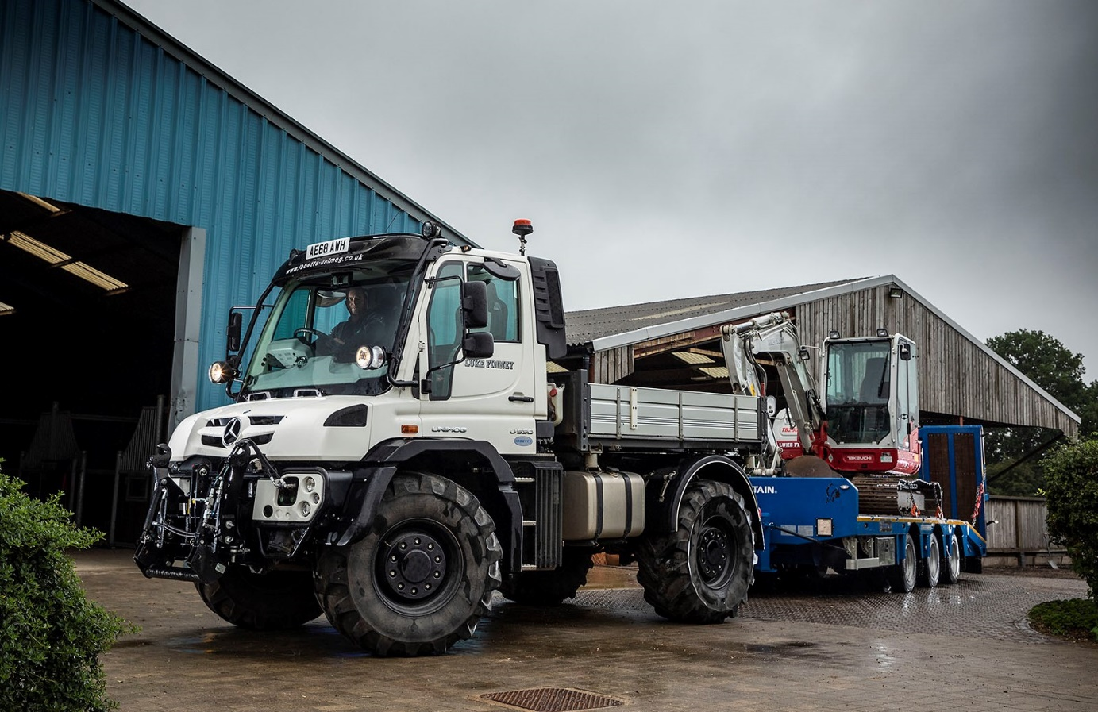

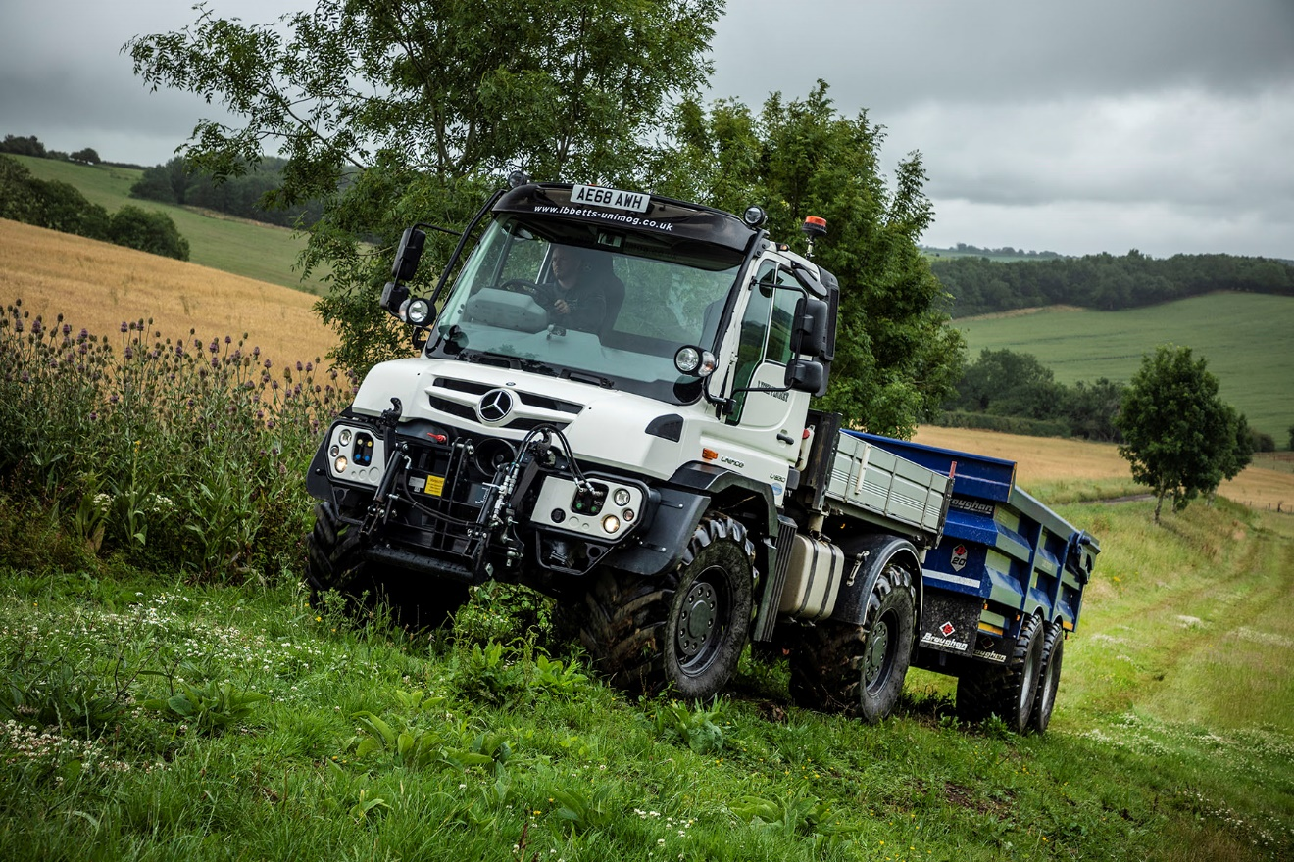

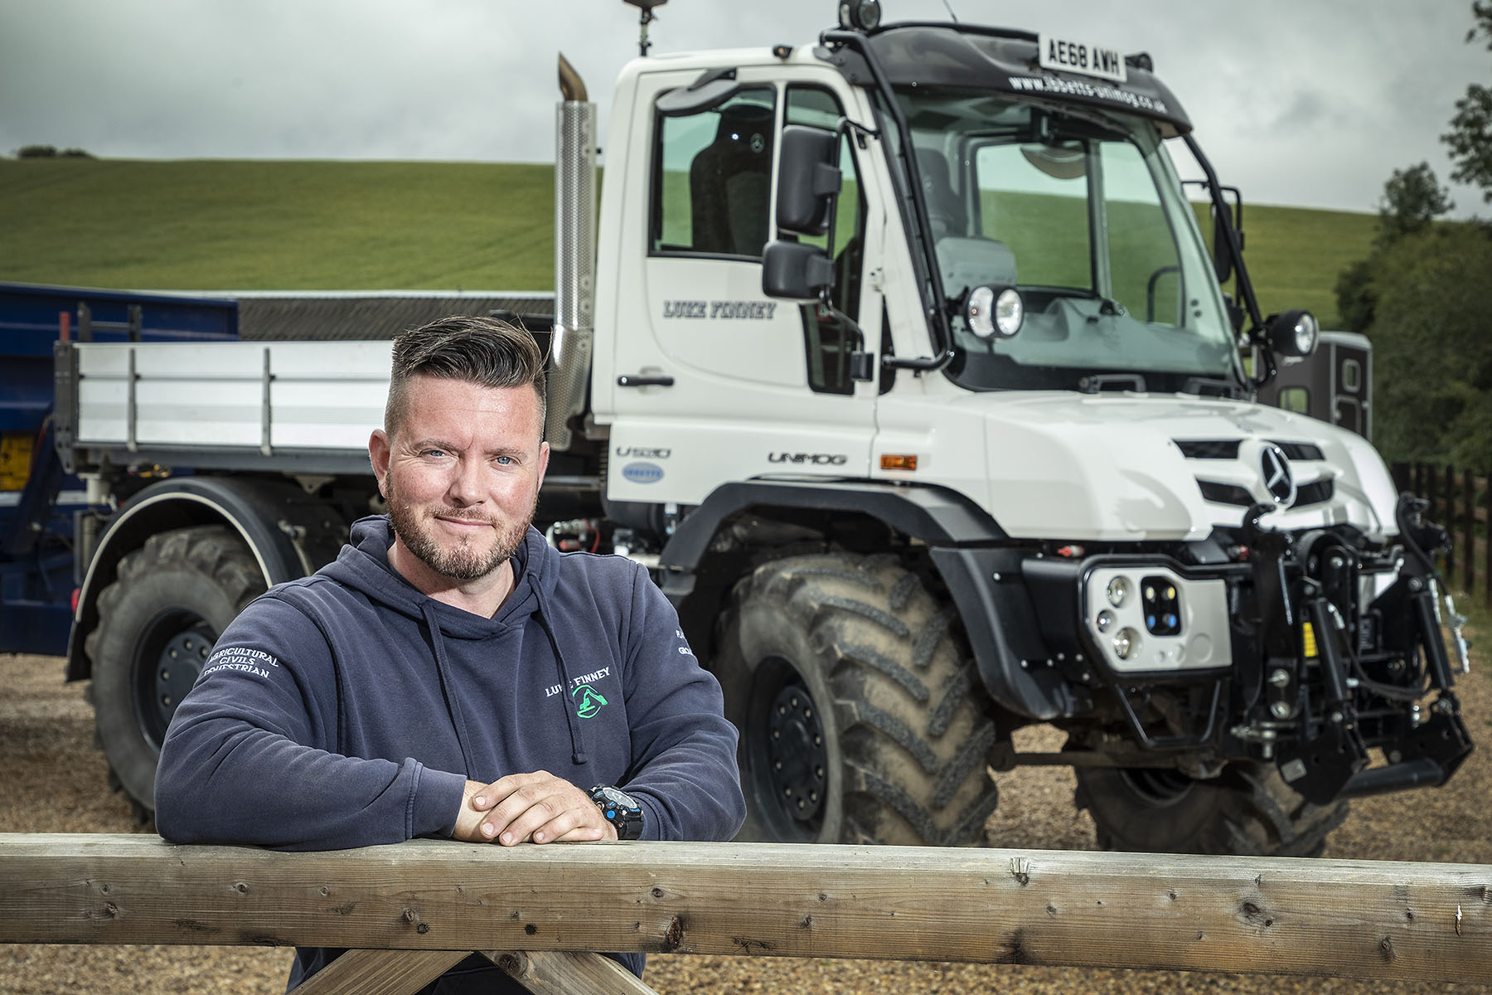

Only the best: Luke Finney is a convert to the versatile Mercedes-Benz Unimog

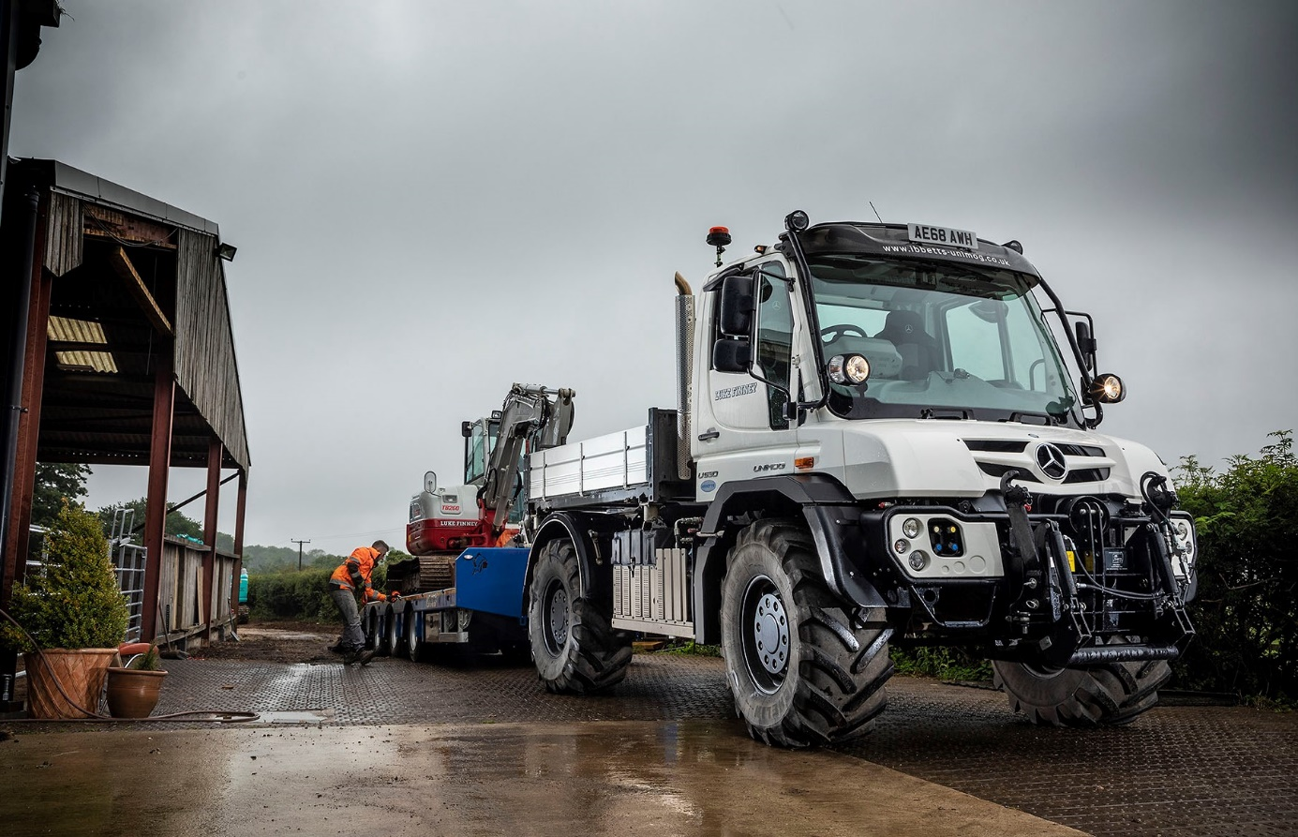

ends

For more information, or to request bigger/higher-res image files, please contact:
John Ripley or Steve Warren
Impact Communications, 01926 842126
John: 07771 484595, john@impactcom.co.uk
Steve: 07770 470251, steve@impactcom.co.uk



