

Date: 15 August 2019

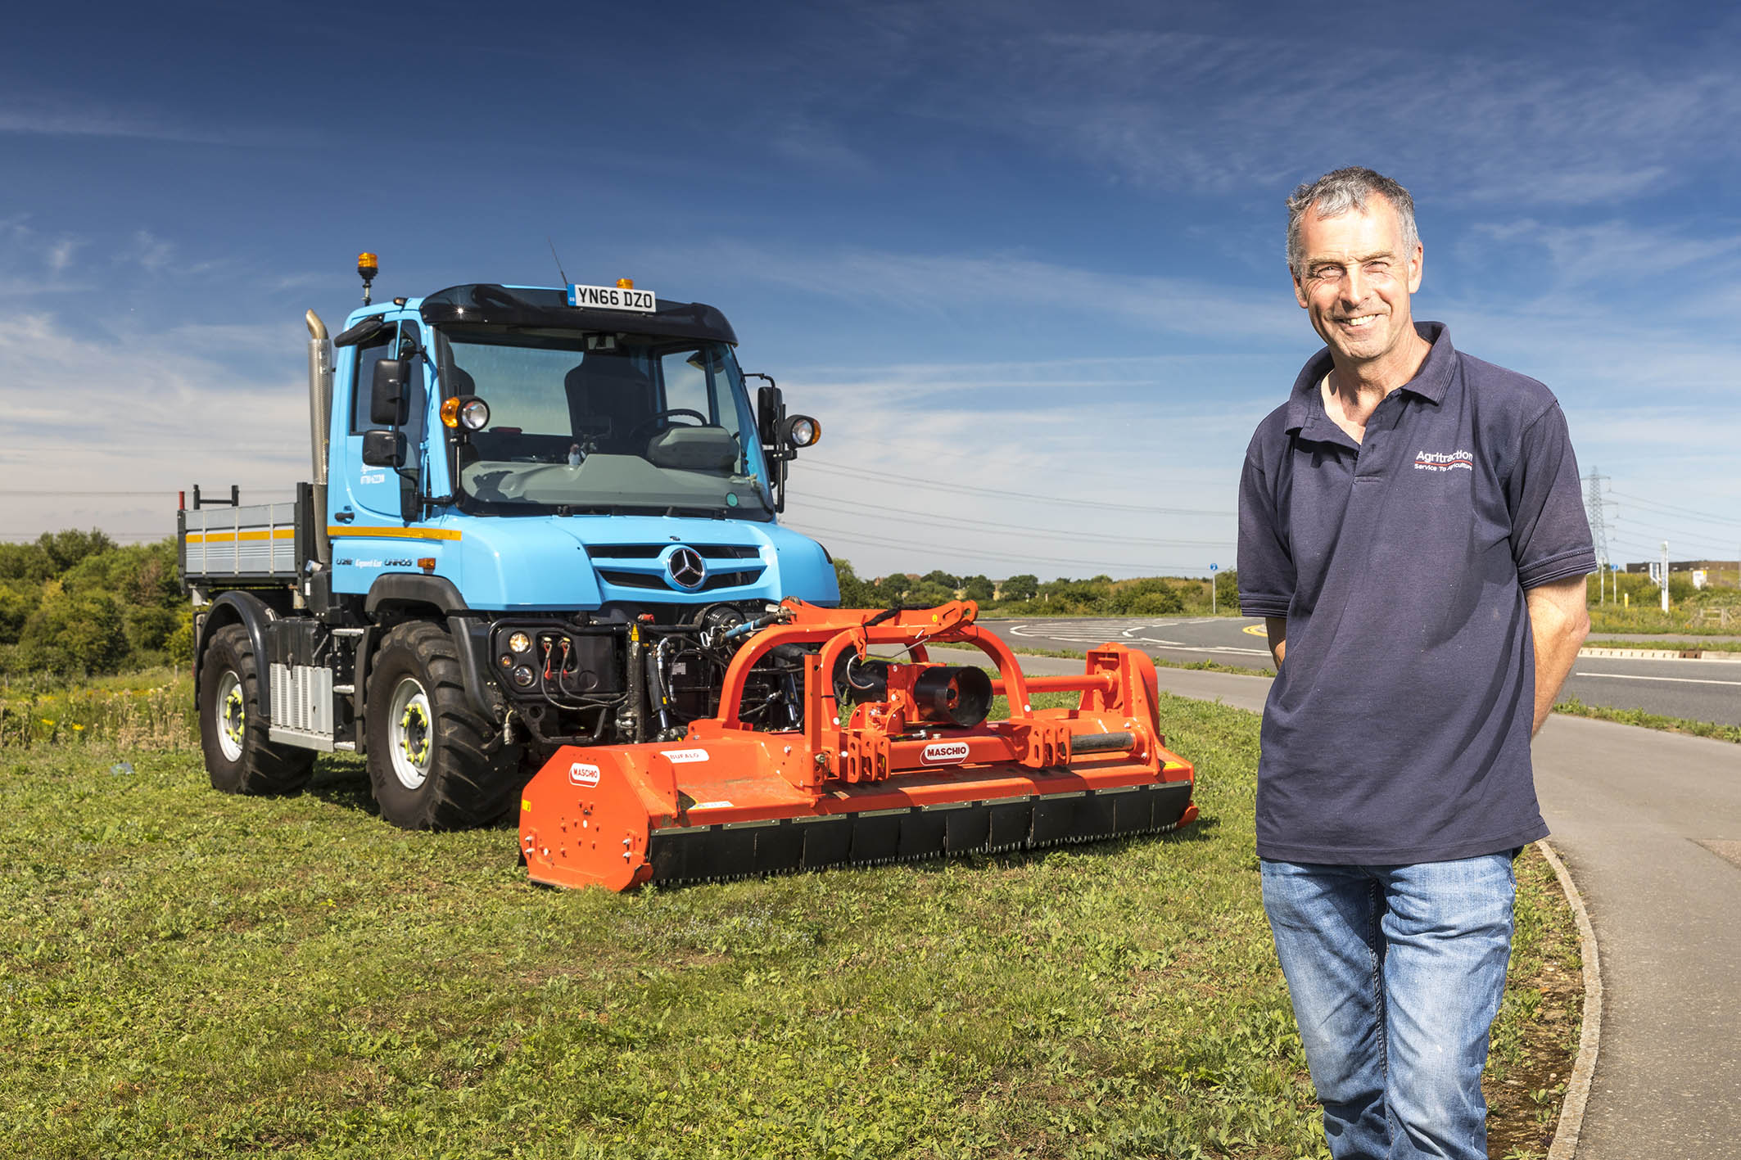

“Anything, anywhere, anytime”: That’s Agritraction’s Guy Gregson, with his new Mercedes-Benz U218

‘One-man band’ Guy celebrates in style, with Mercedes-Benz Unimog number five

Kent-based contractor Guy Gregson has marked his 30th anniversary in business by treating himself to his fifth all-terrain Mercedes-Benz Unimog.

His U218 implement carrier was supplied by Dealer Lloyd Ltd. It replaces the 23-year-old U1600 which Mr Gregson had been using for the last four years, and which he has now traded in.

The U218 is the smallest truck in the Unimog range and, thanks to its narrow, 2.15m-wide cab, and a 12.6m turning circle comparable to many cars, exceptionally agile. With permanent all-wheel drive and a fuel-efficient 5.1-litre four-cylinder engine that produces 130 kW (177 hp) and up to 750 Nm of torque from 1,200-1,600 rpm, it also offers the go-anywhere capability and 56 mph road speed for which the Unimog is renowned.

Mr Gregson began serving the agriculture and amenity sectors in 1989, with an MBtrac tractor (Mercedes-Benz ceased production of the MBtrac, which was built around a Unimog chassis, in 1991). He bought his first Unimog, a pre-owned U1000, in 1990, and ran it for three years, before replacing it with a new U1600.

In 1999 he switched career tack and for the next 15 years provided haulage services as the owner-driver of a conventional truck, while continuing to serve agricultural customers by operating combine harvesters, and providing grain carting services during autumn cultivations.

In 2014, however, Mr Gregson came full circle when he launched a new venture, Agritraction. He purchased his third Unimog, this time a used U1200 model, to get the business up and running. Within 18 months that truck had made way for the U1600 which he has just replaced.

Operating from the Kingsnorth Industrial Estate, near Hoo, he is now using his new implement carrier to undertake a variety of agricultural tasks, as well as verge and hedge cutting, grass cutting, and overseeding of parks and playing fields. He also serves supermarkets and other corporate customers during the winter, by clearing snow and gritting their car parks.

Crucially, Agritraction also provides traction-only services for agricultural and industrial haulage. Mr Gregson retains his Operator’s Licence and has taxed his U218 as a Large Goods Vehicle. “This means I can utilise its transport ability and high road speed to the full, by running it on motorways,” he explained.

Recalling his first Unimog, Mr Gregson said: “I was hooked from the outset. No other truck could touch it in terms of the sheer breadth of its abilities. That remains every bit as true today, as it was then.

“My last Unimog clocked-up nearly 300,000 km and was fantastically reliable. The U218 represents a huge step forward, though. The visibility from the modern, airy cab is fantastic, while it’s also a lot more comfortable, and significantly quieter.”

He continued: “The new vehicle suits my operation perfectly. It has plenty of power, but is also compact and highly manoeuvrable in tight spaces. I don’t need a huge, cumbersome machine – small is beautiful where my work is concerned.”

Mr Gregson can attach a variety of implements, including his Mulag flail and mower, and a Schmidt snow plough, quickly and easily to the Unimog’s hydraulic and mechanical implement drives, and front PTO shaft.

He is also benefiting from his new truck’s VarioPilot and hydrostatic drive systems. VarioPilot allows the driver to swap between left- and right-hand drive, moving the steering wheel, instrument panel and pedals from one side of the vehicle to the other in less than a minute. This optional feature is ideal for tasks such as mowing and hedge-cutting, which are more easily and safely completed from the verge-side of the vehicle.

Hydrostatic drive, meanwhile, works in conjunction with the mechanical transmission and provides finely-tuned gear changes allowing infinitely variable speeds from a standstill up to just 15.6 mph. “Back or forward, it makes the job so easy that it’s just like riding on an overgrown lawn mower,” enthused Mr Gregson.

The Mercedes-Benz Unimog is widely acknowledged as the world’s leading all-terrain vehicle, with a reputation forged in the harshest operating conditions. The overwhelming majority of those built since 1951 are still in service today.

All Unimogs have 4x4 chassis with single rear wheels, while gross weights vary from 7.5 to 16.5 tonnes. There are two core variants: an implement carrier like Guy Gregson’s with front, side and rear attachment points, and an ultra-high mobility truck with extreme torsional flexibility, which can accommodate a range of bodies. Both are superbly adaptable to a huge variety of roles.

www.agritraction.co.uk

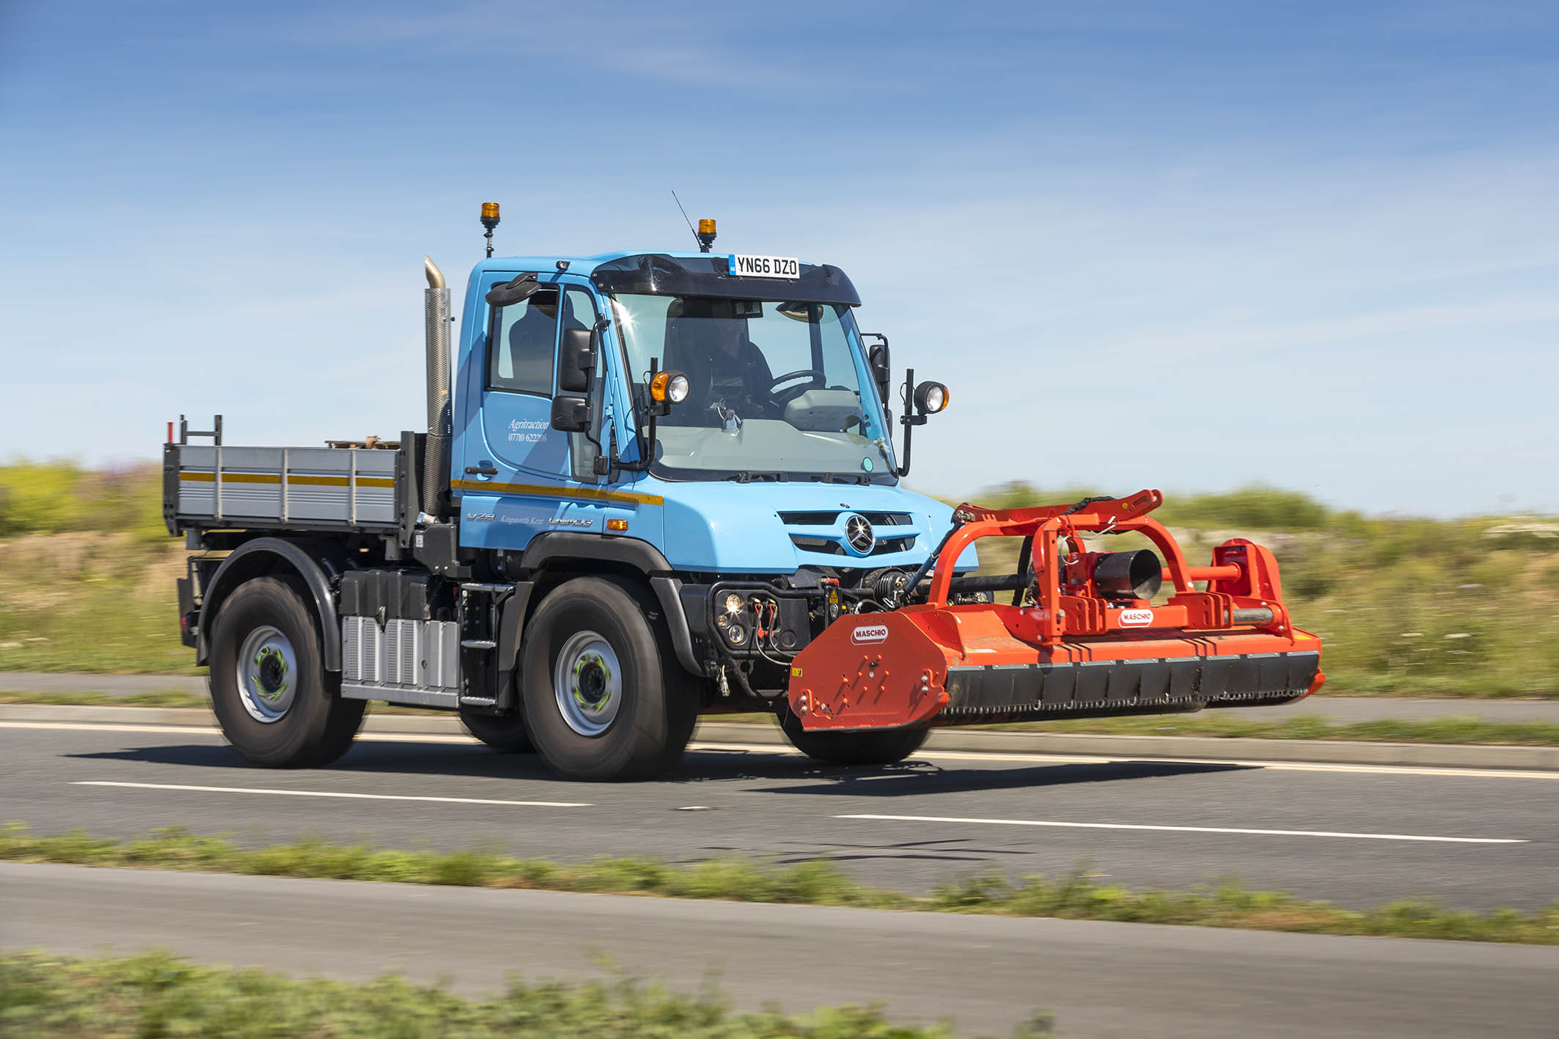

Fast forward: Its 56 mph road speed is key to the Unimog’s appeal for Guy Gregson
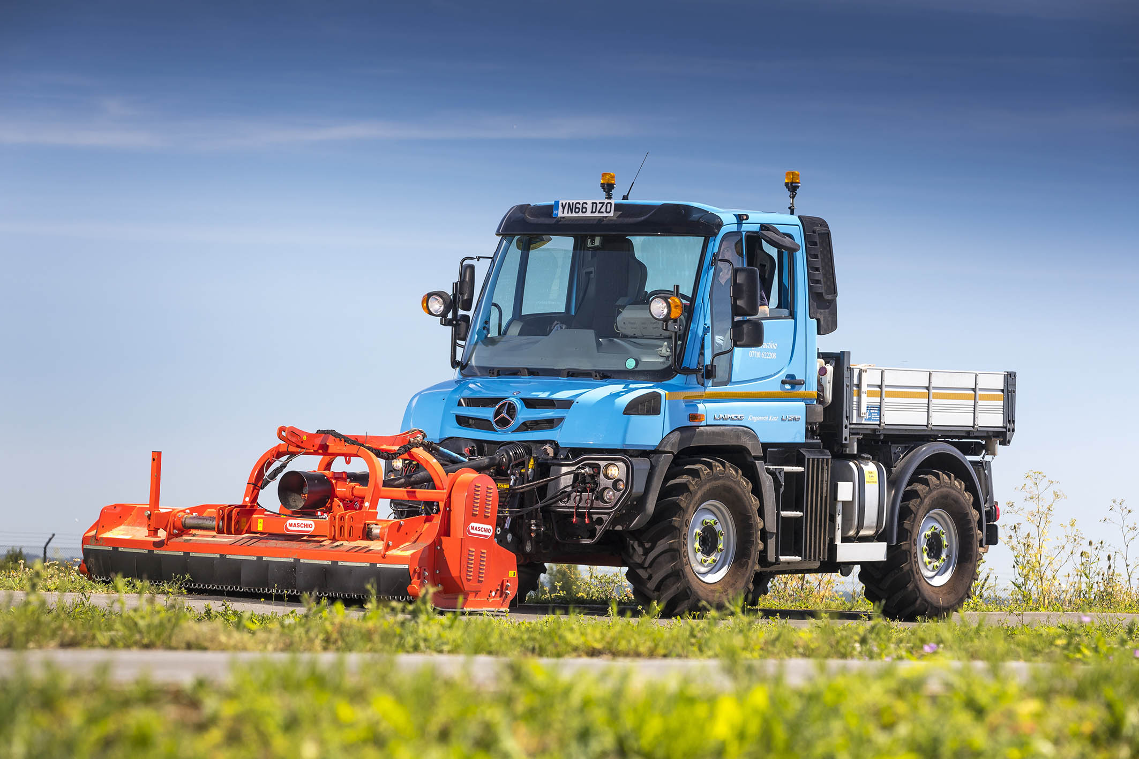

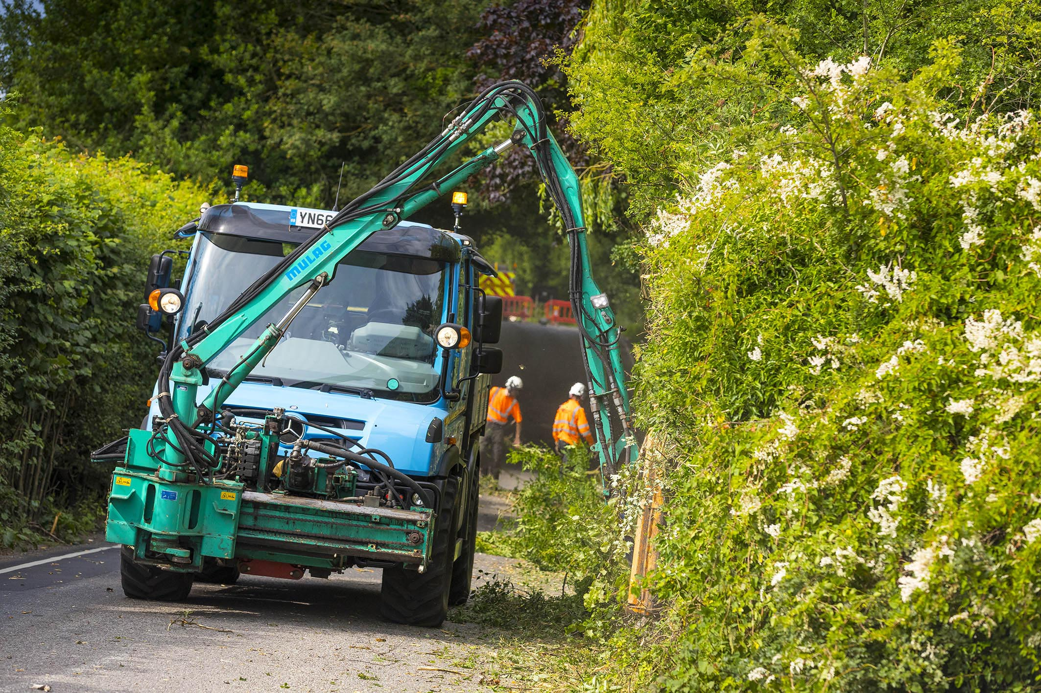

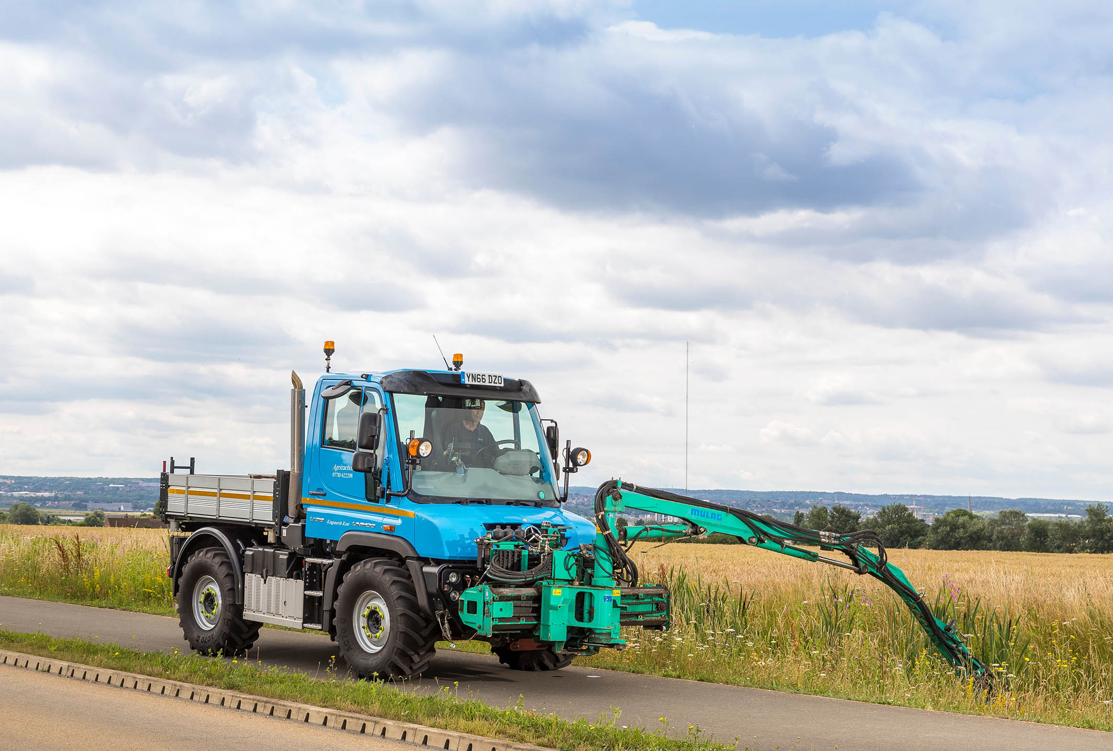

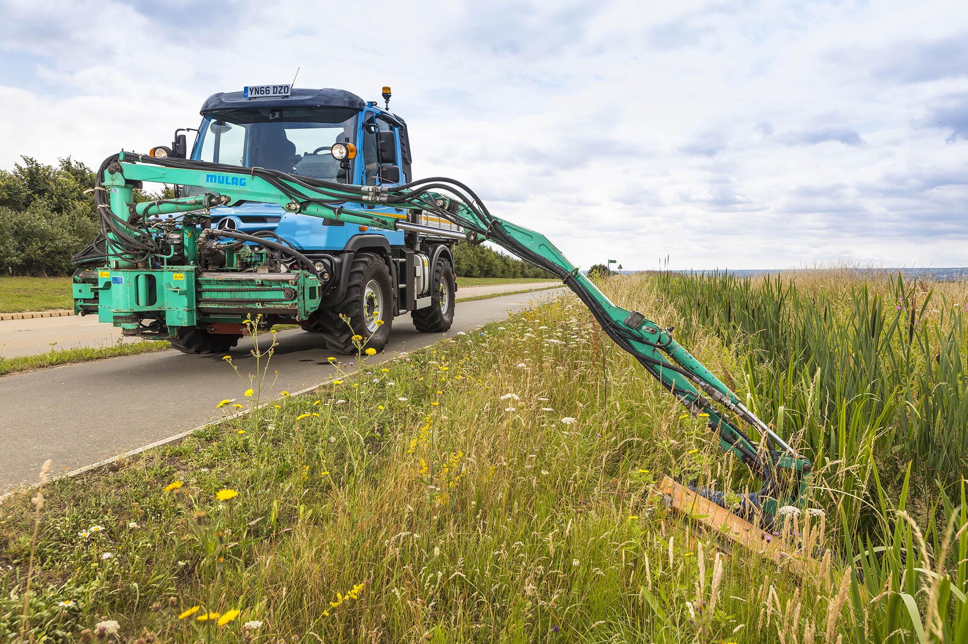

ends

For more information, or to request bigger/higher-res image files, please contact:
Steve Warren or John Ripley
Impact Communications, 01926 842126
Steve: 07770 470251, steve@impactcom.co.uk
John: 07771 484595, john@impactcom.co.uk

