

Date: 7 March 2022

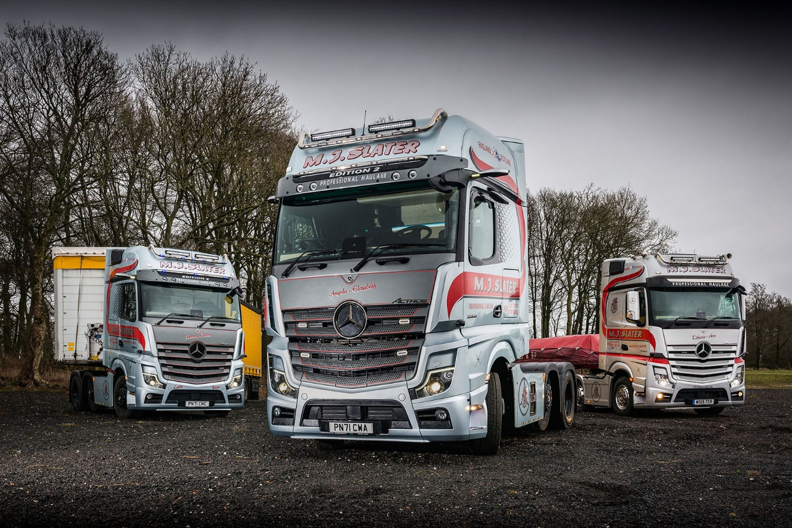

Leaders of the pack: MJ Slater’s Mercedes-Benz Actros Edition 2 tractors, left and centre, are pictured with its 2019 Actros1

MJ Slater reaches twin peaks of exclusivity with awesome Actros Edition 2s from Ciceley Commercials

Cumbria’s MJ Slater is holding a pair of aces in the shape of two stunning, limited-edition Mercedes-Benz tractor units.

Just 400 Actros Edition 2s have been built for customers worldwide, and of these a handful reached the UK. Only by getting its order in very early was MJ Slater able to bag a brace.

Having set its first Edition 2 on the road late last year, the Carlisle-based operator has now taken delivery of the second. Both arrived via the local branch of Dealer Ciceley Commercials.

Long-serving drivers David Johnston and Leszek Kozyra have been entrusted with MJ Slater’s new flagships – and earned instant bragging rights among colleagues who all enjoy top-class, highly specified trucks. The fleet also includes a three-year-old unit from the previous Actros1 line of limited-run Mercedes-Benz ‘specials’.

One of the best-looking trucks on the road, the Mercedes-Benz Actros Edition 2 showcases the manufacturer’s industry-leading efficiency and safety technology, while simultaneously elevating driver appeal to a new level.

Established in 1988, MJ Slater offers general and specialised haulage services, as well as next-day deliveries. Its nine trucks, the majority of which are from Mercedes-Benz, operate throughout the UK, hauling mainly steel and concrete for importers, manufacturers and stockholders, and working with standard, extendable, urban flatbed and Euroliner trailers.

Its latest trucks are easily recognisable thanks to their Moonstone Grey grilles and sun visors – each incorporating four additional LED headlights – above which are deep black panels with EDITION 2 lettering. Other external highlights include illuminated three-pointed stars in dark chrome with black closed covers, gloss black trim, stainless steel entrance steps, three more LED headlights behind the cab, and chassis frame covers.

Their Gigaspace cabs, meanwhile, are every bit as eye-catching on the inside. An abundance of stitched black Nappa leather contrasts with dashboard components in carbon. There are sliding and tilting sunroofs, eight colours of ambient lighting, and drivers’ suspension seats that incorporate climate and massage functions.

The trucks also boast rear wall locker systems complete with microwave ovens and flat screen TVs, while a brushed and polished aluminium badge on the co-driver’s side hails each Edition 2 as “One of 400”.

“We don’t hold back when it comes to choosing the best, most highly appointed trucks for our drivers,” said Managing Director Mick Slater. “We consider it only fair, as they spend so much time in their vehicles.

“Our work means the lads are almost always away all week, every week – they spend more time in the cab than they do at home, so we want to make the living experience as comfortable as possible for them.”

David Johnston, driver of the first Edition 2, said: “It’s a fantastic truck, with lots of space and a real luxury feel. Unsurprisingly, it draws a lot of attention and admiration from other drivers out on the road.”

Leszek Kozyra added: “My new cab has all the home comforts I could wish for and it looks great too. The Edition 2 is a real driver’s truck.”

The new units lead the way when it comes to safety and efficiency as well. MirrorCam, Mercedes-Benz Trucks’ pioneering alternative to conventional mirrors, is fitted as standard on all Actros. So, too, are the latest version of Predictive Powertrain Control, which manages gear changes to optimise fuel economy, and Active Brake Assist 5, the emergency braking system that outperforms its rivals, particularly in its responses to pedestrians stepping into the vehicle’s path.

Edition 2 drivers also benefit from the upgraded interactive version of the radical, twin-screen Multimedia Cockpit, which boasts a larger, 12in instrument panel and comes with extra functionality, including satellite navigation. Other items on the lengthy specification list include Proximity Control Assist, Bi-xenon headlamps with a cleaning system, and LED tail-lights.

“They’re such smart-looking trucks and very good on fuel too, even with loads that are always heavy and usually far from aerodynamic,” continued Mick Slater.

“The final, and possibly most important, piece of the jigsaw, is the excellent relationship we enjoy with Ciceley Commercials. Sales Executive Mike Ferguson knows our business and understands our requirements very well, while his service department colleagues will always do their utmost to carry out any work on our vehicles at times that best suit our busy operating schedule.

“All of this explains why, since we bought our first Actros in 2012, Mercedes-Benz has gone on to claim the lion’s share of our fleet. We also have another highly specified tractor on order from Ciceley Commercials, which is due for delivery in the autumn.”

MJ Slater boasts a strong family ethos – Mick Slater’s wife Angela runs the office, and son Callum and son-in-law Samuel are drivers. Edition 2 driver David Johnston, meanwhile, is the uncle of Traffic Manager John Johnston.

www.mjslaterhaulage.co.uk

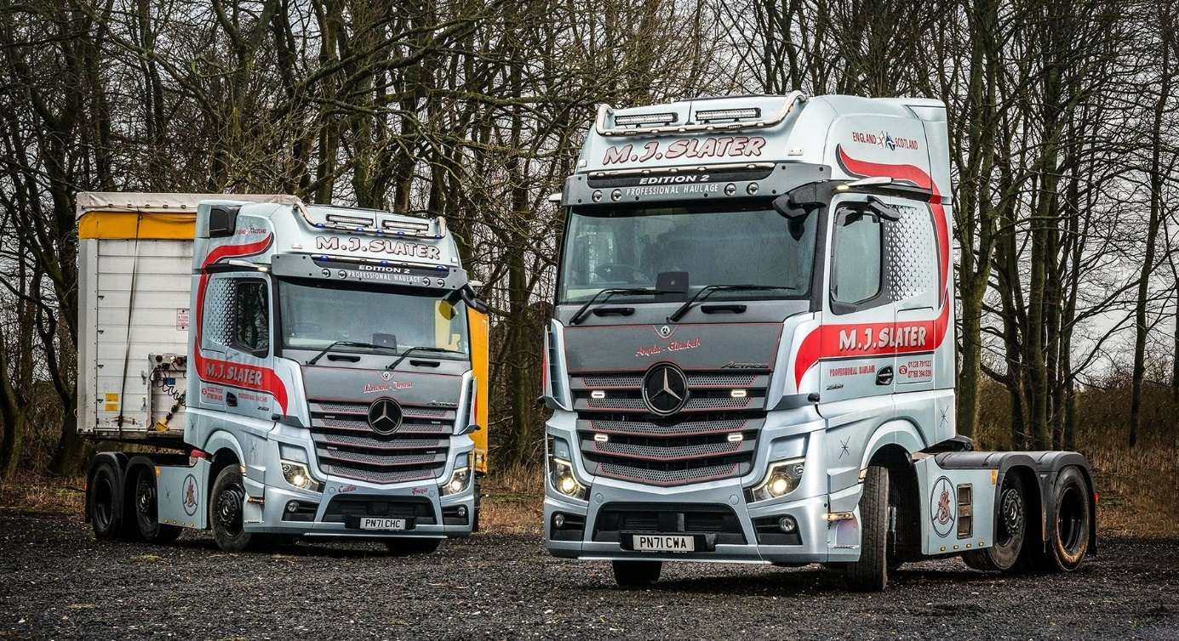
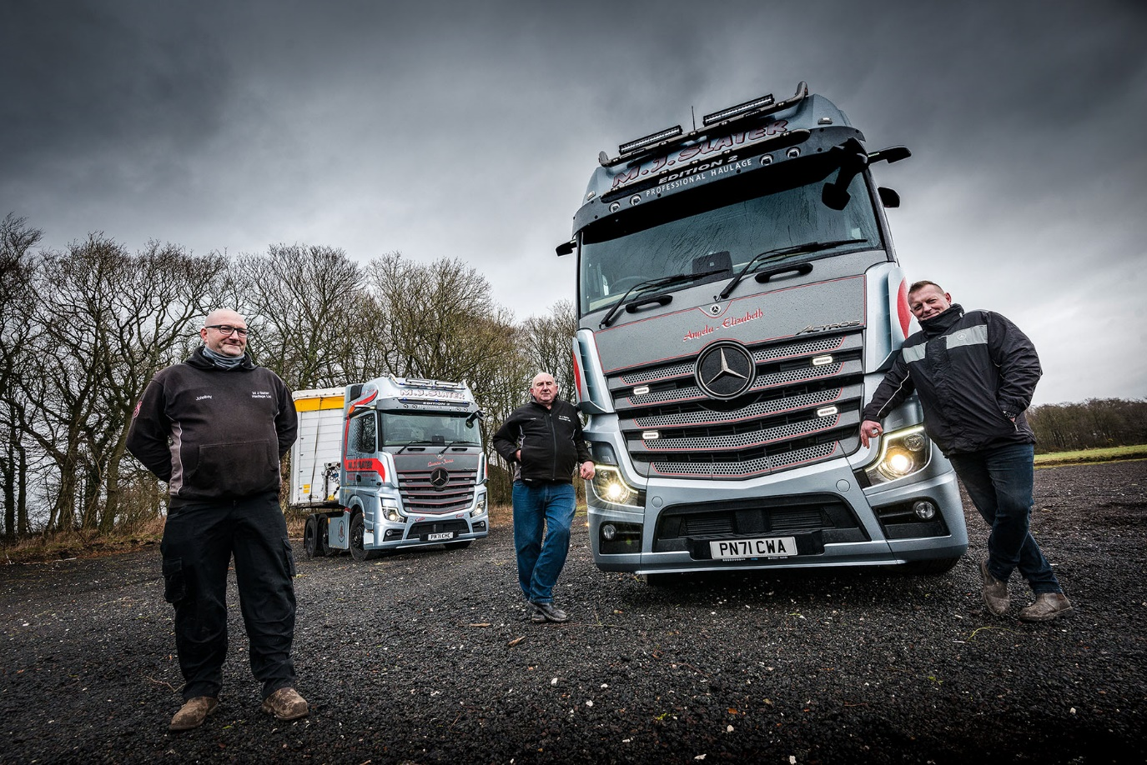

When only the best will do: MJ Slater Traffic Manager John Johnston, left, with drivers David Johnston, centre, and Leszek Kozyra, and their new Actros Edition 2s

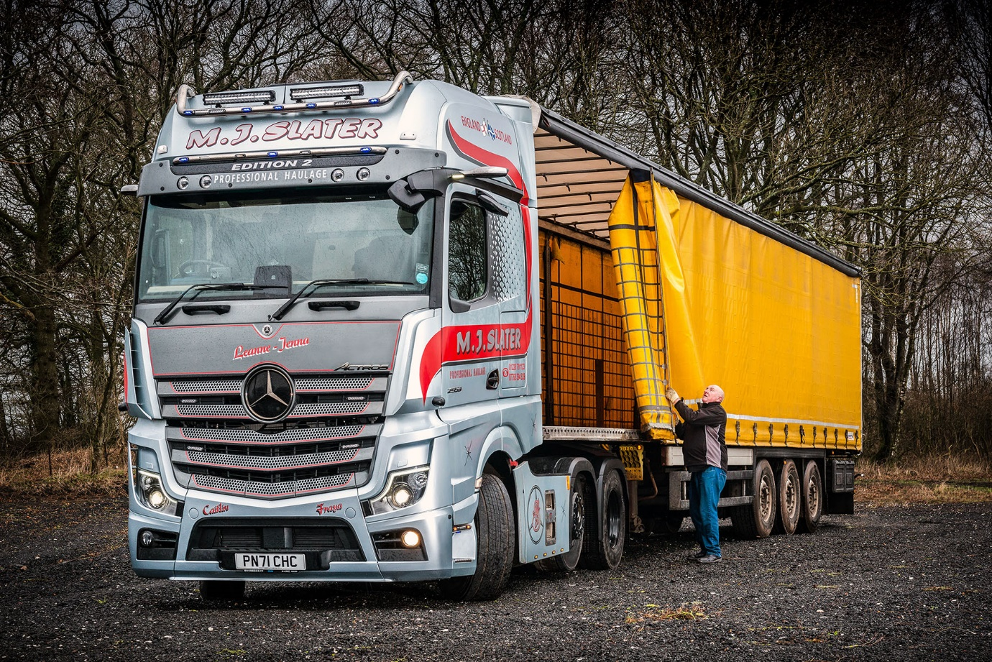

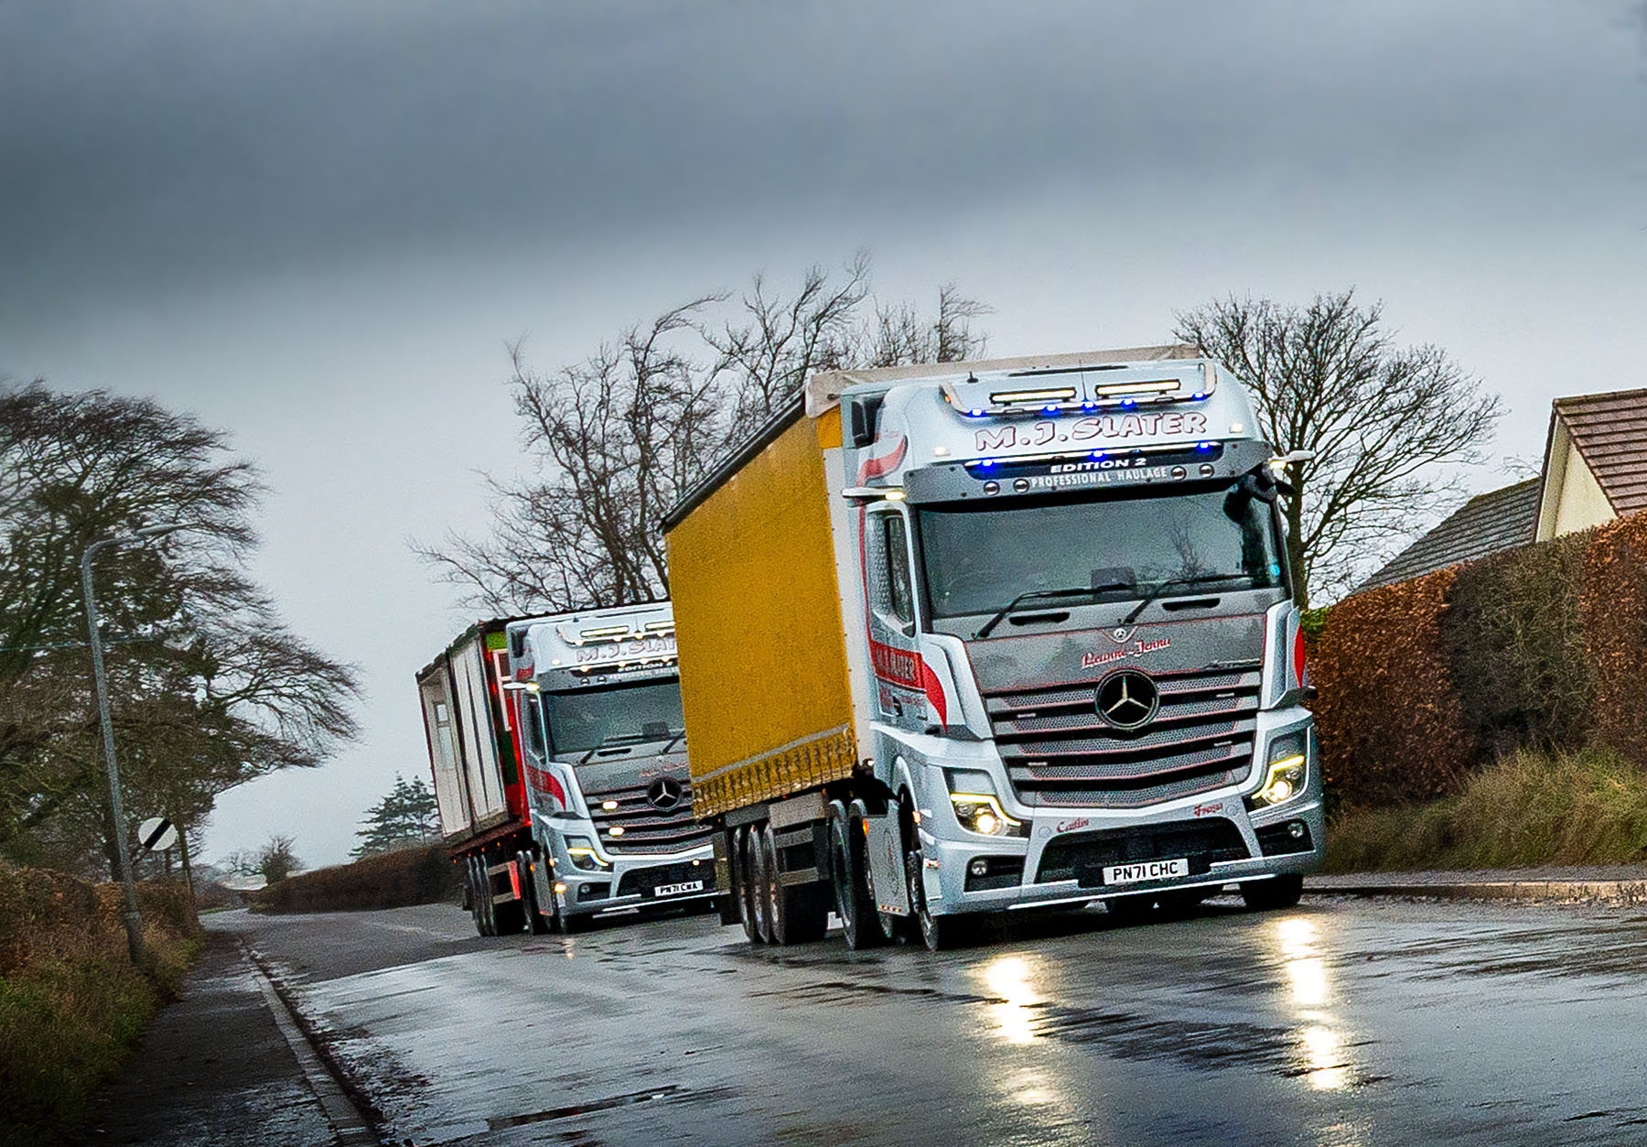

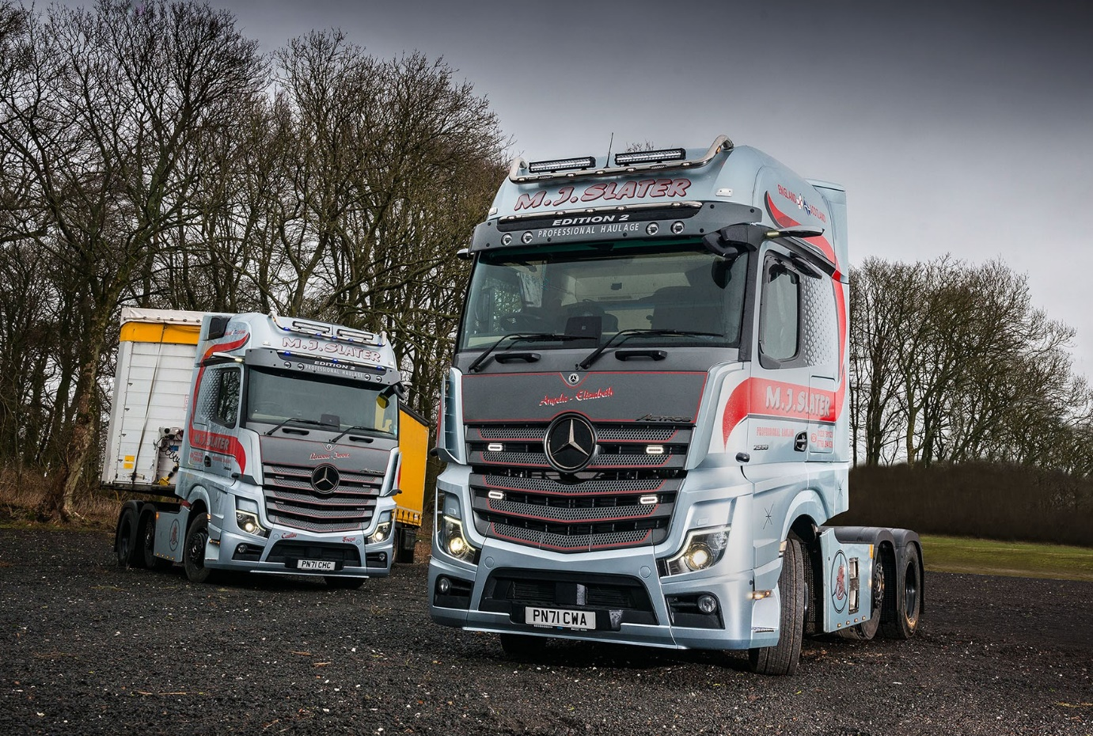

ends

For more information, or to request bigger/higher-res image files, please contact:
John Ripley or Steve Warren
Impact Communications
John: 07771 484595, john@impactcom.co.uk
Steve: 07770 470251, steve@impactcom.co.uk

