

Date: 14 December 2021

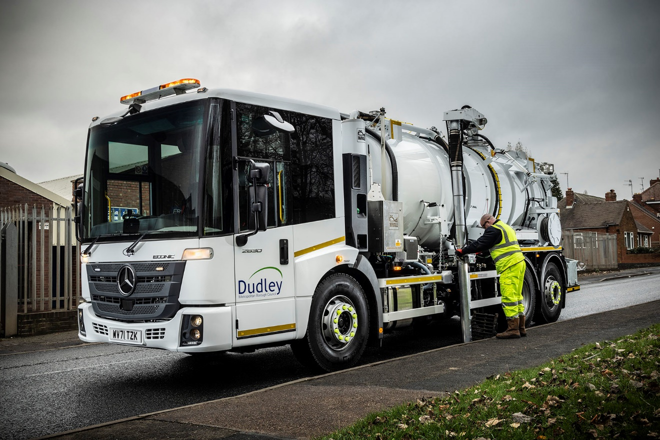

Dudley Council plays it safe by choosing another Mercedes-Benz Econic from Rygor Commercials

Proven reliability and unrivalled safety standards led Dudley Council back to the low-entry Mercedes-Benz Econic for the latest, highly specialised addition to its fleet.

The West Midlands authority’s new vacuum tank gully emptier is based on a 26-tonne Econic 2630 L chassis supplied by the Kidderminster branch of Dealer group Rygor Commercials.

The truck is powered by a 7.7-litre ‘straight-six’ engine that produces 220 kW (299 hp) and drives through a six-speed Allison automatic transmission. The six-wheeler’s steered rear axle enhances manoeuvrability.

Fitted with water tanks and jetting/vacuum equipment by Whale Tankers, of Solihull, it has replaced Dudley Council’s previous, 18-tonne Econic gully emptier.

“The new vehicle’s extra weight capacity and longer wheelbase has allowed us to fit larger water tanks,” said Highways & Transport Maintenance Manager Graham Timmins. “This means there’s less time travelling backwards and forwards to empty and refill, so it can spend longer on the job.

“It’s a more efficient solution but one that also offers all the benefits of Econic operation, which we’ve come to appreciate in our borough over many years, as well as the excellent customer service we receive from Rygor Commercials.”

Mercedes-Benz Econics are a common sight on the streets of Dudley, as the council also runs a fleet of 35 refuse collection vehicles based on the same model. The latest, though, is used for suction cleaning of drainage gullies on roads across the metropolitan borough, and to empty septic tanks at domestic and commercial properties. It can also clear blocked drains by jetting clean water at high pressure.

The Econic is equipped with a VisionTrack camera system, while Mercedes-Benz safety aids include Active Brake Assist 4 emergency braking technology – which can detect vehicles ahead and stationary objects in its own lane, at speeds of up to 56 mph (90 km/h). It can initiate maximum braking to bring the truck to a complete stop, and at speeds of up to 31mph (50km/h) can also detect moving pedestrians.

“As well as being extremely reliable the Econic is very popular with our crews,” continued Mr Timmins. “The low entry step to the cab makes life much easier for operatives who are in and out through the door many times in a working day.

“The deep, wraparound windscreen and low seating position, meanwhile, give drivers an unbeatable field of vision, while any areas that cannot easily be seen are covered by the camera system. This helps to enhance safety not only for our drivers and crews, but also for the general public, and particularly vulnerable road users.

“This Econic is a complex vehicle but Rygor’s Fleet Sales Manager Jeremy Price liaised with the body equipment supplier on our behalf, as he always does. We’ll maintain the truck in-house – our workshop team receives regular parts deliveries from Rygor to ensure we’re never stuck waiting for a vital item, and, should we need it, expert technical advice is always just a phone call away.”

As with all new Econics supplied through the Mercedes-Benz Trucks UK’s Dealer network, Dudley Council’s vehicles are backed by comprehensive three-year/160,000 km manufacturer’s warranties.

Jeremy Price added: “I’ve been working with Dudley Council for two decades now and have supplied vehicles in different sizes and configurations for a variety of roles. The close relationship we’ve developed is testament to our consultative way of working and dedication to Setting Standards.”

www.dudley.gov.uk

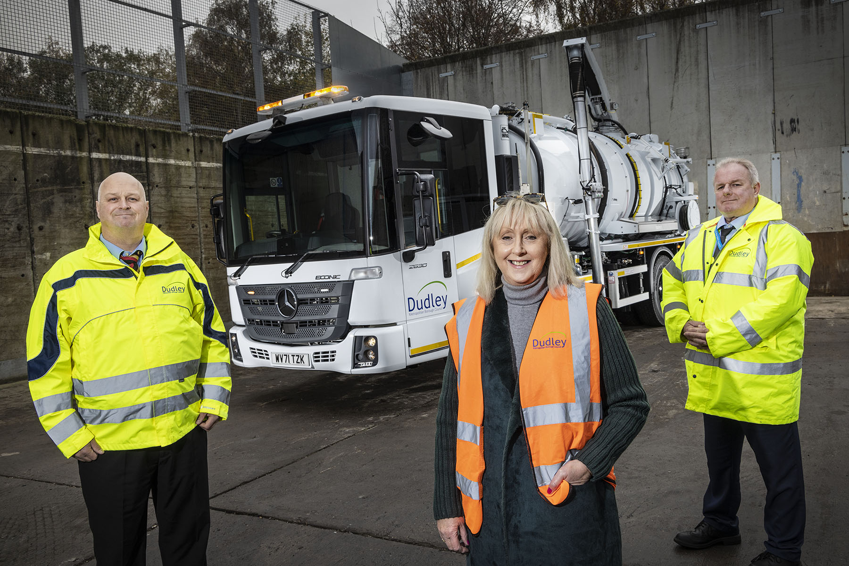

Wise council: Dudley’s Contract & Development Officer Peter Cooper, left, Cabinet Member for Public Realm Karen Shakespeare, and Highways & Transport Maintenance Manager Graham Timmins, with their latest Mercedes-Benz Econic

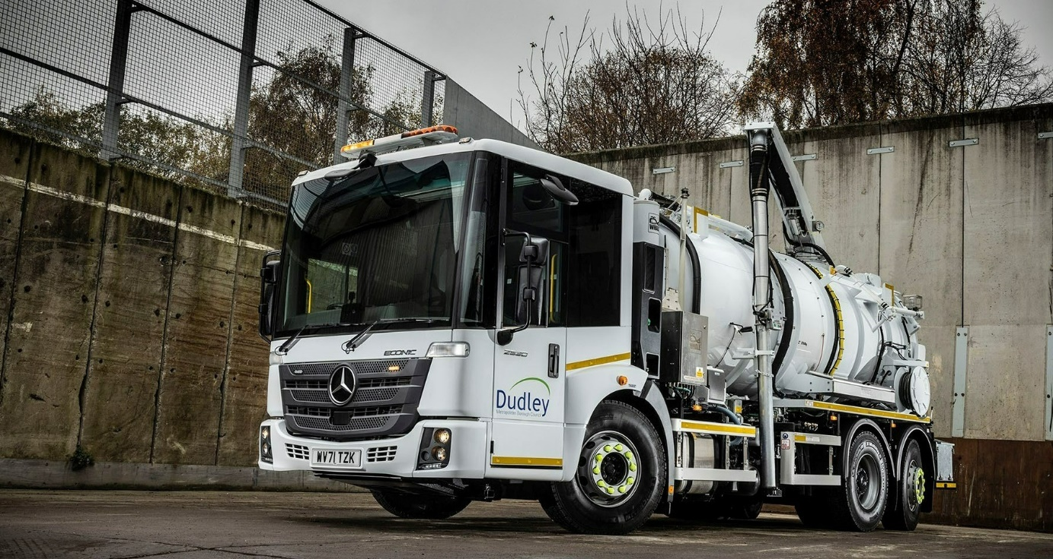
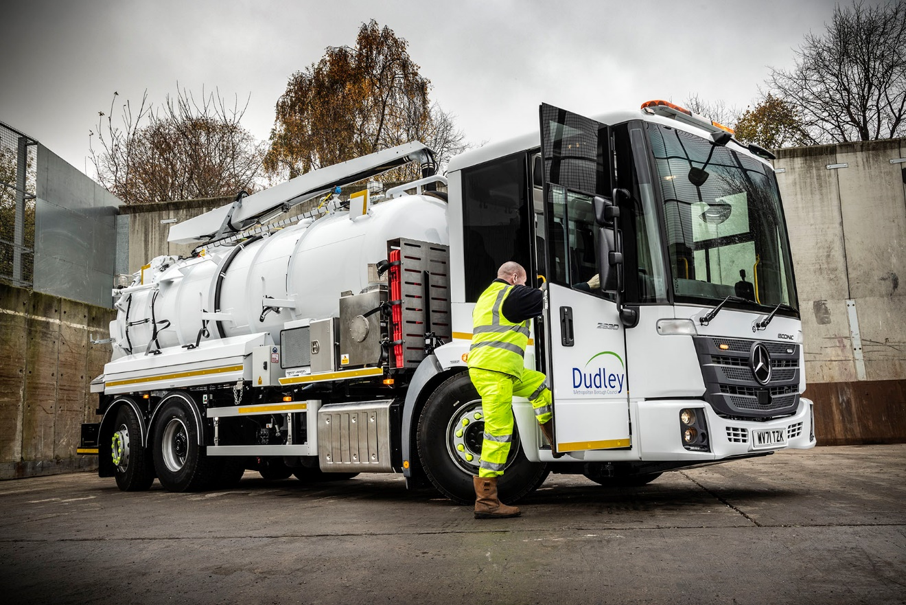

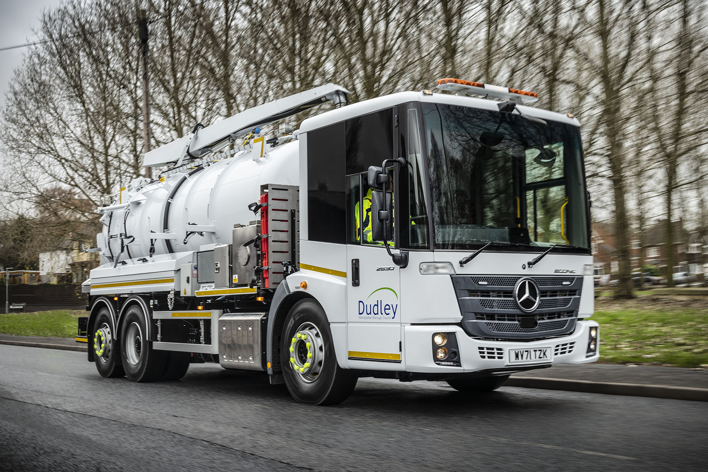

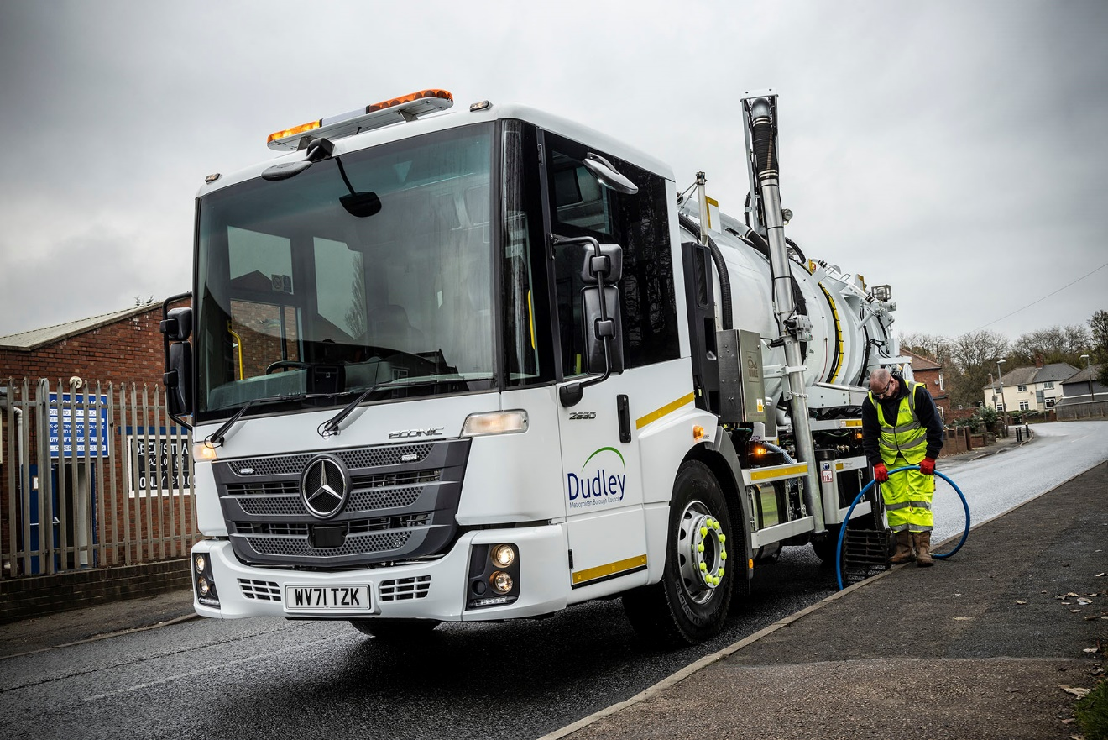

ends

For more information, or to request bigger/higher-res image files, please contact:
John Ripley or Steve Warren
Impact Communications
John: 07771 484595, john@impactcom.co.uk
Steve: 07770 470251, steve@impactcom.co.uk

Notes to Editors: Rygor Commercials

Award-winning Mercedes-Benz Commercial Vehicle Dealer group, Rygor Commercials, has branches in Berkshire, Gloucestershire, Oxfordshire, Somerset, West London, Warwickshire, Wiltshire, and Worcestershire, offering extensive coverage for customers throughout the M5, M4 and M42 corridors.

The Rygor business has developed and gone from strength to strength in recent years, investing in extensive renovations of its sites across the country as well as a brand-new, dedicated Heathrow Truck Centre which opened in 2020. With six industry and network awards under its belt in the past 24 months, Rygor continues to be dedicated to providing exceptional customer service, which Sets Standards. The Dealer was delighted to be announced as winner in the ‘Franchised Dealer of the Year’ category at the 2019 Commercial Motor Awards and ‘Van Dealer of The Year 2021’ at the What Van? Awards, accolades which not only demonstrate the company’s focus on customer satisfaction, but also its commitment to the development, training, and wellbeing of its team members.

With a proven track record, Rygor is proud to be selling, maintaining and supporting the most prestigious name in commercial vehicles.

For more information, in the first instance please contact Kate Ruberry-Shoemack, Head of People and Communications at Rygor – kateruberry-shoemack@rygor.co.uk, or, in her absence, Communications Assistant, Talitha Scott – talithascott@rygor.co.uk.

