

Date: 10 May 2019

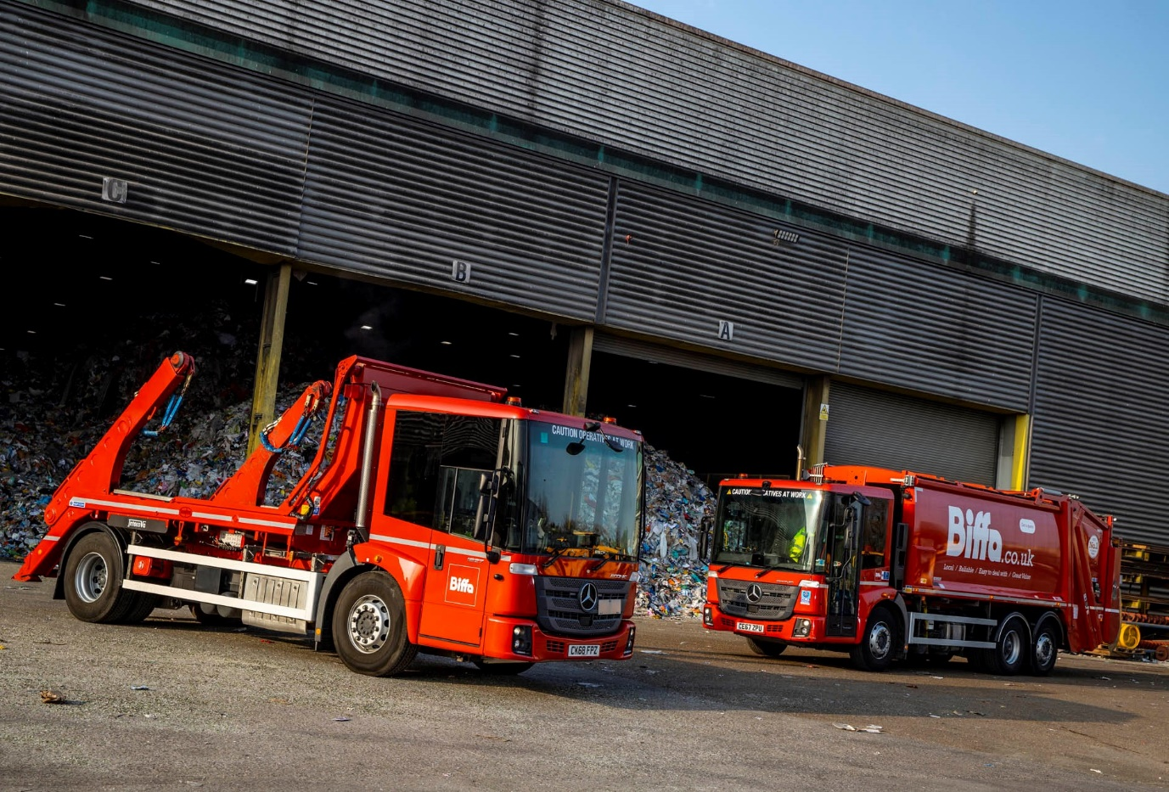

Biffa boosts its Mercedes-Benz Econic fleet with new body variants

Integrated waste management and recycling leader Biffa has added 43 more Mercedes-Benz Econic trucks – including its first skiploaders and hookloaders based on the low-entry chassis – to the 51 it acquired in 2017-18.

These vehicles were all supplied by South Wales Dealer Euro Commercials. The overwhelming majority are 6x2 Econic 2630L variants with rear-steer axles and Dennis Eagle compactor bodies.

The only exceptions are the three 18-tonne Econic 1827L skiploaders and a pair of 32-tonne 3235L ENA hookloaders included in the latest batch, which are fitted with bodywork by Boughton Engineering. As ENA variants, the eight-wheelers have single front steer axles, double-drive bogies, and rear-steer axles, a configuration that ensures a high degree of manoeuvrability.

Biffa is now trialling these vehicles in London, where the Econic, having secured a five-star Direct Vision rating, is proving increasingly popular with safety-conscious operators across a range of applications.

The first Mercedes-Benz Econics hit UK roads 20 years ago, and Biffa has since played a significant role in the model’s development. Today, Econics account for a large proportion of the refuse collection vehicles on its Industrial & Commercial Division’s 1,500-strong truck fleet.

Greater Safety is one of the three pillars of Mercedes-Benz Trucks’ all-embracing RoadEfficiency strategy. The Econic offers unrivalled visibility thanks to its deep, panoramic windscreen and full-height, glazed folding side door. This, allied to a seating position which is much lower than a conventional truck’s, allows the driver to make direct eye contact with cyclists and pedestrians at junctions or in traffic queues.

These attributes, coupled with a full complement of factory-fit safety systems, have enabled Mercedes-Benz to land a string of high-profile orders for Econic-based vehicles from operators in the construction, distribution and other sectors, for whom the protection of vulnerable road users has become a top priority.

Biffa’s latest Econics are all powered by economical in-line six-cylinder engines. The RCVs produce 220 kW (299 hp), while the skiploaders employ 200 kW (272 hp) and the hookloaders 260 kW (354 hp) versions of the same, advanced 7.7-litre powerplant.

Significantly, while the RCVs drive through fully automatic six-speed Allison gearboxes, the skiploaders and hookloaders are equipped with 12-speed Mercedes PowerShift 3 transmissions

Although well proven in other models bearing the three-pointed star, the manufacturer’s own, smooth-shifting automated manual transmission was only made available to Econic customers recently. Its introduction reflects the requirement for a more fuel-efficient alternative to the established Allison system, which is so well-suited to stop-start waste collection duties.

Biffa Fleet Project Engineer Colin Bagnall confirmed: “The Econic is our preferred low-entry RCV chassis. It is reliable and cost-effective in operation, while our crews appreciate its comfortable, air-conditioned, walk-through cab.”

Biffa’s commercial refuse collection vehicles are based throughout the UK. “We used to buy 6x4 variants,” explained Mr Bagnall. “However, to reflect the fact that a much higher proportion of the trade waste we collect is now recycled at our own transfer facilities, rather than being sent to landfill, we switched about three years ago from double-drive to 6x2 rear-steer chassis.”

Biffa undertakes the majority of vehicle inspections and maintenance in its own workshops. “Mercedes-Benz Trucks has a strong Dealer Network, though, and we also rely on its members to undertake warranty work and, from time to time, other assignments,” said Mr Bagnall.

Commenting on the introduction of its first Econic-based skiploaders and hookloaders, he continued: “These vehicles represent a new departure for us, and underline our commitment to safe, compliant operation in busy urban areas.

“We’ll be monitoring their performance closely but the initial feedback from drivers has been entirely positive. They particularly appreciate the excellent visibility which the Econic offers.”

Mr Bagnall added: “Although we’ve been running Econics for many years, our relationship with Euro Commercials, from which we also buy other Mercedes-Benz truck models, is still a relatively new one.

“The Dealer provides an excellent service,” he confirmed. “Our tender documents are professionally completed and submitted in good time, while its team are very pleasant to deal with.

“As the prime contractor, Euro Commercials liaises with our other suppliers and oversees the bodybuilding process. It also provides regular updates on our orders – the spreadsheets are both comprehensive and accurate, and backed up by weekly contact calls. If any issues do arise, they are always addressed very promptly.”

Established in 1912, Biffa operates from headquarters in High Wycombe, Buckinghamshire, and no fewer than 195 other sites nationwide. Its Municipal Division services over 2.4 million households and collects 4.1 million bins every week.

www.biffa.co.uk
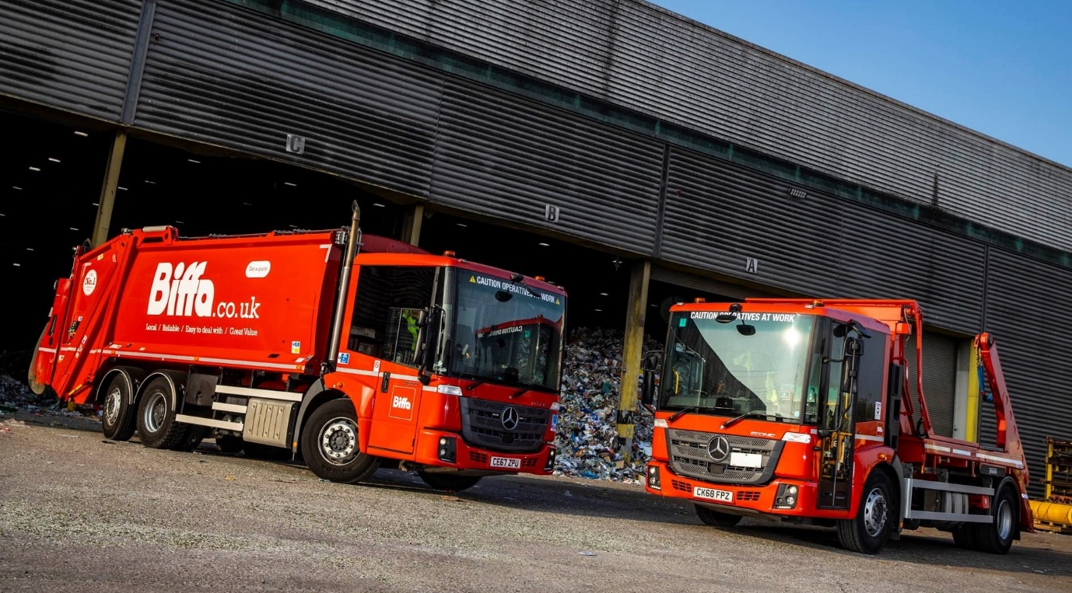

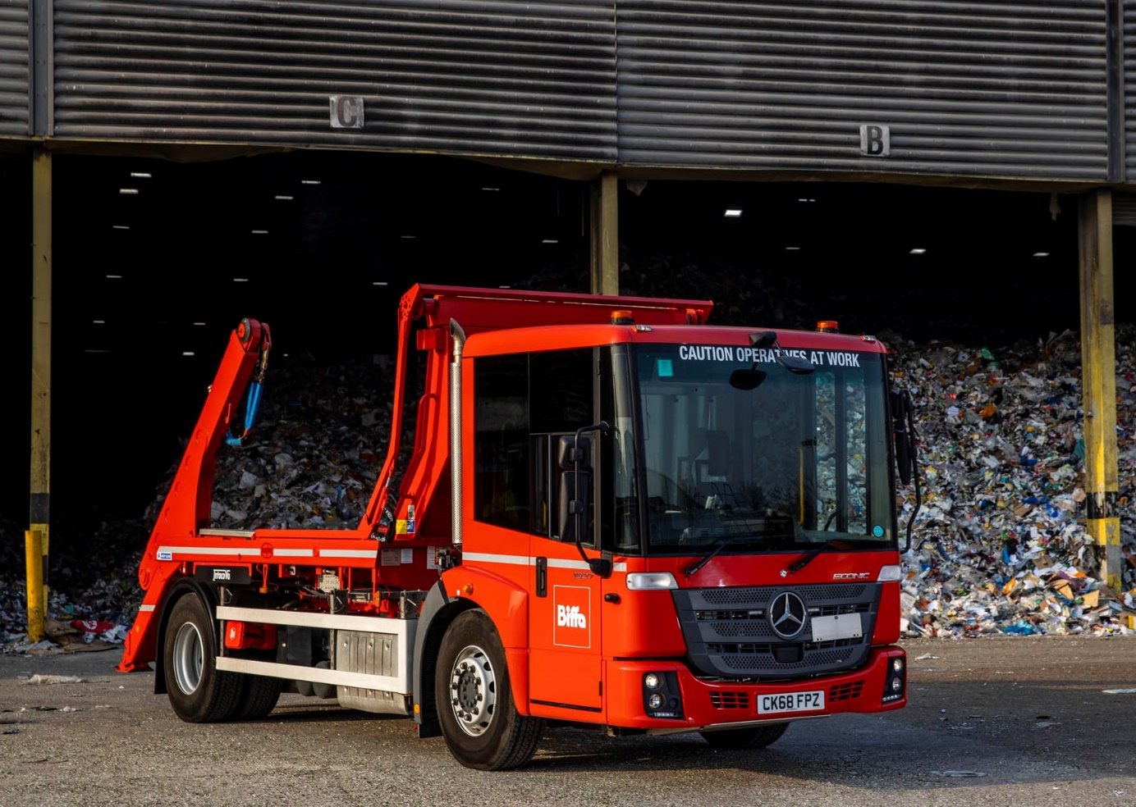

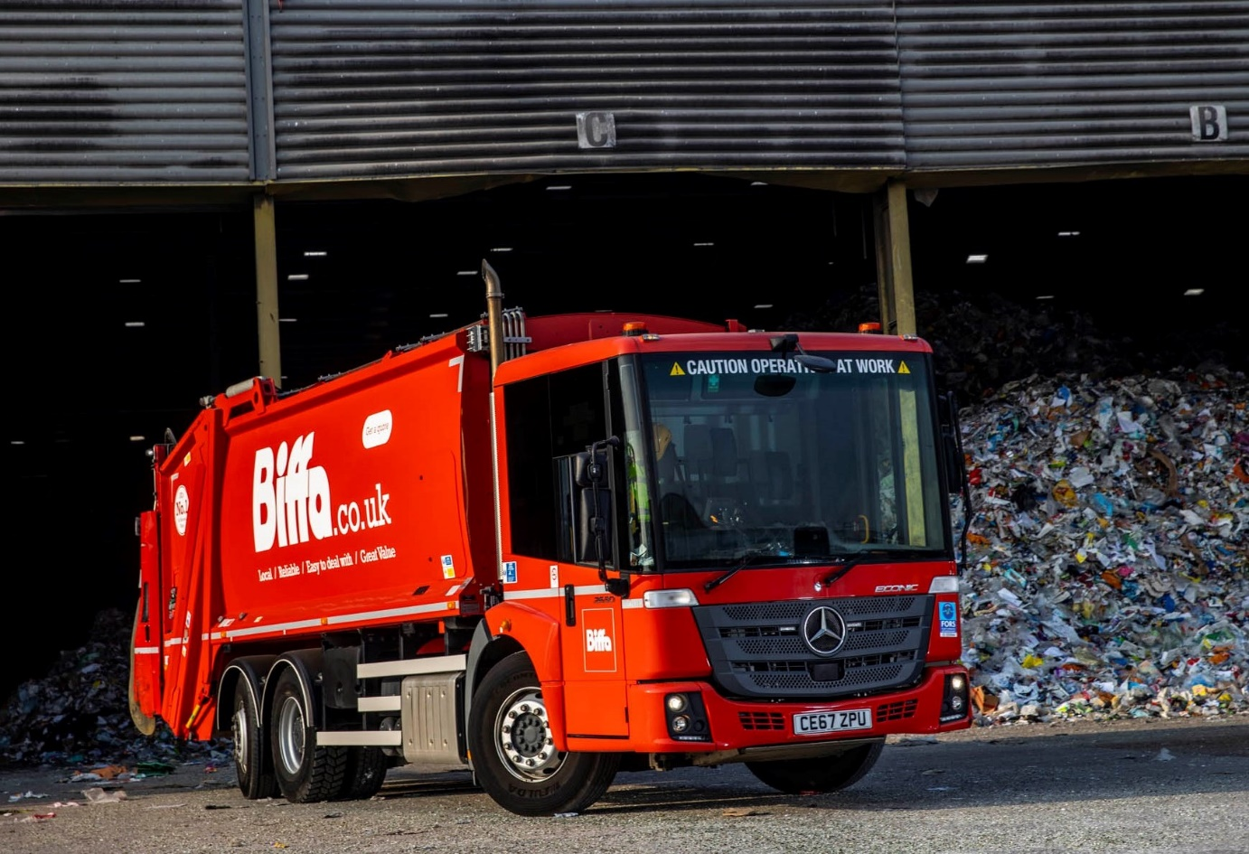

ends

For more information, or to request bigger/higher-res image files, please contact:
John Ripley or Steve Warren
Impact Communications, 01926 842126
John: 07771 484595, john@impactcom.co.uk
Steve: 07770 470251, steve@impactcom.co.uk



