
Date: 23rd October 2025

Ciceley Commercials announces new Mercedes-Benz Truck & Bus dealership at Eurocentral, Scotland

- Ciceley Commercials Ltd announces plans for a brand-new Mercedes-Benz Truck & Bus dealership at Eurocentral, Scotland
- New £8 million dealership will create around 40 new jobs and opens in autumn 2026
- The 4.75-acre plot includes 12 work bays and an Authorised Testing Facility (ATF) lane plus full service, parts and sales facilities for Mercedes-Benz trucks and service and parts facilities for Mercedes-Benz buses
- Temporary workshop to open in mid-2026 for essential servicing and maintenance, with main building due for completion in autumn 2026

Ciceley Commercials Ltd, a trusted name in commercial vehicle sales and support for over 50 years, is proud to announce plans for a brand-new Mercedes-Benz Truck and Bus dealership at Eurocentral, Scotland.
A family-owned and operated business, Ciceley has grown with a clear focus: to support truck operators with exceptional service, honest relationships and continued investment in the future. The new £8 million Mercedes-Benz Truck and Bus facility, now approved for development, represents Ciceley Commercials’ commitment to bringing that ethos to operators in Scotland.
Work on the new site will begin shortly, with a temporary workshop expected to open mid-2026 to provide essential servicing and maintenance during construction of the main building. The full dealership is scheduled to open in autumn 2026.
Ciceley is delighted to appoint Clark Contracts as the main contractor for the project. Like Ciceley, Clark Contracts has over 45 years of history, a strong reputation for quality, and a shared focus on sustainability and staff development. Based in Scotland, they bring valuable local expertise and a proven track record of delivering high-quality projects. Both companies share a strong people-ﬁrst culture. Clark Contracts’ award-winning apprenticeship and academy programmes mirror Ciceley’s own “grow your own” approach to developing talent, making them the ideal partner to bring this exciting new dealership to life.
Michael Scanlan, Director, commented: “We’re delighted to have been appointed to deliver this project for Ciceley Commercials and look forward to collaborating with our new client and the wider design team as work gets underway on site.”
Situated on a 4.75-acre plot at Eurocentral, the dealership will include:

12 work bays
- An Authorised Testing Facility (ATF) lane
- Full service, parts, and sales facilities for Mercedes-Benz trucks
- Service and parts facilities for Mercedes-Benz buses
- Around 40 new jobs for local people

"We’re thrilled to be expanding our support network into Scotland," said Andy Heys, Dealer Principal at Ciceley Commercials Ltd. "Working closely with Mercedes-Benz, we’ve secured the ideal location and designed a facility that truly reﬂects the needs of Scottish truck operators.
“This marks an exciting new chapter for Ciceley, but while we grow, we remain true to our roots and proud of our family business culture. Our story began in the early 1970s when Brian Morgan opened a fruit and veg stall in Blackburn. When Brian started maintaining his own delivery truck, word soon spread, and other stallholders asked him to do the same for their vehicles. From there, he developed a passion for commercial vehicles and worked tirelessly to become one of the very ﬁrst Mercedes-Benz franchise dealers in the UK.
“Today, at 93, Brian is still involved in the business, alongside the rest of the Morgan family. His son Russell is now our Chairman, and his grandsons Adam and Sam play an active role in day-to-day operations. That sense of family, care, and dedication is what drives us forward, and it will continue to shape everything we do in Scotland and beyond."
Daimler Truck UK also welcomed the announcement, recognising the investment as a key milestone in strengthening the brand’s support network across Scotland.
“We are delighted to be working in close partnership with Ciceley Commercials on this important development,” said Leonhard Niemann, Head of Dealer Network Development at Daimler Truck UK. “Ciceley’s reputation for customer dedication and operational excellence makes them the ideal partner to support our customers in

Scotland. This new site will ensure operators in the region have access to the outstanding service and support they expect from the Mercedes-Benz network.”

Sales and Marketing Director, Daimler Truck UK, Stuart Jeggo, added: “We have committed signiﬁcant effort to ensure this region of our network receives the experienced, dedicated, and robust support it deserves. Expanding Ciceley Commercials into Scotland presents an excellent opportunity to better serve our customers. Additionally, the new site will provide a top-tier Sales offering that complements the high-quality Aftersales services that Ciceley have proven over the years.”
Ciceley Commercials has been honoured as both the Mercedes-Benz Truck Service Dealer of the Year and Truck Sales Team of the Year, accolades that highlight the team's dedication and the strong relationships built with operators across the UK.
Andy Heys concludes: “As a family-run business, we see this new dealership as more than just a facility—it’s an opportunity to serve new communities while continuing to deliver the quality and care our current customers value. We look forward to welcoming operators, both longstanding and new, to our Eurocentral site.”

Ends.

For media enquiries, please contact:
Lorraine Howard Marketing Manager Ciceley Commercials Ltd 01254 669850
l.howard@ciceley.com www.ciceley.com

About Ciceley Commercials
Founded in 1973, Ciceley Commercials is a trusted Mercedes-Benz dealership offering comprehensive van, truck, and bus services across the North West. With a heritage rooted in family values and customer care, Ciceley continues to lead the way in service excellence across the commercial vehicle industry.
For more information call head office on 01254 669850

Images
High-res versions available here > Ciceley Mercedes-Benz Eurocentral

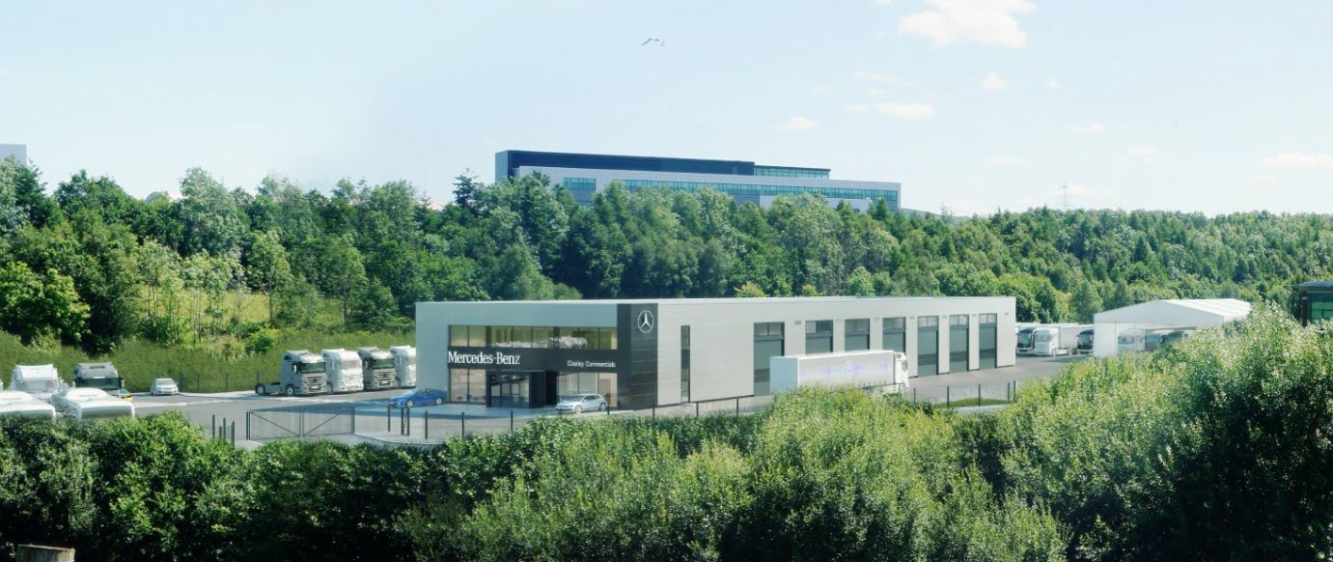

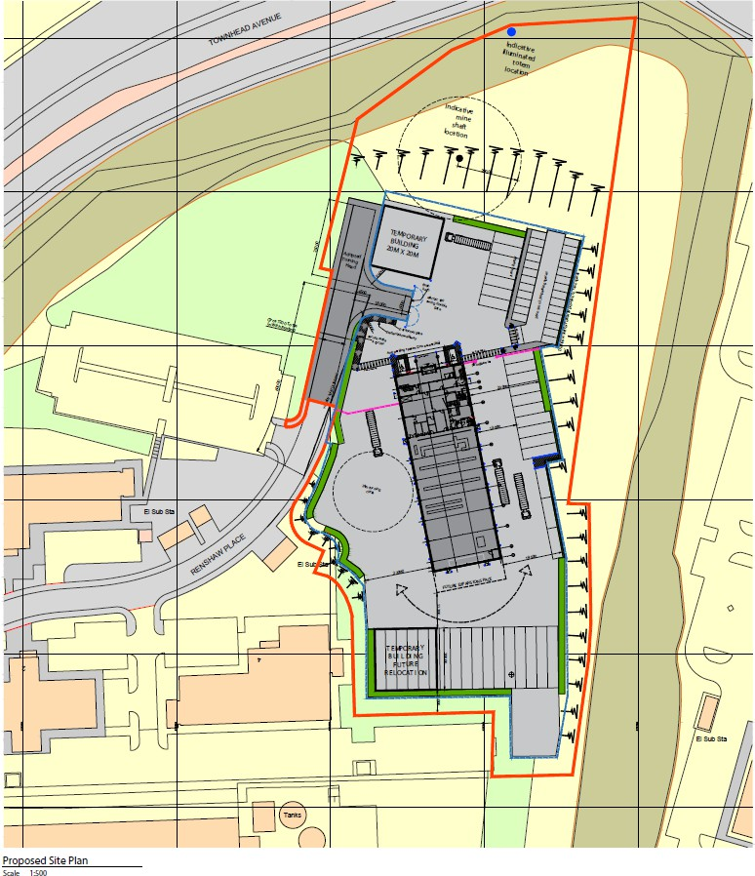
Artists impressions of proposed site at Eurocentral

Eurocentral Proposed Plan

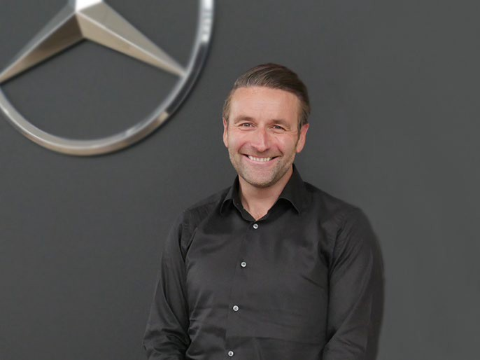

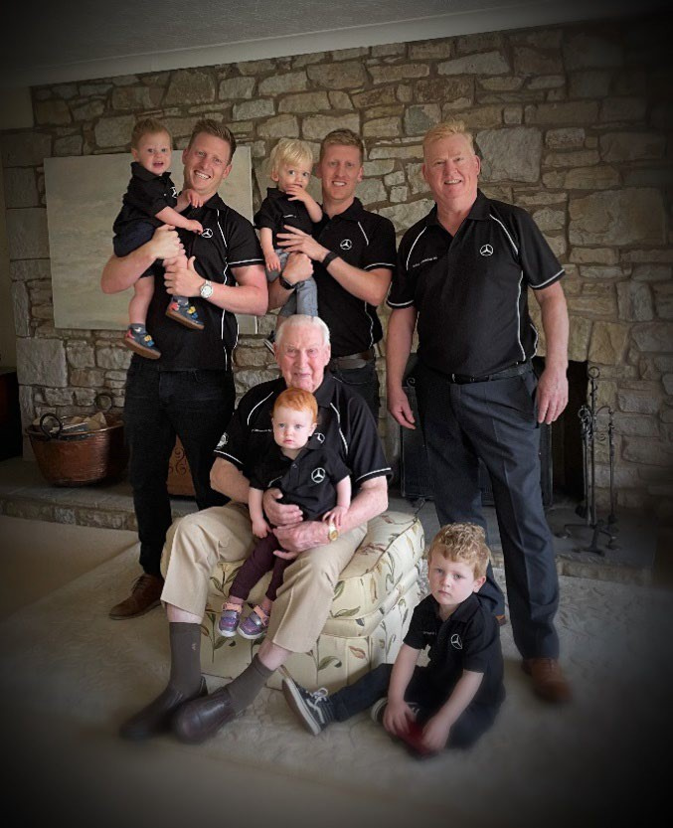
Four generations of the Morgan family, owners of Ciceley Commercials Ltd
Andy Heys, Dealer Principal, Ciceley Commercials Ltd

