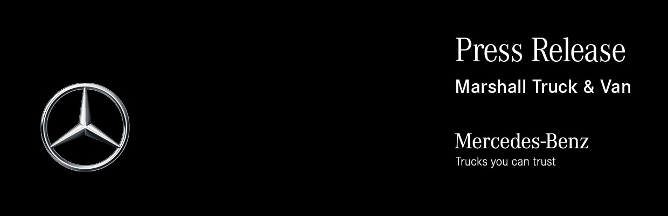

Date: 27 July 2022

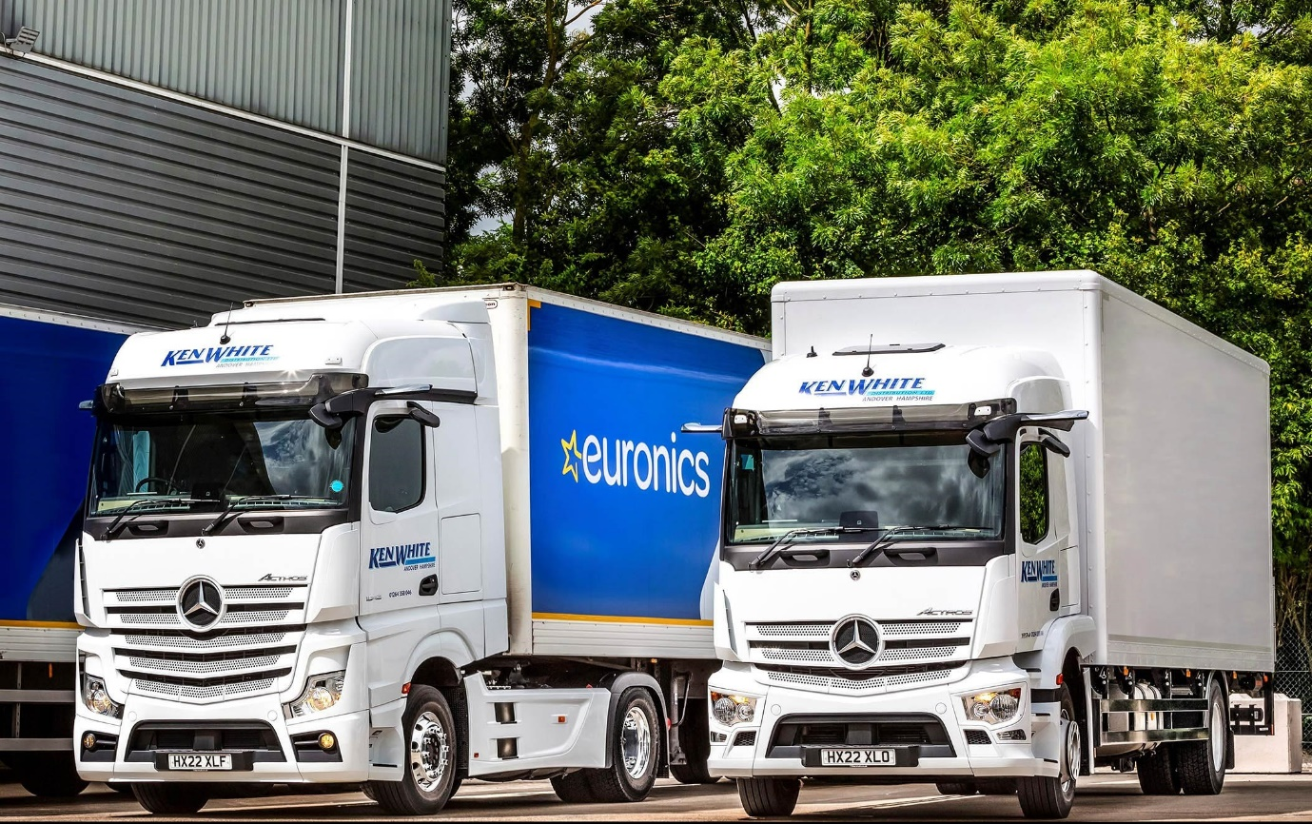

Electrical goods distributor takes another step on the road to a Mercedes-Benz ‘White-wash’

Just five years ago Ken White Distribution ran only Swedish-built trucks – today, all but three of its 26 vehicles wear the three-pointed star of Mercedes-Benz.

The Andover-based operator has gradually transformed the profile of its fleet by acquiring four or five new trucks each year from local Dealer Marshall Truck & Van.

It has just added another 4x2 Actros tractor unit and a pair of 18-tonners from the same model range, which have box bodies by Wessex Vehicle Services, of Salisbury.

As previously, Ken White Distribution secured competitive funding from Mercedes-Benz Finance and has signed-up to Complete Service Contracts. Its new Actros are now being inspected and serviced at Marshall Truck & Van’s Andover workshop, which has just undergone a £1-million refurbishment so the Dealer’s team is better able to support customers.

Established in 1980, Ken White Distribution offers general haulage services but specialises in the transportation of white goods and other electrical equipment nationwide. Euronics, an international association of independent electrical retailers, has been its leading customer for nearly 40 years – the operator is responsible for deliveries to stores and warehouses across the south of England, a contract that accounts for some 80% of its turnover.

Ken White Distribution’s success in retaining such a prestigious client for so long owes much to the vast experience and loyalty of its management team and pool of drivers. Founder Ken White has worked in the transport industry since he left school; now 69, he remains at the helm as Managing Director. Co-Director and Transport Manager Ian Reeve, meanwhile, joined the business in 1984.

Reflecting the light weight of many of the consignments it carries, all 12 of Ken White Distribution’s tractor units are 4x2 models and plated at 28 tonnes GCW. The latest, an Actros 1842 variant with flat-floored BigSpace cab, is powered by a 12.8-litre in-line six-cylinder engine producing 310 kW (421 hp).

With the exceptions of a pair of 7.5-tonners, all of Ken White Distribution’s rigid trucks are 18-tonners. Its new Actros 1824s have aerodynamic StreamSpace cabs and employ 175 kW (238 hp) 7.7-litre ‘straight-sixes’.

The image-conscious operator is committed to running trucks that look good as well as doing the job. Its Mercedes-Benz trucks are smartly finished with colour-coded grilles and bumpers, and sun visors, while the tractor units are additionally fitted with side skirts.

Like all of the Actros Ken White Distribution has purchased since late 2019, the most recent additions to its fleet came with a full complement of advanced technology. Highlights include MirrorCam, the manufacturer’s ground-breaking replacement for conventional mirrors; Active Brake Assist 5 with its industry-leading pedestrian recognition capability; and a revised version of the fuel-saving Predictive Powertrain Control system.

Mercedes-Benz Trucks’ radical Multimedia Cockpit features twin, tablet-style screens, one with ‘touch’ functionality, in place of traditional switchgear – Ken White Distribution specifies the upgraded interactive version which, in addition to a larger, 12in instrument panel, comes with extra functionality, including satellite navigation.

Completing the picture, the operator also relies on Daimler Fleetboard telematics, principally to map and track its vehicles.

Key to the company’s decision to switch to Mercedes-Benz, were the promises of industry-leading aftersales back-up it received from Marshall Truck & Van. The Dealer has been true to its word and delivered on all of these commitments.

“The maintenance contracts are very cost-effective and the service we receive from the team at Marshall Truck & Van’s Andover workshop is absolutely fantastic,” enthused Ian Reeve. “They’re very flexible and when an issue crops up, as one always will from time to time with even the best trucks, they can always be relied upon to resolve it quickly and efficiently.

“We still have our own workshop, but we entrust the maintenance of our Mercedes-Benz trucks to the Dealer because it makes our lives so much easier.”

Mr Reeve continued: “Our Mercedes-Benz trucks have proved impressively reliable, are good on fuel, and look great. We employ a number of long-serving drivers and I’ll admit there was a bit of resistance to the introduction of MirrorCam from some of them. But they were quickly won over when they started using the system and now, because the visibility is so much better, they all think it’s brilliant.”

He added: “Marshall’s Truck Sales Executive John Sunderland also provides a first-class service. We’ve known each other for a long time and John was very persistent in knocking our door for years before he finally secured that first, breakthrough order.

“Since then, of course, the relationship between our two companies has gone from strength-to-strength. We look forward, therefore, to replacing our last three Swedish tractor units with more Actros, and completing the process of moving to an all-Mercedes-Benz fleet.”

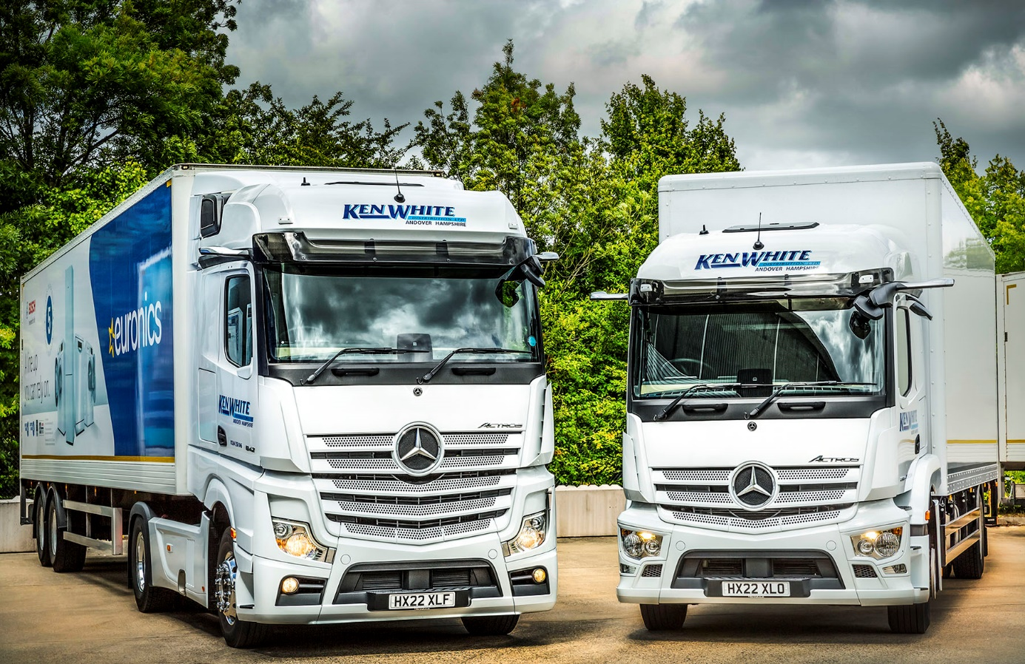

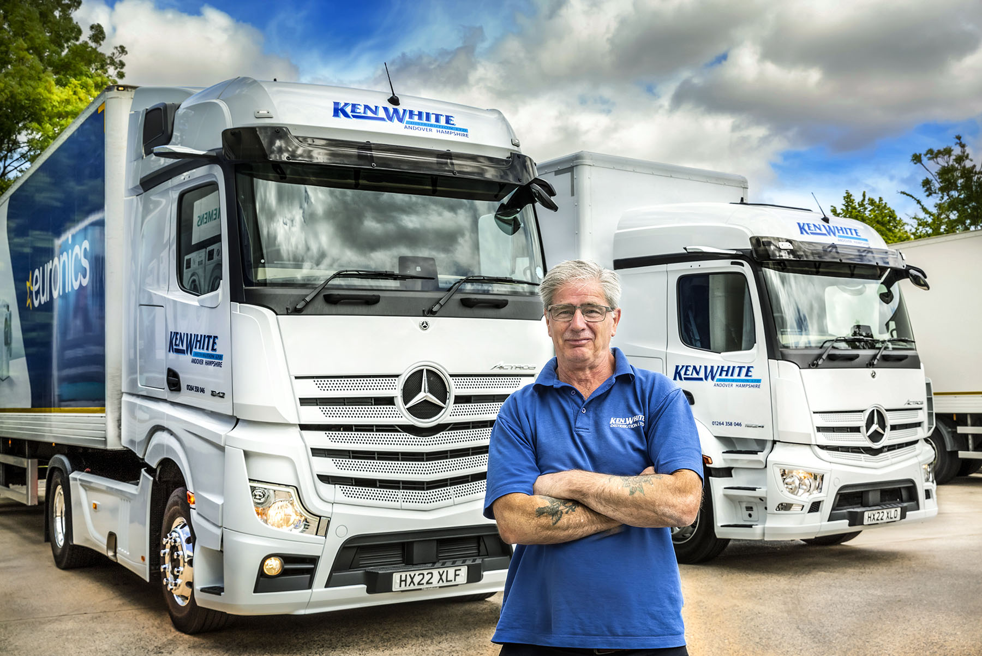

“Fantastic back-up”: That’s the verdict of Director and Transport Manager Ian Reeve on the customer-focused aftersales support that Ken White Distribution receives from Marshall Truck & Van

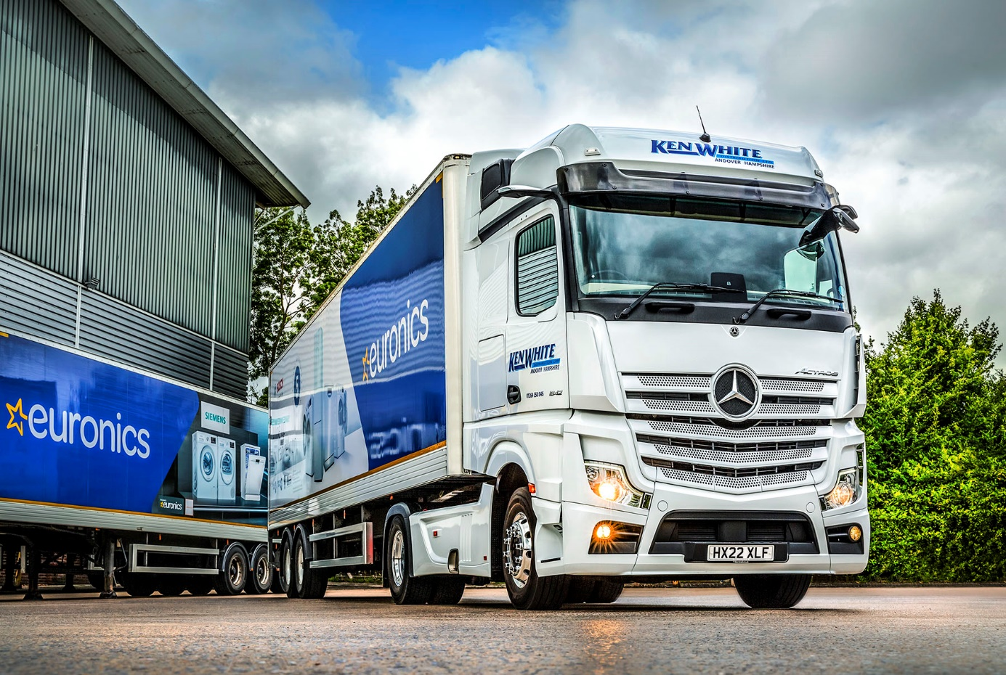

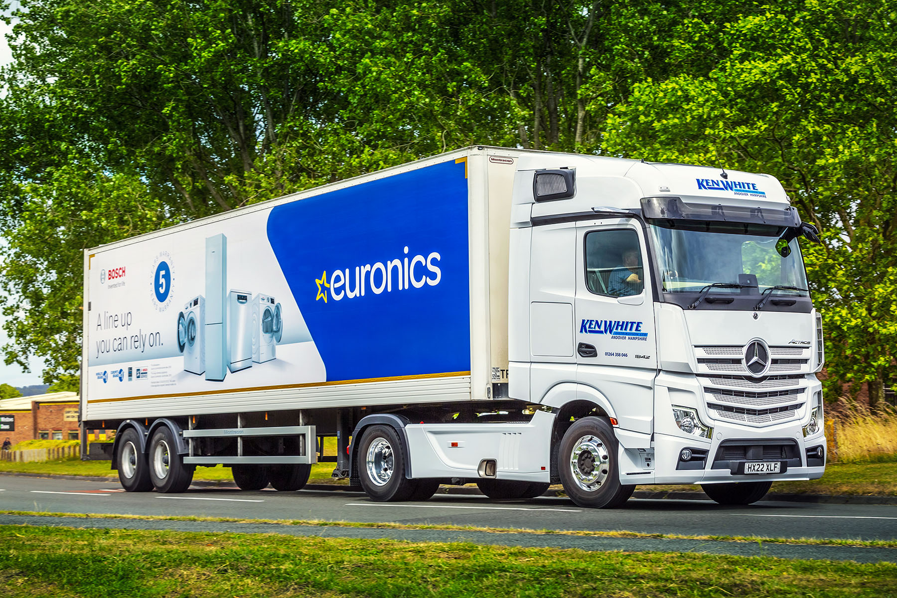

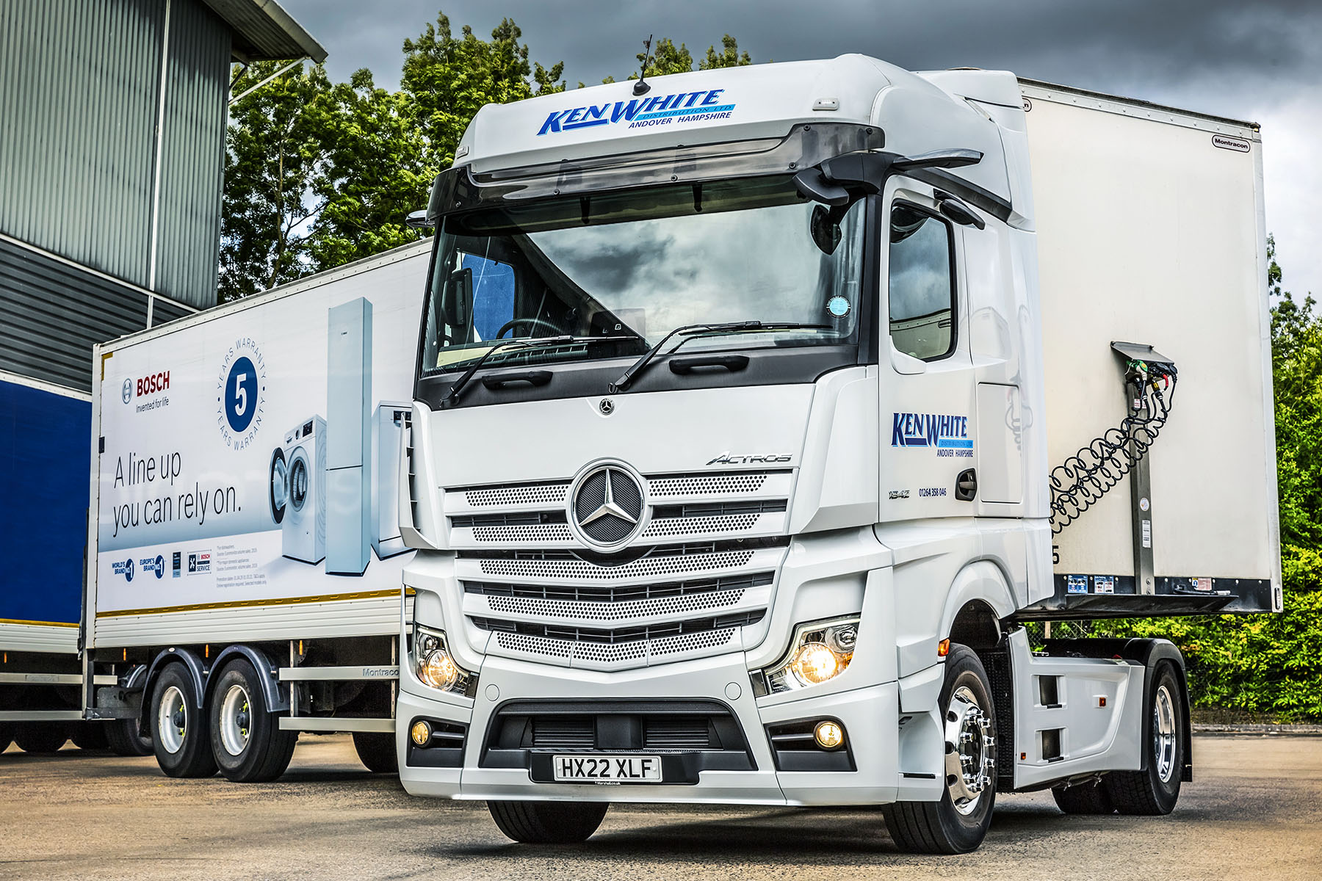

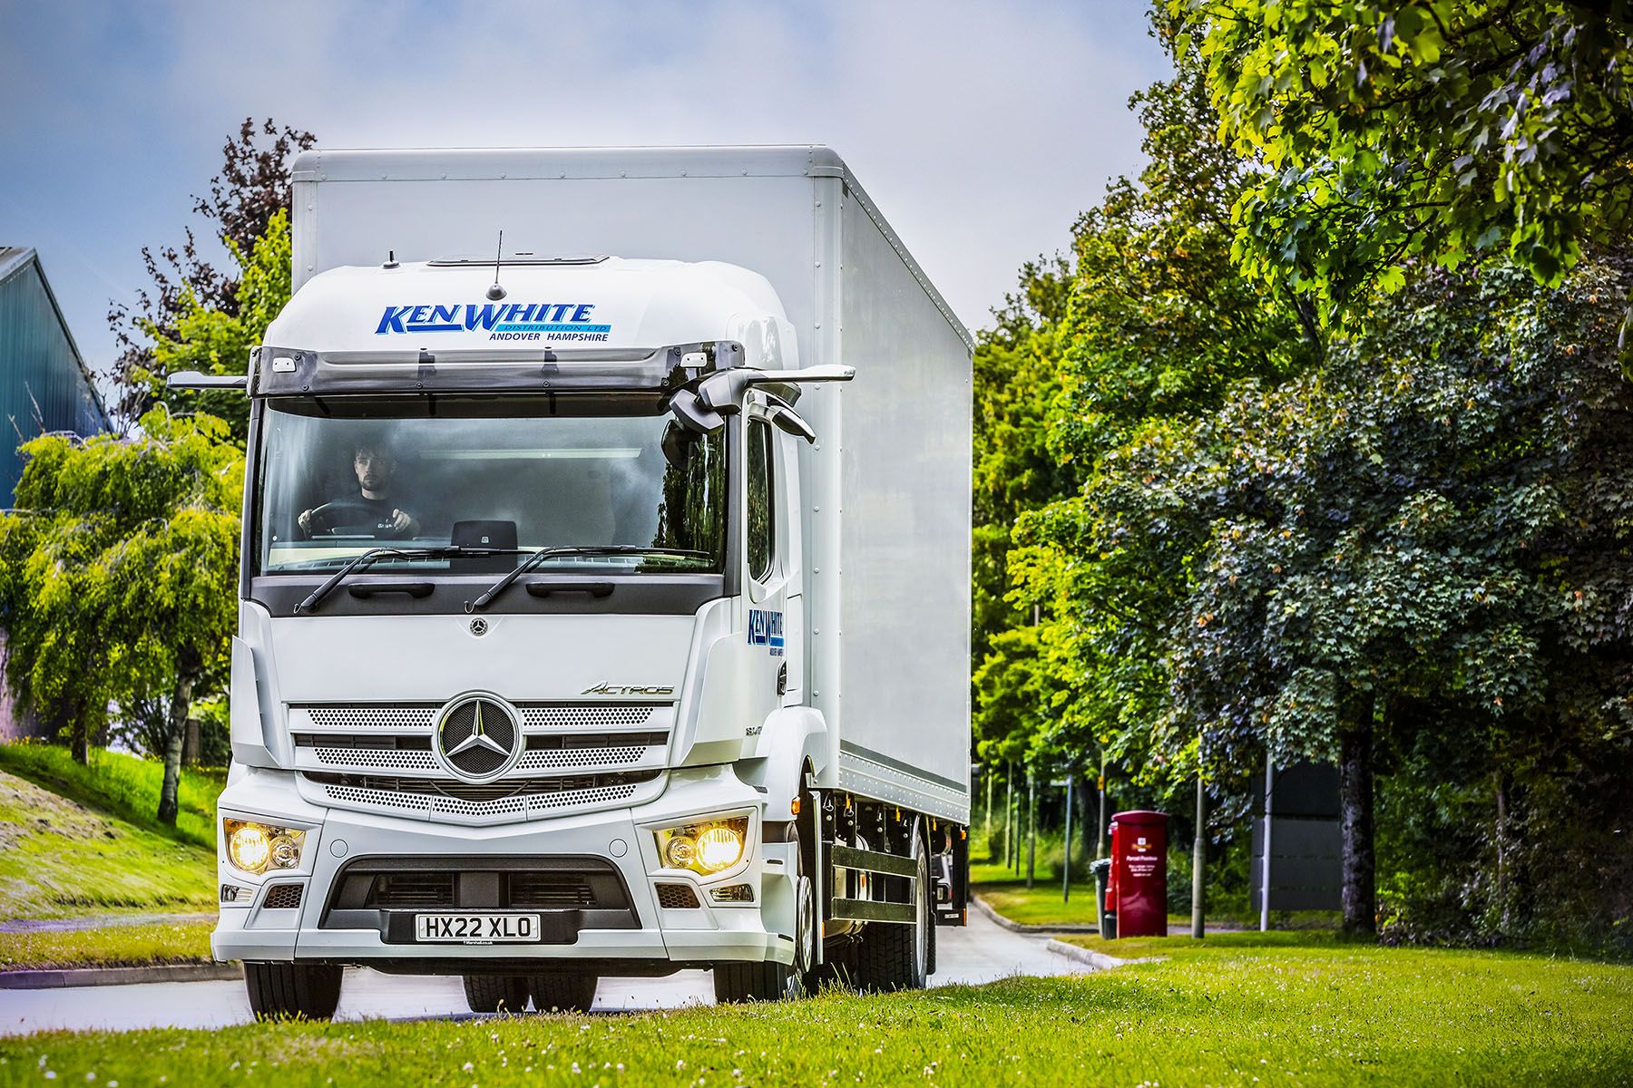

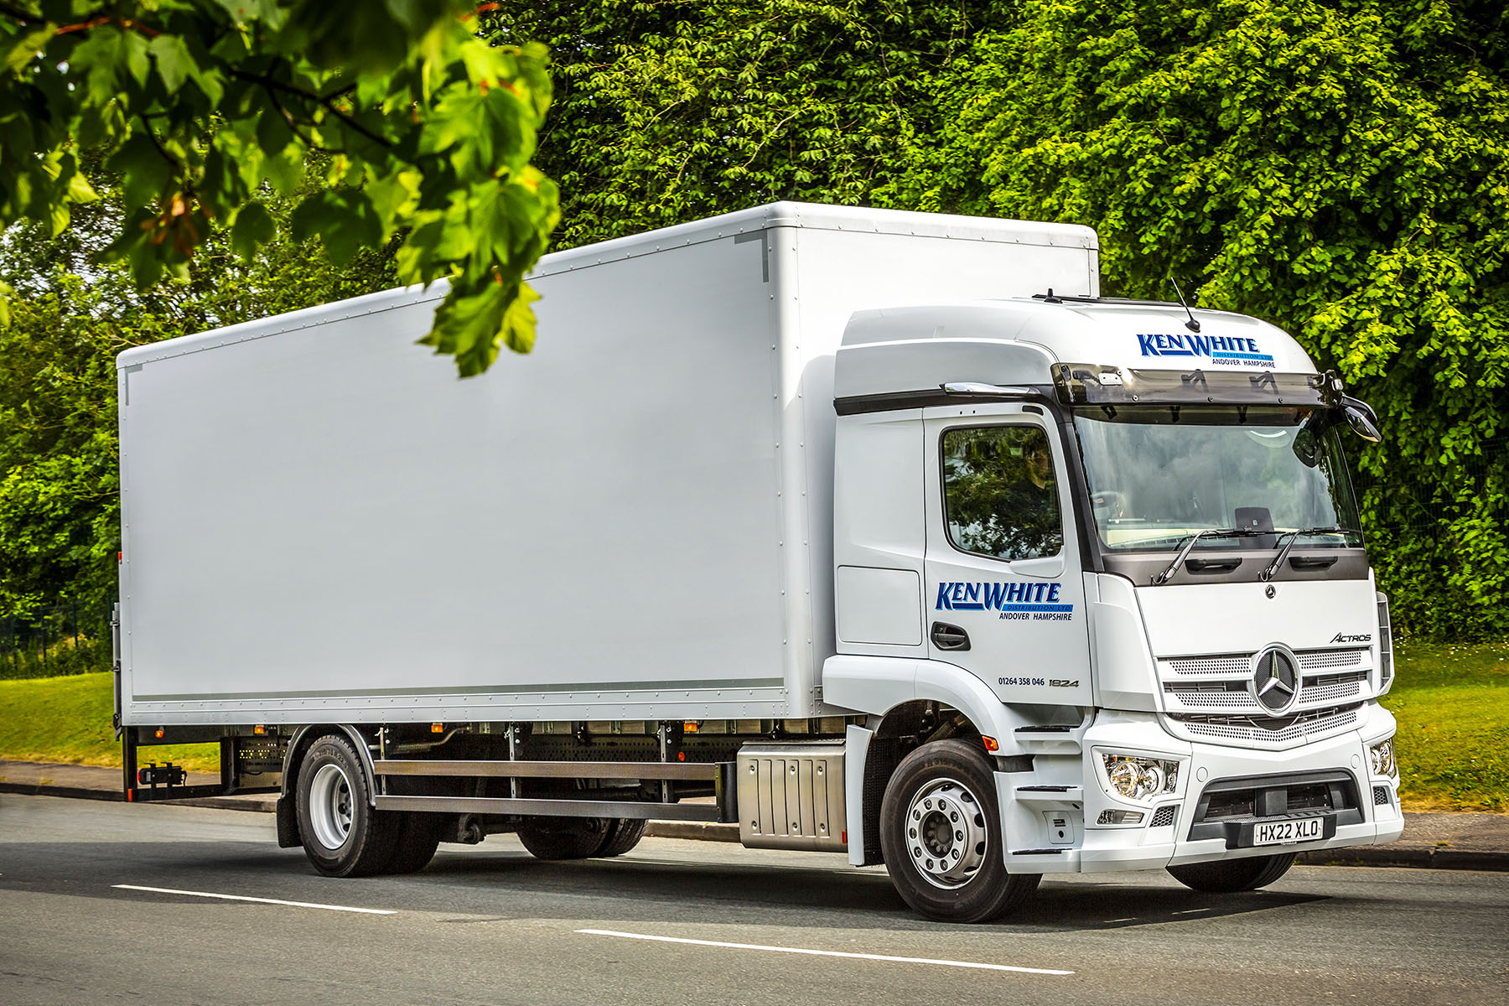

ends

For more information, or to request bigger/higher-res image files, please contact:
Steve Warren or John Ripley
Impact Communications
Steve: 07770 470251, steve@impactcom.co.uk
John: 07771 484595, john@impactcom.co.uk

