

Date: 8 December 2020

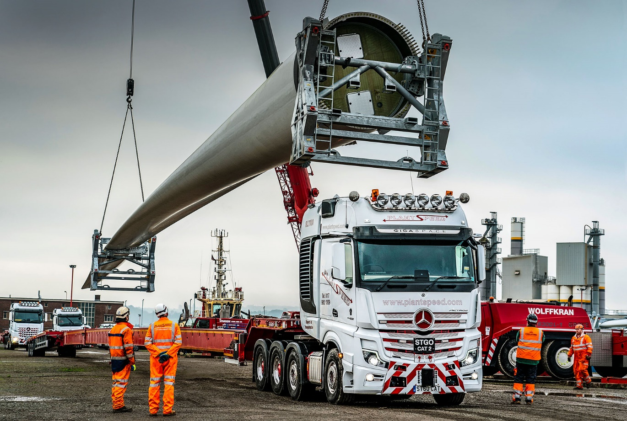

Plant Speed’s three Mercedes-Benz SLTs play the starring roles in a new ‘blade runner’ epic

Heavy haulage specialist Plant Speed deployed its trio of 250-tonne Mercedes-Benz SLT tractor units to transport what are believed to be the longest wind turbine blades ever moved by road in this country.

Leading the line was the Bristol-based operator’s latest flagship, an 8x4 Actros 4463 which arrived last month (November) via established partner City West Commercials. The UK’s first new-generation SLT model, it has a range-topping GigaSpace cab and is equipped with innovative MirrorCam technology, as well as conventional mirrors.

Also drafted in for the prestigious commission from a major European shipping and logistics concern were Plant Speed’s two Arocs eight-wheelers, both 4163 variants, while its Mercedes-Benz Sprinter vans performed escort duties.

The blades and their ‘spacer frames’ measured 68.252 metres in length and weighed around 24 tonnes each. Unloaded from the vessel at Avonmouth Dock, they were then secured for transportation on Plant Speed’s purpose-designed, Nooteboom extendable Super Wing Carrier trailers.

The 24-mile journey to Magor, on the opposite, Monmouthshire bank of the Severn Estuary, took in stretches of the M5 and M4 – including the Prince of Wales Bridge – and was completed without incident in just an hour and 20 minutes.

“Good planning is key to a move of this nature,” revealed Plant Speed Managing Director Paul Lomas. “We’d undertaken a ‘dry run’ and worked through every aspect of the operation in fine detail beforehand, so that on the day it all ran like clockwork.”

Established by Mr Lomas in 2003, Plant Speed is already highly experienced in the transportation of blades and other turbine components, and looking forward to further expansion of the sector heralded by Prime Minister Boris Johnson’s recent announcement that by 2030 wind energy will generate enough electricity to power every home.

The company runs a fleet of 16 trucks which is dominated by the three-pointed star. In addition to the three SLTs, the line-up includes a pair of double-drive Arocs tractor units plated for operation at 180 and 120 tonnes GCW respectively, five 68-tonne Actros tractors with 6x2 tag axle configurations and an 8x2 drawbar rigid with crane.

All were supplied by City West Commercials, whose Avonmouth headquarters is less than five miles from its customer’s base in Hallen. Plant Speed maintains its fleet in-house but relies on the dedicated Mercedes-Benz Trucks Dealer for the South West for warranty and technical support, and parts deliveries. “We have a great relationship with City West Commercials, which understands our business and what we need,” reported Mr Lomas.

The latest SLT has replaced Plant Speed’s first 250-tonne truck, an Actros Titan which had been on the road since early 2013. Like its two Arocs stablemates, the new Actros is powered by a top-rated, 15.6-litre in-line six-cylinder engine that produces 460 kW (625 hp).

While the Arocs are steel sprung, with the exception of its front axle the Actros rides on air. Mr Lomas said air suspension offered increased flexibility and finer control when picking up and dropping heavily laden trailers, and a weighing system that confirmed the loads over the second and two drive axles. “It just adds another level of safety,” he observed.

Ultimately, however, Plant Speed’s latest purchasing decision owed every bit as much to aesthetics, as it did to functional capability. “Our Arocs SLTs are muscular and purposeful in appearance, and continue to perform exceptionally well,” said Mr Lomas. “I really wanted an Actros on this occasion, though, as it’s such a fantastic looking truck.”

Mercedes-Benz Trucks’ ground-breaking MirrorCam system has won enthusiastic reviews from operators whose vehicles are engaged in more mainstream transport applications. Designed to replace conventional mirrors, the cameras relay images to screens mounted inside the cab, on the A-pillars, and offer much-enhanced rear-facing visibility.

Although Plant Speed’s new Actros is also fitted with standard mirrors, Paul Lomas is impressed. “I believe strongly in adopting new technology at an early stage,” he said. “The benefits that MirrorCam offers in low light situations and in wet weather when the cameras and screens are unaffected by rain, are very obvious.

“However, we’ve also fitted mirrors on the advice of Mercedes-Benz because, as it’s currently configured, MirrorCam cannot clearly see the ends of our exceptionally long trailers. It’s obvious to me that camera-based systems will become the norm in the future, and I’ve no doubt that with further development the manufacturer will overcome this issue.

“For the time being, its combination of MirrorCam and mirrors means our Actros SLT gives us the ‘best of both worlds’.”

When specifying his latest truck Mr Lomas drew not only on his own knowledge and experience, but also – as he has done over many years – that of trusted City West Commercials’ Truck Sales Manager Simon Johnson-Taylor. Beautifully finished, and sporting a roof-mounted light bar and airhorns, the Actros boasts an exhaustive list of optional equipment.

Mercedes-Benz SLT chassis are exceptionally robust, and provide the ideal mount for heavy duty front and rear coupling points. They are also instantly recognisable, due not only to their fourth axles (where fitted), but also to the large side panels at the rear of the cab. These direct airflow for enhanced cooling of the clutch via a radiator mounted in the tower behind the cab. This tower also houses various ancillaries such as the air and fuel tanks, and batteries.

Mr Lomas is an enthusiastic proponent of the SLT’s Turbo Retarder Clutch, which works in conjunction with the 16-speed Mercedes PowerShift 3 automated manual transmission, in place of the traditional manual gearbox and torque converter clutch set-up.
Designed to be wear-free and fuel-efficient, the Turbo Clutch is capable of handling and delivering some 3,000Nm of torque, significantly more than a torque converter. It also incorporates its own, powerful integrated retarder; without this, a separate retarder would be necessary to assist the high-performance engine brake in bringing a fully loaded 250-tonne rig safely to a halt.

www.plantspeed.com

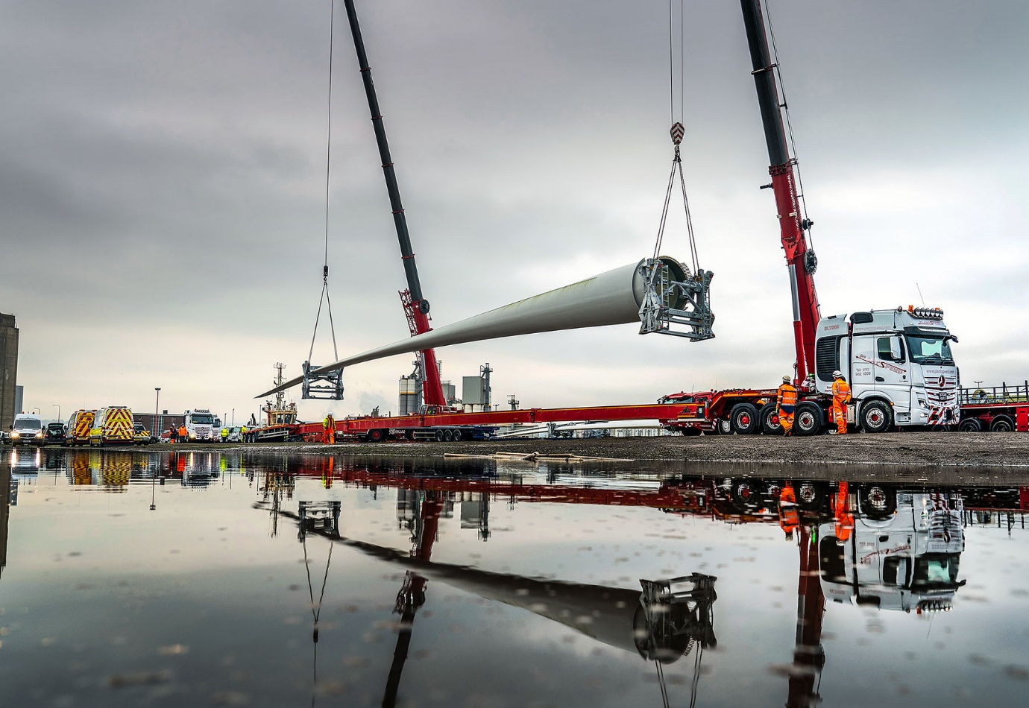

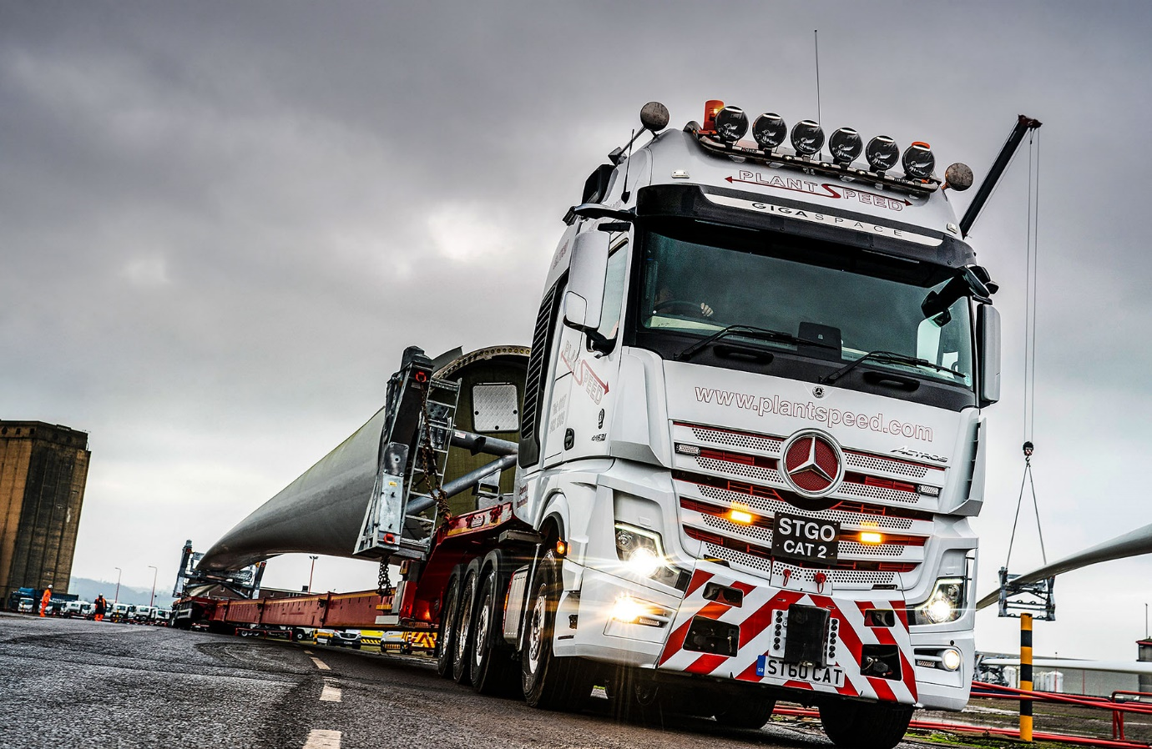

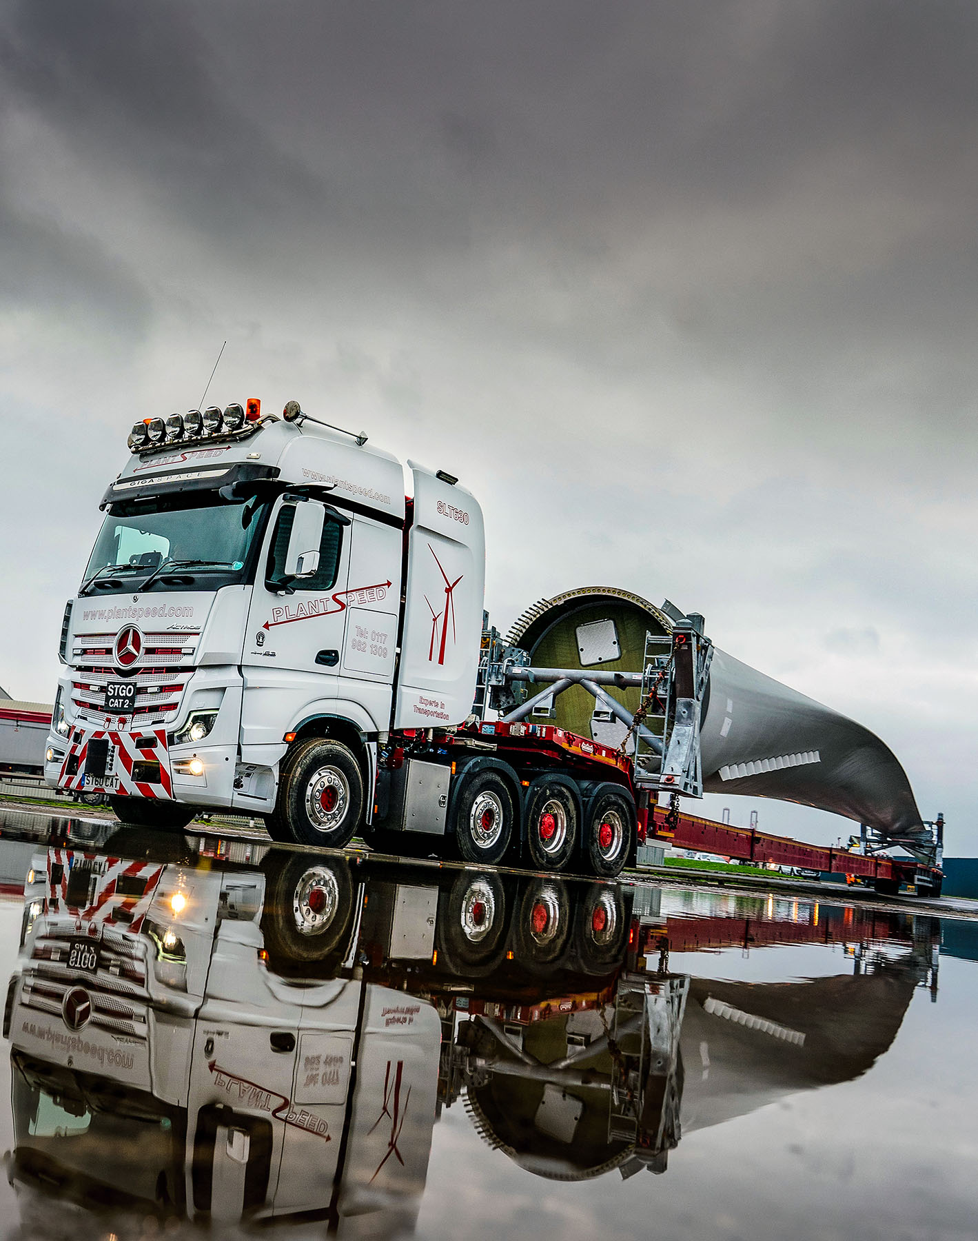

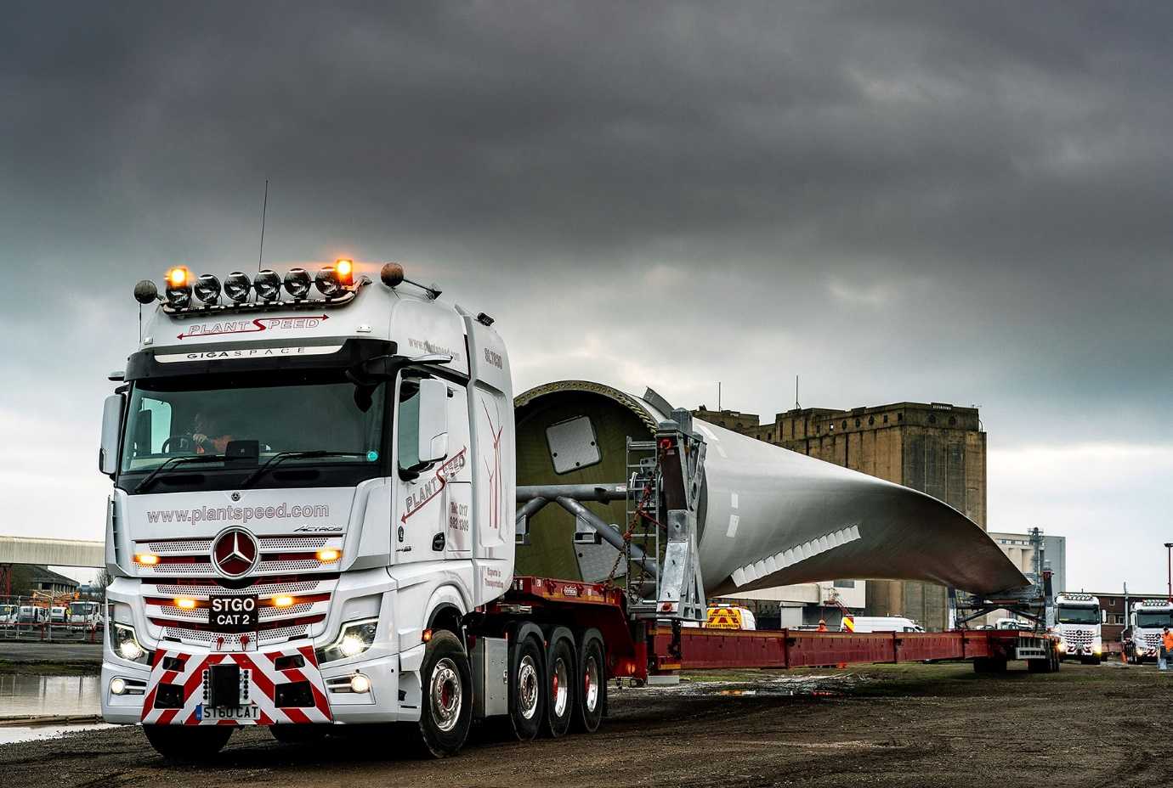

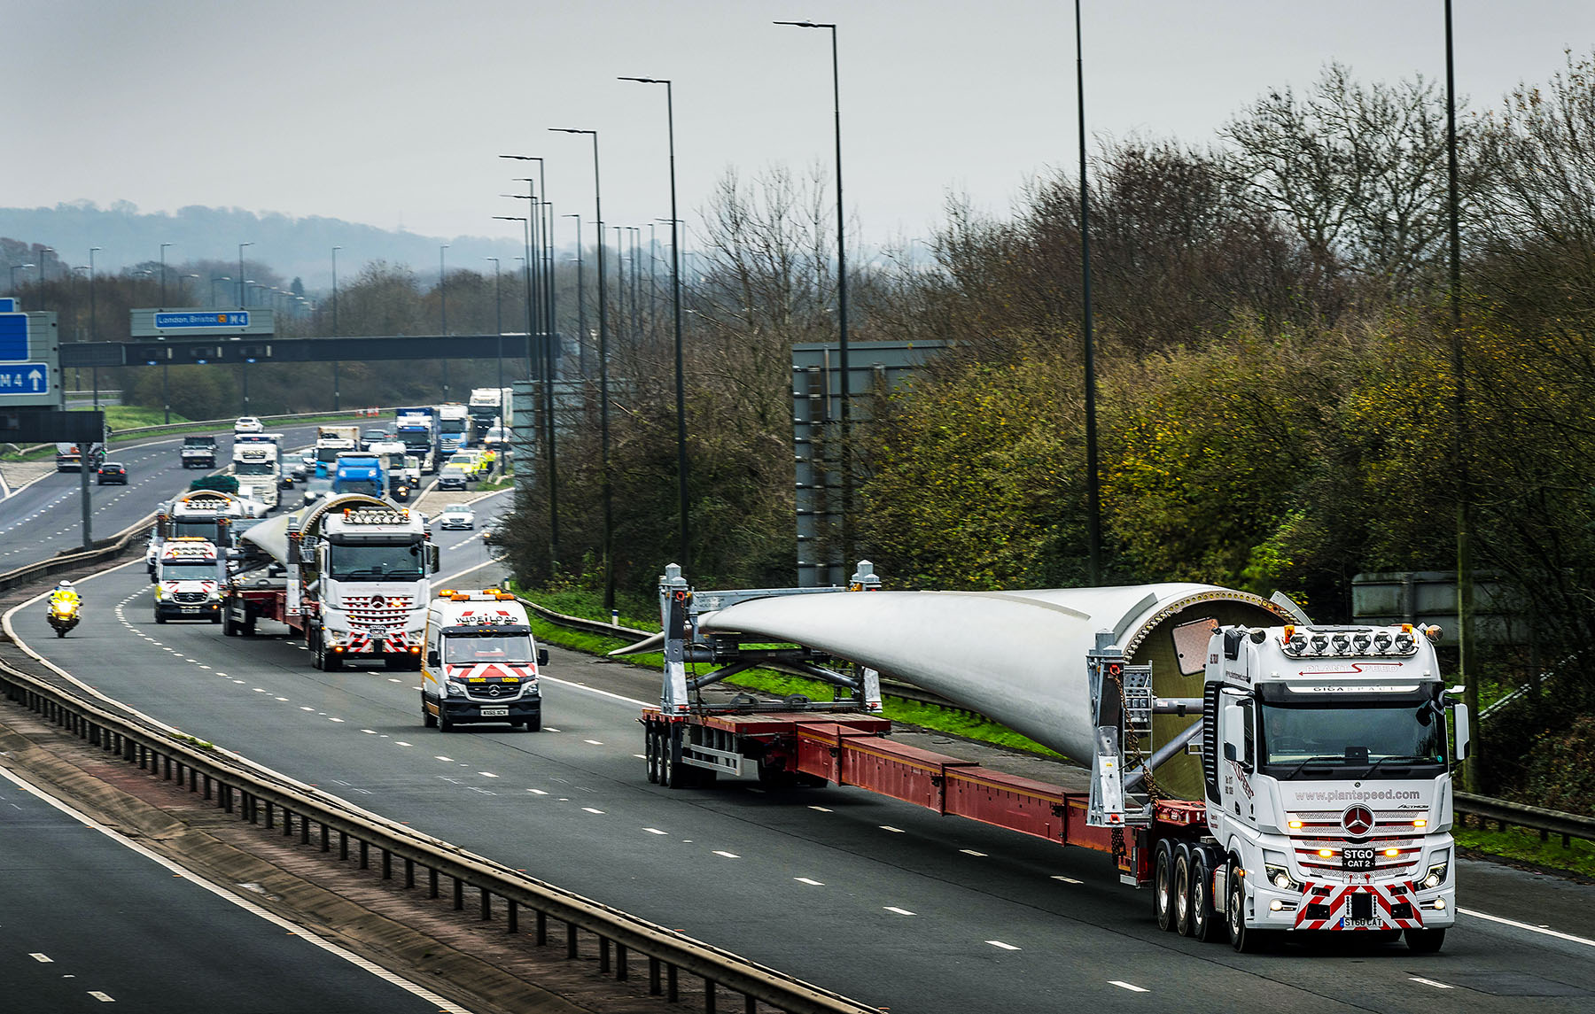

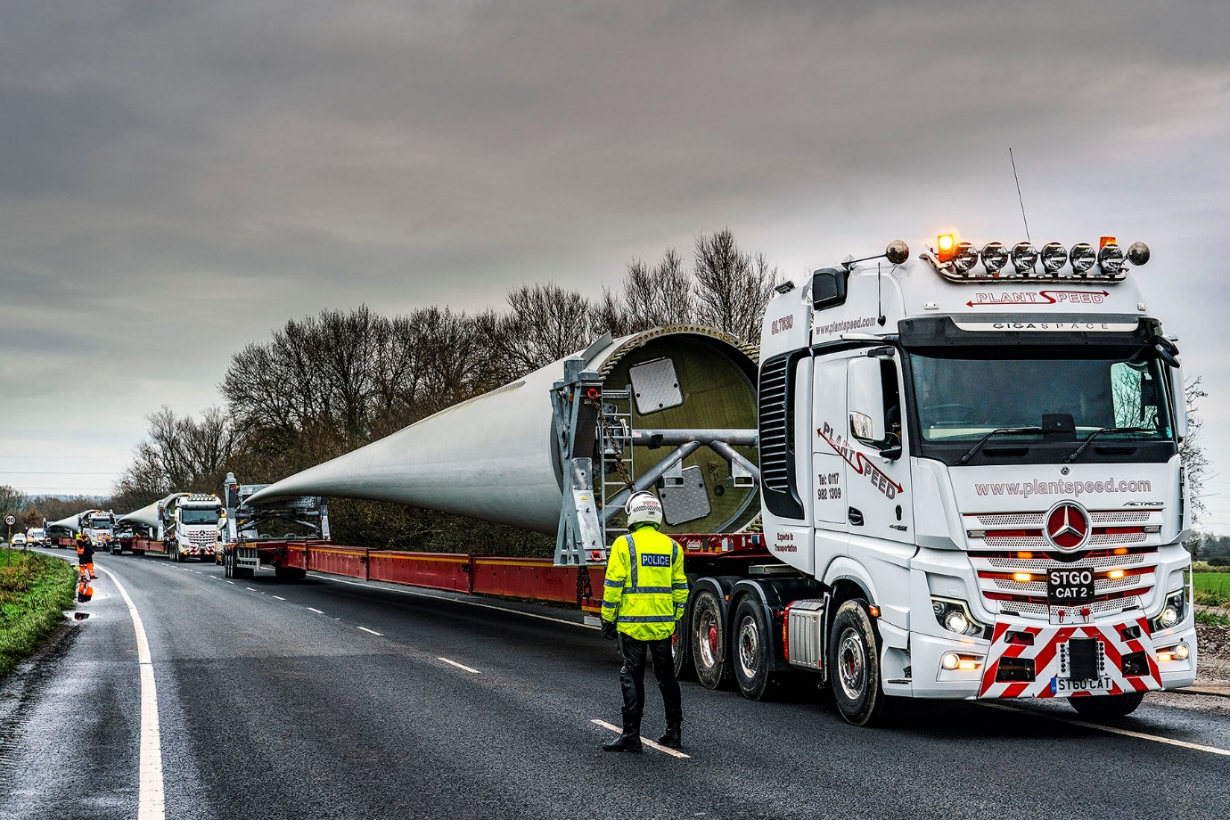

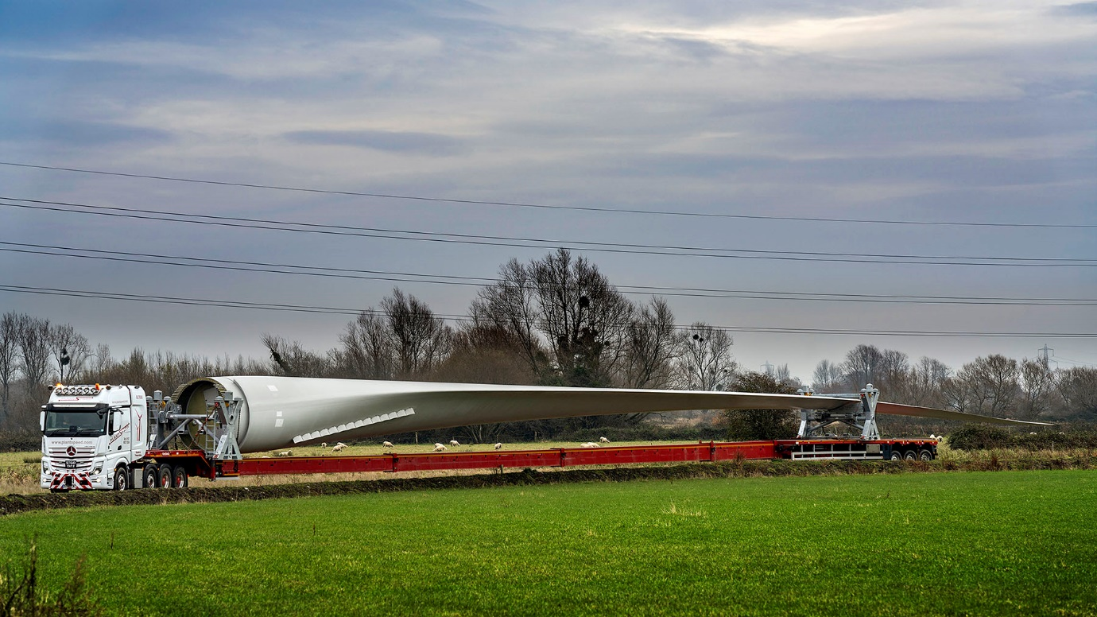

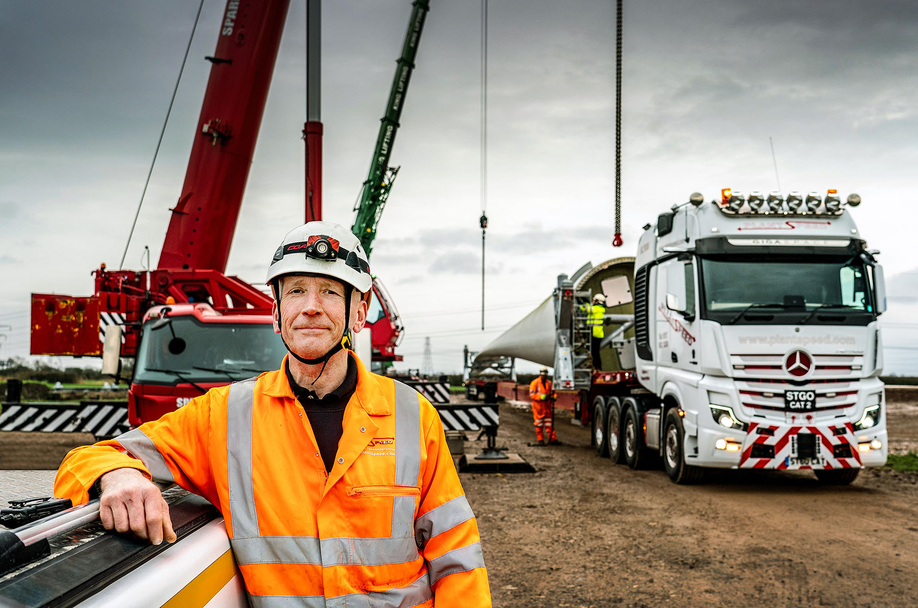

Mission accomplished: Plant Speed’s Paul Lomas is pictured at the delivery site in Magor, with his company’s new Mercedes-Benz Actros SLT

ends

For more information, or to request higher-res image files, please contact:

Jamie Fretwell at Mercedes-Benz Trucks UK Ltd
07712 519230, jamie.fretwell@daimler.com

or

Steve Warren or John Ripley
Impact Communications, 01926 842126
Steve: 07770 470251, steve@impactcom.co.uk
John: 07771 484595, john@impactcom.co.uk

About Mercedes-Benz Trucks UK Ltd
Mercedes-Benz Trucks UK Ltd is the sales and marketing organisation responsible for all Daimler truck products in the UK, including FUSO Canter. In 2019, the company registered 6,963 new trucks. Mercedes-Benz accounted for 6,188 new trucks registered in 2019, making it the third-biggest truck brand in the UK. Meanwhile, FUSO registrations hit 775 – including 580 new trucks over 6.0-tonnes. The flagship new Mercedes-Benz Actros which won the 2020 International Truck of the Year award, features seven core innovations including MirrorCam, Multimedia Cockpit and Active Brake Assist 5. Our premium range of innovative trucks – Actros, Arocs, Atego, Econic and Unimog – draw upon more than 125 years of exceptionally high standards of quality, backed up by our promise of Trucks You Can Trust.
www.mbtrucks.co.uk

