

Date: 16 September 2019

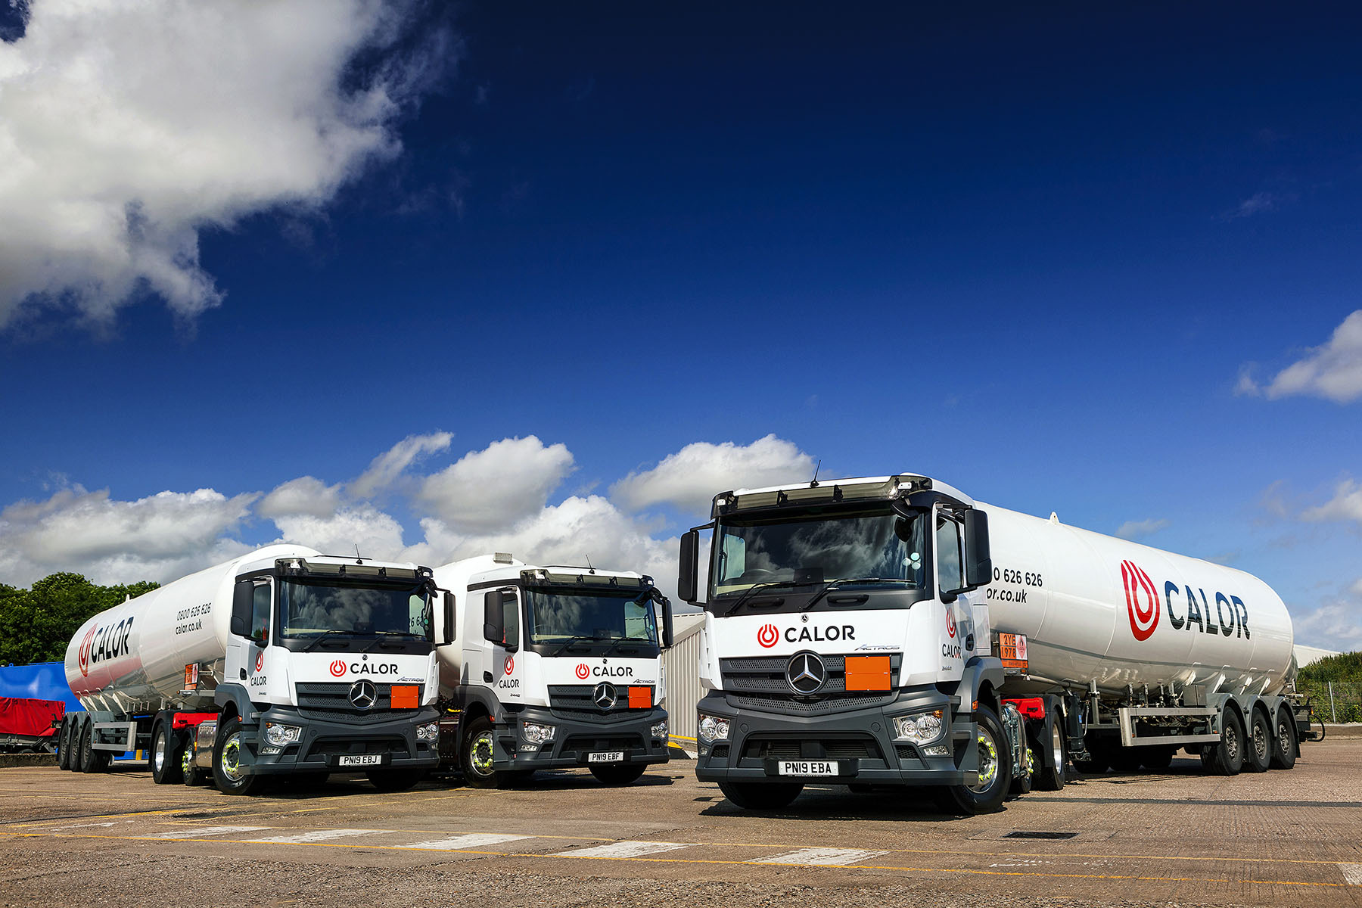

Gas leader Calor embraces a ‘new flame’ by ordering 30 Mercedes-Benz trucks

Calor’s continual determination to improve safety while maximising efficiency has prompted it to add Mercedes-Benz trucks to its established fleet – the high-profile gas supplier’s first 20 vehicles to wear three-pointed stars are now operating from its depot in Immingham.

Dealer Ciceley Commercials will shortly deliver another 10 trucks, all Antos 26-tonners with bodies by Lakeland Tankers, of Stourbridge. These will be based across nine of Calor’s national network of sites.
Safety is at the core of the Calor business and it was essential that any new vehicles in the fleet reflected this operational focus. The new Calor units, like all roadgoing Actros tractors, are equipped with Mercedes-Benz Safety Packs. In addition to the Active Brake Assist 4 emergency braking system – which incorporates pedestrian recognition technology – these include Proximity Control Assist and a driver’s airbag.

Calor’s National Vehicle Engineering Manager Alan Harrison and senior colleagues were treated to a demonstration at Mercedes-Benz Trucks’ Wentworth Park Customer Experience Centre, near Barnsley, of Active Brake Assist 4’s ability to prevent or minimise the effects of accidents,.

“Seeing the system in action, and the speed with which it can bring a truck safely to a halt with no driver input, was a real eye-opener,” said Mr Harrison. “Safety was a crucial consideration when we sat down to evaluate the bids we’d received, and its leadership in the field was instrumental in enabling Mercedes-Benz to win our business.”

Active Brake Assist 4 employs multi-mode radar to monitor moving and stationary objects in front of the vehicle, and sounds an audible warning when it senses potential for a collision. If the driver takes no action it will apply staged braking followed by full braking power to prevent a crash, or dramatically reduce the effects of an impact. The system is looking for moving pedestrians from a standstill, even one stepping into the truck’s path from behind a parked car.

Mr Harrison said that despite being more highly specified in terms of safety equipment, the Actros were also lighter than the Euro V tractor units they were replacing.

Calor’s new tractors are 2446 models with small-wheeled (17.5in) mid-lift axles which offer a weight saving of approximately 300kg compared to the standard version with 22.5in wheels, while also freeing up valuable space on the chassis.

By also specifying 2.3m-wide ClassicSpace cabs, the narrower of the two widths available, and alloy wheels, Calor was able to hit one of its prime targets – that the new trucks should be no heavier than their five-year-old predecessors.

“In fact,” said Mr Harrison, “the Actros are 300 kg lighter! Given that the trend in recent years has been for trucks to become gradually heavier as they are loaded with more technology, this is a very impressive figure, and one that will translate into a welcome increase in payload potential.”

The Actros are now working with tank trailers, hauling bulk loads of liquid petroleum gas to filling plants around the UK. The Antos 2535s, meanwhile, will join a fleet of close to 200 rigid tankers which deliver LPG – including an increasing proportion of BioLPG, a low-carbon renewable alternative – to domestic and commercial customers.

Calor will continue to enhance its delivery fleet to improve safety and efficiency, and employ the latest technology, such as BioLPS, LNG and electrification where practical and where regulations allow, to drive down emissions.

Calor took advantage of Mercedes-Benz Finance funding, and five-year ExtendPlus warranties. “Price will always be a major factor, of course,” continued Mr Harrison. “Whether the projected long-term running costs can be achieved remains to be seen.”

Calor’s Immingham Site Manager Andy Allan said the Actros had been well received by their drivers. “They’re enthusiastic about the truck’s pulling power and its very comfortable cab, while the fuel-saving Predictive Powertrain Control is exceptionally user-friendly,” he said.

Recalling the product presentation day at Wentworth Park, Alan Harrison added: “We were very well hosted by Mercedes-Benz Trucks Key Account Manager Brent Manning and Ciceley Commercials Fleet Sales Executive Guy Beech, who put together a package that ticked all our boxes.

“They have gone far above and beyond simply supplying the vehicles. The day was extremely useful, and our driver-trainers have since attended further sessions at Wentworth Park, to familiarise themselves fully with all of the safety and fuel-saving technology fitted to our new trucks. We’re fully confident that we’ve made the right decision and are now looking forward to building an ongoing relationship with Mercedes-Benz Trucks.”

www.calor.co.uk

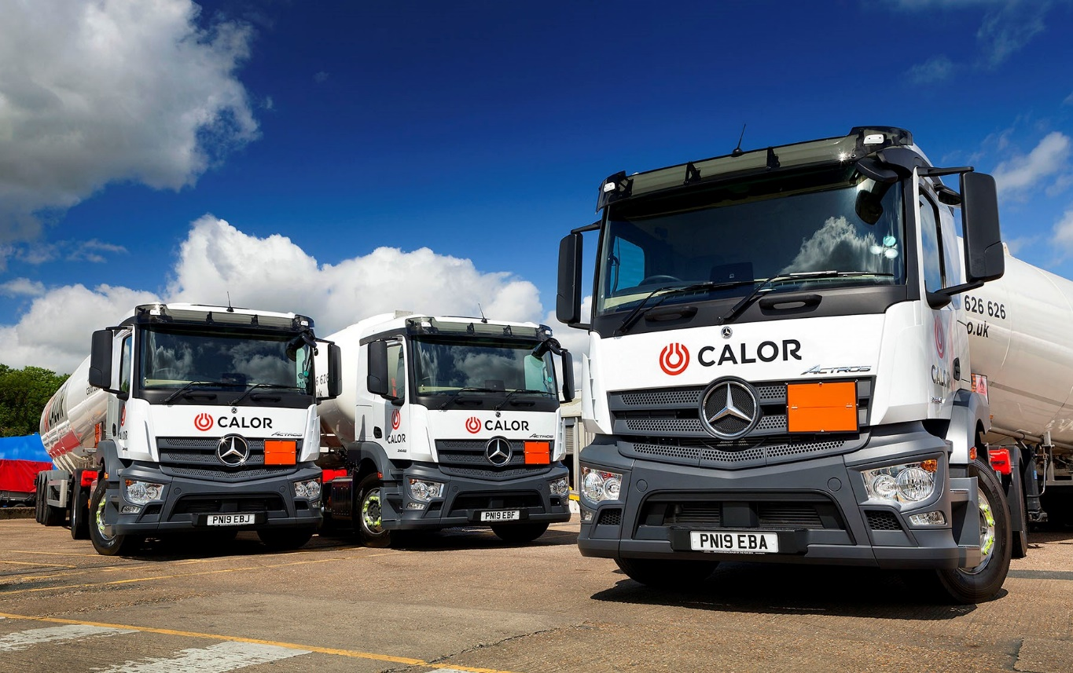

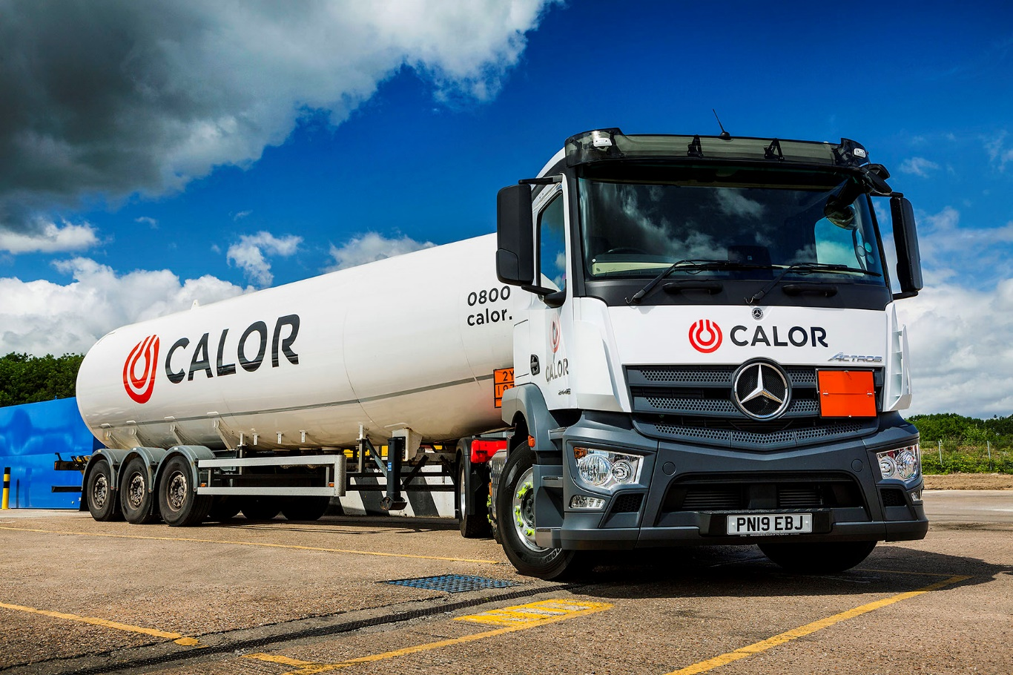

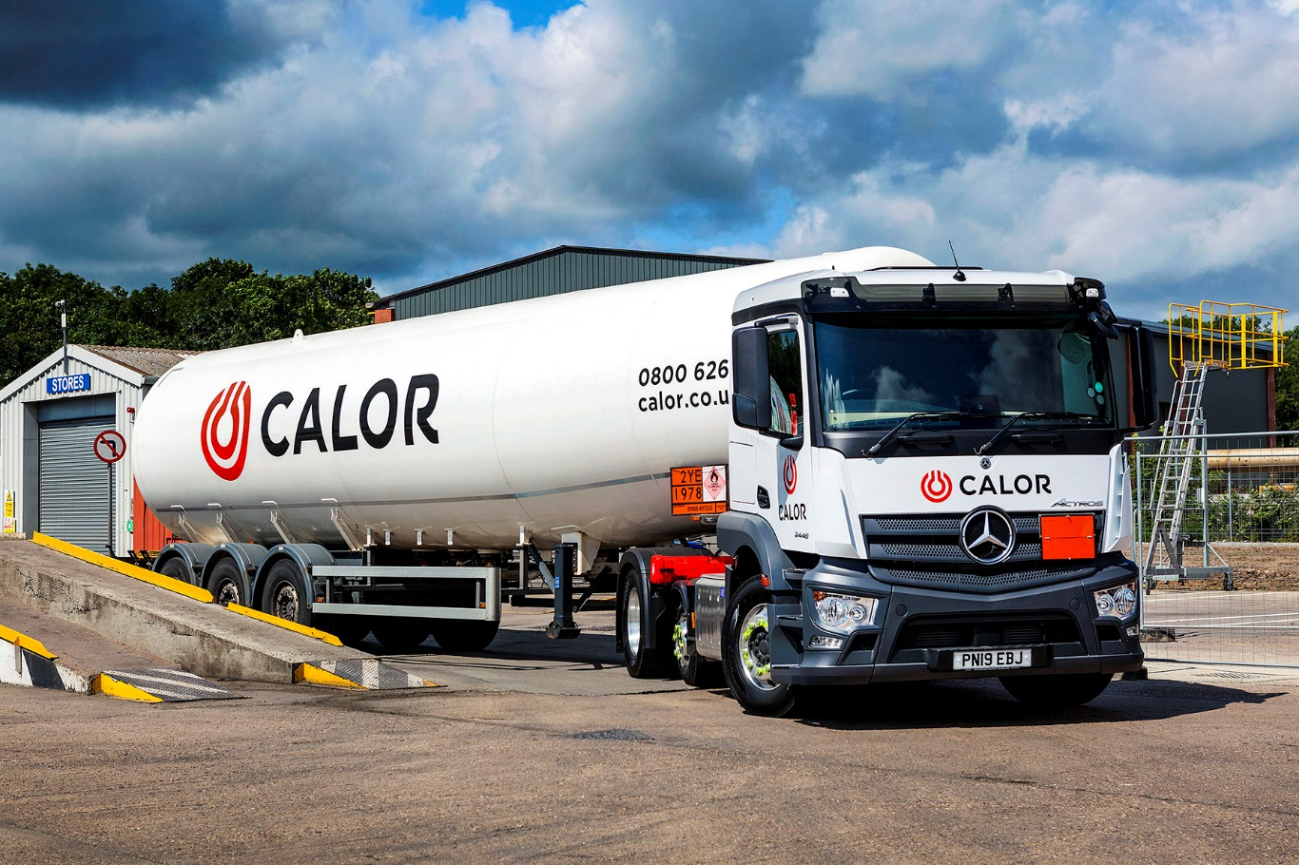
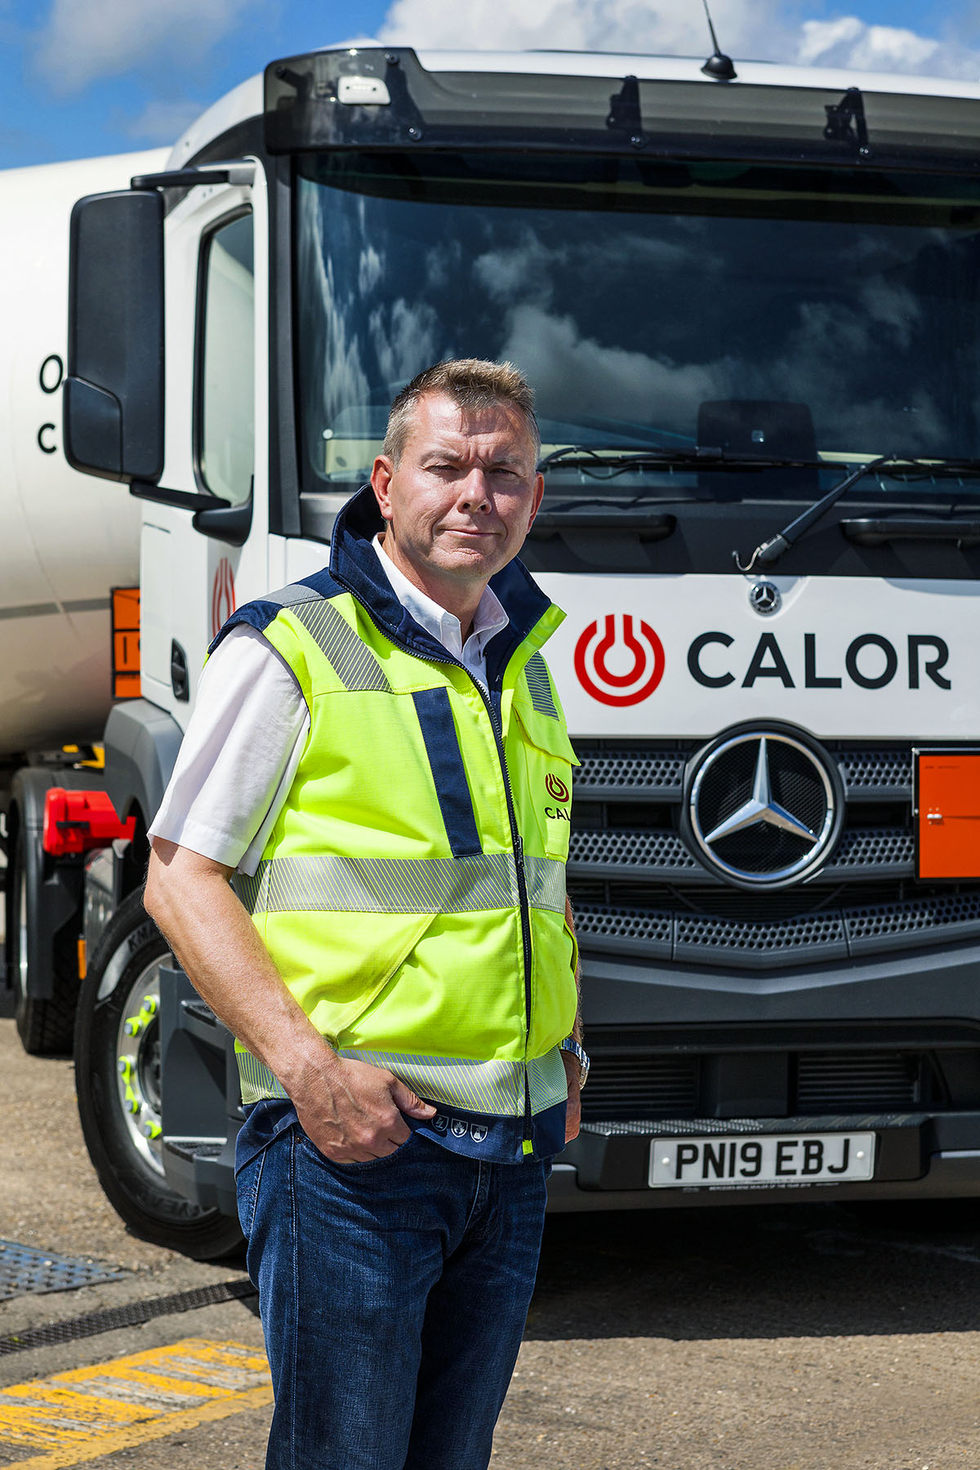

Impressed: Andy Allan of Calor says his drivers are delighted with their new Actros

ends

For hi-res image files, please visit:
media.mbtrucks.co.uk

For further information, please contact:
Jamie Fretwell, PR & Internal Communications
Mercedes-Benz Trucks
07712 519230, Jamie.Fretwell@daimler.com
or

John Ripley or Steve Warren
Impact Communications, 01926 842126
John: 07771 484595, john@impactcom.co.uk
Steve: 07770 470251, steve@impactcom.co.uk

About Mercedes-Benz Trucks UK Ltd

Mercedes-Benz Trucks UK Ltd is the sales and marketing organisation responsible for all Mercedes-Benz truck products in the UK, including FUSO Canter.

In 2018, the company registered 8,061 new trucks. After growth in 2017, Mercedes-Benz registrations levelled off to 7,223 trucks in 2018, ensuring it retained its title as the second-biggest truck brand in the UK. Meanwhile, FUSO made great strides to reach 838 registrations – including 675 new trucks over 6.0-tonnes.

For more than 125 years, Mercedes-Benz has stood for innovative vehicles that meet exceptionally high standards of quality. Our claim to perfection, sustainability and avant-garde design is now embodied in the next generation of trucks: Actros, Arocs, Atego, Econic and Unimog.

www.mbtrucks.co.uk

