

Date: 17 September 2020

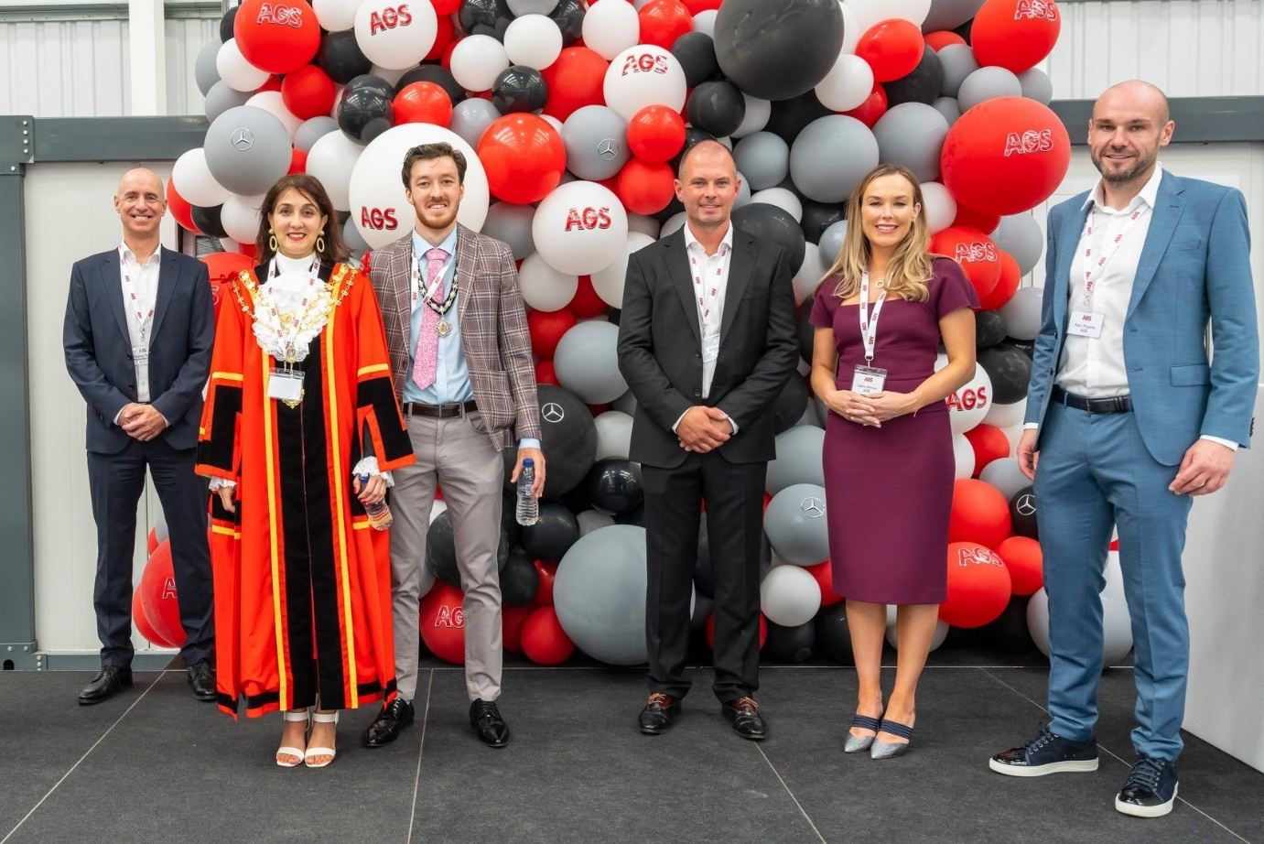

Take-off: Mayor of Hillingdon Councillor Teji Barnes is pictured with, from left,
Mercedes-Benz Trucks Managing Director Wolfgang Theissen; Cameron Bell, the Mayor’s Escort; and AGS proprietors Richard and Laura Holmes, and Paul Mcgerty

It’s ‘up, up and away’ as AGS opens its £6-million Heathrow workshop for Mercedes-Benz Trucks

Leading fleet operators whose commercial vehicles work in and around London Heathrow were among those helping Mercedes-Benz Trucks’ latest Authorised Repairer to launch a magnificent workshop facility on the edge of the airport.
The new Managing Director of Mercedes-Benz Trucks UK hailed AGS’s £6-million investment as evidence of its confidence in the future, and commitment to the brand’s customers. The development significantly enhances Mercedes-Benz Trucks’ local representation, allowing operators to benefit from increased choice.

In only his second week in the job, Wolfgang Theissen told guests: “When you’ve read your newspapers in the last weeks and months you may have thought the world had come to a stop. So isn’t it great that we have today an event like this, where we see an inspiring team believing in the business going forward.”

Flanked by AGS Joint Managing Directors Richard Holmes (Operations) and Paul Mcgerty (Finance), and with their co-owner, Richard’s wife Laura, looking on, Wolfgang said that when Covid-19 struck: “You didn’t stop, you carried on, and we thank you for that. Welcome to the Mercedes-Benz Trucks family.”

Constructed on a two-acre site at Airport Gate, the comprehensively equipped 64,000 sq ft workshop boasts no fewer than 39 bays of varying lengths, 17 of which have commercial vehicle pits. Two dedicated Authorised Testing Facility (ATF) lanes will be used by inspectors from the Driver and Vehicle Standards Agency (DVSA) to undertake commercial vehicle MoT tests.

Wolfgang Theissen assured his audience of the fundamental importance to Mercedes-Benz Trucks of high-quality aftersales back-up. He said the new workshop was perfectly located, in a busy area with many major fleet operators, and praised AGS’ expertise in vehicle maintenance and repairs.

Earlier, Councillor Teji Barnes, the Mayor of Hillingdon, had praised the building’s sustainability credentials – the energy collected by roof-mounted solar panels, for example, would be used to charge electric vehicles. “This is an environmentally-friendly workspace with an ‘Excellent’ rating that puts it in the top 10% of ‘green’-assessed buildings,” she said. “At a time when we are recovering from a pandemic and trying to get back on our feet, it is so inspiring to see and be part of this new beginning.”
In addition to trucks, AGS Heathrow maintains and repairs trailers, cars, vans and coaches. Responding on behalf of the AGS management team, Paul Mcgerty referred to “a whirlwind year” and thanked colleagues across the business for their support – “Without them we wouldn’t be here,” he said.

A leading provider of round-the-clock vehicle maintenance and repair support for the aviation and commercial fleet sectors, AGS also offers a full range of recovery, fleet management, and contract hire and ‘spot’ rental services. It has depots at Gatwick Airport and Manchester Airport, and smaller facilities at other UK airports.

Paul said the company’s appointment in January as a Mercedes-Benz Trucks Approved Repairer had “brought a new chapter to our business, and we want all of you, our customers, our suppliers, our staff, to be part of it.”

He added: “We’d also like to thank Mercedes-Benz Trucks for making this investment in us, just as we’re investing in you, and for giving us this fantastic opportunity to move forward.”

Key to the appeal of the new partnership for Mercedes-Benz Trucks was AGS’s focus on customer service. This is reflected in its impressive track record for meeting the most demanding performance standards on turnarounds for vehicle servicing and repairs, which will underpin Mercedes-Benz Trucks’ Zero Tolerance on Downtime commitment.

www.automaniaser.co.uk

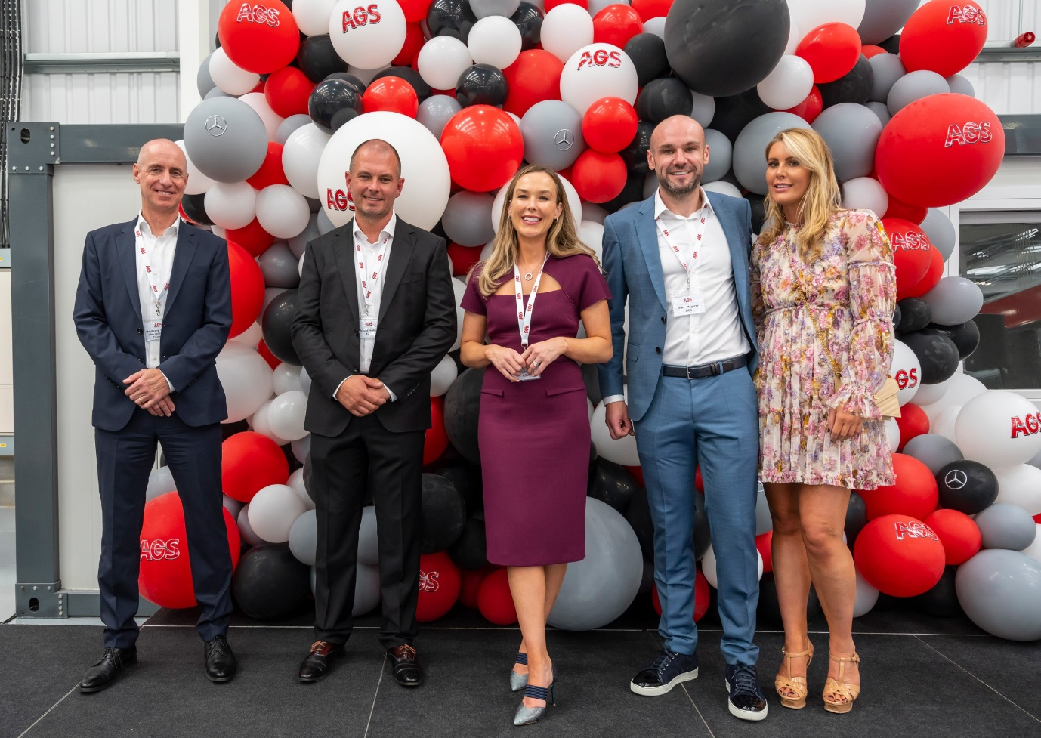

New partnership: Mercedes-Benz Trucks’ Wolfgang Theissen is pictured, left, with AGS proprietors Richard and Laura Holmes, and Paul Mcgerty, and Rebecca Quinn

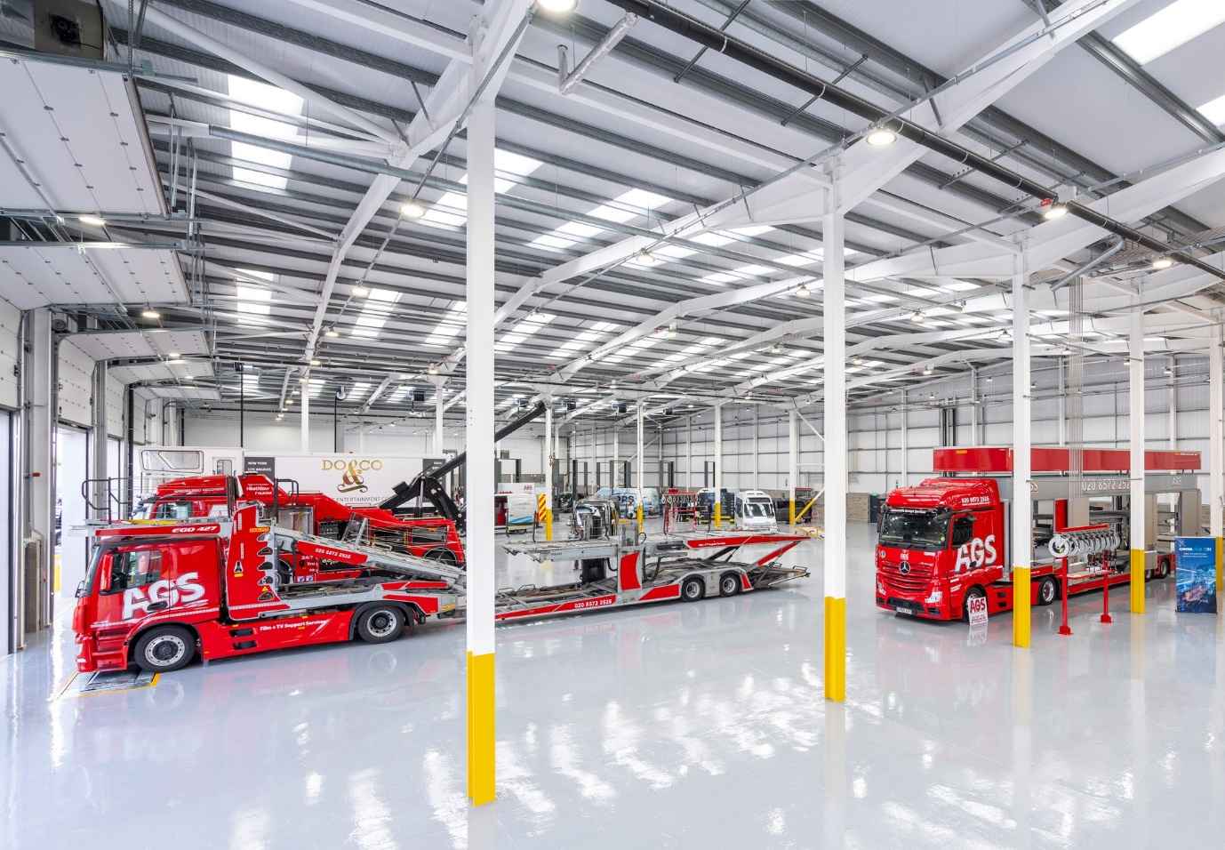

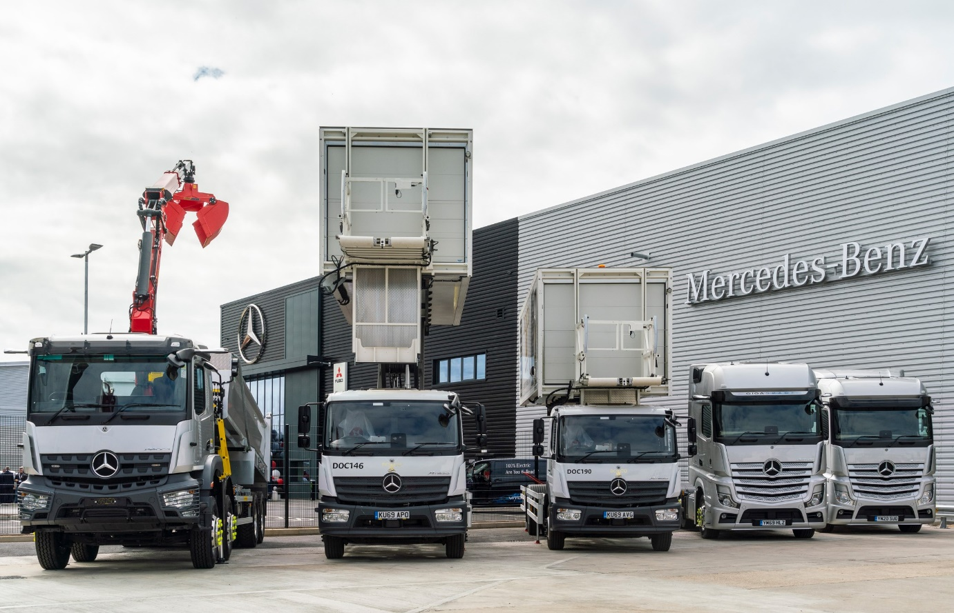

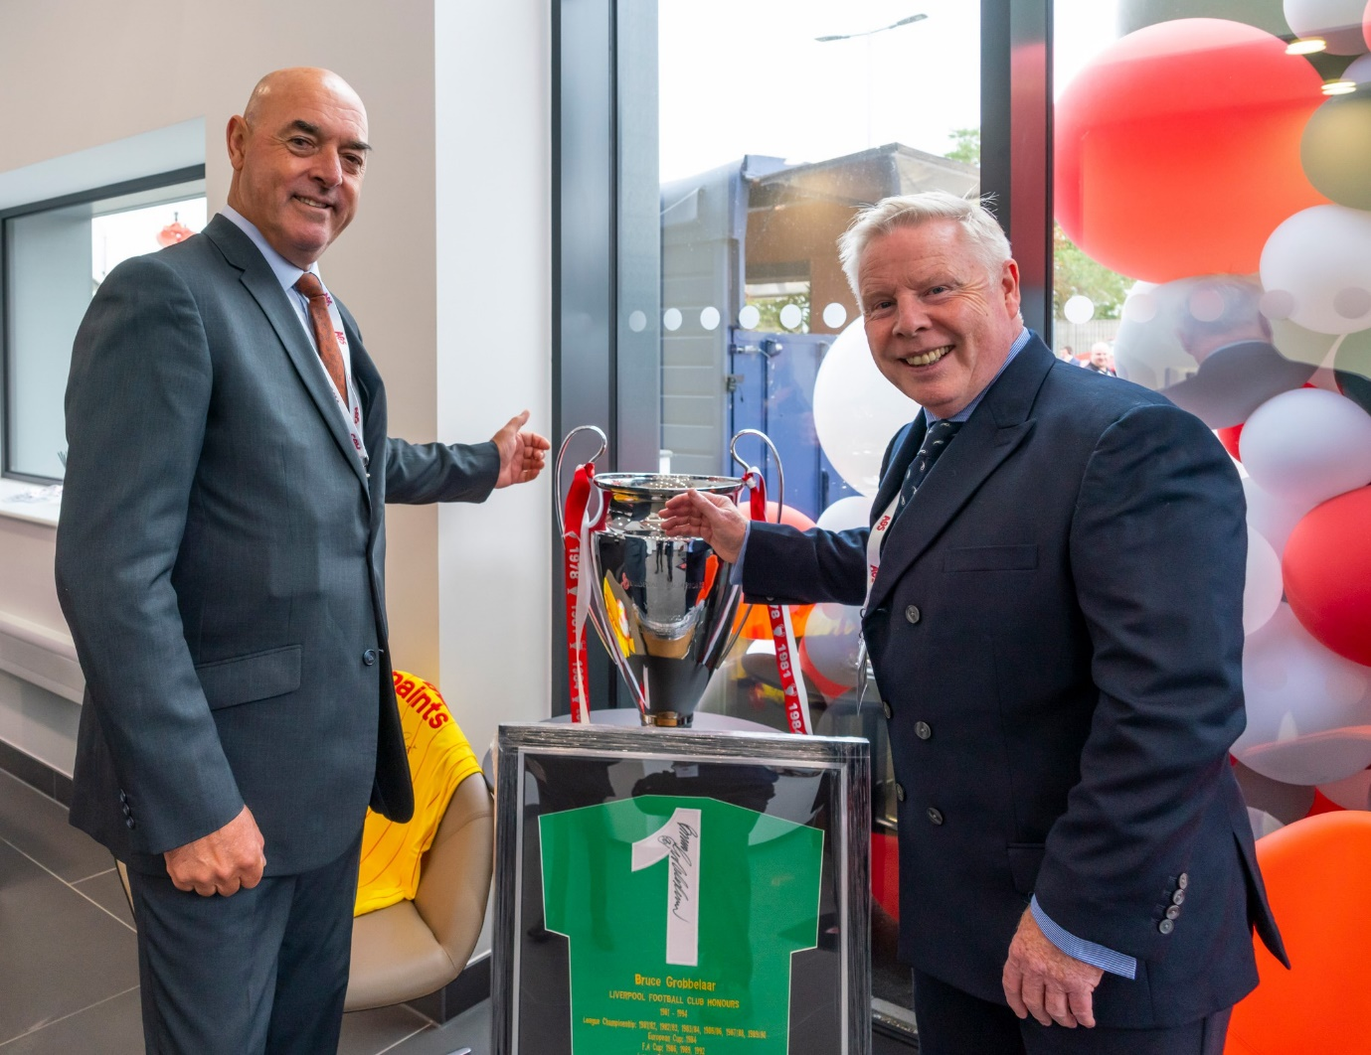

Kick-off! VIP guests at the AGS Heathrow launch included ex-Liverpool FC ‘legends’ Bruce Grobbelaar, left, and Sammy Lee – proprietors Richard Holmes and Paul Mcgerty both grew up in the city, although while Richard is a Liverpool fan, Paul supports rivals Everton

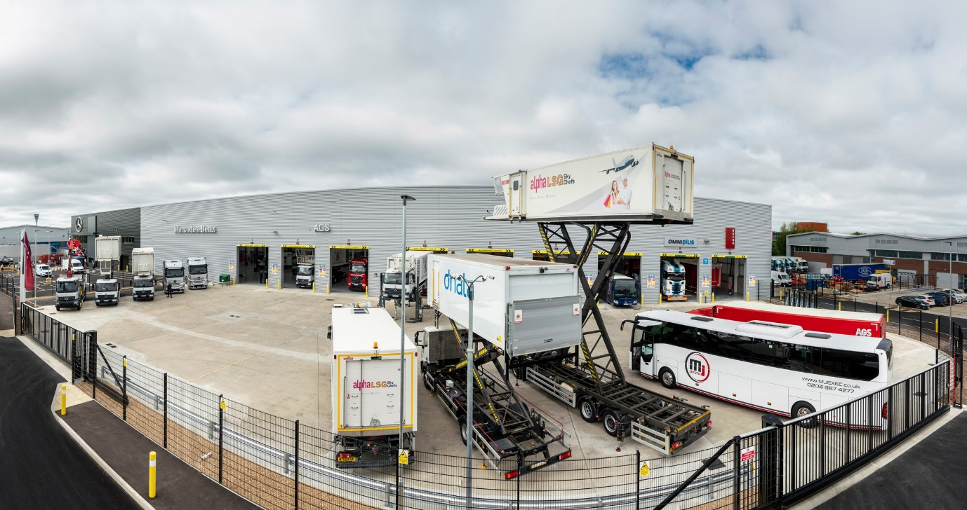

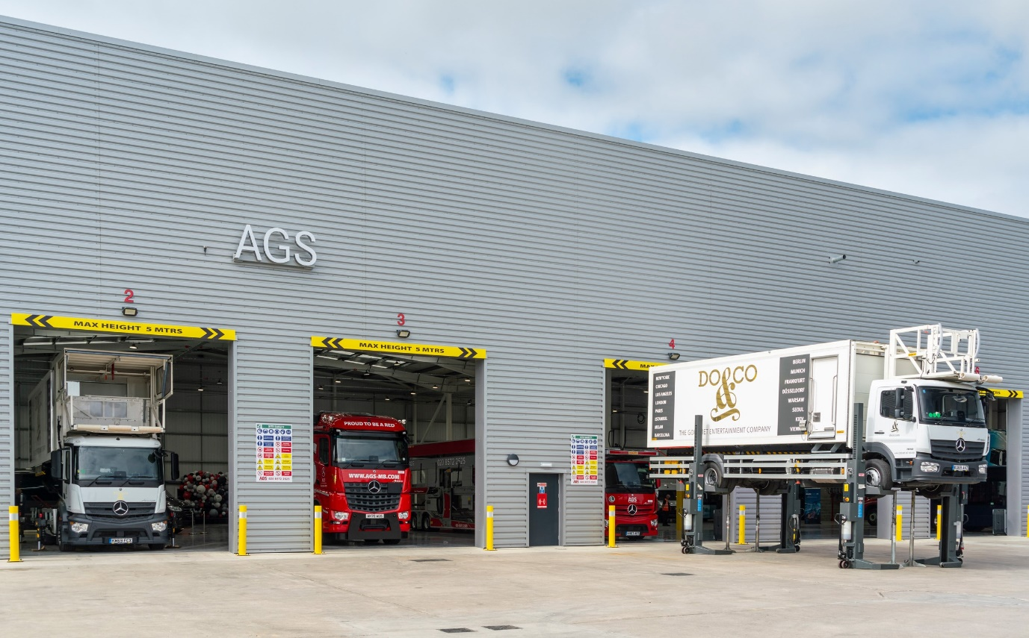

ends

For more information, or to request higher-res image files, please contact:

Jamie Fretwell at Mercedes-Benz Trucks UK Ltd
07712 519230, jamie.fretwell@daimler.com

or

Steve Warren or John Ripley
Impact Communications, 01926 842126
Steve: 07770 470251, steve@impactcom.co.uk
John: 07771 484595, john@impactcom.co.uk

About Mercedes-Benz Trucks UK Ltd
Mercedes-Benz Trucks UK Ltd is the sales and marketing organisation responsible for all Daimler truck products in the UK, including FUSO Canter.

For more than 125 years, Mercedes-Benz has stood for innovative commercial vehicles that meet exceptionally high standards of quality. Our claim to perfection, sustainability and avant-garde design is now embodied in the next generation of trucks: Actros, Arocs, Atego, Econic and Unimog.
www.mbtrucks.co.uk

