

Date: 24 February 2020

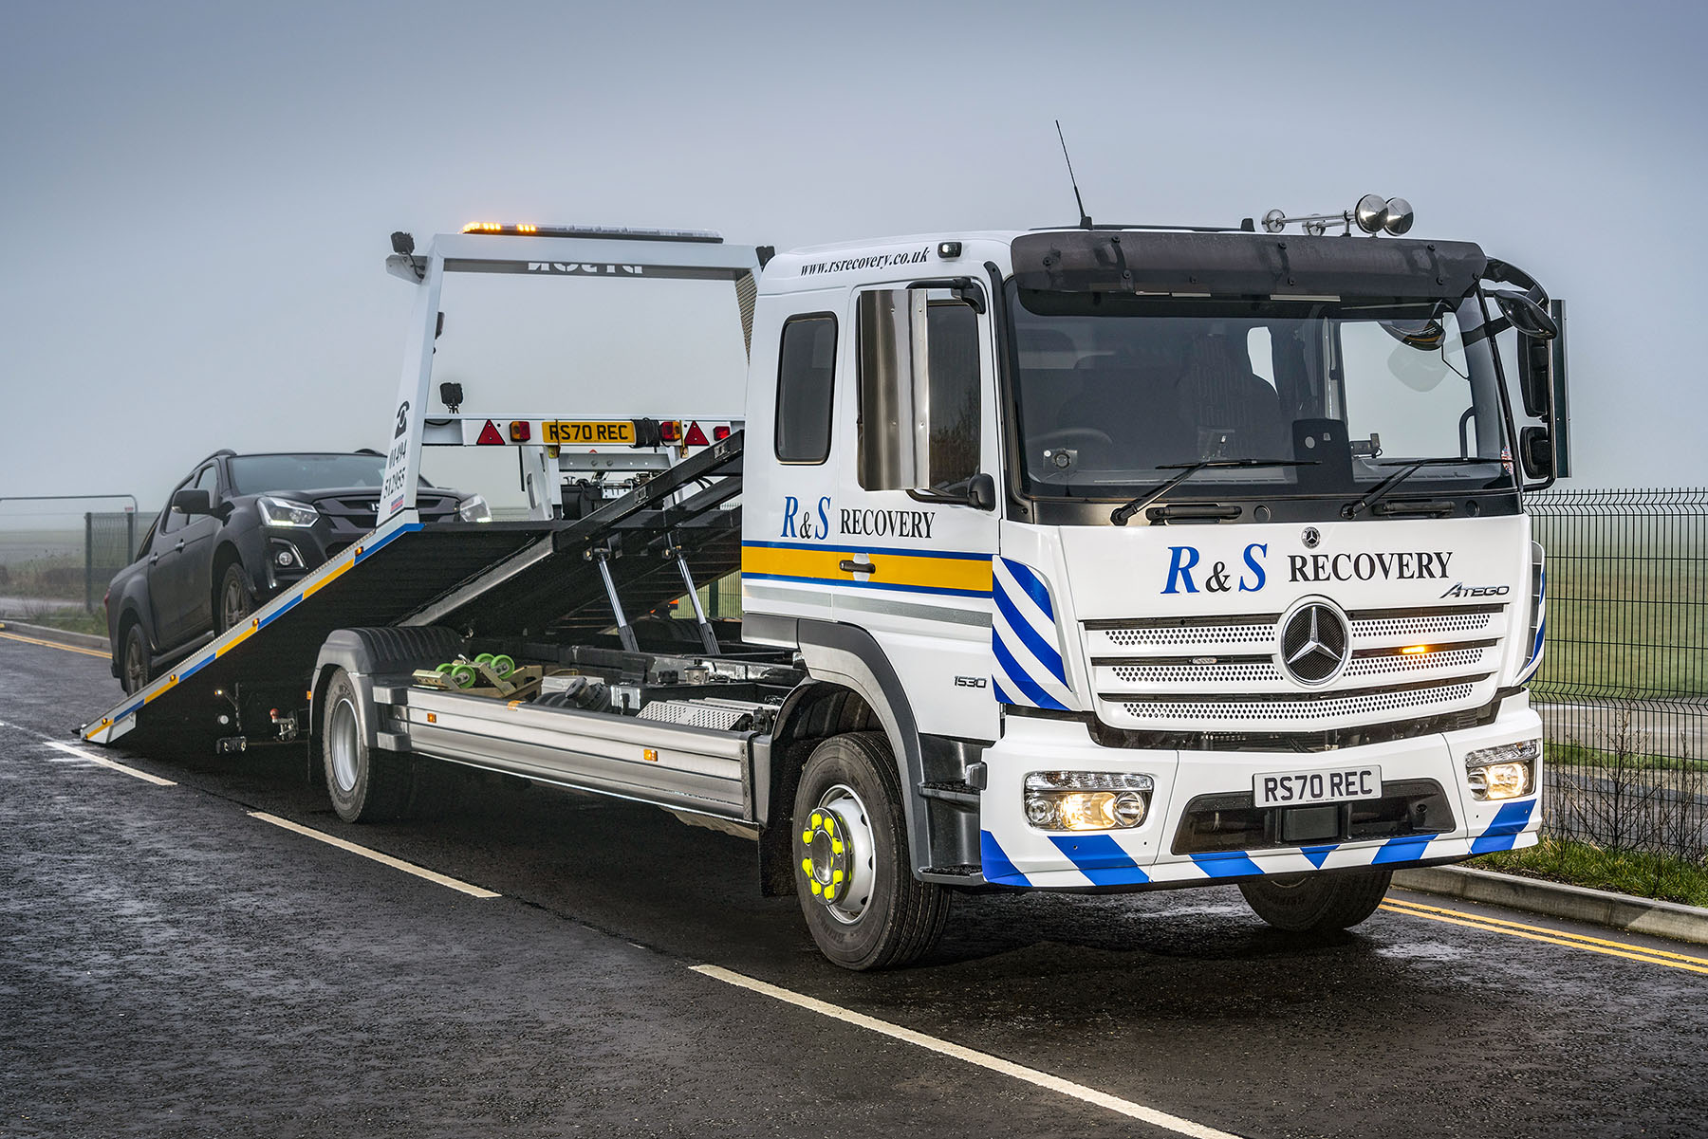

R&S raises its recovery game with dependable Mercedes-Benz Atego

R&S Recovery Services’ new Mercedes-Benz is already proving impressively versatile, thanks to a cab that’s roomy enough to accommodate five passengers, but not so long that it eats into space better used for the load bed.

The High Wycombe-based operator purchased its 15-tonne Atego from Rygor Commercials, a Dealer for which it works as a sub-contractor. The truck has a ClassicSpace L-cab with additional side windows and an innovative seat-bunk combination. This option provides seating for four people, each of whom gets an integrated safety belt; the seat can also be pulled out and double as a bed if required.

As a 1530 model the Atego is powered by a 7.7-litre ‘straight six’ engine which produces 220 kW (300 hp). Its 27ft Hydraloader LA Low Approach tilt-and-slide body was built in Droitwich, Worcestershire, by specialist manufacturer Roger Dyson – it features extendable ramps to reduce the loading angle still further, and a spectacle lift.

R&S Recovery Services General Manager Philip Leslie explained: “We had very specific requirements when choosing this truck. It had to be able to carry a large van or two cars, as well as several passengers, but without losing the agility that comes with a compact overall length. And, of course, we demand excellent reliability.

“The Atego is extremely well engineered and we know from experience that Mercedes-Benz trucks are highly dependable. With a payload of six tonnes, our latest can easily carry the largest vans, fully laden.

“The availability of the seat-bunk combination in a vehicle of this size was a key attraction too. It means we can carry additional passengers, but because the cab is much shorter than a full-sized crew cab more of the overall length is available for the load bed.”

R&S Recovery Services’ fleet ranges from heavy wreckers capable of recovering 44-tonne tractor and trailer combinations or large coaches, to vans equipped with tools and parts to carry out repairs at the roadside. The company’s core client base includes commercial vehicle operators, as well as Highways England – it also works as a sub-contractor to Mercedes-Benz Trucks Dealers, including Rygor Commercials.

“A lot of our work is with truck and trailer fleets, but we could also be called out to the scene of a road traffic collision,” continued Mr Leslie. “The fact that we can seat five passengers in the cab, carry two cars on the bed and potentially a third on the spectacle lift makes this Atego highly flexible.”

Purpose-designed for light- and medium-duty distribution work, as well as construction applications, the Mercedes-Benz Atego range from 7.5-16 tonnes GVW offers outstanding dynamics, comfort and manoeuvrability. It also enjoys an unrivalled reputation for rugged reliability.

Having operated Atego-based recovery trucks previously, R&S is already familiar with these attributes. “The Atego is a proven performer,” affirmed Mr Leslie. “It’s exceptionally durable, but also comfortable and easy to operate – the new truck is already a hit with driver Craig Toppin.”

Established in 2003 as a family firm with three trucks and a service van, R&S Recovery Services now covers a large swathe of South-East England from its headquarters and other depots in Bicester, Guildford, Maidenhead and West London.

“We’ve worked with the team at Rygor for many years as both a customer and a supplier, and have developed a strong professional relationship,” Mr Leslie continued. “Sales Executive James Collier, who handled our latest order, was extremely attentive and kept us well informed throughout the process.”

James Collier added: “Vehicle recovery is a tough application and this means, understandably, that R&S expects a great deal from its trucks and suppliers. The combination of the robust Atego chassis, and Rygor’s determination to set the highest standards of customer service, provided the ideal mix.”

www.rsrecovery.co.uk

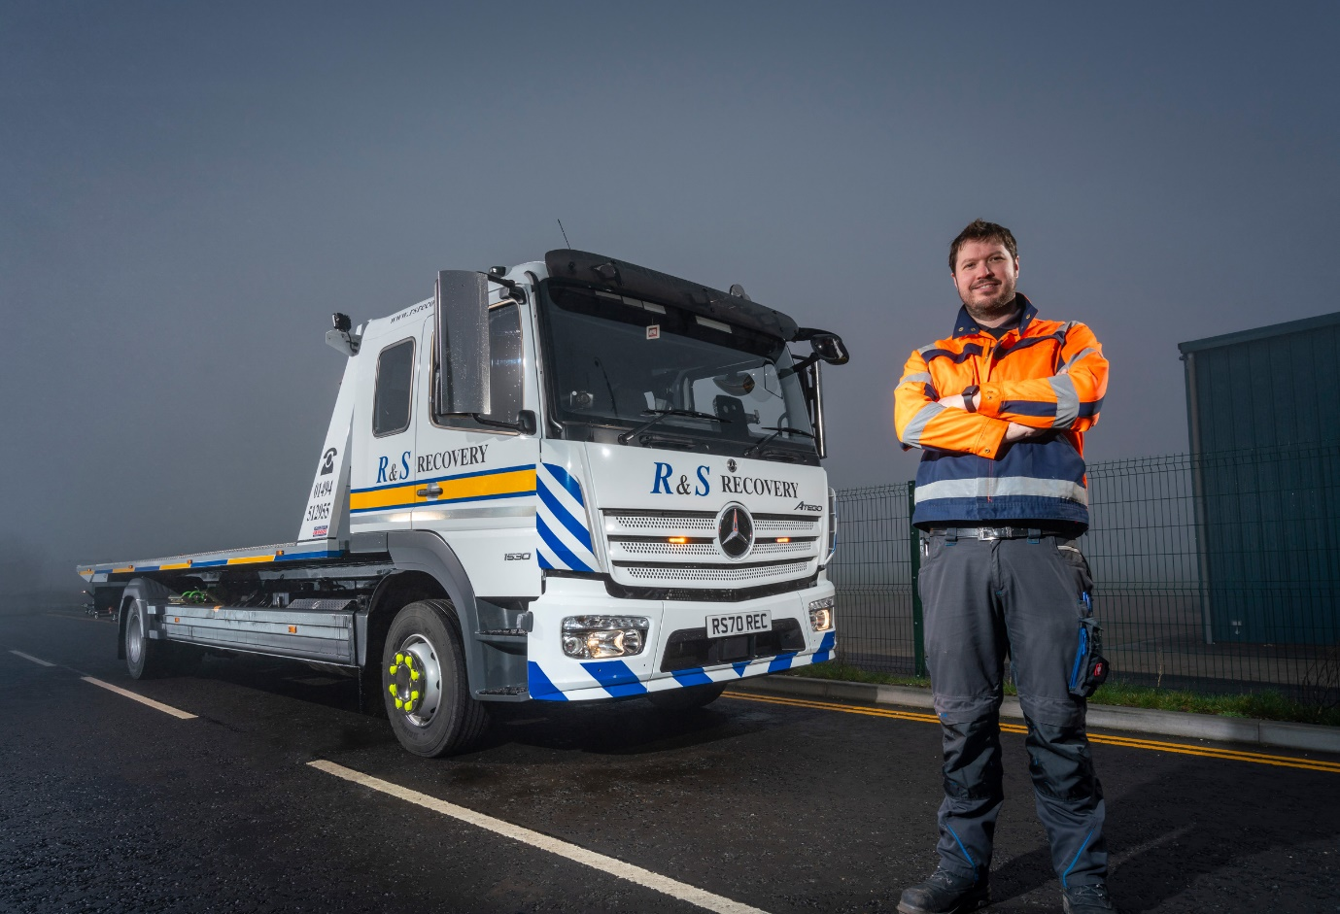

Shining star: R&S Recovery Services’ new Mercedes-Benz Atego, seen here with General Manager Philip Leslie, will be a welcome sight to any driver stranded after a breakdown
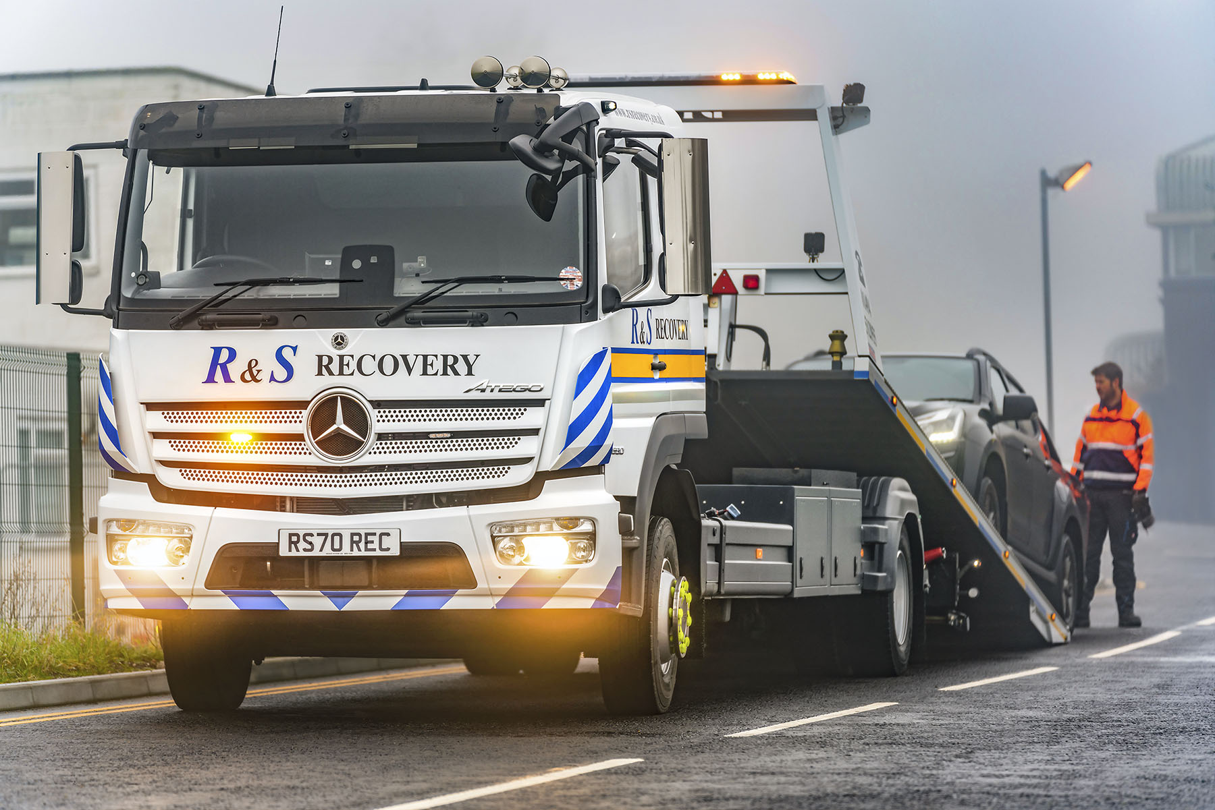

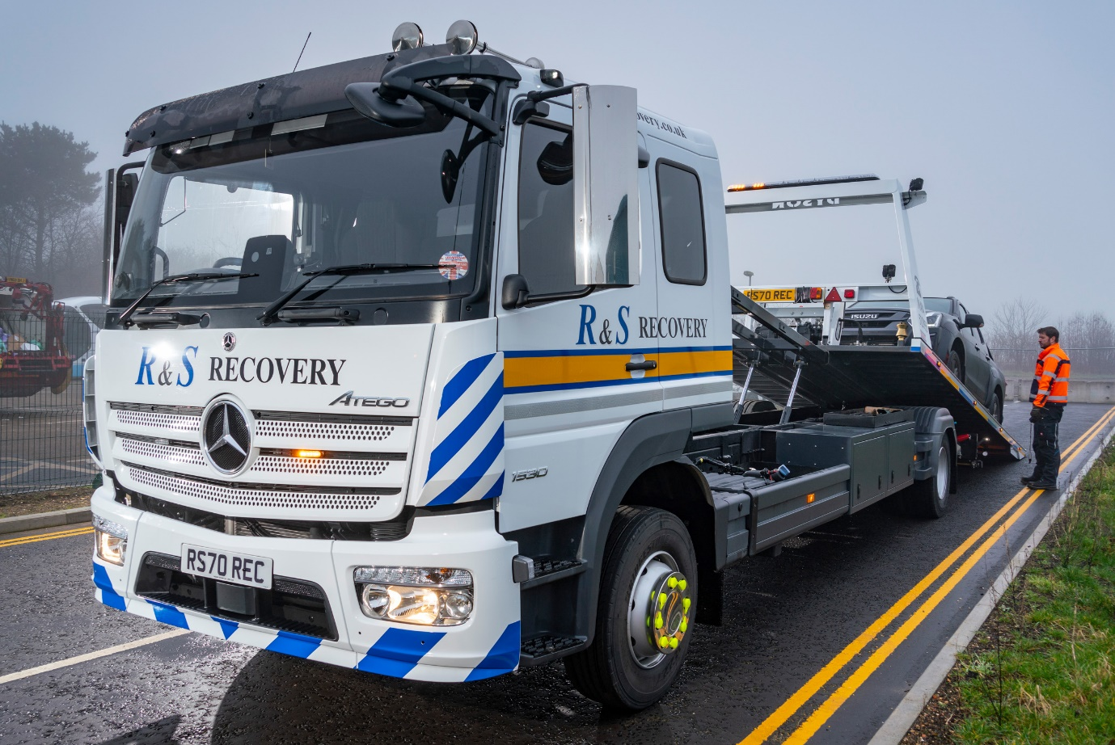

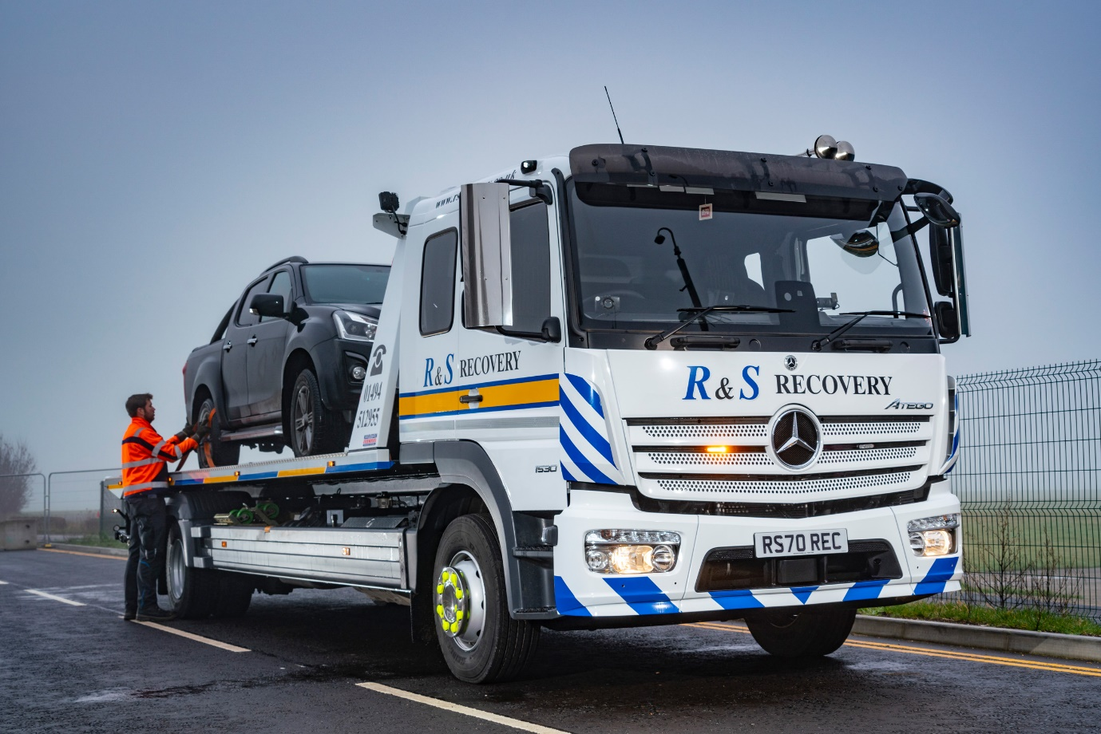

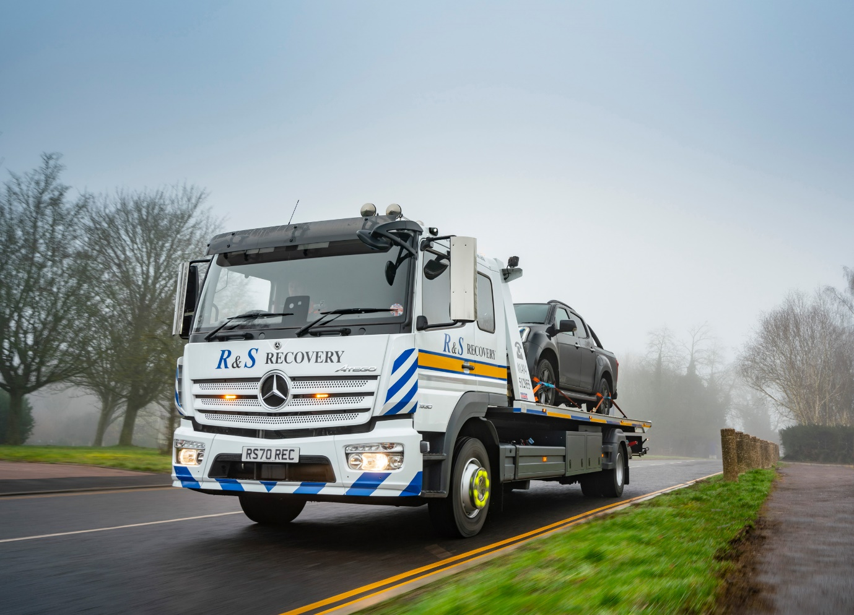

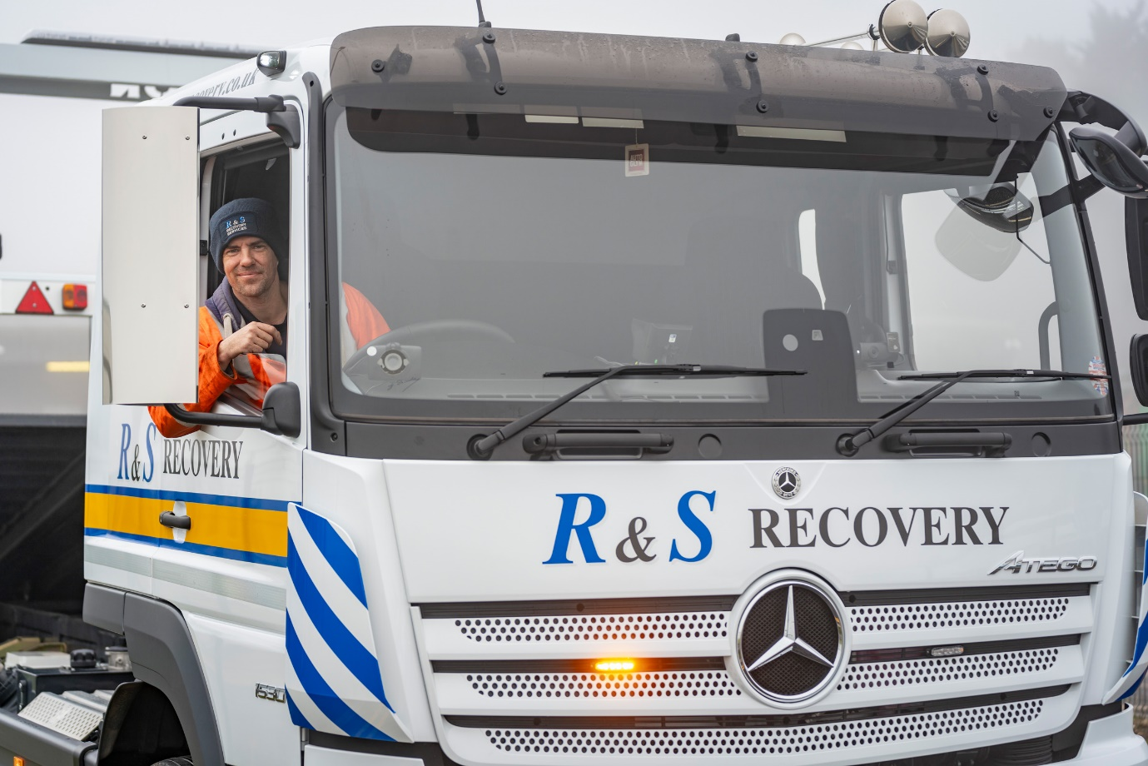

At the wheel: Driver Craig Toppin is delighted with his new Mercedes-Benz Atego

ends

For more information, or to request bigger/higher-res image files, please contact:
Steve Warren or John Ripley
Impact Communications, 01926 842126
John: 07771 484595, john@impactcom.co.uk
Steve: 07770 470251, steve@impactcom.co.uk

Notes to Editors: Rygor Commercials

Award-winning Mercedes-Benz Commercial Vehicle Dealer group, Rygor Commercials, has branches in Berkshire, Gloucestershire, Oxfordshire, Somerset, West London, Warwickshire, Wiltshire, and Worcestershire, offering extensive coverage for customers throughout the M5, M4 and M42 corridors.

The Rygor business has developed and gone from strength to strength in recent years, investing in extensive renovations of its sites across the country as well as a brand-new, dedicated Heathrow Truck Centre which opened in 2020. With six industry and network awards under its belt in the past 24 months, Rygor continues to be dedicated to providing exceptional customer service, which Sets Standards. The Dealer was delighted to be announced as winner in the ‘Franchised Dealer of the Year’ category at the 2019 Commercial Motor Awards and ‘Van Dealer of The Year 2021’ at the What Van? Awards, accolades which not only demonstrate the company’s focus on customer satisfaction, but also its commitment to the development, training, and wellbeing of its team members.

With a proven track record, Rygor is proud to be selling, maintaining and supporting the most prestigious name in commercial vehicles.

For more information, in the first instance please contact Kate Ruberry-Shoemack, Head of People and Communications at Rygor – kateruberry-shoemack@rygor.co.uk, or in her absence, Communications Assistant, Talitha Scott – talithascott@rygor.co.uk.

