

Date: 3 March 2022

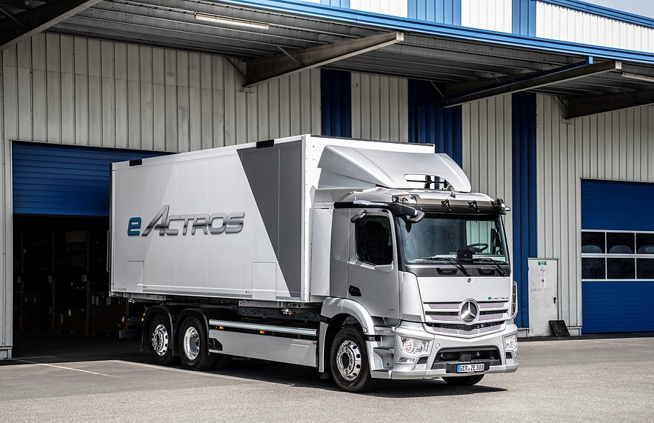

Heavy-duty distribution with zero emissions:
Mercedes-Benz Trucks UK begins sales of the all-electric eActros

UK truck operators are being invited to enter a new age of sustainable road transport by placing the first orders for right-hand drive versions of the battery-electric Mercedes-Benz eActros.

Aimed at those engaged in heavy-duty, short-haul distribution, the ground-breaking vehicle produces zero tailpipe emissions and offers a range of up to 249 miles (400 km) ⁽¹⁾. It is now available to order as a 4x2 or 6x2 chassis, with deliveries to UK customers beginning in May.

Mercedes-Benz Trucks UK has adopted the ‘direct sales’ model already successfully employed for the 7.5-tonne FUSO eCanter, the world’s first fully electric light-duty truck to enter series production.

However, while – initially, at least – eActros orders can only be placed with the manufacturer, members of its Dealer network are also embracing the opportunity to take their next steps on the road to a cleaner, ‘greener’ future.

Co-operation Partnership Agreements have been eagerly taken up, with sales teams standing ready to provide expert advice on the eActros and channel ‘live’ leads to specialist eConsultants at Mercedes-Benz Trucks UK.

Dealers are also investing significant sums in the technical training and additional equipment needed to secure ‘eTruck-ready’ status for their workshops – 17 locations have already been accredited, with more set to follow in the coming months.

Developed and extensively tested in real-life conditions with operators across Europe, eActros is the first series-produced electric truck to bear a three-pointed star. It comes as a 4x2 variant with 19-tonnes gross weight and three battery packs, and as a six-wheeled 27-tonner with either three or four battery packs.

Each battery pack has an installed energy capacity of 112 kWh ⁽²⁾, and a useable capacity of 97 kWh ⁽³⁾. As a result, the eActros 300 with three battery packs can travel up to 300 km, while the four-battery pack eActros 400 achieves up to 400 km.

The 4x2 chassis with three battery packs offers a maximum body and payload allowance of 10.6 tonnes – this rises to 17.7 tonnes in the 6x2 chassis with three batteries, or 16.6 tonnes for the longer-range version of the 6x2 with four battery packs.

The drive unit at the vehicle’s heart comprises a rigid electric axle with a pair of integrated electric motors and a two-speed transmission. Both liquid-cooled motors generate a continuous output of 330 kW (443 hp) and peak power of 400 kW (536 hp). Electrical energy recovered through recuperation while braking is fed back into the batteries for use by the drive system.

The highly efficient electric motors offer constant delivery of power with high starting torque for powerful acceleration. Impressive comfort and low levels of noise – roughly half those of a conventional diesel truck – combined with reduced vibration contribute to a relaxed, low-stress driving experience, while the vehicle’s low centre of gravity helps when cornering. The truck rides on full air suspension and despite the fact that the batteries are safely and securely housed beneath the frame, it is no higher than a standard vehicle.

The eActros can be charged with up to 160 kW – when connected to a regular 400A DC charging station three battery packs need just over an hour to recharge from 20 to 80% capacity.

Its low operational noise makes the eActros ideal for night-time deliveries in built-up areas. Drivers benefit too – the interior noise level has been reduced by 10 dB, roughly corresponding to a halving of the perceptible noise level.

Standard equipment, meanwhile, includes MirrorCam, Multimedia Cockpit, Active Brake Assist 5, Sideguard Assist and an Acoustic Vehicle Alerting System.

“The eActros is a new truck for a new era,” declared Ross Paterson, Head of Special Trucks at Mercedes-Benz Trucks UK. “It represents an important step towards our goal of offering an entirely CO₂-neutral product range by 2039, which we’ll achieve using a combination of battery-electric and hydrogen fuel cell technology.”

Ross pledged: “We are committed to supporting our customers by making their transitions from diesel to electric power as easy and seamless as possible. To this end we’ll provide comprehensive product training for drivers and operators.

“Our team of eConsultants can provide valuable advice and assistance on other aspects of its operation such as charging infrastructure, as well as a range of digital services to increase utilisation and optimise the total cost of ownership.”

Supporting this, James Venables, eConsultancy Manager at Mercedes-Benz Trucks UK, added: “I’ve worked within Mercedes-Benz for 20 years and have never been more excited than I am right now. Following extensive European trials in the harshest operating conditions, the time is right to bring the eActros to UK operators. We’re confident it’s the right truck for our customers, with the right powertrain, the right range and the right payload capacity.

“Every bit as importantly, though, we’re doing so much more than just selling a truck; we’re also helping to decarbonise the entire heavy-duty transport operation by recommending charging infrastructure partners, providing depot surveys, and offering use-case profiling and route analysis. Starting sales of the eActros is an important step in our journey to zero-emission trucking and we’re eager to see the first units on UK roads.”

For further information on the all-new eActros, visit https://www.mercedes-benz-trucks.com/en_GB/emobility/world/our-offer.html

- The range was determined internally in optimum conditions, including four battery packs after preconditioning in partially loaded distribution traffic without a trailer at 20°C outside temperature.
- Nominal capacity of new battery, based on internally defined boundary conditions, may vary depending on use case and ambient conditions.
- Energy available for regular truck operation with new batteries. Based on internally defined boundary conditions, may vary depending on use case and ambient conditions.

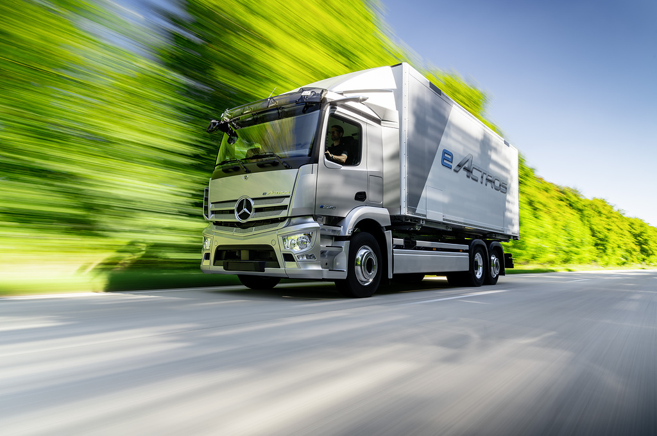

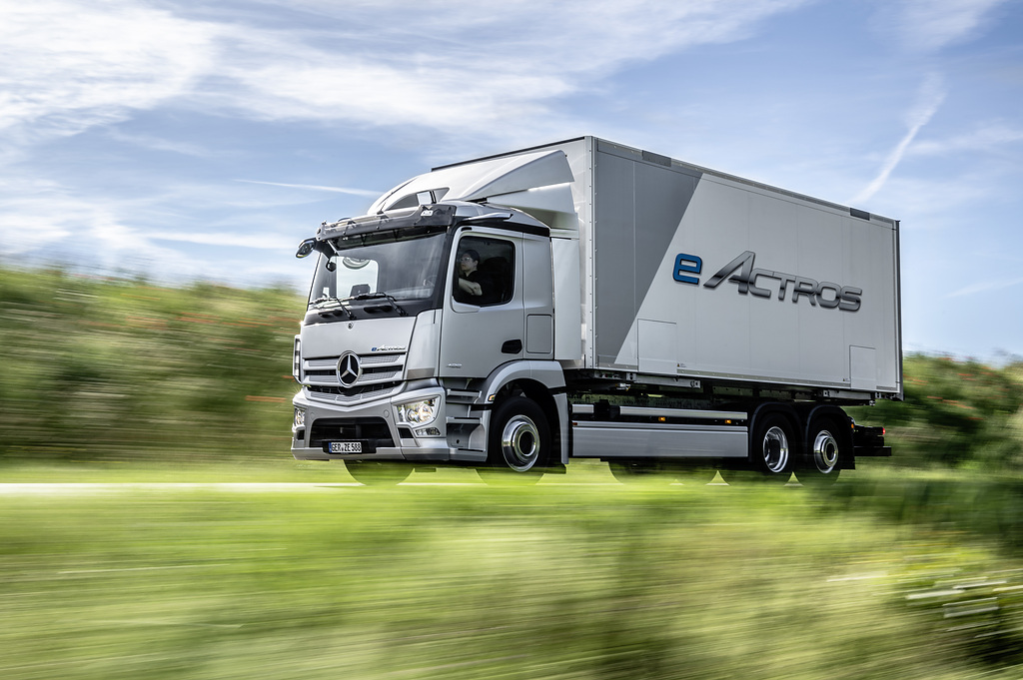

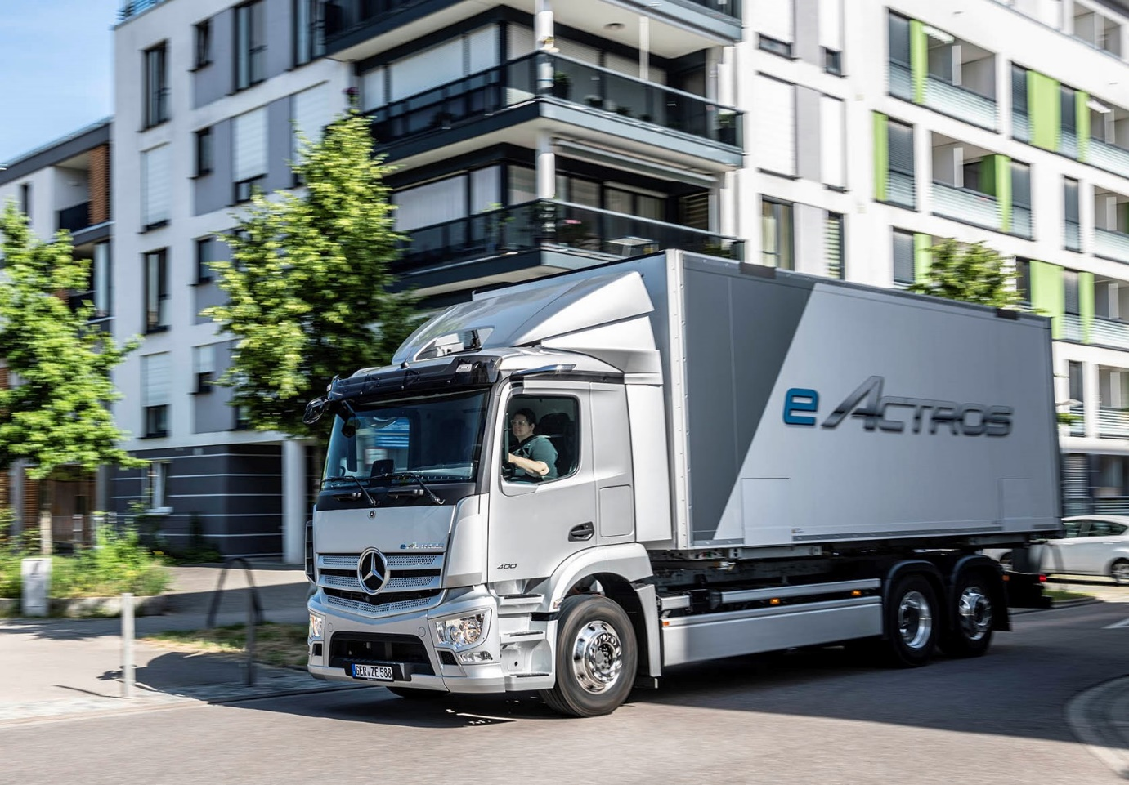

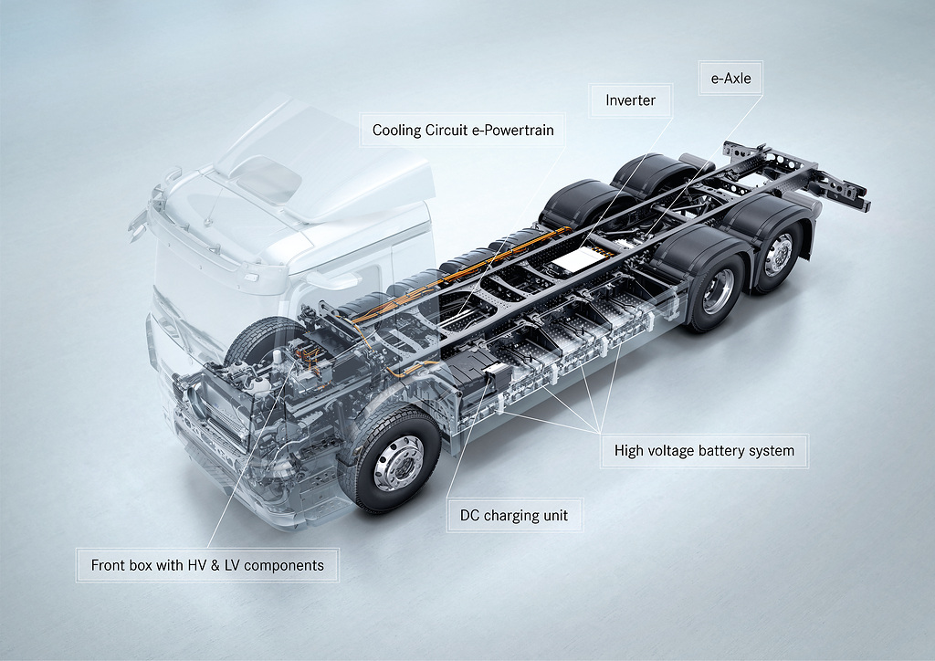

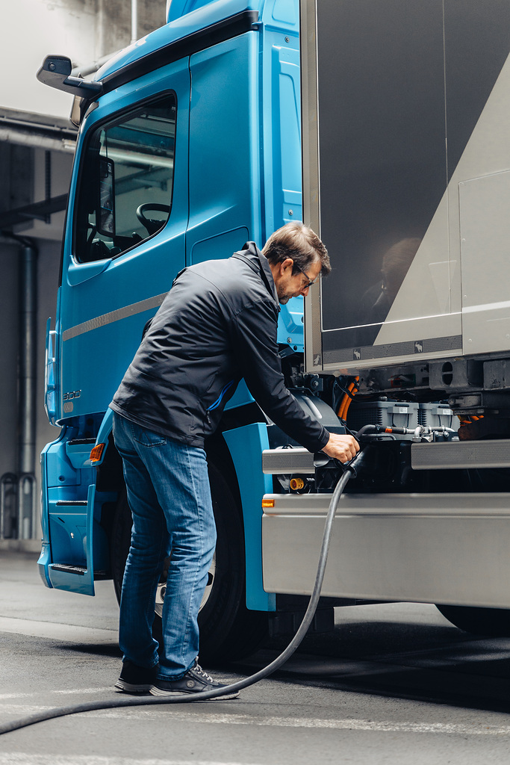

ends

For more information, or to request higher-res image files, please contact:

Jamie Fretwell at Mercedes-Benz Trucks UK Ltd
07712 519230, jamie.fretwell@daimler.com

or

Steve Warren or John Ripley
Impact Communications
Steve: 07770 470251, steve@impactcom.co.uk
John: 07771 484595, john@impactcom.co.uk

