

Date: 23 July 2019

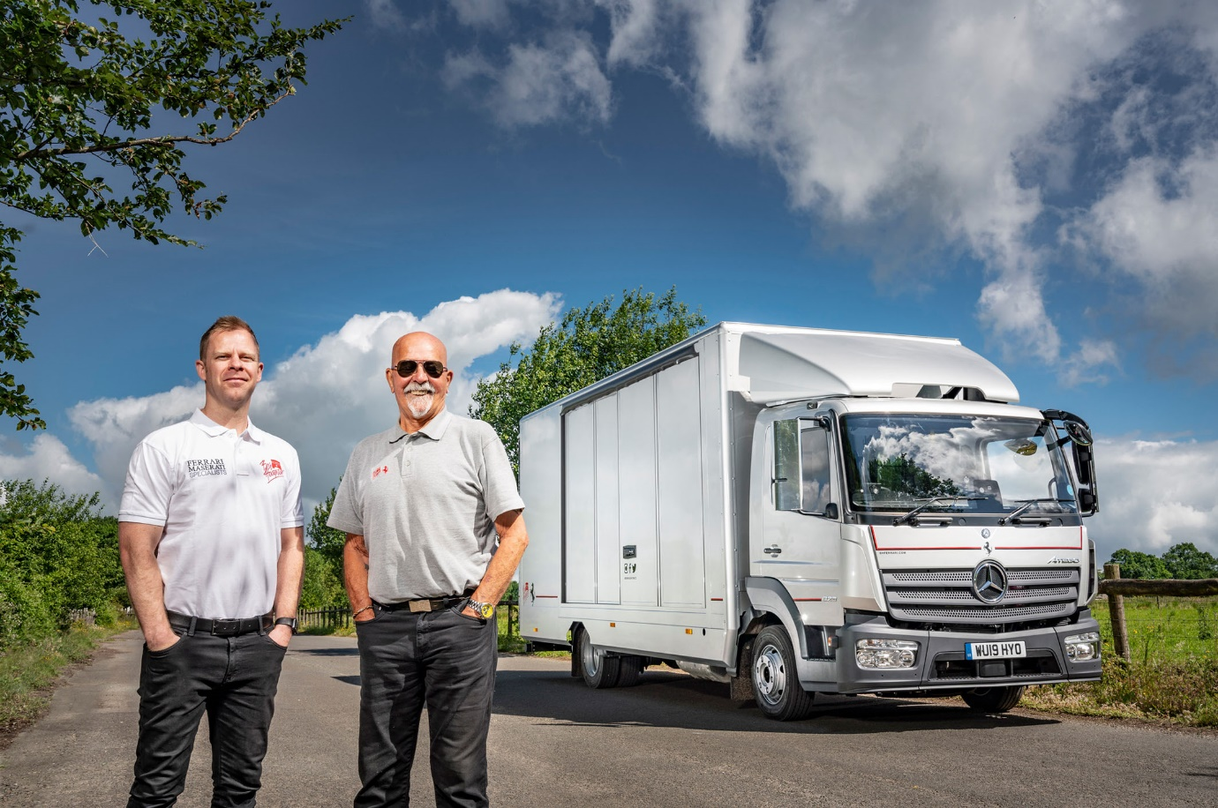

Worthy successor: David Houghton, left, and Mike Marshall, with the 7.5-tonne Atego that Bob Houghton has purchased to replace its previous, 15-year-old version

Bob Houghton invests in another classic from Mercedes-Benz Dealer Rygor Commercials

They’ve long been and remain the fiercest of rivals on the racetrack, but Mercedes-Benz and Ferrari make a formidable team for supercar specialist Bob Houghton Ltd.

The Cheltenham-based company’s last 7.5-tonne Mercedes-Benz Atego transporter proved outstandingly reliable when it came to transporting Italian classics, providing 15 years’ exceptional service.
No surprise, then, that having finally decided to stand down its previous workhorse, founder’s son David Houghton immediately contacted local Mercedes-Benz Dealer Group Rygor Commercials to discuss its replacement.

An Atego 823 model with ClassicSpace L- day cab, Bob Houghton’s new 7.5-tonner has a 170 kW (231 hp) 5.1-litre four-cylinder engine which is paired with a smooth and efficient six-speed Mercedes PowerShift automated manual transmission.

The truck’s covered single-car transporter body is by Oxford Specialist Coachbuilders, of Chipping Norton. Built to a high standard, it features sliding doors on both sides. The hydraulically-operated rear closure, meanwhile, doubles as a ramp for loading and unloading the exotic and in many cases highly valuable machinery which clients entrust to Bob Houghton’s expert technicians and restorers. Additional slide out ramps can be used to reduce the load angle, thereby eliminating the risk of damage to cars that sit particularly low.

The Atego is fitted with a roof-mounted air deflector and stylishly finished with subtle coachlines and logos, including, immediately above the grille-mounted Mercedes-Benz three-pointed star, the prancing horse motif of the Italian brand with which Bob Houghton has enjoyed an association that goes back 55 years.

Mr Houghton was just 14-years-old in 1964, when he first worked on a Ferrari which belonged to a friend. An avid racing enthusiast, he established the company that bears his name in 1981. Today, while continuing to specialise in classic models, including building engines and preparing race cars, Bob Houghton also maintains and undertakes private sales of supercars on behalf of its clients.

David Houghton, who has now assumed responsibility for the day-to-day running of the business, commented: “Bob Houghton has forged an enviable reputation which is based on our engineering and mechanical expertise.

“We recognise and appreciate fine machinery, and that’s what we see in the Mercedes-Benz Atego. Our former truck provided exceptional service for a decade-and-a-half. It was only towards the very end, as one or two issues started to crop up, that we decided the time had finally come to replace it. Given past experience, we were only ever going to do so with another Atego.”

Bob Houghton is using its new truck to undertake many collections and deliveries. “Many of the cars we carry represent highly valuable investments for their owners, so they don’t do many road miles,” continued David Houghton.

“This means that safety and assured handling are every bit as important as reliability. Our latest Atego ticks all of these boxes, and looks great too – with its premium-quality image and smartly styled cab, the truck can only help us to reassure clients that their precious cars will receive the dedicated care and attention they deserve.”

Driver Mike Marshall is equally enthusiastic about his new truck. “Mike’s delighted with the Atego’s comfort and driving dynamics,” reported Mr Houghton. “The technology’s moved on a bit over the last 15 years, of course – his new truck is air-conditioned, for example, while in place of the manual gearbox he now has a Mercedes PowerShift automated manual transmission

“But Rygor’s Truck Training Manager Chris Moore provided an excellent handover and was prepared to take as long as necessary to ensure that Mike was familiar with all of the controls. In fact,” he added, “we couldn’t have asked any more of the Dealer, which has provided an exceptional service.”

The new truck will be maintained by the workshop team at Rygor Commercials’ recently refurbished and extended Oxford branch. Fleet Sales Manager Jeremy Price added: “A testimonial from a company like Bob Houghton is high praise indeed. We are delighted that Bob, David and the team continue to put their faith in Mercedes-Benz truck technology, and it was a genuine pleasure to be able to provide them with a new vehicle which is perfectly tailored to their needs.”
www.bhferrari.com

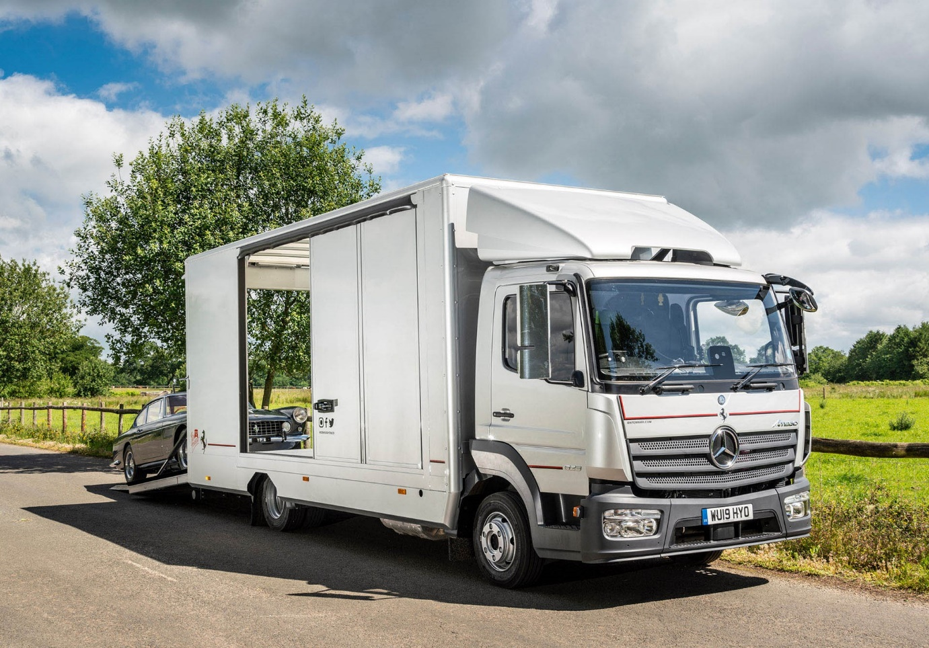

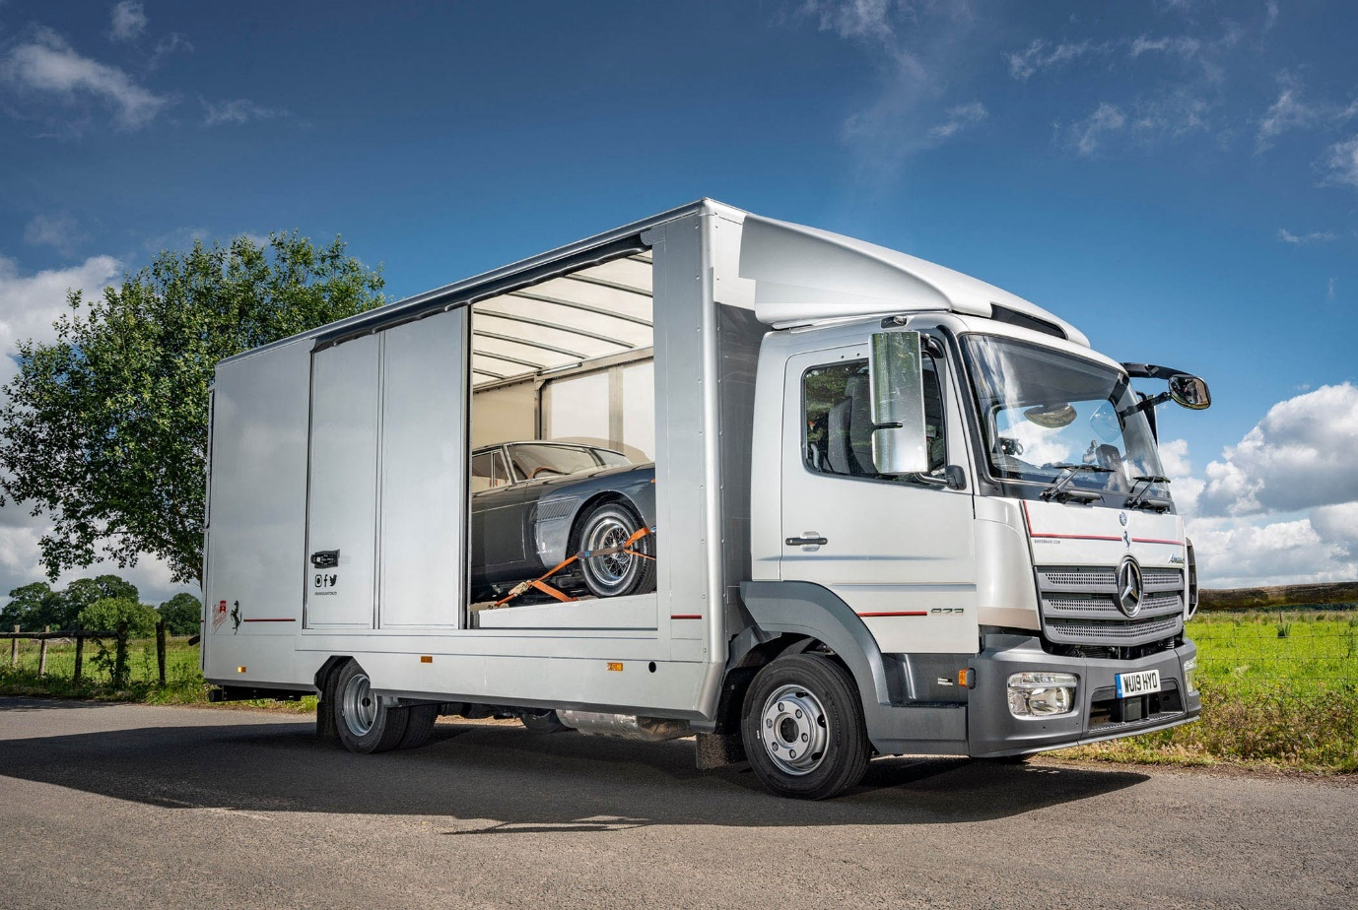

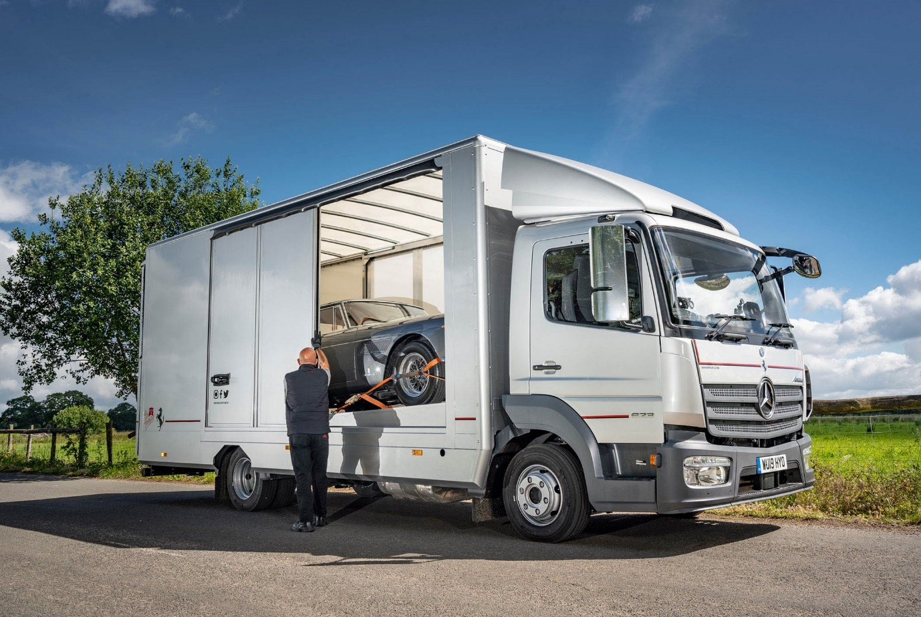

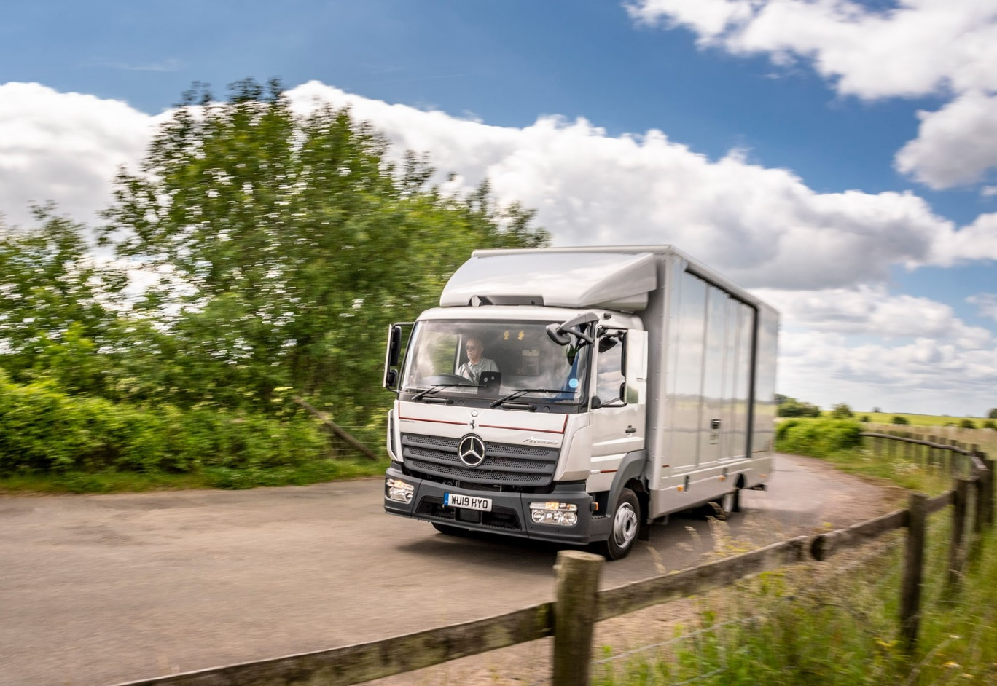

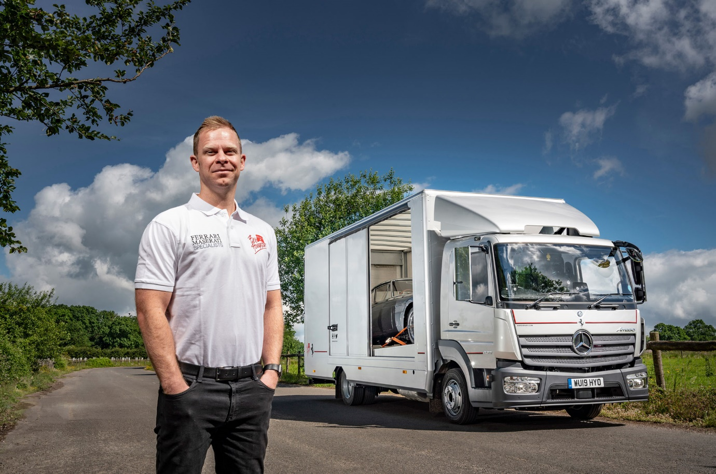

Trusting once again to the three-pointed star: David Houghton, with Bob Houghton’s new Mercedes-Benz Atego transporter

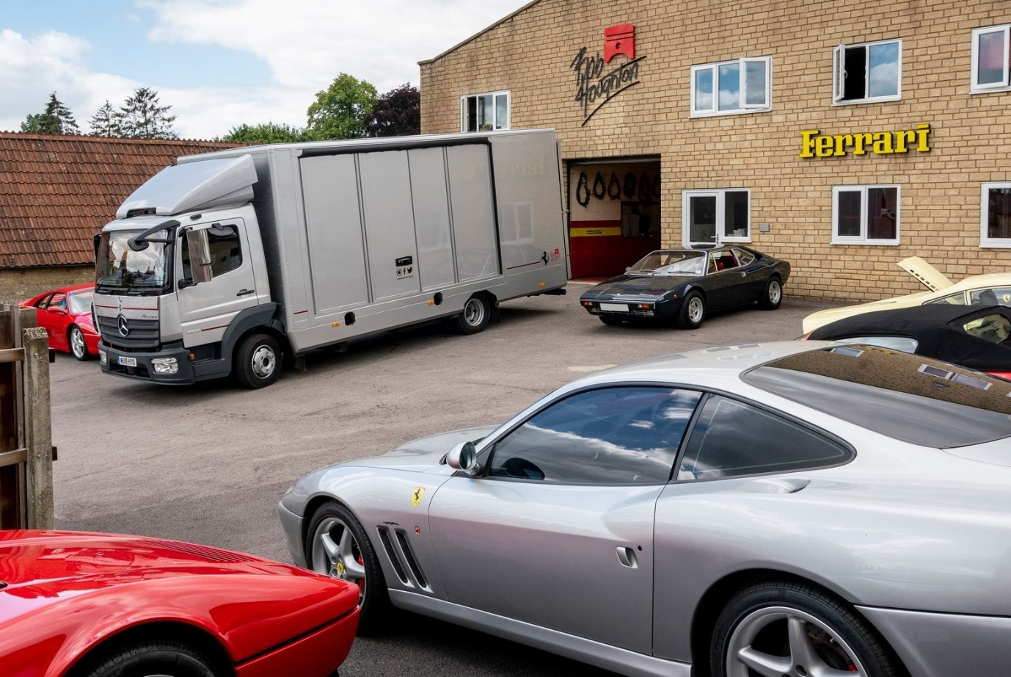

ends

For more information, or to request bigger/higher-res image files, please contact:
Steve Warren or John Ripley
Impact Communications, 01926 842126
Steve: 07770 470251, steve@impactcom.co.uk
John: 07771 484595, john@impactcom.co.uk

Notes to Editors: Rygor Commercials

Mercedes-Benz Commercial Vehicle Dealer group, Rygor Commercials, has 10 branches throughout Berkshire, Gloucestershire, Oxfordshire, Somerset, West London, Warwickshire, Wiltshire and Worcestershire, offering extensive coverage for customers through the M5, M4 and M42 corridors.

The business has expanded and gone from strength to strength in recent years, launching its flagship Gloucester branch in late 2016 and undergoing a significant refurbishment of its Oxford branch in 2018. With a proven track record, the award-winning Rygor Commercials is proud to be selling and supporting the most prestigious name in commercial vehicles.

For more information, in the first instance please contact Kate Ruberry-Shoemack, Communications Manager at Rygor – kateruberry-shoemack@rygor.co.uk

