

Date: 5 October 2020

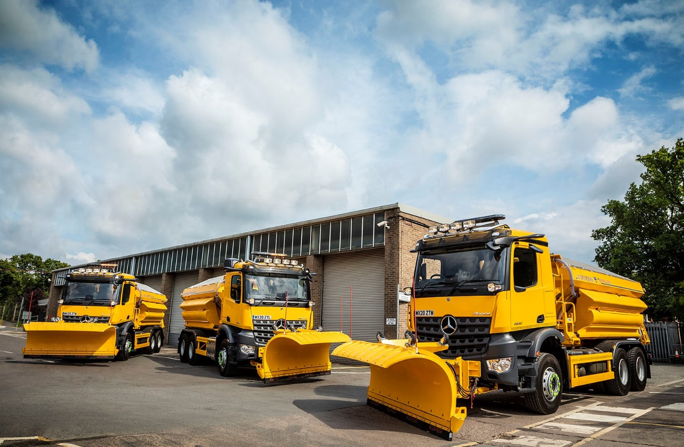

Worcestershire County Council gears up for winter with six new Mercedes-Benz Arocs gritters from Rygor

The well-proven combination of Mercedes-Benz trucks and gritting bodywork by Econ will be keeping Worcestershire’s roads open this winter.

Local Dealer group Rygor Commercials has supplied three new-generation Mercedes-Benz Arocs 2630Ks with ground-breaking MirrorCam technology instead of conventional mirrors, and will deliver three more before the end of the year.

The muscular Mercedes-Benz Arocs range is purposed designed for construction and associated applications. With 6x4 drivelines and full steel suspension offering excellent ground clearance, Worcestershire County Council’s new trucks are ideally suited to winter maintenance operations.

They have ClassicSpace M-cabs, and 7.7-litre, in-line six-cylinder engines, which produce 220 kW (299 hp) and drive through 12-speed Mercedes PowerShift 3 automated transmissions.

MirrorCam represents a major safety advance. The compact cameras relay images to screens mounted on the A-pillars. Not only do they provide much improved rearward vision, but they also eliminate the forward-facing blind spots caused by conventional mirrors. These benefits are sure to be appreciated by drivers working in challenging conditions on cold, dark nights.

Winter equipment leader Econ Engineering, of Ripon, North Yorkshire, has been a supplier to Worcestershire County Council for the last 13 years. Each of the new trucks has a 9m³ body which is operated via its latest Spargo Touch in-cab controls, and spreads pre-wet solution carried in tanks mounted either side of the hopper.

On-board weighing systems eliminate the risk of overloading, and roof-mounted Kelsa bars with four spotlights further assist drivers. The Econ E-Ploughs have ceramic edges which allow the vehicle to plough right up to the road surface, clearing it of snow and ensuring that salt treatment has the maximum effect.

Worcestershire County Council owns approximately 40 gritters. Every one of them – including a pair of 3.5-tonners used to treat car parks and other areas with restricted access – wears a Mercedes-Benz three-pointed star, and is fitted with an Econ body. These vehicles stand ready for deployment, at four depots strategically located across the county.

The authority’s Fleet Manager Tim McNicholas confirmed: “Our relationship with
Mercedes-Benz goes back many years, so we know its products well, as do our crews. The trucks are very well built and exceptionally reliable, which is particularly important given the job they do.

“When ice or snow are threatened, we need every piece of equipment to be available to keep the roads open and safe. We keep our gritters for 10 years, and experience has proved that over this life cycle Mercedes-Benz trucks do not let us down.”

The gritting fleet is maintained at Worcestershire County Council’s main depot in Warndon, Worcester – the workshop is managed on the authority’s behalf by Ringway. The highways services leader’s technicians are Mercedes-Benz-trained and have access to all of the specialist diagnostic and other equipment needed to ensure the vehicles perform at their best. A member of Rygor Commercials’ Kidderminster team is also based at Warndon, to manage the parts stock.

Worcestershire County Council disposes of its Mercedes-Benz gritters at auction. “Local authority vehicles have a reputation for being well maintained, so prospective buyers are happy to purchase them,” confirmed Mr McNicholas. “The trucks invariably do well in terms of resale values.”

He continued: “We must always abide by procurement rules, of course, but endeavour to support the local business community wherever possible. Our very good relationship with Rygor Commercials goes back many years, and the Dealer’s aftersales support is first class.

“Once again, its Fleet Sales Manager Jeremy Price was extremely helpful in providing product information, and we look forward to seeing how MirrorCam in particular is received by crews.”

Jeremy Price added: “I sold my first Mercedes-Benz gritters to Worcestershire County Council in 2004, and was delighted to have the opportunity to supply Tim McNicholas and his colleagues with the latest additions to their winter maintenance fleet.

“Gritters provide a vital service to the community and it’s gratifying that Worcestershire County Council continues to trust Mercedes-Benz vehicles backed by Rygor to perform this role.”

www.worcestershire.gov.uk

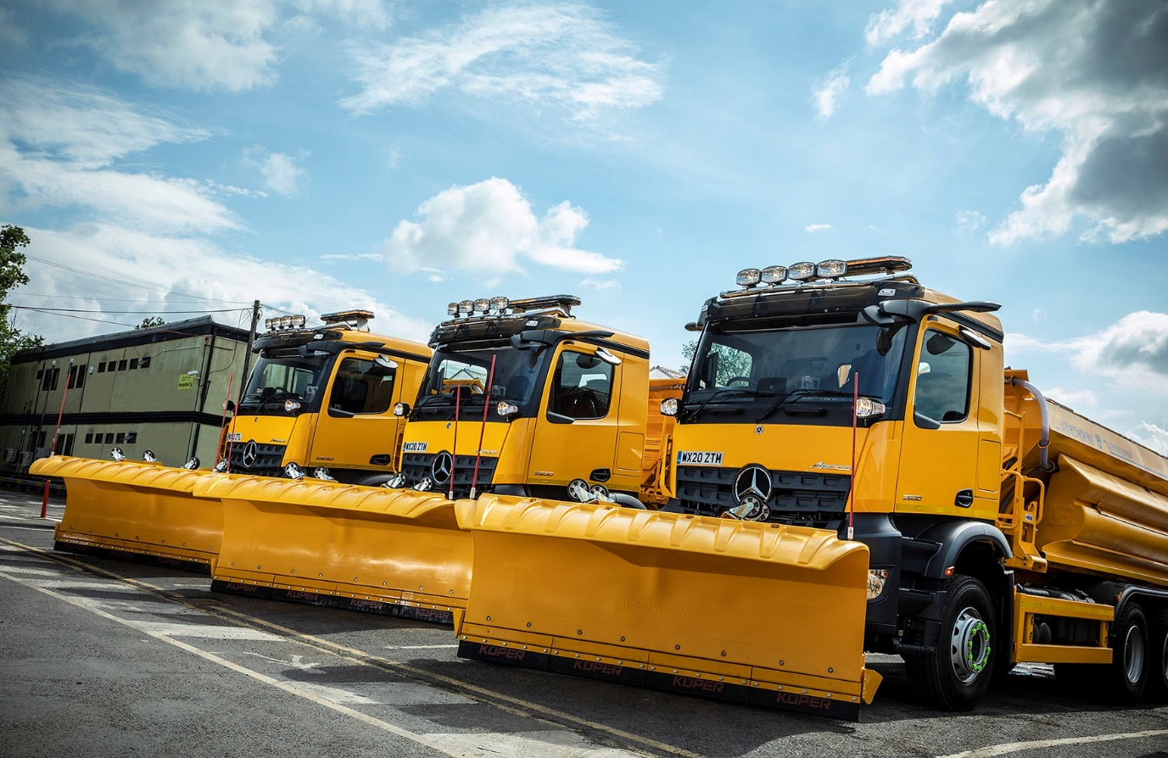

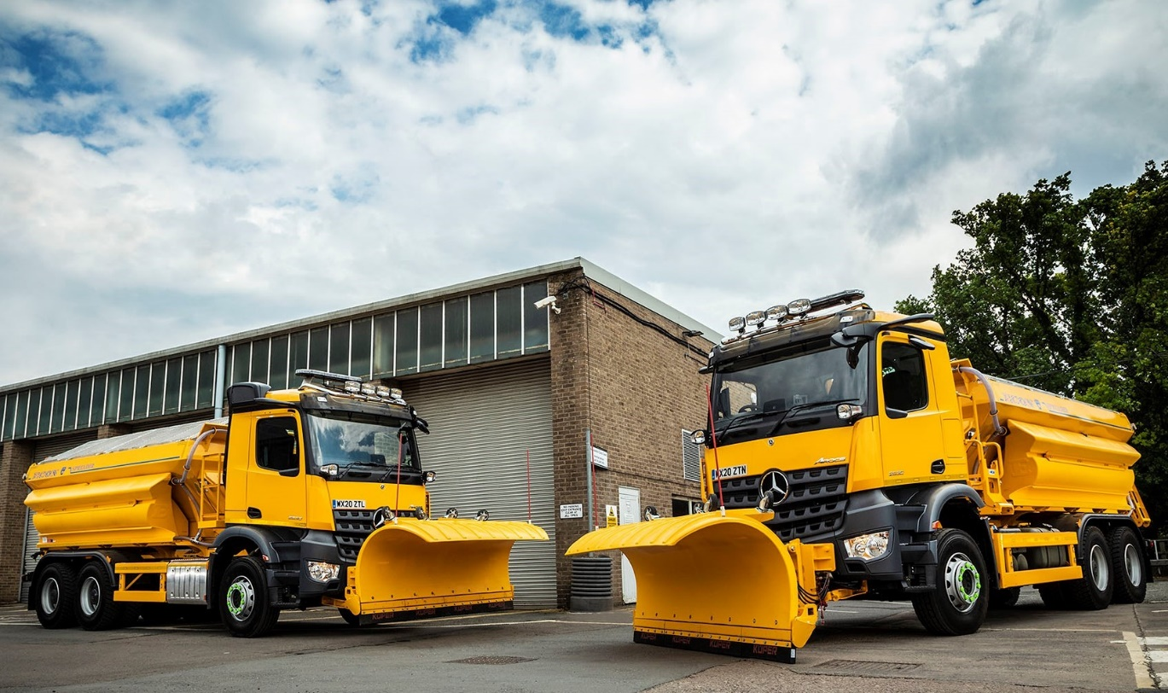

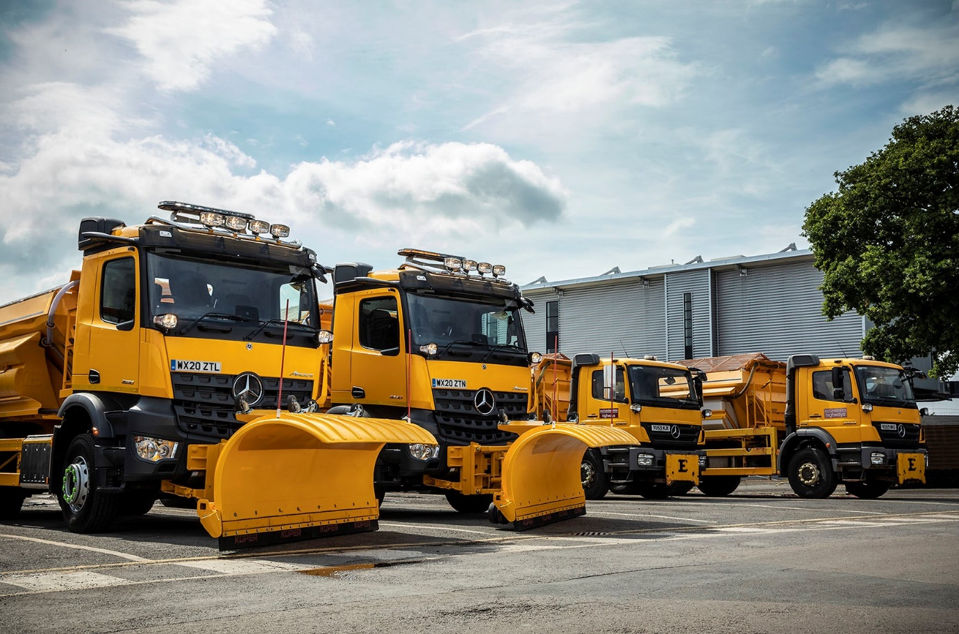

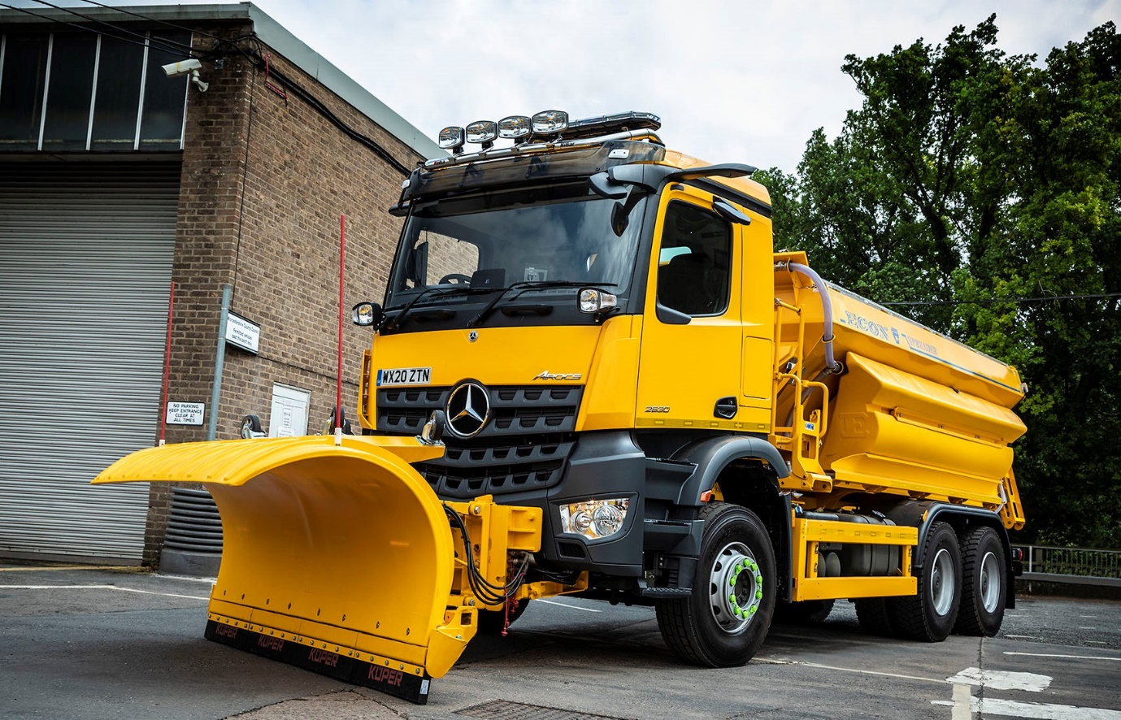

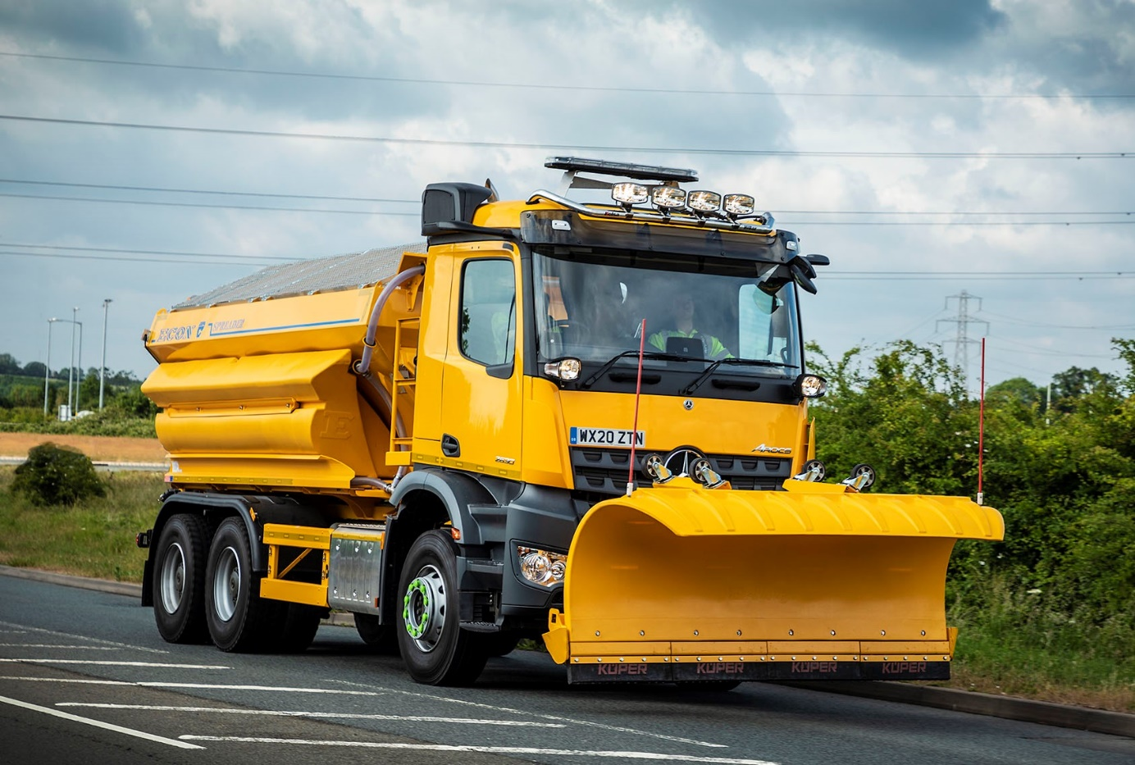

ends

For more information, or to request bigger/higher-res image files, please contact:
Steve Warren or John Ripley
Impact Communications, 01926 842126
Steve: 07770 470251, steve@impactcom.co.uk
John: 07771 484595, john@impactcom.co.uk

Notes to Editors: Rygor Commercials

Award-winning Mercedes-Benz Commercial Vehicle Dealer group, Rygor, has branches throughout Berkshire, Gloucestershire, Oxfordshire, Somerset, West London, Warwickshire, Wiltshire and Worcestershire, offering extensive coverage for customers throughout the M5, M4 and M42 corridors.

The Rygor business has expanded and gone from strength to strength in recent years, launching its flagship Gloucester branch in late 2016 (which won Showroom of the Year at the 2018 Commercial Motor Awards) and undergoing a significant refurbishment of its Oxford branch in 2018. Rygor was delighted to be announced as winner of the ‘Best Sales Team’ award at the 2019 AM Awards, demonstrating our continued commitment to our customers and dedication to providing exceptional customer service.

With a proven track record, Rygor is proud to be selling and supporting the most prestigious name in commercial vehicles.

For more information, in the first instance please contact Kate Ruberry-Shoemack, Head of People and Communications at Rygor – kateruberry-shoemack@rygor.co.uk

