

Date: 29 January 2021

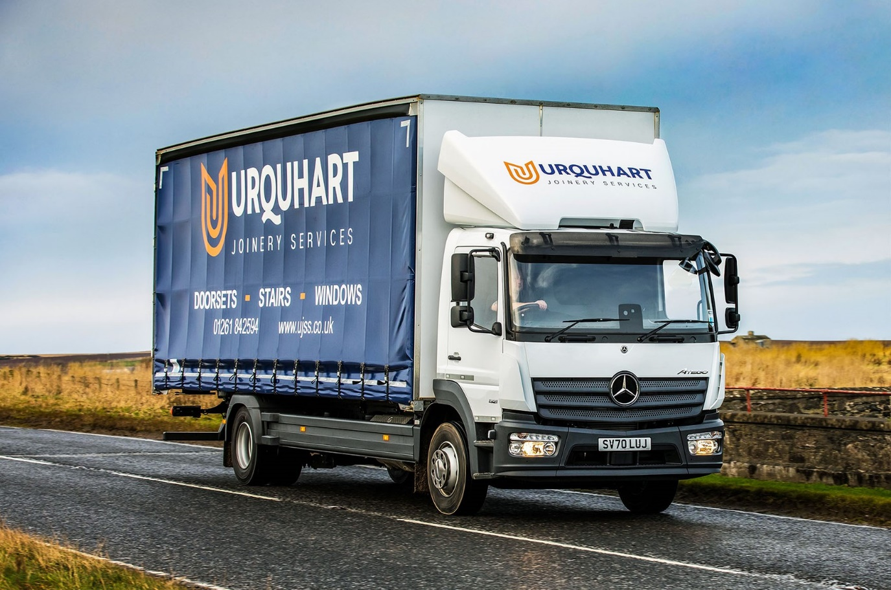

Mercedes-Benz Atego reliability and BLS Truck & Van back-up dovetail perfectly for Urquhart Joinery Services

Aberdeenshire’s Urquhart Joinery Services enjoys an enviable reputation for the high quality of its work – and demands the same exemplary standards from its truck supplier.

No surprise, then, that when the family-owned firm decided to replace its seven-year-old Mercedes-Benz, its first call was to Dealer BLS Truck & Van for another vehicle from the same model range.

Proprietor David Urquhart established his business 42 years ago, in the coastal town of Portsoy, near Banff. Urquhart Joinery Services now employs a workforce of 28 people and offers a bespoke design and manufacturing service encompassing a variety of timber products, but primarily staircases, and door and window sets.

The new 13.5-tonne Atego 1321L has a ClassicSpace S-cab and a 5.1-litre engine rated at 155 kW (211 hp). Fitted with a curtainside body by Micra Truck Bodies, of Wakefield, the truck offers a useful extra tonne of payload capacity compared to its 12-tonne predecessor.

Urquhart Joinery Services relies on a fleet of seven Mercedes-Benz vans, as well as its single truck, to distribute products as far north as the Shetland Islands, and south to Scotland’s Central Belt. The Atego is now being inspected and maintained at BLS Truck & Van’s Aberdeen workshop, under a seven-year Mercedes-Benz Complete Service Contract.

“The COVID-19 pandemic has made life extremely difficult for many people, but we were very fortunate throughout 2020,” said Mr Urquhart. “We managed to maintain a significant volume of work, which helped us through the lockdowns – although, of course, we’ve introduced new working practices to help keep our customers and staff safe.

“One thing that hasn’t changed, though, is our choice of truck,” he continued. “Our previous Atego has proved over the last seven years to be impressively rugged and reliable. When we stood it down it had more than 300,000 km on the clock, but still looked smart and had never let us down. We’ve tried other makes of truck in the past, but none came close in terms of quality.”

The company’s insistence on a truck bearing the three-pointed star has the full backing of driver Nick Nelson. “Nick loves his new Atego,” said Mr Urquhart. “The engine has plenty of power for hilly roads, while the cab is well designed and exceptionally comfortable, not least because we specified air suspension on the rear axle – this makes for a smoother, more relaxing ride, as well as helping to protect our products from transit damage.

“Another key attraction is the customer-focused back-up we receive from the BLS Truck & Van team in Aberdeen. The Dealer is still relatively new to the Mercedes-Benz franchise but has impressed with its investments in people and facilities, and commitment to supporting operators like ourselves,” continued Mr Urquhart.

“Sales Executive Chris Dyer handled our latest order extremely efficiently. He arranged the competitively priced funding from Mercedes-Benz Finance, and managed the bodybuilding phase on our behalf. We also trust his Service department colleagues to keep our truck roadworthy and operating at peak efficiency.”

Purpose-designed for light- and medium-duty distribution work, as well as construction applications, the Mercedes-Benz Atego range from 7.5-16 tones GVW offers outstanding dynamics, comfort and manoeuvrability. It also enjoys an unrivalled reputation for durability.

“When we choose a new truck our focus is on the total cost of operation over a seven-year life, and our experience confirms that the Atego is a clear winner,” Mr Urquhart said. “With the expert support of BLS & Van, I’ve every confidence that like its predecessor our latest Mercedes-Benz will exceed expectations.”

ujss.co.uk

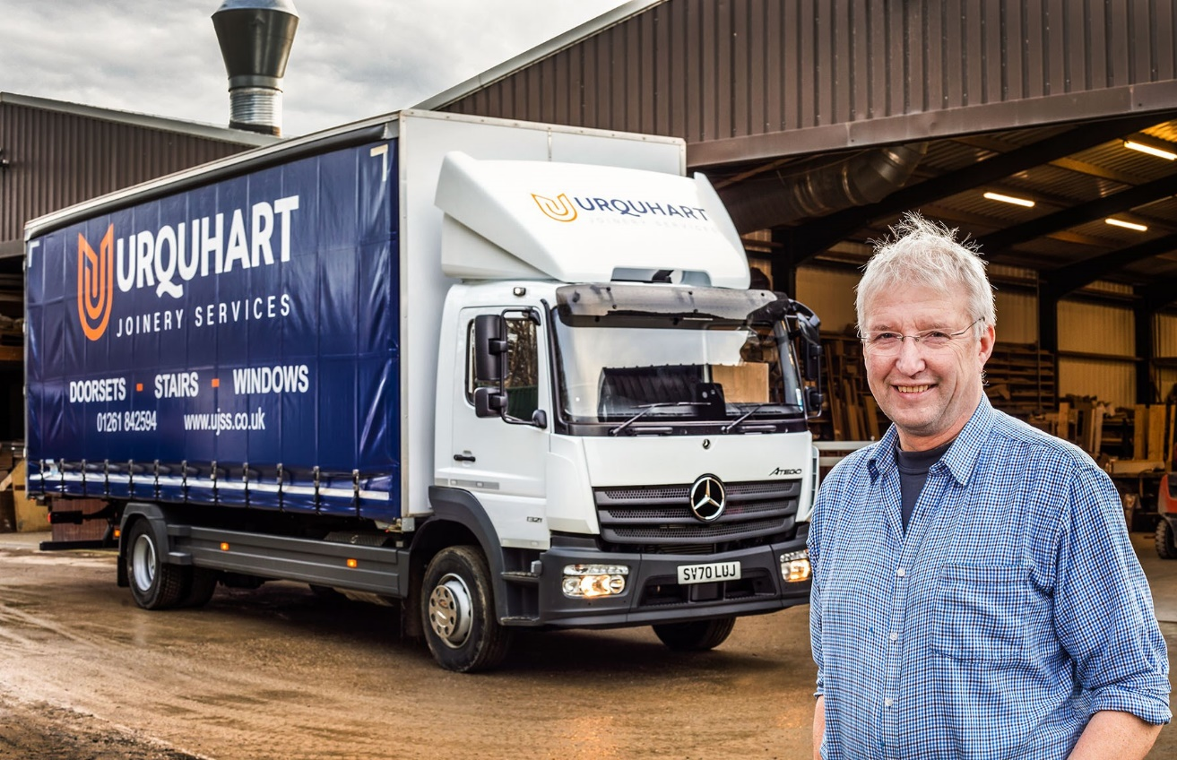

Built to last: The Mercedes-Benz Atego’s longevity is its key attribute for David Urquhart

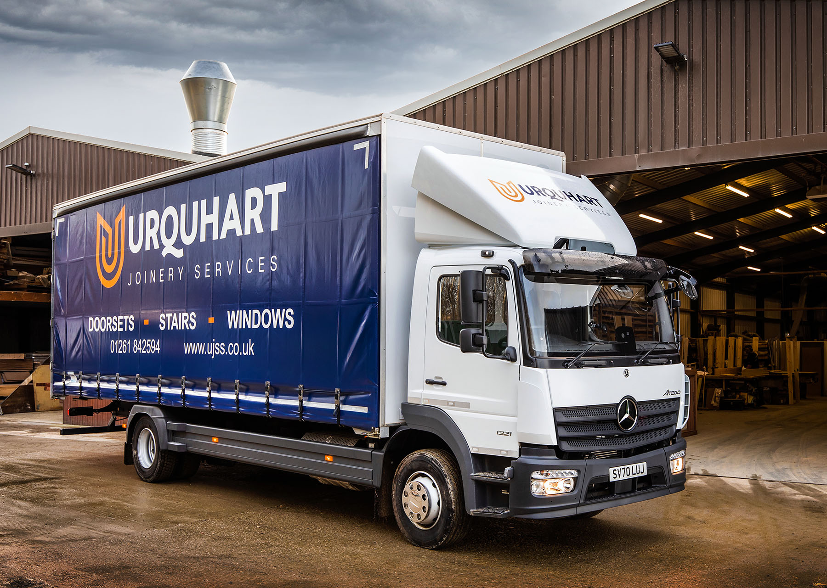
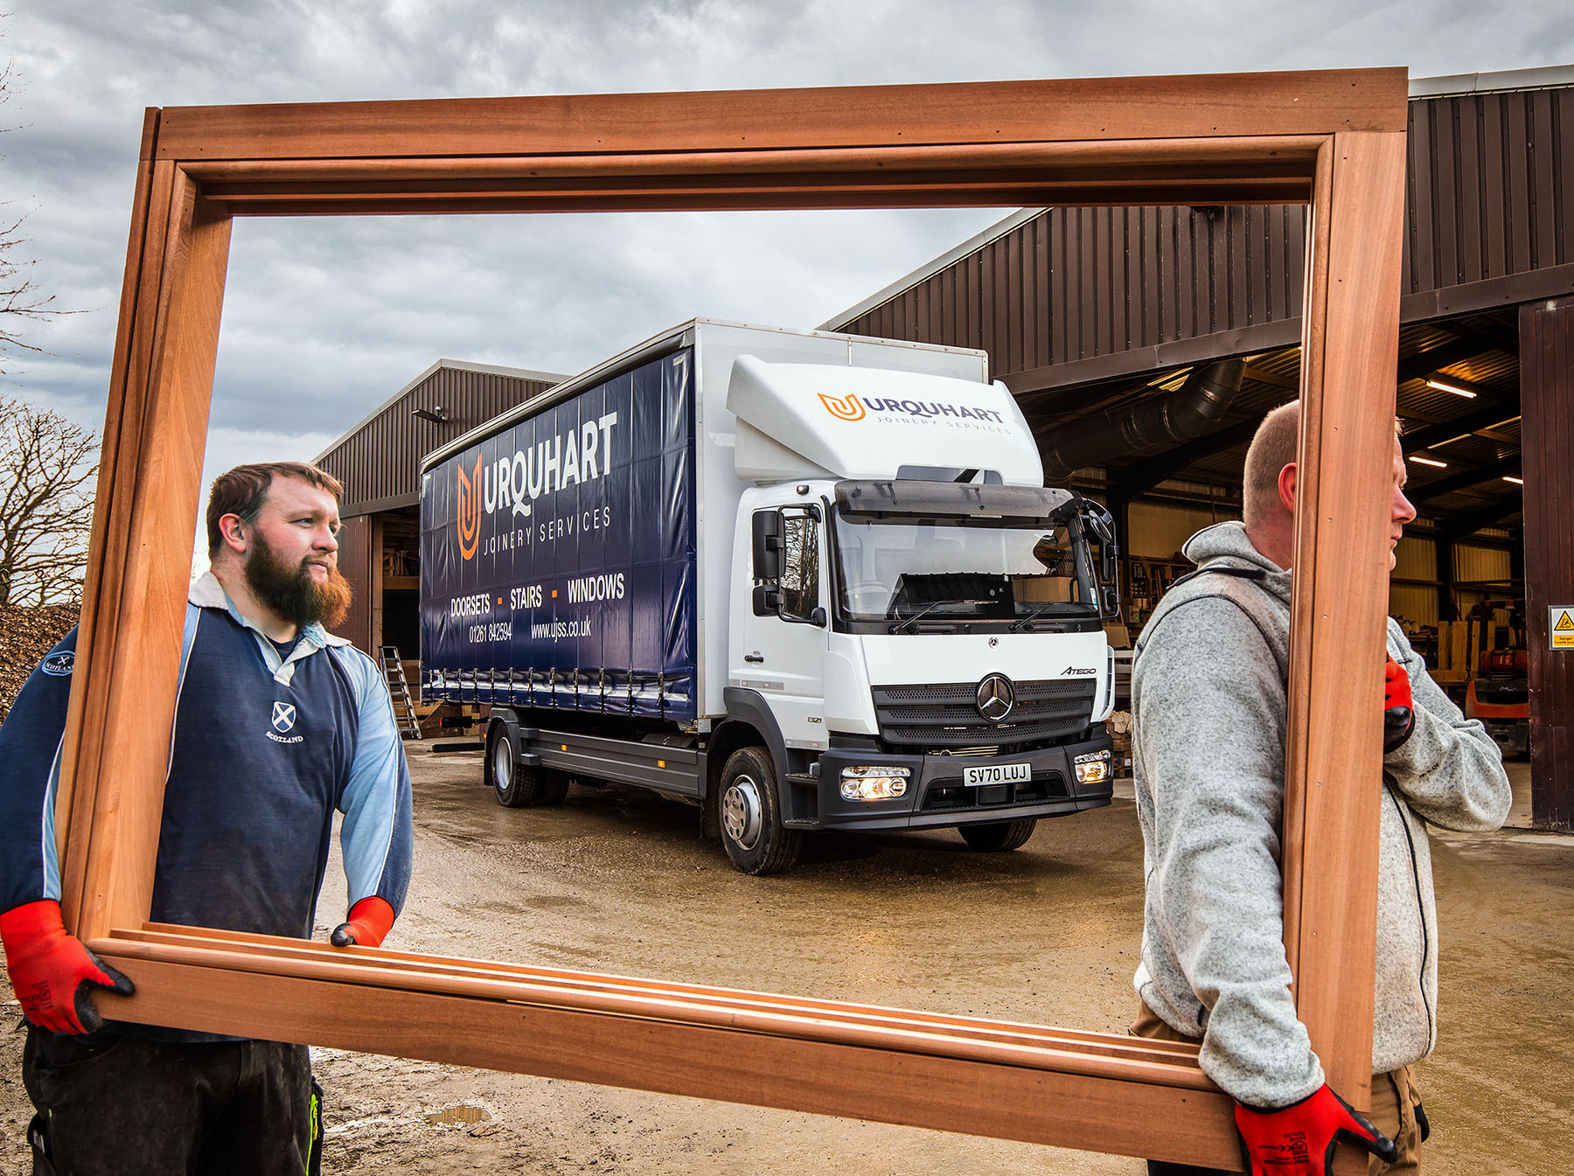

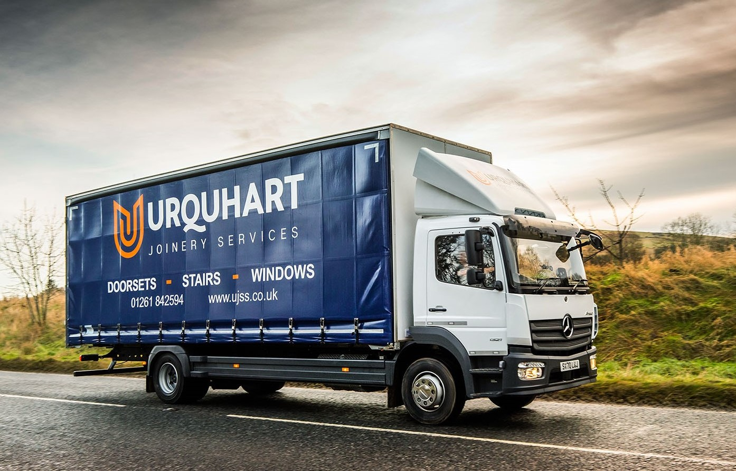

ends

For more information, or to request bigger versions of image files, please contact:
John Ripley or Steve Warren
Impact Communications, 01926 842126
John: 07771 484595, john@impactcom.co.uk
Steve: 07770 470251, steve@impactcom.co.uk



