

Date: 24 August 2022

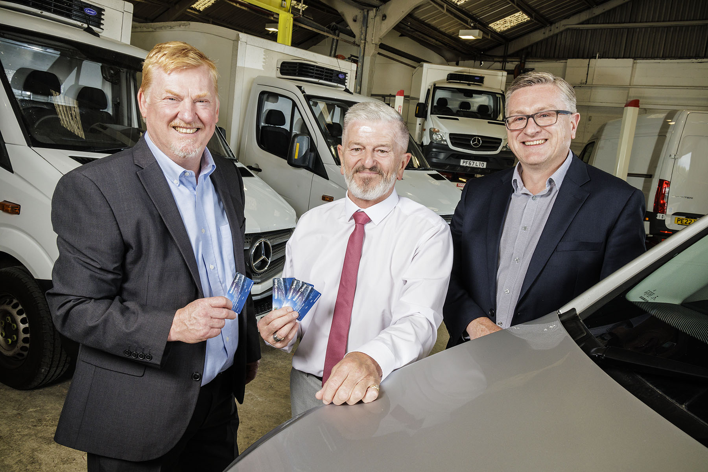
Hall of fame: Long-serving Steve, centre, is pictured with Ciceley Commercials Chairman Russell Morgan, left, and CEO Simon Wilson

Fifty years and counting for Ciceley Commercials’ unstoppable Steve Hall
Give that man a gold star for loyalty and longevity – Steve Hall has celebrated a stunning 50 years of employment at Mercedes-Benz Dealer Ciceley Commercials.

Steve reached his half-century at the end of July but has no plans to slow down just yet. He still relishes his role as Manager of the Company’s Van Preparation Centre in Blackburn – and insists he has no intention of retiring anytime soon.

“Absolutely not,” declared 65-year-old Steve. “This is a great place to work and the job is constantly evolving, with new challenges to face every day. I get to spend time with a fabulous group of people and look forward to coming in every morning. I genuinely love it.”

Ciceley Commercials was a Seddon Atkinson agent when Steve began his career as a 15-year-old apprentice technician in 1972. The following year it was appointed to represent Mercedes-Benz and is now one of the brand’s longest-serving UK Dealers.

The short commute from his home in the town still takes Steve to the headquarters site on Ciceley Lane, Blackburn, at which he started out. He also worked as Service Manager at Ciceley Commercials’ flagship branch on Junction 4 of the M65 – Steve ran the busy 24-hour workshop and was instrumental in the opening of the Authorised Testing Facility, at which inspectors from the Driver and Vehicle Standards Agency carry out truck MOT tests.

It was during this time that Steve saw his hard work – and the high performance of his department – rewarded, when he won the title of Mercedes-Benz Commercial Vehicle Service Manager of the Year on two occasions.

In his current role Steve leads a team of 13 specialists who carry out final inspections and prepare every new and used van prior to delivery to customers.

The job, of course, has changed out of all recognition. “When I started out the tools of our trade were spanners and torque wrenches,” he recalled. “For some time now, though, it’s been more common to see one of our technicians using a laptop to carry out a diagnostic test on a vehicle. And now there’s another big change underway, as the electric vehicle revolution gathers pace.”
Ciceley Commercials Chairman Russell Morgan and CEO Simon Wilson thanked Steve for his long and dedicated service by presenting him with a set of four VIP hospitality season tickets to Ewood Park, home of his beloved Blackburn Rovers FC.

An avid football fan who has been following Rovers for even longer than he’s been employed at Ciceley Commercials, Steve still lives within a couple of miles of his workplace and has five children and 12 grandchildren. His daughter Jenny is a Service Receptionist at the Dealer’s Junction 4 site, while son-in-law Ben Jones is Workshop Foreman at the Van Preparation Centre.

Simon Wilson said: “We are incredibly proud of Steve’s long and distinguished career. It reflects Ciceley Commercials’ philosophy of nurturing the brightest and best people to ensure that we can continue providing the very highest levels of service to all our customers.

“We have a strong family ethos at Ciceley. As the longest-serving member of our team Steve is leading the way but more than a quarter of our team have been part of the ‘family’ for at least 15 years.”
He continued: “Steve has made a hugely significant contribution to our ongoing success. His breadth of knowledge and experience is vast and we’re very lucky to have held onto him for so long – and even luckier that he has no plans to retire just yet!”
Ciceley Commercials sells and supports the most technologically advanced commercial vehicles on the market including Mercedes-Benz Sprinter Vito and Citan vans; Actros, Arocs, Atego and Econic trucks; and FUSO Canter light trucks. The range includes a number of zero-emission electric models.

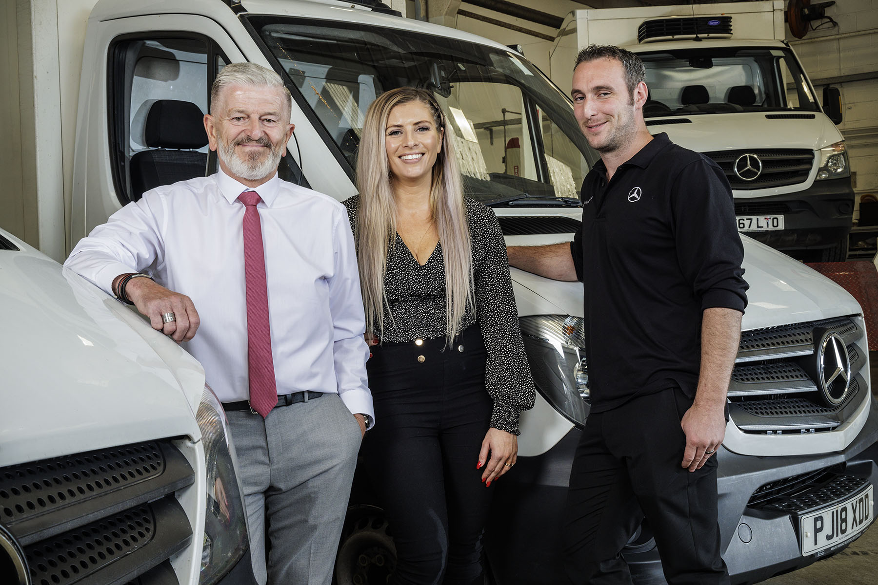

Keeping it in the family: Steve Hall is pictured with two of his Ciceley Commercials colleagues, daughter Jenny and son-in-law Ben Jones

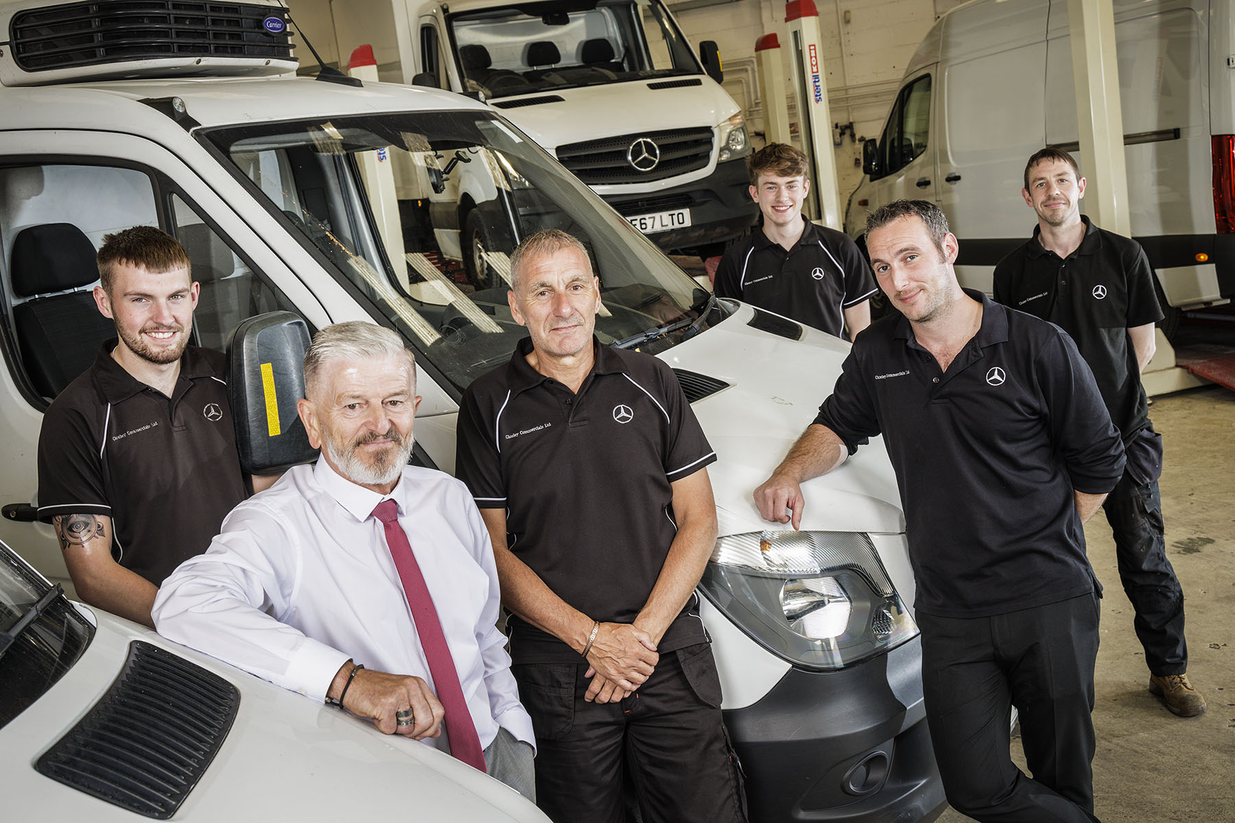

Front-runners: Steve Hall is pictured with members of his Van Preparation Centre team

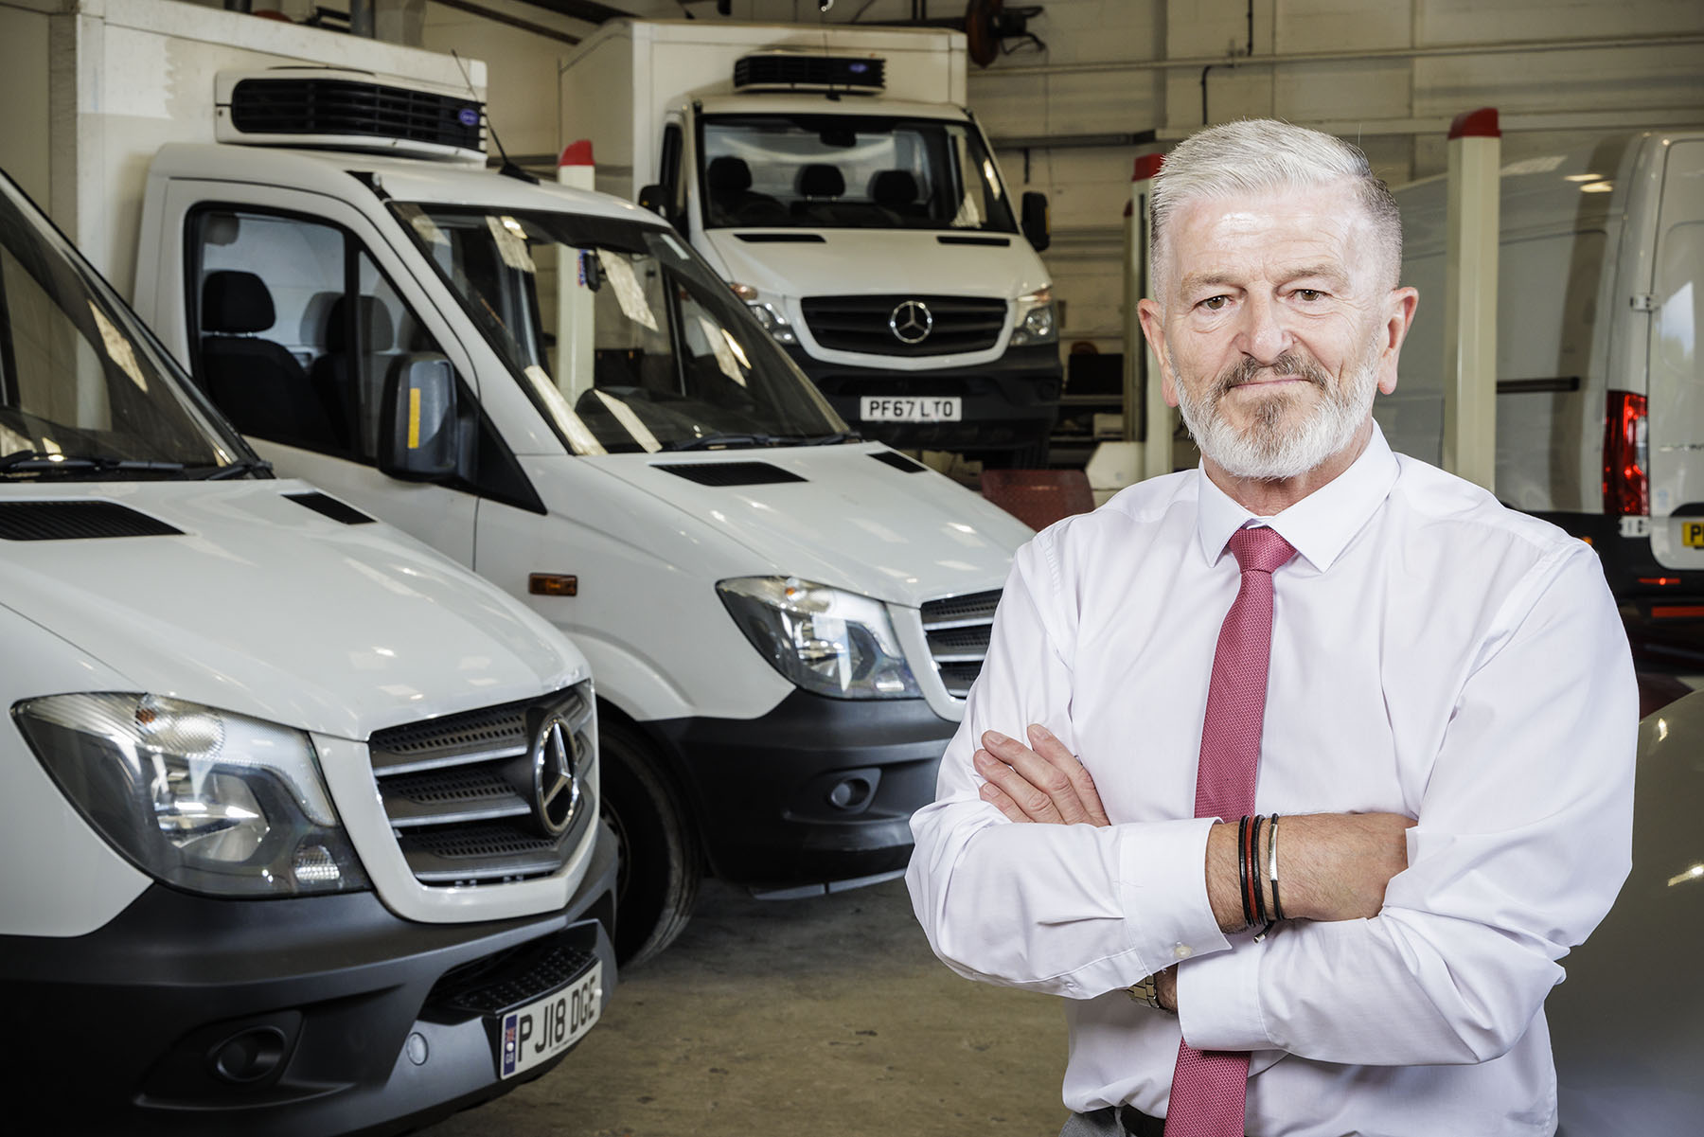

A true ‘three-pointed star’: Ciceley Commercials’ long-serving Steve Hall

ends

For more information, or to request bigger/higher-res image files, please contact:
John Ripley or Steve Warren
Impact Communications
John: 07771 484595, john@impactcom.co.uk
Steve: 07770 470251, steve@impactcom.co.uk

