

Date: 18 May 2022

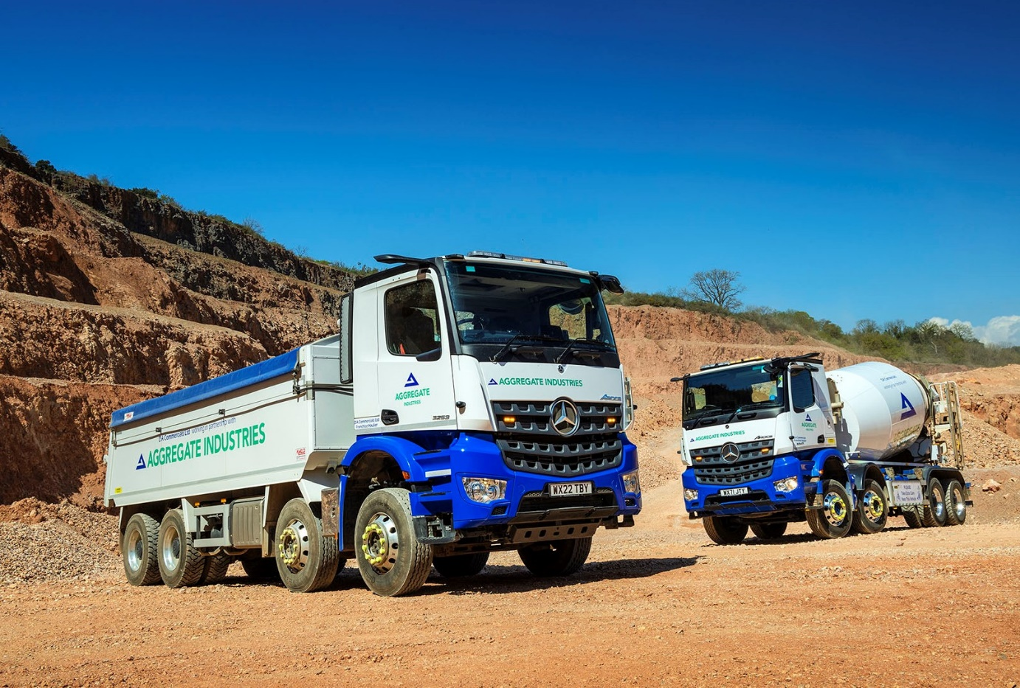

Potent Mercedes-Benz Arocs tipper rises to the occasion for DA Commercials

Devon’s DA Commercials is already saving time and hopes also to cut its fuel bill after specifying its latest Mercedes-Benz multi-wheeler with a powerful 390 kW (530 hp) engine.

Supplied by dedicated Mercedes-Benz Trucks Dealer City West Commercials, the Arocs 3253 tipper makes the steep ascent to the top of Telegraph Hill at Haldon, near Exeter, five times a day.

DA Commercials is based in the village of Beer and provides haulage services to the construction sector. Its eight trucks deliver concrete, Tarmac, aggregates and sand throughout the South West.

Acquired with competitive funding support from Mercedes-Benz Finance, the latest addition to the fleet is working out of Stoneycombe Quarry, near Newton Abbott, and serves sites in and around Exeter. Each load represents a round trip of approximately 40 miles.

Owner-driver Dan Ayling established DA Commercials in 2013 and purchased his first construction-specification 8x4 Arocs from City West Commercials Truck Sales Executive Richard Smith the following year.

The new truck is his fourth and the most potent yet, having been specified with the highest of the five outputs available from Mercedes-Benz Trucks’ 12.8-litre OM 471 in-line six-cylinder engine.

It has a ClassicSpace M-cab and an insulated aluminium tipping body by Aliweld, of Ryton, Newcastle upon Tyne. High-tech driver aids include MirrorCam, the ground-breaking camera-based replacement for conventional mirrors, and Multimedia Cockpit, interactive, the optionally upgraded version of the manufacturer’s radical twin-screen dashboard – this boasts a larger, 12in instrument panel and comes with extra functionality, including satellite navigation.

Fitted with a roof-mounted Ecco light bar and Alcoa Dura-Bright alloy wheels, the high-riding truck wears the colours of leading customer Aggregate Industries. So, too, does the Arocs 3243 truck mixer with 10.7-litre, 315 kW (428 hp) ‘straight six’ and body by McPhee, Glasgow, that DA Commercials purchased last September.

Dan Ayling explained: “The mixer makes up to six deliveries a day and the journeys are shorter – sometimes it won’t do more than 20 miles in a day but it spends a lot of time ticking over on sites.

“Whereas the tipper has to get over the top of Telegraph Hill five times a day. We’ve found that using bigger engines for this work is both quicker and more fuel-efficient, because the truck is not having to work as hard.”

Mr Ayling previously favoured a Swedish truck brand but now believes that Mercedes-Benz offers the best combination of product technology and service. He is a big fan of MirrorCam: “Rear visibility is certainly better – reversing into tight spots is very easy now,” he said.

“More importantly, though, by doing away the mirrors and replacing them with roof-mounted cameras Mercedes-Benz has also effectively eliminated a massive, forward-facing blind spot. I’ve been driving for more than 20 years and can tell you that’s a huge safety benefit, particularly on the approaches to roundabouts.”

The new tipper is driven by Marc Major while the latest truck mixer – which is also equipped with MirrorCam – is assigned to James Habayeb. “Both were sceptical about MirrorCam but very quickly changed their minds once they’d tried it,” reported Mr Ayling. “They’re getting on really well with the new dashboard too, as it’s so easy to use.”

DA Commercials also runs a 2019 Arocs mixer but sold its original Mercedes-Benz in December. “There was nothing wrong with the truck; it just made sense to downsize the fleet a little,” recalled Mr Ayling. “Pricewise, I did very well. The 2014 Arocs went for nearly three times the figure achieved for a 2014 French-built tipper I sold at the same time.

“Our Mercedes-Benz trucks have lived up to their reputation for reliability, while on the evidence of that first sale they will also do so when it comes to residual values.”

As with its previous Arocs, the new tipper is the subject of a six-year Mercedes-Benz Complete Service Contract, and maintained at the nine-bay workshop on the Greendale Business Park at Woodbury Salterton, Exeter, that City West Commercials opened in 2018.

My Ayling added: “The Dealer’s aftersales service is good while I couldn’t wish for a better sales contact than Rich Smith. He’s at the top of his game, always upbeat and a really nice guy to do business with. In fact, my relationship with Rich, and the trust I place in him, also helps to explain why Mercedes-Benz is now getting repeat custom from me.”

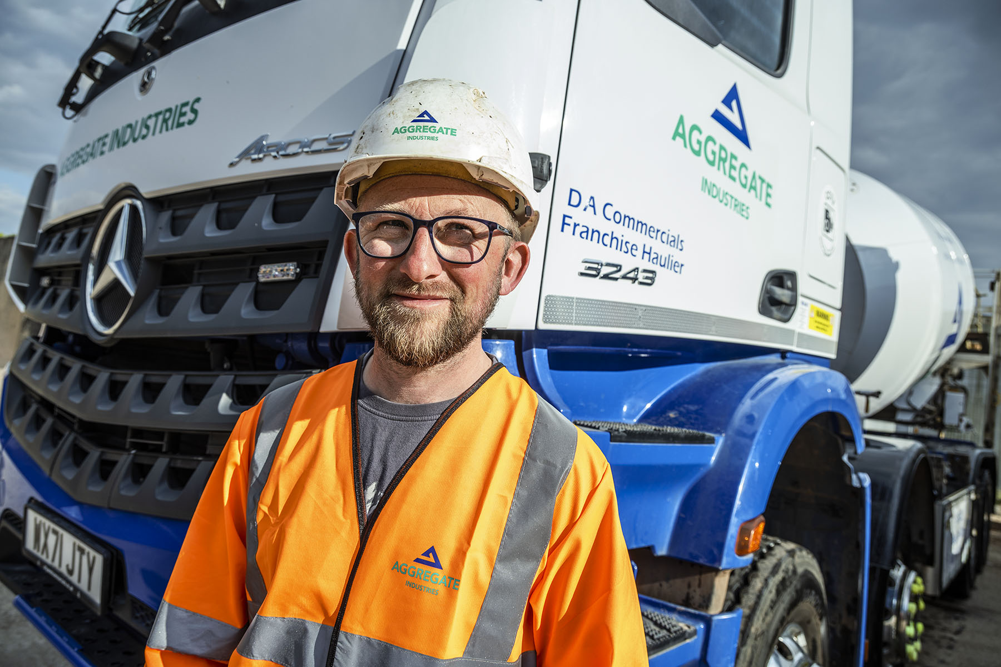

Impressed: DA Commercials proprietor Dan Ayling is delighted with the performance of his new Mercedes-Benz Arocs, and with the service he receives from City West Commercials

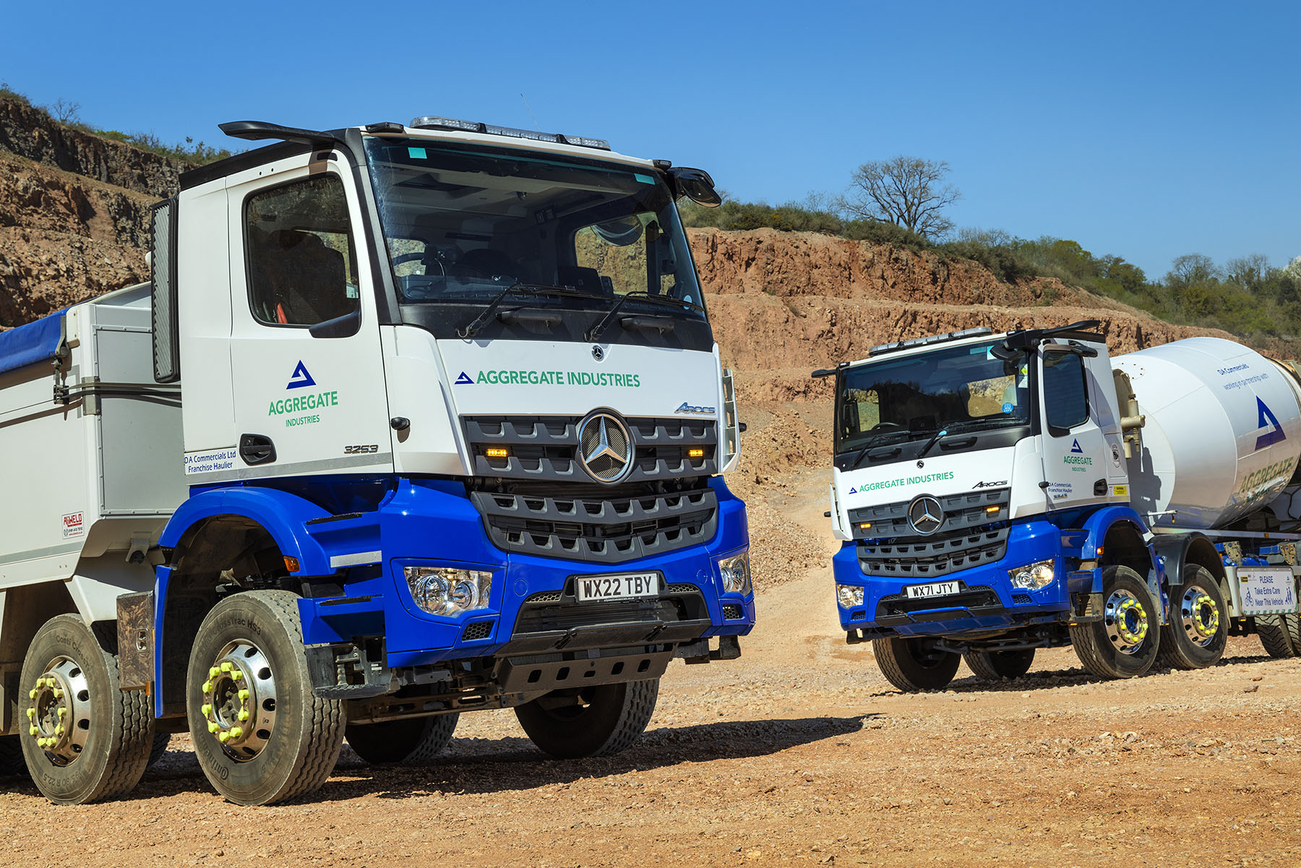

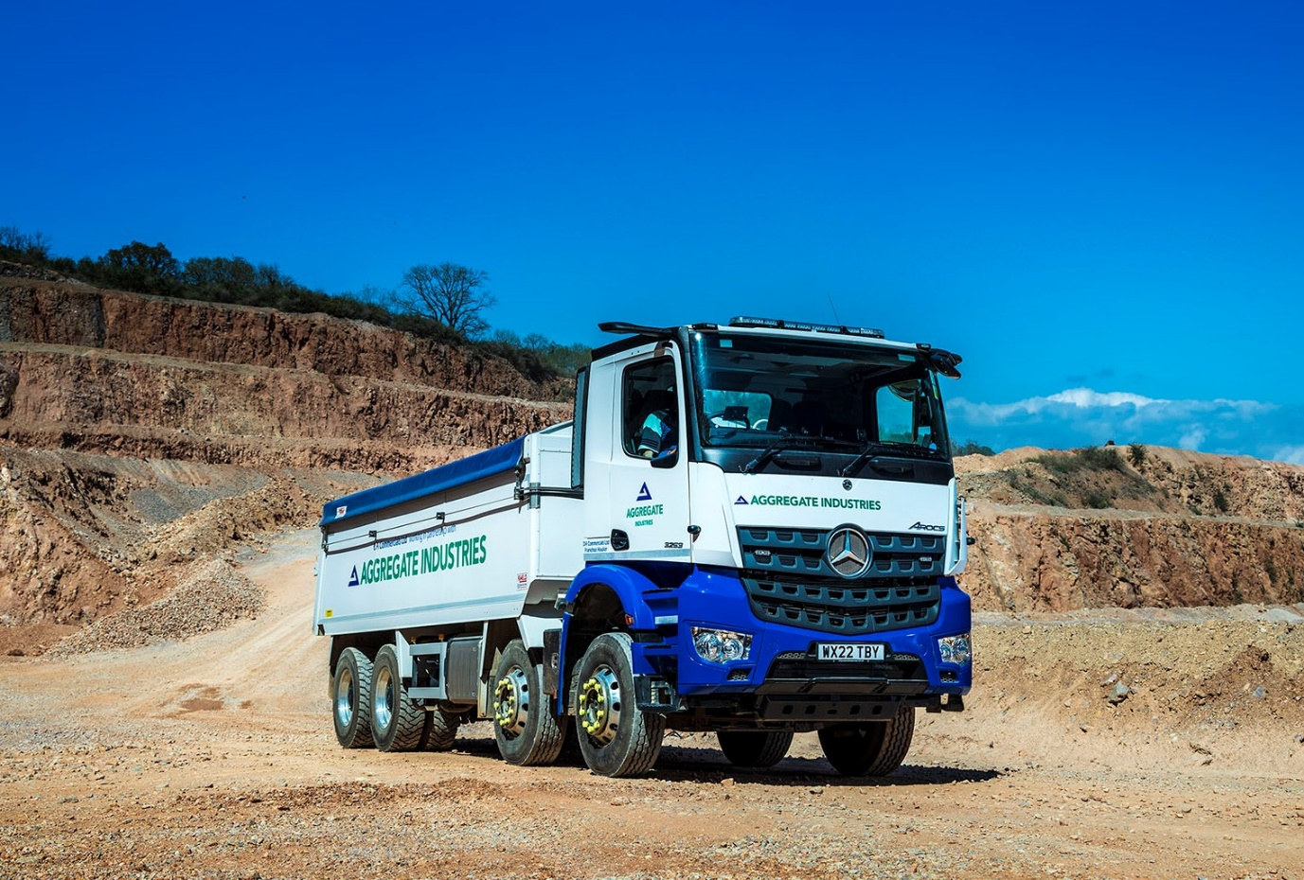

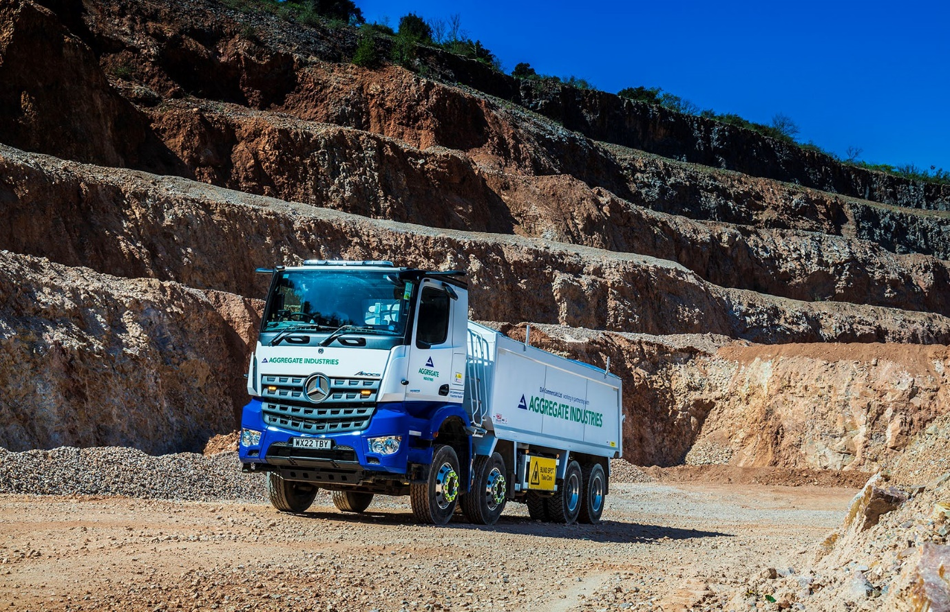

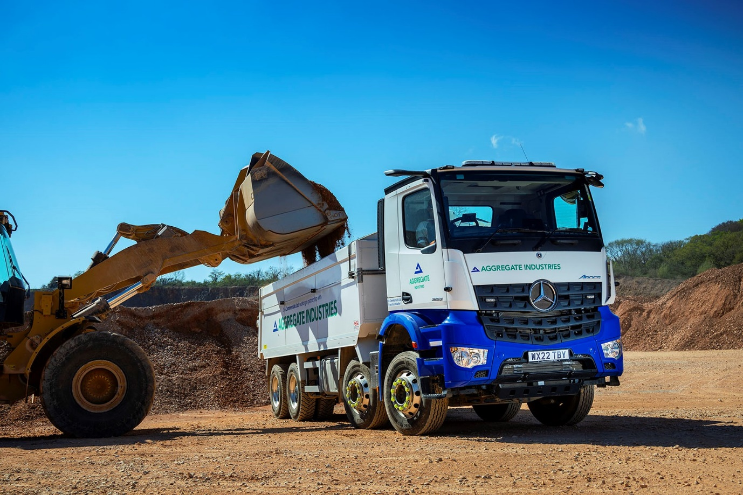

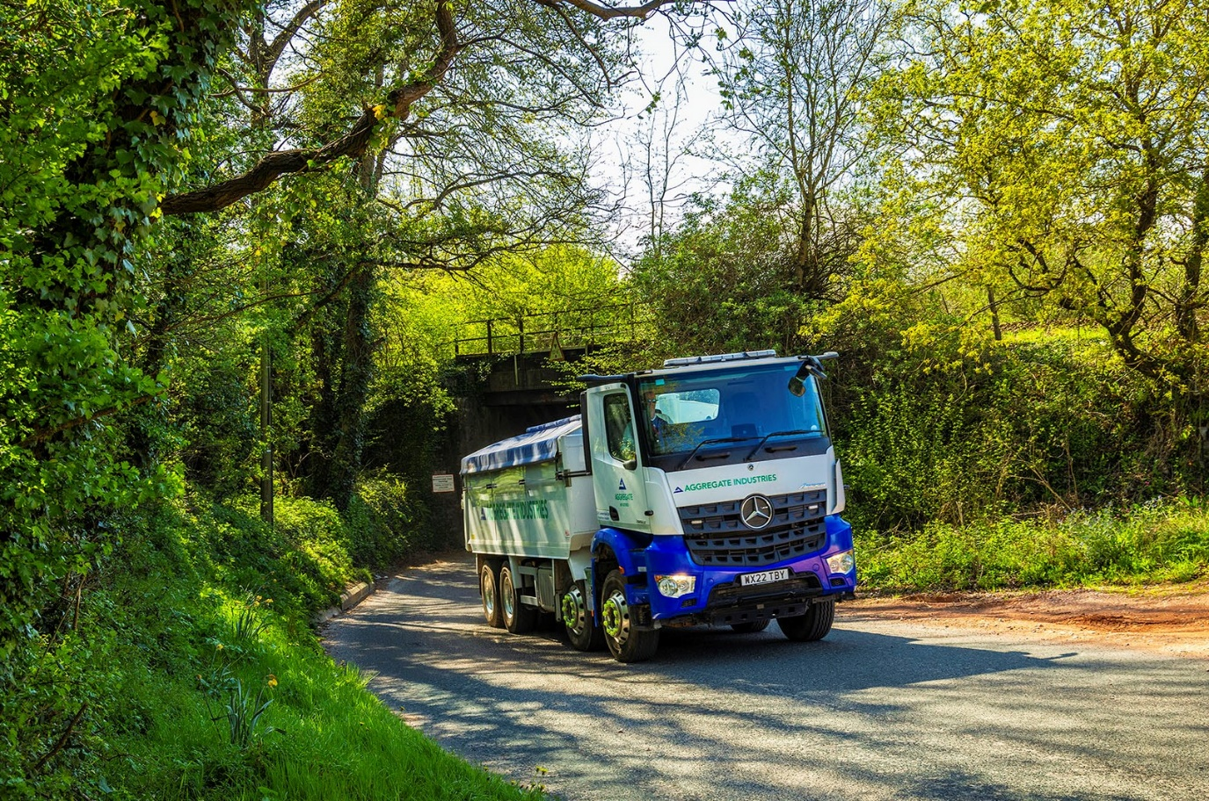

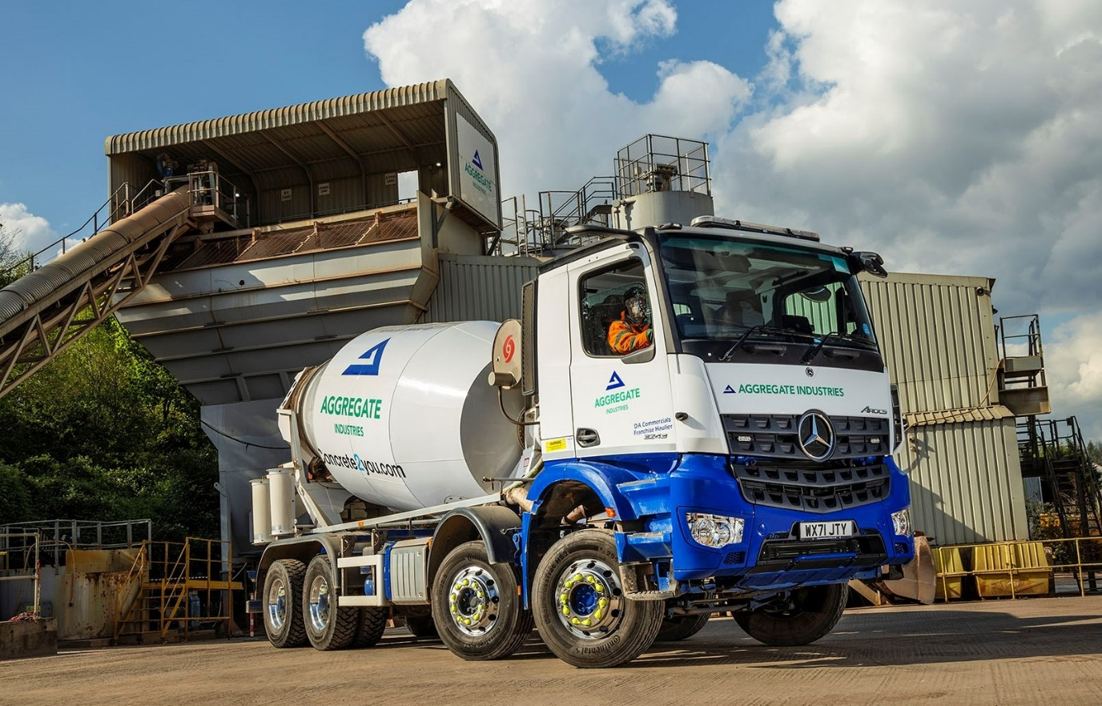

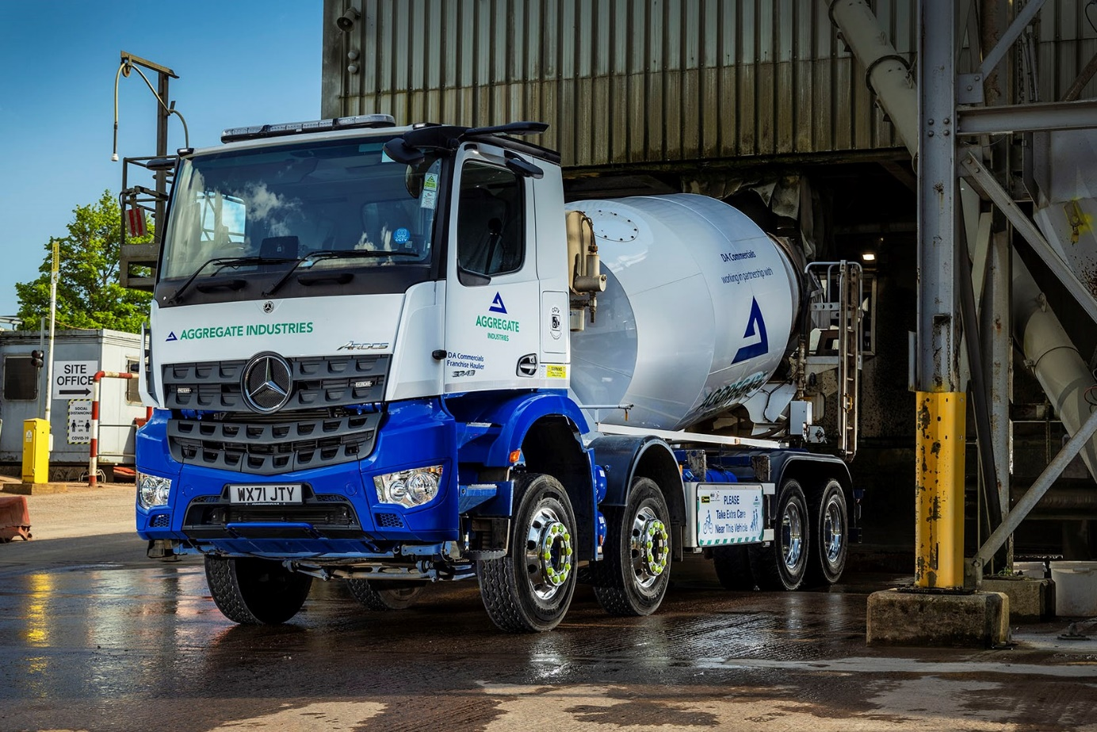

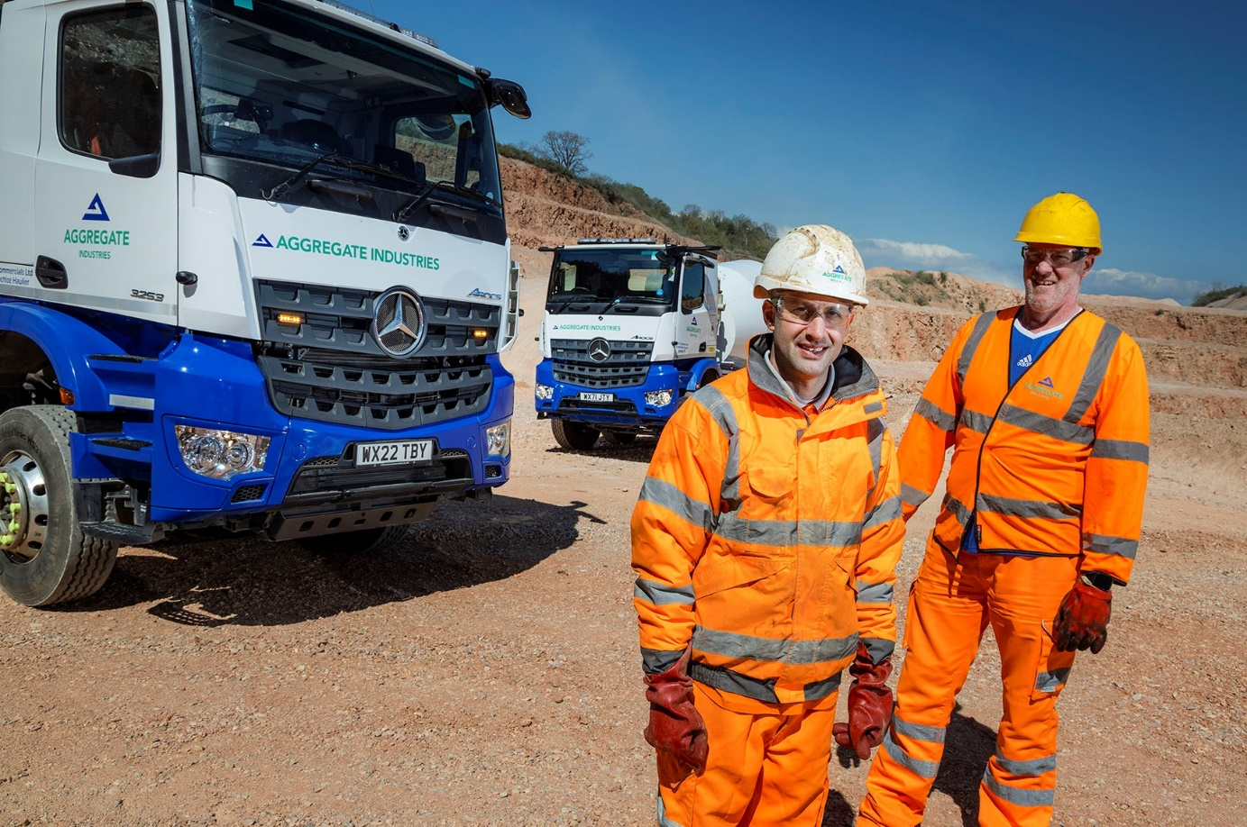

No looking back: DA Commercials drivers James Habayeb, left, and Marc Major were initially sceptical about MirrorCam, but quickly won over by Mercedes-Benz Trucks’ camera-based replacement for conventional mirrors

ends

For more information, or to request bigger/higher-res image files, please contact:
Steve Warren or John Ripley
Impact Communications
Steve: 07770 470251, steve@impactcom.co.uk
John: 07771 484595, john@impactcom.co.uk

