

Date: 11 March 2019

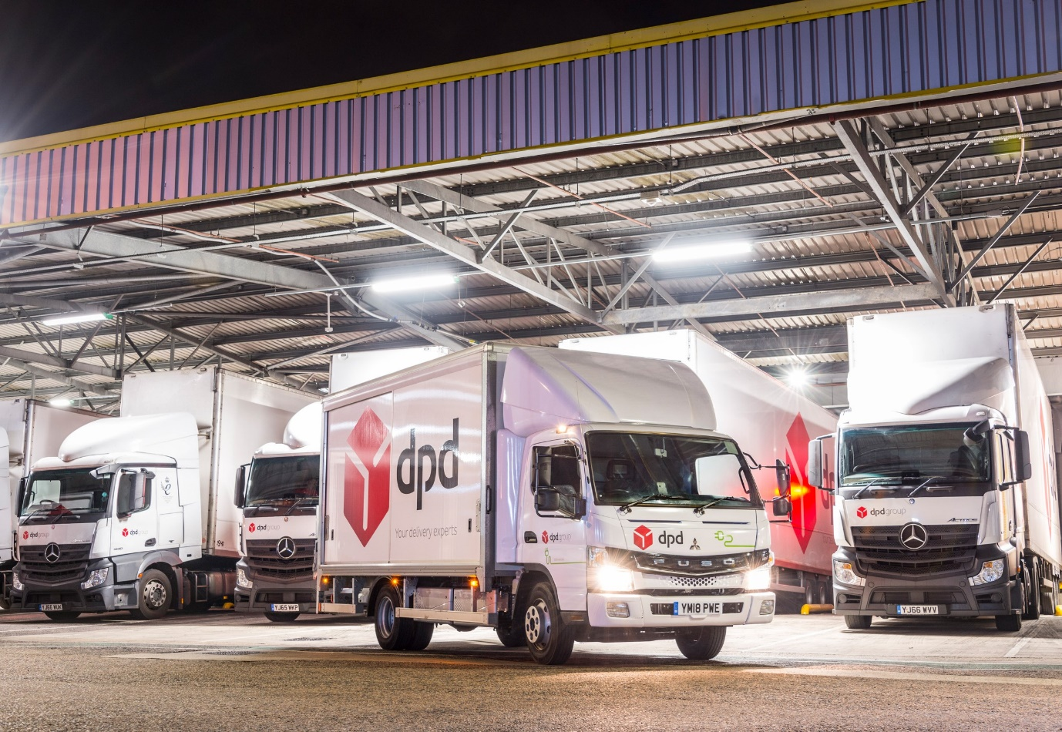

Clean air act: The FUSO eCanter represents a genuinely sustainable alternative for customers engaged in urban distribution operations, and is integral to DPD’s EV strategy

DPD driver relishes his zero-emission FUSO eCanter’s ‘sounds of silence’

Delivery leader DPD has issued a glowing half-year report on the performance of its first fully-electric FUSO eCanters, the 7.5-tonne trucks having proved 100% reliable and won enthusiastic driver feedback for their comfort and quietness.

“Reducing and neutralising our carbon footprint by providing smarter and more efficient urban delivery solutions, and investing in innovation, are at the heart of DPD’s DrivingChange programme,” explained Rob Fowler, the company’s General Manager – Corporate Social Responsibility & General Planning. “We want to be the leader in alternative fuel vehicles in the UK, and the FUSO eCanter is integral to our EV strategy.

“Aside from the fact that it produces zero tailpipe emissions and therefore offers exemplary environmental credentials, this vehicle is ideally suited to urban operation thanks to its combination of agility and high payload potential. We’ve had no issues during their first six months in service with either of our eCanters, and on the basis of their reliability and performance we look forward to commissioning more.”

The world’s first fully electric light-duty truck to enter series production, the FUSO eCanter represents a major advance in the battle to improve air quality in towns and cities. DPD took delivery of two vehicles at a launch event last year, where others were presented to Hovis and Wincanton PLC for operation in the capital.

DPD’s eCanters are based at its London City Distribution Centre in Bermondsey, south of the Thames. The first delivery, for driver Michael Zammett, is always the same. Having unplugged his truck from its overnight charging point, he loads the Bevan-built box body via a Dhollandia tail-lift then heads for the UK’s first, all-electric parcel delivery depot, which was opened by DPD on Vardon Street, Westminster, last October.

Depending on the traffic conditions, the route takes him over Westminster or Lambeth Bridges. Either, way, it’s a journey of less than three-and-a-half miles, but typically takes the best part of 45 minutes to complete. Twenty years a professional, Michael is used to negotiating the very worst that central London’s congested streets can throw at him.

“It’s important, particularly when you’re under pressure, to remain cool at the wheel,” he said. “The traffic can be frustrating at times, but there’s nothing to be gained from getting stressed; it doesn’t get you there any quicker. Plus, of course, a calm, relaxed driver, is also a safer driver, and safety is DPD’s number one priority.”

His truck’s smooth, near silent driveline complements this approach. With its instant torque delivery, it is lightning quick from 0–30 mph, and Michael acknowledges: “When you first drive an eCanter it’s the instant acceleration that is most striking. But what you then, very quickly come to appreciate, is that it’s also so much quieter than a diesel-engined vehicle. The lack of noise and vibration makes the experience at the wheel far more enjoyable, and means I’m nothing like as tired at the end of the day.”

The FUSO eCanter, which is scheduled to go on general sale via the Mercedes-Benz Dealer network in 2020, offers cost savings worth up to 1000 Euro for every 10000 kilometres covered, compared to a diesel-engined truck. Powered by six 420 V and 13.8 kWh lithium-ion batteries, its electric drivetrain with permanent-magnet motor delivers 129 kW (180 hp) via a single-gear transmission in the rear axle. The truck offers a body and payload allowance of up to 4.5 tonnes, and a single charge allows effective operating ranges of more than 62 miles (100 km).

That, for Michael Zammett, is more than enough; he will rarely cover half this distance in a full day’s shift. The electric Canter shares the tight turning circle of its diesel- and hybrid-powered stablemates, and on reaching the smart new Westminster depot, with the additional aid of his reversing camera it’s a simple task for Michael to manoeuvre his vehicle into position outside, so the process of unloading can begin.

The first of eight such facilities which DPD plans to open in London – the second will be in Shoreditch – it employs an all-electric fleet of 18 vehicles to make final mile deliveries of up to 2,000 parcels per day. On returning to the London City Distribution Centre, Michael takes his statutory 45-minute break before reloading and setting out again on a round of general deliveries in central London.

He is delighted to be playing his own small part in shaping the future of transportation. “I feel privileged, being one of the first to drive a fully-electric truck for DPD in the UK,” Michael confided. “It’s quite an honour to be honest.”

www.dpd.co.uk

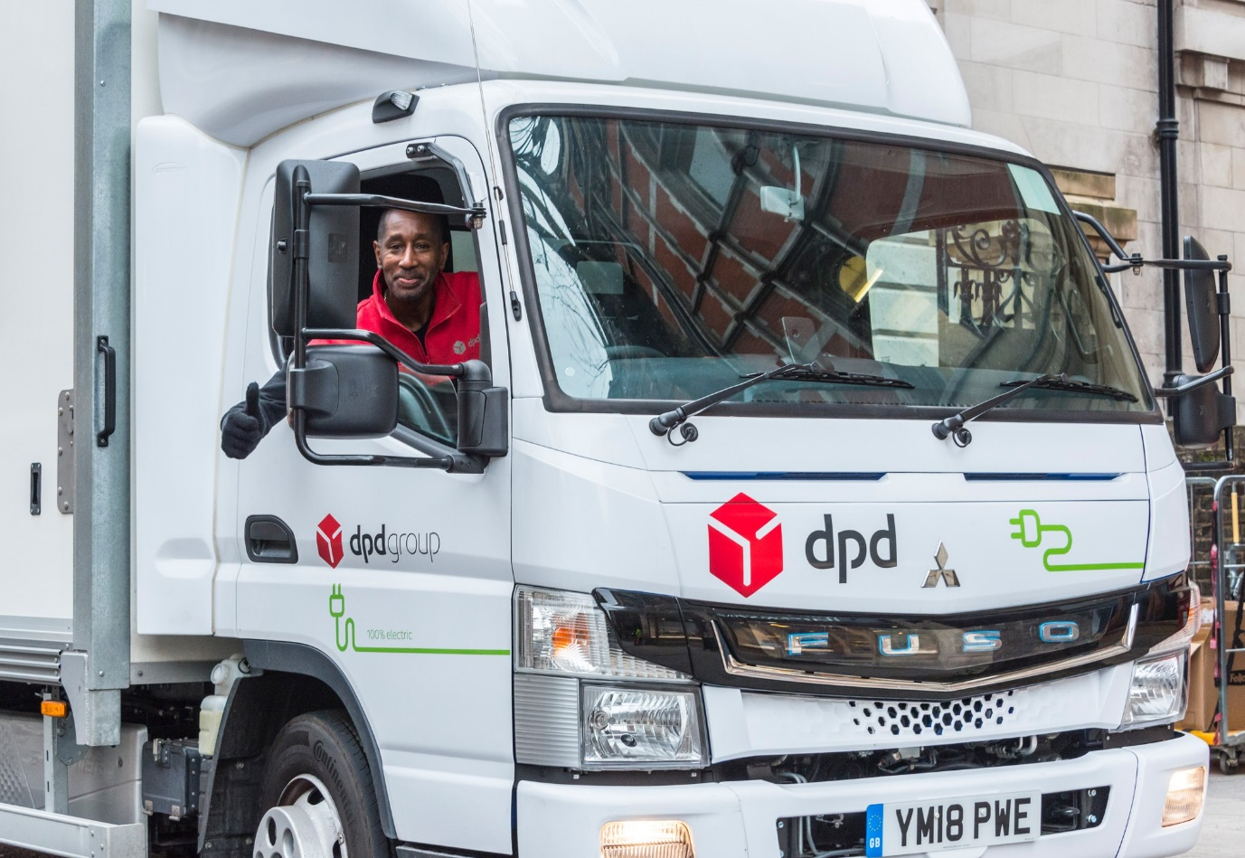

Cool, calm and collected: Driver Michael Zammett says the absence of noise from his FUSO eCanter helps to make life at the wheel less tiring and stressful
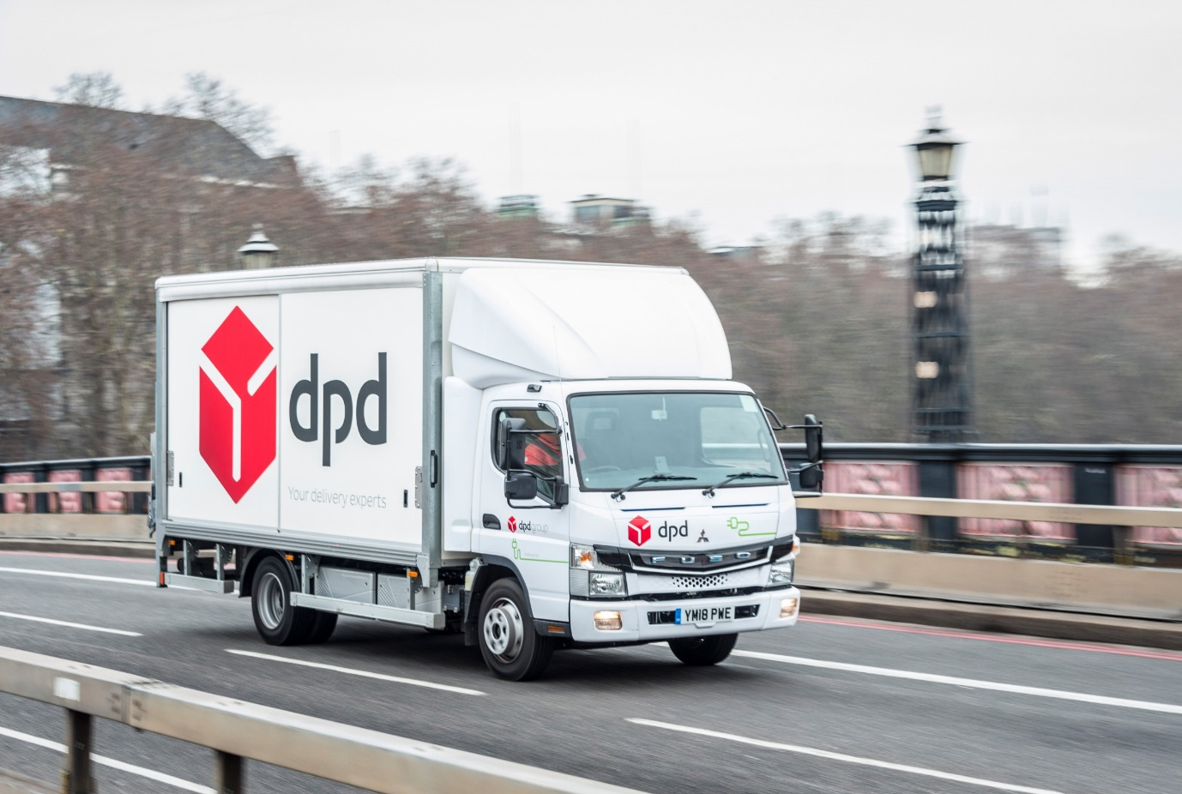

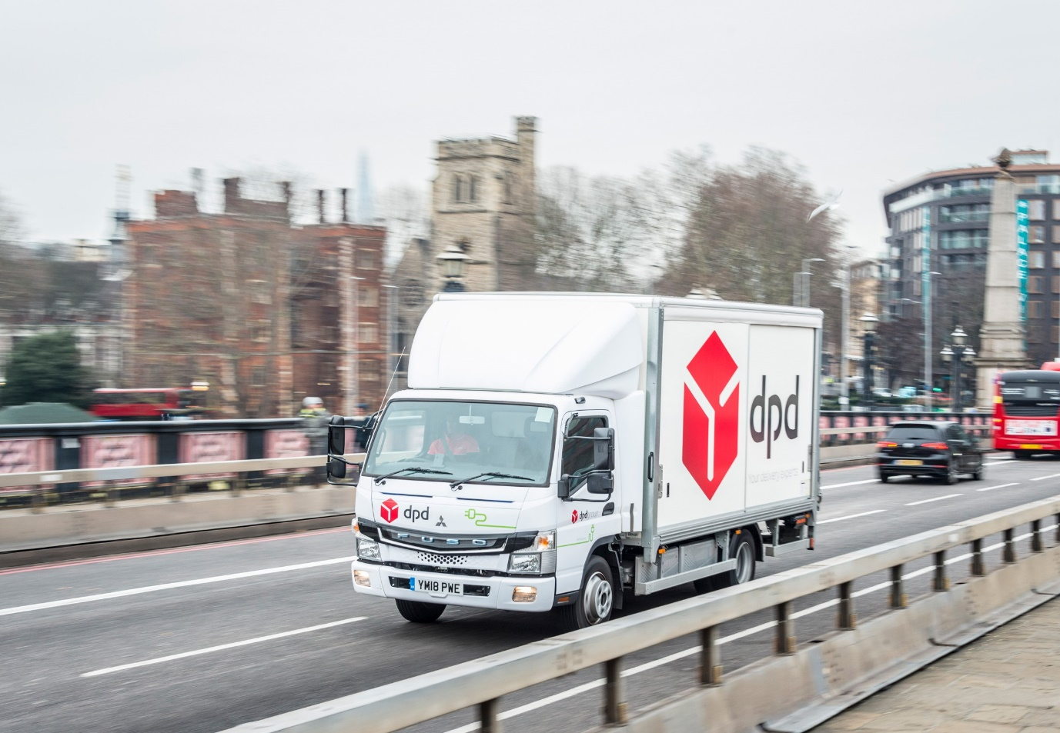

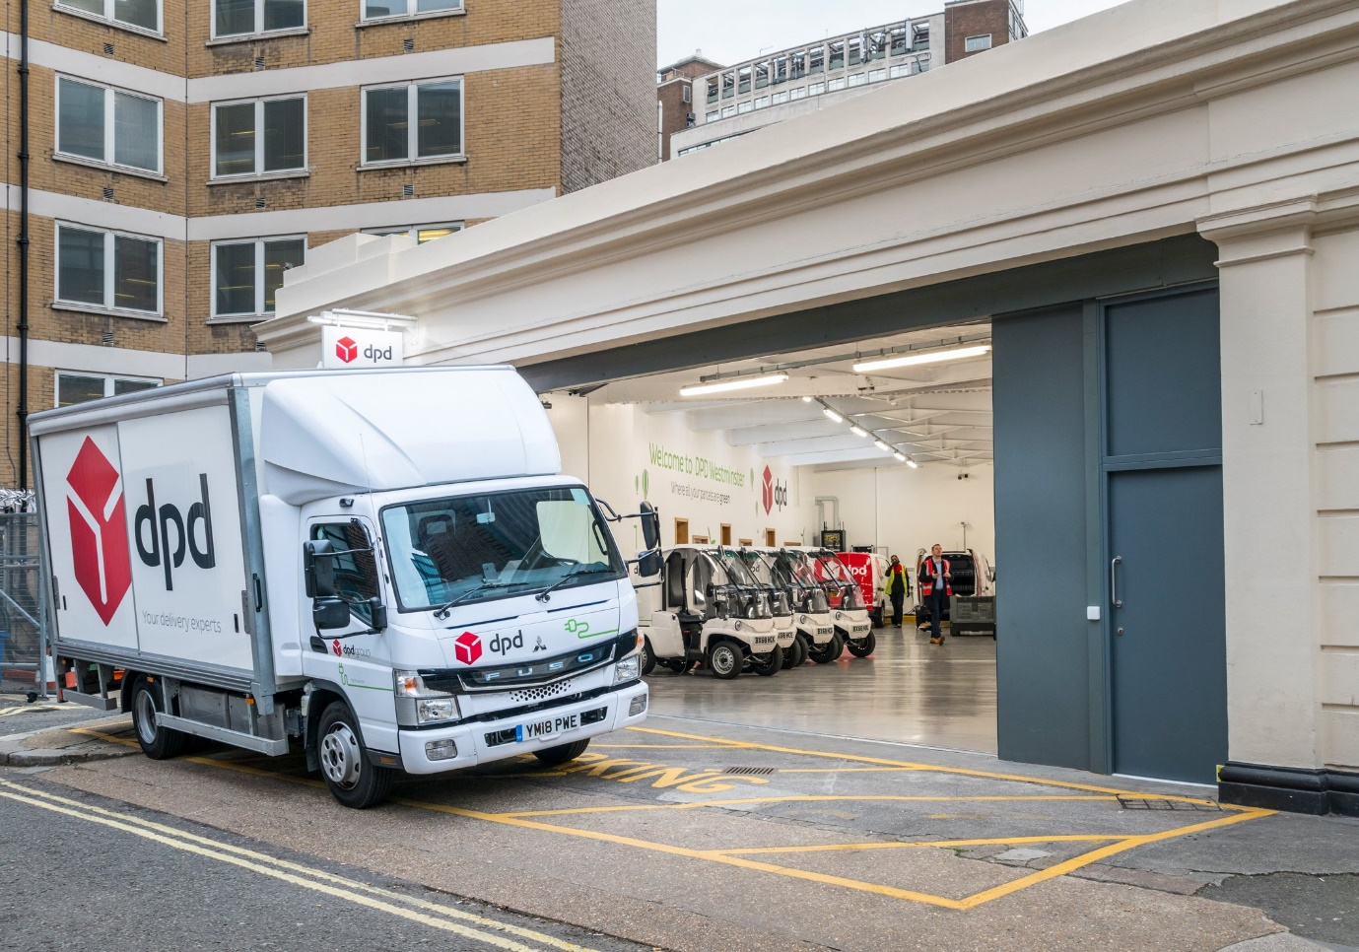

Leading from the front: Having opened its first all-electric final mile delivery depot in Westminster last October, DPD plans to add another seven across the capital

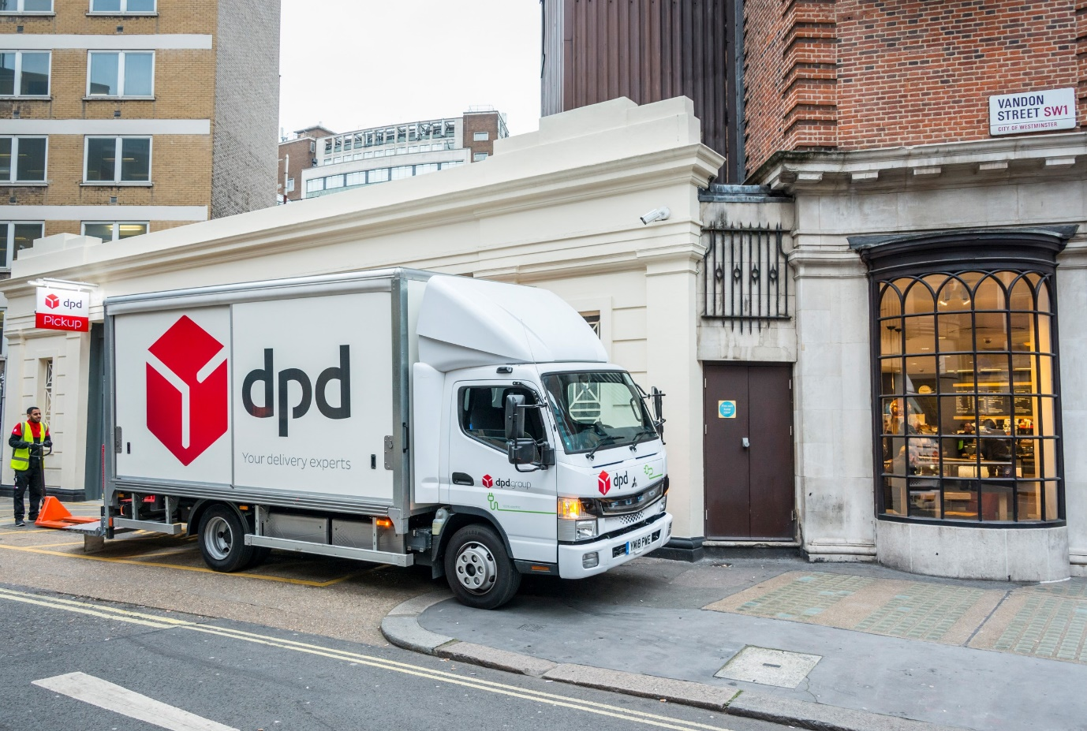

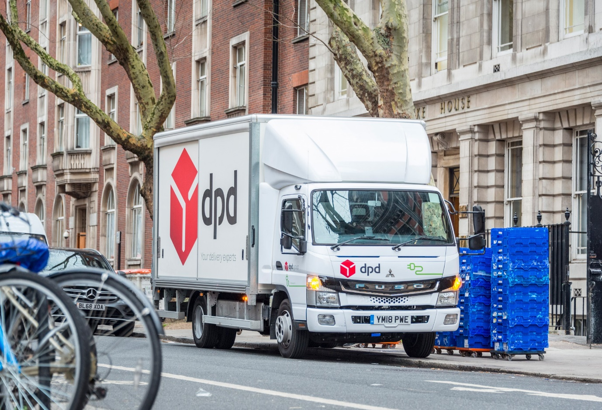

ends

For hi-res image files, please visit:
media.mbtrucks.co.uk

For further information, please contact:
Jamie Fretwell, PR & Internal Communications
Mercedes-Benz Trucks
07712 519230, Jamie.Fretwell@daimler.com
or

Steve Warren or John Ripley
Impact Communications, 01926 842126
Steve: 07770 470251, steve@impactcom.co.uk
John: 07771 484595, john@impactcom.co.uk

About Mercedes-Benz Trucks UK Ltd

Mercedes-Benz Trucks UK Ltd is the sales and marketing organisation responsible for all Mercedes-Benz truck products in the UK, including FUSO Canter.

In 2018, the company registered 8,061 new trucks. After growth in 2017, Mercedes-Benz registrations levelled off to 7,223 trucks in 2018, ensuring it retained its title as the second-biggest truck brand in the UK. Meanwhile, FUSO made great strides to reach 838 registrations – including 675 new trucks over 6.0-tonnes.

For more than 125 years, Mercedes-Benz has stood for innovative vehicles that meet exceptionally high standards of quality. Our claim to perfection, sustainability and avant-garde design is now embodied in the next generation of trucks: Actros, Arocs, Atego, Econic and Unimog.

www.mbtrucks.co.uk

