

Date: 20 May 2022

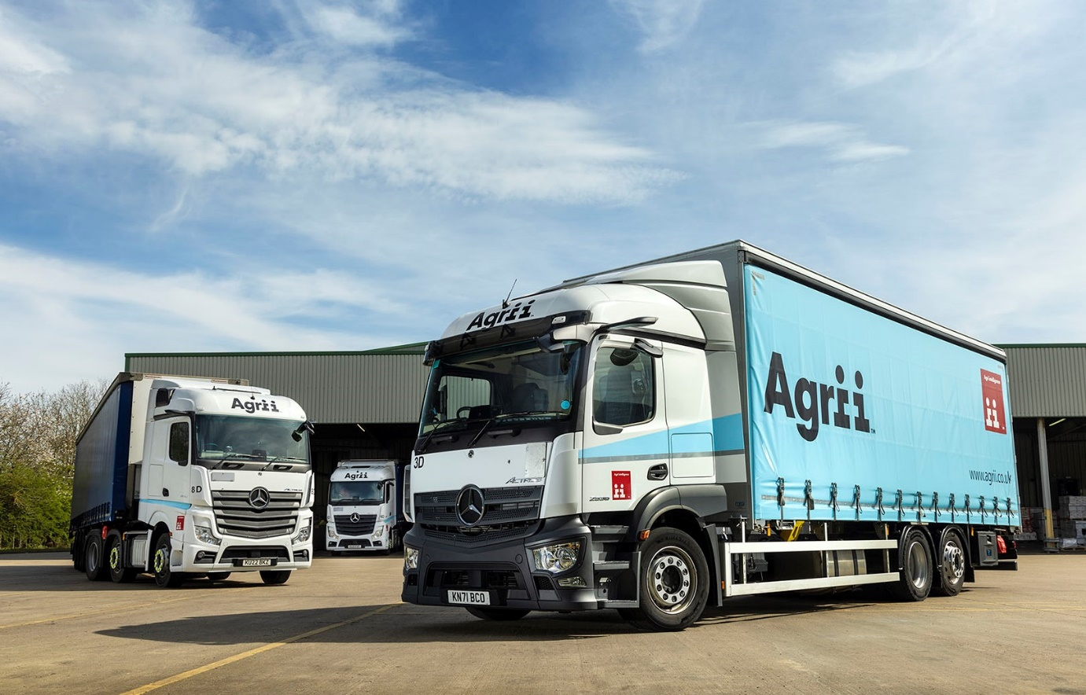

Agrii begins growing its own with the backing of Mercedes-Benz Dealer Intercounty Truck & Van

Agricultural services and agronomy business Agrii has sown the seeds for a bumper crop of skilled employees by establishing a dedicated driver academy and ordering a new fleet of 22 Mercedes-Benz trucks.

The company hopes the combined appeal of a structured staff development programme and some of the most advanced and comfortable vehicles on the road will help it to attract and retain drivers of the highest calibre.

Agrii began doing business with Dealer Intercounty Truck & Van early last year. Since then it has taken delivery of five Mercedes-Benz Actros tractor units – including an exclusive Edition 1 model – and four 26-tonne Actros. Also due to enter service over the coming months are two more tractors and another six-wheeled rigid, as well as 10 Atego 15-tonners.

National Distribution Manager Richard Pinnock said that together with the Agrii Driver Academy Initiative (www.agriidriveracademy.com), which went ‘live’ this month (May), the company’s investment in the finest new vehicles reflects its determination to provide the best working environment for members of its team, both now and in the future.

“We’re putting a lot of effort into this programme and vehicle selection is a critical part of the equation,” he asserted. “Our research indicated that these Mercedes-Benz trucks are the best available for the work we do, and they’ve already been well received by our drivers.”

Working from a national network of depots, Agrii’s trucks deliver seed, fertiliser and other agricultural products to farms across the UK. The tractor units make the biggest ‘drops’, as well as trunking at night from its site at Alconbury, Cambridgeshire, to depots as far afield as Inverness.

The 26-tonners are all LnR models, with lower chassis that help to maximise volume, while also making life easier for drivers when unloading at farms. “These low-riding rigids are absolute gems,” enthused Mr Pinnock. “The reduced deck height really does make a difference. The smaller Atego, meanwhile, will give us even more flexibility to use the best-sized vehicle for each delivery run.”

He continued: “We’re delighted with our Mercedes-Benz trucks and I can’t praise Intercounty’s Sales Executive Amit Verma highly enough. He’s made a real effort to understand the precise nature of our business and has put in the time to help us come up with the optimum specifications for what is definitely not a standard road transport application.”

There was praise too, for the Dealer’s aftersales service. Transport Manager Jonathan Read said: “We began using Intercounty’s Peterborough branch in March, after commissioning the first Actros tractor unit for our depot in nearby Alconbury.

“I have been very happy with the support from day one. The keys to a strong partnership between any service provider and transport department are honesty and communication. Provided you have these, any issues or problems that might occur within the fleet can be successfully managed.

“Intercounty are very proactive when it comes to communication. When vehicles are due in the workshop they’ll always contact us at an early enough stage so that we can plan around any issues. We’re confident, too, that we can trust what the Dealer tells us.”

With the exception of the Edition 1, which has a range-topping GigaSpace cab and a 460 kW (625 hp) 15.6-litre in-line six-cylinder engine, Agrii’s Actros tractor units are all 2545 StreamSpace variants with 12.8-litre ‘straight sixes’ that produce 330 kW (450 hp). One of the next pair of tractors to arrive will be to identical specification, while the second will be a 2551 model with a 375 kW (510 hp) version of the same engine.

The rigid vehicles already on the road and those yet to come also employ six-cylinder powerplants. The 6x2 Actros 2536s have StreamSpace cabs and 10.7-litre, 265 kW (360 hp) engines. Their curtainside bodies are by Lincoln Commercial Bodies, which will also be building the bodies for the Atego 1530s. These will have ClassicSpace L-cabs and 7.7-litre units with 220 kW (300 hp) outputs.

Lead Driver Ian Coker was one of the first to receive the keys to a new Actros tractor unit, and has since clocked-up 70,000 miles. “It’s just great,” he declared. “The seat is really comfortable and very easy to adjust so I have a perfect driving position that provides excellent visibility from the cab.

“On the road the Actros is such a relaxing drive. Predictive Powertrain Control is a really useful feature and it’s very reassuring to know that if something were to go wrong Active Brake Assist 5 is on hand to intervene. My truck hasn’t missed a beat either.”

Transport Co-ordinator & Driver-Trainer Peter Dudgeon is impressed with Mercedes-Benz Trucks’ radical dashboard design, which replaces traditional switchgear with twin tablet-style screens, one with ‘touch’ functionality.

“The Multimedia Cockpit is highly intuitive to use and all systems are easy to access from the steering wheel controls,” he noted. “MirrorCam (the manufacturer’s ground-breaking replacement for conventional mirrors) gives a great view to the rear, even allowing you to see the ‘blind side’ when reversing. I also like the fact that you can switch on the cameras when you’re parked up at night, to keep an eye on anyone poking around the vehicle.

“The ‘Hold’ function on the brakes is ideal for hill starts when loaded or empty,” he continued, “while the Mercedes Powershift transmission is a lot smoother than the gearboxes on other vehicles I’ve driven. For me, the overall feel of quality, from the new dash to the comfortable seats and bed, is unmatched by any other manufacturer.”

The Agrii Driver Academy was set up in partnership with training provider WTTL, of Devizes, Wiltshire, to provide an innovative solution to the continuing challenges of the driver recruitment market.

Applicants hoping to join the Agrii team apply for a place and, if accepted, become trainee drivers. Through guided education and practice they progress to increasingly larger and heavier vehicles, earning as they learn, on the way to becoming fully qualified heavy goods drivers. The first intake of 12 applicants have now embarked on their journey towards qualification at the end of a two-year programme with a broad curriculum that will equip them with the range of skills required for the job.

Richard Pinnock added: “We believe this ‘joined-up’ approach, whereby recruits are supported throughout the training process, will help to produce drivers who are invested in the Agrii approach and will be keen to continue growing and learning as their careers with us progress.

“It makes sense for the business too. A home-grown workforce, with increased retention, will give us better value for money. Staff completing the course will be equipped to operate at the highest levels, not just as drivers but as ambassadors for our brand. Communication with our customers in the farming sector, as well as understanding their needs and the pressures they face, are key skills for an Agrii driver.”

Agrii is a division of Origin Enterprises PLC, an agri-service business with operations throughout Europe. It provides technologies and strategic products to support primary food producers. The company acts as an advisor for varietal selection, nutrition, crop protection, and other techniques to improve crop performance. Fertilizers, animal feed, seeds, and other agricultural supplements are sold to enhance farming productivity. It delivers products to farms from local distribution centres, and agronomists study the timing of applications to achieve the best results for customers.

agrii.co.uk

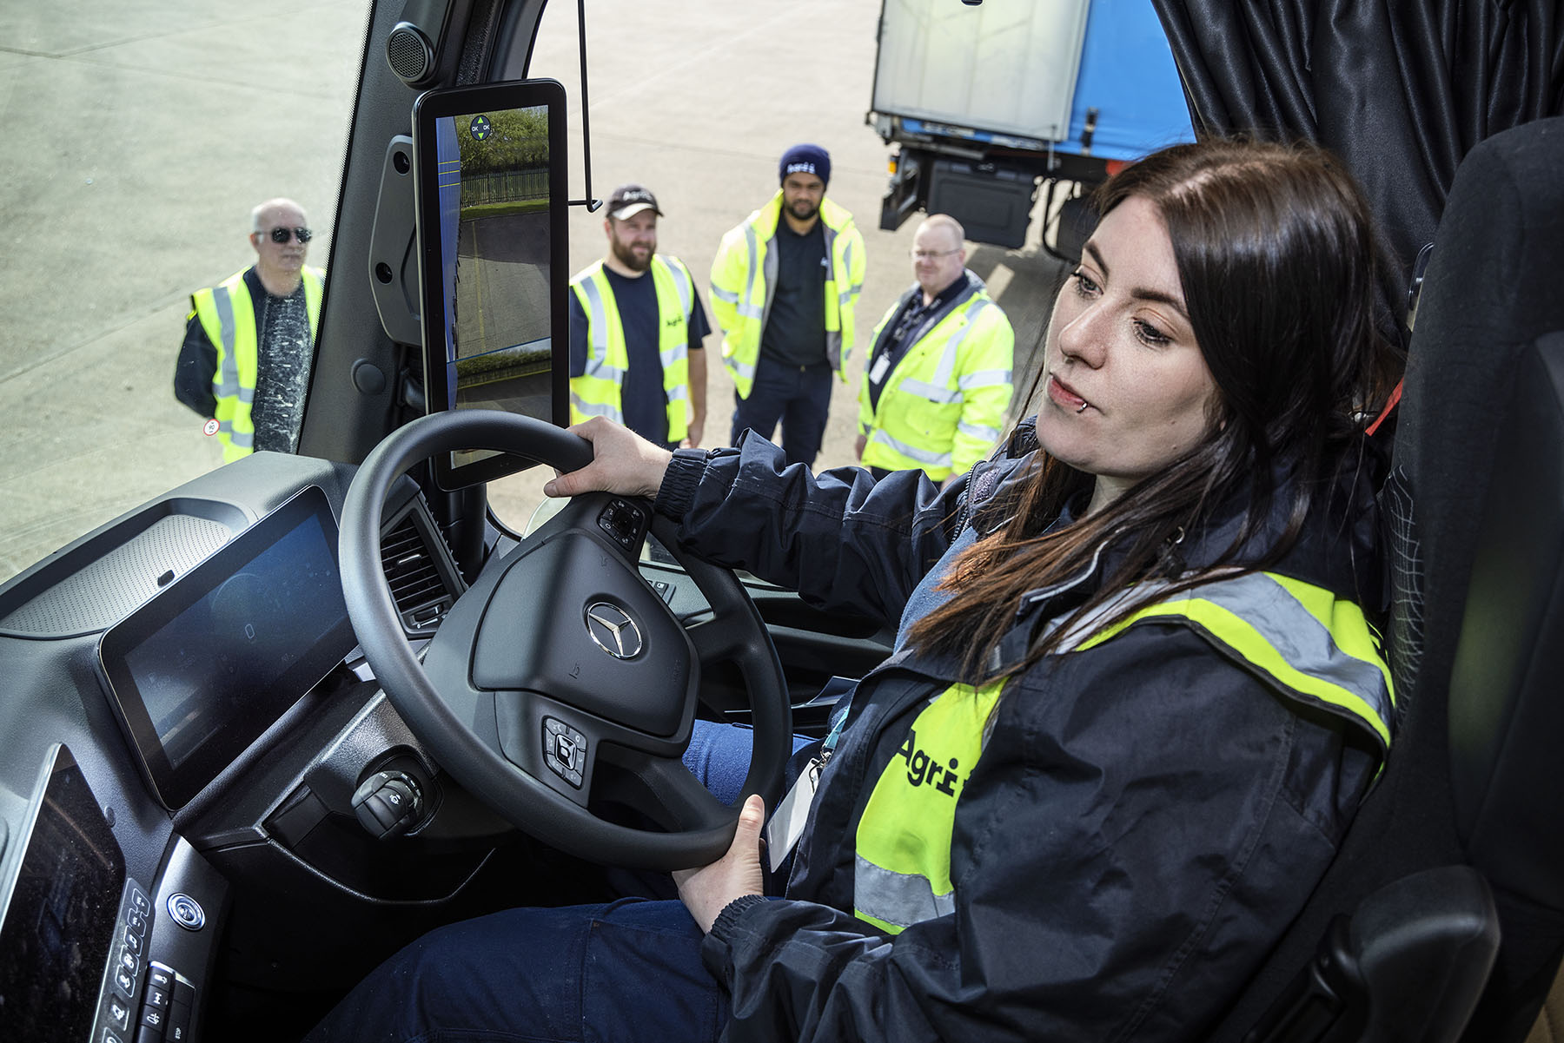

Vision on: Agrii driver Nikki Blackburn benefits from MirrorCam’s clear field of view

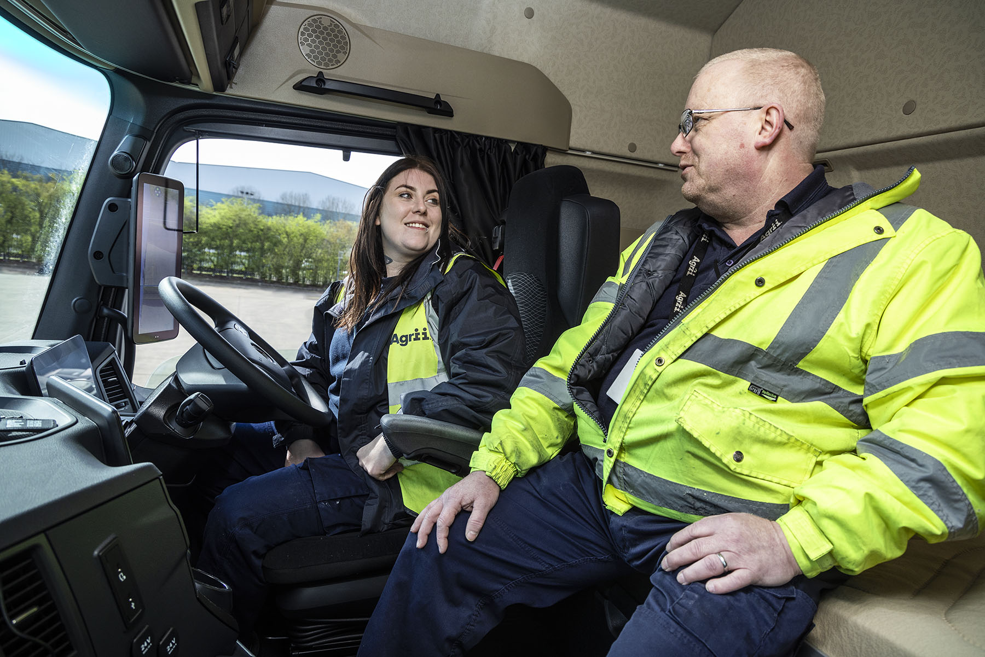

Wise words: Driver Nikki Blackburn receives some tips from Transport Co-ordinator and Driver Trainer Peter Dudgeon

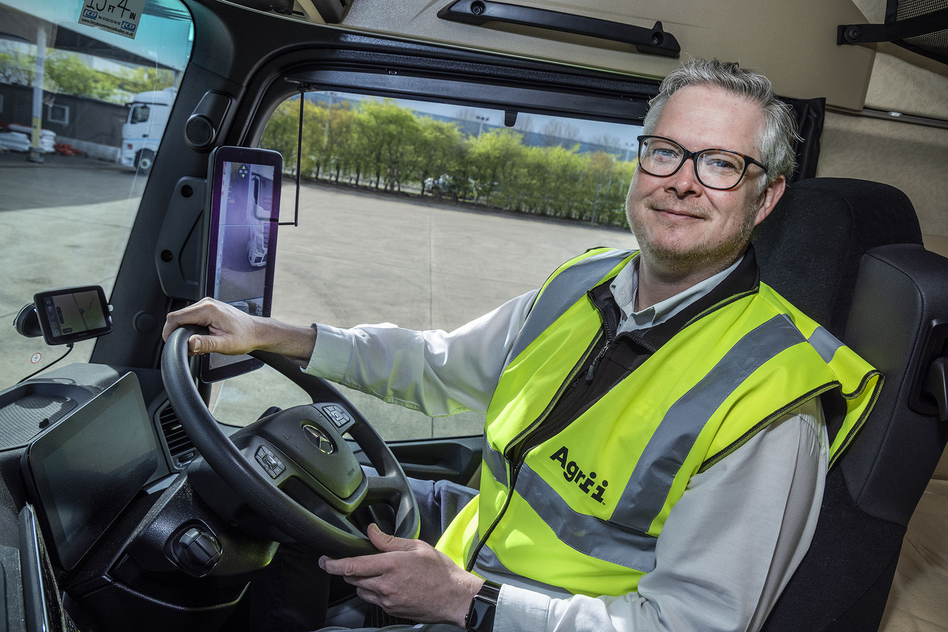

Impressed: Transport Manager Jonathan Read has only praise for Intercounty Truck & Van

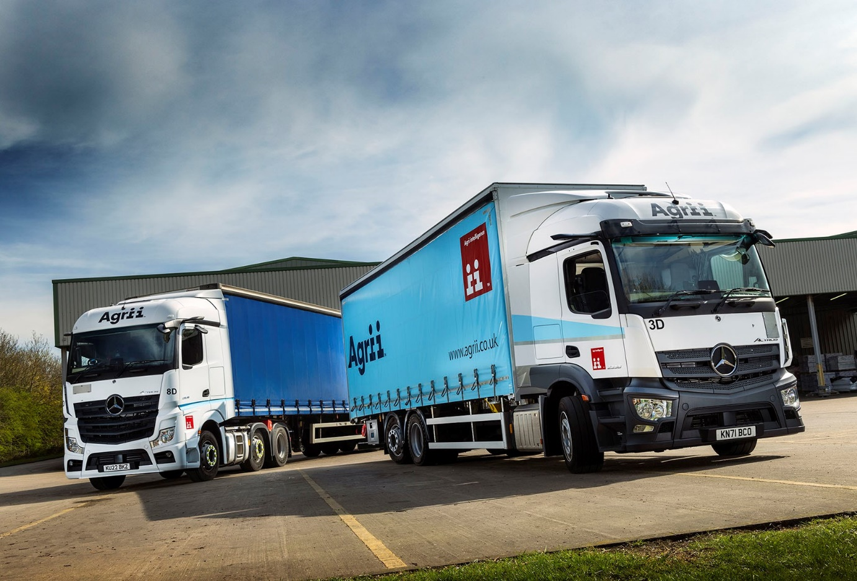

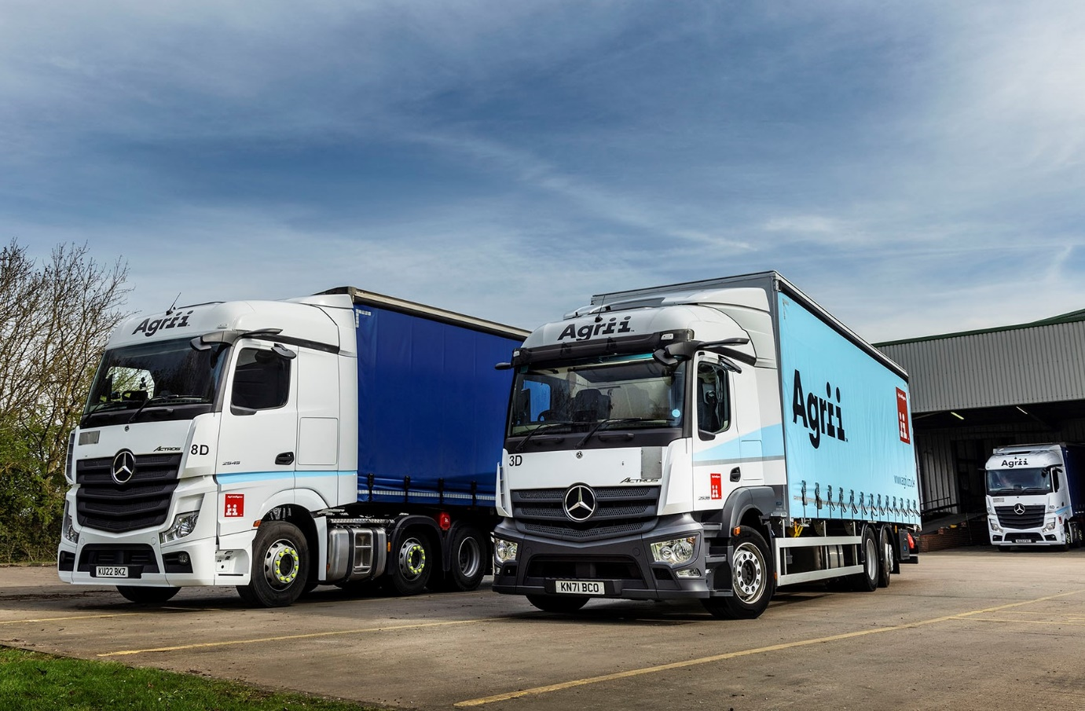

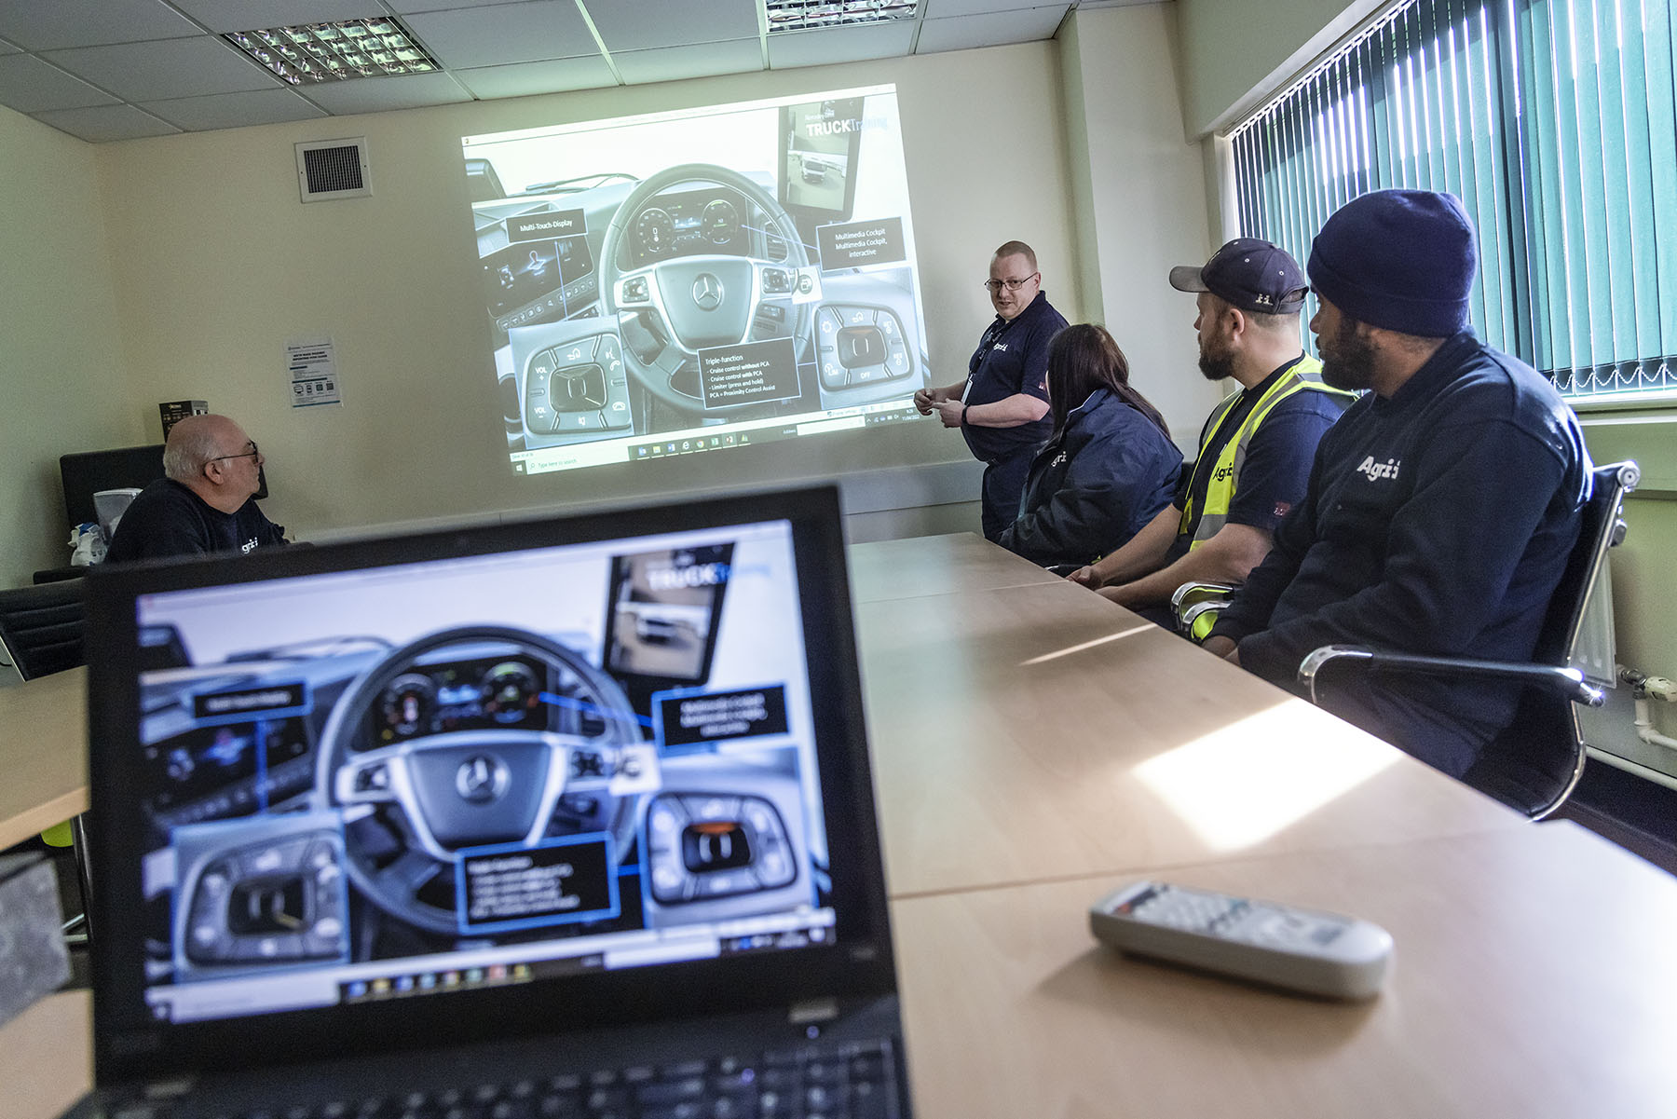

First class: Driver Trainer Peter Dudgeon offers colleagues some expert advice on the features of the Mercedes-Benz Actros cockpit

ends

For more information, or to request bigger/higher-res image files, please contact:
John Ripley or Steve Warren
Impact Communications
John: 07771 484595, john@impactcom.co.uk
Steve: 07770 470251, steve@impactcom.co.uk

