

Date: 24 November 2021

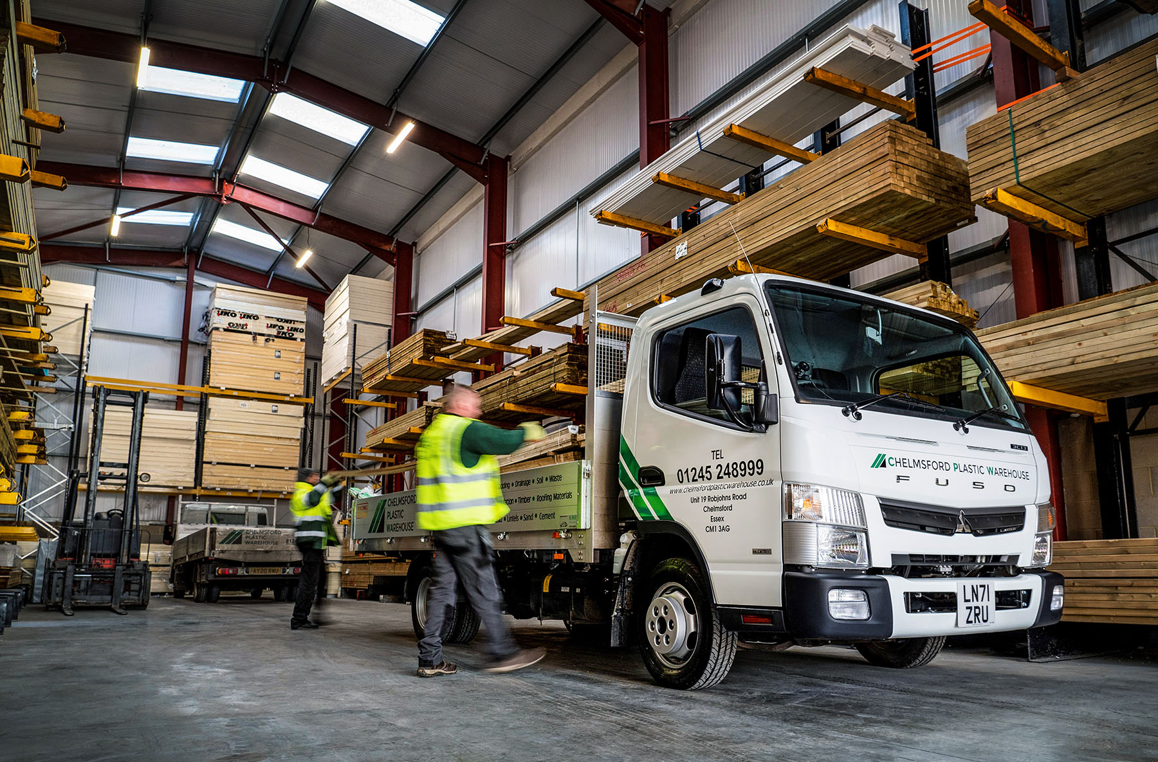

Reliable FUSO Canter workhorses drive continued growth for Chelmsford Plastic Warehouse

Builders’ merchant Chelmsford Plastic Warehouse bought its first FUSO Canter in 2017, and since then has never wavered in its loyalty to the ruggedly reliable light truck.

The service-led company runs a fleet of eight 3.5-tonne Canters – six work from its headquarters in Chelmsford, Essex, while the remaining couple are based at its branch in Benfleet.

The latest has just been delivered by Motus Truck & Van. The Dealer sells and supports Mercedes-Benz as well as FUSO trucks – both brands are part of the Daimler Truck family –
and will also be supplying Chelmsford Plastic Warehouse with another Canter next spring.
The operator’s new 3C13 variant is powered by a fuel-efficient 3.0-litre common-rail turbodiesel that produces 96 kW (130 hp) and 300 Nm of torque at 1,300-3,000 rpm, and drives through a five-speed manual gearbox. Its body is the work of KMR Engineering, of Hadleigh, Ipswich.

Established in 2003, Chelmsford Plastic Warehouse specialised initially in plastic products such as fascias, soffits and guttering. It quickly became apparent, though, that customers wanted to source all of their building materials from a single supplier.

The company embarked on a strategy of expansion, adding new lines to its range every year, and opening the Benfleet branch in 2011. Customers opting to collect their orders are served by helpful and knowledgeable staff. Most, though, take advantage of Chelmsford Plastic Warehouse’s prompt and efficient delivery service, which brings the product straight to their doors.

In addition to plastic items, the FUSO Canters transport a broad range of timber and sheet materials, lintels, roofing felts and slates, fencing and decking and much more throughout the South-East, as far north as Peterborough.

Finance Manager Sandra Garratt recalled: “We were running another type of vehicle prior to 2017, but then we bought our first Canter and have never looked back. It’s a better truck all round, and a lot more reliable, as well as being great value – for the money you get a really good truck.

“The 67-plated vehicle we’ve just stood down to make way for the new truck had covered more than 130,000 miles but given us no trouble at all. We were really pleased too, with the price we sold it for.”

Key to the 3.5-tonne Canter’s appeal in a weight segment dominated by van-based vehicles, are its strength and durability, attributes that owe much to its tough, ladder frame chassis.

“We work our vehicles hard,” she continued. “They venture regularly onto rough building sites to make their deliveries, and come in for plenty of abuse. But experience has shown that over a three- or four-year life the Canters stand up to the punishment really well.

“The drivers like them too, not least because the Canter is very manoeuvrable thanks to its tight turning circle – that’s a big advantage when we’re delivering in residential streets or on busy sites.”

If the vehicle has earned Chelmsford Plastic Warehouse’s appreciation, so, too, has Motus Truck & Van’s customer-focused aftersales back-up. “The support we receive from the Dealer’s Colchester team has always been first class,” added Sandra Garratt. “Nothing is ever too much trouble, and the same is true of its Canter Sales Specialist Nigel Thomas, whose service is excellent.”

www.chelmsfordplasticwarehouse.co.uk

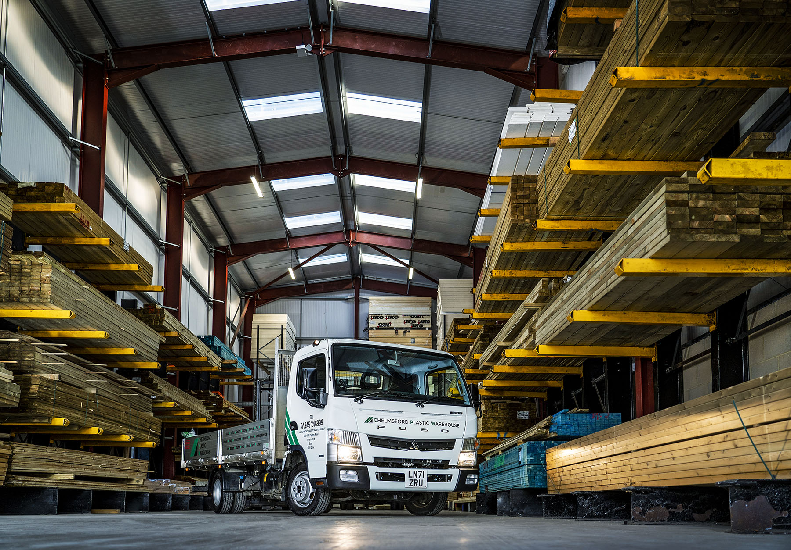

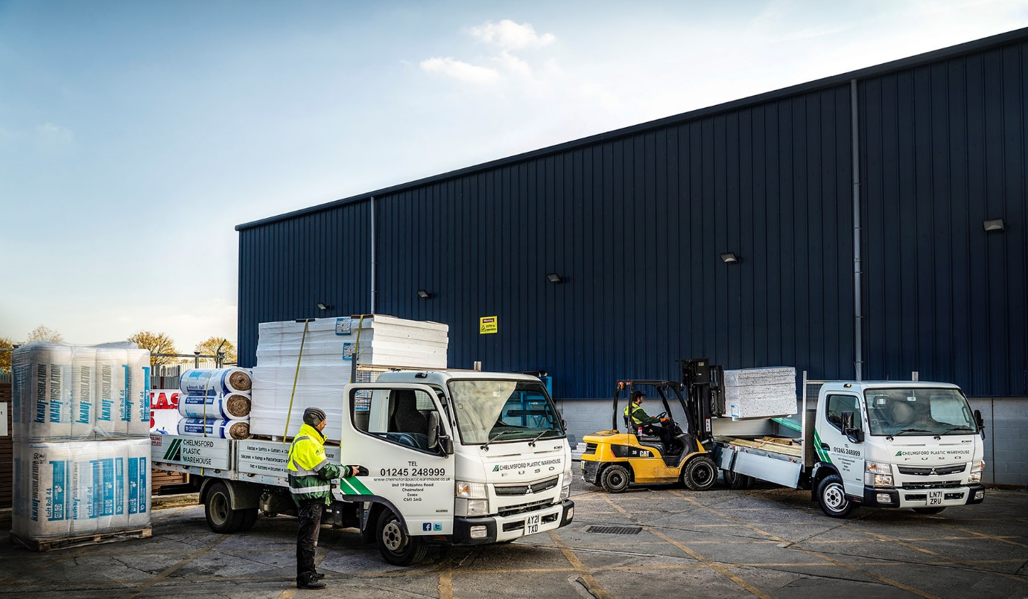



Favouring FUSO: Finance Manager Sandra Garratt said Chelmsford Plastic Warehouse has never looked back since it switched to the 3.5-tonne Canter four years ago

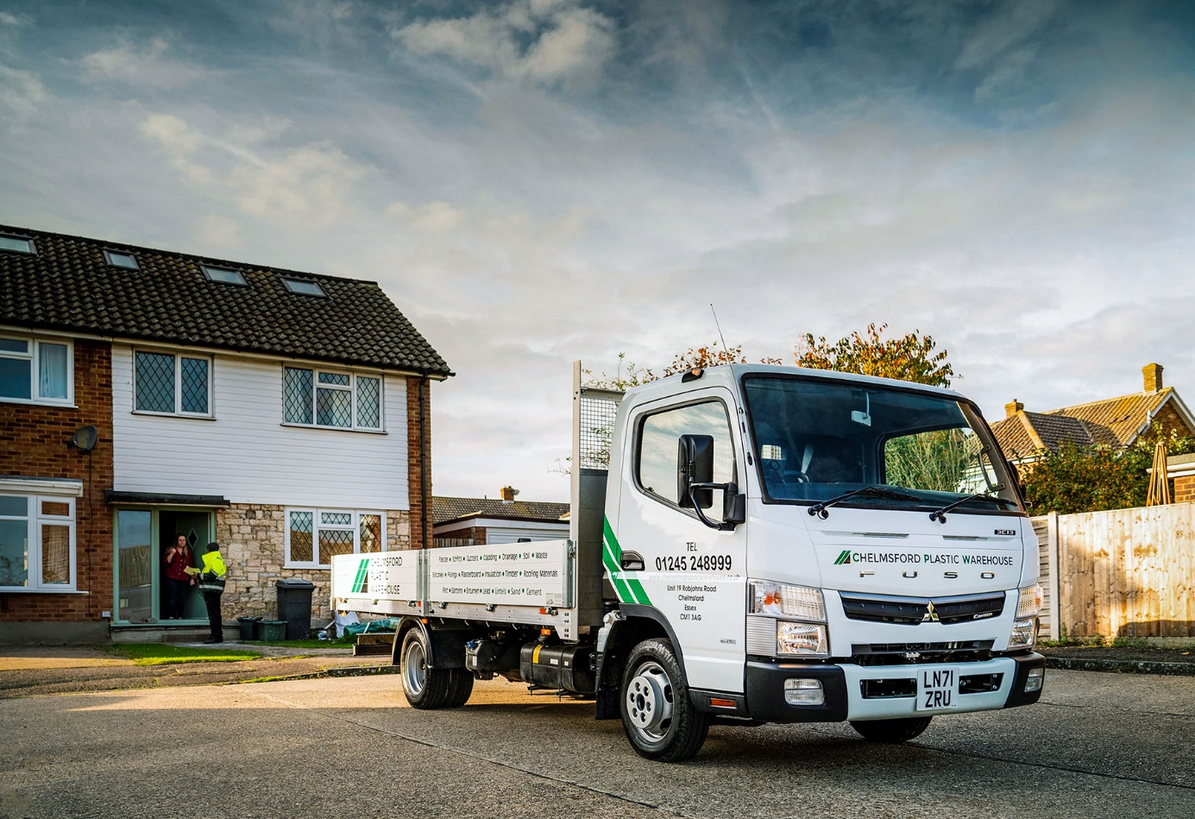

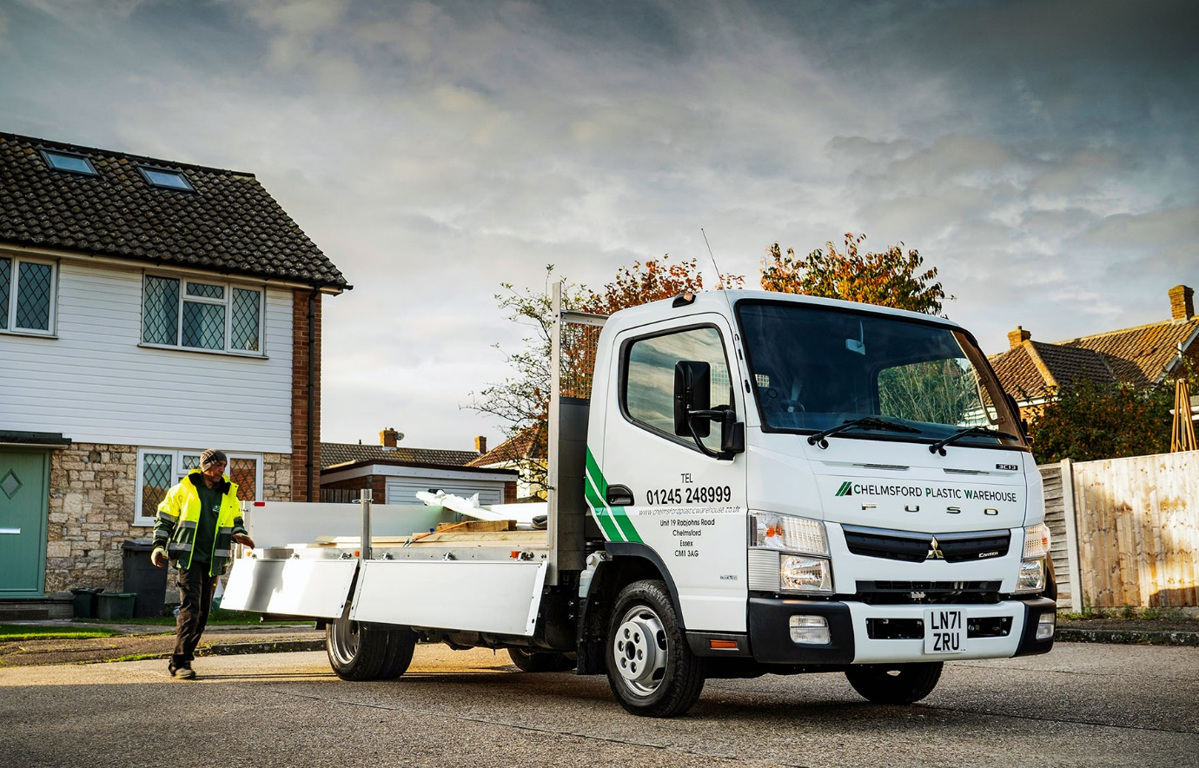

ends

For more information, or to request higher-res image files, please contact:

Steve Warren or John Ripley
Impact Communications
Steve: 07770 470251, steve@impactcom.co.uk
John: 07771 484595, john@impactcom.co.uk

