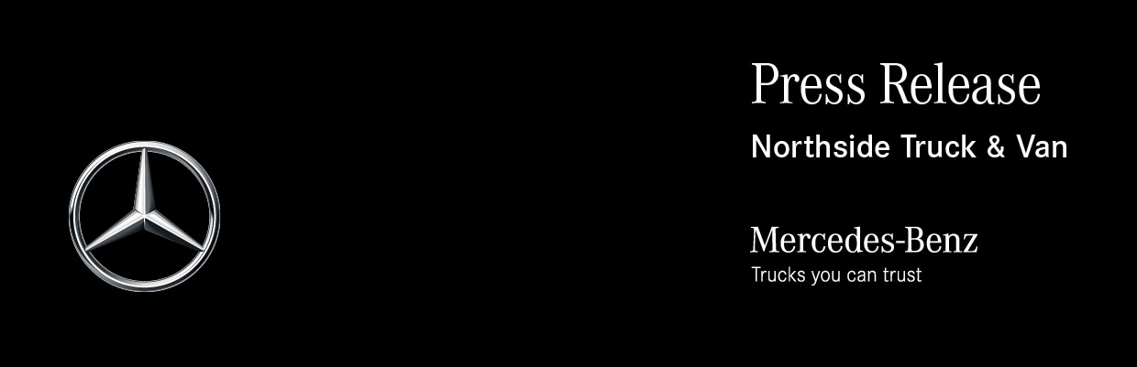

Date: 30 November 2021

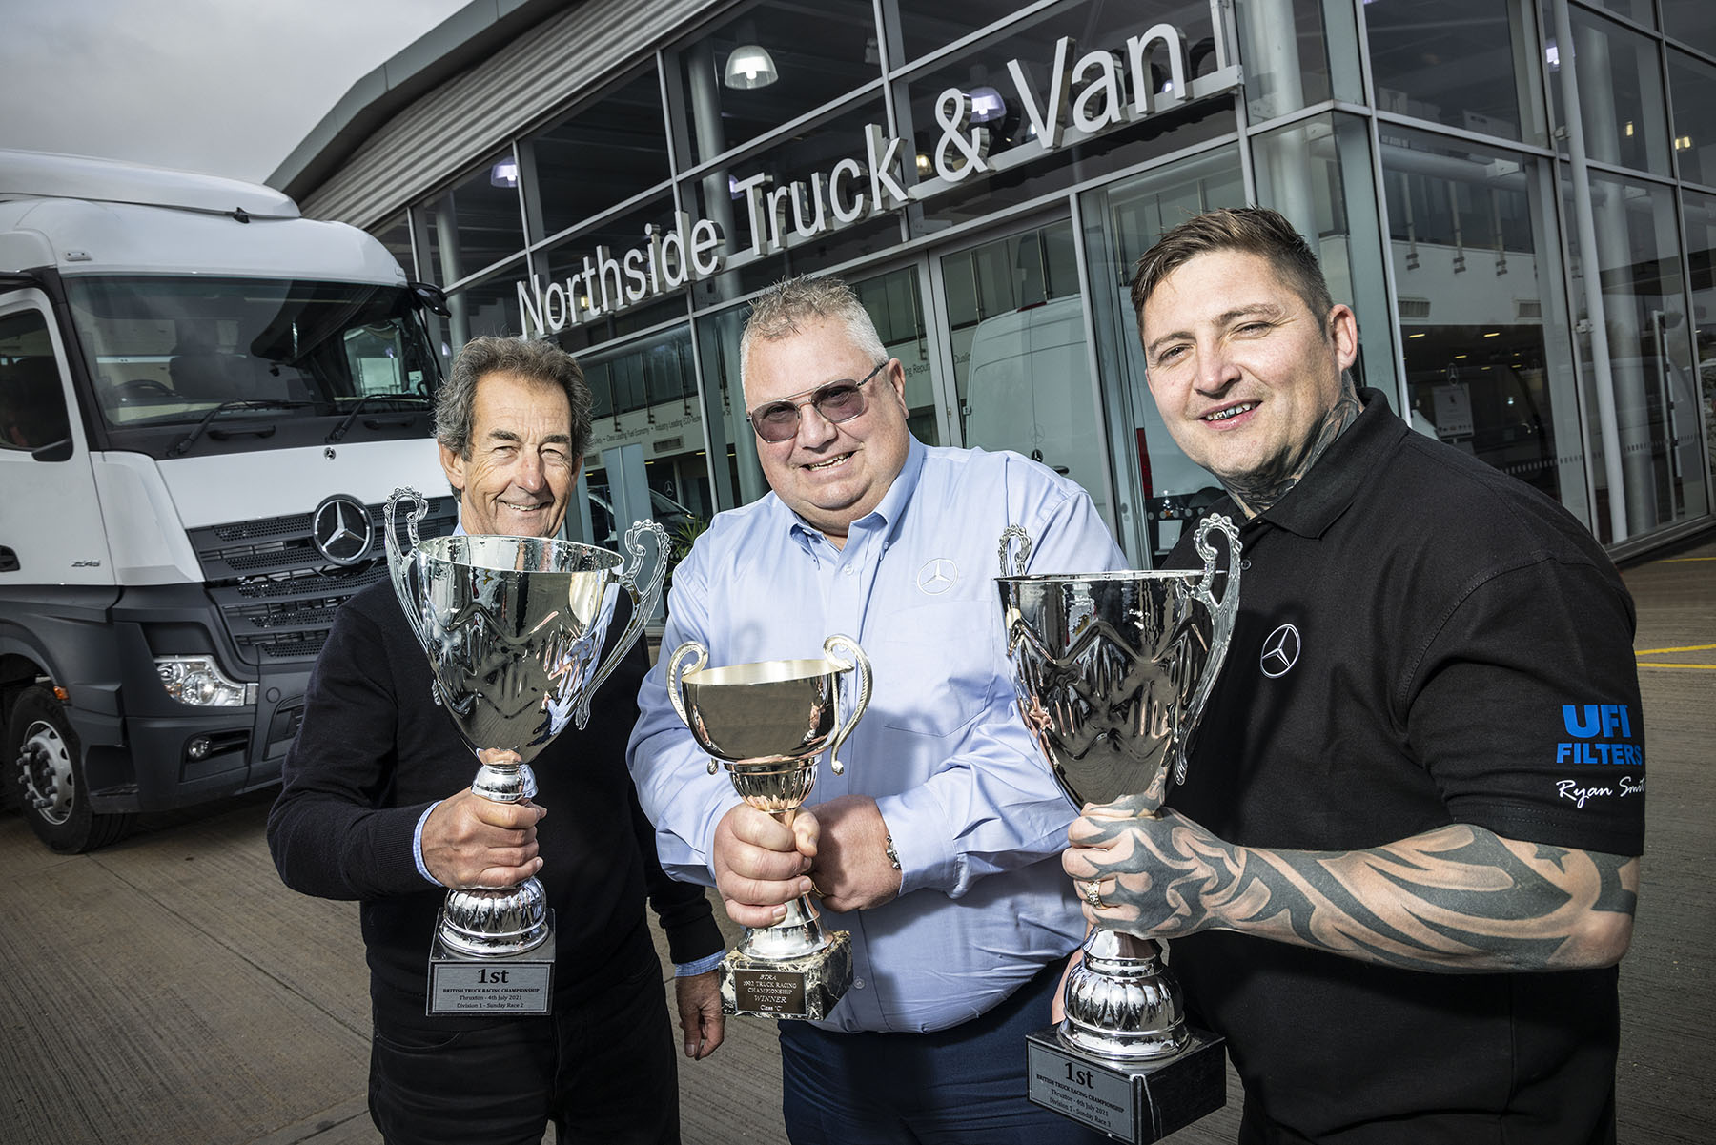

Winners all: Northside Truck & Van Managing Director Keith Sims is flanked by truck racing champions Steve Parrish, left, and Ryan Smith

Race ace Ryan Smith pays tribute to backer Northside Truck & Van for its title-winning parts performance

Newly-crowned British Truck Racing Association Division 1 Champion Ryan Smith dropped in on Northside Truck & Van to thank the Mercedes-Benz Dealer for ‘pulling out all the stoppers’ so he could clinch his sixth successive title.

Mansfield-based Ryan took his trophies along to show colleagues at his sponsor’s Doncaster branch, who had avidly followed his campaign in a Mercedes-Benz racing truck throughout the season.

His nail-biting victory in this month’s (November) Championship deciding round at Brands Hatch meant that Ryan became the first driver to win a truck racing title at the wheel of a Mercedes-Benz since all-time great Steve Parrish triumphed in 1996. Steve was also at Northside Truck & Van to add his congratulations to those of the Dealer’s team.

Although Mercedes-Benz is one of the most successful marques in motor sport, its Trucks division does not enter a ‘factory’ team in racing events. “This made our victory over some much bigger and better-funded manufacturer teams all the sweeter,” said Ryan. “To be the first person since Steve to drive a truck bearing the three-pointed star to a Championship was a great feeling.”

He continued: “As a relatively small outfit we have relied heavily on the support of our sponsors throughout the season. And when it came to the crunch, Northside had a very important role to play by supplying the vital parts at short notice that allowed me to compete.

“We were wearing through our brake discs and pads much quicker than expected during qualifying and by the end of the final session I realised we had none left,” recalled Ryan. “Northside Managing Director Keith Sims was at Brands Hatch for the weekend to support the team, and asked me how things were going.

“When I explained that we had a problem Keith was straight on the phone to his Parts department back in Yorkshire. They couriered the parts we needed down to Kent overnight so we were ready to race the following morning. Without those brakes we would not have won, it’s as simple as that.”

Keith added: “I’d travelled down to Brands Hatch with After Sales Director Gavin Hewitt and After Sales General Manager Mark Radford, to support Ryan and his team throughout the practice, qualifying and race across the whole weekend.

“Luckily the race truck’s entire back axle and braking set-up is the same as a standard Mercedes-Benz Atego, so we quickly checked our stock online and confirmed we had the required parts at our Leeds branch.

“It was late in the evening by this time but our on-duty Parts Specialist Danny picked the items Ryan needed off the shelf and put them on a van to be delivered straight to the race track, in plenty of time for Ryan’s mechanics to fit them to the truck. He went on to win four of the five races the next day, and clinch the trophy in fantastically impressive style.”

Congratulating the new champion, Steve Parrish paid tribute to the dedication and hard-work required to win not just one but six titles. “I’m delighted to pass on the mantle of the last driver to win a title in a Mercedes-Benz,” he said. “Truck racing is a fantastic spectator sport and really does attract fans of all ages. It gave me lot of great memories and I’m sure it will do the same for Ryan.”

In addition to Doncaster and Leeds, Northside Truck & Van also sells and supports Mercedes-Benz and FUSO Canter trucks from locations in Bradford, Hull, Immingham and Sheffield.

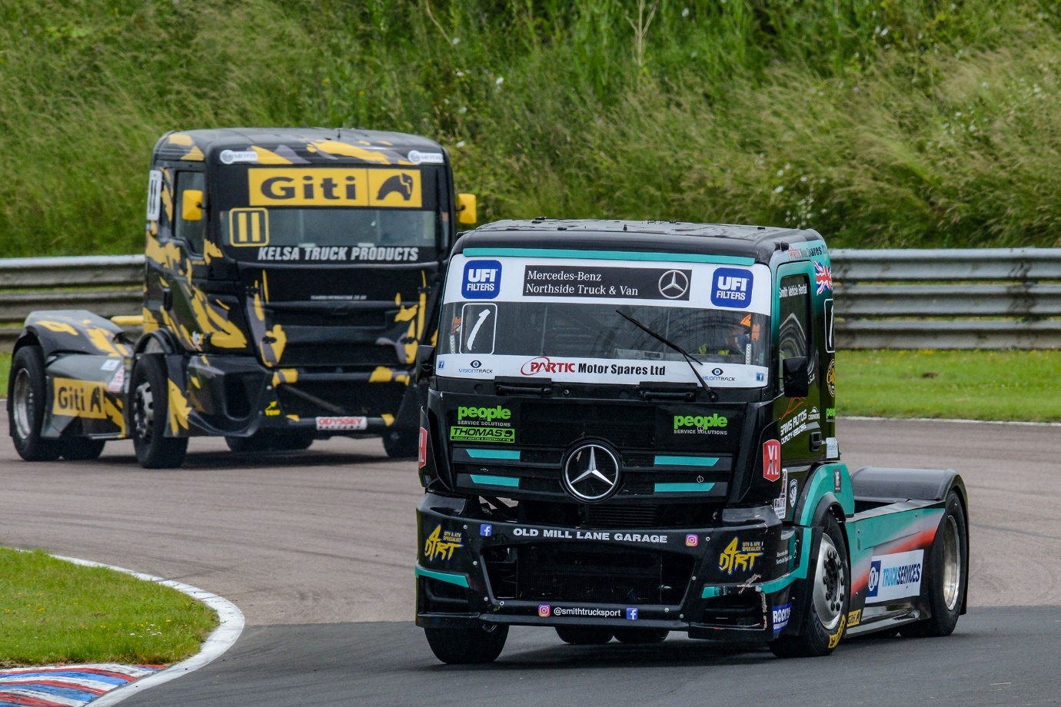

Out in front: Ryan Smith piloted his Mercedes-Benz racing truck to championship glory

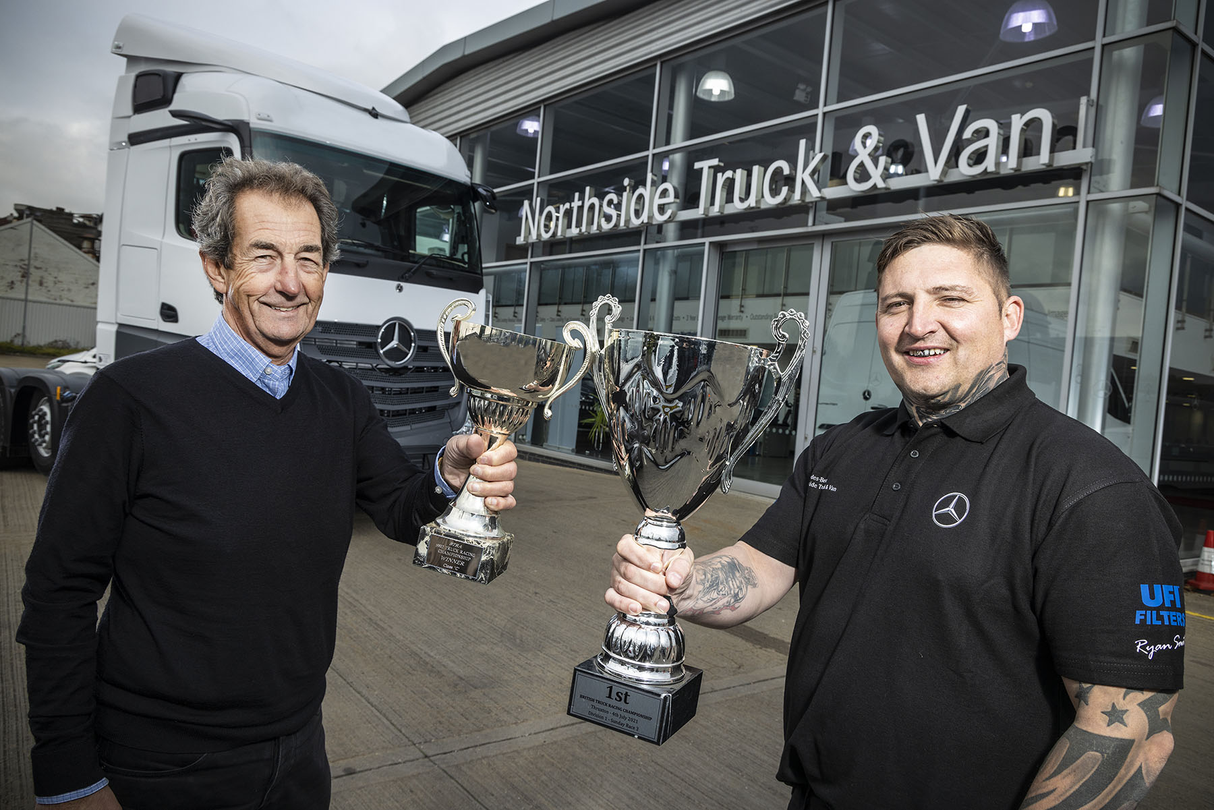

Champions past and present: Steve Parrish, left, and Ryan Smith have both driven Mercedes-Benz tractor units to truck racing glory

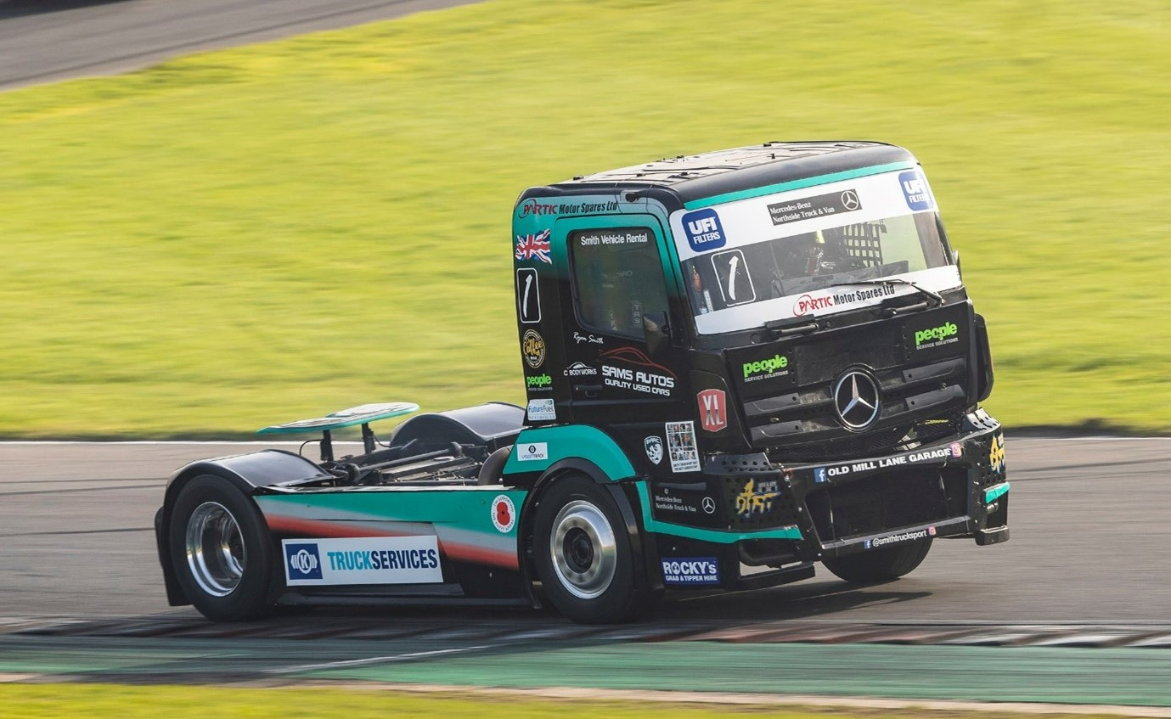
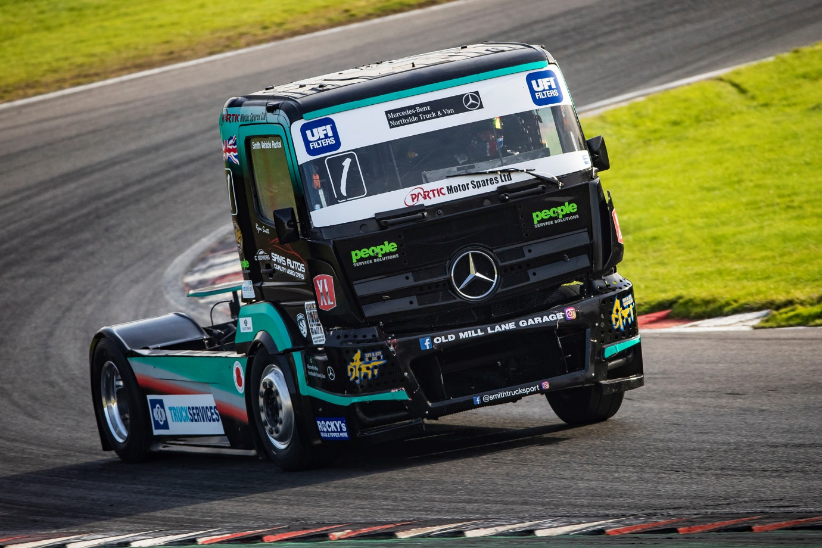

ends

For more information, or to request bigger/higher-res image files, please contact:
Steve Warren or John Ripley
Impact Communications
John: 07771 484595, john@impactcom.co.uk
Steve: 07770 470251, steve@impactcom.co.uk

