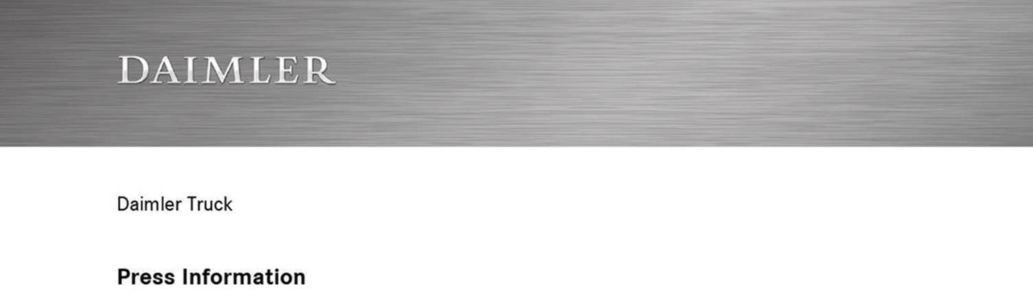

Date: 3 September 2020

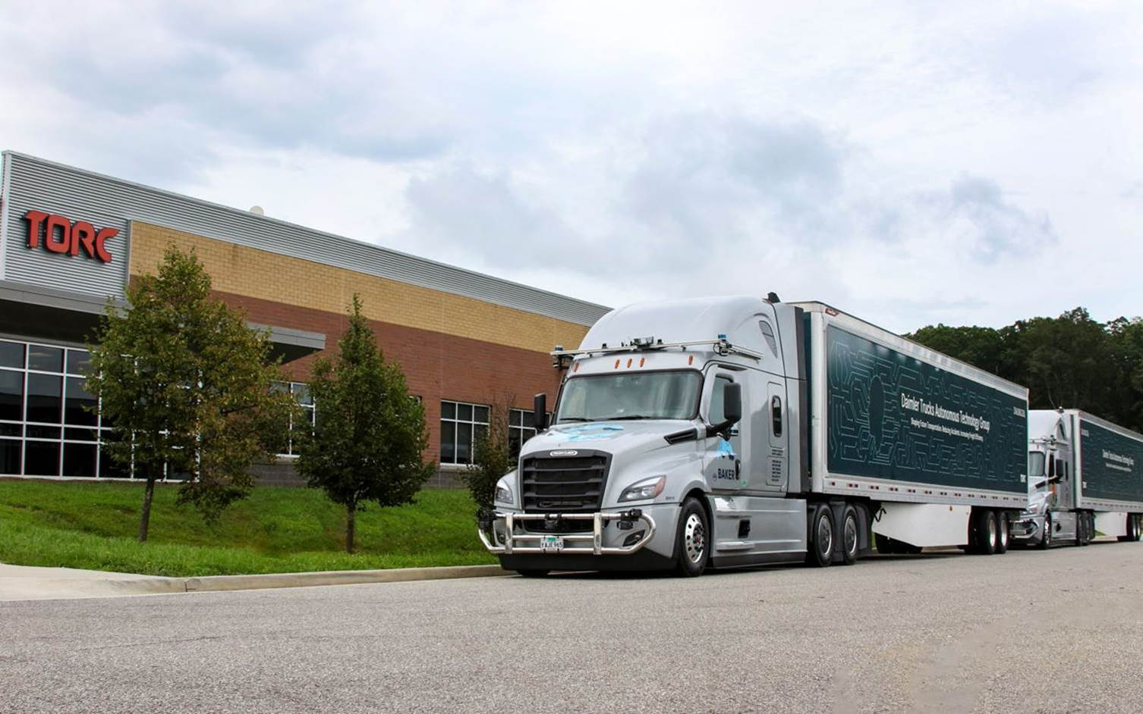

Daimler Trucks and Torc Robotics celebrate one year of successful collaboration, adding testing center in New Mexico

- First anniversary of partnership with Torc Robotics as part of Daimler Trucks’ Autonomous Technology Group

- Common goal: bringing series-produced highly automated trucks (SAE Level 4) to the road within decade

- Public road vehicle deployment enters new phase with additional testing center for next generation vehicle testing in New Mexico

- COVID-19 impact: Focus on software simulation, successful restart of public road testing in Virginia in June 2020 with safety and health protocols

- Martin Daum, Chairman of the Board of Management of Daimler Truck AG and Member of the Board of Management of Daimler AG: “After one year of collaboration with Torc, we have successfully deployed trucks with SAE Level 4 intent technology on public roads and expanded our test fleet with trucks, miles and learnings. Partnering with Torc has created a unique and even more powerful team of innovators at Daimler Trucks. We remain fully committed to this collaboration and to focusing on the shared goal of bringing highly automated trucks to series production.”

Blacksburg / Stuttgart / Portland - September 2020 marks one year of Daimler Trucks and Torc Robotics partnering as a team after the U.S. based automated driving technology company became part of Daimler Trucks’ Autonomous Technology Group. One year together, collaboratively pursuing a common goal of bringing series-produced highly automated trucks (SAE Level 4) to the roads within the decade; including on-road deployment of a Level 4 test fleet, initiation of redesign of truck chassis, adoption of a hub-to-hub model, formalized rigorous testing protocols, formal truck safety driver certification process, and extended software capabilities. Now, the Autonomous Technology Group will extend its testing to New Mexico by building up a new testing center in Albuquerque. Expanding to a new location will support testing and provide data for more use cases of next generation vehicles on public roads starting this fall.

Daimler Trucks and Torc started their collaboration in spring 2019. Initial public road testing on highways began in September in southwest Virginia, where Torc is headquartered. Additionally, closed-track road testing is conducted in Madras, OR, at Daimler Trucks North America’s High Desert Proving Grounds. In February 2020, Daimler Trucks and Torc announced plans to expand testing of automated truck technology to additional locations, adding new public routes in the U.S., but the activation was postponed due to COVID-19 pandemic.

During the pandemic downtime, the teams continued testing by focusing on robust simulation testing. Public road testing with safety and health protocols in place resumed in Virginia in June 2020 and will be continued with the next generation of automated driving software. The team in Oregon, will continue focusing on the development of vehicle safety systems, which are critical for delivering the safety standards for self-driving trucks today and in the future. The goal is to refine a truck chassis that is perfectly suited for highly automated driving and includes the redundancy of systems needed to achieve safe, reliable driving.

Collaboration results in unique and powerful team

Martin Daum, Chairman of the Board of Management of Daimler Truck AG and Member of the Board of Management of Daimler AG: “After one year of collaboration with Torc, we have successfully deployed trucks with SAE Level 4 intent technology on public roads and expanded our test fleet with trucks, miles and learnings. Partnering with Torc has created a unique and even more powerful team of innovators at Daimler Trucks. We remain fully committed to this collaboration and to focusing on the shared goal of bringing highly automated trucks to series production.”

Roger Nielsen, Daimler Trucks Board Member, President and CEO of Daimler Trucks North America: “We know this will not happen overnight, but with our priority and vision for safer roads and efficiencies for our customers, we are committed to the journey. We listen carefully to our customers and we see potential to deliver commercial value to them and to society.”

Partnership has exceeded expectations

Dr. Peter Vaughan Schmidt, Head of Autonomous Technology Group at Daimler Trucks: “The partnership has enabled both our teams to move faster on developing Level 4 trucks, providing Daimler engineers with insights on how the technology will impact truck design, and providing Torc with data and perspective on what technology will work best for the trucking industry. We will implement the results of our collaboration in the next phase of public road testing later this year.”

“We have accomplished a lot during the first year,” said Michael Fleming, CEO of Torc Robotics. “In addition to testing our technology stack on trucks on the highway in Virginia, we have scaled up our team and grown quickly - recently opening our expanded headquarters in Virginia to accommodate this growth. Daimler’s commitment to safety, innovation leadership of truck technology and foundational knowledge of on-road scenarios that truckers encounter has moved our system faster than we could have done alone as a technology firm. By working with the inventor of the truck and number one truck OEM, we are convinced that Level 4 trucks can be commercialized safely with a strong business case.”

Daimler Trucks and Torc Robotics: Vehicle and software testing expertise

Daimler Trucks has dozens of years of experience in testing and validating the durability, reliability and safety of commercial vehicles around the world. In 2019, Daimler Trucks North America, the North America market share leader, unveiled the first SAE Level 2 automated truck, the Freightliner Cascadia. With Active Drive Assist (Mercedes-Benz Actros, FUSO Super Great) and Detroit Assurance 5.0 with Active Lane Assist (Freightliner Cascadia), Daimler Trucks has delivered automated driving features into series production.
Similarly, Torc has 15 years of experience in commercializing self-driving technology in heavy-duty, safety-critical applications. Moreover, Torc’s “Asimov” autonomous driving system has been tested on public roads including a cross-country journey. As a result of combining their extensive technology and testing experience, Daimler Trucks and Torc have developed a comprehensive validation approach and safety protocols for automated driving; aligned with the federal framework policy for testing and commercial deployment of SAE Level 4 automated trucks.

All automated test drives require the combination of a safety conductor, overseeing the system, and a highly trained safety driver, certified by Daimler Trucks and Torc. All safety drivers hold commercial driver’s licenses and are specially trained in vehicle dynamics and automated systems.

Daimler Trucks in market leading position as demand grows – best testing conditions in the U.S.

According to the U.S. Bureau of Transportation Statistics, the U.S. has seen the tonnage of goods shipped by trucks increase by 56 percent in the past decade. This number is expected to nearly double in the next two and a half decades. These developments contribute to a growing need for safe, reliable, cost-effective trucking solutions. Daimler Trucks North America’s role, as the U.S. market leader, and as the innovation leader for the industry, provides a unique position to safely develop and test automated truck technologies.

Autonomous Technology Group – a global technology powerhouse for automated driving

Following the investment announcement in automated driving at the beginning of last year, Daimler Trucks established the Autonomous Technology Group in June 2019. Together with Torc and Daimler Trucks North America, Daimler Trucks’ global organization for automated truck driving brings together its worldwide experience and expertise. The group takes responsibility for the overall strategy and implementation of the automated driving strategic roadmap, including research and development, testing and validation and setting up the required operations infrastructure and network. The Autonomous Technology Group has a global reach with experts working in various locations throughout the company’s worldwide development network located in Portland, Madras and Blacksburg in the U.S. and in Stuttgart, Germany.

Torc Robotics: software experts, part of the Daimler Trucks family

Based in Blacksburg, Virginia, Torc became part of the Autonomous Technology Group in August 2019, following Daimler Trucks’ investment in the company. The combination of the two companies’ strengths creates a unique partnership – blending Torc’s expertise in self-driving software development and vehicle integration with Daimler Trucks’ experience in delivering reliable and safe trucks. By offering advanced, road-ready technology, plus years of experience in heavy vehicles, Torc has grown into a global industry leader in the field of automated driving. Torc’s SAE Level 4 virtual driver system “Asimov” has been integrated and tested successfully in multiples platforms running on public roads from urban to long-distance highway routes as well as in rain, snow, fog and varying light conditions.

Daimler Trucks North America develops redundant vehicle chassis and infrastructure

As part of this research and development, Portland-based Daimler Trucks North America (DTNA) is refining a truck chassis that is perfectly suited for highly automated driving as well as the redundancy of systems needed to achieve safe, reliable driving. As part of the Autonomous Technology Group, DTNA is also researching the infrastructure required for the operational testing of initial application cases. DTNA is contributing to the successful development of automated driving technology and vehicle integration for heavy-duty trucks.

Daimler Trucks, the pioneer of automated trucks

Daimler Trucks is the pioneer of truck automation. In 2014, the world’s leading truck manufacturer presented the Mercedes-Benz Future Truck 2025, the world’s first automated truck, and was the first to demonstrate the technological opportunities and great potential that automated trucks offer customers and society. In 2015, Daimler’s Freightliner Inspiration Truck obtained the first-ever road license for a partially automated commercial vehicle demonstrating the promise of automated driving on the highways of Nevada. Today, Daimler offers partially automated driving features (SAE Level 2) with the Mercedes-Benz Actros, the Freightliner Cascadia and the FUSO Super Great.

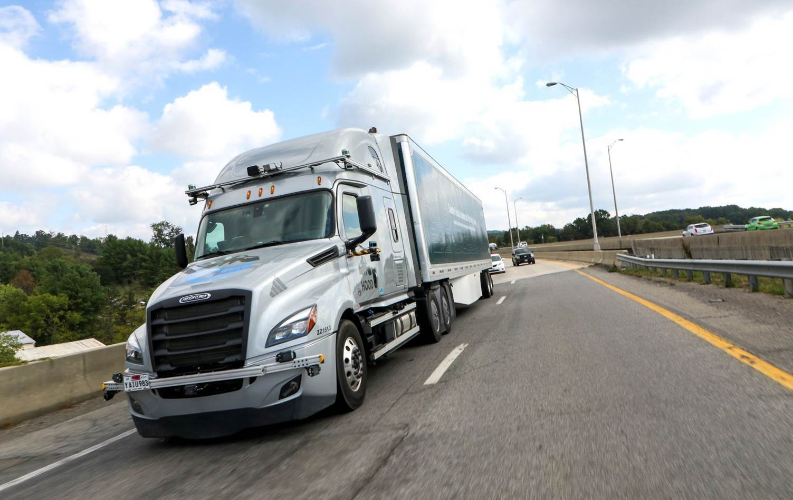

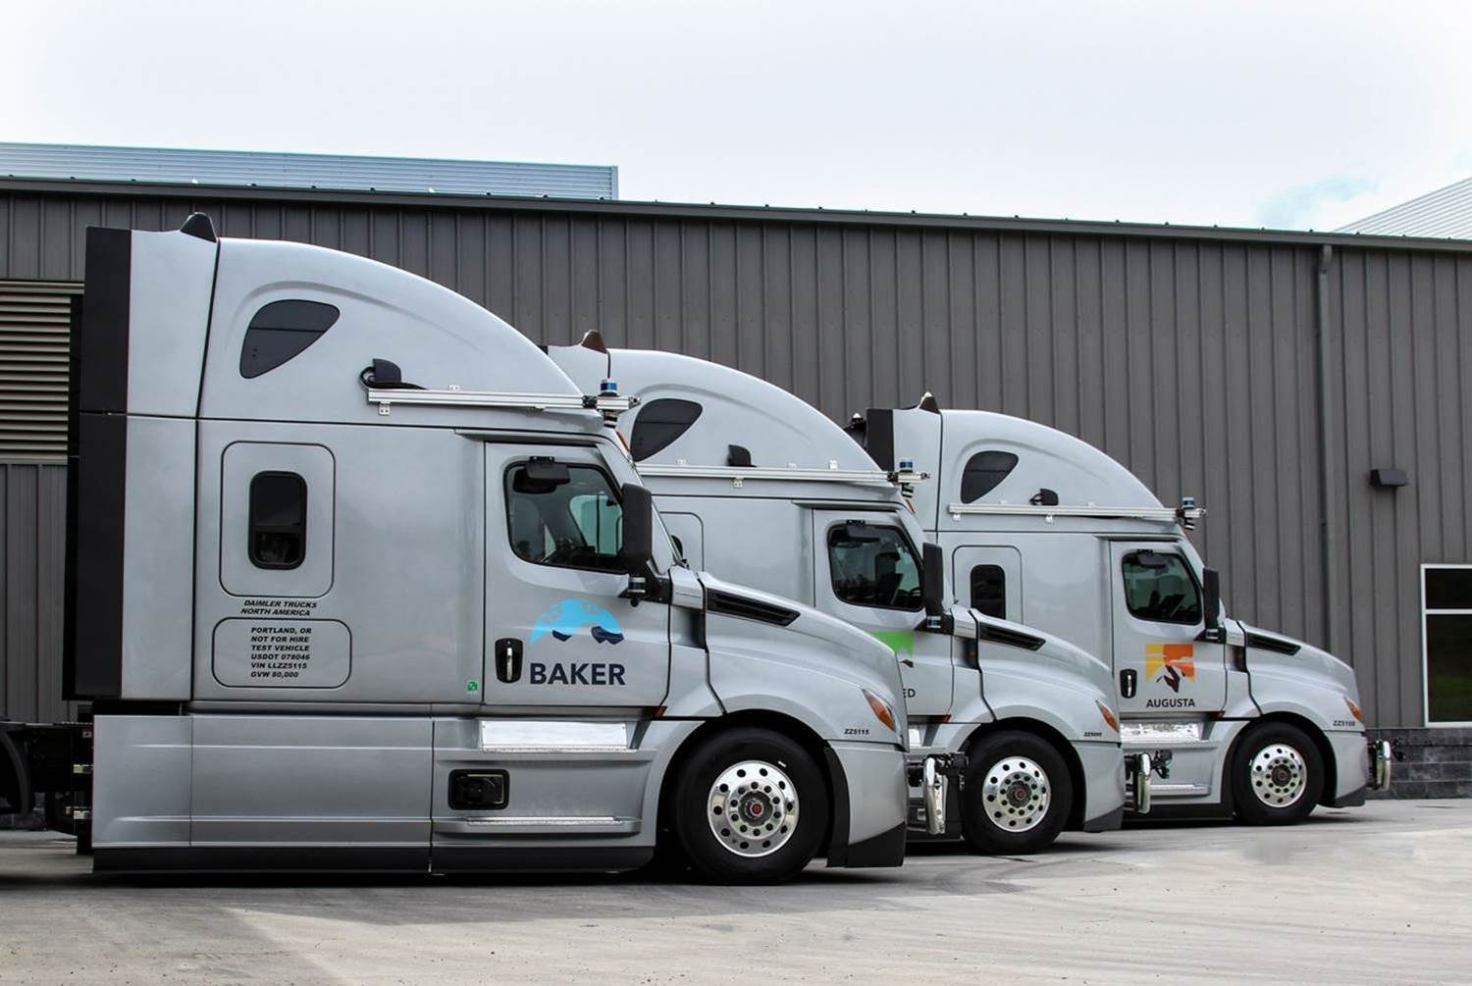

ends

Contacts:
Alexandros Mitropoulos, +49 (0) 711 17-7 78 68, alexandros.mitropoulos@daimler.com
Peter Smodej, +49 (0) 711 17-5 32 30, peter.smodej@daimler.com
Andrea Corso, +1 (917) 327-6198, andrea.corso@daimler.com

or

Jamie Fretwell at Mercedes-Benz Trucks UK Ltd
07712 519230, jamie.fretwell@daimler.com

Further information from Daimler Truck is available at:
www.media.daimler.com and www.daimler-truck.com

This document contains forward-looking statements that reflect our current views about future events. The words “anticipate,” “assume,” “believe,” “estimate,” “expect,” “intend,” “may,” ”can,” “could,” “plan,” “project,” “should” and similar expressions are used to identify forward-looking statements. These statements are subject to many risks and uncertainties, including an adverse development of global economic conditions, in particular a decline of demand in our most important markets; a deterioration of our refinancing possibilities on the credit and financial markets; events of force majeure including natural disasters, pandemics, acts of terrorism, political unrest, armed conflicts, industrial accidents and their effects on our sales, purchasing, production or financial services activities; changes in currency exchange rates and tariff regulations; a shift in consumer preferences towards smaller, lower-margin vehicles; a possible lack of acceptance of our products or services which limits our ability to achieve prices and adequately utilize our production capacities; price increases for fuel or raw materials; disruption of production due to shortages of materials, labor strikes or supplier insolvencies; a decline in resale prices of used vehicles; the effective implementation of cost-reduction and efficiency-optimization measures; the business outlook for companies in which we hold a significant equity interest; the successful implementation of strategic cooperations and joint ventures; changes in laws, regulations and government policies, particularly those relating to vehicle emissions, fuel economy and safety; the resolution of pending government investigations or of investigations requested by governments and the conclusion of pending or threatened future legal proceedings; and other risks and uncertainties, some of which we describe under the heading “Risk and Opportunity Report” in the current Annual Report. If any of these risks and uncertainties materializes or if the assumptions underlying any of our forward-looking statements prove to be incorrect, the actual results may be materially different from those we express or imply by such statements. We do not intend or assume any obligation to update these forward-looking statements since they are based solely on the circumstances at the date of publication.

Daimler Trucks & Buses
Daimler Trucks & Buses is one of the world’s largest commercial vehicle manufacturers, with more than 35 primary locations around the world and approximately 100,000 employees. The company brings seven vehicle brands under one roof: Mercedes-Benz (light, medium and heavy trucks, city buses, overland buses and coaches) and Setra (overland, long-distance and premium coaches) are its European traditional brands; North American brands include Freightliner Trucks (in weight classes 5 to 8 serving a wide range of commercial vehicle applications), Western Star (heavy and long-haul heavy-duty trucks) and Thomas Built Buses (light to medium weight buses); and Asian brands Bharat Benz, based in Chennai, India (9- to 55-ton trucks, medium- and heavy-duty buses) and FUSO, headquartered in Japan (trucks and buses for Asia, the Middle East, Africa, Europe and Latin America). Thus, Daimler Trucks & Buses offers its customers around the globe a broad portfolio of commercial vehicles, from minibuses to heavy trucks for specialized transport. In short: products and solutions for all who keep the world moving. More than 120 years ago, Gottlieb Daimler and Carl Benz laid the foundation for the modern transport industry. Over the past decades, Daimler’s Truck and Bus divisions have consistently set standards for the entire transportation industry - in terms of safety, fuel efficiency and driver and passenger comfort. Now it’s time for the next evolutionary step: emission-free, automated and connected driving. Daimler Trucks & Buses is working to bring these important technologies to volume series production, across brands, divisions and regions. The company aims to take its vision of CO2-neutral transport and accident-free driving a major step closer and contribute to the sustainability of global goods and passenger transport. In 2019 Daimler Trucks & Buses delivered a total of around one-half million trucks and buses to customers. In 2019 sales for individual business units amounted to €40.2 billion at Daimler Trucks and €4.7 billion at Daimler Buses. EBIT came to €2.5 billion for Daimler Trucks and €283 million for Daimler Buses.

