

Date: 22 November 2022

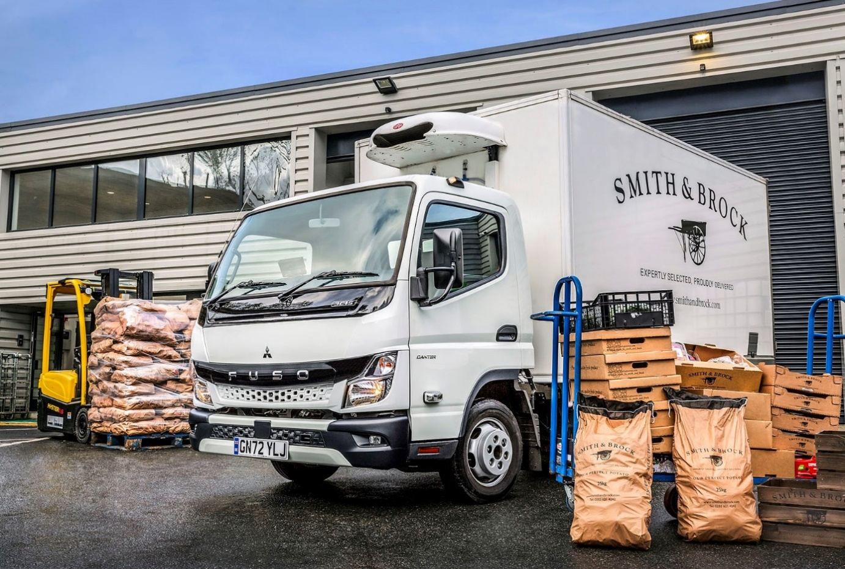

Smith & Brock picks the ‘best of the bunch’ with all-new FUSO Canter from Sparshatt Truck & Van

Fruit and vegetable wholesaler Smith & Brock has capped a landmark year by commissioning its first temperature-controlled truck from the latest FUSO Canter range.

Dealer Sparshatt Truck & Van is currently processing orders from the fast-growing firm for another six fridge-bodied 3.5-tonners, a couple of which should be in service by the end of the year.

Clearly distinguished from the outgoing model by its redesigned cab and striking new ‘face’, the all-new Canter is more comfortable than the version it replaces, thanks in part to the improved interior insulation that reduces noise. Reinforced rear underrun protection also minimises the effects of an impact in the event of an accident.

Smith & Brock was established in 2016 by brothers Nick and Joe Fowler, and numbers some of London’s best-known hotels and restaurants, as well as bars, pubs, event and contract caterers, and schools, among its customers. The ‘Knock Knock’ doorstep delivery service it launched during the Covid pandemic was hugely popular with private customers across the capital.

In response to the relentless increase in demand, Smith & Brock moved last spring to a new and much larger, purpose-built headquarters in Deptford, south-east London. The facility, which represents a £1.2-million investment, features state-of-the-art temperature-controlled refrigeration and paperless warehousing applications. Meanwhile, the company has retained its previous premises in nearby Camberwell, and this is now dedicated to the production of prepared vegetables, fruit juices and the like.

Smith & Brock – reflecting the support they had received, the brothers paired their wives’ maiden names to form the title of the business – began trading with a single rented van. Today, a little over six years later, it operates its own fleet of 32 vehicles. Most are vans but in addition to its latest Canter, the line-up also includes three 7.5-tonners and seven 3.5-tonne examples from the previous generation of the popular light truck range.

Chosen for their market-leading body and payload potential, the larger Canters have been in service the longest – two were registered in late 2017, the other in 2019. They undertake deliveries throughout the Home Counties.

The smaller Canters were all supplied by Sparshatt Truck & Van, which also sells and supports Mercedes-Benz trucks. And it is the 3.5-tonne version that will form the backbone of the fleet in years to come, as Smith & Brock continues to expand, and replaces its vans with the more ruggedly reliable, twin rear-wheeled FUSO.

The company has relied for the last five years on the support of father-and-son team Phil and Luke McElhatton, of Maidstone-based PJM Transport Consultancy, to ensure that its transport operation is efficient and compliant.

Explaining the decision to switch to the Canter, Phil McElhatton said: “Smith & Brock started out with vans but the experience has proved pretty disastrous. We’ve had all sorts of problems – engines have gone down, while clogged dpf filters have been and continue to be a particularly common problem.

“The manufacturer’s representative has told us to drive them down the motorway to clear the filters but that’s not a lot of help when you’re based in London, and the work entails multi-drop deliveries in and around the city. We’re trying to save fuel and help the environment, so the last thing we want to be doing is sending vehicles on unnecessary trips out to the M25.”

He continued: “We’ve had the same dpf filter issues with more than one brand of van but never with the Canters. I don’t know what FUSO have done, but they seem to have cracked the problem. In fact, the Canter has proved to be a more reliable vehicle all round, which is why it’s now firmly established as Smith & Brock’s chassis of choice.”

Like its previous 3.5-tonne Canters, and those which have yet to come, the latest addition to the fleet is a 3C15 variant. Its 3.0-litre common-rail turbo-diesel engine produces 110 kW (150 hp) and an impressive 370 Nm of torque which, thanks to variable turbine technology, is available from low engine speeds. A newly developed, compact exhaust system means the all-new 2022 version also meets the EURO VI – STEP E emission standard.

This powerplant is paired with a smooth-shifting and fuel-efficient DUONIC automated dual-clutch transmission with Eco Mode, Parking and Creep functions. It is ideally suited to operation in congested urban areas, where the Canter’s very tight turning circle is also a major asset.

The new Canter has a single compartment body by established supplier Coolfreeze, which also fitted its GAH refrigeration system, and has made a positive impression on Phil McElhatton. “It’s a great step forward,” he enthused. “I was surprised by how much more modern and attractive it looks.”

Smith & Brock’s Canters are independently maintained by a third-party provider that fits only genuine FUSO parts supplied by Sparshatt Truck & Van, thereby ensuring optimum vehicle performance and continuity of the three-year, unlimited mileage warranties.

The Dealer’s Group FUSO Specialist Dan Brunning also won praise from Mr McElhatton. “I’ve known Dan for a number of years and he can always be relied upon to provide a first-class service,” he confirmed.

Smith & Brock co-founder Joe Fowler added: “Our philosophy has always been about delivering the highest-quality produce while doing things the right way. That’s why we have a clear strategy and a flat structure that means everyone mucks in and is proud to do so, and why we choose to work with small, artisanal growers whose passion translates into the most flavourful produce. It’s also why we’re now re-configuring our fleet around FUSO Canters supplied by Sparshatt Truck & Van.”
www.smithandbrock.com

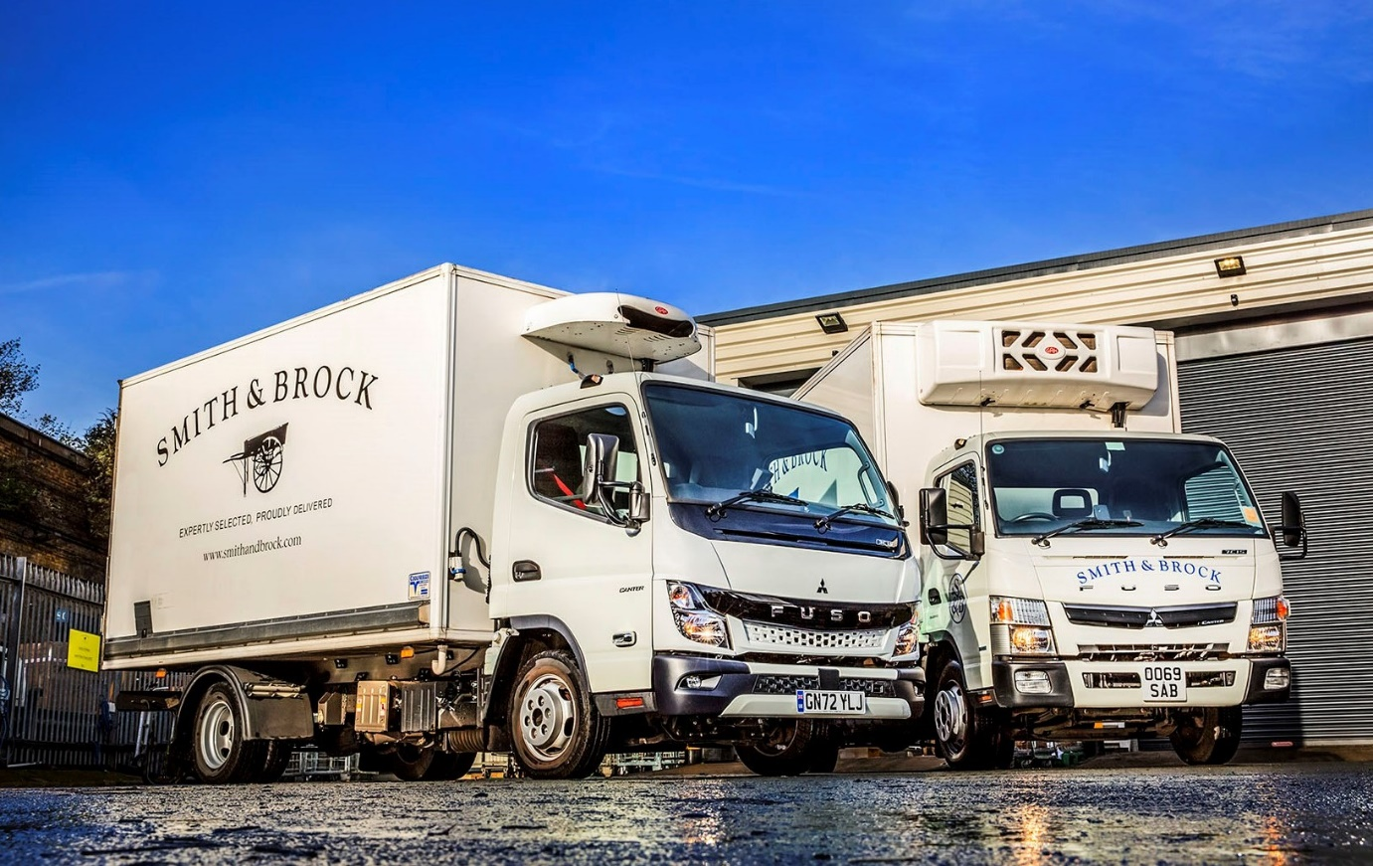

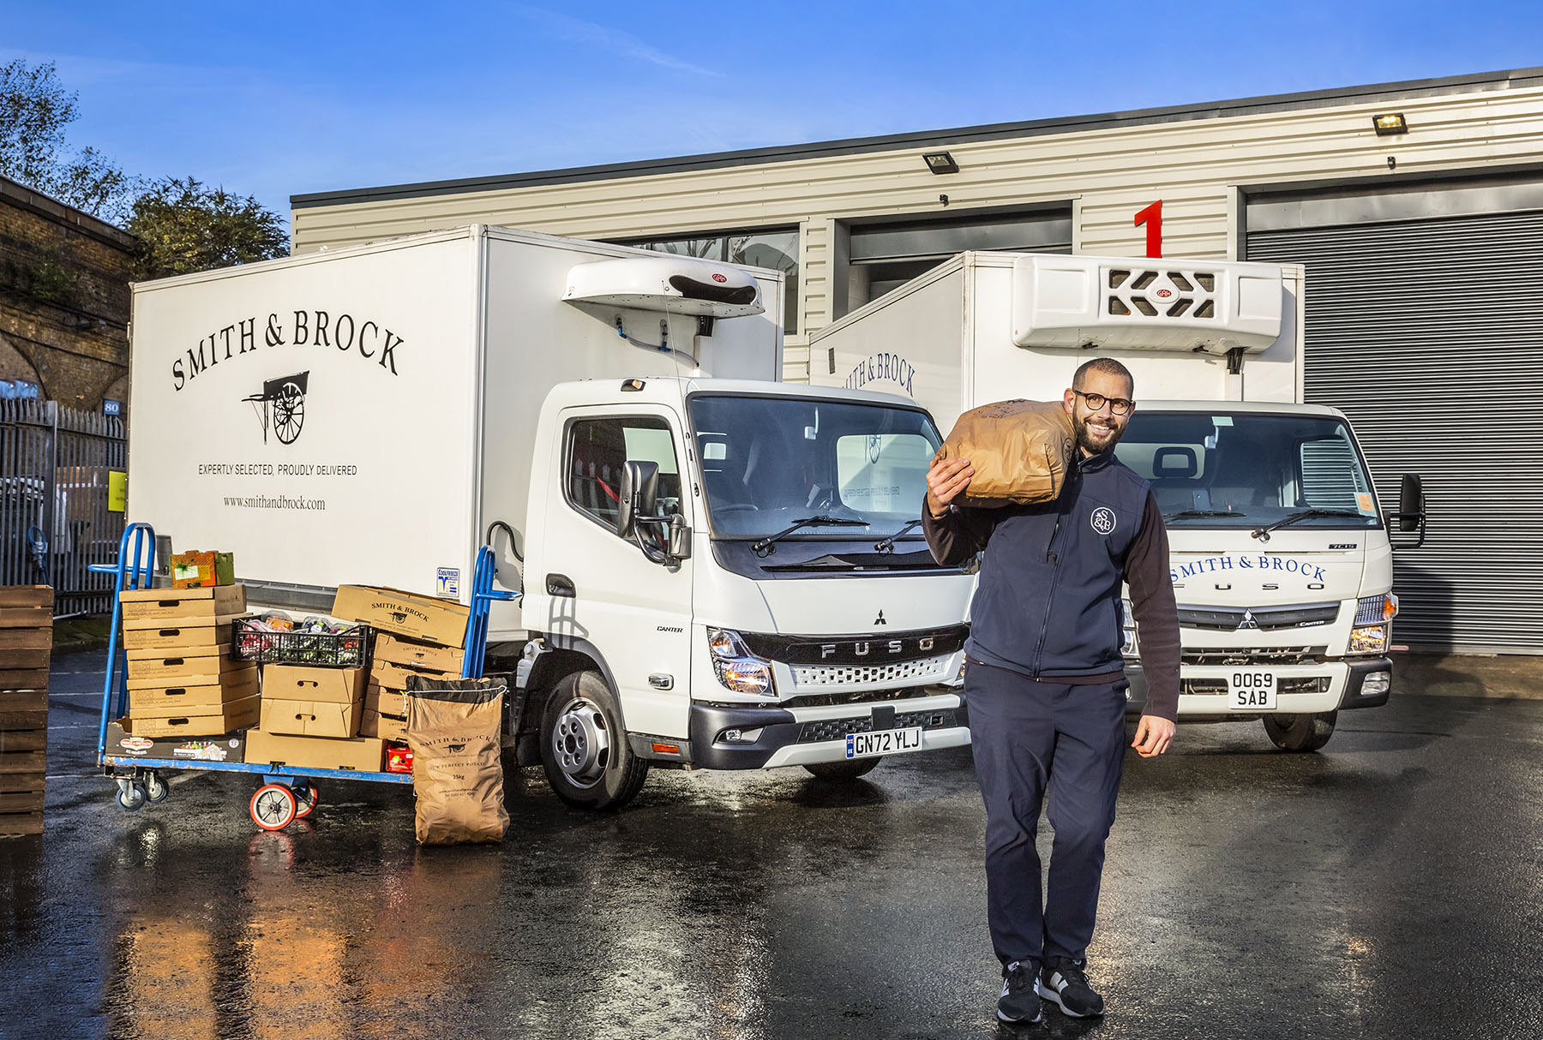

“Mucking in”: Smith & Brock co-founder Joe Fowler is pictured with the company’s first all-new FUSO Canter, and one of its 7.5-tonners from the previous model generation

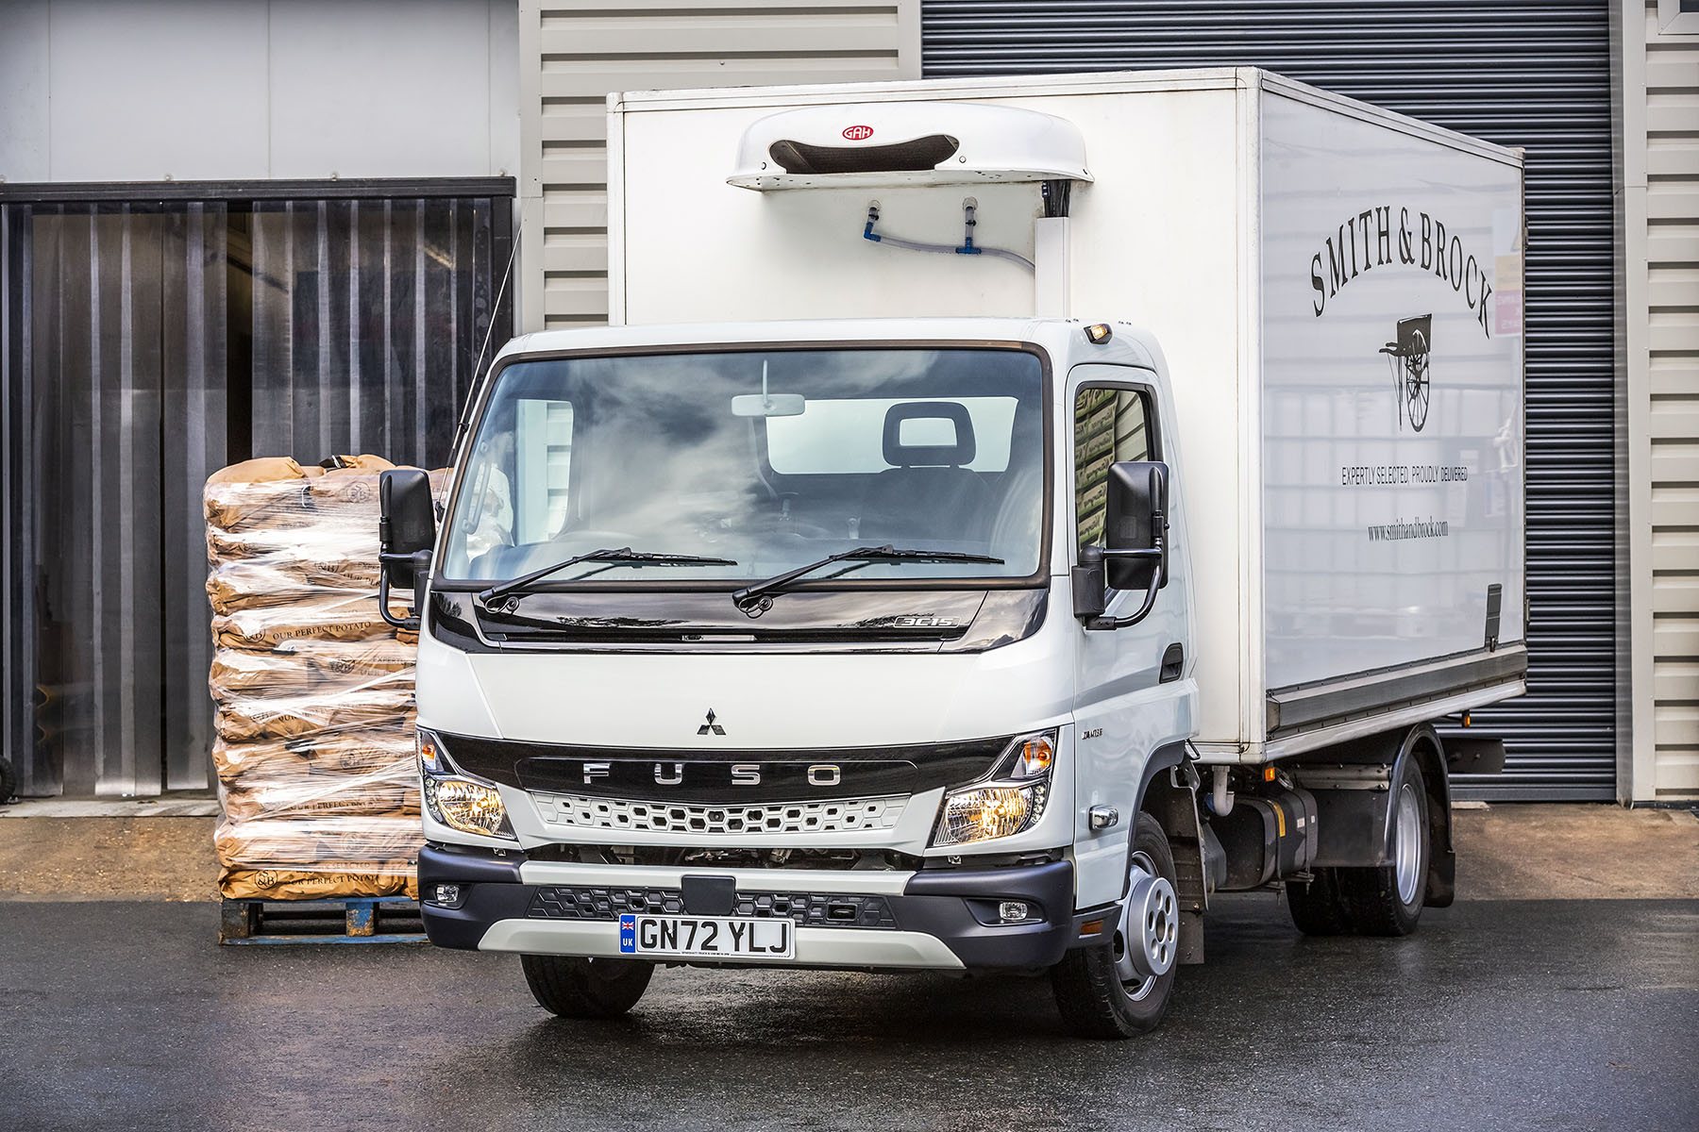

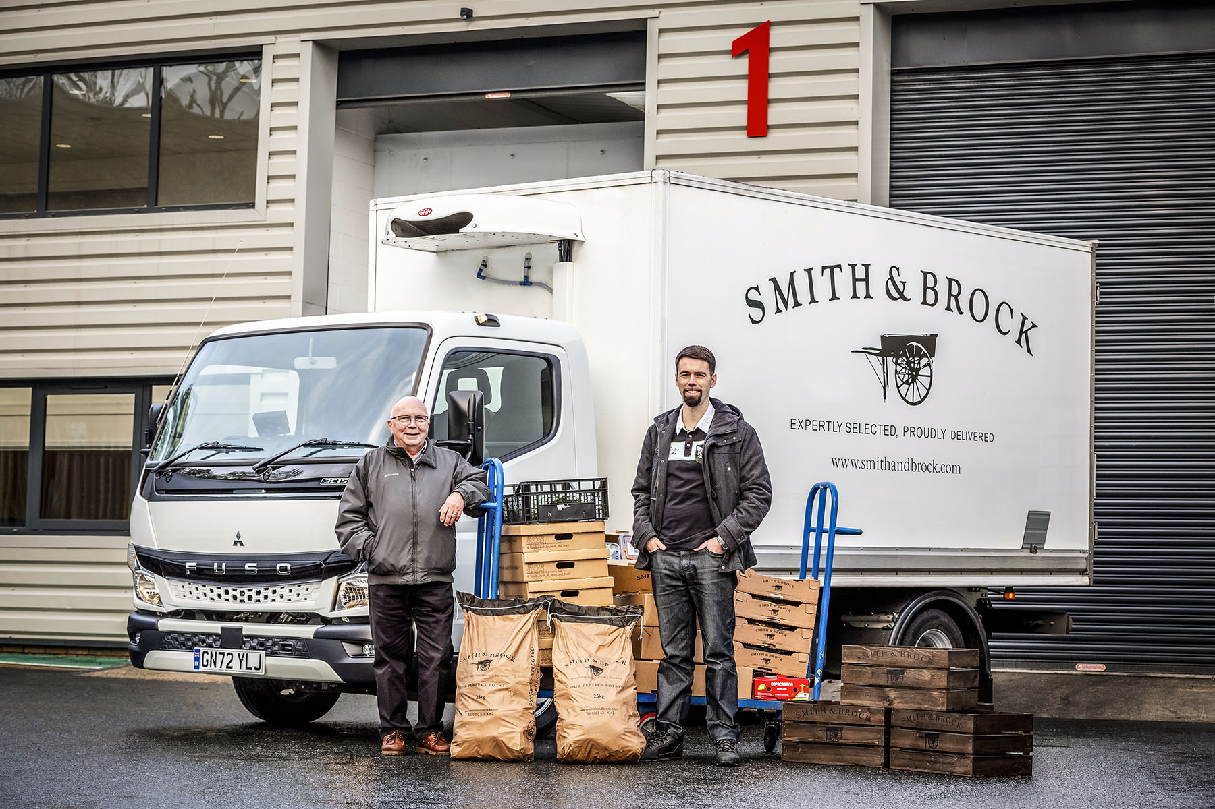

Expert advice: Smith & Brock relies on the support of Phil, left, and Luke McElhatton, of PJM Transport Consultancy

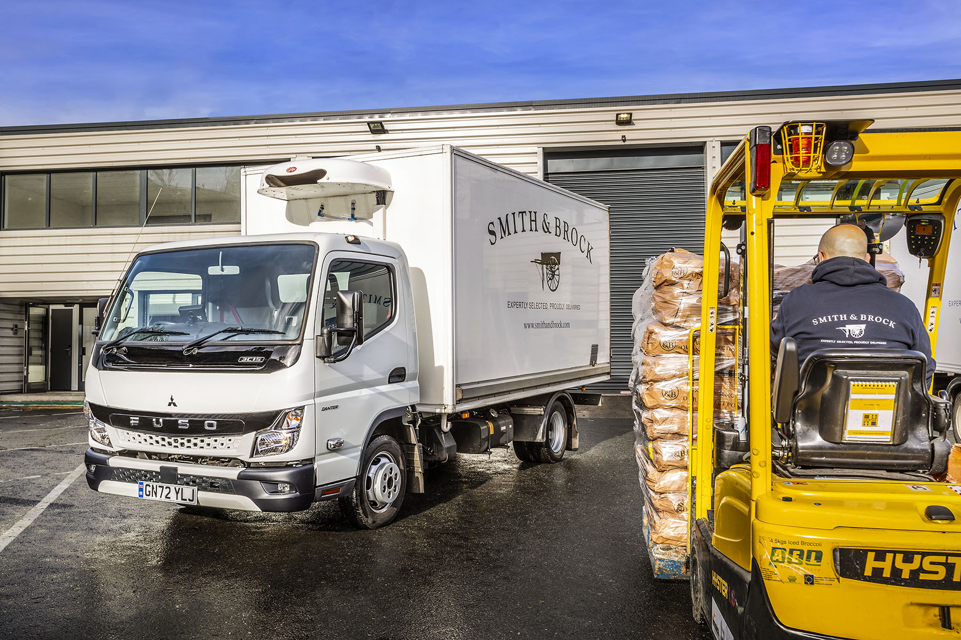

ends

For more information, or to request bigger/higher-res image files, please contact:
Steve Warren or John Ripley
Impact Communications
Steve: 07770 470251, steve@impactcom.co.uk
John: 07771 484595, john@impactcom.co.uk

