

Date: 28 June 2023

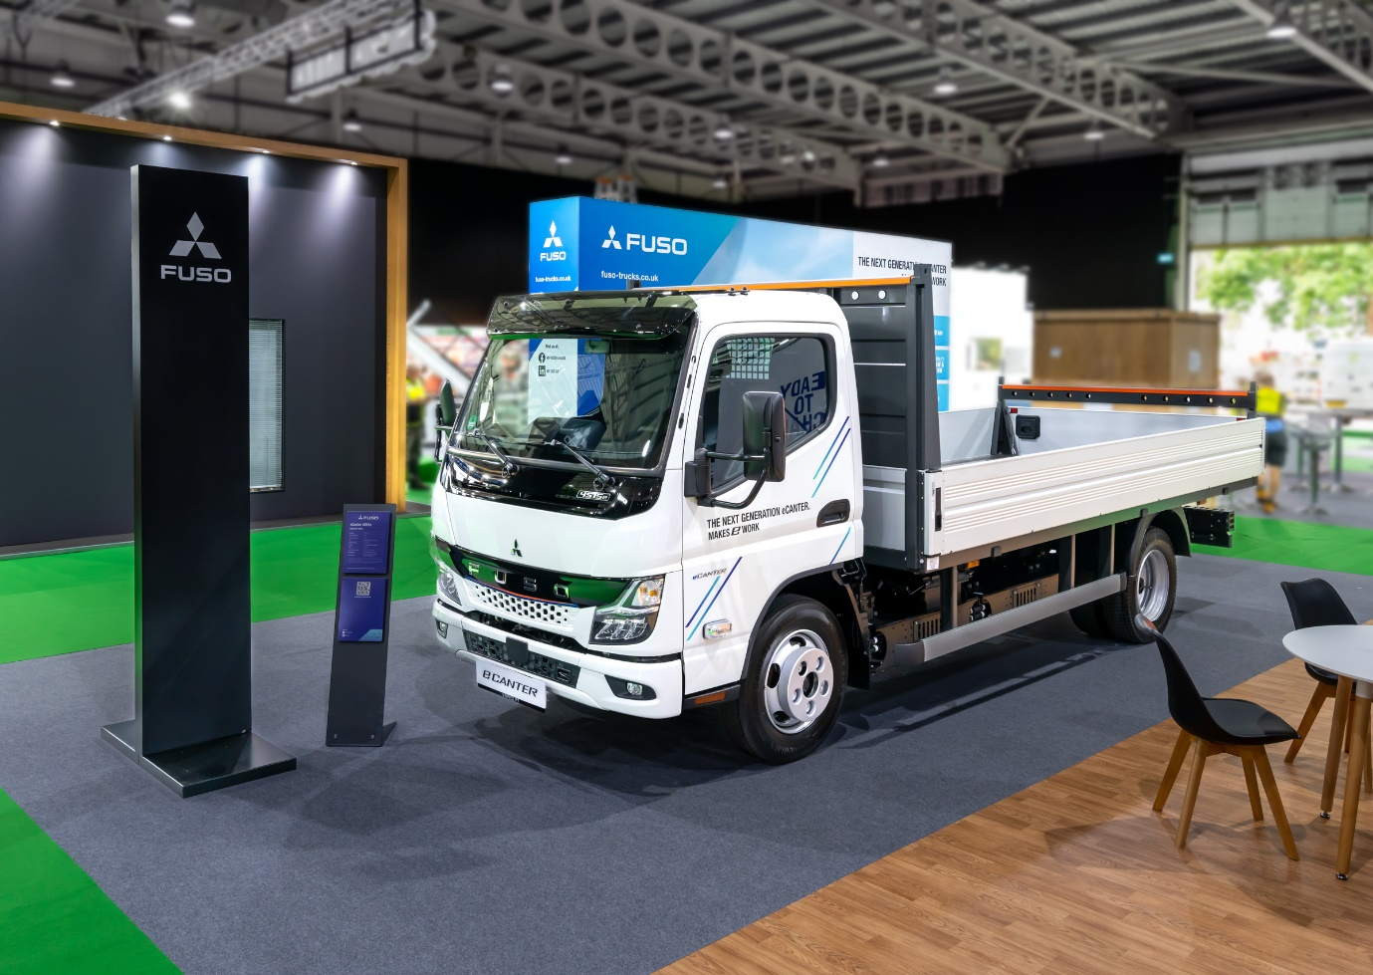

Next Generation FUSO eCanter sparks positive reaction at RoadTransport Expo

The all-electric Next Generation FUSO eCanter light truck made its debut at this week’s Road Transport Expo event at Stoneleigh, Warwickshire, just a month after production started at the brand’s factory in Portugal.

With a line-up of models offering more power and efficiency as well as a longer range than its predecessor, the Next Generation eCanter proved a popular draw for visitors to the three-day exhibition.

The model displayed was a 4S15e with Standard 1.7 metre-wide, three-seater cab and 129 kW motor. The M battery pack fitted provides a range of up to 140 km, while the 2,500 mm wheelbase chassis – one of six lengths available – was fitted with an alloy tipping body by Scattolini.

The Next Generation eCanter is designed to offer versatility across a variety of applications, with a range of flexible funding options available through Daimler Truck Financial Services.

The previous eCanter was a single model, with a 7.49-tonne GVW and 3,400 mm wheelbase. Now customers have the choice of six wheelbases, from 2,500 to 4,750 millimetres, and gross weights of 4.25, 7.49 or 8.55 tonnes. Load capacity can be up to 5.0 tonnes.

The Next Generation eCanter is powered either by an electric motor with 430 Nm of torque and outputs of either 110 kW or 129 kW. Maximum speed is electronically limited to 89 km/h.

Depending on the wheelbase, three different battery packs are available: S, M and L. The batteries use lithium iron phosphate (LFP) cell technology, which ensures long service life and more usable energy.

The S variant has a nominal capacity of 41 kWh and range of up to 70 kilometres. In M models these parameters increase to 83 kWh and 140 kilometres. The most powerful L version boasts a nominal 124 kWh, while potential range goes up to 200 kilometres – double that of the previous eCanter and comfortably more than the distance usually covered per day in light distribution traffic. Recuperation can increase the range even further, while at the same time minimising charging breaks.

The Next Generation eCanter’s charging unit supports both alternating current (AC) and direct current (DC), at up to 104 kW. DC fast charging from 20 to 80% of capacity is possible in approximately 24 minutes with the S battery pack, or 26 and 39 minutes for M and L versions, respectively. AC charging (11 and 22 kW) takes approximately four to six hours, depending on the battery pack.

FUSO GB Head of Future Sustainability James Venables said: “The Next Generation eCanter builds on the success of the previous model, which has proved itself to be a reliable and efficient performer in operation across Europe since its launch in 2017.

“Adding even more efficient drivelines, longer ranges and a much wider choice of body lengths and weights will make the Next Generation eCanter an even more attractive proposition to a broader spectrum of operators than ever before.”

Visitors the Road Transport Expo also had the opportunity to take part in a ‘ride & drive’ in a FUSO eCanter 7C15e from the previous model range, while a diesel-powered Canter 3S13 tipper was displayed on the brand’s main outside stand.

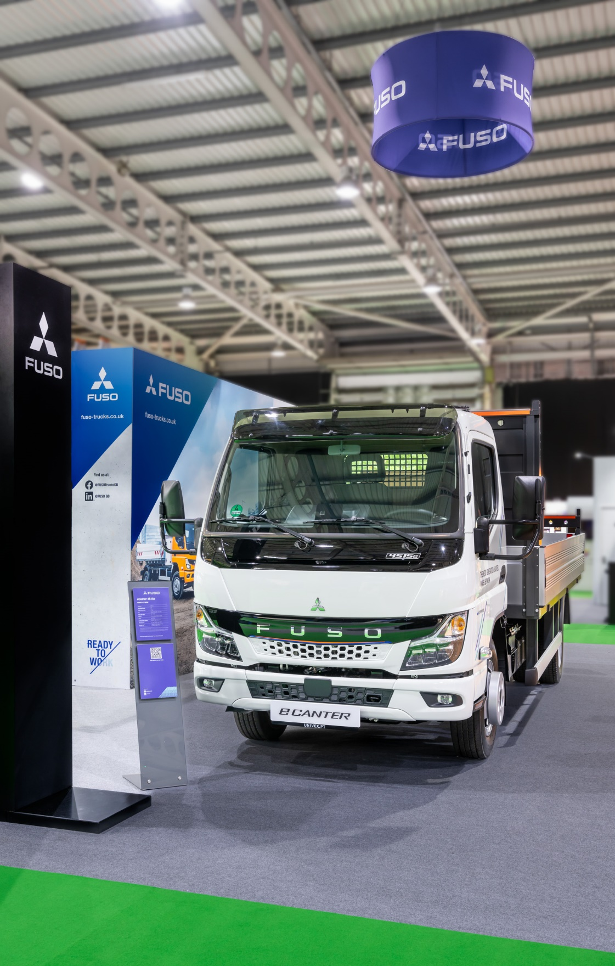

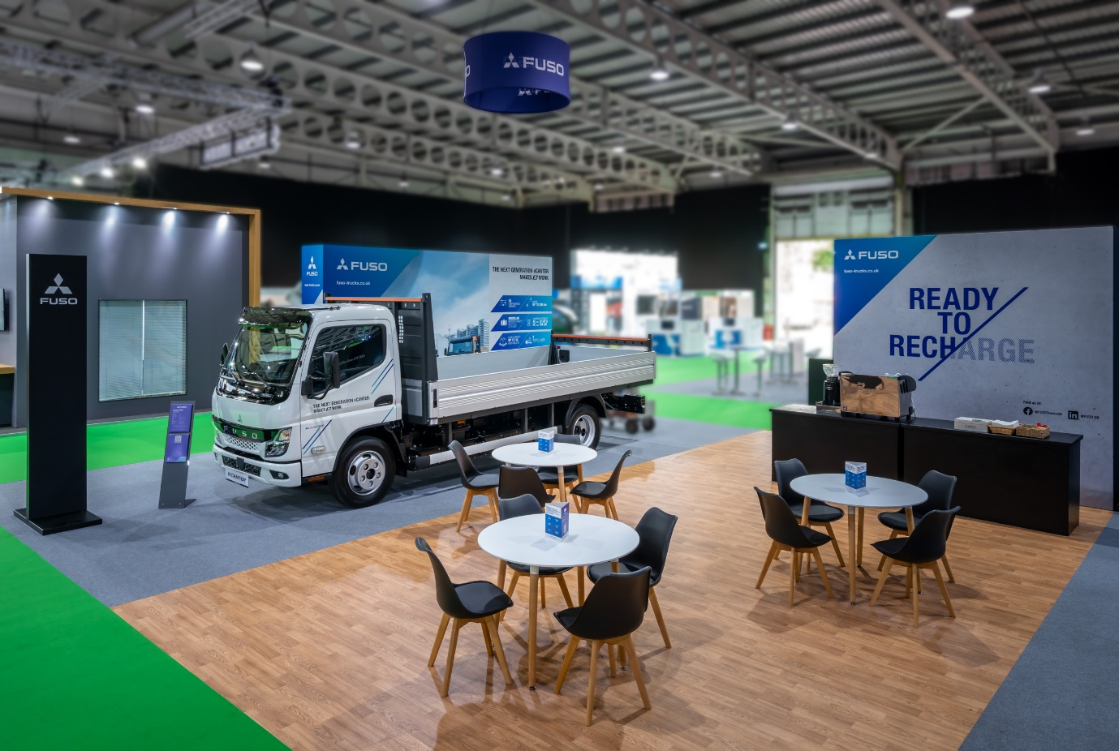

ends

For more information, or to request higher-resolution images, please contact:

Jamie Fretwell: 07712 519230, jamie.fretwell@daimlertruck.com

or

John Ripley: 07771 484595, john.ripley@loopagency.co.uk

