

Date: 21 May 2019

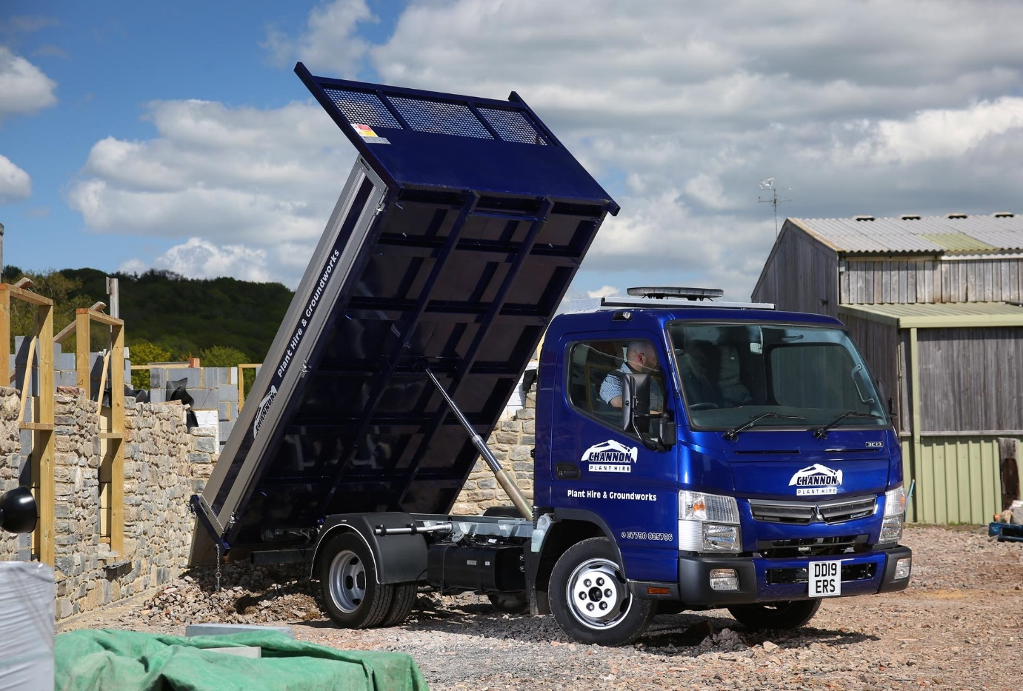

Channon chooses another tough Canter tipper from Rygor Commercials

The rugged reliability of his previous, “indestructible” 3.5-tonne FUSO Canter tipper meant that Craig Channon had no hesitation in turning to Dealer Rygor Commercials for a like-for-like replacement.

The proprietor of Channon Plant Hire & Groundworks, of Cheddar, Somerset, said: “My truck is a workhorse. I need it to start every day, and never let me down. That’s exactly what my last Canter has done, and I’ve every confidence its successor will prove to be every bit as good.”

The new Canter 3C13 is finished in eye-catching metallic blue, and powered by a 3.0-litre common-rail turbo-diesel engine which produces 96 kW (130 hp) and combines high levels of torque with impressive fuel economy.

Like other FUSO Canter Dealers in Britain, Rygor Commercials is also a member of the franchised Mercedes-Benz Trucks network. Supplied from stock and delivered within a month of the order being placed, Mr Channon’s new tipper has a Comfort day cab and is fitted with a steel body with aluminium dropsides, which was built by Brit-Tipp, of Warrington. Rygor Truck Sales Executive Marcus Cahalin also arranged competitive Mercedes-Benz Finance funding.

Key to the Canter’s appeal at 3.5 tonnes GVW, is its strength and durability – like its larger stablemates, the vehicle is built around a robust, ladder-frame chassis, which serves as an ideal base for a wide variety of bodies.

“The Canter is as compact and manoeuvrable as a van, but as tough and practical as a small truck,” said Mr Channon. “I use mine on the groundworks side of the business, to carry topsoil, stone and other materials.

“Whatever the load, the truck is well balanced and the handling assured. With its gross train weight of 7.0 tonnes it’s also a very good towing vehicle, so ideal for transporting my mini-diggers to and from sites.”

Established in 2014, Channon Plant Hire & Groundworks provides a friendly, reliable service to customers throughout Avon and Somerset. Mr Channon bought his previous, 2008 Canter second-hand, and had already owned it for a couple of years when he launched his business.

“That truck has been fantastic, indestructible, so I’m keeping it as a back-up,” he enthused. “The new one looks every bit as well built, but the cab is a definite improvement, being quite a bit roomier and more comfortable. It looks great, too, and should double as a very effective mobile ad for my company.”

Although the new truck arrived via Rygor’s Swindon branch, Mr Channon buys parts from the Dealer’s more conveniently located service centre at Chilcompton. “The team there have always been very helpful,” he added.

Marcus Cahalin said: “Rygor’s stock programme means we can offer customers access to a range of new Mercedes-Benz and FUSO vehicles which are pre-bodied and available at short notice. For operators who can’t afford to wait for a chassis to be built, shipped to the UK, and then sent to a third-party specialist to be fitted with a body, it represents an ideal solution.”

From tippers, tipper-grabs and mixers, to tractor units including specialist low-entry Mercedes-Benz Econic variants, Rygor always has a comprehensive range of ready-to-work vehicles available to try, and to buy. Visit www.rygor.co.uk/truck to review the Dealer’s latest stock of pre-built new and Approved Used vehicles.

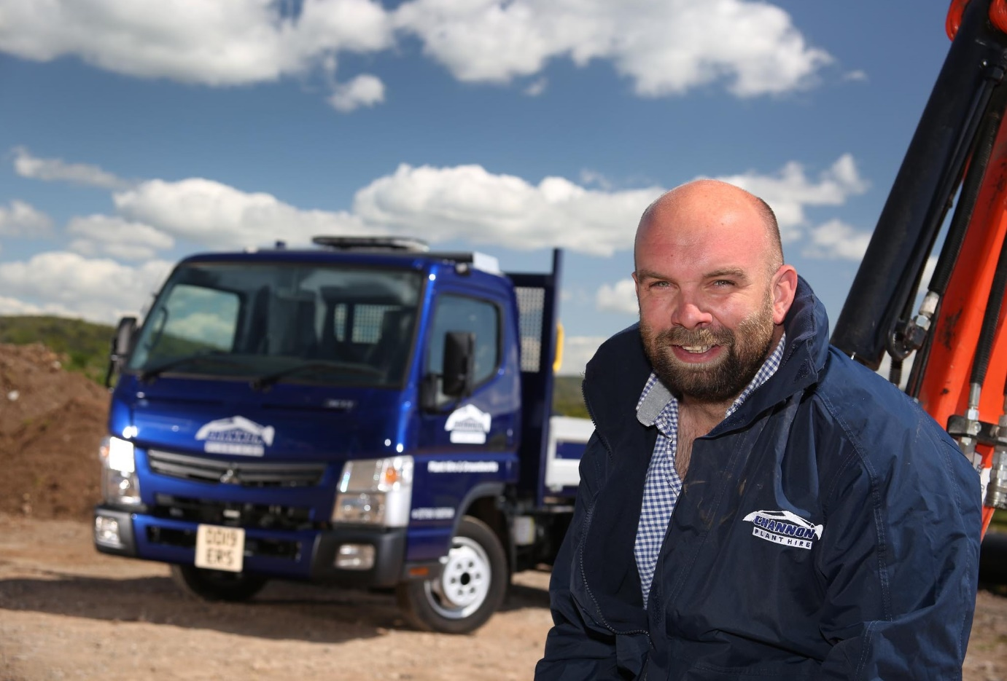

True blue: That’s Craig Channon, with his smart new FUSO Canter

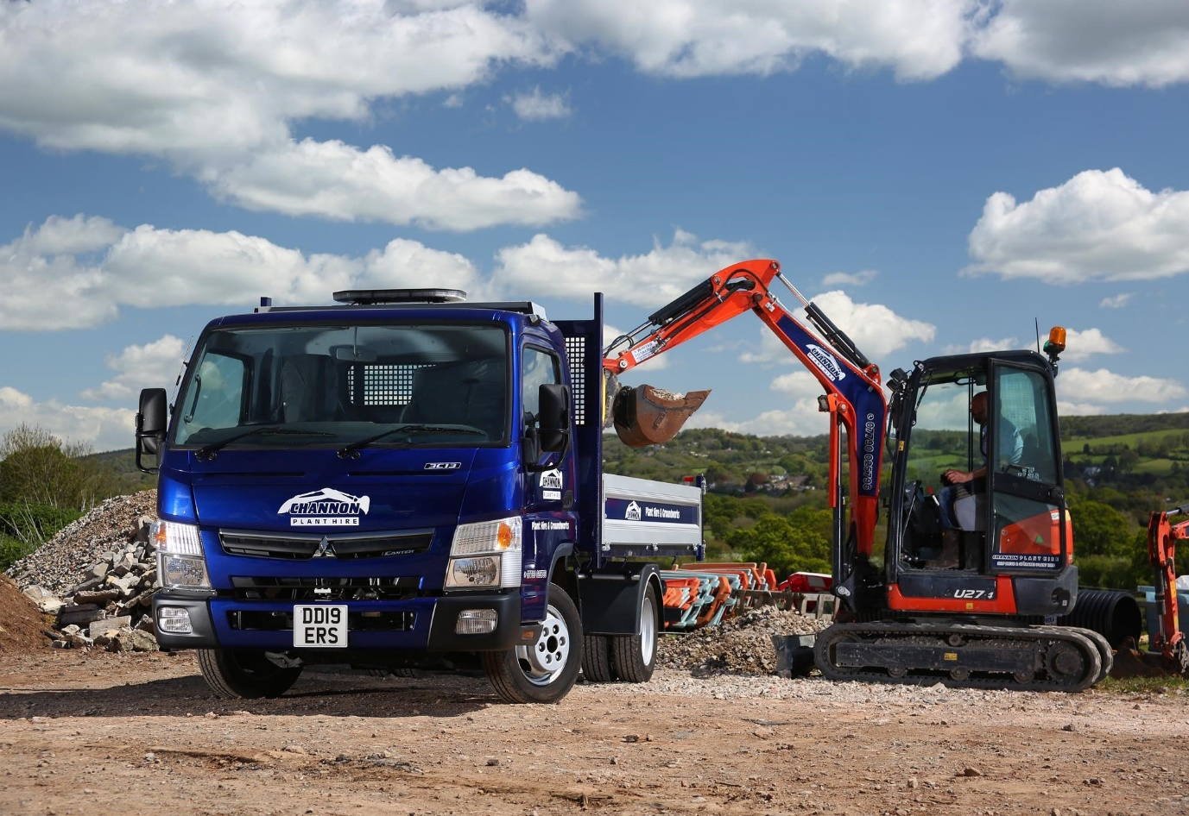

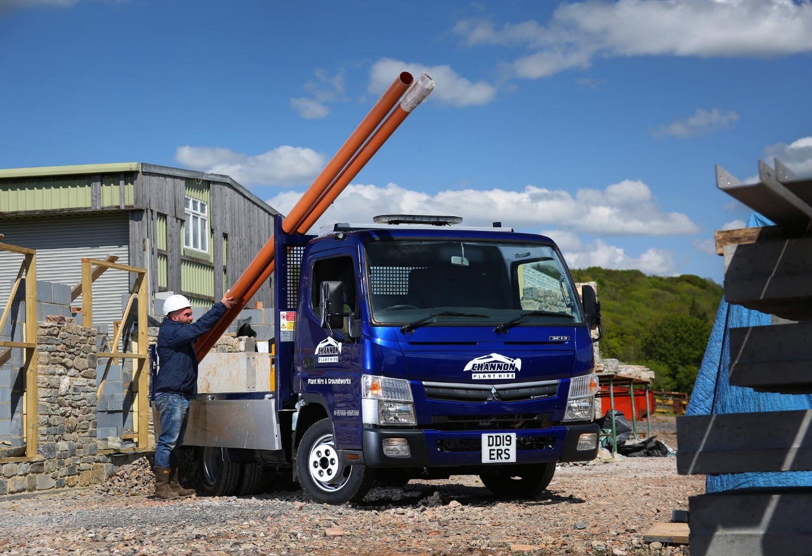

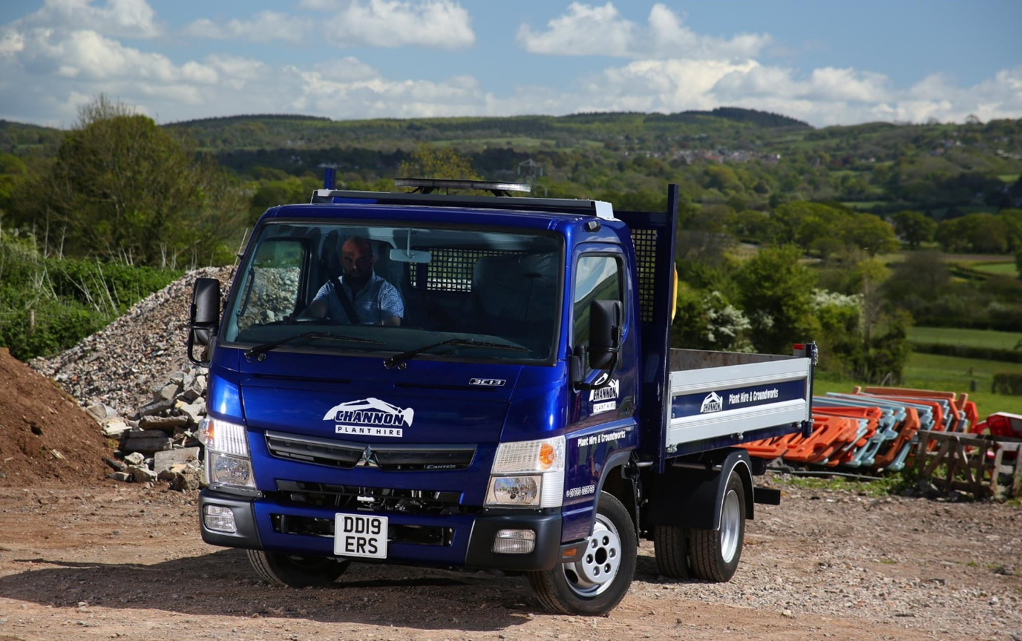
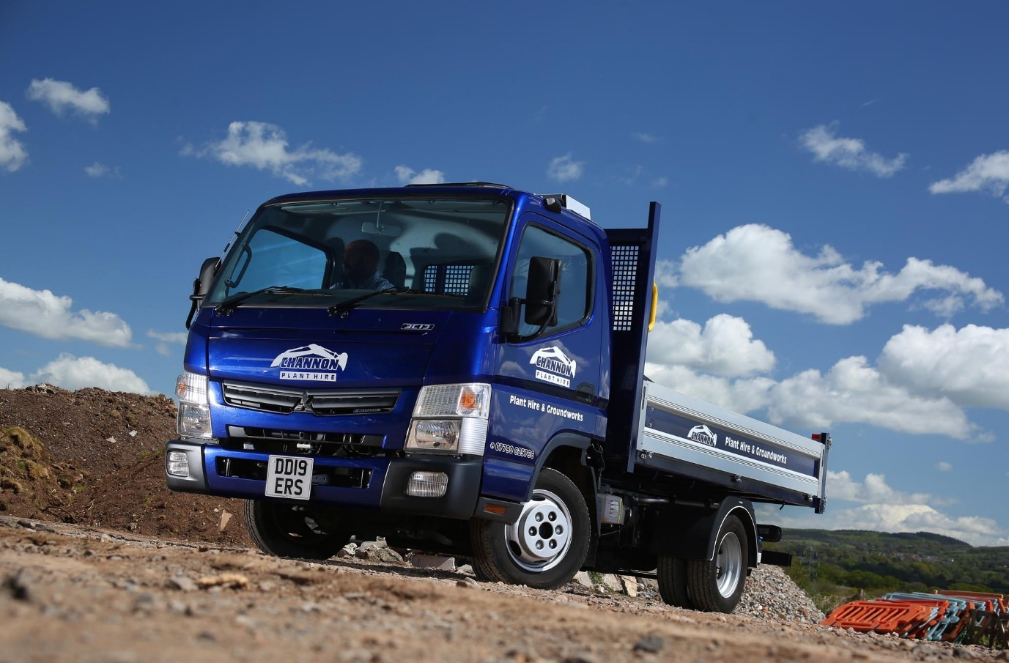

For more information, or to request bigger/higher-res image files, please contact:
Steve Warren or John Ripley
Impact Communications, 01926 842126
Steve: 07770 470251, steve@impactcom.co.uk
John: 07771 484595, john@impactcom.co.uk

Notes to Editors: Rygor Commercials

Mercedes-Benz Commercial Vehicle Dealer group, Rygor Commercials, has 10 branches throughout Berkshire, Gloucestershire, Oxfordshire, Somerset, West London, Warwickshire, Wiltshire and Worcestershire, offering extensive coverage for customers through the M5, M4 and M42 corridors.

The business has expanded and gone from strength to strength in recent years, launching its flagship Gloucester branch in late 2016 and undergoing a significant refurbishment of its Oxford branch in 2018. With a proven track record, the award-winning Rygor Commercials is proud to be selling and supporting the most prestigious name in commercial vehicles.

For more information, in the first instance please contact Kate Ruberry-Shoemack, Communications Manager at Rygor – kateruberry-shoemack@rygor.co.uk

