

Date: 7 November 2023

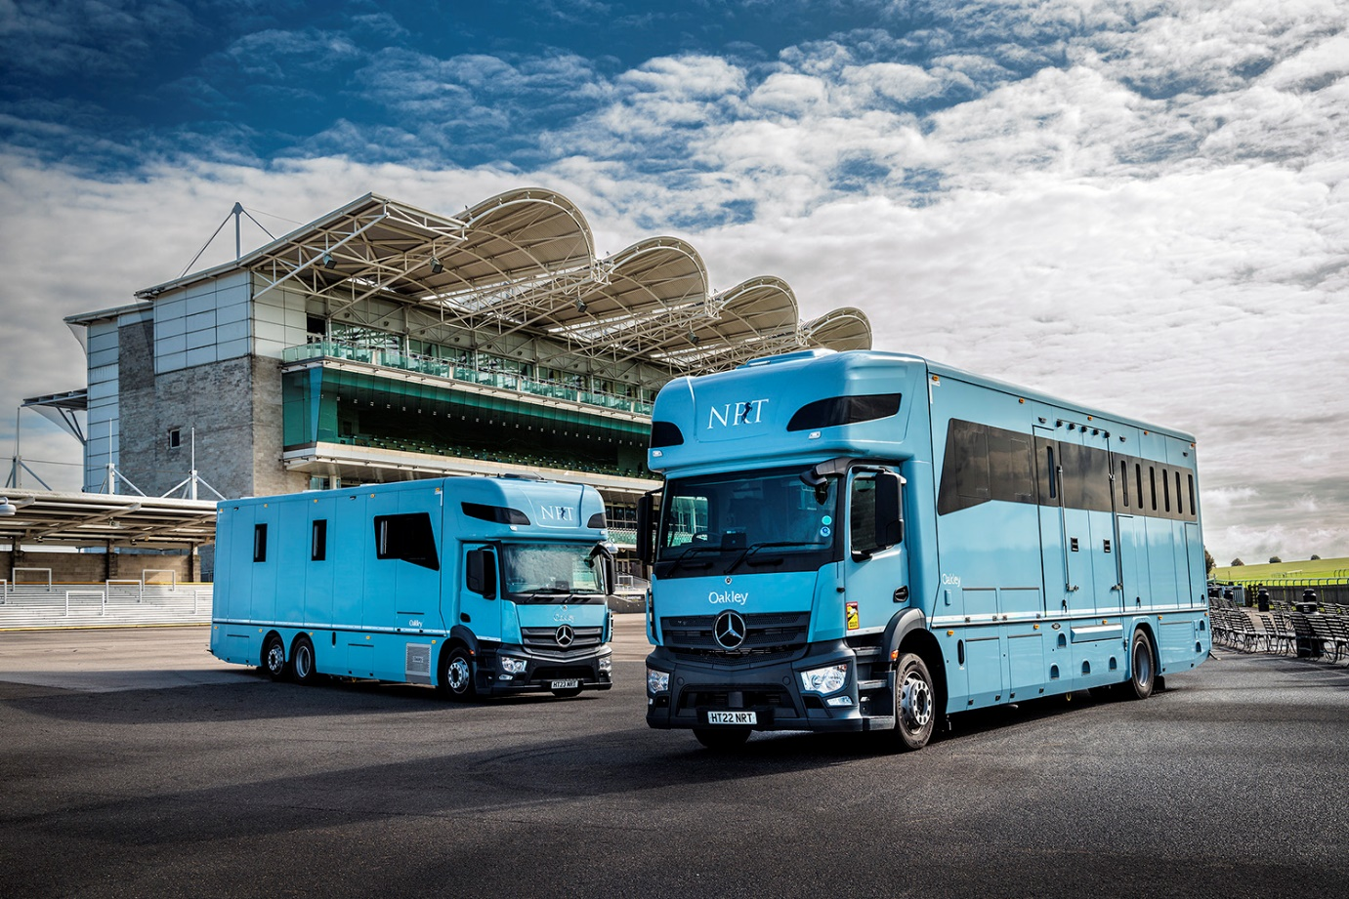

NRT races ahead of the field with new Actros horse transporters

Horses travelling to and from the UK and Europe can now make their journeys in the utmost safety, comfort and style in a pair of new Mercedes-Benz Actros transporters.

Delivered to NRT Horse Transport Ltd by Dealer Motus Truck & Van, the two trucks have jumped straight into position as flagships of the operator’s fleet.

One is a 26-tonne Actros 2536, powered by a 10.7-litre, 265 kW (360 hp) in-line six-cylinder engine; the other is an 18-tonne 1830 model, with a smaller 7.7-litre powerplant which produces 220 kW (300 hp). Both have 2.3-metre ClassicSpace cabs and 320 mm engine humps, which allow for a lower floor and driving position, improving both vision and ease of access for their drivers. The 26-tonner’s 6x2 chassis features a rear steering axle, for increased manoeuvrability.

Both have bodies by leading equine transport specialist Oakley Horseboxes, of Hertfordshire. The larger truck has individual stalls for nine horses, while the 4x2 model has space for seven. Cameras and remote temperature control systems mean the stall areas can be monitored and kept at the ideal temperature from the cab. The bodies can be accessed via loading ramps to the sides and rears, and both trucks feature underfloor lockers.

Although the transporters are designed to provide first-class accommodation for horses, human passengers are not ignored. The cabs have optional, upgraded interactive versions of the Mercedes-Benz Multimedia Cockpit, while the bodies boast comfortably furnished groom areas with seating as well as washing and toilet facilities, and roof-mounted sleeping pods.

NRT Operations Manager Jason Anderson said the two new trucks represent the latest stage in a five-year programme to replace all 15 vehicles on the fleet with new Mercedes-Benz chassis.

“We are committed to providing the highest standards of comfort and safety for travelling horses, passengers and our own staff. We believe that Mercedes-Benz and Oakley are at the forefront of design and manufacture in their respective fields, so we’re confident that these vehicles are the best we could get,” he said.

“We strive to make continual improvements and these new additions will ensure that we can offer the highest standards to horse owners, with a complete service to all destinations. Our choice of Mercedes-Benz was strongly influenced by access the comprehensive package of safety assistance systems fitted to the Actros. Meanwhile the addition of cameras, sensors and additional lighting systems in the stalls means the driver has access to everything required to provide the exacting level of care that is the foundation of NRT’s reputation.”

He continued: “Road Transport is a key area of our business. We are frequently travel into or close to major town and cities throughout the UK and Europe, many of which have either introduced low-emission zones or are considering doing so. By meeting the latest emissions standards these new trucks strengthen the fleet as well as ensuring total compliance when travelling through major cities in this country and beyond.”

www.nrthorsetransport.co.uk

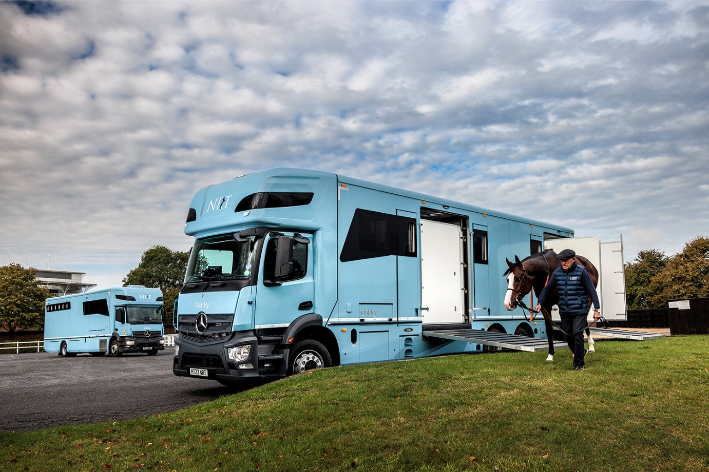

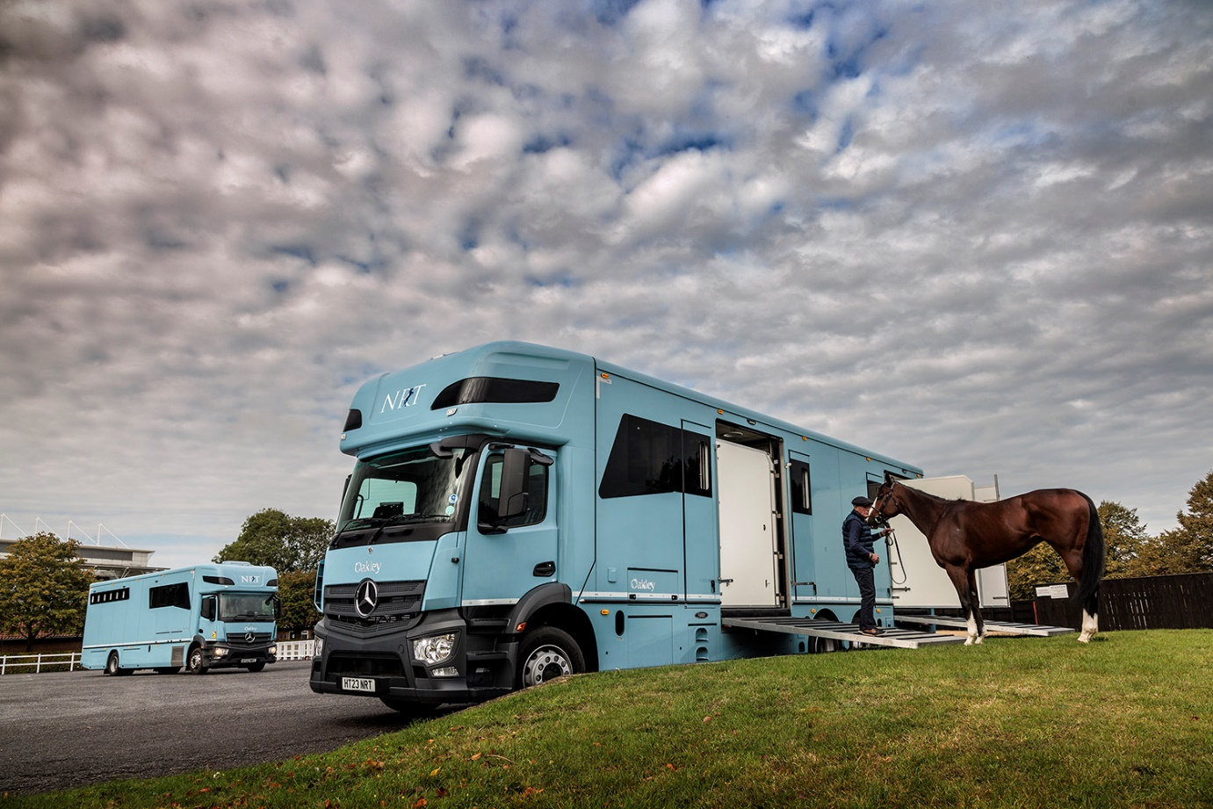

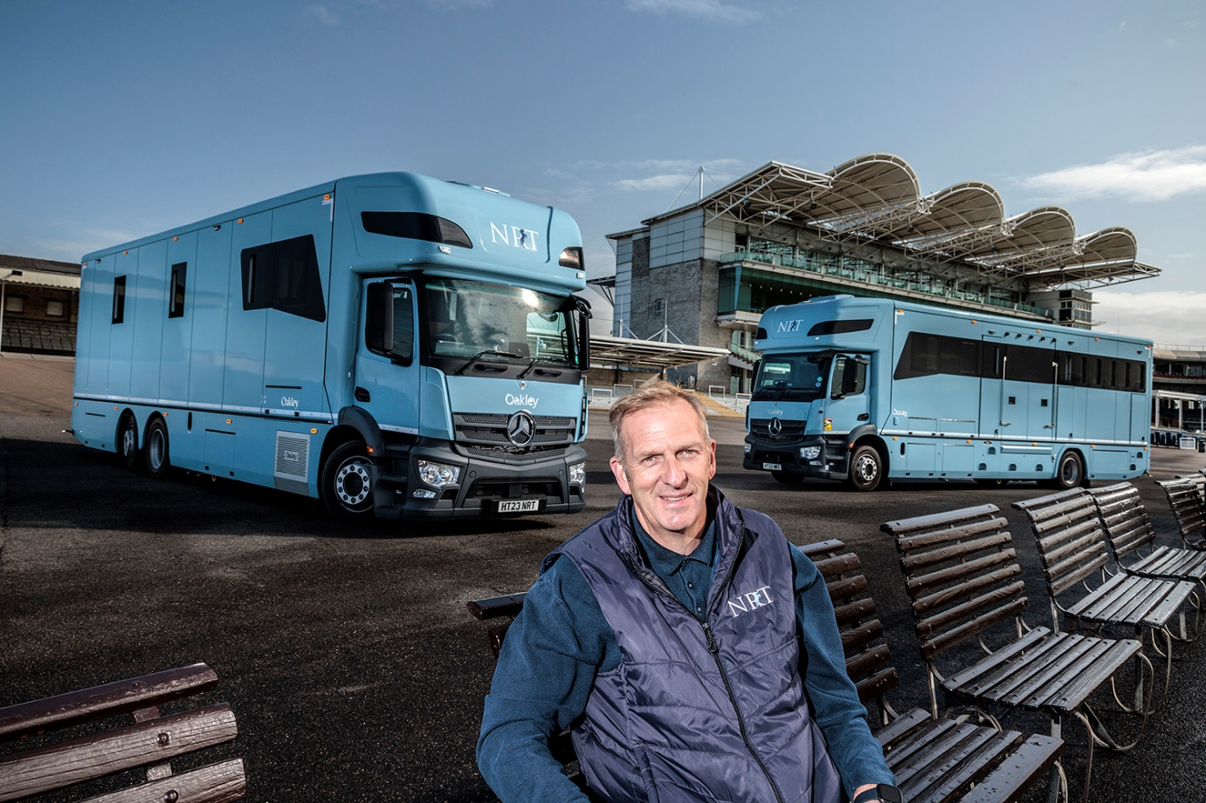

Horses for courses: NRT’s Jason Anderson says the company’s new Actros transporters are the best vehicles for the job

ends

For more information, or to request bigger/higher-res image files, please contact:
John Ripley: 07771 484595, john.ripley@loopagency.co.uk

