

Date: 20 September 2019

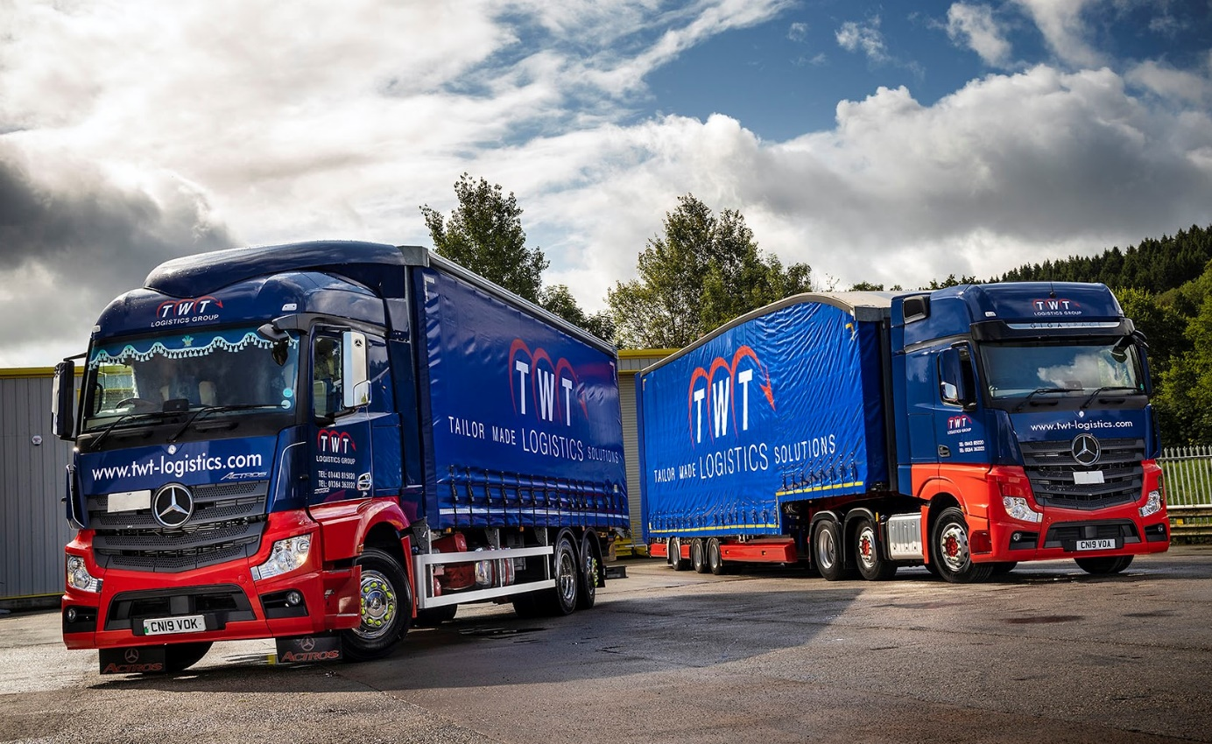

TWT upgrades its fleet with 12 Mercedes-Benz Actros

Mercedes-Benz is making fresh in-roads into the fleet of South Wales-based TWT Logistics Group, which has commissioned a dozen Actros models from local Dealer Euro Commercials within the last year.

Although it has operated trucks bearing the three-pointed star in the past, the family-owned company had more recently been favouring other brands. Smartly finished in its predominantly blue livery with colour coded bumpers and highlights in red, the Actros are proving economical to run and have been positively received by drivers.

Key to TWT’s decision to resume buying Mercedes-Benz trucks was the appointment by Euro Commercials in 2017 of Gary Clark as its Truck Sales Manager. He previously represented another manufacturer, and enjoys a strong working relationship with TWT Logistics Managing Director Trevor Taylor and his colleagues.

“I’ve known Gary since he was a kid in the workshop,” said Mr Taylor. “The Actros is clearly a premium quality vehicle, and right up there with the best on the road. But this is a business in which people and leadership are every bit as important as the trucks themselves. Gary has worked hard to win our business and we trust him to deliver on the commitments he’s made.”

TWT Logistics purchased a pair of Approved Used 65-registered Actros 2545 StreamSpace tractor units with 330 kW (450 hp) six-cylinder engines late last year. Next to arrive, as the company embarked on its 2019 fleet modernisation programme, were four new 2548 tractors with range-topping GigaSpace cabs and 350 kW (476 hp) straight-sixes.

A 26-tonne Actros 2532 StreamSpace with 235 kW (320 hp) engine and curtainside body by Tiger Trailers, of Winsford, Cheshire, entered service in July, since when TWT has bought another two GigaSpace tractor units, this time 2551 models with 375 kW (510 hp) powerplants.

Completing the Mercedes-Benz line-up are a trio of Actros 2551 GigaSpace tractors which are the subject of a rental agreement with Euro Commercials – TWT intends also to buy these vehicles at the end of the term.

Established by Mr Taylor in 1988, the TWT Logistics Group quickly developed a reputation for handling time-critical consignments. It now operates a fleet of 90 trucks and vans, and 135 trailers, and provides a broad range of transport, distribution and warehousing services to an impressive portfolio of ‘blue chip’ customers.

The six-wheeled rigid works from the company’s nine-acre headquarters site at Ystrad Mynach, near Caerphilly, which is also home to a fully equipped commercial vehicle workshop.

The tractors, however, are all based at its Switch International satellite in Andover. The subject of three-year Mercedes-Benz Complete Service Contracts, they are being inspected by the manufacturer’s Hampshire Dealer, which has a branch less than three miles away.

Trevor Taylor was a recent visitor to the Mercedes-Benz truck factory at Wörth, in Germany. “I was hugely impressed,” he said. “From an engineering perspective the attention to detail and commitment to quality was superb.”

He continued: “These are still early days but our new Actros look fantastic and are performing every bit as well as we’d hoped. Long-term reliability is going to be crucial, of course, and I’m confident these trucks are going to deliver on that score.

“As far as fuel-efficiency is concerned, mpg returns for the tractors are in the nines, which is what we were looking for. Good drivers are also extremely hard to come by, so it’s essential that we look after ours. One way we can do that is by providing them with premium quality, highly specified equipment. I’m pleased to say that the Actros have been very well received.”

twt-logistics.com

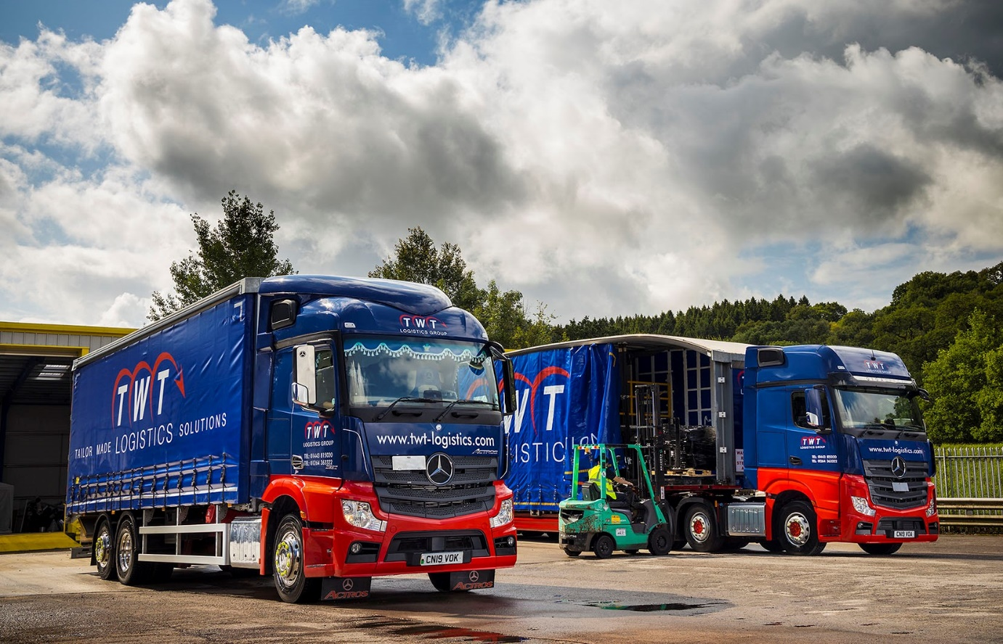

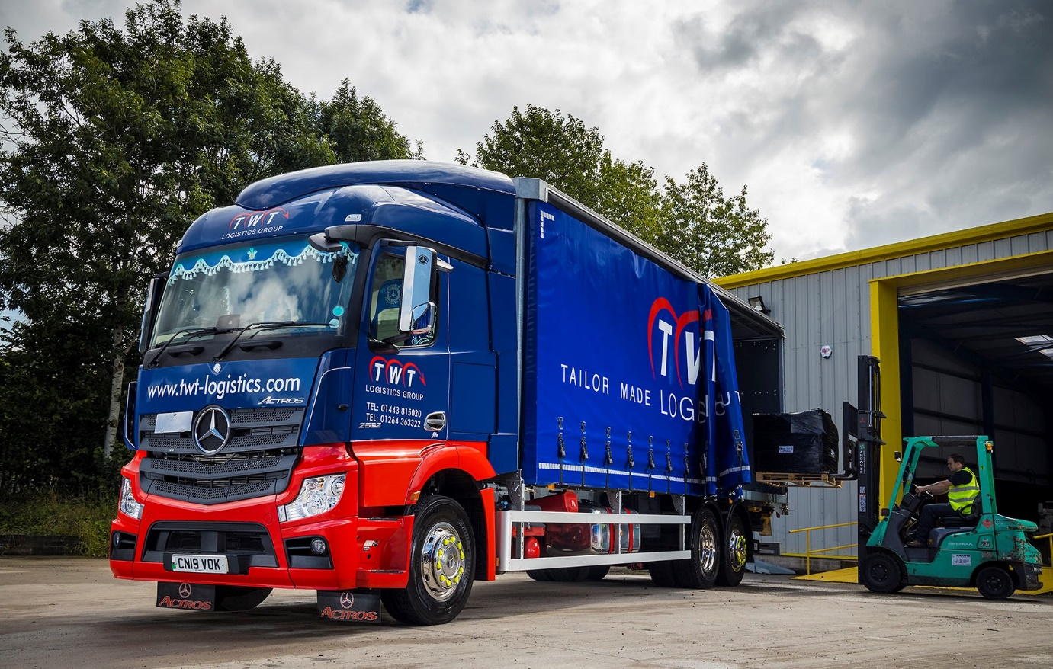
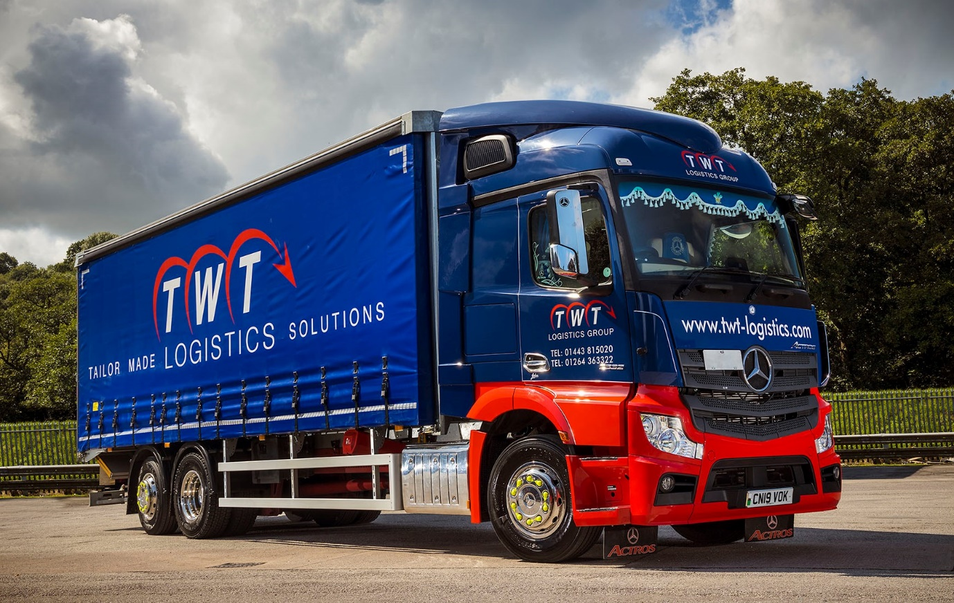

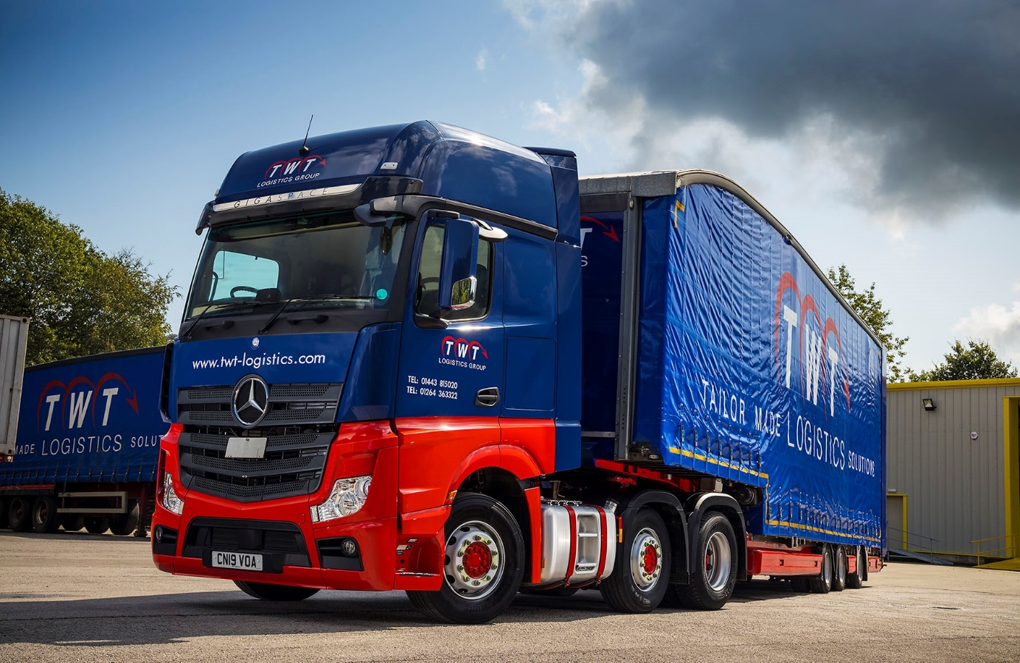
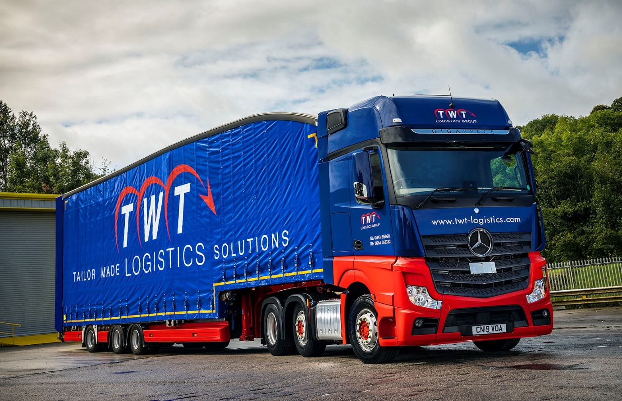

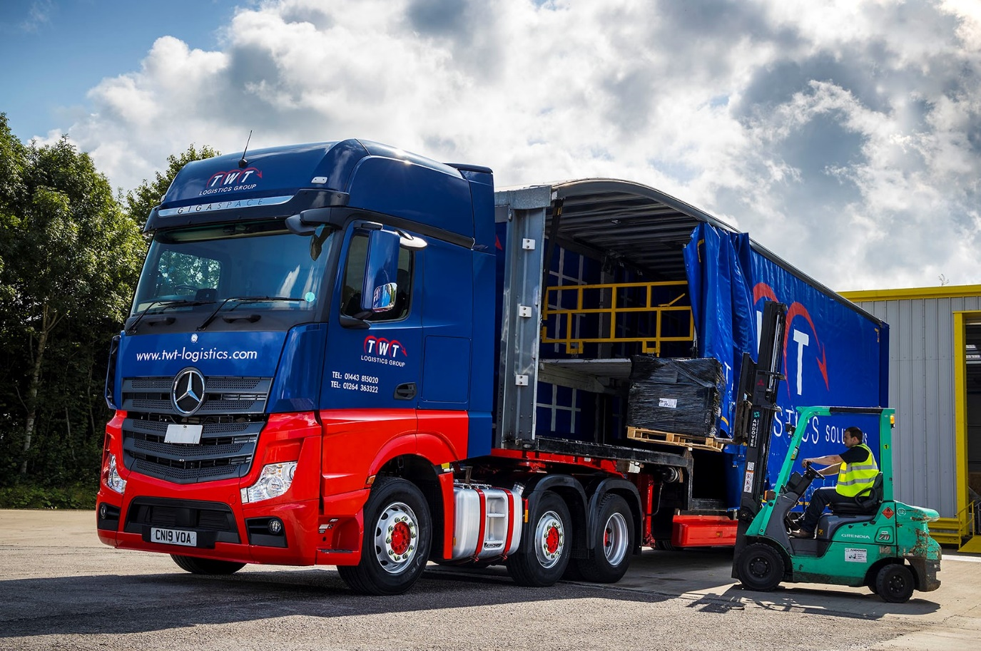

ends

For more information, or to request bigger/higher-res image files, please contact:
Steve Warren or John Ripley
Impact Communications, 01926 842126
Steve: 07770 470251, steve@impactcom.co.uk
John: 07771 484595, john@impactcom.co.uk



