

Date: EMBARGO: 00:01, 11th February 2025

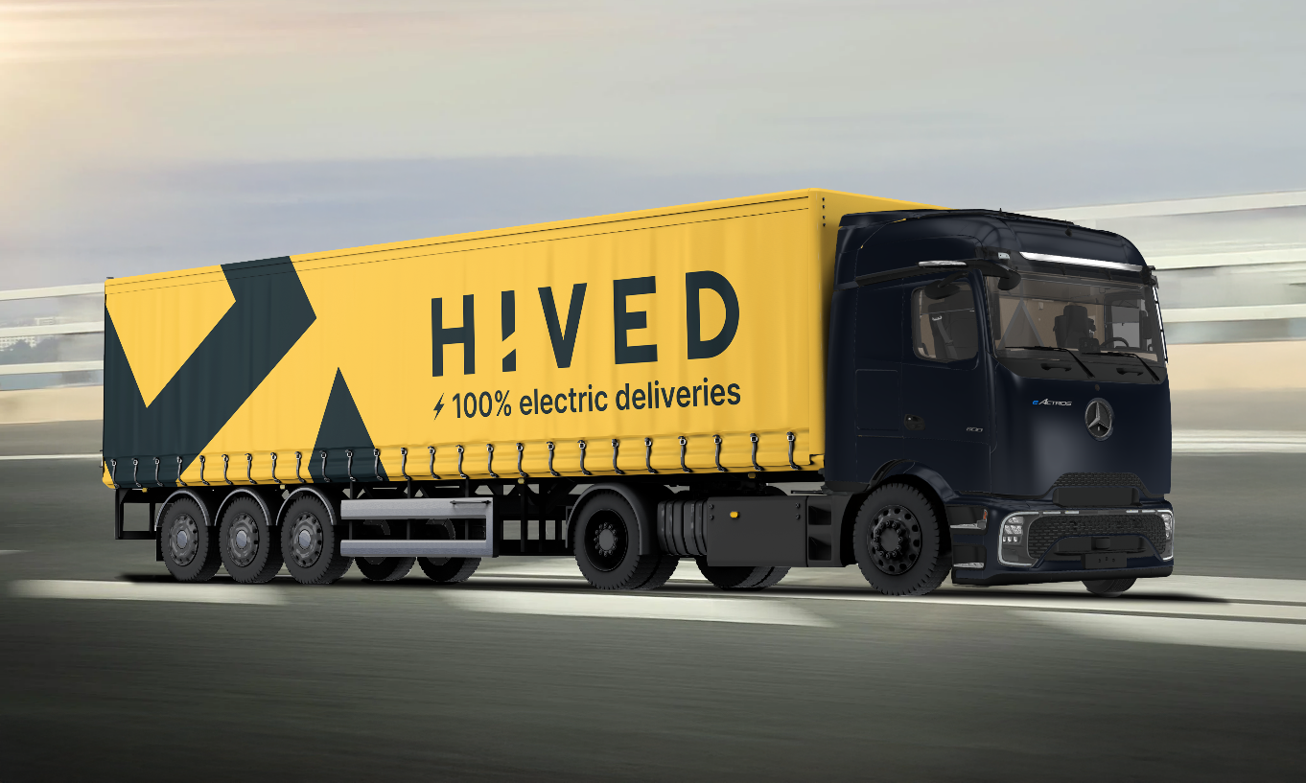
HIVED expands UK’s first fully electric parcel delivery network with 11 eActros from Mercedes-Benz Trucks

- 11 Mercedes-Benz eActros (9 x eActros 600, 2 x eActros 400) ordered by HIVED as it scales its end-to-end, fully electric parcel delivery network for ecommerce
- HIVED – the only delivery company to operate an all-electric fleet across the middle and final mile – will invest in its own charging infrastructure to support its nationwide network
- Battery capacity of over 600 kWh¹ means eActros 600 can achieve a range of at least 500 km²
- The eActros 600 is International Truck of the Year 2025

The leading all-electric parcel delivery company HIVED has placed an order for 11 Mercedes-Benz eActros, recently voted International Truck of the Year 2025, as it expands the UK’s only end-to-end electric delivery network, covering middle and final mile.

HIVED has ordered nine eActros 600 and two eActros 400 from Mercedes-Benz Dealer partner, Motus Truck & Van. They will operate across HIVED’s nationwide middle mile network, collecting from retailer warehouses for delivery to end customers.

The eActros 600 is the perfect choice for HIVED’s middle mile deliveries as its large battery capacity of over 600 kWh¹ means it can travel at least 500 km² (310 miles²) on a single charge.

In the next year, HIVED plans to install megawatt chargers, a rarity for the U.K. charging infrastructure, at its hubs in West London, the Midlands and Manchester. These megawatt chargers will allow the eActros 600 to charge from 20 to 80% in just 30 minutes and, in effect, level the playing field between diesel and electric HGVs.

Stuart Jeggo, Sales & Marketing Director of Daimler Truck UK Limited said: “HIVED’s rapid growth in the UK is extremely impressive, so we are delighted to be the chosen partner for their first eHGVs. I look forward to seeing the first vehicles delivered and out on the road later this year.”

James Venables, Head of Future Sustainability of Daimler Truck UK Limited added: “HIVED’s commitment to end-to-end, all electric delivery service is a great example of how switching to electric trucks can improve sustainability of any company, particularly in the delivery sector. This progressive, future-focussed company is the ideal partner for us and the eActros.”

HIVED’s Co-founder and Chief Product Officer, Mathias Krieger commented: “This is a major moment for the logistics industry. In an industry where the status quo is to run a mixed fleet at best, HIVED is the first delivery company to operate an all-electric delivery network across the middle and final delivery mile. With the eActros, HIVED continues to redefine what a modern delivery company looks like with our expanded electric middle mile capacity.”

ends

Notes:
- ¹ The eActros 600 has three battery packs, each with 207 kWh. These offer an installed total capacity of 621 kWh. Nominal capacity of new battery, based on internally defined boundary conditions, may vary depending on use case and ambient conditions.
- ² The range was determined internally under specific test conditions, after preconditioning with a 4x2 tractor unit with a 40 tonnes total towing weight at 20°C outside temperature in long-haul operation and may deviate from the values determined in accordance with Regulation (EU) 2017/2400
- Image of Mercedes-Benz Truck eActros with HIVED branding is representative example.

For more information, please contact:
Nick Ford, PR & Communications Manager, Daimler Truck UK
Email: nick.ford@daimlertruck.com
Mobile: 07712 235962

John Rawlings, Account Director, Loop
Email: john.rawlings@loopagency.co.uk
Mobile: 07847 371436

