

Date: 15 April 2019

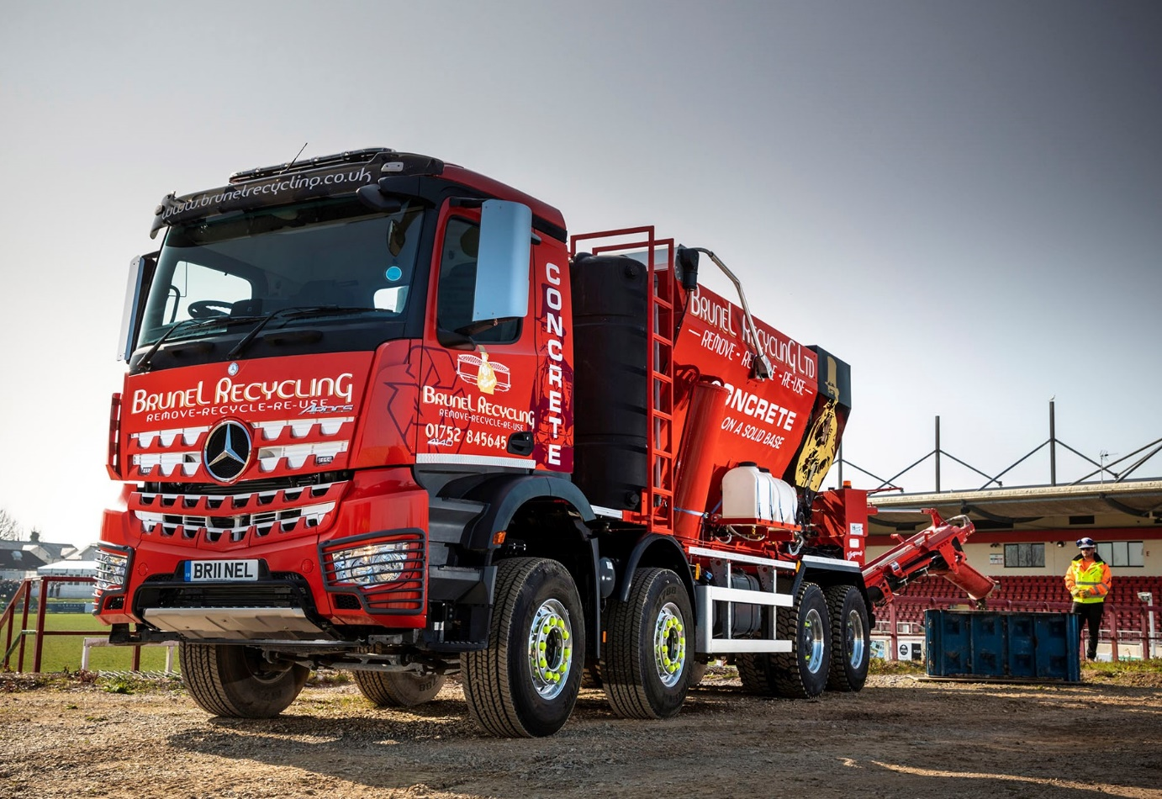

Mercedes-Benz Trucks Dealer Rygor mixes it up for Brunel Recycling

Cornwall’s Brunel Recycling has added the latest string to its Mercedes-Benz bow, in the shape of a high-riding eight-wheeler with volumetric mixer body.

Essentially a truck mixer and concrete batching plant rolled into one, the new truck is based on a muscular Arocs 4140K chassis supplied by Dealer Group Rygor Commercials.

Built in Buckingham by concrete equipment specialist Utranazz, the Hydromix HM12H-E body features separate compartments for sand, stone, cement and water. These raw materials are then metered and mixed into fresh concrete when and where it is needed. The unmixed product remains useable indefinitely, eliminating costly wastage.

The Arocs range is purpose-designed for construction work and related applications. A real head-turner in the operator’s bright red livery, the new truck has a ClassicSpace M-cab and pairs an advanced, 10.7-litre straight-six engine which produces 290 kW (394 hp), with a smooth Mercedes PowerShift 3 automated transmission.

Brunel Recycling purchased its first Mercedes-Benz, an 8x4 Arocs tipper, from Rygor in 2015. To this, it then added another three tippers and a tipper-grab, before taking delivery last year of a hook-loader. All six of these 32-tonne vehicles are based on Arocs 3240K chassis; with one exception the tippers, and the tipper-grab, have Thompson bodies, while the hook-loader’s roll on-roll-off equipment is by HARSH.

Family-owned Brunel Recycling’ headquarters are in Saltash, where it owns a fully licensed and permitted landfill and waste transfer station. The company’s roots date back to 1989, when Dave Venables established his landfill, which he then developed into a waste transfer station, skip-hire firm, and recycling facility.

Today, having changed its name from Brunel Skips to Brunel Recycling, and adopted the ‘Remove-Recycle-Reuse’ motto which is proudly emblazoned on its Mercedes-Benz trucks, it provides a comprehensive portfolio of haulage, demolition, recycled aggregates and, now, concrete services to customers throughout Devon and Cornwall.

Brunel Recycling’s graded aggregates are widely used for construction projects in Plymouth and the surrounding area. The firm also supplies top soils and biomass, undertakes site clearances, demolitions and muckaway work, and offers heavy plant and machinery for hire.

His father – the owner of Plymouth Albion rugby club – having retired, Managing Director Brian Venables now runs the business with his Director brother Max, whose wife Nadine is Operations Manager.

Brian Venables said Brunel Recycling’s experience of operating Mercedes-Benz trucks over the last four years had been entirely positive. “They’ve been totally reliable and are very economical,” he confirmed.

“The Arocs is clearly built to withstand the rigours of our kind of work. The excellent ground clearance is a big advantage when we’re off-road, and it’s very comfortable to drive. The Arocs also looks and sounds brilliant,” he added. “It’s a seriously cool truck, and the guys love it.”

Acquired, like its previous Arocs, with competitive funding support from Mercedes-Benz Finance, Brunel Recycling’s volumetric mixer is already opening doors to new business opportunities. “We do a lot of slabs and foundations for houses, and the new truck offers a very cost-effective means of delivering the concrete,” explained Mr Venables. “It didn’t come cheap, but this vehicle has added another string to our bow, and I’m confident it will prove over time to have been a wise investment.”

Mr Venables also praised the service provided by Rygor Commercials Truck Sales Executive Marcus Cahalin. “Marcus is a joy to work with,” he observed. “I’m quite a fiery character but he knows how to handle me. If ever an issue crops up, as they always will from time to time, he remains very calm and ensures that it’s resolved with the minimum of fuss.”

Marcus Cahalin said: “Every truck Rygor supplies is important to its owner, and we endeavour to reflect this by providing an appropriately high level of service to each and every one of our customers. Every now and then, though, a truck comes along which really stands out from the crowd, and Brunel Recycling’s volumetric mixer is certainly one. It’s a fantastic machine, and was a real pleasure to deliver.”

www.brunelrecycling.co.uk

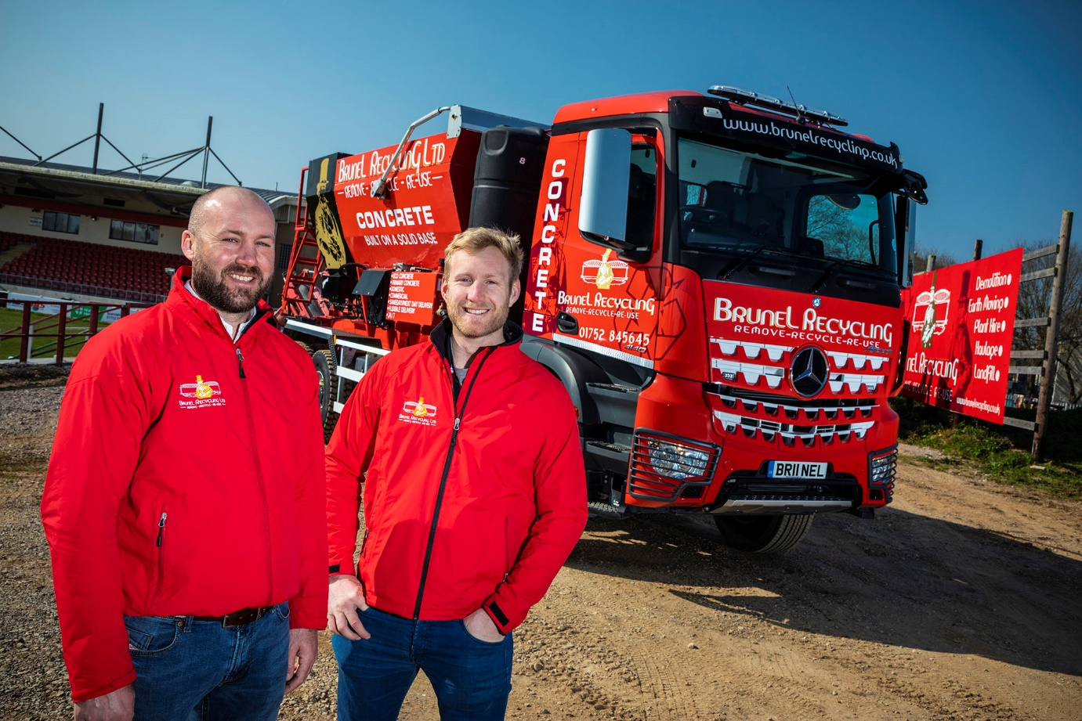

Keeping it in the family: Brothers Brian, left, and Max Venables, are now running their seventh Mercedes-Benz Arocs from Rygor Commercials

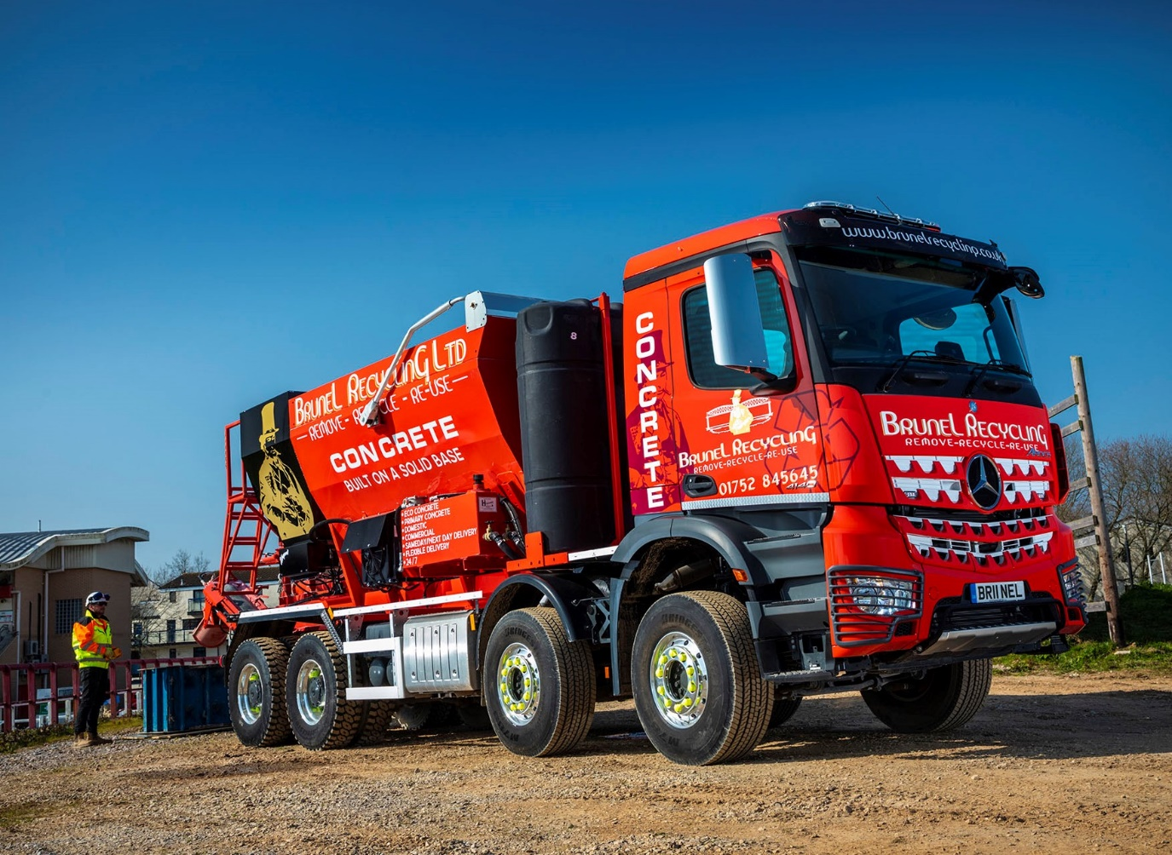

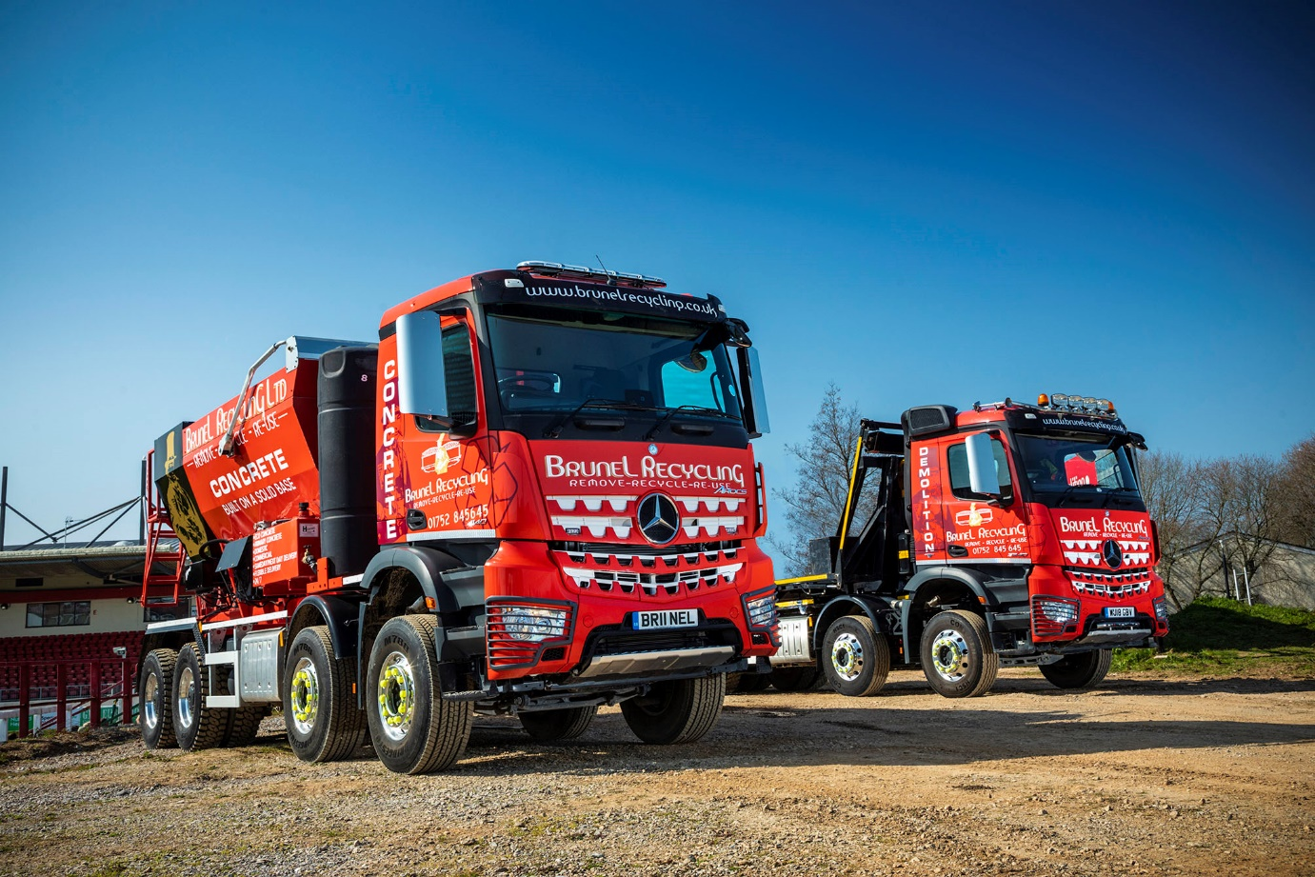

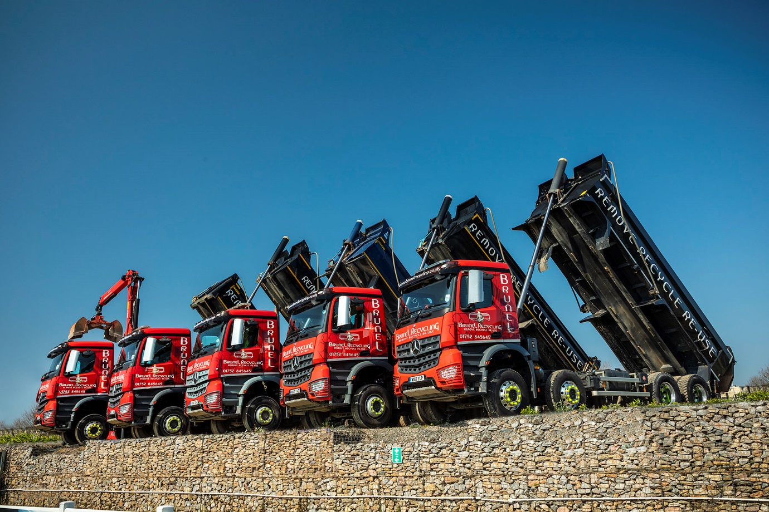

ends

For more information, or to request bigger/higher-res image files, please contact:
Steve Warren or John Ripley
Impact Communications, 01926 842126
Steve: 07770 470251, steve@impactcom.co.uk
John: 07771 484595, john@impactcom.co.uk

Notes to Editors: Rygor Commercials

Mercedes-Benz Commercial Vehicle Dealer group, Rygor Commercials, has 10 branches throughout Berkshire, Gloucestershire, Oxfordshire, Somerset, West London, Warwickshire, Wiltshire and Worcestershire, offering extensive coverage for customers through the M5, M4 and M42 corridors.

The business has expanded and gone from strength to strength in recent years, launching its flagship Gloucester branch in late 2016 and undergoing a significant refurbishment of its Oxford branch in 2018. With a proven track record, the award-winning Rygor Commercials is proud to be selling and supporting the most prestigious name in commercial vehicles.

For more information, in the first instance please contact Kate Ruberry-Shoemack, Communications Manager at Rygor – kateruberry-shoemack@rygor.co.uk

