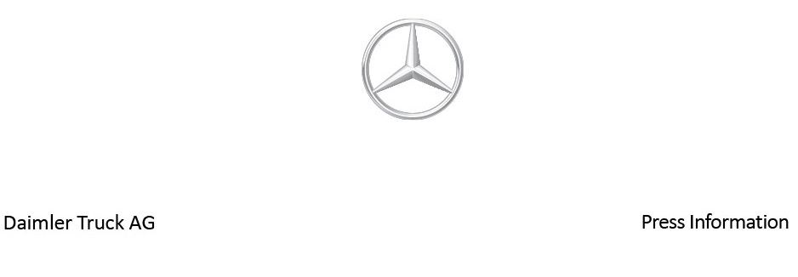

Date: 7 April 2022

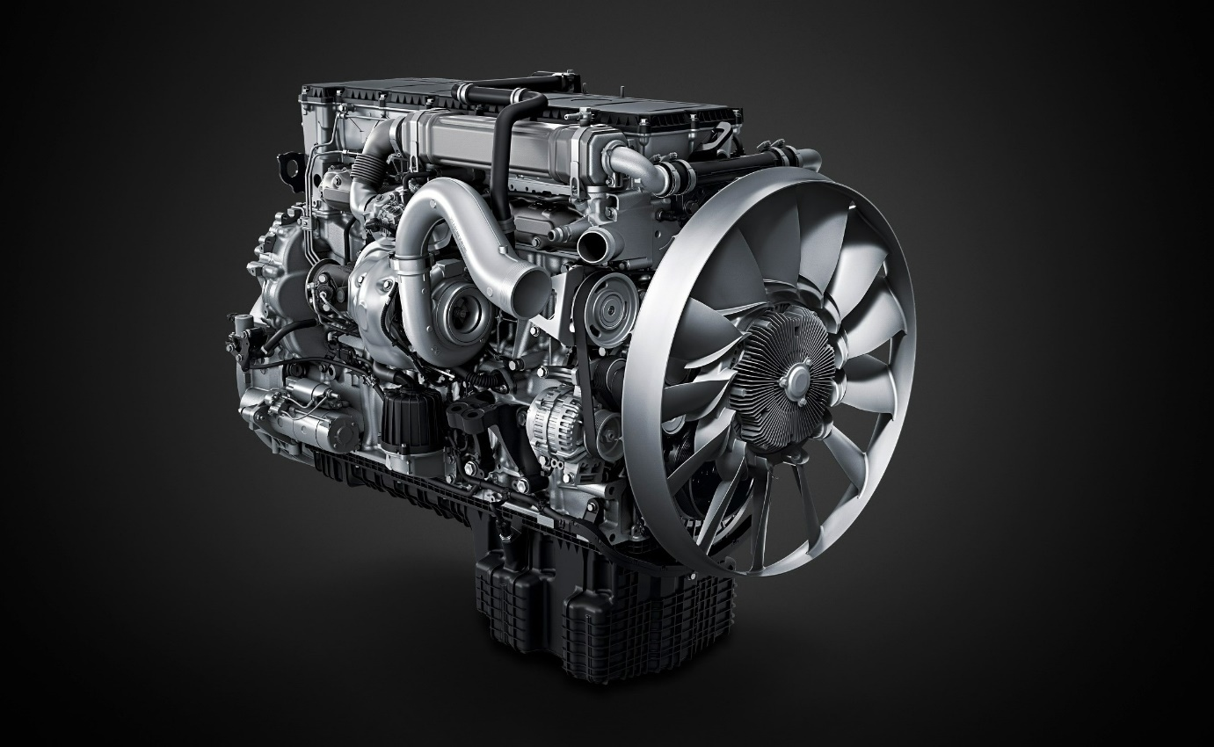

Full power – even more efficiency: In 2022, Mercedes-Benz Trucks will be launching the third generation of its OM 471 heavy-duty commercial vehicle engine on the market

- Drivetrain optimisation

- Further reduction of fuel consumption by up to 4%

- Newly-developed exhaust gas aftertreatment system

- Increased fuel efficiency and compliance with the strictest emissions standards such as Euro Vie

- Made-to-order turbochargers in a fuel consumption- and performance-optimised variant

- Powershift Advanced for faster gear shifts and clear reduction of torque interruption

- Extended Top Torque range for more torque in gears 7 to 12

- Manufactured at the Mannheim engine plant

- Karin Rådström, CEO Mercedes-Benz Trucks: "With the third generation of the OM 471, we consistently focused on the needs of our customers. Our goal was to decrease the Total Cost of Ownership (TCO) and reduce fuel consumption. Our customers will benefit, as will the environment."

Stuttgart – Powerful, extremely reliable, profitable in day-to-day operations, fuel-saving and yet also dynamic: Haulage firms make a variety of demands on their trucks – because they are what earn them their crust. Especially given the acute shortage of drivers, it is also important to have a strong trump card in hand, namely trucks that drivers enjoy driving. The drivetrain, which constitutes approx. 50%, and thus the largest share, of a truck’s added value, plays an important part here.
Mercedes-Benz Trucks has already set new standards with its two previous generations of its OM 471 heavy-duty engine: The engine system, transmission and axles of the integrated drivetrain around the OM 471 are optimally configured to each other and manufactured in the company’s own power systems plants to the highest quality standards. The Mercedes-Benz Mannheim plant takes the lead here: a centre of competence for heavy-duty commercial vehicle engines from Daimler Truck and part of the global production network for drive components.

High-tech pays off

With the third generation now available to order and available from October 2022,
Mercedes-Benz Trucks is launching the next stage and fielding its best-selling heavy-duty commercial vehicle engine with a whole range of efficiency-enhancing innovations. Each of these optimsation measures helps serve the high demands of fleet operators and professional truck drivers.

Karin Rådström, Member of the Board of Management of Daimler Truck Holding AG, responsible for the Europe and Latin America regions, and the Mercedes-Benz Trucks brand, commented: “With the third generation of the OM 471, we consistently focused on the needs of our customers. Our goal was to decrease the Total Cost of Ownership (TCO) and reduce fuel consumption. Our customers will benefit, as will the environment.”

The third generation of the OM 471 installed in the Mercedes-Benz Actros and the
Mercedes-Benz Arocs features a host of technical innovations. “All innovations that consistently aim at reducing the Total Cost of Ownership (TCO) in terms of fuel-saving driving, lower operating costs and higher yields, without sacrificing performance, driving dynamics or driving comfort,” explained Christoph Mertens, Project Manager for the new engine at Daimler Truck. Like the earlier second generation, engineers at Mercedes-Benz Trucks have again made remarkable progress with their third generation. In other words: High-tech pays off, is good for the environment, and makes driving fun.

Greater fuel efficiency thanks to further optimised combustion, application-oriented turbochargers and reduced friction

The improvements in efficiency for the third generation of the OM 471 are the result of a number of engine innovations. For example, the geometry of the piston recess, the injection nozzle design and the parameters of the cylinder head relevant for gas exchange were subject to an extensive optimisation process. In this way, the compression ratio of the six-cylinder in-line engine has been increased from 18.3:1 to 20.3:1. This leads to more efficient combustion, with a peak ignition pressure of 250 bar.

One of the most important levers in increasing fuel efficiency in modern diesel combustion engines is turbocharging optimisation. With the third generation of the OM 471,
Mercedes-Benz Trucks is introducing two new turbochargers developed and manufactured in-house which are precisely adapted to the broad range of customer requirements. In the consumption-optimised variant, the focus is on the lowest possible fuel consumption– it is predestined for use in long-distance haulage with an engine rated at up to 350 kW (476 hp).

The second turbocharger variant is designed for high performance and a high engine braking force and is ideal for use in the heavy-duty and construction sector with an engine rating of up to 390 kW (530 hp). For the lower and medium performance levels of the OM 471, the maximum fuel saving compared with the previous generation is up to 4%, and for the upper performance levels up to 3.5%. Thanks to lower consumption, both operating costs as well as CO₂ emissions are reduced. The high-power variant is also used in the lower performance levels for the construction applications of the Arocs.

Reduced friction losses and pressure control with low-viscosity oil

In addition to combustion and turbocharging, friction reduction is the third important lever for improving fuel efficiency. For this purpose, the third-generation OM 471 has a newly developed engine oil pressure control valve. It is installed behind the engine oil pump and in front of the oil thermostat. An electrical actuator enables characteristics map-controlled use of the pressure-reducing valve. Available reductions in engine oil pressure are determined in a complex matrix that takes into account all engine components and their specific requirements, such as lubrication or cooling. A newly-developed engine oil with low viscosity enhances oil pressure control – it improves fuel efficiency without reducing oil change intervals or increasing the wear on affected engine components.

Newly-developed exhaust gas aftertreatment system

The exhaust gas aftertreatment system, which has been completely revamped and adapted to the new combustion and control system of the OM 471, also helps improve fuel efficiency. The system limits the counterpressure and also increases the uniformity index of the AdBlue, which leads to improved NOx conversion and lower fuel consumption. The NOx sensors together with the closed and adaptive NOx closed-loop control circuit and a predictive SCR temperature model have enabled emission stability to be improved even further. It is even compliant with the strictest emission standards, such as Euro VIe, which call for effective limitation of exhaust gas emissions over the entire normal service life of a vehicle under normal usage conditions.

High driving dynamics thanks to PowerShift Advanced and Top Torque

Alongside profitability, robustness and reliability, Mercedes-Benz Trucks has once again turned its attention to another important factor for customers in the third generation of the OM 471, namely driving dynamics. Engineers have trained their sights on the drivetrain for this purpose. For example, the new PowerShift Advanced automated transmission control enables faster and smoother moving off and acceleration in many situations thanks to precise gear selection. Faster gear changes reduce the torque interruption time by up to 40% in the upper range. Accelerator pedal parameterisation has also been further optimised: Increased sensitivity in the lower pedal travel enables significantly more sensitive manoeuvring, while the direct response time in the upper pedal travel results in increased dynamics under high load requirements. It also makes it easier to drive around, and accelerate out of roundabouts.

Another highlight is the extended Top Torque range. Available for engine output levels 330 kW (450 hp) and 350 kW (476 hp) in conjunction with the G281 transmission, a powerful 200 Nm torque is available to the crankshaft in gears 7 to 12 in the ‘A Standard’ program. ‘Power at the press of a button’ for more performance that is available when you really need it – for example on highway on-ramps or when overtaking. All the while saving diesel. More added value that pays off in every respect for drivers and fleet operators alike.

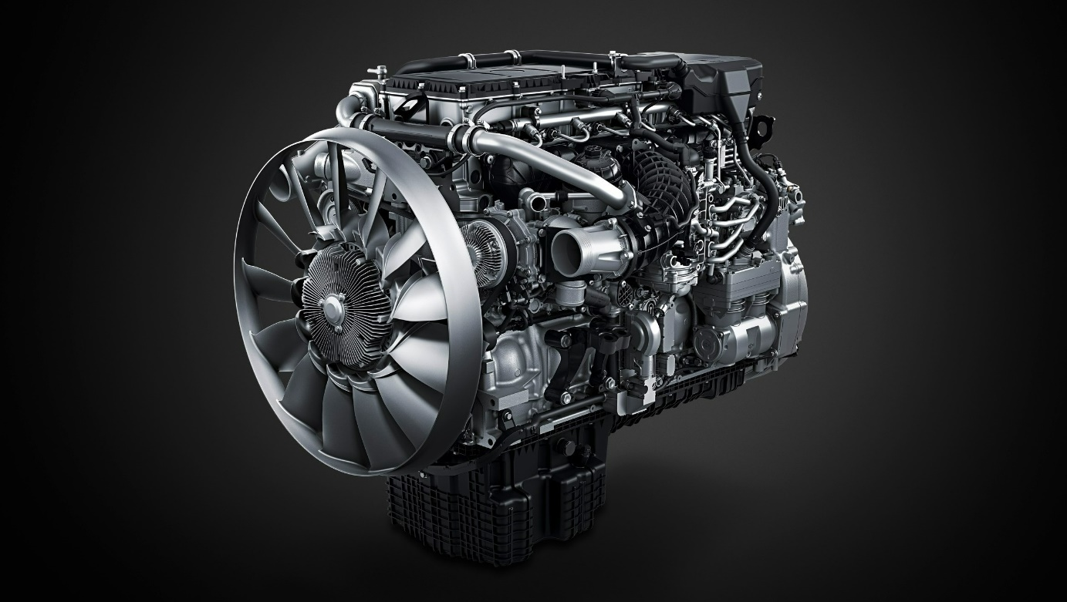

ends

For more information, please contact:

Jamie Fretwell at Mercedes-Benz Trucks UK Ltd
07712 519230, jamie.fretwell@daimler.com

or

Steve Warren or John Ripley
Impact Communications
Steve: 07770 470251, steve@impactcom.co.uk
John: 07771 484595, john@impactcom.co.uk

or

Carola Pfeifle, +49 160 8612423, carola.pfeifle@daimlertruck.com
Ulrike Burkhart, +49 160 861 3757, ulrike.burkhart@daimlertruck.com

Further information on Daimler Truck are available at:
www.media.daimlertruck.com and www.daimlertruck.com

Forward-looking statements:
This document contains forward-looking statements that reflect our current views about future events. The words “anticipate,” “assume,” “believe,” “estimate,” “expect,” “intend,” “may,” ”can,” “could,” “plan,” “project,” “should” and similar expressions are used to identify forward-looking statements. These statements are subject to many risks and uncertainties, including an adverse development of global economic conditions, in particular a decline of demand in our most important markets; a deterioration of our refinancing possibilities on the credit and financial markets; events of force majeure including natural disasters, pandemics, acts of terrorism, political unrest, armed conflicts, industrial accidents and their effects on our sales, purchasing, production or financial services activities; changes in currency exchange rates, customs and foreign trade provisions; a shift in consumer preferences towards smaller, lower-margin vehicles; a possible lack of acceptance of our products or services which limits our ability to achieve prices and adequately utilize our production capacities; price increases for fuel or raw materials; disruption of production due to shortages of materials, labor strikes or supplier insolvencies; a decline in resale prices of used vehicles; the effective implementation of cost-reduction and efficiency-optimization measures; the business outlook for companies in which we hold a significant equity interest; the successful implementation of strategic cooperations and joint ventures; changes in laws, regulations and government policies, particularly those relating to vehicle emissions, fuel economy and safety; the resolution of pending government investigations or of investigations requested by governments and the conclusion of pending or threatened future legal proceedings; and other risks and uncertainties, some of which are described under the heading “Risk and Opportunity Report” in this Annual Report. If any of these risks and uncertainties materializes or if the assumptions underlying any of our forward-looking statements prove to be incorrect, the actual results may be materially different from those we express or imply by such statements. We do not intend or assume any obligation to update these forward-looking statements since they are based solely on the circumstances at the date of publication.

Daimler Truck at a glance
Daimler Truck Holding AG ("Daimler Truck") is one of the world's largest commercial vehicle manufacturers, with over 40 main locations and more than 100,000 employees around the globe. The founders of Daimler Truck have invented the modern transportation industry with their trucks and buses a good 125 years ago. Unchanged to this day, the company's aspirations are dedicated to one purpose: Daimler Truck works for all who keep the world moving. Its customers enable people to be mobile and get goods to their destinations reliably, on time, and safely. Daimler Truck provides the technologies, products, and services for them to do so. This also applies to the transformation to CO2-neutral driving. The company is striving to make sustainable transport a success, with profound technological knowledge and a clear view of its customers' needs. Daimler Truck's business activities are structured in five reporting segments: Trucks North America (TN) with the truck brands Freightliner and Western Star and the school bus brand Thomas Built Buses. Trucks Asia (TA) with the FUSO and BharatBenz commercial vehicle brands. Mercedes-Benz (MB) with the truck brand of the same name. Daimler Buses (DB) with the Mercedes-Benz and Setra bus brands. Daimler Truck's new Financial Services business (DTFS) constitutes the fifth segment, the product range in the truck segments includes light, medium and heavy trucks for long-distance, distribution and construction traffic and special-purpose vehicles used mainly in the municipal and vocational sector. The product range of the bus segment includes city buses, school buses and intercity buses, coaches and bus chassis. In addition to the sale of new and used commercial vehicles, the company also offers aftersales services and connectivity solutions.

