

Date: 24 May 2022

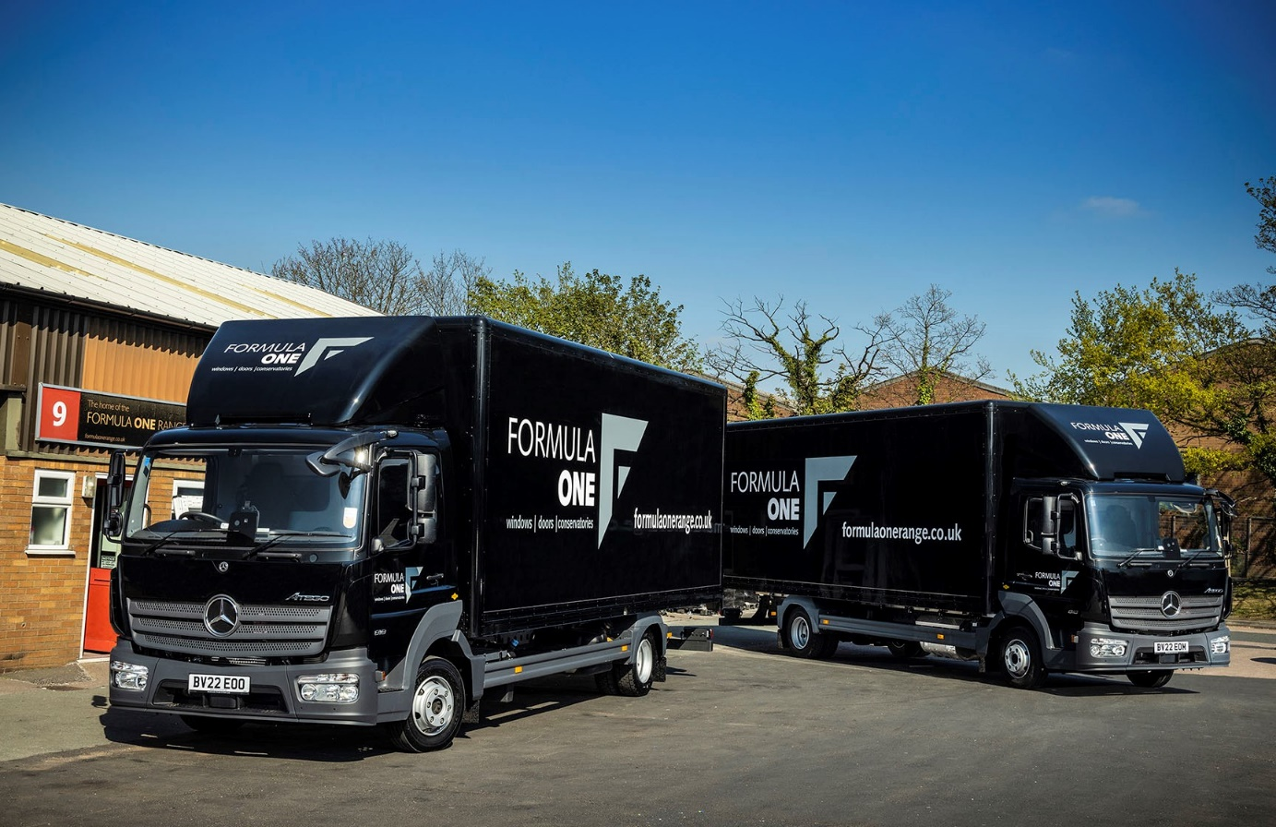

Two more Mercedes-Benz Atego trucks keep Formula One in pole position

The Formula One Group knows a winner when it sees one – which explains why the West Midlands-based fabricator and installer of premium-quality UPVC windows, doors and conservatories has been relying on Mercedes-Benz trucks since it began trading 24 years ago.

The recent arrivals of another couple mean it now runs a fleet of five eye-catching Atego 7.5-tonners, all of which were supplied by Midlands Truck & Van.

The Formula One Group commenced manufacturing operations in 1998, at the head office in Walsall that it still shares with associate business Rapid Frame. From the outset, Formula One sold its products nationwide on a supply-only basis. However, since opening a retail branch in Telford in 2009 it has also carried out installations at more than 2,500 homes across Shropshire and the West Midlands.

The company’s latest Atego are both 818 variants with 5.1-litre four-cylinder engines that produce 130 kW (177 hp) and drive through six-speed Mercedes PowerShift 3 automated manual transmissions.

Their ClassicSpace S-cabs have optional ventilated driver’s suspension seats with integral armrests and were smartly finished at the Mercedes-Benz factory in Deep Black. Likewise the trucks’ roof-mounted air deflectors and box bodies, which are by Fred Smith & Sons, of West Bromwich.

Purpose-designed for light- and medium-duty distribution work, and construction applications, the Atego range from 7.5 to 16 tonnes GVW offers precise handling with exceptional ride comfort, and is renowned for its reliability and durability.

That reputation is certainly borne out by Formula One’s experience. Owner and Managing Director Martin Corcoran explained: “We take great pride in providing first class service and will always go the extra mile to ensure total customer satisfaction.

“It’s imperative to the success of our business that we honour the delivery commitments we make. We’ve always relied on the Atego because we know it won’t let us down. Ours average 75,000 miles a year but we still have a 2016-registered truck that’s now covered 1.2 million miles and continues to do a great job, day in, day out.”

Mr Corcoran continued: “In addition to its fantastic build quality the Atego is very smooth and comfortable, which is crucial given the distances our drivers have to cover. It’s also fuel-efficient, cost-effective to operate and, being a Mercedes-Benz, the safest vehicle in its weight class.”

Image is key to the Atego’s appeal as well. “The three-pointed star is an internationally recognised symbol of quality,” said Mr Corcoran. “As such, it complements our own brand values perfectly. Just like our Mercedes-Benz trucks, superior design, technical excellence, reliability and durability are all hallmarks of the Formula One Range™.”

Completing the picture for the Formula One Group is the customer-focused aftersales support it receives from the workshop team at the branch in Smethwick that Midlands Truck & Van opened at the end of 2020. “The Dealer is excellent in its response to any issues that crop up,” added Mr Corcoran.

www.formulaonerangetelford.co.uk/

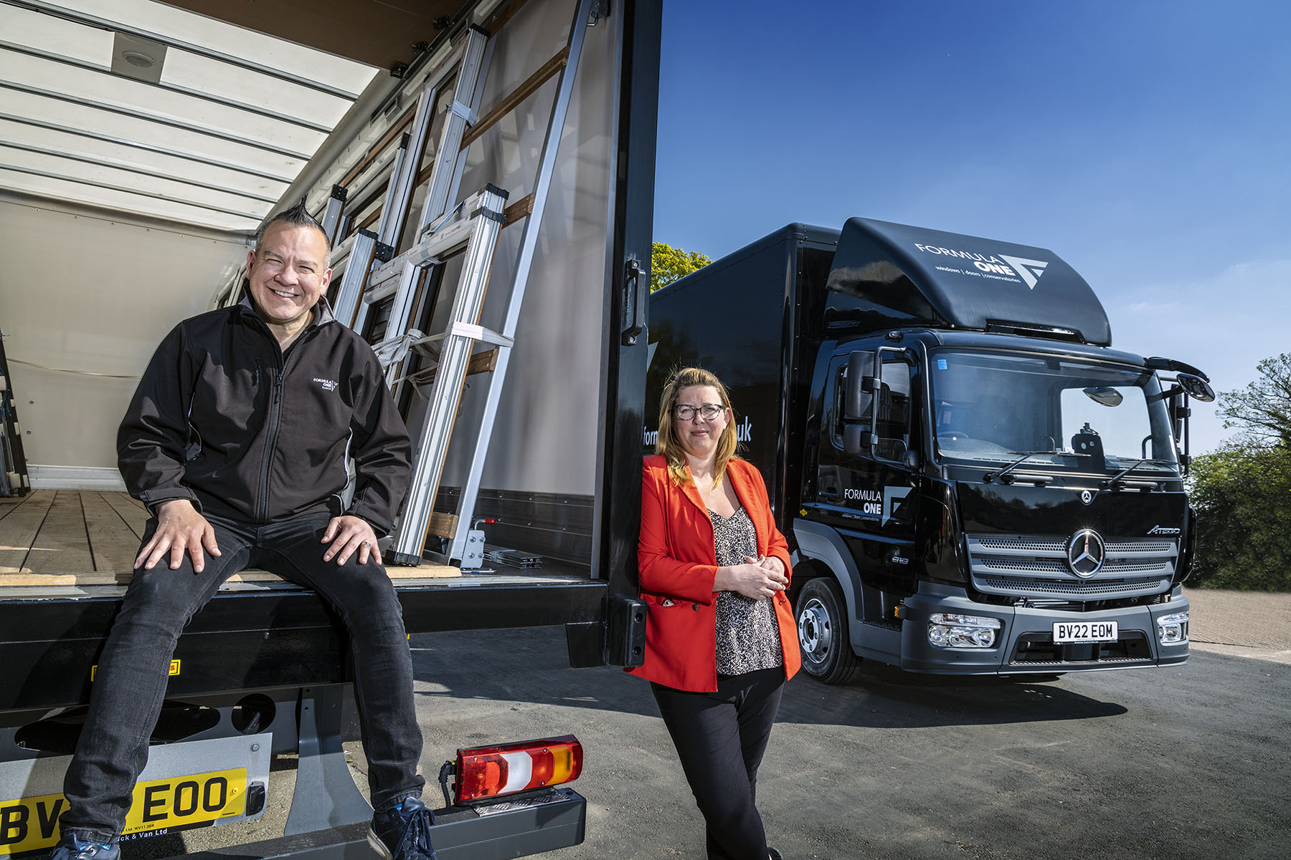

Advancing with Atego: Formula One Group Managing Director Martin Corcoran and Sales & Marketing Manager Annabel Russell know they can rely on their Mercedes-Benz trucks

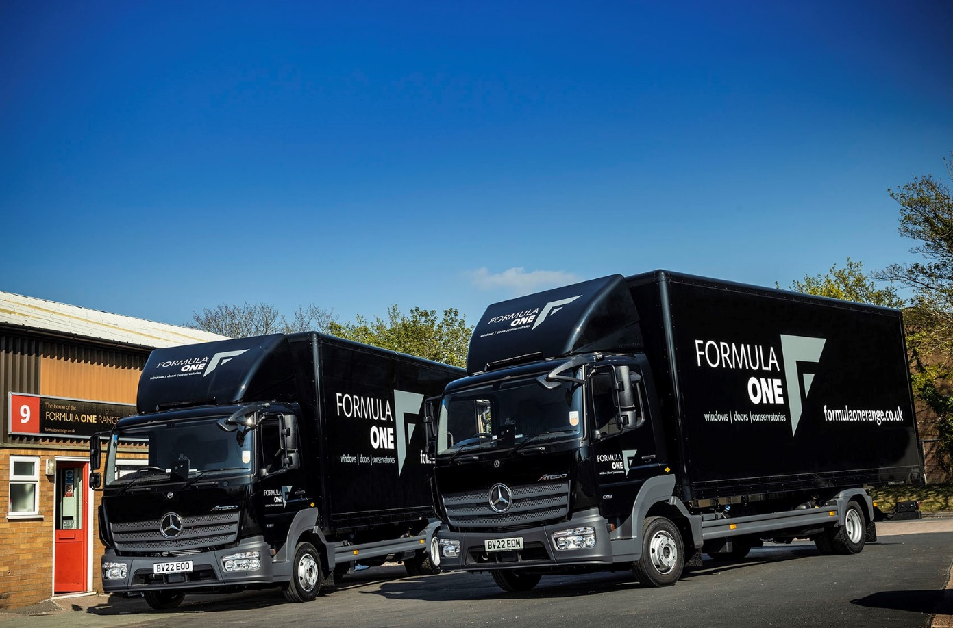

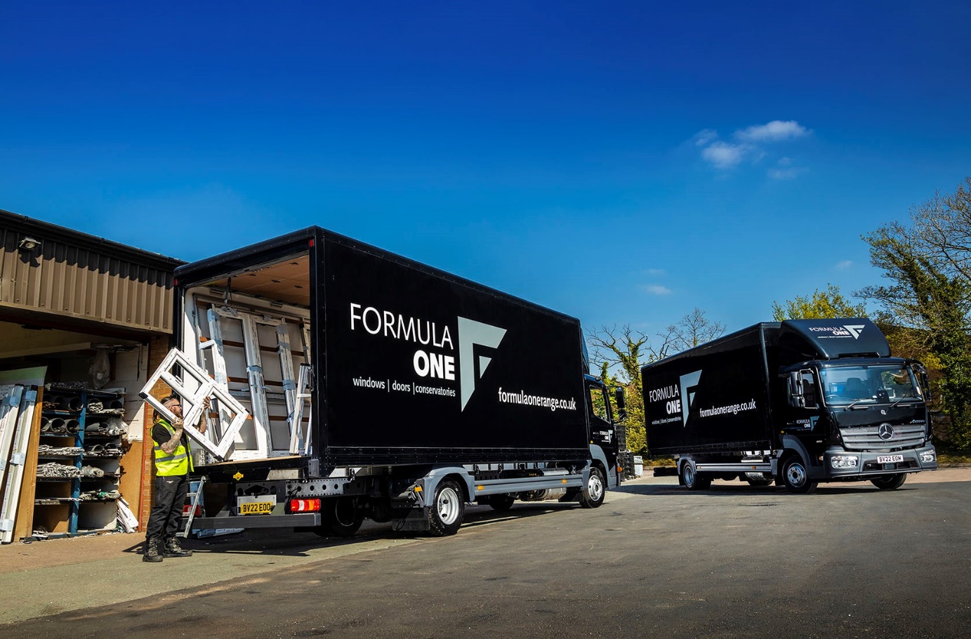

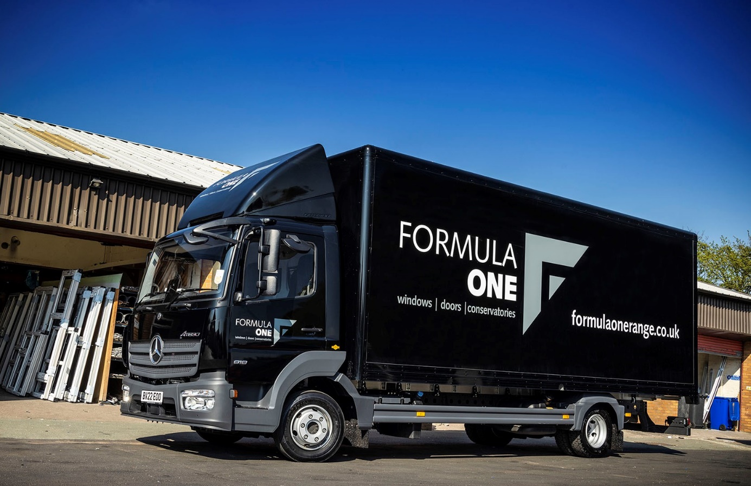

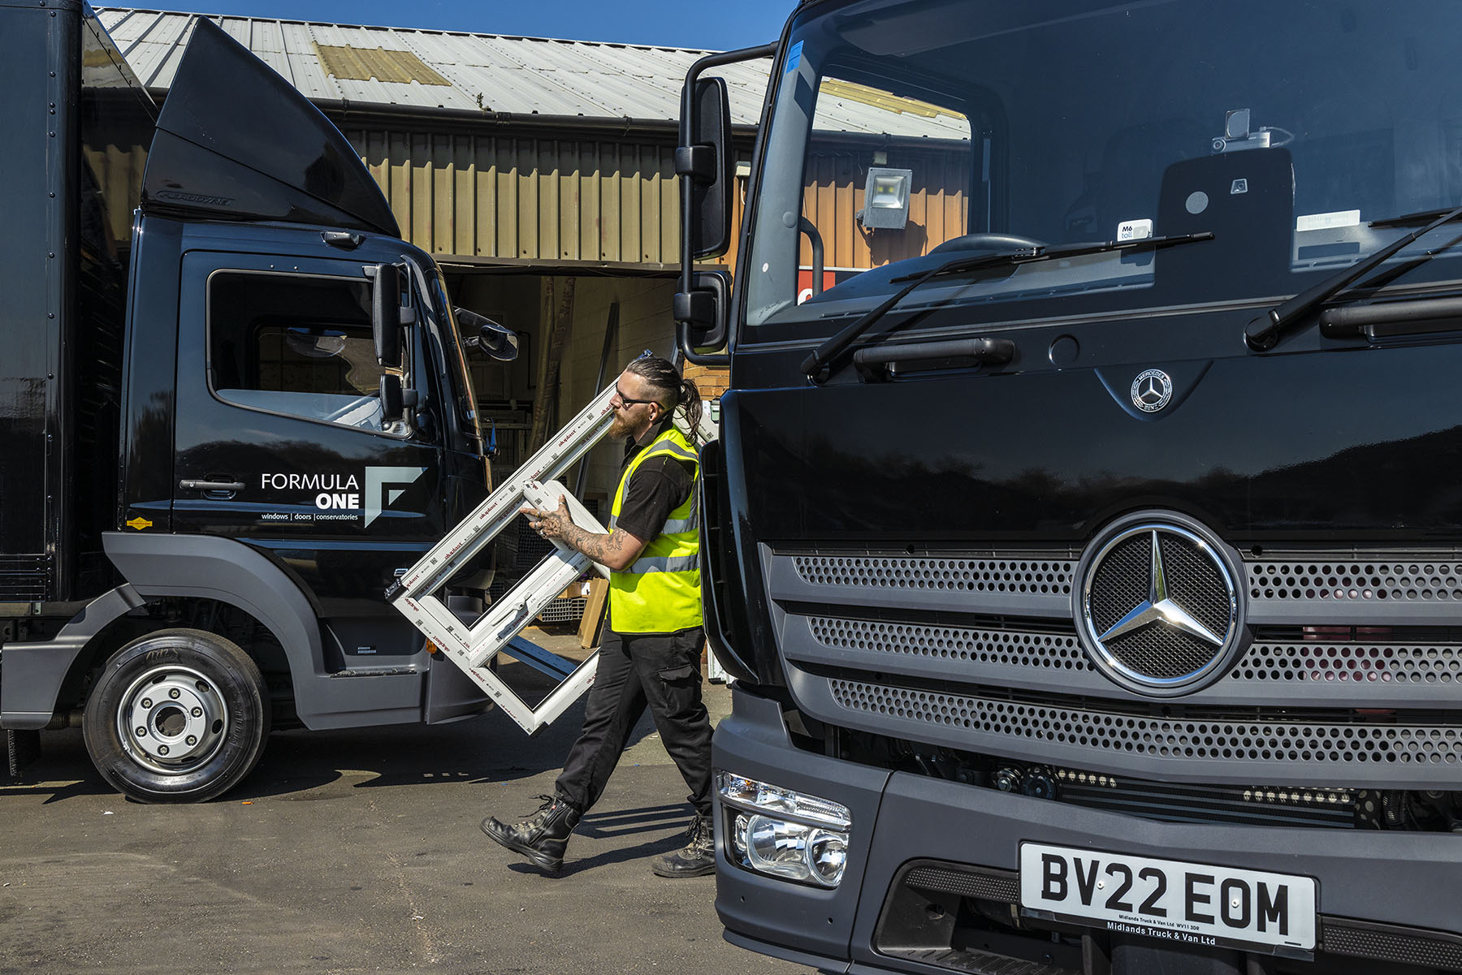

ends

For more information, or to request bigger/higher-res image files, please contact:
Steve Warren or John Ripley
Impact Communications
Steve: 07770 470251, steve@impactcom.co.uk
John: 07771 484595, john@impactcom.co.uk



