

Date: 9 June 2020

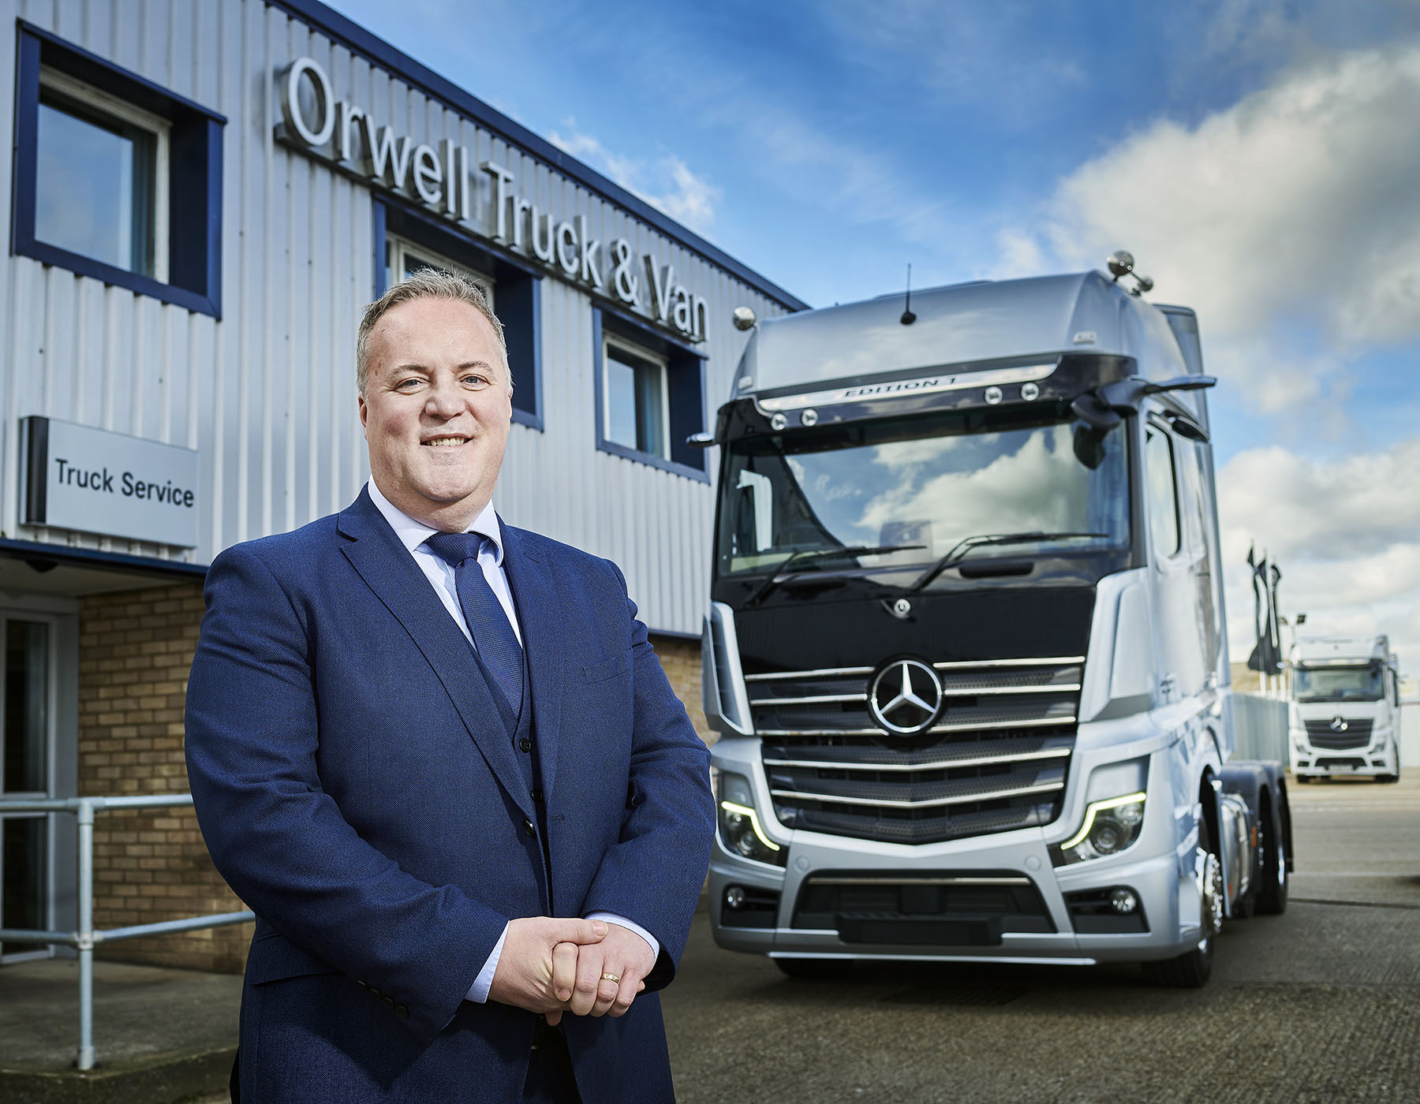

Leading from the front: Managing Director Lee Seward is proud of the way colleagues have continued to support customers throughout the Covid-19 pandemic

Customer care is key for Mercedes-Benz Dealers Orwell and S & B as they look forward to the ‘new normal’

Mercedes-Benz Dealers Orwell Truck & Van and S & B Commercials have marked the lifting of lockdown restrictions by extending the remit of their new customer contact centre to serve truck as well as van operators.

Owned by the Motus Group, the ‘sister’ companies have kept the workshops open at all seven of their branches throughout the Covid-19 pandemic, and prioritised emergency service vehicles as well as those working to keep food retailers supplied and in other key sectors.

Orwell Truck & Van has headquarters and a dedicated van centre in Ipswich, and other branches in Colchester, Newmarket and Norwich. S & B Commercials operates from its Hatfield head office, Stansted and Thurrock.

Lee Seward took up his role as Managing Director of both Dealerships in December. Having spent his entire career in the automotive sector – he started out as an apprentice technician and had a 20-year association with another German brand – it is the first time he has worked with Mercedes-Benz.

Lee’s focus from the outset has been on delivering the very highest levels of aftersales support, and on achieving consistency across the two businesses so that the standards of customer care achieved by the best are matched by the rest.

The contact centre was introduced with the aim of making it easier for operators to book vehicles in for routine maintenance and urgently needed repairs, and to submit sales enquiries. It has also relieved branch staff of some of the burdens of basic administrative work, freeing them to focus on service quality and the provision of regular, timely progress updates to customers.

Van customers have been benefiting since the call centre was opened in February and continued to do so throughout the lockdown period – although colleagues were working from home, they were able to provide an efficient service. With dedicated personnel now in place, it has just begun supporting truck operators as well.

Lee has also re-organised his management team. Aftersales Director Paul Smith was recruited last year and is new to the Mercedes-Benz brand, whereas Commercial Director Graham Balsom, who has overall responsibility for sales, joined S & B nearly 20 years ago.

To further improve controls and co-ordinate the introduction of new systems and processes across what, historically, were entirely separate, family-owned dealerships, Lee has appointed four Regional General Managers. All have extensive experience of supporting commercial vehicle operators, particularly from an aftersales perspective. Shawn Blake is responsible for Hertfordshire, Phil Claxton for Norfolk, Scott Duncan for Suffolk, and Geoff Taylor for Essex.

The multi-franchise Motus Group (UK) acquired Orwell Truck & Van in 2013 and S & B Commercials the following year, and has invested heavily in their branch infrastructure. Since Lee’s arrival it has purchased an additional half an acre of land in order to provide additional parking space and room for vehicles to manoeuvre at Orwell’s branch on Norwich’s Airport Industrial Estate, and will shortly begin work on a £1 million-plus project to extend the workshop and parts department at S & B Thurrock. As well as adding two full-length truck bays to the existing four – S & B also runs a dedicated van servicing facility nearby – this scheme will improve traffic flow around the site.

With comprehensive Covid-19 barriers and protocols now in place at all locations, and furloughed colleagues returning, both companies have their sights set firmly on the future. “We were starting to see the fruits of the measures we’d introduced and gain some real momentum, so from a purely business perspective the lockdown was extremely frustrating,” said Lee.

“However, like everyone else we had to work with the cards we were dealt, and in many respects it’s been a positive experience. I’m hugely proud of the way we’ve responded, changing the way we do things to keep the lines of communication flowing, and remaining open at all locations to support the emergency services and others who have performed so heroically throughout this unprecedented crisis.

“The next couple of months will be crucial as our own businesses, and those we serve, continue to emerge from the lockdown. I have the good fortune to lead a very talented, committed team, and am determined to ensure that whatever form the ‘new normal’ takes, Orwell Truck & Van and S & B Commercials will be there to keep our customers moving.”

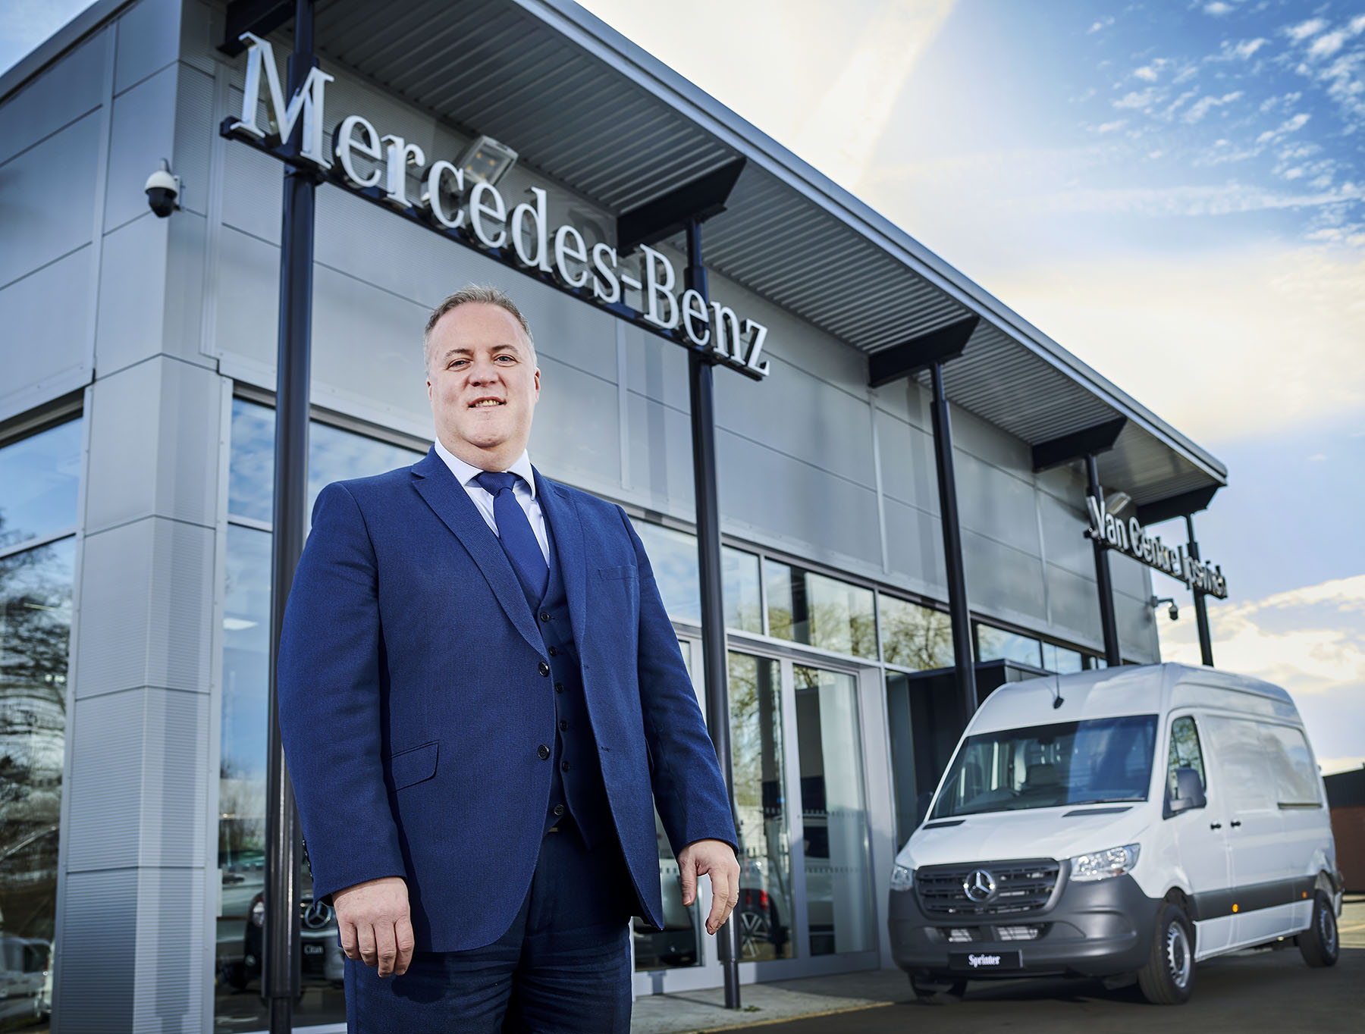

ends

For more information, or to request bigger/higher-res image files, please contact:
Steve Warren or John Ripley
Impact Communications, 01926 842126
John: 07771 484595, john@impactcom.co.uk
Steve: 07770 470251, steve@impactcom.co.uk

