

Date: 6 June 2023

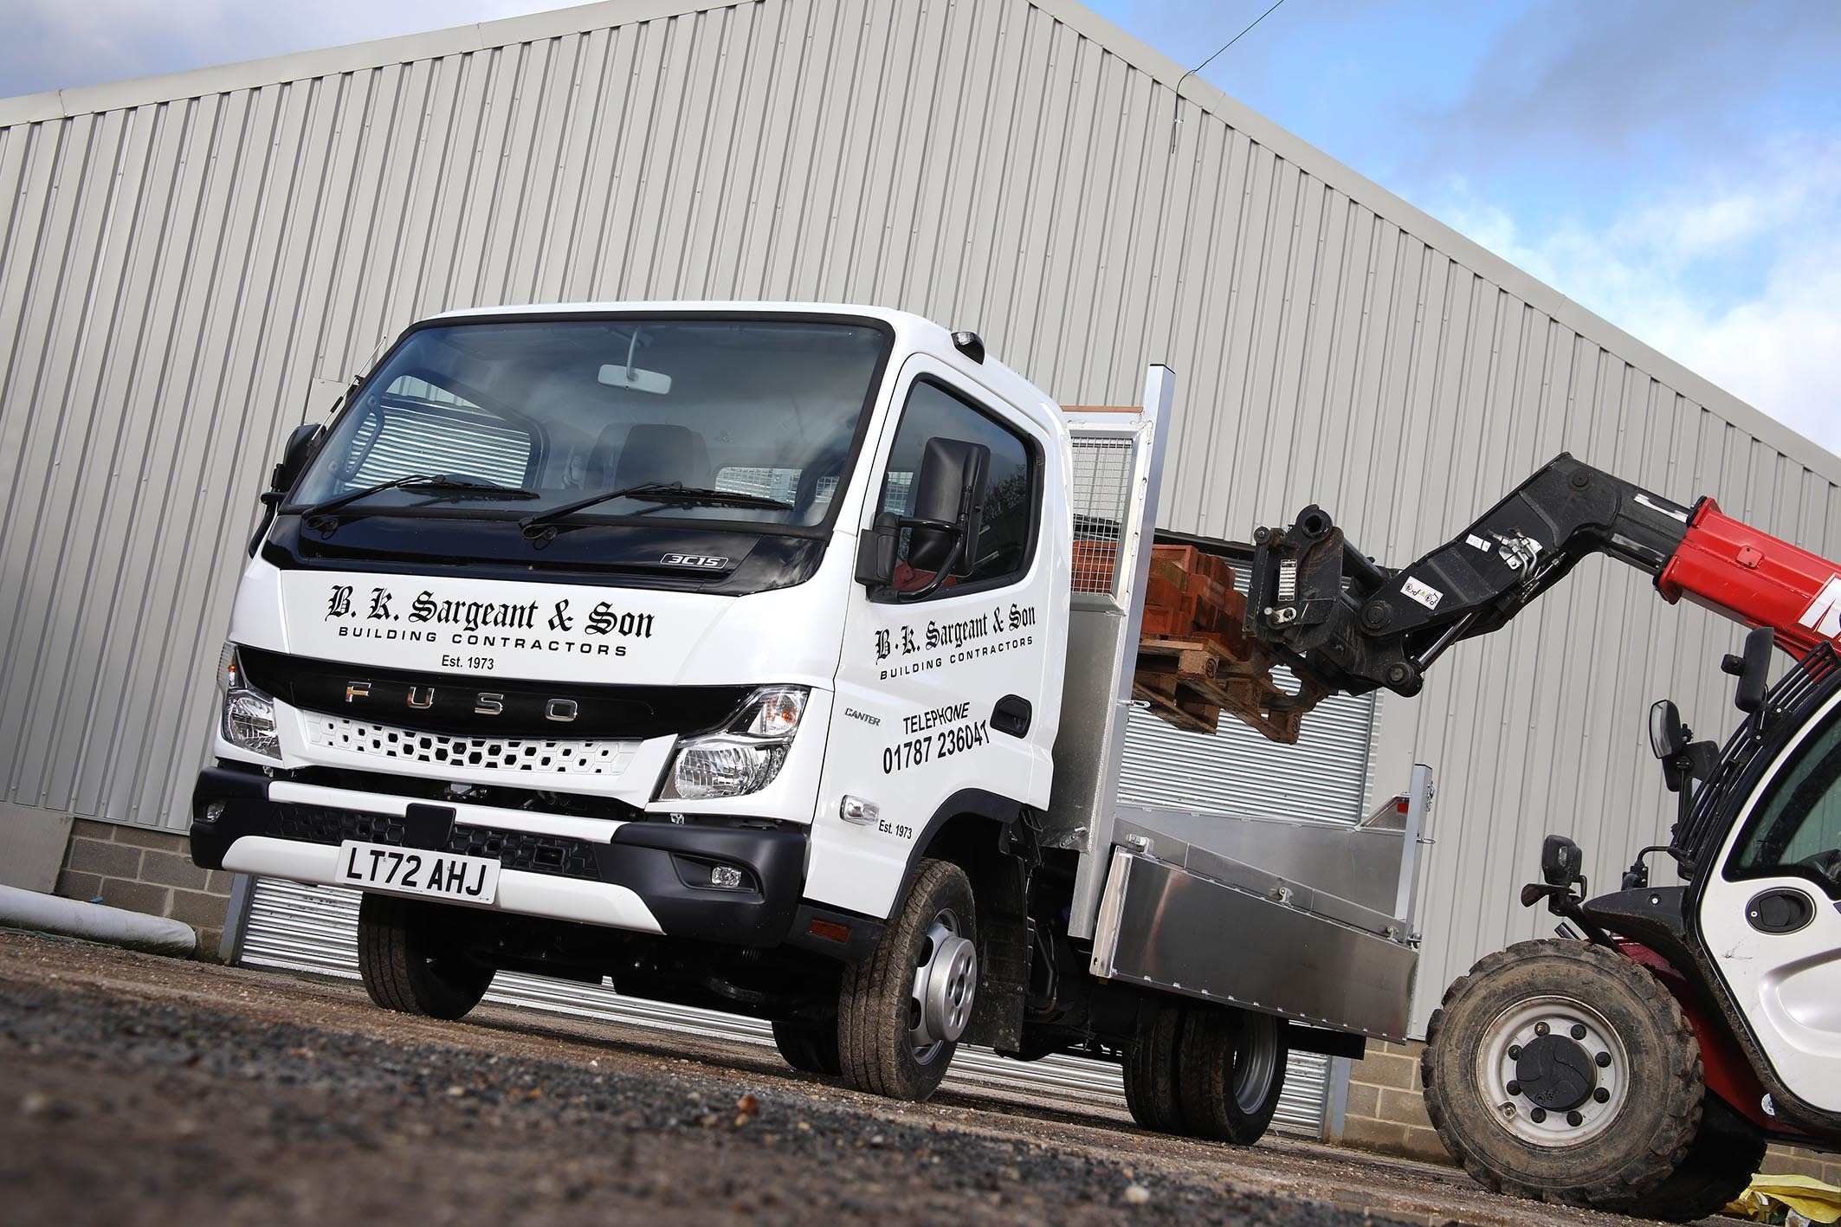

Sargeant recruits another FUSO Canter from Motus Truck & Van

Essex building contractor BK Sargeant & Son has strengthened its ranks by calling up a proven tough performer, in the shape of a 3.5-tonne FUSO Canter tipper.

Based in rural Great Yeldham, the family-owned firm specialises in conversions and refurbishments of historic buildings – a role for which the Canter has demonstrated its fitness for purpose time and again.

“This is our eighth,” said Director James Sargeant. “We’ve tried other vehicles in the past but for our particular set of requirements the Canter really is the ideal package.”

Supplied by Motus Truck & Van, it has lined up alongside two older Canters. One is two years old, the other still going strong after seven years’ service. The fleet also includes four vans.

As a 3C15 model the new Canter is powered by a 3.0-litre common-rail turbo-diesel engine producing 110 kW (150 hp) and an impressive 370 Nm of torque which, thanks to variable turbine technology, is available from low engine speeds.

This engine drives through a smooth-shifting and fuel-efficient DUONIC automated dual-clutch transmission with Eco Mode, Parking and Creep functions. The chassis has a 2,500 mm wheelbase – the shortest of eight sizes available – and was fitted with an alloy tipping body by KMR Engineering, of Ipswich.

The vehicle is Sargeant’s first from the all-new Canter range introduced last year. Sporting a redesigned cab and striking new ‘face’, the latest version is more comfortable than the model it replaced, thanks in part to improved interior insulation that reduces noise. Reinforced rear underrun protection also minimises the effects of an impact in the event of an accident.

Meanwhile a newly developed, compact exhaust system means the Canter also meets the EURO VI – STEP E emission standard.

“The new cab is great but really it just builds on what was already a very strong foundation,” said Mr Sargeant.

“A lot of our work is on barn conversions and upgrades of very old buildings, where access can be very tight. Often there just isn’t room to get a big truck in, either to collect a skip or to make a delivery.

“That means we have to do almost everything ourselves, from removing site waste to bringing in a wide range of materials, and the Canter has shown itself to be well up to any task required. It’s a real workhorse, much sturdier than other options we’ve tried in the same weight category, while the cab is roomy and comfortable and the DUONIC gearbox makes it really easy to drive.

“We certainly work our Canters hard but they perform well even when fully loaded. The short wheelbase makes them very manoeuvrable and the twin rear wheels offer great traction on rough sites. Bodywork is good too, in this job they inevitably get knocked around a bit but they never seem to rust.”

Like its predecessors Sargeant’s new tipper will be serviced and maintained in the workshop at Motus Truck & Van’s Witham branch.

“Sales Executive Daniel Allen was very attentive throughout the ordering process, handling all the liaison with our bodybuilder and keeping us fully informed throughout,” reported Mr Sargeant.

BK Sargeant & Son, which celebrates its 50th anniversary this year, was founded by Mr Sargeant’s father, Barry, who has now handed over most of his responsibilities his son. “He still takes an active interest in the business but I look after most of the day-to-day activities now,” said James Sargeant.

“Our work on historic buildings requires a high level of craftsmanship, and we also pride ourselves on a very customer-focused approach to all our projects. I’m pleased to say Motus have demonstrated a similar standard of exacting attention to detail.”

www.bksargeantandson.co.uk

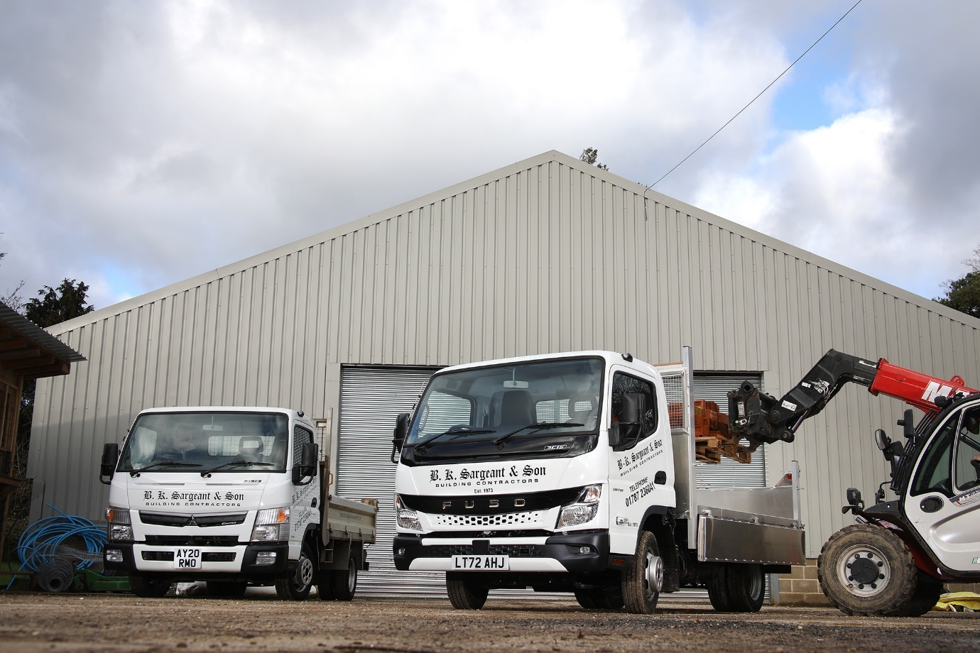

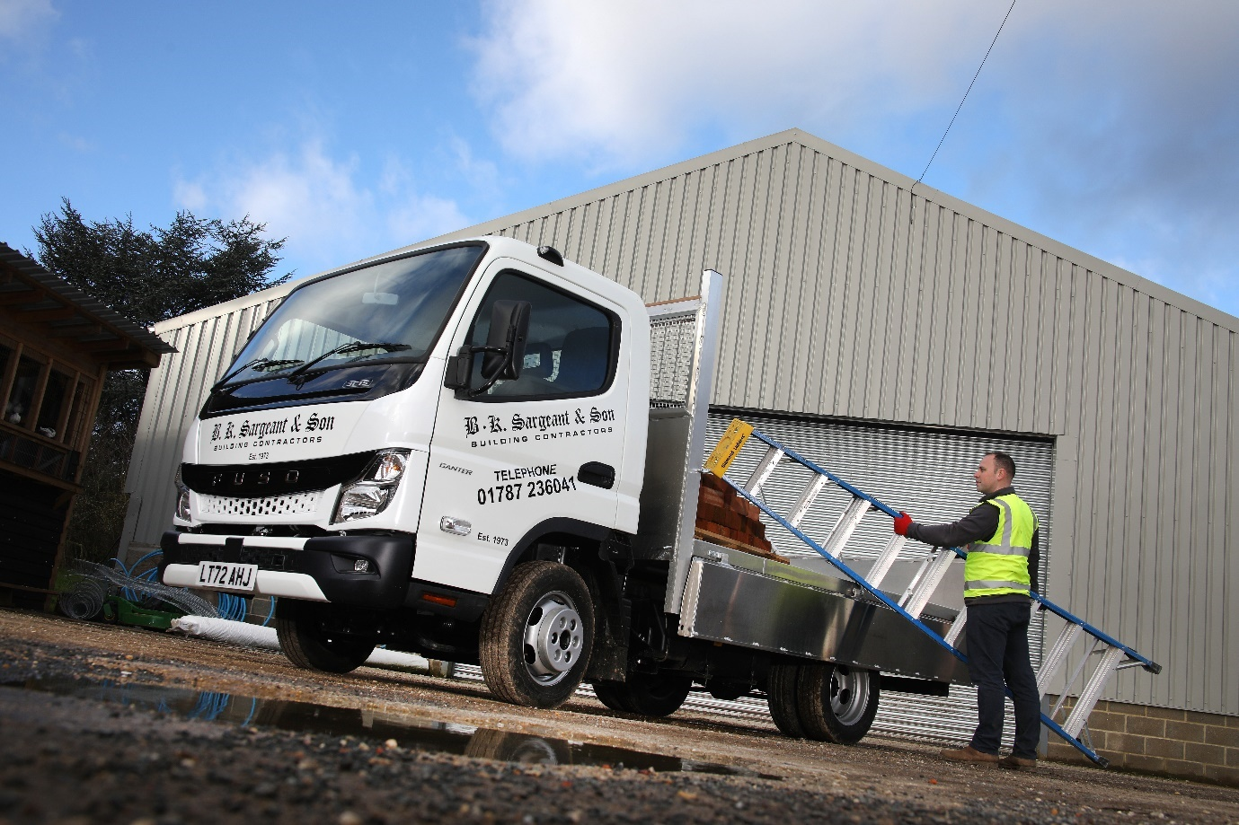

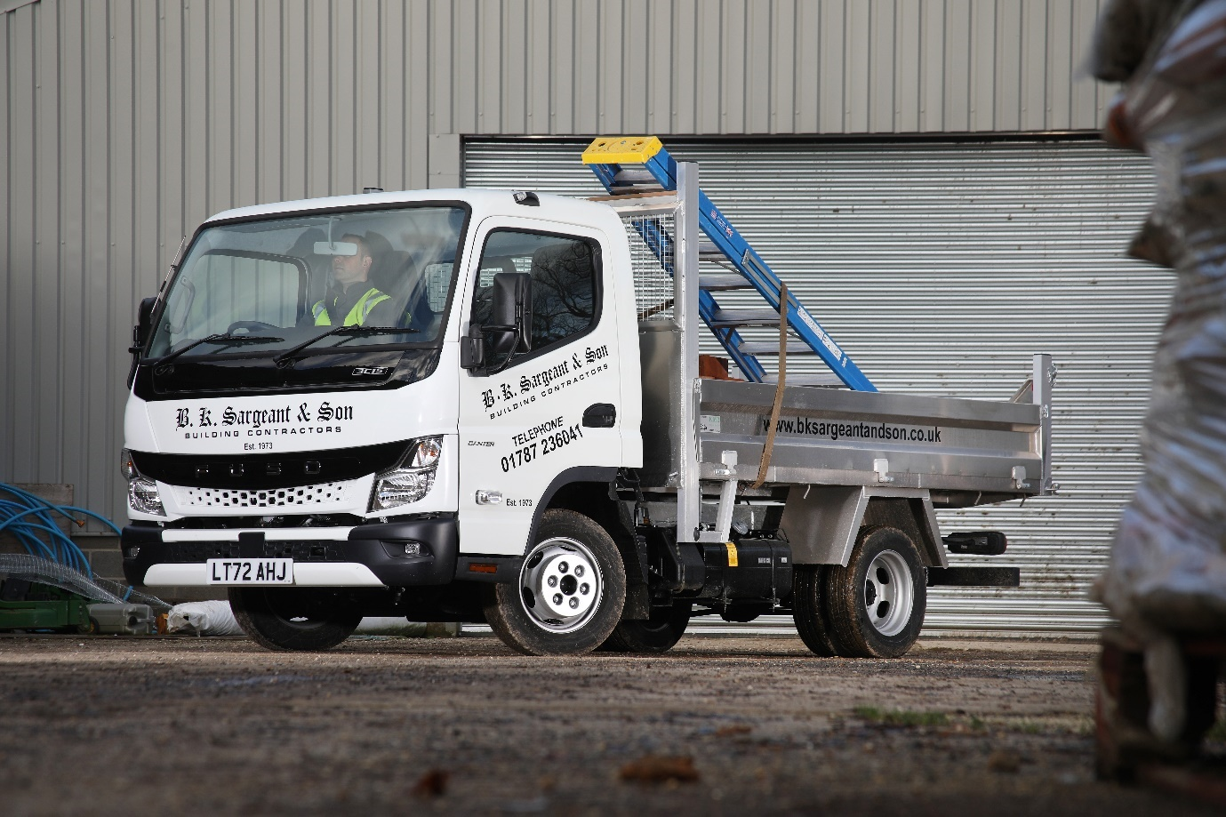

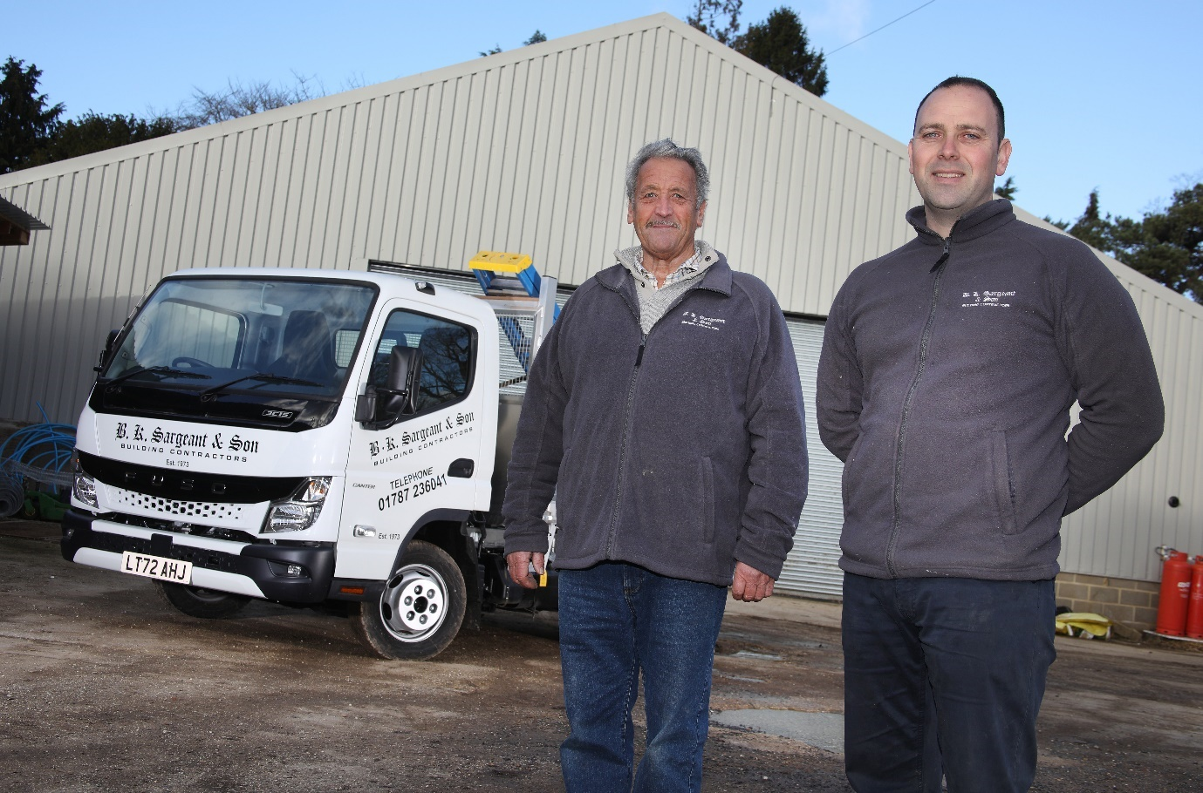

Generation game: Company founder Barry Sargeant, left, with son James and their latest FUSO Canter tipper

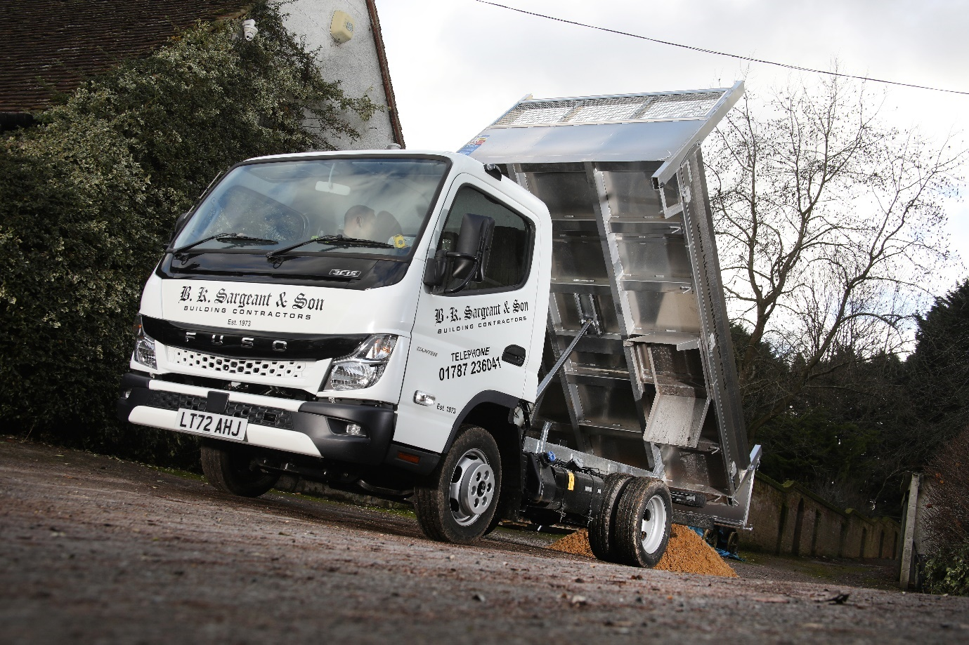

ends

For more information, or to request bigger/higher-res image files, please contact:
John Ripley: 07771 484595, john.ripley@loopagency.co.uk

