

Date: 28 January 2019

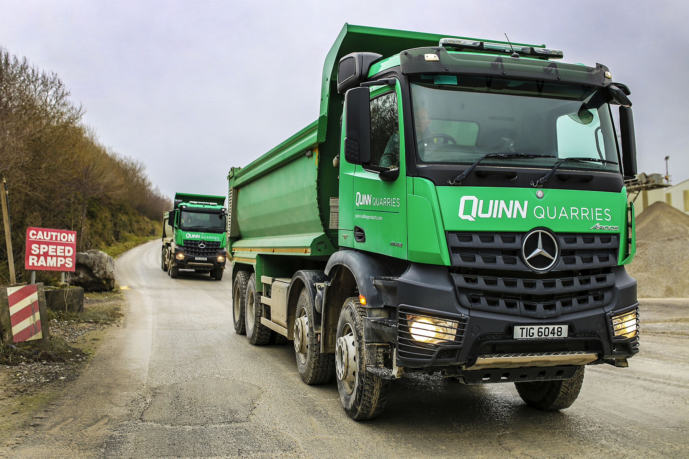

Quinn Building Products chooses 14 efficient off-road tippers from Mercedes-Benz

Construction materials leader Quinn Building Products is enjoying peak performance from a new fleet of Mercedes-Benz ‘mountain’ trucks.

The 14 tippers were supplied to Derrylin-based Quinn by Northern Ireland Dealer MBNI Truck & Van. All are 8x4 Arocs 4148 models with 12.8-litre straight-six engines rated at 350 kW (476 hp), and ClassicSpace cabs. Each truck is capable of carrying a 33-tonne payload.

They transport loads of aggregate from the operator’s Doon and Swanlinbar quarries to its Quinn Cement plant at Ballyconnell. The journey entails a fully-laden run down the long, steep descent known locally as ‘the mountain’ – optional equipment includes powerful water retarders which enhance safety, while reducing wear and tear on brakes and drivelines.

“It’s an extremely demanding task and requires vehicles built to the very highest standards,” said Transport Manager Brian McManus. “You can’t cut corners on specification for a job like this.”

The rugged Arocs range is purpose-designed for construction-related applications, while Greater Safety is one of the three pillars of Mercedes-Benz Trucks’ all-encompassing RoadEfficiency strategy, the others being Low Total Costs and Maximised Use.

“We’ve been buying Mercedes-Benz trucks since 1988 and they’ve proved over the years to provide outstanding quality and solid reliability,” Mr McManus continued. “We know we’ll get great value for money, and that we can depend not only on the vehicles themselves, but also on the Dealer’s back-up.

“We have developed a strong relationship with MBNI Truck & Van, as well as the manufacturer, and it’s because we’ve been so well served that Mercedes-Benz vehicles now account for the greater part of our 150-strong fleet.”

Over the last year Quinn has also taken delivery of 24 Actros 2445 StreamSpace tractor units with small, 17.5-in wheels on the mid-lift axles, which save weight and free up useful space on the chassis. Powered by 330 kW (450 hp) engines, the Actros transport bagged and bulk cement powder, as well as a range of building products. Quinn has recently commissioned three road-going 32-tonne Arocs 3240s, too – one has an insulated tar-specification tipping body, the other two with mixer drums for concrete deliveries.

Most of Quinn’s recent Mercedes-Benz trucks are are backed by ExtendPlus Contracts, which supplement the standard vehicle warranties. Cover is extended to four years and takes in mechanical, electronic and electrical components. The operator undertakes routine maintenance in its own workshop, for which MBNI Truck & Van maintains an imprest parts stock and provides technical advice and assistance if required.

“The introduction of our new tippers represents a major step in our fleet renewal programme,” added Mr McManus. “By the end of 2020 we will have replaced all of the older trucks on our fleet, as well as ageing plant machinery.

“These investments will reduce our environmental impact, boost efficiency, and allow us to meet ever-increasing demand, while continuing to provide the top-quality services that our customers have come to expect.”

Quinn Building Products is one of the UK and Ireland’s most experienced and diverse manufacturers of construction materials. Established in the early 1970s, the company supplies high-performance rigid insulation, aerated thermal blocks, cement, concrete roof tiles, hollowcore pre-cast flooring and stair systems, and a wide range of related aggregates.

www.quinn-buildingproducts.com

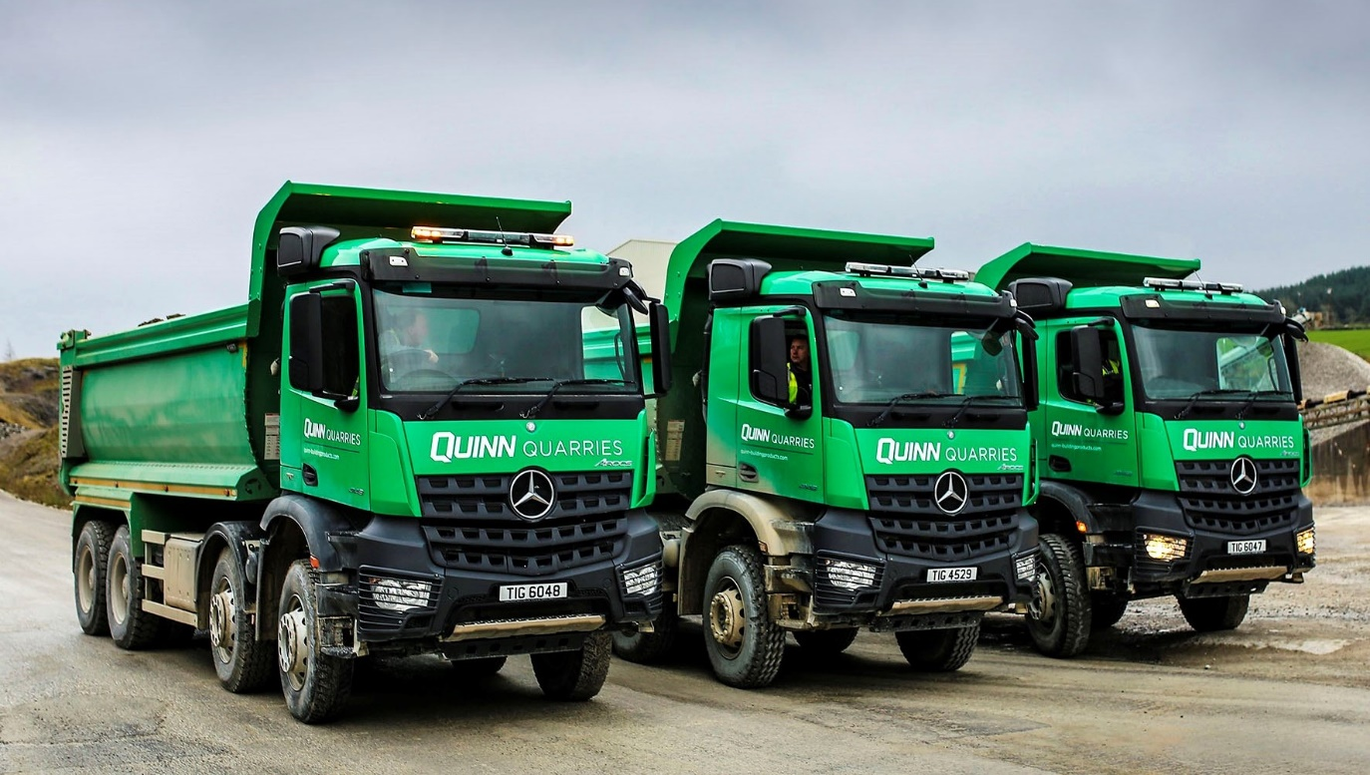

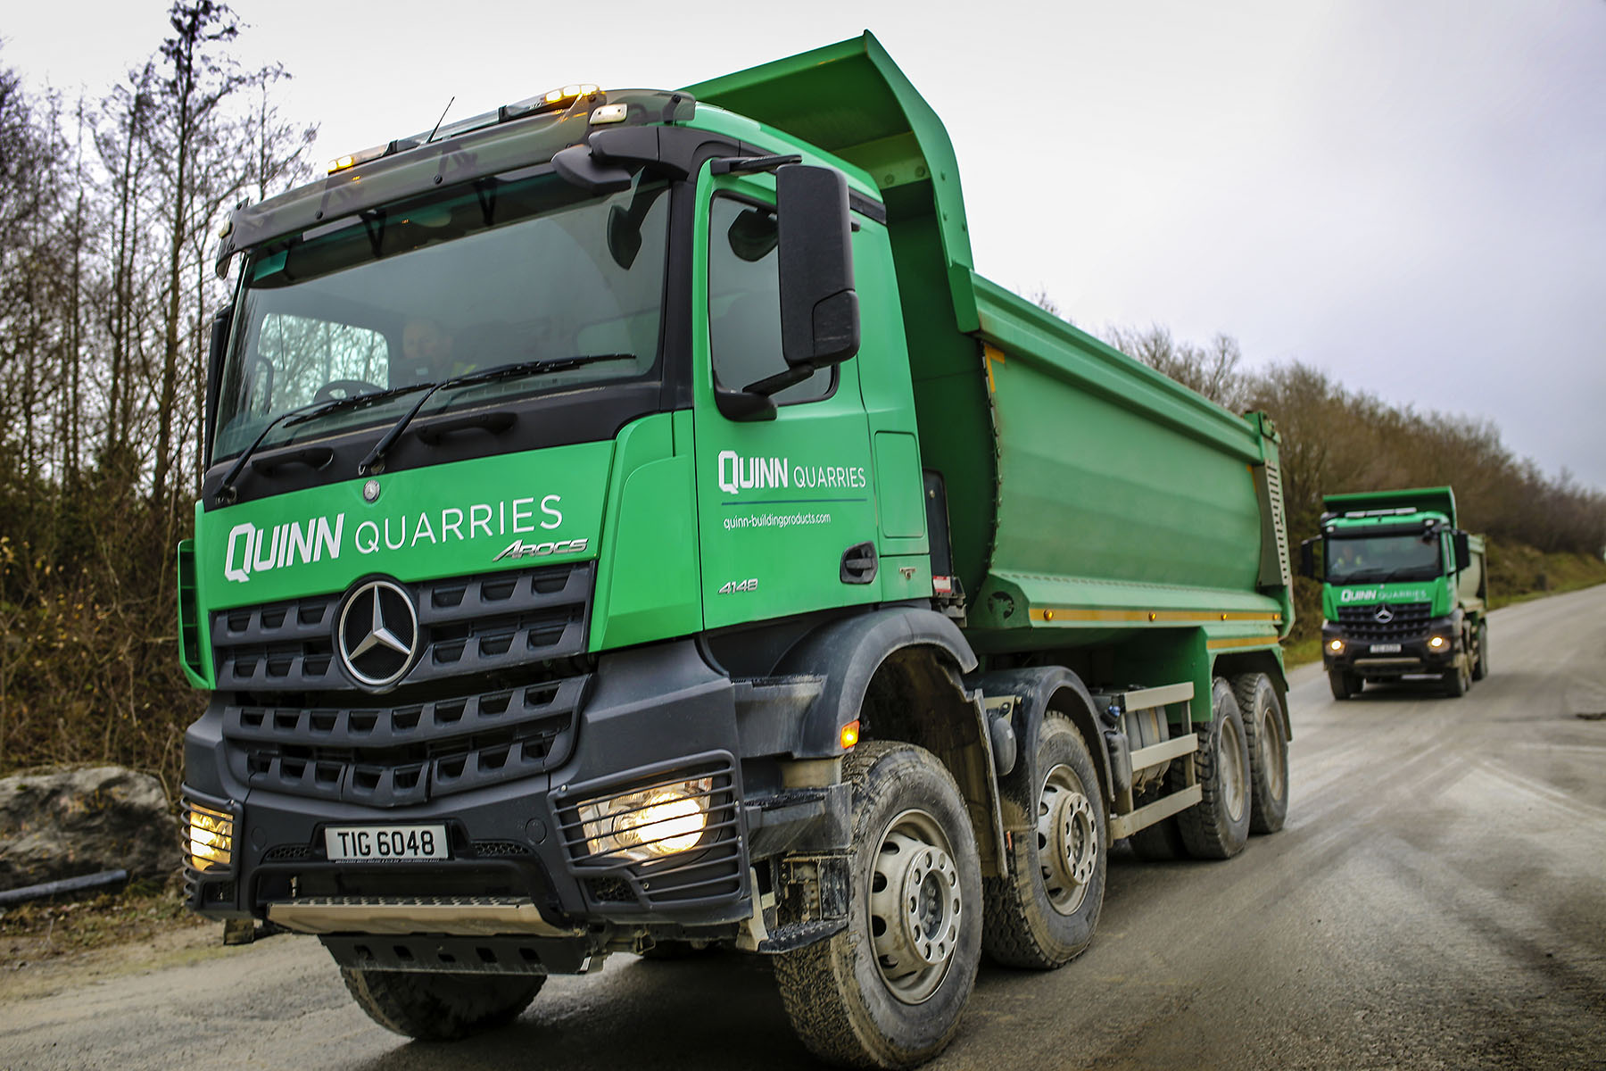

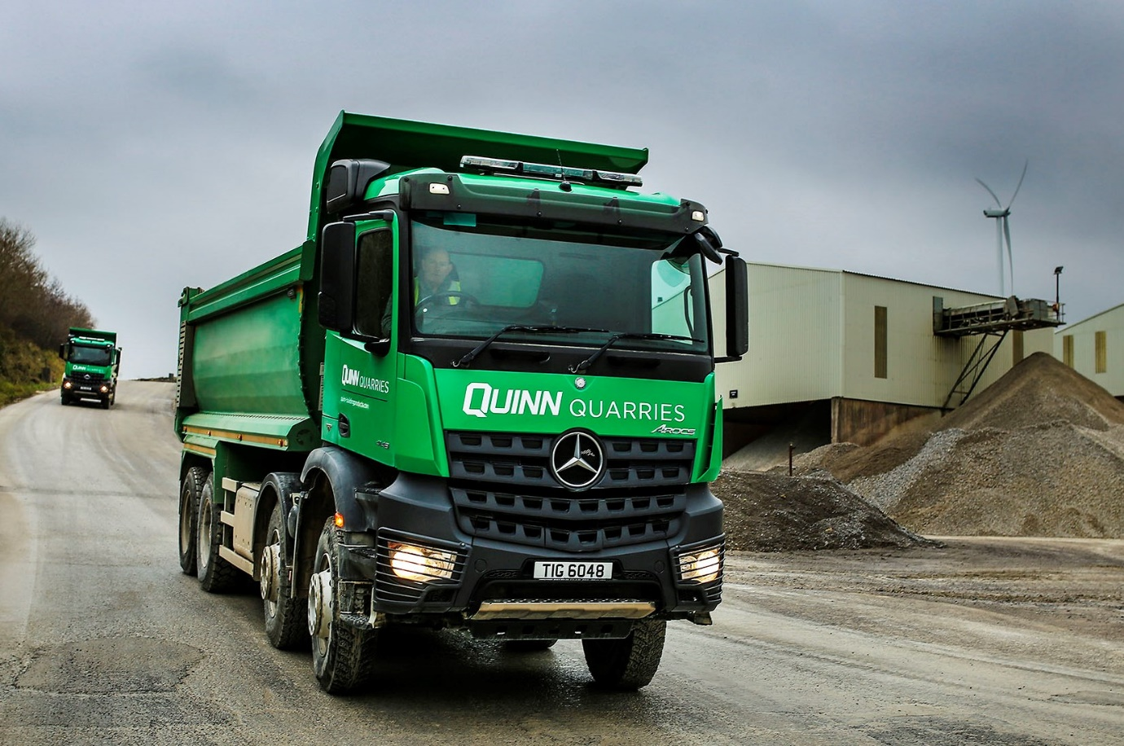

ends

For more information, or to request bigger/higher-res image files, please contact:
John Ripley or Steve Warren
Impact Communications, 01926 842126
John: 07771 484595, john@impactcom.co.uk
Steve: 07770 470251, steve@impactcom.co.uk



