

Date: 12 May 2021

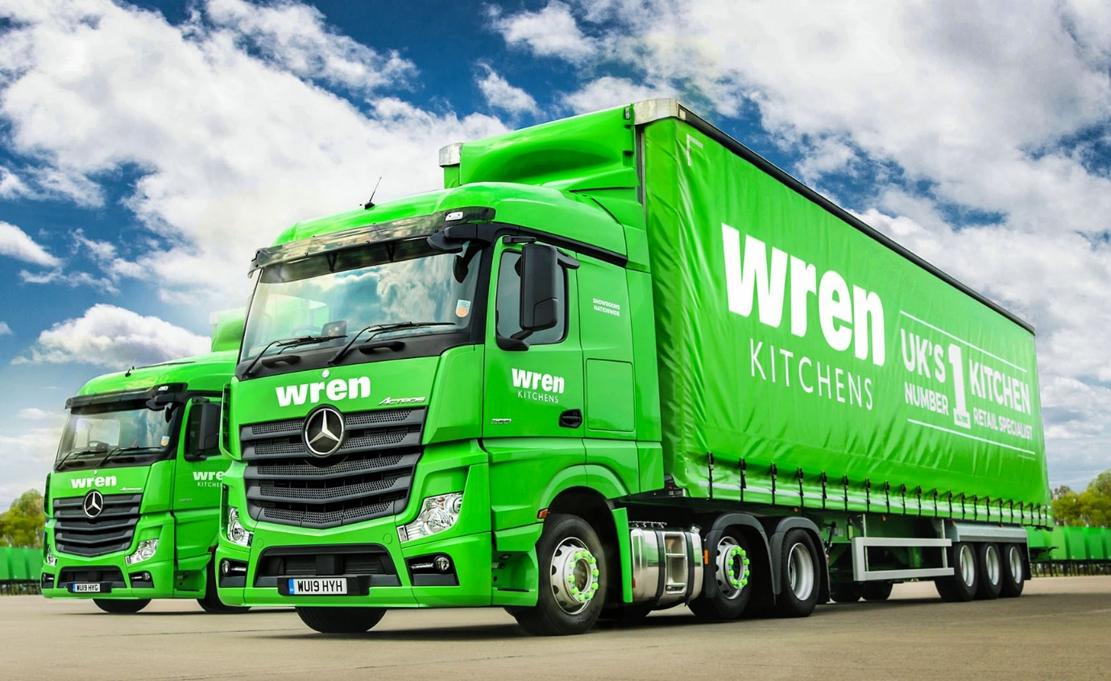

Fleetboard telematics drive fuel savings for high-profile own-account fleets

One year on from Wren Kitchens’ decision to install Fleetboard in all 100 of its trucks, the Daimler-owned telematics system has served up an impressive improvement in fuel efficiency.

The UK’s number one specialist retailer, which delivers more than 2,000 kitchens every week, has seen average returns shoot up by 1.5 mpg across a fleet that extends from 7.5-tonne rigids to 44-tonne tractor and semi-trailer combinations. The majority are by Mercedes-Benz.

The Yorkshire- and Lincolnshire-based company’s National Transport Compliance Manager David Cooper reported: “We’re currently averaging 12 mpg across the fleet. A year ago, before we installed Fleetboard, that figure stood at 10.5 mpg.”

He explained: “We wanted to leave it a full 12 months before making the comparison. This, we thought, would give us time to fully ‘bed in’ the technology to our fleet management process, and to ensure that our drivers and transport planners were using it effectively. Now we’ve done so, the results speak for themselves.”

Wren Kitchens is a market leader in the innovation, design, manufacture and supply of luxurious yet affordable fitted kitchens on both sides of the Atlantic. The company is proud to own its entire supply chain, from initial customer consultation to delivery.

Eight tractor units transport large and heavy granite worktops from its manufacturing site in Barton-upon-Humber, North Lincolnshire, to a network of six depots nationwide. The rigids, most of which work with demountable box bodies, deliver kitchens to customers’ homes – 99.94% of consignments arrive on time and in full.

Fleetboard records and processes technical data from the vehicle, then rates the driver’s style at the wheel. Criteria monitored include speed, braking, stops and idle times with the engine running, and – for vehicles bearing the three-pointed star – use of the Mercedes PowerShift transmission’s Eco-Roll function. Operators can use this information to incentivise their drivers and initiate targeted training where shortcomings in behaviour at the wheel are identified.

David Cooper continued: “We were seeking to increase mpg returns and an obvious way to achieve this was by helping our drivers to become more efficient. This meant we needed a telematics system that would show us where there was room for improvement and serve as a coaching aid to help training and development.

“Following a broad review of the products available from different suppliers we concluded that Fleetboard offered the most comprehensive and user-friendly solution. In the year since we introduced the system it has delivered everything we hoped for, and more.

“Our drivers embraced Fleetboard from the beginning as a tool to help them do their jobs in the best way possible. The reports it generates encourage them to drive in a more economical manner.

“The Fleetboard App, which they all use, provides constant updates and reminders to help them maintain the most efficient style at the wheel. Not only has it raised performance across the board, but it has also ‘levelled up’ the figures so that all are now operating to a very high standard.”

Fleetboard is also assisting Wren Kitchens’ management team. “Functions like the ability to monitor tacho information in real time, and live congestion and road restriction updates, have proved invaluable to traffic office colleagues,” said Mr Cooper. “Our entire distribution function has benefited, and, of course, by reducing fuel consumption we’re driving down the impact of our operations on the environment too.”

The fuel and other efficiency savings achieved by Wren Kitchens will come as no surprise to lighting specialist Dextra Group, as Fleetboard telematics have been adding a shine to its distribution operation for more than 15 years now.

Established over 40 years ago, the country’s largest and most successful privately-owned lighting manufacturer serves a nationwide client base of installing contractors and direct corporate accounts.

Dextra’s smartly liveried fleet is integral to its industry-leading service. Every truck is a Mercedes-Benz – most are 4x2 Actros tractor units that are plated for operation at 32 tonnes GCW and pull double-deck trailers restricted to a height of 4.0 metres for operation on the Continent.

Operations Director Tim Pickford said: “Fleetboard is deeply embedded into everything we do. It allows me, easily and in real time, to keep tabs on the performance, position and productivity of every driver and every vehicle in our fleet.

“For our office and driving staff Fleetboard is the most useful tool. With the proactive support of Fleetboard Business Development Manager John Armes and his team, we’ve made the system an integral part of our drive to operate with maximum efficiency.”

Mr Pickford said Dextra’s traffic planners found the system’s mapping functions invaluable. The Time Management facility, which was used to download tachograph information remotely, also helped the company to ensure that those on the front line were always fully compliant with working hours regulations.

Fuel economy is key for Dextra as well. “Fleetboard allows us to analyse the performance of every vehicle and every driver,” continued Mr Pickford. “We’re alerted very quickly if anyone is not operating at the highest level, and the data the system provides – on factors such as incidences of harsh braking or acceleration – makes it easy to pinpoint where improvements can be made.

“Our tight-knit team of 25 drivers, meanwhile, appreciate the fact that we have invested in the best, most modern vehicles to help them work as comfortably, efficiently and safely as possible. We post ‘league tables’ of their Fleetboard scores, which are measured on overall driving style, and take into account the difficulty of the route. These help to foster an atmosphere of friendly competition, as the guys like to see how well they and their colleagues are doing. They recognise that an efficient driving style is also safer and less stressful, so they’re fully engaged.”

Mr Pickford added: “We’re big believers in technology, and the benefits it offers in terms of safety, reliability and improved fuel economy, which, in turn, helps to reduce environmental impact. That’s why two of our latest Mercedes-Benz trucks were among the first in the UK to be fitted with the manufacturer’s ground-breaking Active Drive Assist system.
“Over the years Fleetboard’s capabilities have been constantly improved and extended to keep it at the forefront of our efforts to operate as efficiently as possible. Our Actros artics are averaging 12 mpg but we’ve seen figures as high as 16.5 mpg on the rare occasions one of them is running light. It’s safe to say the system is making a very significant contribution.”

Wrenkitchens.com

Dextragroup.co.uk

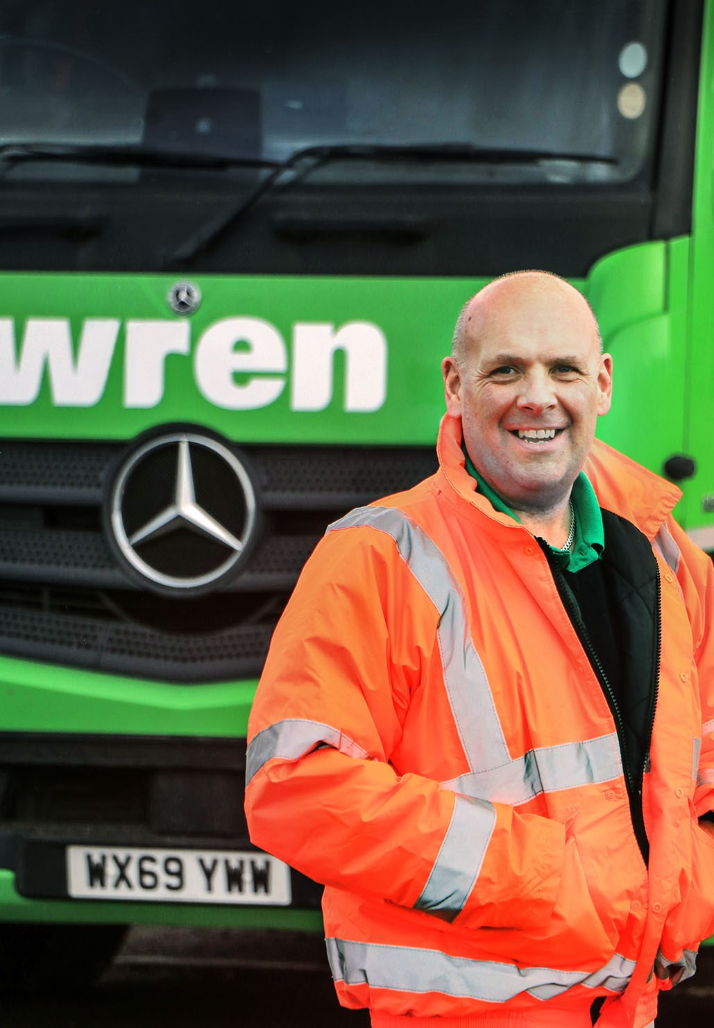

Numbers game: Wren Kitchens’ National Transport Compliance Manager David Cooper has seen a 1.5 mpg increase across his fleet thanks to Fleetboard

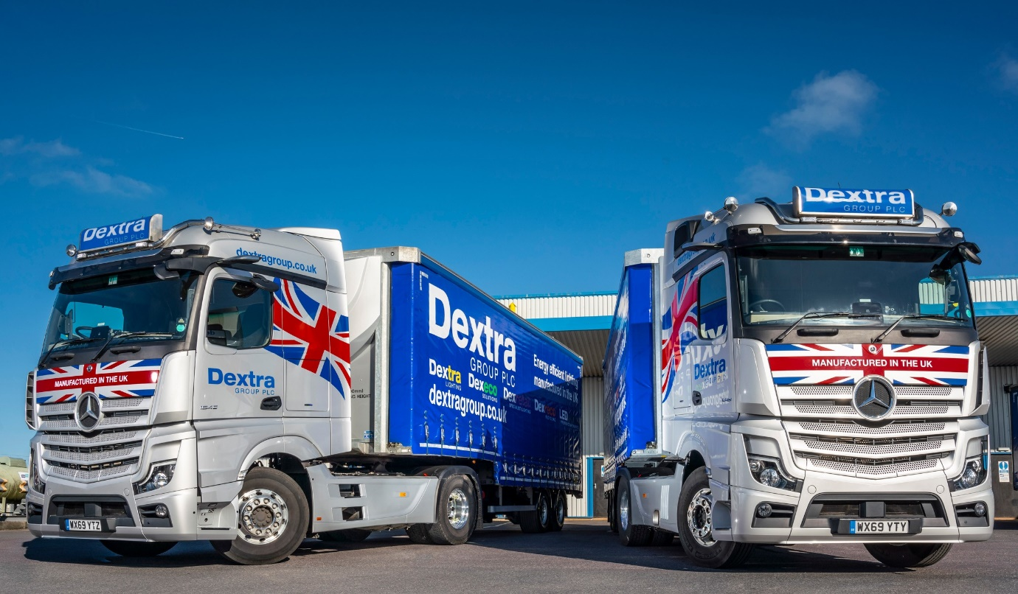

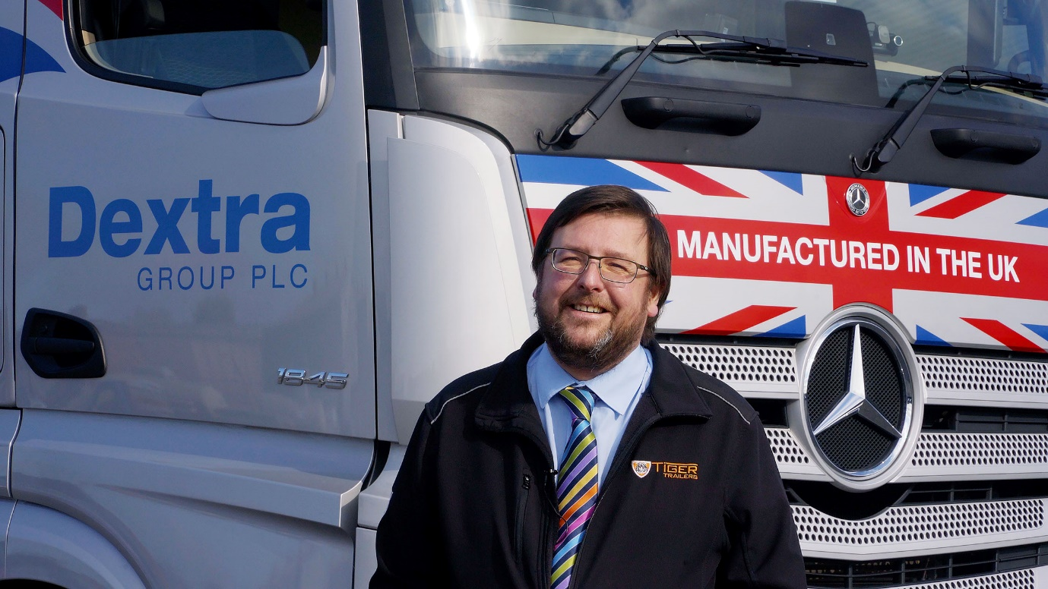

Seeing the light: Tim Pickford of Dextra Group praised the contribution that Fleetboard makes to fleet efficiency and safety

ends

For more information, or to request higher-res image files, please contact:

Jamie Fretwell at Mercedes-Benz Trucks UK Ltd
07712 519230, jamie.fretwell@daimler.com

or

Steve Warren or John Ripley
Impact Communications, 01926 842126
Steve: 07770 470251, steve@impactcom.co.uk
John: 07771 484595, john@impactcom.co.uk

