

Date: 12 March 2019

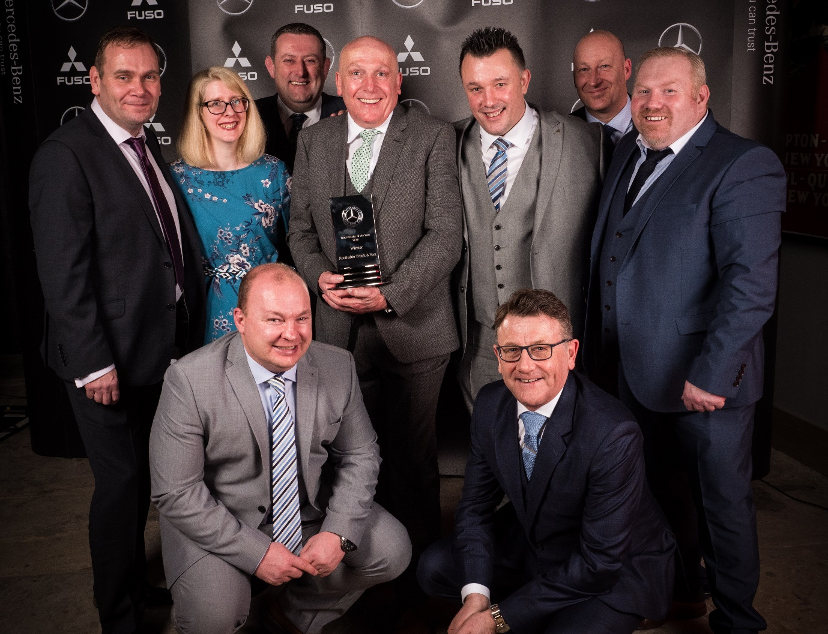

Northside’s done it again! Managing Director Russ Hallowes, with trophy, and colleagues celebrate their third consecutive Mercedes-Benz Truck Dealer of the Year award

Mercedes-Benz Trucks Dealer Northside notches a prestigious hat-trick

Consistently high levels of performance across all areas of its business carried Northside Truck & Van to the Mercedes-Benz Trucks Dealer of the Year title for a remarkable third year in succession.

Managing Director Russ Hallowes stepped up to collect the coveted trophy at the manufacturer’s annual celebration of franchisee excellence, which was staged at Liverpool’s Titanic Hotel.

“This is a fantastic achievement, especially given the tough competition we faced from the other 16 members of the Mercedes-Benz Trucks Dealer Network,” declared Russ. “It underlines yet again our unwavering commitment to the brand we represent, as well as to our colleagues and customers.”

Northside, which has now won the same award in four of the last five years, sells and supports the Mercedes-Benz Trucks range, as well as FUSO Canter light trucks, from a network of seven branches strategically located throughout Yorkshire and North Lincolnshire.

The prestigious accolade recognised another magnificent set of results during 2018. It was a year that saw a change of leadership – having previously served as Aftersales Director, Russ Hallowes was promoted to the top job in May – but no let-up in the company’s relentless drive to provide customers with the industry’s finest service.

Key to Northside’s success is the company’s philosophy of ‘growing its own’. The Dealer is firmly wedded to a strategy of staff development; indeed, when members of its 551-strong team travel to Mercedes-Benz HQ in Milton Keynes, or to third-party providers, to attend courses, they do so in one of eight vans each bearing the pledge: ‘Investing in training, investing in you’.

Russ, who began his own career as an apprentice technician, declared: “The ethos at Northside is that if you do right by your people, they’ll do right by you. The customer will always be number one, but so, too, are those who work for this business. Our people are our greatest asset, and experience has proved that motivated, engaged colleagues are more productive and – crucially – more likely to deliver customer satisfaction.”

In the face of a challenging market, which declined 4.3% year-on-year, Northside Truck & Van registered more than 1,100 new Mercedes-Benz and FUSO vehicles with gross weights of 7.5 tonnes or above in 2018, as well as 200 used models.

Meanwhile, its aftersales team posted another highly impressive set of results, with workshop labour sales and parts sales up by 6% and 16% respectively. Northside’s Service 24h emergency assistance technicians repaired 88% of the vehicles they attended at the roadside before sending the drivers on their way, while 96% of the trucks prepared by the Dealer for an MoT test by a Driver and Vehicle Standards Agency (DVSA) inspector sailed through first time.

Russ said the creation last year of new Group Aftersales Manager positions dedicated to Truck and Van – both roles were also filled by internal promotions – had provided heightened focus on meeting the needs of the two sets of customers.

Northside’s workshop opening hours reflect its determination to deliver on Mercedes-Benz Trucks’ Zero Tolerance on Downtime promise. Every one of its branches remains open through the night; six of the seven are also open on Sundays, and two of them – Leeds and Sheffield – only close on Christmas Day.

Mercedes-Benz Trucks Managing Director Mike Belk commented: “Northside is rightly proud of its admirable track record of staff retention and development. This is a business in which there is no ‘them’ and ‘us’; instead, everyone is working to achieve the same goal.

“Rather than excelling in one or two areas, the winner of our Dealer of the Year Award must be a genuine all-rounder. Not only do they consistently exceed our targets in terms of vehicle sales and aftersales performance, but our research confirms that Russ and his team also deliver outstanding customer service. Northside continues to be a fantastic ambassador for the Mercedes-Benz Trucks brand.”

The full list of award winners was as follows:
- Truck Dealer of the Year – Northside Truck & Van
- Truck Customer Service & Parts Dealer of the Year – Ciceley Commercials
- Truck Technical Team of the Year – Sparshatts Truck & Van
- Truck Sales Dealer of the Year – Roanza Truck & Van
- Truck Sales Administration Team of the Year – Mertrux Truck & Van
- Mercedes-Benz Finance Truck Dealer of the Year – Intercounty Truck & Van
- Truck Marketing Dealer of the Year – Rygor Commercials
- Truck Service Manager of the Year – Dave McGinnis, Ciceley Commercials
- Truck Parts Manager of the Year – Mark Bowman, Western Commercial
- Truck Service 24h Technician of the Year – Chris Atkinson, Intercounty Truck & Van
- Truck Trainer of the Year – Ben Clark, Roanza Truck & Van
- Truck Sales Leader of the Year – Ian Brown, Mertrux Truck & Van
- Truck Sales Star of the Year – Martin Kemsley, Sparshatts Truck & Van
- Used Truck Sales Star of the Year – Paul Diamond, Roanza Truck & Van

www.northside.co.uk

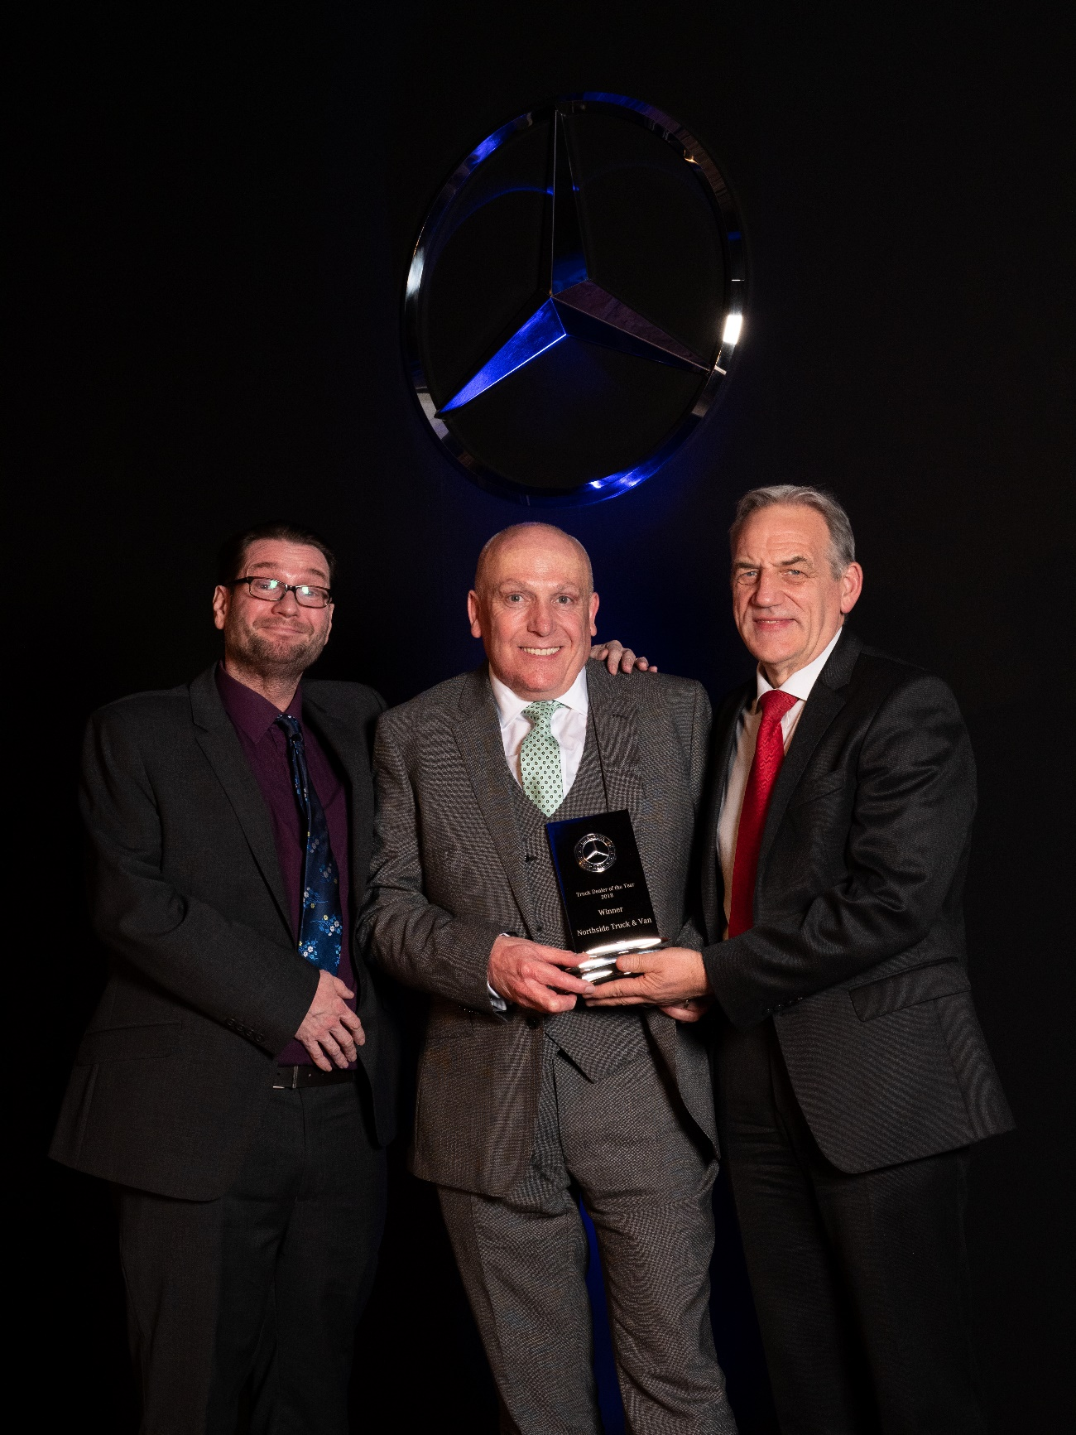

Winning ways: Northside’s Russ Hallowes collected the Dealer of the Year trophy from Mercedes-Benz Trucks Managing Director Mike Belk, right, and guest presenter Gary Delaney

ends

For hi-res image files, please visit:
media.mbtrucks.co.uk

For further information, please contact:
Jamie Fretwell, PR & Internal Communications
Mercedes-Benz Trucks
07712 519230, Jamie.Fretwell@daimler.com
or

Steve Warren or John Ripley
Impact Communications, 01926 842126
Steve: 07770 470251, steve@impactcom.co.uk
John: 07771 484595, john@impactcom.co.uk

About Mercedes-Benz Trucks UK Ltd

Mercedes-Benz Trucks UK Ltd is the sales and marketing organisation responsible for all Mercedes-Benz truck products in the UK, including FUSO Canter.

In 2018, the company registered 8,061 new trucks. After growth in 2017, Mercedes-Benz registrations levelled off to 7,223 trucks in 2018, ensuring it retained its title as the second-biggest truck brand in the UK. Meanwhile, FUSO made great strides to reach 838 registrations – including 675 new trucks over 6.0-tonnes.

For more than 125 years, Mercedes-Benz has stood for innovative vehicles that meet exceptionally high standards of quality. Our claim to perfection, sustainability and avant-garde design is now embodied in the next generation of trucks: Actros, Arocs, Atego, Econic and Unimog.

www.mbtrucks.co.uk

