

Date: 30 April 2019

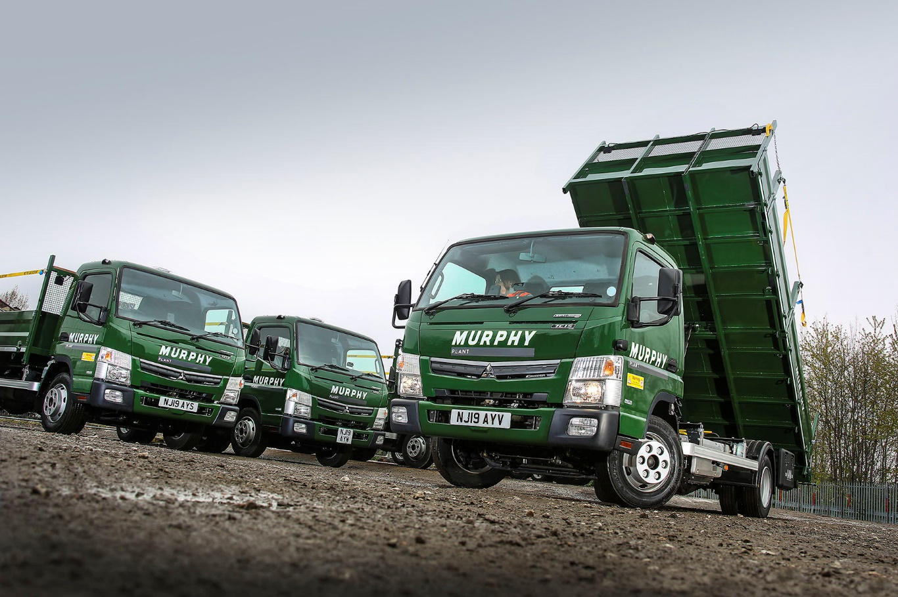

Murphy switches to 20 FUSO Canter Eco Hybrids for London ULEZ

Construction and engineering contractor J Murphy & Sons has responded to the introduction of London’s Ultra Low Emissions Zone (ULEZ) by investing in a fleet of FUSO Canter tippers with hybrid diesel-electric drivelines.

The 20 new vehicles are exempt from the £100 per day charge now being levied on all trucks that venture inside the capital’s busy central area, which do not meet the Euro VI emissions standard. Murphy believes that as well as being significantly cleaner, the new vehicles will deliver running cost savings, while also providing exemplary levels of productivity, reliability and safety.

The Eco Hybrids were supplied by Mercedes-Benz Dealer Bell Truck and Van – like other members of the manufacturer’s franchised network in Britain, it also sells and supports the popular FUSO Canter light truck range.

Fitted with tipping bodies by Penman Engineering, of Dumfries, they are being operated by Murphy Plant, a subsidiary of the Murphy parent company, which provides plant and commercial vehicles to the group’s various contracting divisions.

Murphy Plant Compliance Manager Richard Burnham said: “We’ve had Canters before so we know they’re solid, reliable trucks. We ordered the Eco Hybrids because we wanted to future-proof ourselves not only against the ULEZ, but also against other emissions-based restrictions that might be coming further down the line.

“Of coursem, we are also committed to operating vehicles which are efficient, reliable and safe, not only for our own staff but also for other road users. As a responsible operator, working closely with agencies such as Transport for London (TfL), the Fleet Operator Recognition Scheme (FORS), and Construction Logistics and Community Safety (CLOCS), this is something we take extremely seriously.

“The Canter’s low seating position, compared to a more conventional truck, puts drivers in a better place to make eye contact with cyclists and pedestrians, while the hybrid driveline and automated transmission allow them to focus all their attention on the road ahead, and foster a more relaxed driving style.”

He continued: “The Canter’s compact exterior dimensions and impressive manoeuvrability are also an advantage in tight urban streets. Its light yet robust ladder-frame chassis gives the vehicle a highly competitive payload, and we are confident these new trucks will deliver the reductions in fuel consumption, and therefore exhaust emissions, that we’re looking for.”

The FUSO Canter Eco Hybrid is powered by a 110 kW (150hp) diesel engine which works in parallel with a state-of-the-art 40 kW (54hp) electric motor. From stationary it uses electric power only, then switches to a combination of diesel and electric operation once a speed of around 6 mph has been reached. Depending on the power demand, the electric motor also supports the diesel at higher speeds. Mode switching is seamless, requiring no input from the driver. An Idle Start-Stop system is also fitted as standard and contributes to fuel savings of up to 23% compared to its standard, diesel-engined stablemate.

Founded in 1951, Murphy is a multi-disciplined engineering company employing more than 3,500 engineers, managers and skilled operatives worldwide. Based in Kentish Town, north-west London, it operates across the UK as well as in Ireland and Canada. Sectors in which it is involved include power, water, transportation, natural resources and construction and property, offering key services such as ground engineering, utility connections, highways and streetworks, process engineering, pipeline testing, specialist welding and electrical services. The company invests heavily in a substantial holding of plant, equipment and facilities. In addition to its new FUSO Canters, Murphy runs a fleet of 120 trucks, 15 of which are from Mercedes-Benz.

www.murphygroup.com

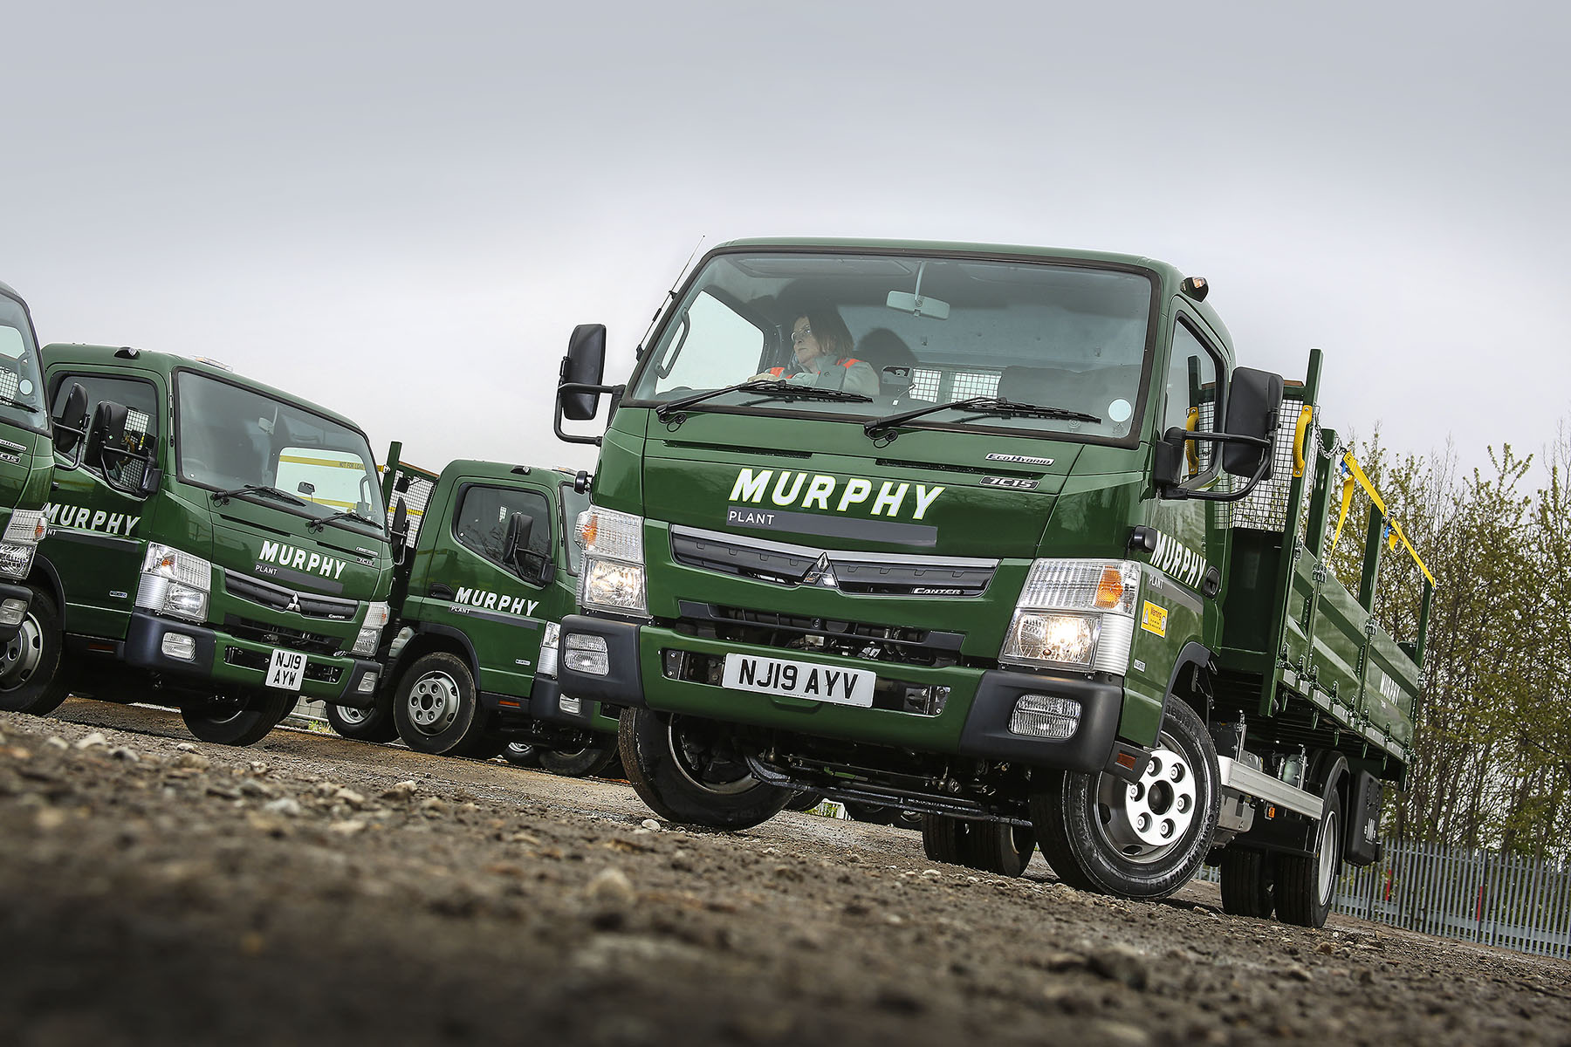

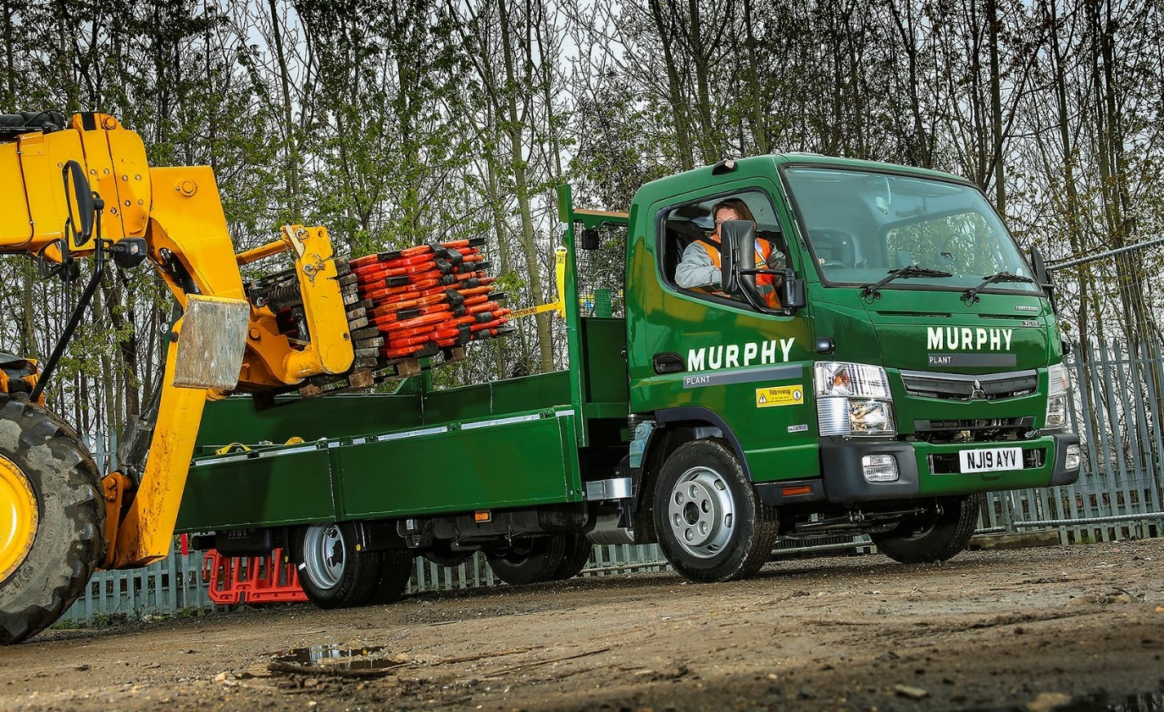

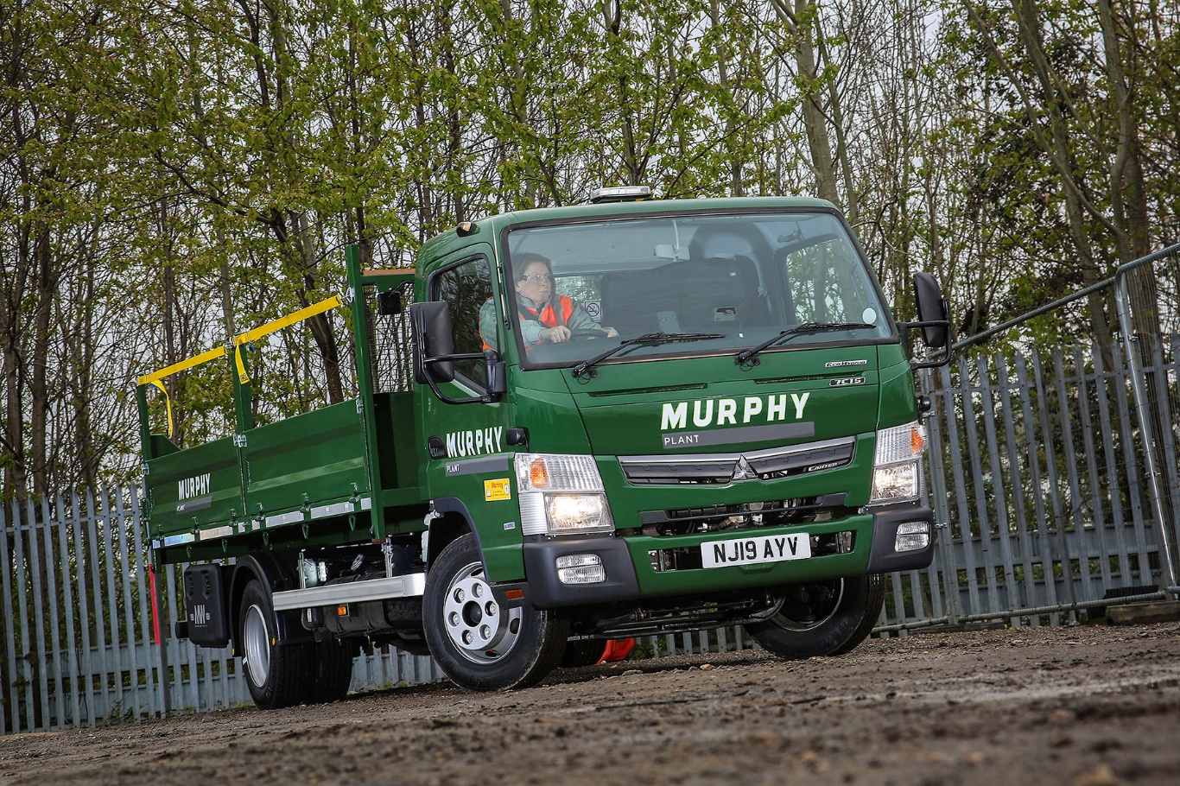

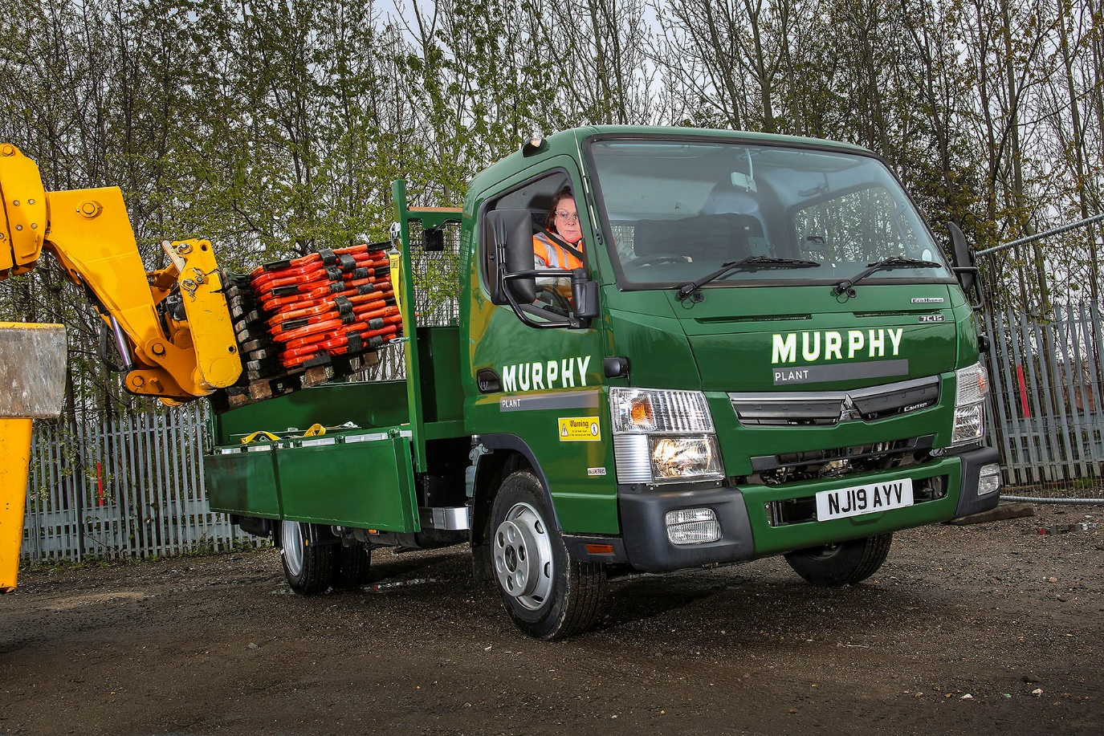

ends

For more information, or to request bigger versions of image files, please contact:
John Ripley or Steve Warren
Impact Communications, 01926 842126
John: 07771 484595, john@impactcom.co.uk
Steve: 07770 470251, steve@impactcom.co.uk

