

Date: 15 June 2023

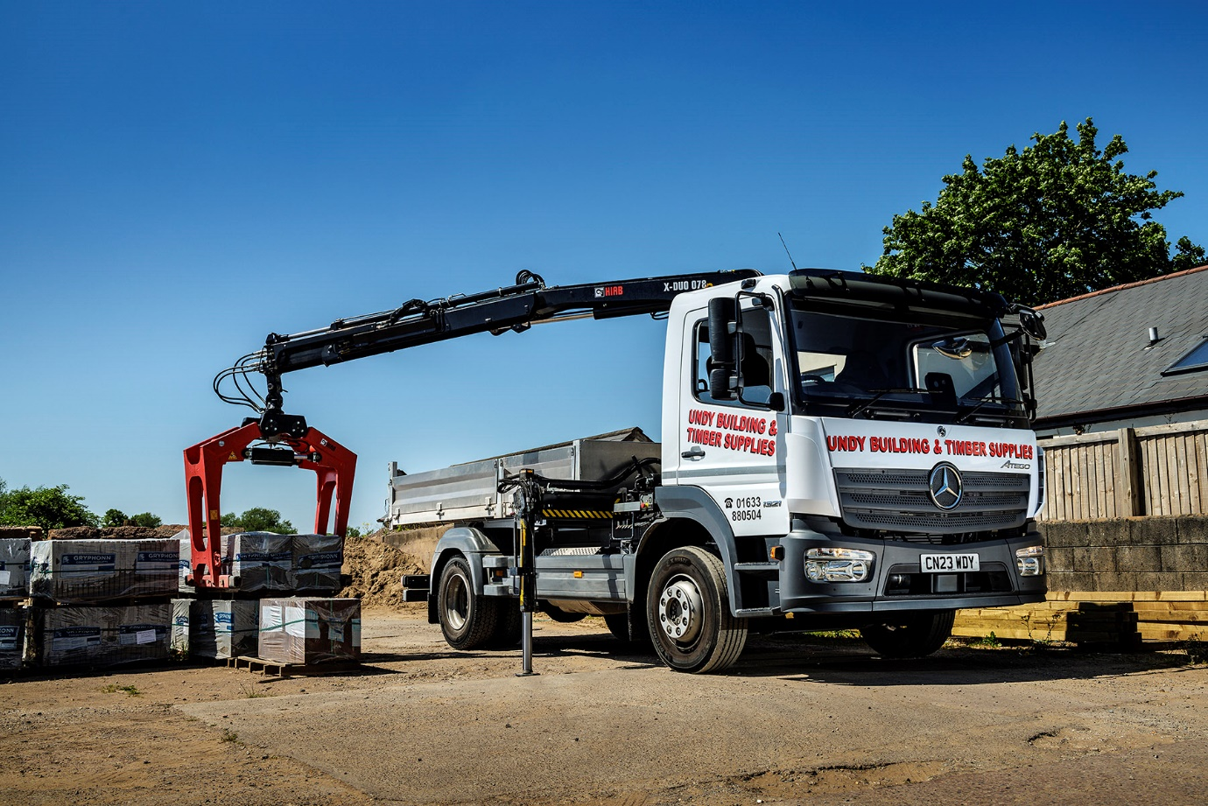

Undy’s new Mercedes-Benz Atego has a tough act to follow

South Wales builders’ merchant Undy Building & Timber Supplies looked no further than another Mercedes-Benz Atego from Euro Commercials, when it needed a new delivery truck – thanks to the proven performance of its long-running predecessor.

The new truck has replaced a previous Atego supplied by the same Dealer a full 20 years ago. Still going strong with a little over 250,000 km on the clock, it was snapped up by a buyer in Cardiff.

A 1321 model, the latest addition to the fleet is powered by a 155 kW (210 hp) 5.1-litre engine and has a ClassicSpace S day cab. The chassis is equipped with an alloy tipper by Neath Bodybuilders, who also fitted a Hiab X-Duo 078 loader crane with Kinshofer grab, rated at 7.4 tonne/metres and with a maximum outreach of 11.6 m.

Based in Undy, Monmouthshire, the company is run by couple Pam and Terry Wood. It sells a range of construction materials from its depot in the village and also delivers to trade and DIY customers in surrounding towns including Caldicot, Chepstow and Newport.

“We’re approaching our 50th year in business,” said Pam. “When we started, Terry was a builder and I ran the builders’ merchant side of the operation – which included driving the lorry for all our deliveries.

“I’m happy to have handed over those duties and prefer to spend my time in the office these days.”

Today, deliveries are undertaken using two smaller tippers and the new 13.5-tonne GVW Atego, which handles the largest consignments. The truck is now being driven by the Woods’ son, Michael – daughter Samantha works for the family business too, looking after administration.

“Given the fantastic performance and longevity of our previous Atego, we were never really going to consider anything else when we came to replace it,” said Pam Wood.

“The old truck never let us down and still looked great, while the service from Euro Commercials over the years has always been excellent. Sales Executive Huw Salway sold us that vehicle but our relationship goes back even further. We bought our first Mercedes-Benz from him back in 1995 and he has been a trusted supplier to our business ever since, so we were very happy to hand him the order for this latest vehicle.”

Michael Wood added: “The previous Atego was a great little workhorse, always good on fuel and hardly ever needed anything other than routine maintenance. I’m sure the new one will be just as reliable and cost-effective to operate, while the comfort and quality of the cab interior is certainly a step up compared to what I’ve been used to.

“At 13.5 tonnes GVW this model combines a very useful payload of over five tonnes, while maintaining a relatively compact footprint and excellent manoeuvrability. It’s a lovely truck to drive and we’re looking forward to many years of dependable service.”

The Mercedes-Benz Atego range from 7.5-16 tonnes GVW offers outstanding driving dynamics, comfort and manoeuvrability. It is also renowned for its industry-leading reliability and durability.

Euro Commercials’ Huw Salway said: “The Mercedes-Benz Atego is the perfect match for the Wood family’s business – both have unbeatable staying power and a real appetite for hard work. We were delighted to receive the order for their latest vehicle and wish Undy Building & Timber Supplies every success in the future.”

www.undybuildingsupplies.co.uk

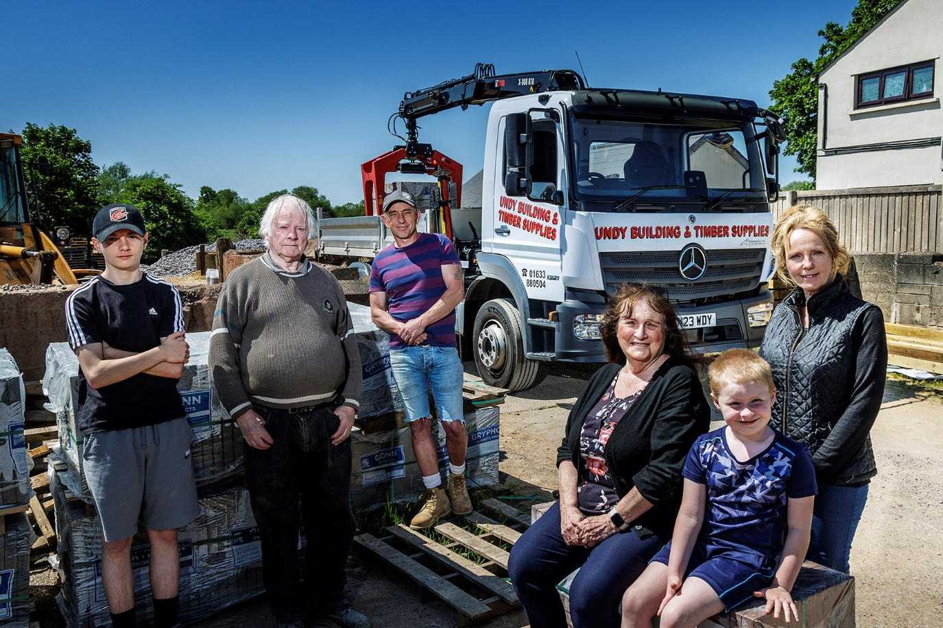

Family values: Terry (second left) and Pam Wood (fourth left), with son Michael, daughter Samantha, and grandsons Michael Jr. (far left) and Joshua, and their new Mercedes-Benz Atego

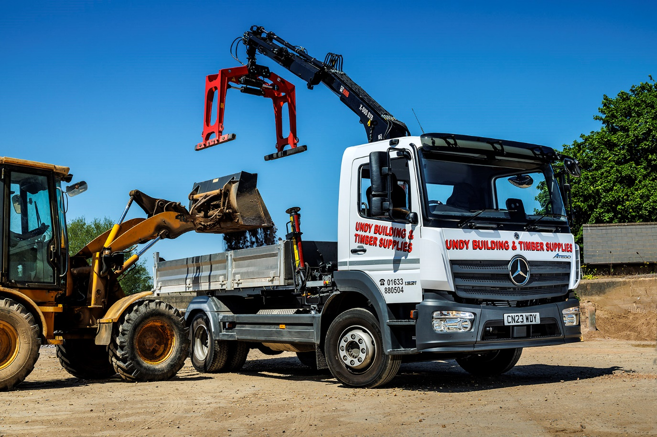

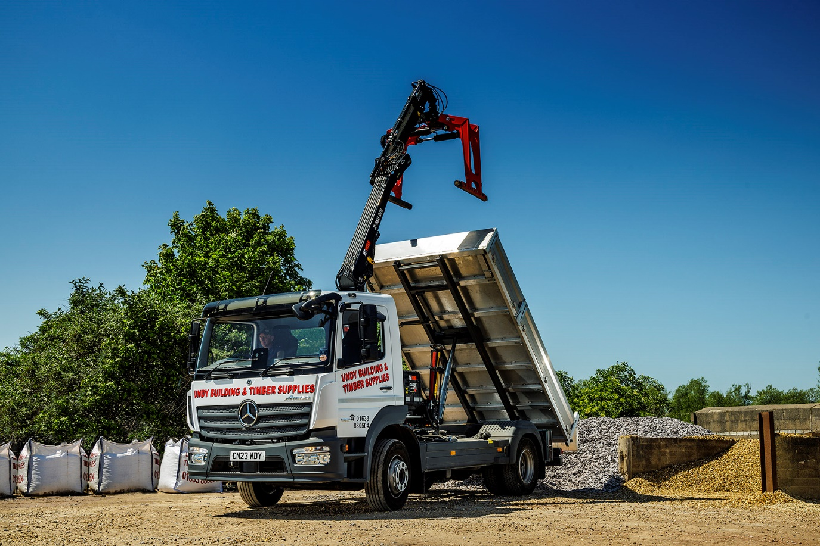

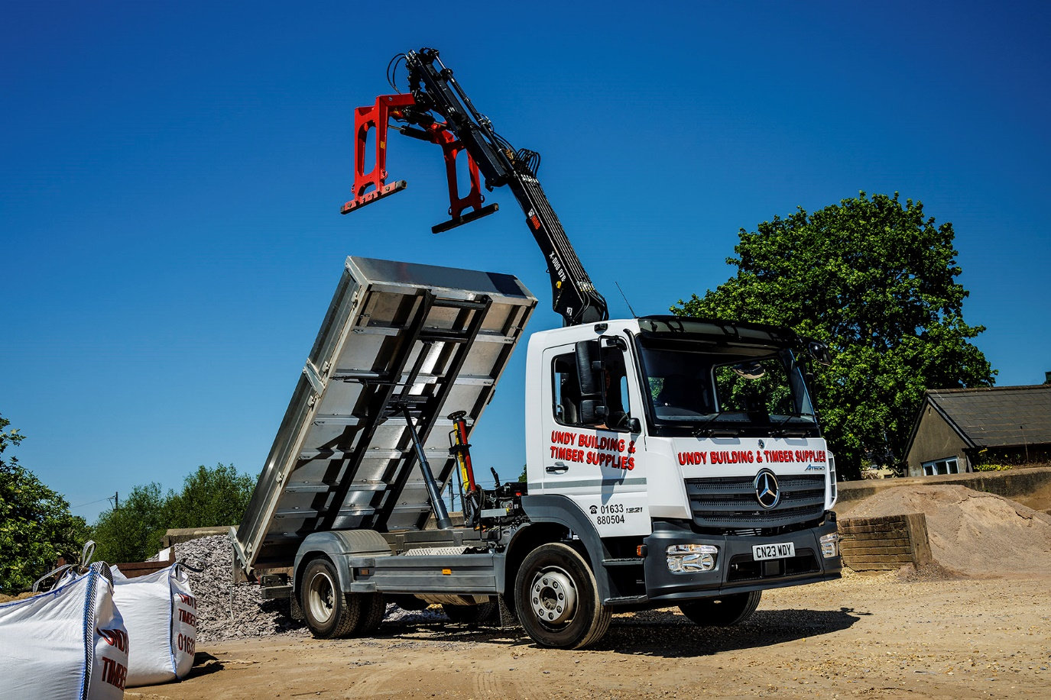

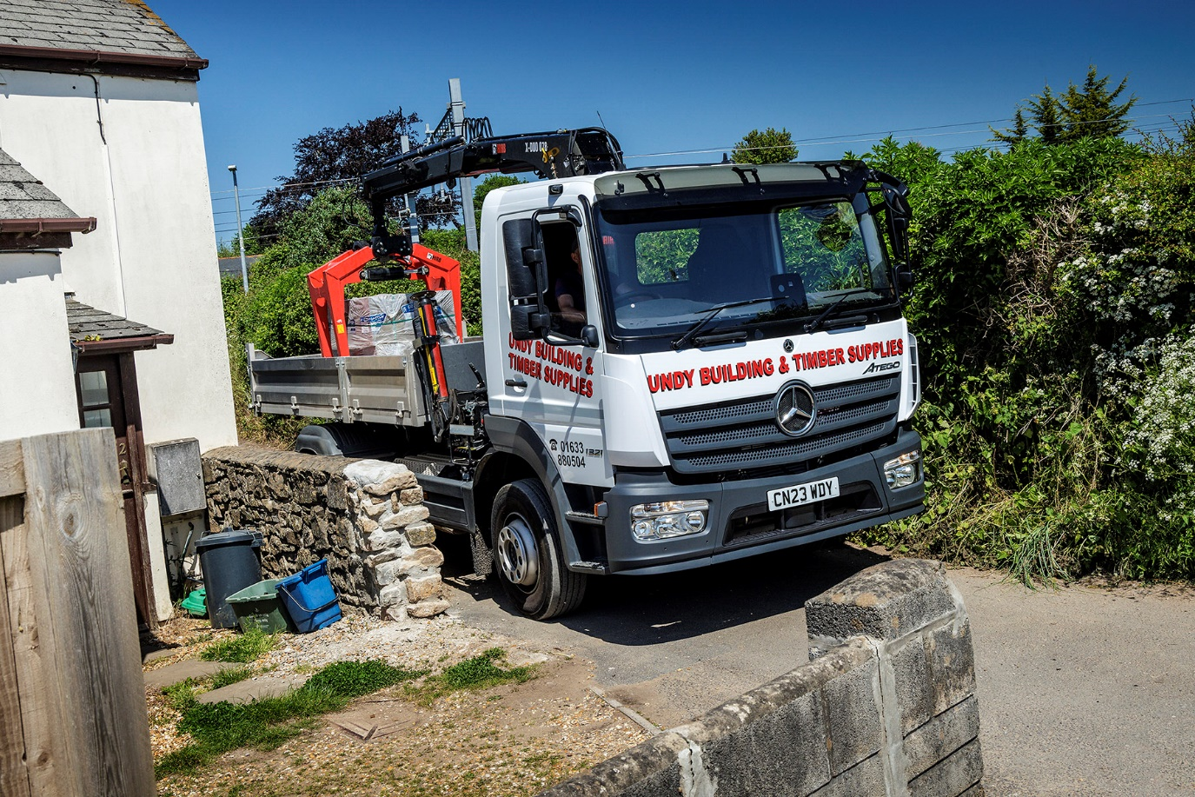

ends

For more information, or to request bigger/higher-res image files, please contact:
John Ripley: 07771 484595, john.ripley@loopagency.co.uk

