

Date: 14 January 2025

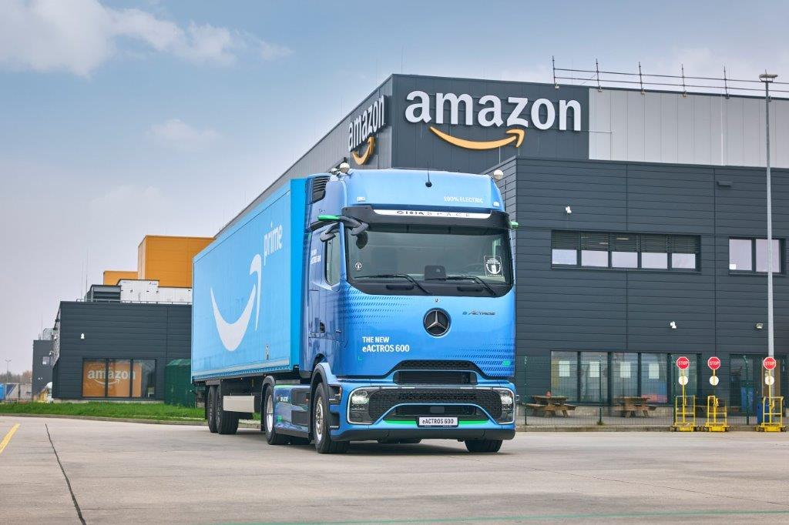
Major contract for Mercedes-Benz Trucks: Amazon delivers order of more than 140 eActros 600 for the UK

- Largest e-truck (eHGV) order to date for Mercedes-Benz Trucks and Amazon
- Over 140 of more than 200 eActros 600 ordered by Amazon will join its UK network, with the rest in Germany. They are expected to transport over 300 million packages every year in the UK
- Heiko Selzam, Managing Director of Daimler Truck UK Limited commented: “Since supplying the 7.5T Fuso eCanter in 2021, we are excited to continue to build on this electric journey with our partners at Amazon. This order of more than 140 eActros 600 for the UK signifies their understanding of the importance these trucks will have as they drive to reach their net-zero carbon emissions targets.”

Amazon has placed its largest-ever order of more than 200 battery-electric heavy goods vehicles – and has selected the Mercedes-Benz eActros 600 - also the largest order for electric trucks in the history of Mercedes-Benz Trucks.

Over the next 18 months, the eActros 600 trucks will be deployed across high-mileage routes in Amazon’s middle-mile network in the UK and Germany transporting cargo containers to and from Amazon’s fulfilment centres, sort centres and delivery stations. Before placing the order, Amazon undertook testing of a prototype eActros 600 at one of its logistics centres in Germany.

More than 140 of the eActros 600 trucks will be deployed in the UK and are expected to transport more than 300 million packages each year with no exhaust emissions once fully operational.

Amazon intends to install additional fast charging infrastructure across its key UK sites, including 360kW electric charging points capable of charging the eActros 600 trucks from 20 to 80 per cent in just over an hour. The electric trucks have a range of 310 miles (500 km) on a full charge.
Karin Rådström, Chairwoman of the Board of Management of Daimler Truck AG, commented: “We are very pleased that Amazon, a pioneer in the transformation towards alternative drives, has chosen the eActros 600, a gamechanger for sustainable transportation.”
Heiko Selzam, Managing Director of Daimler Truck UK Limited commented: “Since suppling the 7.5T Fuso eCanter in 2021, we are excited to continue to build on this electric journey with our partners at Amazon. This order of more than 140 eActros 600 for the UK signifies their understanding of the importance these trucks will have as they drive to reach their net-zero carbon emissions targets.”
Stuart Jeggo, Sales & Marketing Director of Daimler Truck UK Limited said: “This groundbreaking order from our partners at Amazon solidifies the status of the eActros 600 in the electric truck market. Many months of hard work from both sides have gone into making this all possible. I’m excited to see these trucks grace the UK’s roads in 2025.”
James Venables, Head of Future Sustainability of Daimler Truck UK Limited added: “Winning the prestigious award of International Truck of the Year for 2025 was an incredible accolade for the eActros 600 and this order from Amazon really validates the truck as the technology leader in its class. It is also further acknowledgement of the value the eActros 600 has to a pioneering company with their sights firmly set on a net-zero future. Our dealer network is primed and ready to support Amazon as we look forward to welcoming these electric trucks on the road in the UK later this year.”
Andreas Marschner, Vice President of Worldwide Operations Sustainability at Amazon, said: “The order of more than 200 eActros 600 underlines our commitment to being a leader in electrifying our transportation network in Europe. It is the biggest electric heavy truck order by Amazon to date anywhere in the world and is an important step as we work to achieve our Climate Pledge commitment to reach net zero carbon emissions across our operations by 2040.”

About the eActros 600
The high battery capacity of over 600 kilowatt hours¹ - hence the model designation 600 – and a new, highly efficient electric drive axle developed in-house enable the eActros truck to achieve a range of 500 kilometers² (310 miles) without intermediate charging. This range is achieved in realistic and practical conditions with a gross combination mass of 40 tonnes, which can also be significantly exceeded depending on the driving style and route.

Intermediate charging during statutory driver breaks – even without megawatt charging (MCS) – mean the eActros 600 could cover over 1,000 kilometres per day, as long as charging infrastructure is available.

This flagship eHGV has already proven its capabilities several times under real-life conditions: In customer use and as part of the “eActros 600 European Testing Tour 2024”, a 15,000 kilometres all-electric development trip through a total of 22 countries with a gross combination mass of 40 tonnes.

In addition, the eActros has been voted “International Truck of the Year 2025”. The award is the most important prize in the industry and is presented annually by the International Truck of the Year (IToY) organisation, consisting of 24 commercial vehicle journalists from Europe.

ends

Notes:
¹ The eActros 600 has three battery packs, each with 207 kWh. These offer an installed total capacity of 621 kWh. Nominal capacity of new battery, based on internally defined boundary conditions, may vary depending on use case and ambient conditions.
² The range was determined internally under specific test conditions, after preconditioning with a 4x2 tractor unit with a 40 tonnes total towing weight at 20°C outside temperature in long-haul operation and may deviate from the values determined in accordance with Regulation (EU) 2017/2400
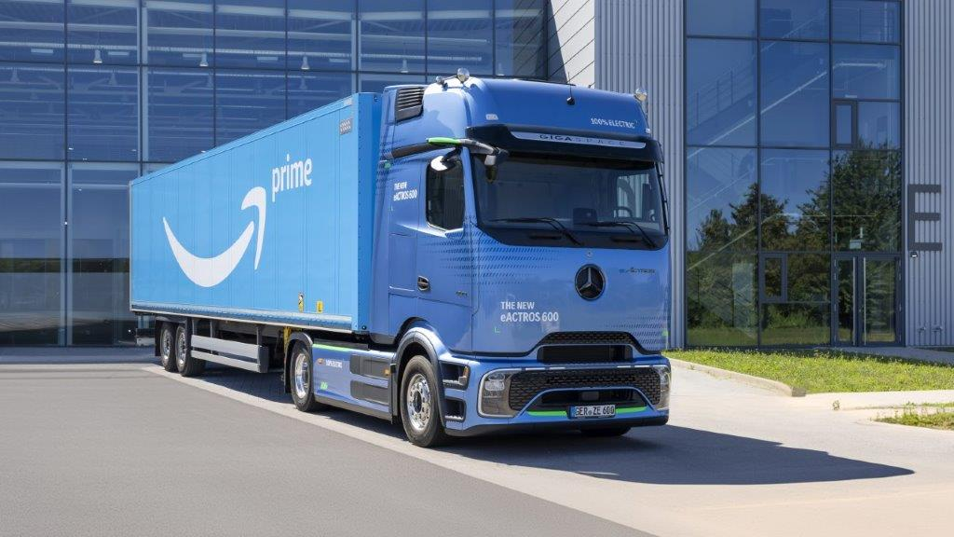
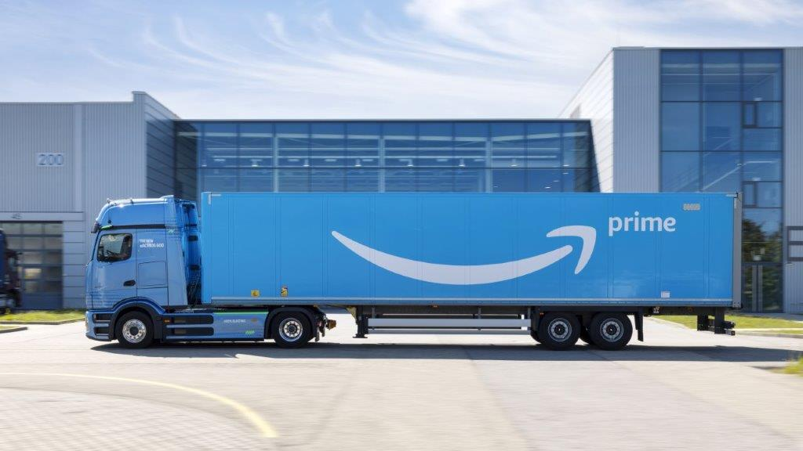
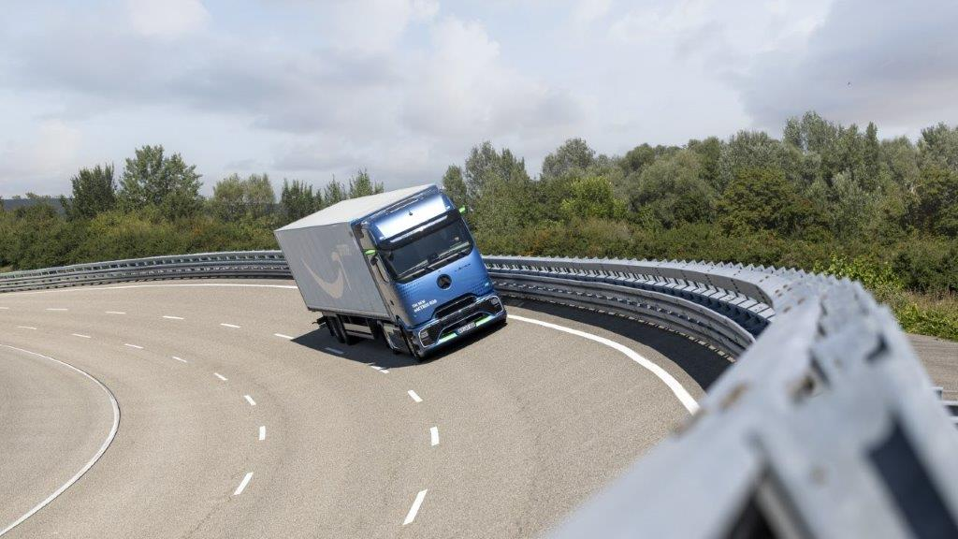
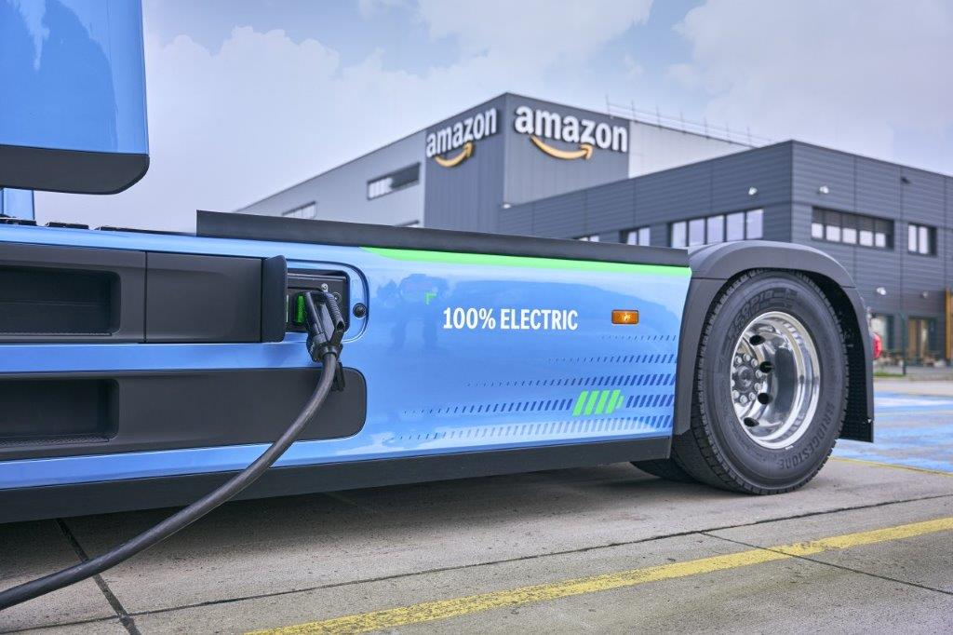
For more information, please contact:

Nick Ford, PR & Communications Manager, Daimler Truck UK
Email: nick.ford@daimlertruck.com
Mobile: 07712 235962

John Rawlings, Account Director, Loop
Email: john.rawlings@loopagency.co.uk
Mobile: 07847 371436

