

Date: 21 February 2019

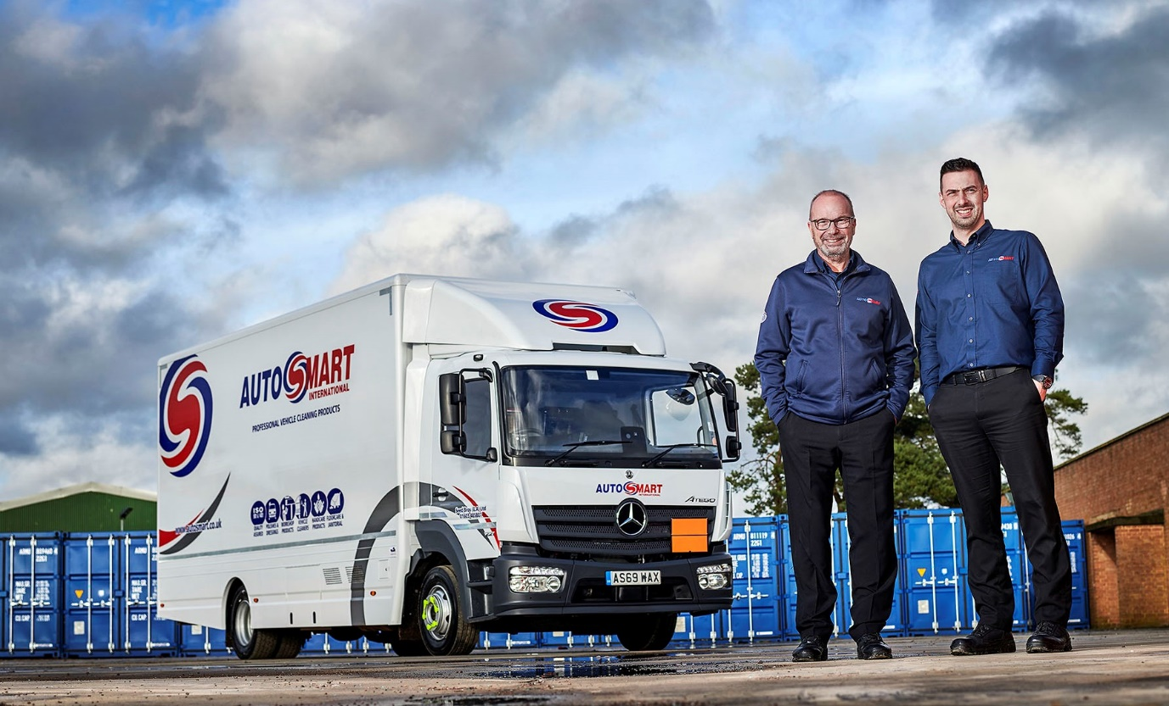

Moving forward with Mercedes-Benz: Managing Director Andrew Seed, left, and Jason Balme, Sales Director, are pictured with Seed Brothers’ latest Atego

Seed grows its Mercedes-Benz fleet with low-height 12-tonne Atego

Long-serving Autosmart franchisee Seed Brothers has taken another step on the road to becoming an all-Mercedes-Benz truck operator by commissioning a new mobile showroom.

Family-owned Seed Brothers has represented the UK and Ireland’s leading manufacturer and distributor of professional vehicle and food processing cleaning products for more than 35 years.

It relies on a fleet of six trucks to cover Norfolk, Suffolk and eastern Cambridgeshire. The arrival of its latest 12-tonne Atego means that all but one of these vehicles wear three-pointed stars.

Acquired with funding support from Mercedes-Benz Finance, the new Atego 1223 LnR is now serving customers in north and east Norfolk, including Norwich and Great Yarmouth. The truck has a ClassicSpace S-cab and low-height frame with air-suspended rear axle. Its 5.1-litre in-line six-cylinder engine produces 170 kW (231 hp) and is paired with a smooth, fuel-efficient Mercedes PowerShift 3 automated transmission.

Seed Brothers’ mobile showrooms are built by Drumack Coachworks, of Ballymena, and smartly racked out and fitted with various tanks. They carry a comprehensive range of Autosmart’s vehicle, janitorial and workshop cleaning products, as well as a variety of accessories. ADR vehicle specifications and driver qualifications reflect the fact that the trucks carry hazardous substances such as traffic film remover (TFR).

Managing Director Andrew Seed, whose father Keith and uncle Bill established the business with a single Bedford truck in 1984, explained: “Our wide customer base includes specialist valeters and detailers, car and van retailers, bus and coach operators, rental companies, hauliers, plant hire and construction firms, and farmers.

“We visit our customers regularly, and work with them to ensure we provide the right solutions for their cleaning requirements. There’s an Autosmart product for every application, and expert service and advice from our professional sales team is guaranteed.”

Seed Brothers bought its first Mercedes-Benz truck, a 7.5-tonne Atego, more than 15 years ago. Since then it has also purchased 10-tonne variants. “These days, though, given the breadth of the Autosmart range, we’ve settled on 12 tonners as being ideally sized for our operation,” said Mr Seed.

He continued: “Our vehicles are highly bespoke so we can’t simply hire a replacement if one’s off the road – a breakdown effectively means that we’re unable to work. For this reason, reliability is the single most important attribute we look for in a vehicle.”

The Mercedes-Benz Atego range extends from 7.5-16 tonnes GVW and is purpose-designed for light- and medium-duty distribution applications. It offers outstanding dynamics, comfort and manoeuvrability, as well as the durability necessary for intensive, multi-drop delivery work.

“We’ve tried other truck brands in the past, but Mercedes-Benz is clearly the best,” continued Mr Seed. “Only on very rare occasions have we had any issues with one of its vehicles, and when they have occurred Orwell Truck & Van has invariably set us back on the road again very quickly.”
Like its stablemates, the new Atego is the subject of a Mercedes-Benz Complete ServiceContract. Most inspections and maintenance take place at the Dealer’s recently refurbished Norwich branch. “We enjoy an excellent relationship with Orwell Truck & Van’s workshop team,” said Mr Seed, “while the service contracts are very cost-effective and allow us to budget with confidence.”

He added: “The Atego’s low-height chassis helps when accessing the showroom while the truck is also comfortable and easy to drive, so very popular with colleagues who are, first and foremost, sales specialists.”

autosmart.co.uk/distributors/east-anglia/

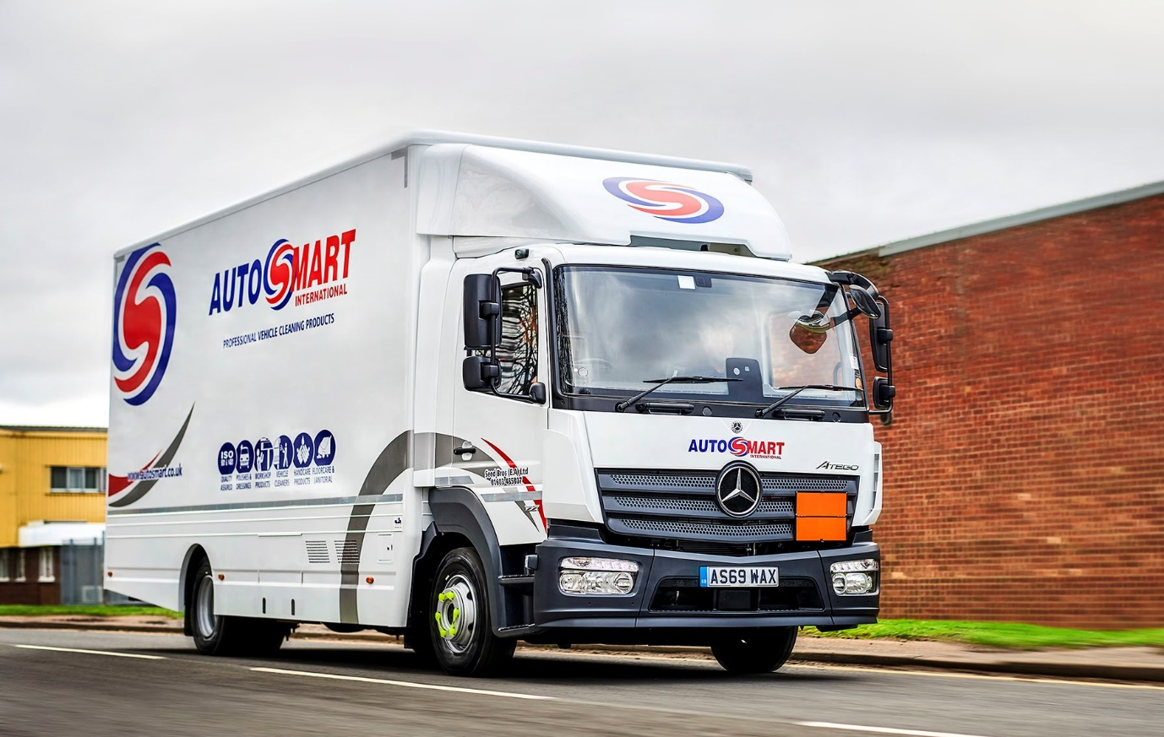

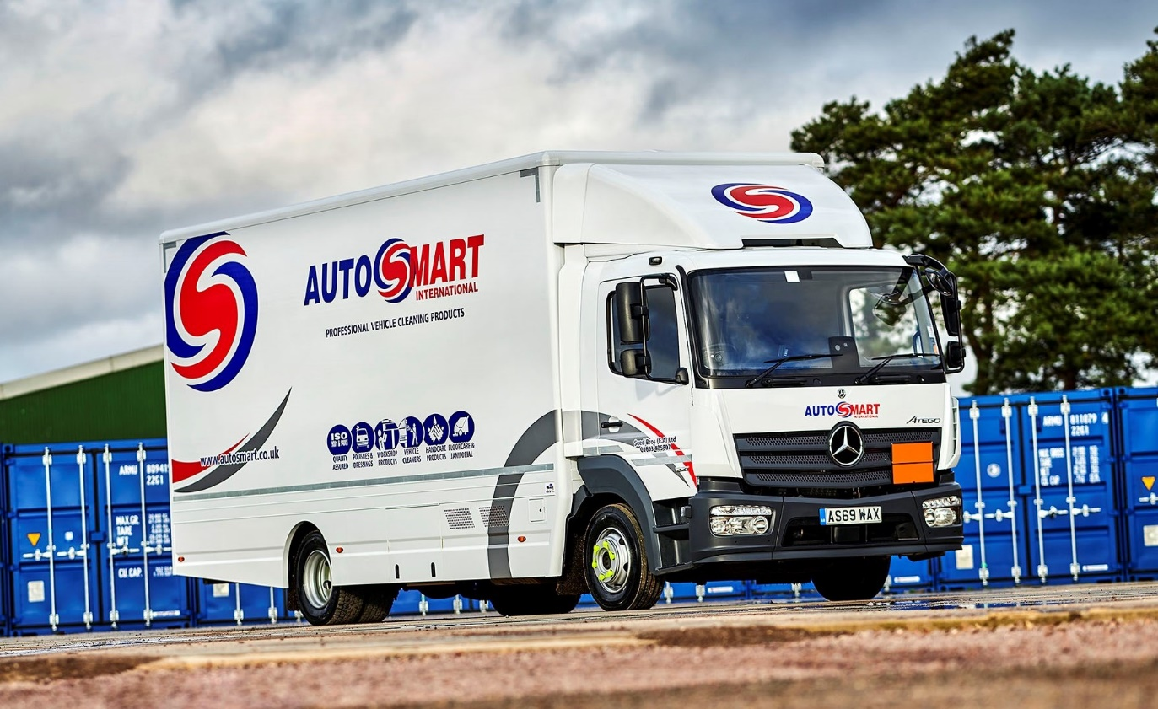

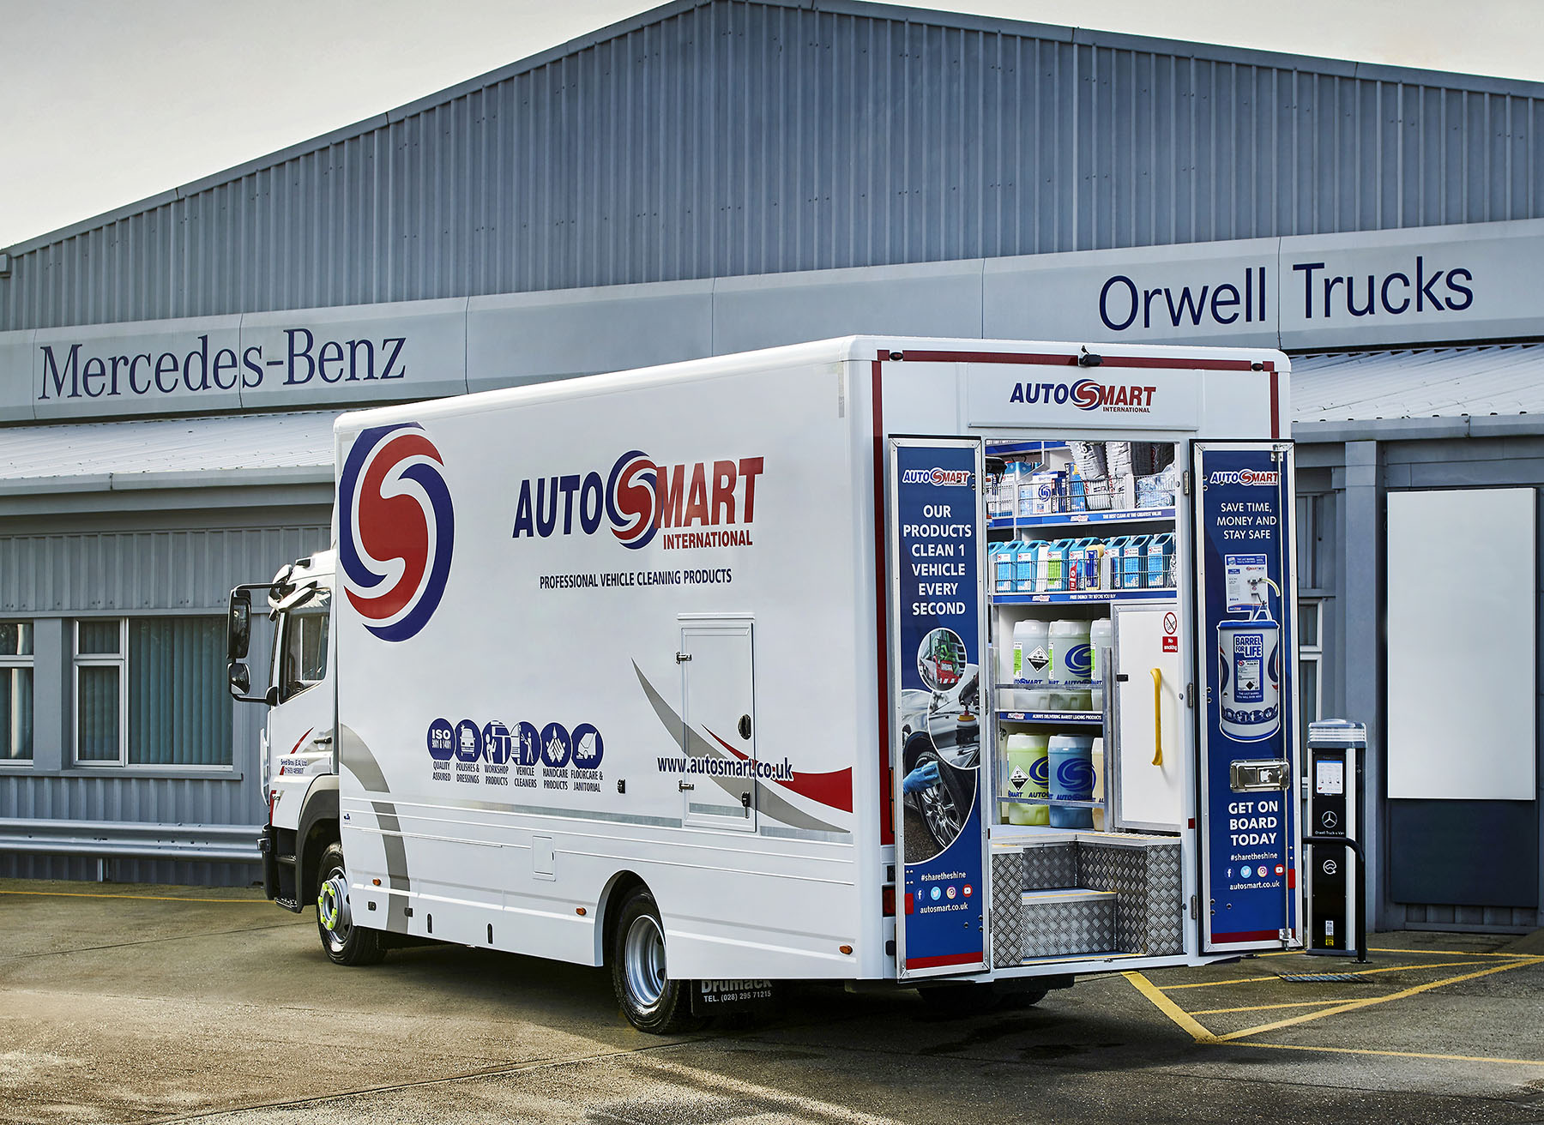

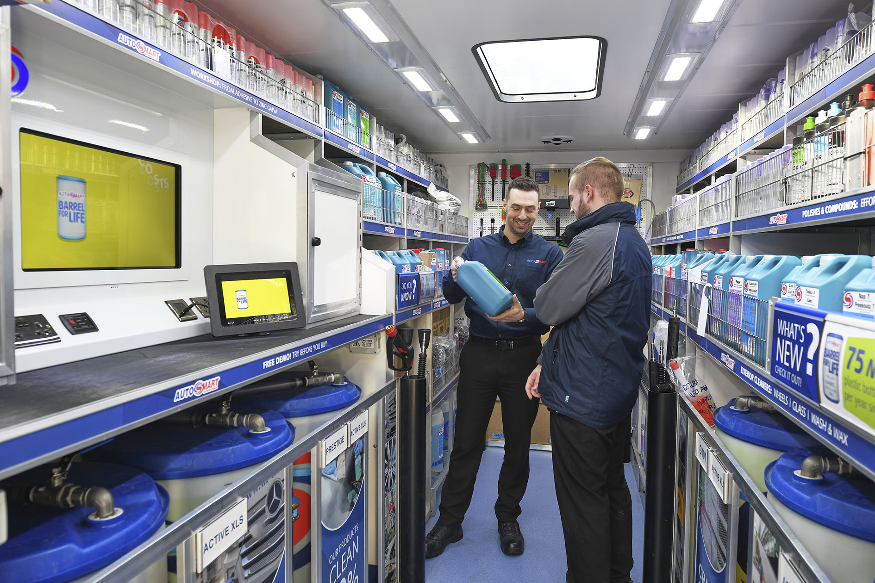

ends

For more information, or to request bigger/higher-res image files, please contact:
Steve Warren or John Ripley
Impact Communications, 01926 842126
John: 07771 484595, john@impactcom.co.uk
Steve: 07770 470251, steve@impactcom.co.uk

