

Date: 7 April 2021

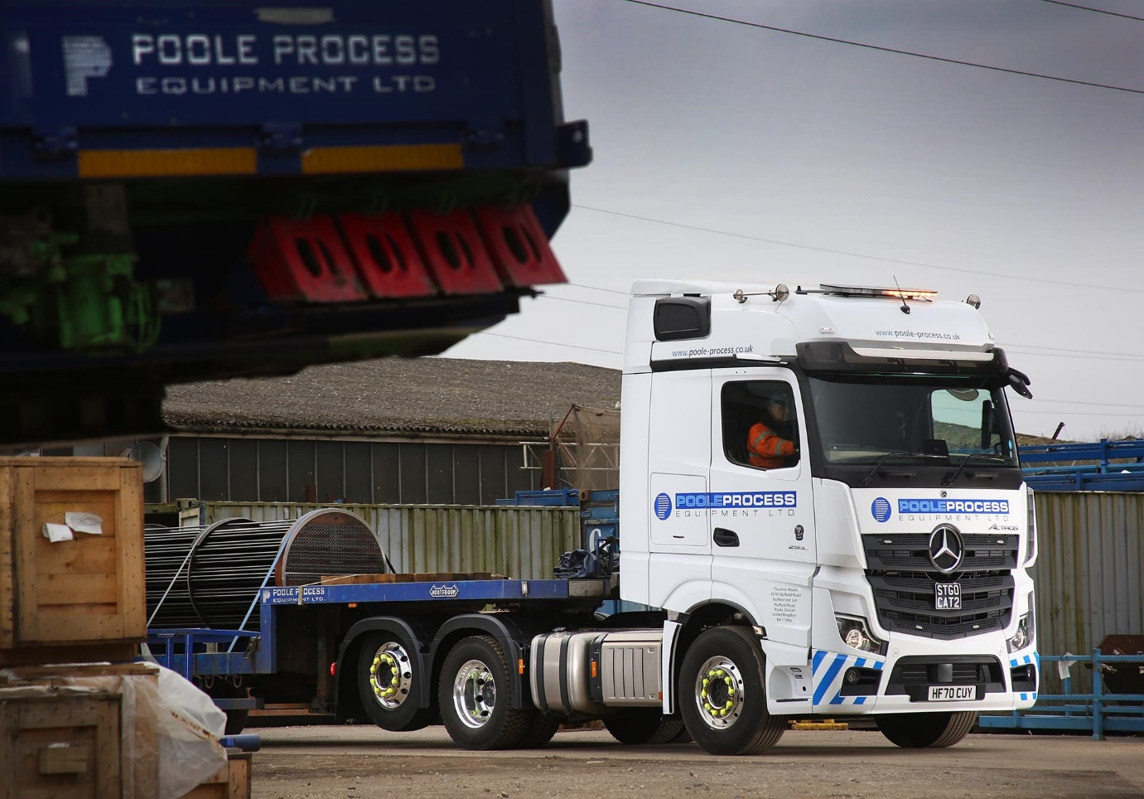

ASL makes a Mercedes-Benz Actros ‘tag match’ for its leading heat exchanger and pressure vessel business

A Teesside-based group that provides highly specialised services to the oil, gas and petrochemical industries has made its latest investment in Mercedes-Benz truck technology – the 65-tonne, tag-axled Actros tractor unit is now in service with Poole Process Equipment.

Over the last 12 months the privately-owned ASL Group has developed a successful partnership with Bell Truck and Van, which represents Mercedes-Benz in the North-East. In addition to its core interests the ASL Group portfolio includes two transport operations, Hoggart Haulage and SM Haulage – within the last year the Dealer has also supplied these with eight Actros tractors, which were delivered in two batches of four.

Located in the Dorset seaside town from which it took its name, ASL’s Poole Process Equipment business is a global leader in the design, manufacture and renovation of heat exchangers and pressure vessels.

These are now being transported to customers nationwide by its new Actros, a 2551 BigSpace model, which is being inspected and maintained by ETS Truck & Van, of Blandford Forum, a recent addition to Mercedes-Benz Trucks’ expanding roll call of Authorised Repairers.

The truck employs a 12.8-litre in-line six-cylinder engine producing 375 kW (510 hp) and works with either a three-axle extendable step-frame semi-trailer, or a twin-axled, rear-steer lowloader – the reduced turning circle offered by its lifting back axle is a useful attribute when manoeuvring on sites with restricted access.

ASL Group Operations Manager Darren Hutchinson said: “We have to get into some very tight spaces when we’re delivering. The lowloader also has a tag axle, so by lifting that as well as the back axle on the tractor we can spin the whole outfit very effectively. The Actros has definitely increased our capability at Poole.”

The ASL Group is co-owned by CEO Peter Johnson, Ron Heward and Richard Walton. Its other businesses include ASL Powerstream, which offers cleaning, cutting and demolition services using high and ultra-high pressure water jetting methods.

The Group’s headquarters are on the ex-ICI Wilton International development near Redcar, which is also home to its two transport operations. Acquired by ASL in the mid-1990s, Hoggart Haulage specialises in lorry loader crane work as well as general transport.

SM Haulage was purchased in 2015 as a single vehicle that serviced a P&O Ferrymasters distribution contract. It continues to serve the same key customer but today, with Ron Heward’s son Adam at the helm as General Manager, runs more than 20 trucks and has just opened its third depot, in Hull.

Hoggart Haulage and SM Haulage placed their first orders for Mercedes-Benz trucks after trialling demonstration units supplied by Bell Truck and Van. These proved significantly more fuel-efficient than vehicles already in service, while driver feedback was also positive.

The subject of Mercedes-Benz Finance contract hire agreements, the trucks commissioned last year are Actros 2548 variants. Like the new tag-axled unit they have flat-floored BigSpace cabs and 12.8-litre ‘straight sixes’, but with outputs of 350 kW (476 hp).

The Mercedes-Benz trucks now in service with ASL Group businesses – including a couple sourced from another Dealer for work on a specific contract – are equipped with high-tech features such as MirrorCam, the camera-based alternative to conventional mirrors that offers greatly improved visibility, and the optionally upgraded interactive version of the twin-screen Multimedia Cockpit. Specifications also include alloy wheels and fridges.

Adam Heward reported: “Our first eight Actros are returning an average of 10.2 mpg, whereas we’re lucky if we get 8 or 9 mpg from other trucks that are doing the same work. The drivers are happy, we’ve had no significant issues with reliability, and when they’re all clean and lined-up our Actros look fantastic; it has to be one of the tidiest trucks on the road.

“The Mercedes-Benz technology is excellent. MirrorCam is clearly a step forward in terms of safety, while with the upgraded Multimedia Cockpit, interactive the trucks have Android Auto and Apple Carplay built in.”

In addition to the Actros it has contract-hired, SM Haulage runs others supplied on a ‘spot’ rental basis by Bell Truck and Van. “These are still early days but we certainly like what we’ve seen of the Dealer so far,” continued Adam Heward. “The service has been very good; its Sales Executive Craig Graham is a great guy and has done a cracking job for us.”

Recalling the decision to place their first order with Bell Truck and Van, Peter Johnson commented: “We liked the sound of the Mercedes-Benz, and we liked what the Dealer was offering us. The three-pointed star was the clincher, though – not only does it convey a positive image of quality, but it also helps with recruitment. Unlike some of its competitors, the Actros is a truck that professionals aspire to drive.”

And ASL Group Transport Manager Ian Sykes added: “As a recent addition to the team I am more than happy with the performance and reliability of the Mercedes-Benz vehicles in our fleet. Having such confidence makes the transport department a very happy place in which to work.”

asl.business

poole-process.co.uk

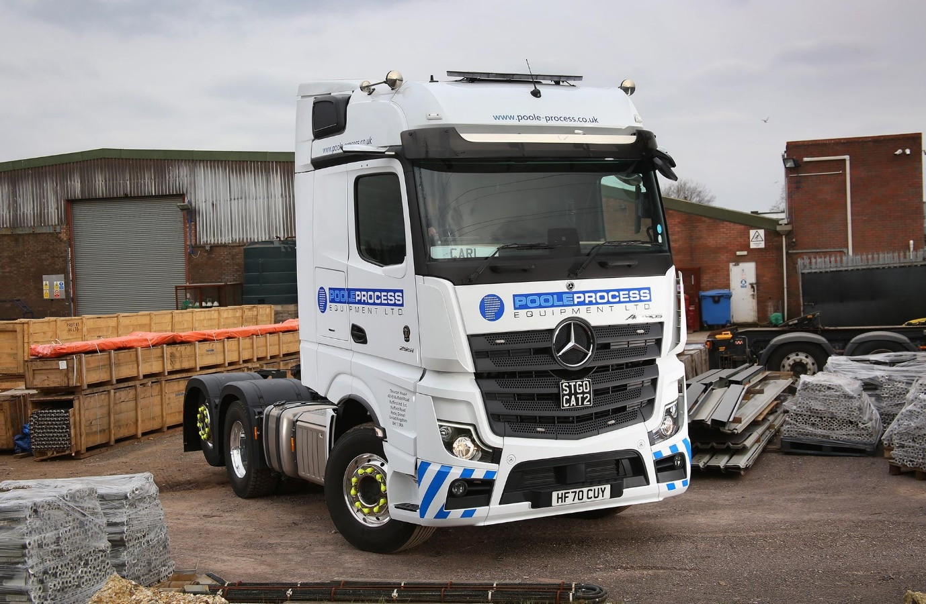

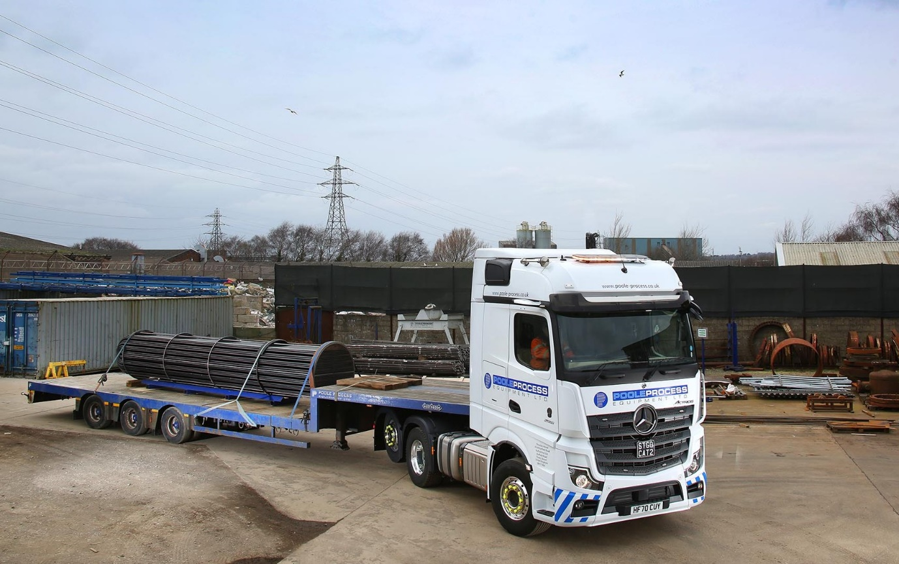

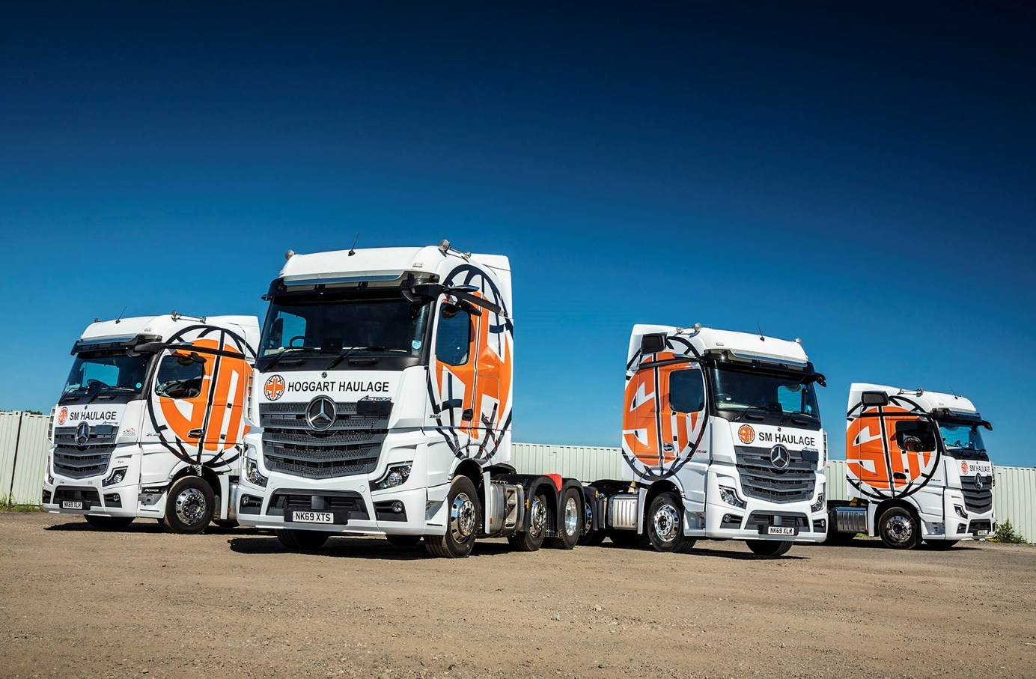

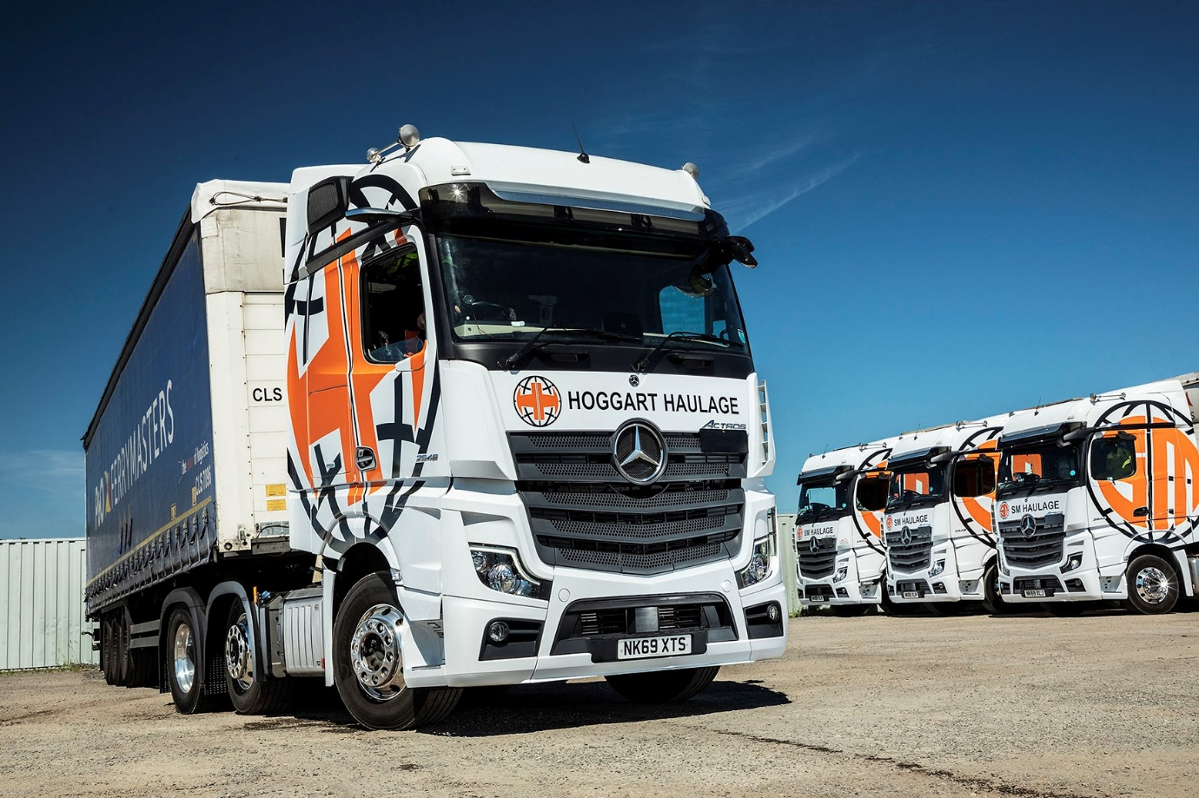

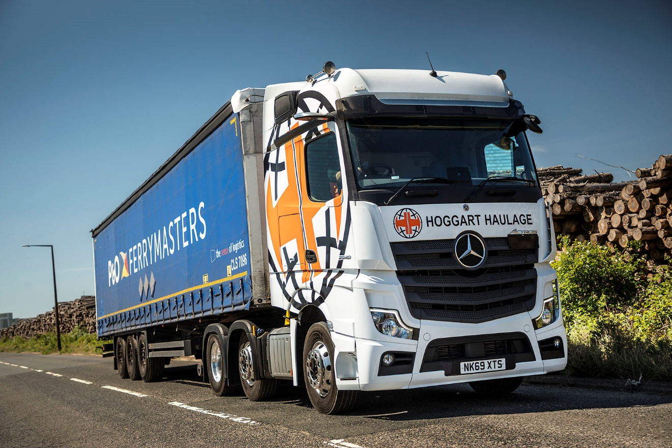

ends

For more information, or to request bigger versions of image files, please contact:
Steve Warren or John Ripley
Impact Communications, 01926 842126
Steve: 07770 470251, steve@impactcom.co.uk
John: 07771 484595, john@impactcom.co.uk

