

Date: 6 November 2019

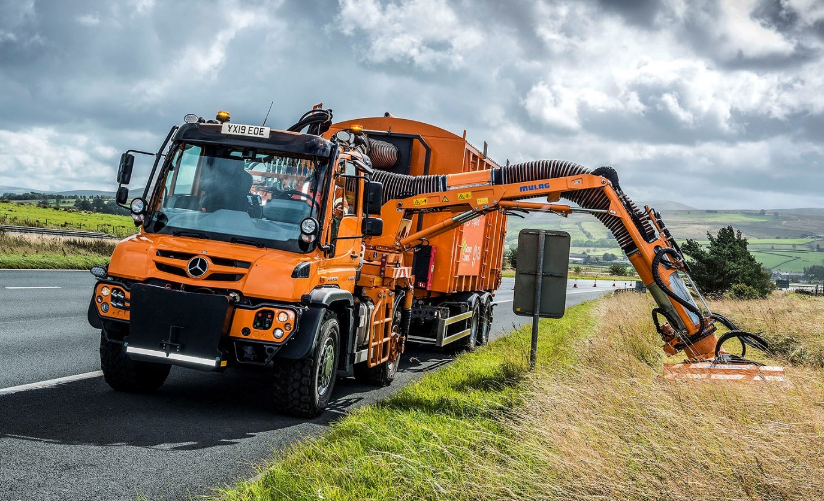

GVA Trees makes a bee-line for another
Mercedes-Benz Unimog

A Mercedes-Benz Unimog is creating a buzz at Yorkshire-based GVA Trees – the company is using its latest workhorse to support the management of habitats for declining wild bee populations.

The 4x4 truck is working on various contracts which entail maintaining grass verges along roads throughout the north of England, including the M6 motorway between Preston and Carlisle.

It was deployed during the summer on operations to help establish and look after ‘corridors’ of wildflowers across Cumbria, which encourage bees, butterflies and other pollinating insects to flourish.

The ‘Get Cumbria Buzzing’ project is the brainchild of Cumbria Wildlife Trust, which co-operates with Highways England to create verges resplendent with flower species carefully chosen to offer food and shelter to insects. GVA works on the scheme for main contractor Ground Control, one of the UK’s leading landscaping and external solutions providers – the Unimog plays its part by cutting and collecting grass, then scarifying the ground ready for planting with wildflower seeds.

Supplied by Dealer South Cave Tractors, the U530 model is powered by a 7.7-litre six-cylinder engine which produces 220 kW (299 hp) and 1,200 Nm of torque. Its fully synchronised, electro-pneumatic transmission has eight forward and six reverse gears – the optional working gear range provides another eight forward and eight reverse gears.

Permanent all-wheel drive, impressive ground clearance, and uprated portal axles which have differential locks and offer extreme levels of articulation, all contribute to the truck’s unrivalled cross-country capability.

GVA also specified the optional Central Tyre Inflation (CTI) system. This unique technology enables the driver quickly and easily, and without leaving the cab, to lower tyre pressures, and has the additional benefit of minimising damage to particularly soft ground.

Another option box ticked was for VarioPilot, which allows the driver to slide the steering wheel and instrument binnacle over to the left side of the cab in just a few minutes – ideal for mowing and similar tasks, which are easier and safer when the driver has a better view of the verge – and then back to the right, for normal road driving.

The trucks works with an engine PTO-powered Mulag mower arm, and a Harsh hookloader trailer with grass collection box, into which the mower’s suction system deposits grass cuttings as it goes.

GVA Trees operates from headquarters in Halifax. The U530 has replaced the company’s previous Unimog on a fleet that includes three other Mercedes-Benz vehicles, an 8x4 Arocs 3240 hookloader and a pair of Vito vans.

Managing Director Ian Whitaker said the Unimog’s unique combination of attributes made it the obvious choice for the job. “When you look at what we need this vehicle to do, there’s nothing else out there with the same range of abilities,” he explained.

“Attaching and powering the mower equipment is no problem, while the truck can easily tow a heavily laden trailer thanks to its gross train weight of 36 tonnes. Working along the verge is made easier by the Unimog’s VarioPilot system, which gives the driver a much better view of the verge and the mower arm. It certainly makes his life easier.

“The Unimog’s cruising speed of 56 mph means it can cover big distances between our base and working sites much quicker and easier than any agricultural tractor – it’s far more fuel-efficient too. The hydrostatic drive system, meanwhile, allows fine control of the truck and its attachments at mowing speed. No other vehicle could tick all of these boxes.”

GVA also took out an ExtendPlus warranty which provides full bumper-to-bumper cover for five years, or up to 450,000 km, whichever is reached first. “This is our flagship vehicle and while we expect it to be extremely reliable over a long, hard working life, the peace of mind offered by the warranty is worth every penny,” said Mr Whitaker.

“Unimogs are extremely complex pieces of kit and can be specified in many different ways,” he continued. “The team at South Cave Tractors provided fantastic support. They put in a great deal of time and effort to understand our requirements, and together we made sure we came up with the ideal package for our particular application.”

All Unimogs have 4x4 chassis with single rear wheels, while gross weights vary from 7.5 to 16.5 tonnes. There are two core variants: an implement carrier like GVA’s with front, side and rear attachment points, and an ultra-high mobility truck with extreme torsional flexibility, which can accommodate a range of bodies. Both are superbly adaptable to a huge variety of roles.

www.gva-trees.com

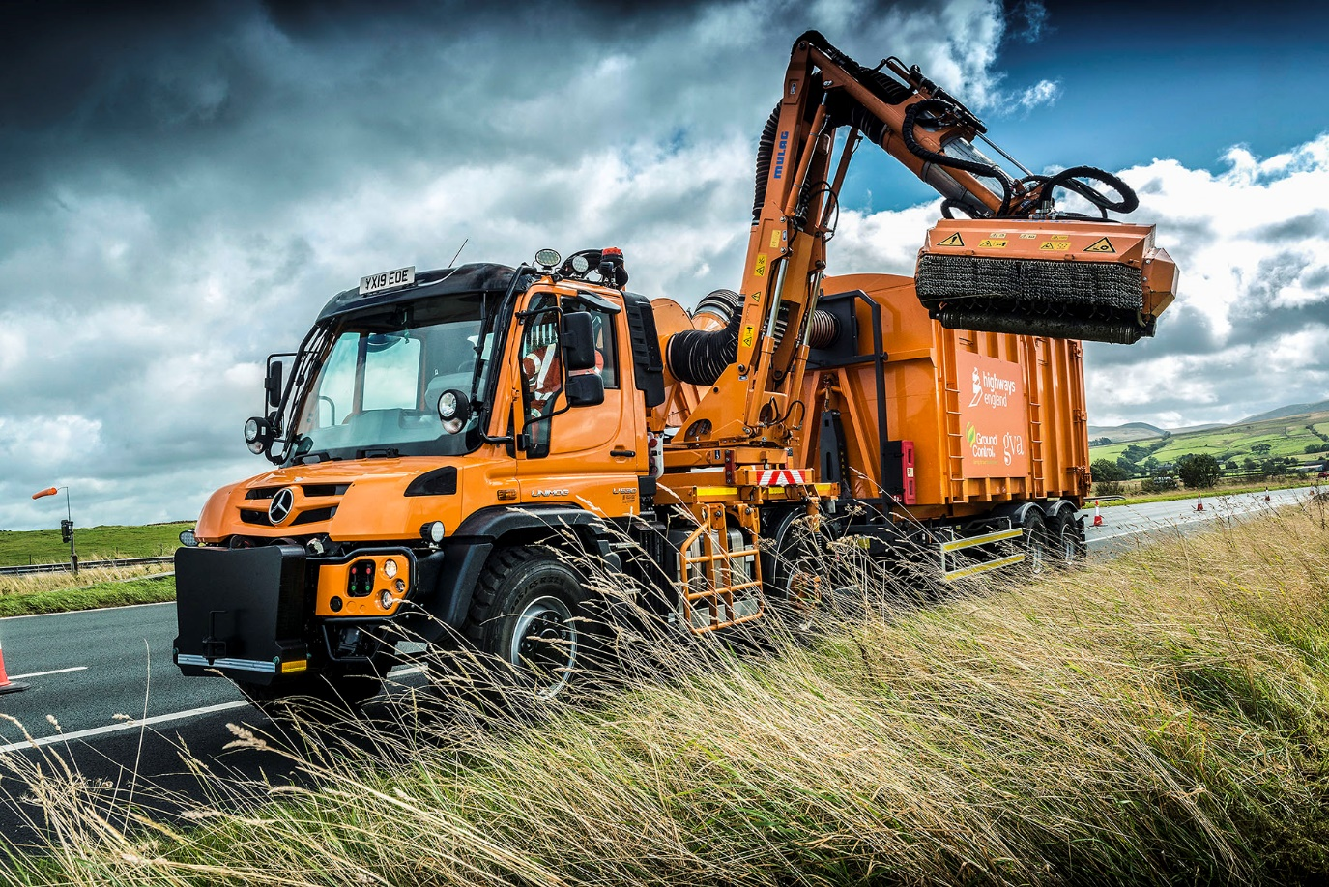

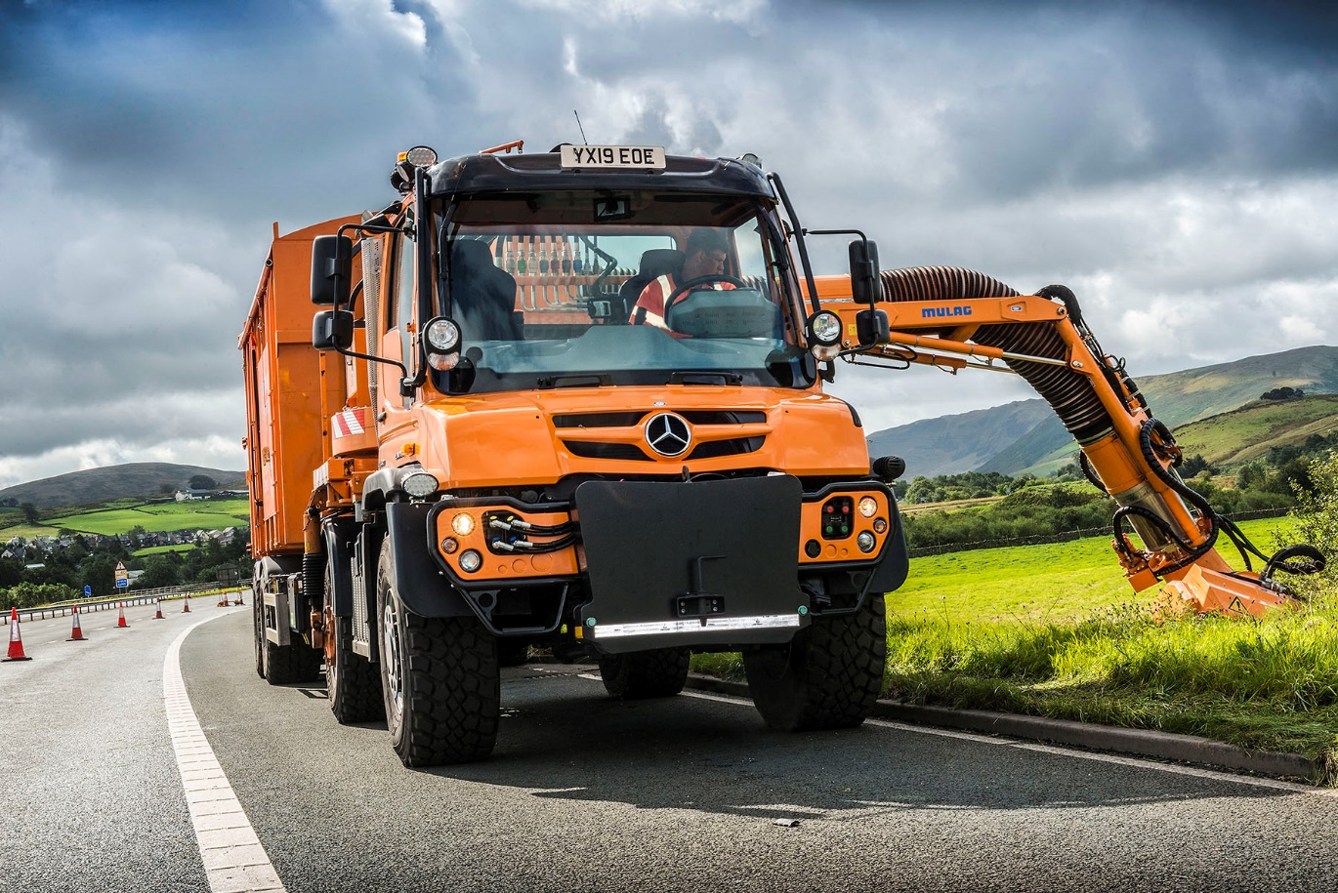

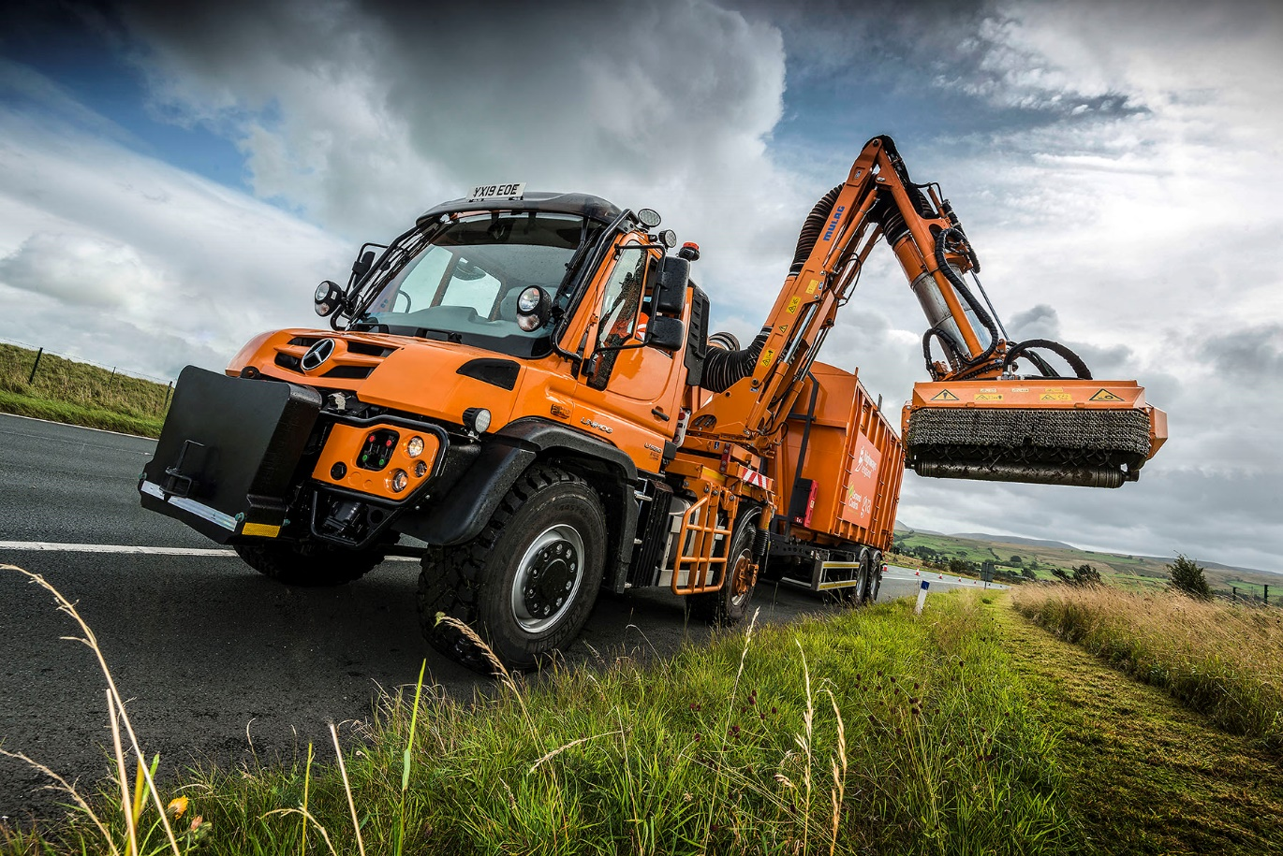

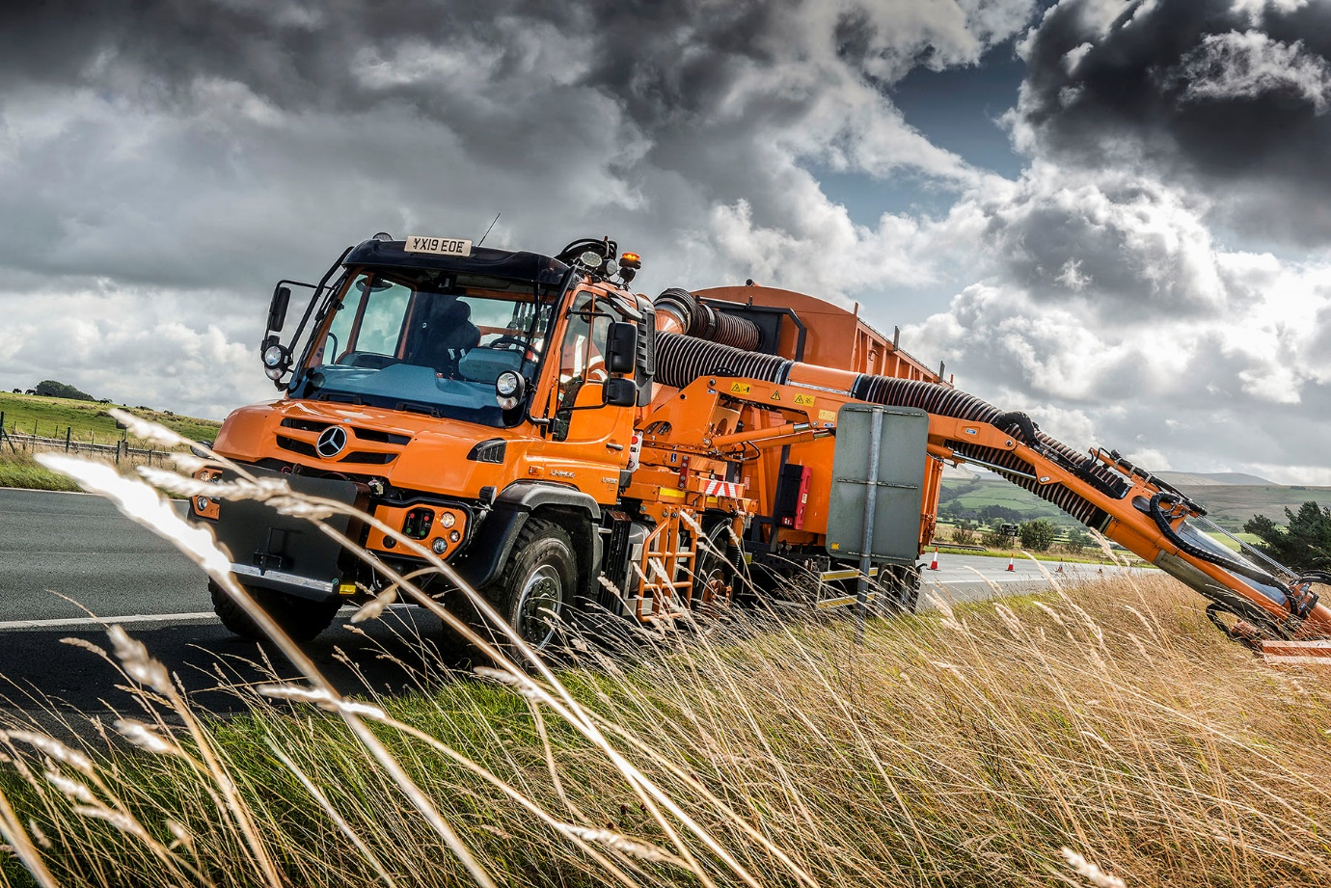

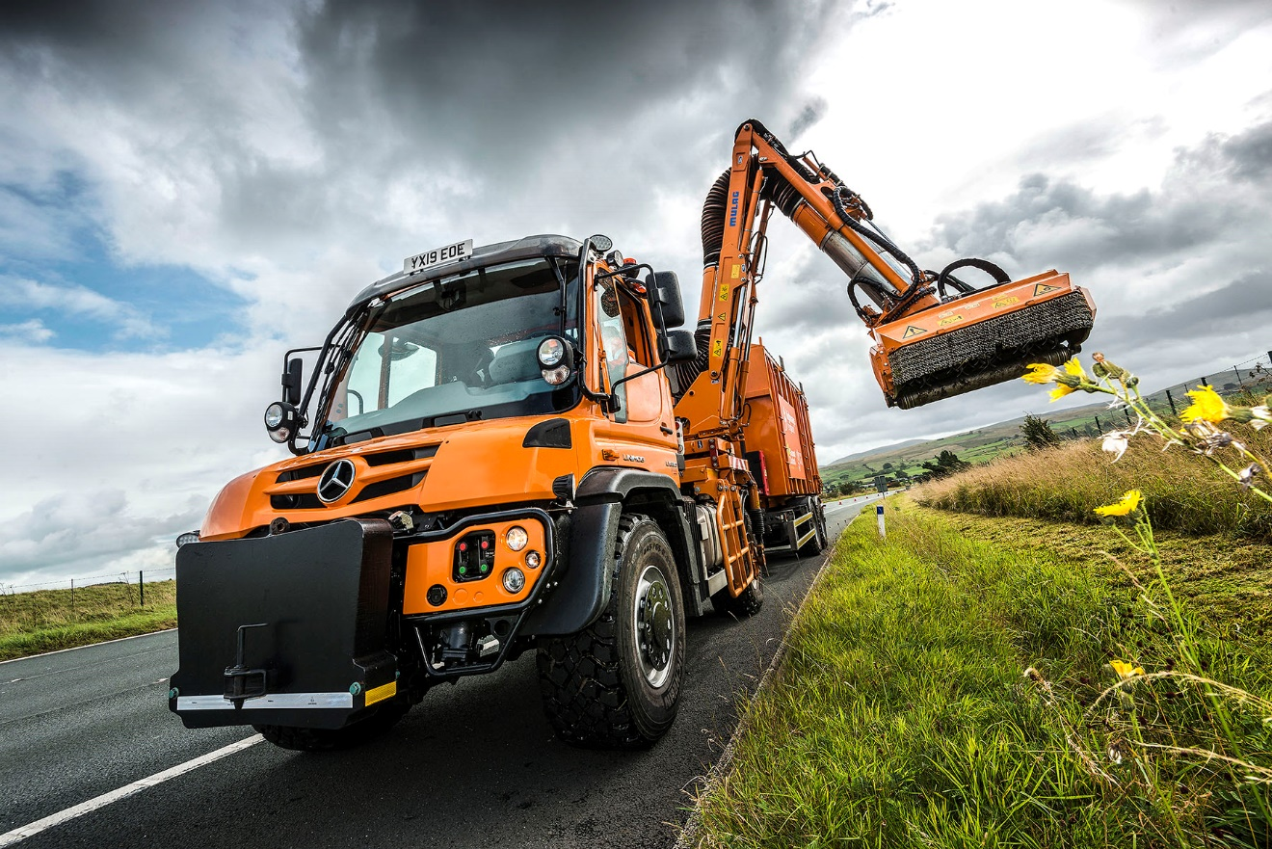

ends

For further information, please contact:
Steve Warren or John Ripley
Impact Communications, 01926 842126
Steve: 07770 470251, steve@impactcom.co.uk
John: 07771 484595, john@impactcom.co.uk



