

Date: 18 September 2019

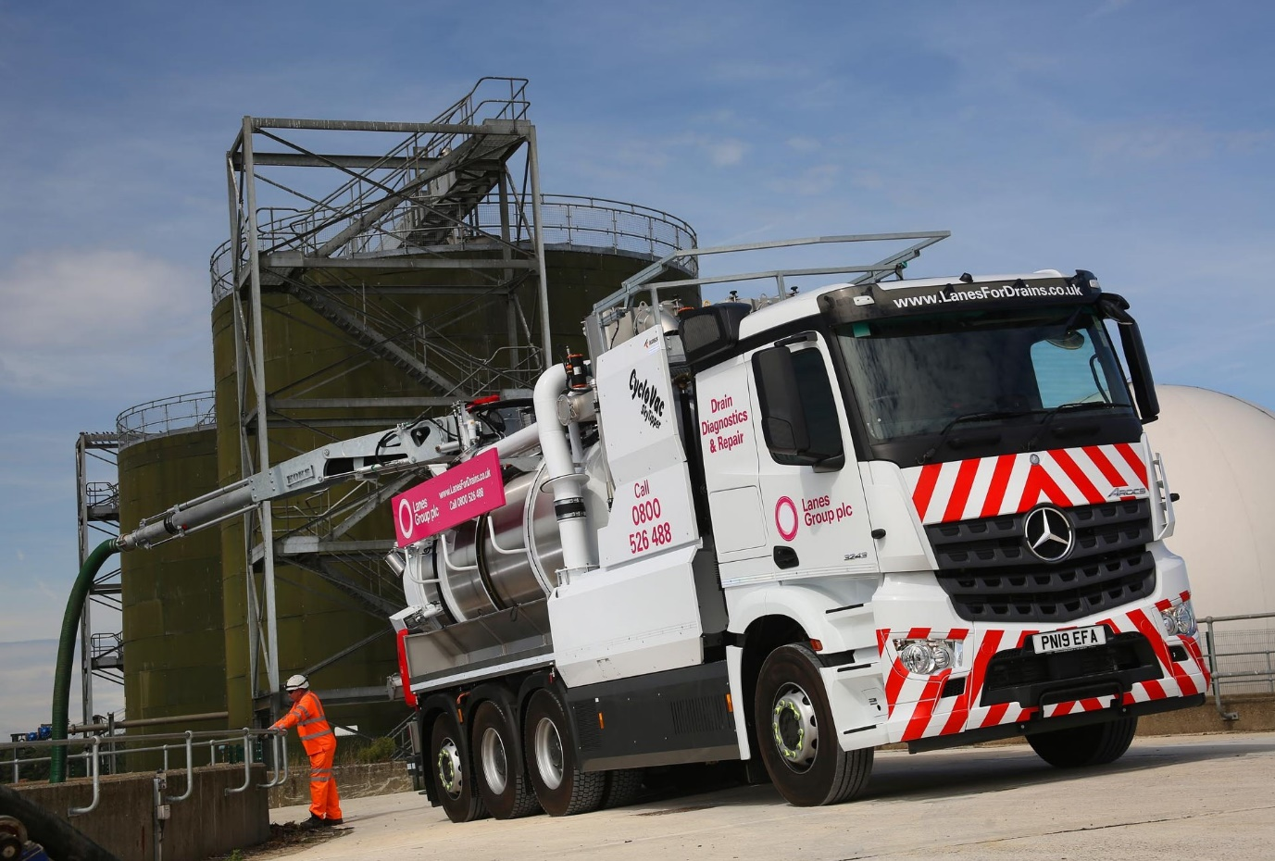

Manoeuvrable Mercedes-Benz Arocs vacuum tankers clean up for Lanes Group Plc

The latest, highly specialised additions to the fleet of wastewater utility solutions and drainage leader Lanes Group Plc are based on 32-tonne Mercedes-Benz chassis supplied and backed by Dealer Ciceley Commercials.

Both are 8x4 Arocs 3243 L ENA models, with single front steer axles, double-drive bogies and rear-steer axles. This configuration gives the ENA variant impressive manoeuvrability, thanks to a turning circle which is significantly tighter than that of a standard construction eight-wheeler.

Lanes Group operates from headquarters in Leeds and runs more than 1,000 trucks, approximately half of which are from Mercedes-Benz, across its various divisions. The fleet includes vacuum tankers in a variety of sizes, as well as specialised closed-circuit tv inspection, recycling and rehabilitation units.

The Arocs have narrow, 2.3 metre-wide ClassicSpace cabs and are powered by 10.7-litre in-line six-cylinder engines which produce 315 kW (428 hp) and drive through 16-speed Mercedes PowerShift 3 automated transmissions.

Dutch bodybuilder KOKS Industry fitted each with a Cyclovac vacuum cleaning unit, comprising a 12m³ stainless steel barrel, 8.100m³ per hour blower pump, and six-inch suction boom capable of collecting wet or dry material over a radius of at least 150 metres. It also features air compressors, a water tank and wash-down pump.

KOKS Industry’s system employs air cyclones with a patented self-cleaning mechanism, instead of a conventional ‘baghouse’. This is both light in weight – the finished vehicle tips the scales at 22 tonnes, leaving an impressive 10-tonne payload allowance – and fuel-efficient.

The trucks are specified to provide cleaning services for customers across a variety of industry sectors including power generation, steel, gas, petrochemicals, cement production and mining. One is now working from Lanes Group’s Manchester depot, while the other is in service with the operator’s Irish subsidiary AQS, in Tipperary.

Lanes Group Plc’s Group Transport Manager Simon Nicholls said: “The Arocs is an ideal base for these vehicles. It is purpose-built for construction-related applications, with a high ground clearance and rugged design. The 32-tonne chassis gives us the hefty body and payload allowance we need, and in ENA configuration also offers a high degree of mobility.

“The Arocs also comes with a comprehensive safety specification which includes the Active Brake Assist emergency braking system. As such it reflects perfectly our commitment to the most rigorous standards of safety and compliance.”

He continued: “Ciceley Commercials impressed from the beginning of this complex order process. Fleet Sales Executive Guy Beech answered all our questions and worked very closely with the KOKS team in The Netherlands, while Business Manager Steve Walker put together a very competitive Mercedes-Benz Finance funding package. Both provided exemplary customer service.

“Any truck is only as good as the back-up behind it, though. We’ve dealt with the team at Ciceley’s Bolton workshop for many years. They will be maintaining the Manchester-based vehicle under a Mercedes-Benz Complete Service Contract and we have full confidence in their ability once again to provide first-class support.”

Launched as Lanes for Drains in 1992 with just five members of staff, Lanes Group Plc now employs more than 2,200. The company is heavily committed to training and development, and is a serial winner of safety awards from the likes of Thames Water and the Royal Society for the Prevention of Accidents.

www.lanesgroup.com

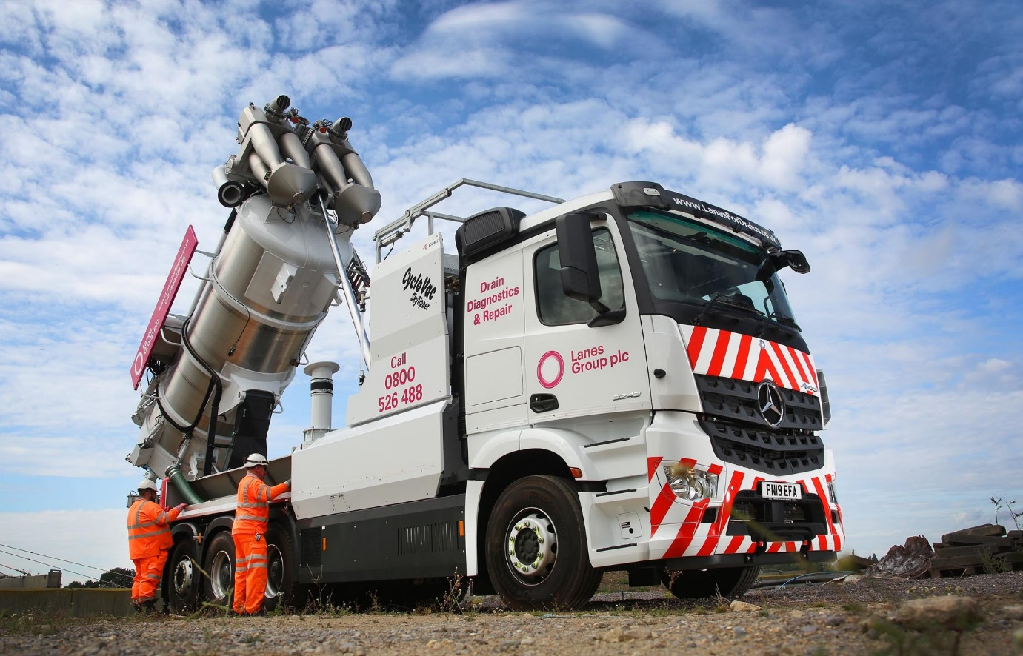

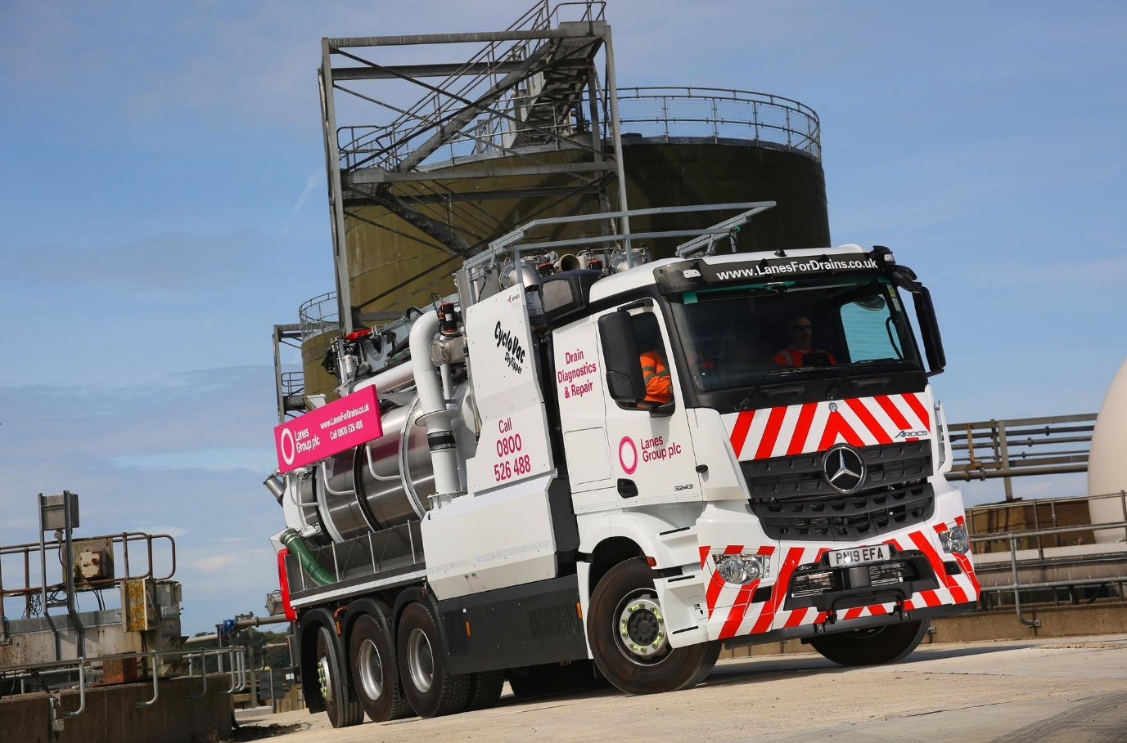
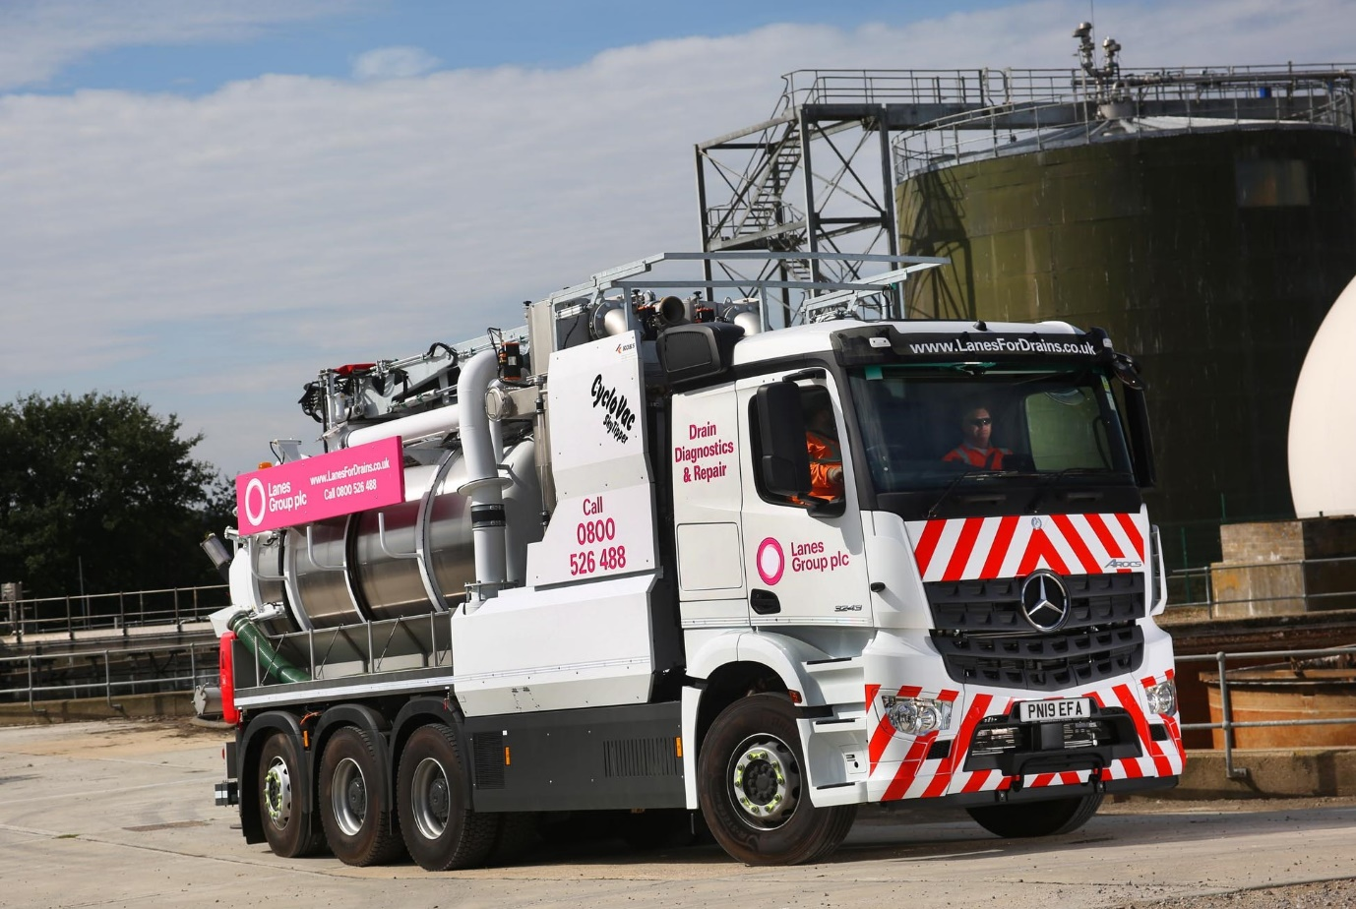

ends

For more information, or to request bigger/higher-res image files, please contact:
John Ripley or Steve Warren
Impact Communications, 01926 842126
John: 07771 484595, john@impactcom.co.uk
Steve: 07770 470251, steve@impactcom.co.uk

