

Date: 8 October 2019

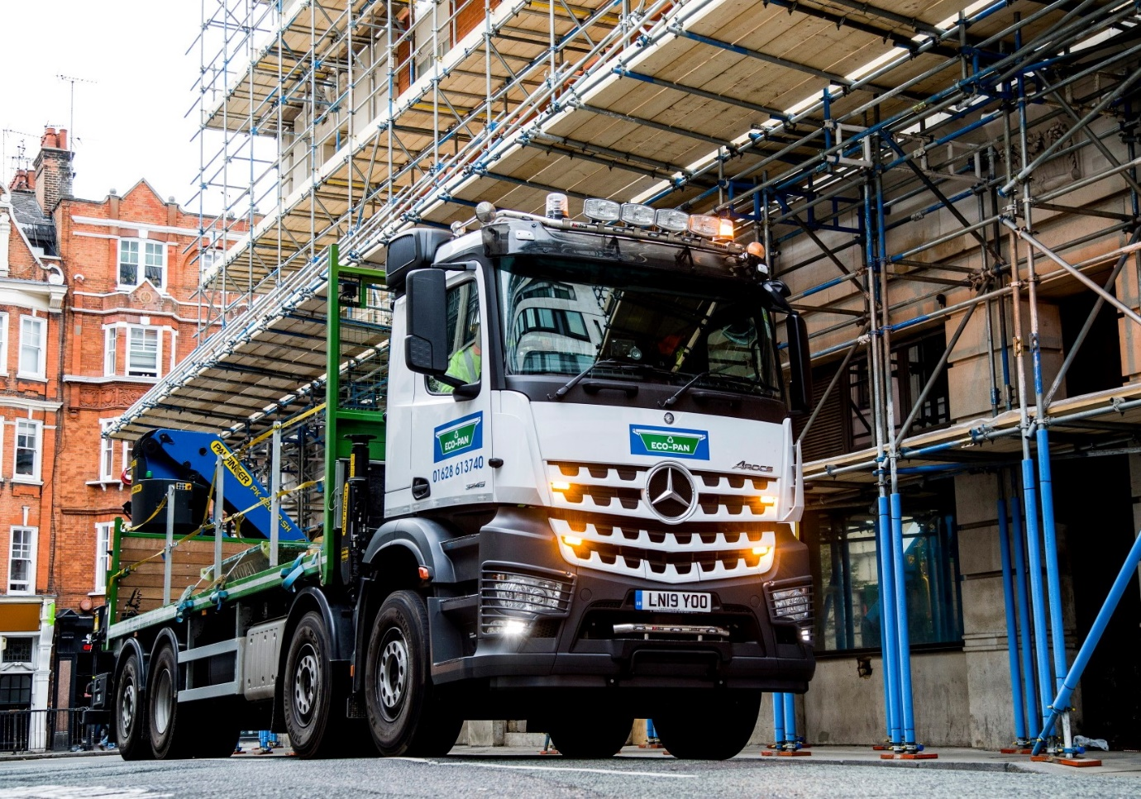

Eco-Pan’s Mercedes-Benz Arocs delivers a concrete solution for the environment

New start business Eco-Pan has drafted a Mercedes-Benz eight-wheeler into the front line of the battle to keep sewers flowing in the capital and beyond.

Headlines last spring highlighted the discovery of a 100-metre-long ‘concreteberg’, which was blocking three Victorian-era sewers in central London. The mass, which weighed an estimated 105 tonnes, was believed to have been created by a construction company pouring surplus cement down a drain – a range of cutting tools, including pneumatic hammer drills and high-pressure jets were needed to break it up.

Eco-Pan provides a cost-effective solution for concrete waste containment and disposal. Customers benefit from fast, reliable deliveries to site of purpose-designed washout pans in two sizes – 2.15m³ and 0.95m³. Once these pans have been filled with the residue from mixing and pumping operations, Eco-Pan collects them and deposits the waste at approved recycling centres.

Launched in May, Eco-Pan trades from headquarters in Epping, Essex, and an operating centre in Maidenhead, Berkshire. The company relied entirely on rented trucks initially, before turning to Mercedes-Benz Dealer S & B Commercials for the first vehicle it has owned outright.

The subject of a seven-year Mercedes-Benz Complete Service Contract, the 8x2/4 Arocs 3245 has a ClassicSpace M-cab and second-generation 330 kW (450 hp) 12.8-litre OM 471 in-line six-cylinder engine. Economy is enhanced by fuel-saving Predictive Powertrain Control technology.

The eight-wheeler is additionally fitted with axle load measuring equipment, and the enhanced manoeuvrability offered by its rear-steer axle is a particular asset when working in central London. S & B also arranged for Dartford-based Truck Align London to install an additional nearside window, improving low-down direct visibility for the driver in an area where cyclists and pedestrians are particularly vulnerable.

Palfinger UK, of Devizes, Wiltshire, built the truck’s 7.6-metre platform body, and supplied and installed the rear-mounted PK 42002 SH high-performance crane, which is capable of lifting a maximum of 14,600 kg, and up to 4,050 kg at a distance of 9.6 metres.

High-profile Mercedes-Benz operator Camfaud Concrete Pumps played a key role in bringing the Eco-Pan concept over to the UK from the United States, where it was introduced in 1999 and is now well established. Camfaud, which is also based in Epping, relies heavily on S & B Commercials to maintain its fleet of more than 50 truck-mounted concrete pumps – with a couple of exceptions, all wear three-pointed stars.

So successful has its new Arocs proved that Eco-Pan has already ordered a second, this from the new-generation range and featuring the ground-breaking MirrorCam system in place of conventional door mirrors, which is due to be delivered in March 2020. Powered by a 10.7-litre ‘straight-six’ producing 355 kW (455 hp) – the engine’s smaller capacity allows the operator to specify a lower cab for work in London – the next truck will also have a bigger crane and pull a drawbar trailer.

Eco-Pan Transport Manager Luke Van Spall explained: “We offer the UK’s first concrete washout service that allows contractors to outsource the risk, providing peace of mind for all their concrete recycling needs. The fact that it comes straight from the mixer and hasn’t been rendered or aged means the waste concrete still has a value, so it can be crushed down into ‘fines’ and used again.”

Although the two businesses operate independently, Eco-Pan is heavily engaged in supporting customers of Camfaud Concrete Pumps, which is promoting the new service. “Obviously we were guided towards S & B by the team at Camfaud,” recalled Mr Van Spall. “They provided glowing recommendations for the Dealer’s aftersales back-up, and for the quality and reliability of Mercedes-Benz vehicles.

“The Arocs is certainly living up to that billing. The chassis is a thing of real beauty, very muscular and purposeful in appearance, while the advanced technology it incorporates is fantastic. We’re particularly pleased with the steered single-wheeled axle at the back, which is a massive advantage when you’re trying to get in and out of tight spaces.”

The truck offers a 13.6-tonne payload and is capable of carrying up to five smaller pans each weighing 2.25 tonnes when filled with concrete residue, a couple of the larger ones which tip the scales at 5.0 tonnes apiece, or combinations of the two sizes. The pans are secured with straps.

Mr Van Spall added: “Our driver Szymon Sawczak came out of a rented truck and was like a child at Christmas when his Arocs arrived. He absolutely loves it.”

www.eco-pan.uk.ltd

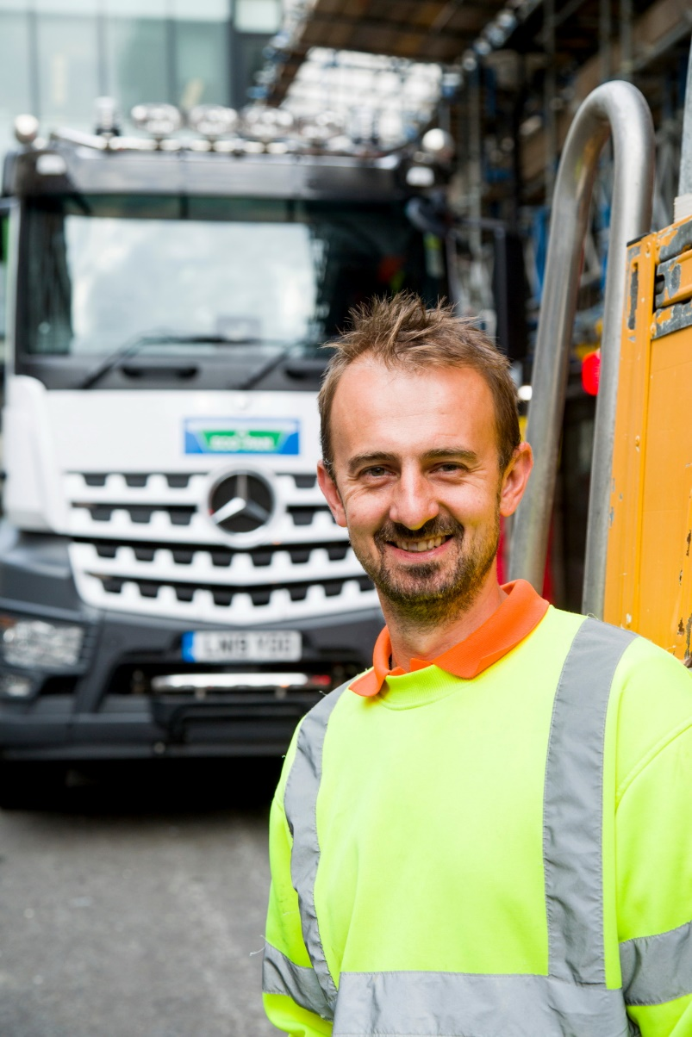

Upwardly mobile: Eco-Pan driver Szymon Sawczak is delighted with his Mercedes-Benz
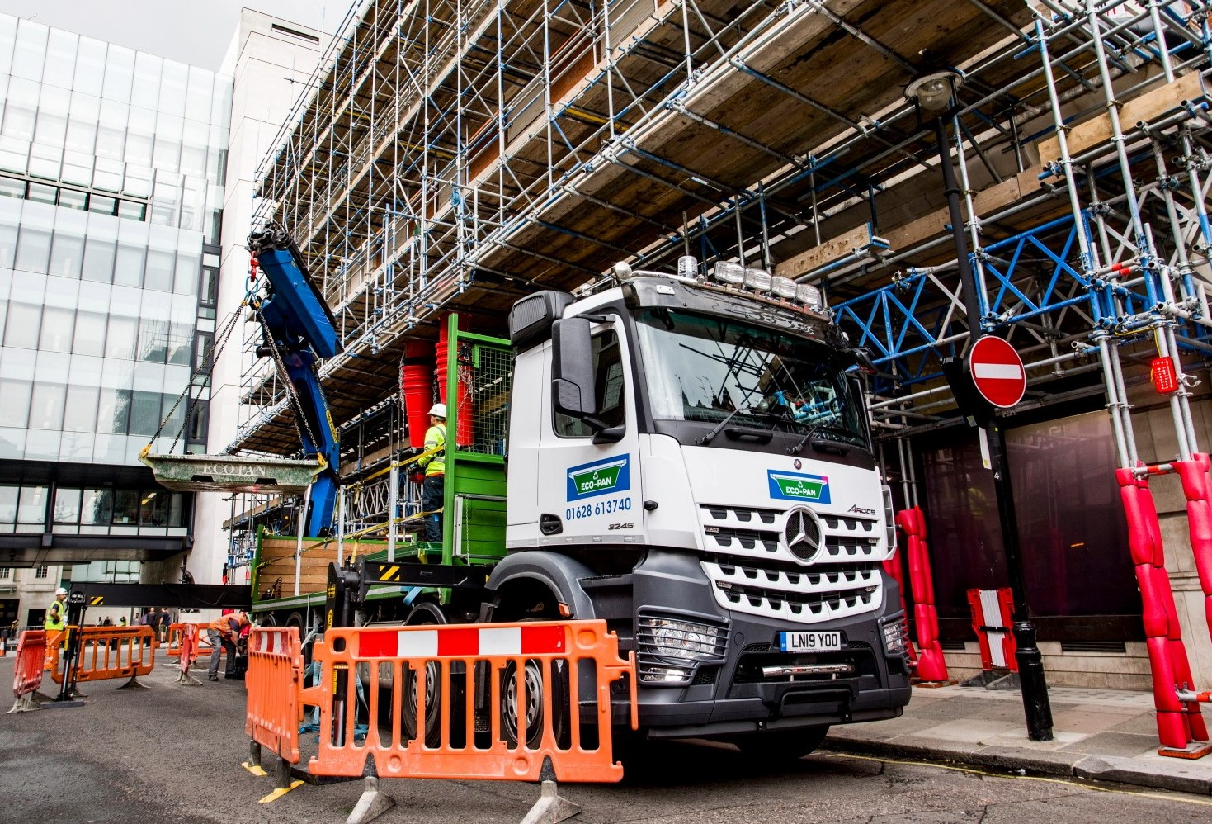

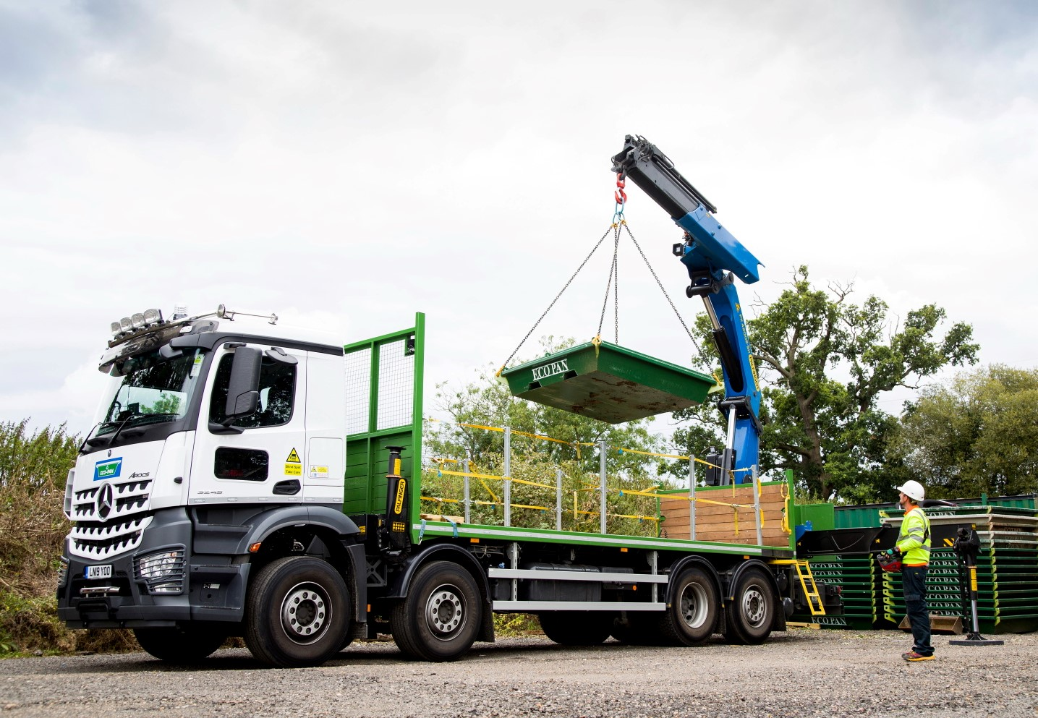

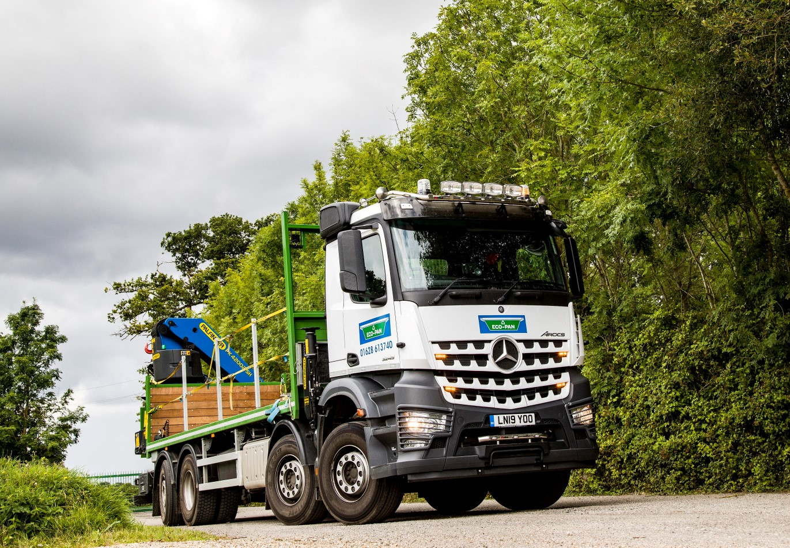

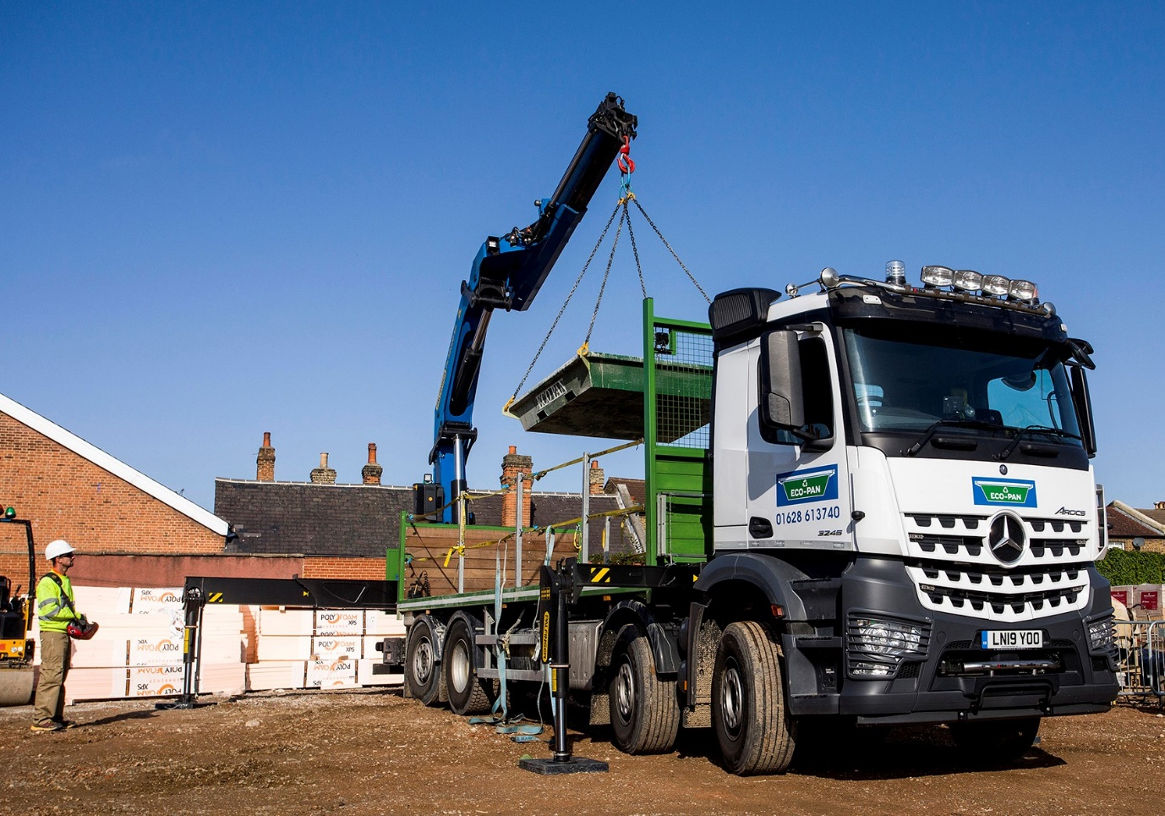

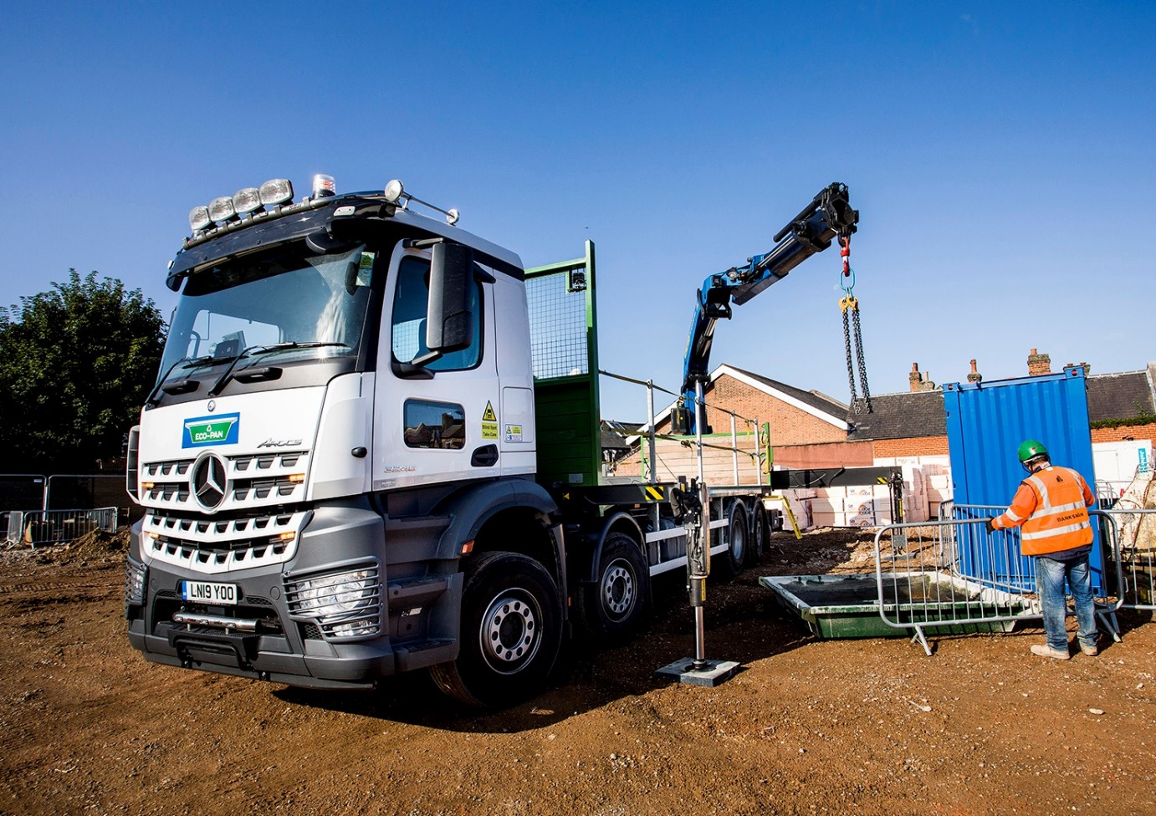

ends

For more information, or to request bigger/higher-res image files, please contact:
Steve Warren or John Ripley
Impact Communications, 01926 842126
Steve: 07770 470251, steve@impactcom.co.uk
John: 07771 484595, john@impactcom.co.uk

