

Date: 10 July 2023

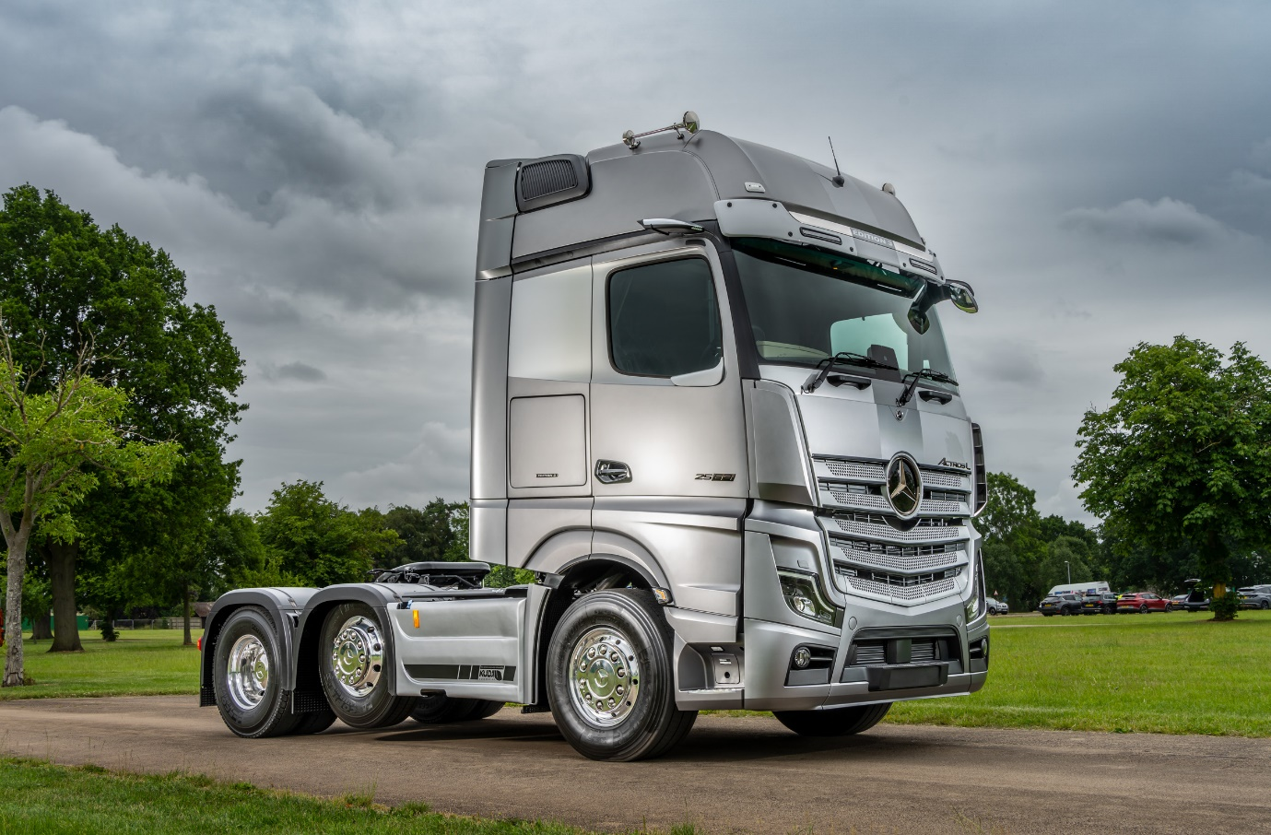

Mercedes-Benz Trucks reaches for the stars with exceptional Actros L Edition 3

UK truck drivers can dream of taking ‘3 steps to heaven’, thanks to the arrival of the latest stunning special edition from Mercedes-Benz.

The Actros L Edition 3 made its first UK appearance at the recent Road Transport Expo event, at Stoneleigh, Warwickshire – and instantly shot to the top of the wish-lists of many visitors who saw it on display.

Taking delivery of one of these exclusive vehicles will remain just a fantasy for all but a lucky few, though. Only 400 are being built world-wide, and of those it’s expected that no more than 20 UK-specification, right-hand drive models will make it to these shores.

The Actros L Edition 3 is quite simply one of the most luxurious trucks available. The exhaustive standard specification includes many items usually only available as optional extras, grouped together under the Driving, Comfort, Media and Stowage Packages. Highlights include:

- Cab exterior painted in exclusive White Aluminium Metallic, with unique stripe design fading to Metallic Steel Grey;

- Sun visor with special EDITION 3 lettering and twin auxiliary LED headlamps;

- Illuminated Mercedes-Benz star grille badge in dark chrome;

- A whole suite of EDITION 3 badges and additional stainless-steel trims.

The cab interior is, if anything, even more special. The Comfort suspended driver’s seat, steering wheel, door handles and instrument panel are all swathed in fine nappa leather with contrast stitching, while the PremiumComfort mattress ensures a restful night’s sleep. Other highlights include a slide-and-tilt glass sunroof, and extensive ambient LED lighting.

Safety and Sight Packages add further enhancements: Multimedia Cockpit, interactive, Proximity Control Assist and Roll Control Assist (for rigids) or Stability Control Assist (for artics), and LED headlights with cleaning system, automatic dipped/main beam and cornering function all feature.

Actros L Edition 3 will be available as a tractor unit or rigid chassis, with a choice of either BigSpace or GigaSpace cab. Engines range from 310 kW (421 hp) to the 15.6-litre, 460 kW (625 hp) range-topper, all of which drive through new and improved PowerShift Advanced automated transmissions. Most vehicles ordered are expected to be at the upper end of this power spectrum.

One lucky British operator, though, is in for an extra treat. Mercedes-Benz Trucks UK has teamed up with automotive enhancement specialist Kuda Automotive to add some more very special touches to a vehicle that will be sold on the home market.

This truck boasts a 21.5-inch LUXMOV flatscreen smart TV, an 800w TruckChef microwave oven, and three CabStore lockers giving an additional 500 litres of storage space. Across the chassis, a large TreadSafe platform provides a level and safe working area behind the cab, while special side-skirts for 6x2 models add improved aerodynamics and a smooth, smart appearance.

Mercedes-Benz Trucks UK Product Manager David Simm said: “The Road Transport Expo was a fantastic event for us, with a number of very significant product launches – including the debut of the Actros L Edition 3. This vehicle is a driver’s dream and, thanks to our collaboration with Kuda Automotive, one extra special unit is decked out with bespoke enhancements to suit UK requirements.”

Kuda Automotive Commercial Director Tim Vincent added: “We worked together very closely with Mercedes-Benz Trucks on this project, and we’re delighted with the results. The features we’ve added, such as the CabStore lockers and LUXMOV TV, are very much focused on the UK market.”

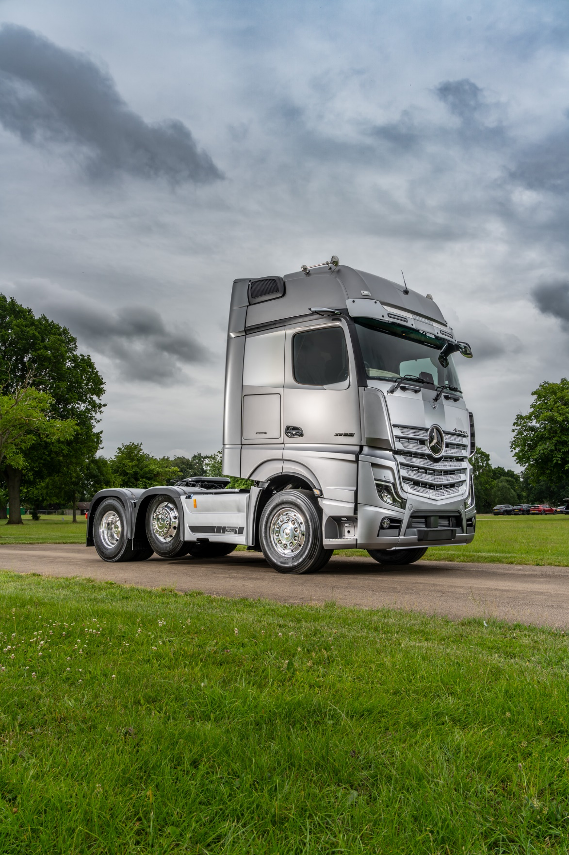

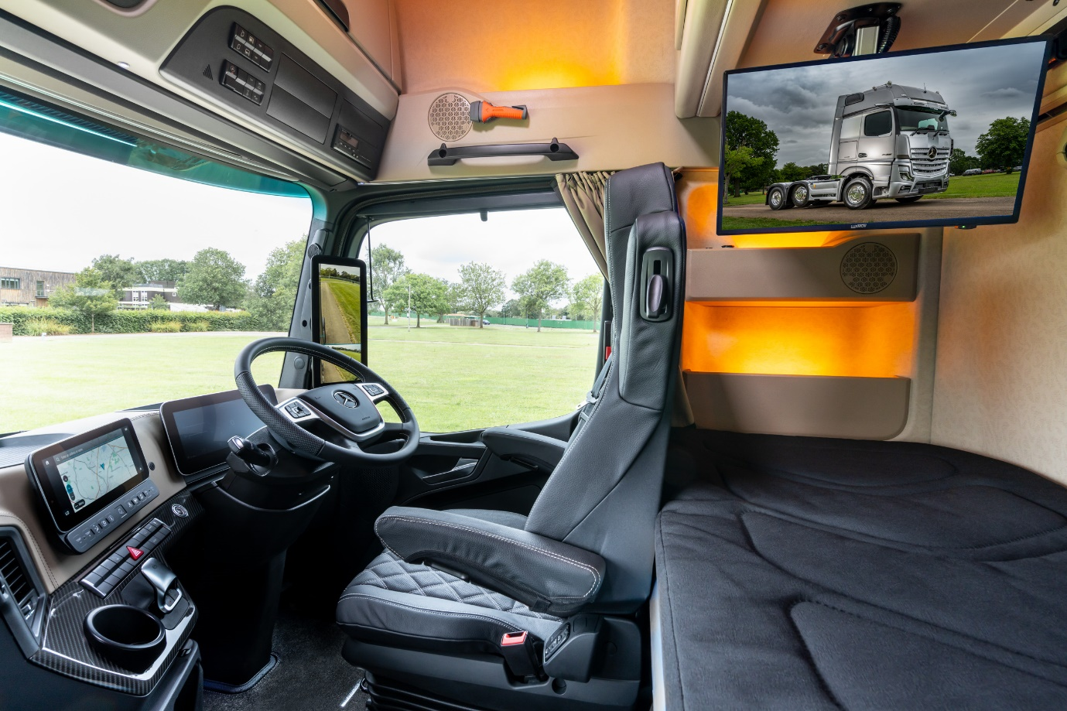

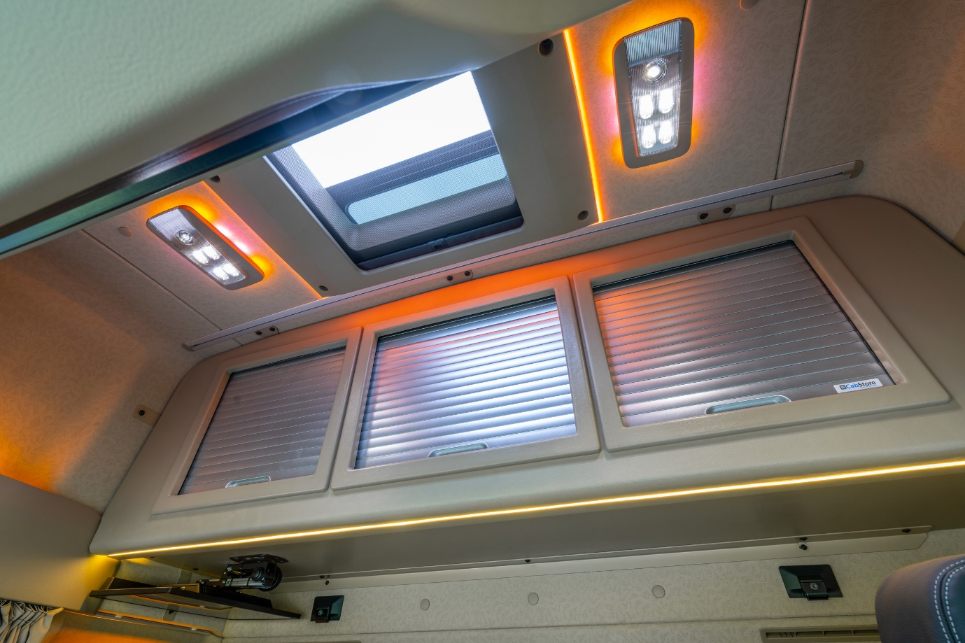

ends

For more information, or to request higher-res image files, please contact:

Jamie Fretwell at Mercedes-Benz Trucks UK Ltd
07712 519230, jamie.fretwell@daimler.com

or

John Ripley: 07771 484595, john.ripley@loopagency.co.uk

